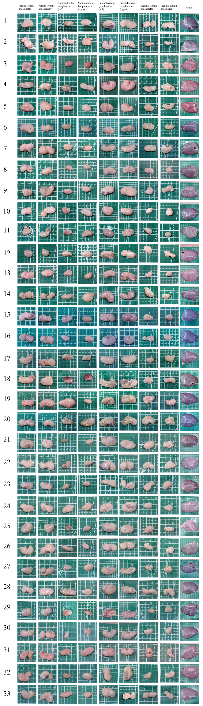

Figure S1. Samples collected aseptically from LPLN, RPLN, LSLN, RSLN, LSpLN, RSpLN, LILN, RILN, and splenic tissue at 0, 3, 7, 15, 30, and 45 days post-infection.
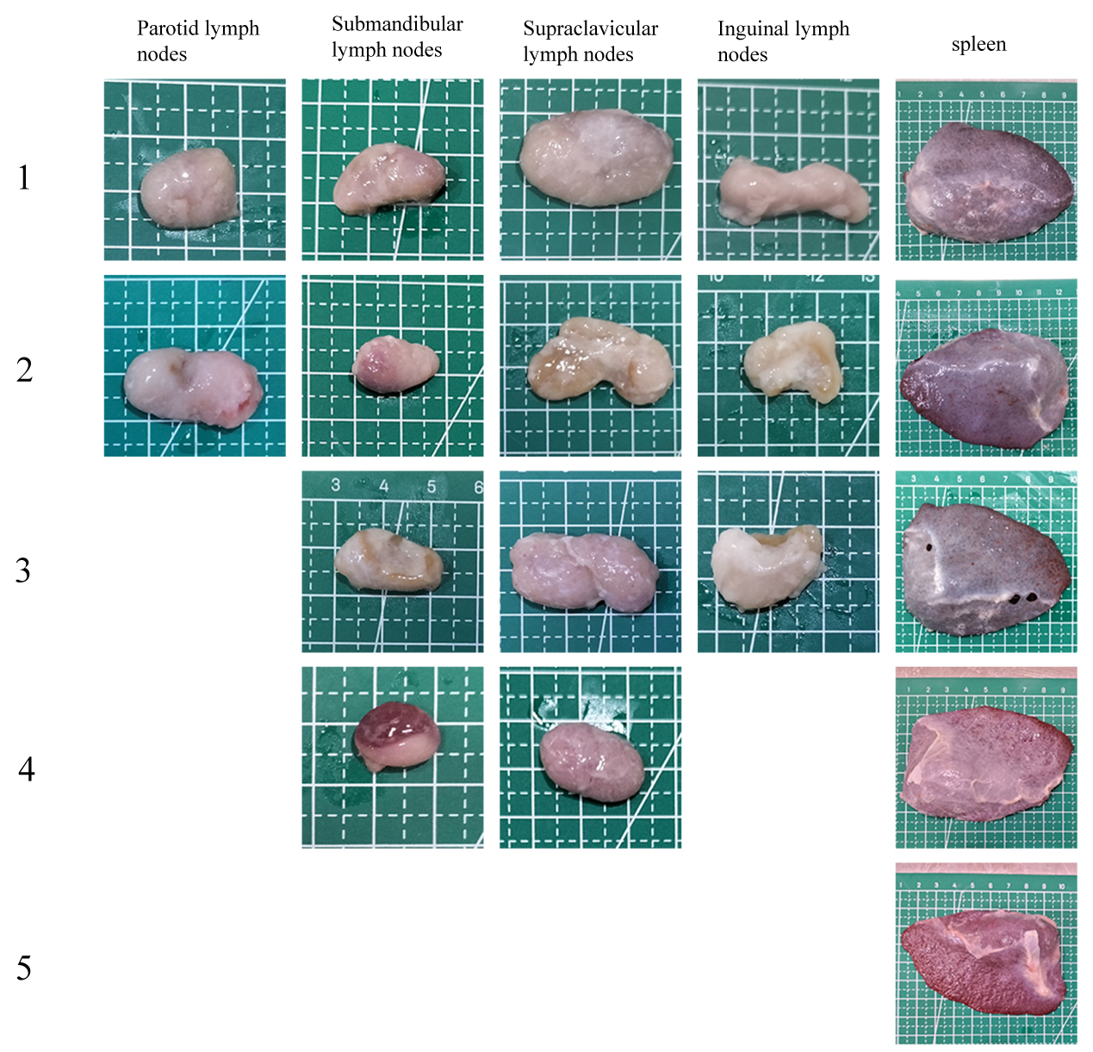
Figure S2. Tissue reference standards corresponding to each grade of gross anatomy scoring.

Table S1. Gross Anatomical Score
Tissue | Scoring Parameter | Scoring Criteria | Score
Lymph node | Color | Entirely white | 0
Lymph node | Color | Areas exhibiting light brown/tan or pale red coloration, accounting for less than 50% of the total tissue area | 1
Lymph node | Color | Areas exhibiting yellowish-brown or reddish coloration, accounting for less than 50% of the total tissue area | 2
Lymph node | Color | Areas exhibiting yellowish-brown or reddish coloration, accounting for more than 50% of the total tissue area | 3
Lymph node | Color | Score 4: Entirely deep red | 4
Lymph node | Area Change | Area size is essentially similar to the control | 0
Lymph node | Area Change | Area is reduced by less than 0.6-fold or increased by more than 1.7-fold but less than 2.25-fold compared to the control | 1
Lymph node | Area Change | Area is increased by more than 2.25-fold compared to the control | 2
Spleen | Hemorrhagic Spots | Smooth surface, no red spots | 0
Spleen | Hemorrhagic Spots | A few scattered red spots on the surface | 1
Spleen | Hemorrhagic Spots | A small number of red spots on the surface | 2
Spleen | Hemorrhagic Spots | A large number of red spots on the surface | 3
Spleen | Marginal Reddening | Normal color at the margin | 0
Spleen | Marginal Reddening | Reddened area accounts for less than 50% of the entire tissue margin | 1
Spleen | Marginal Reddening | Reddened area accounts for more than 50% of the entire tissue margin | 2

Table S2. Histopathological Score Criteria
Scoring Parameter | Scoring Criteria | Score
Inflammation Severity | No significant inflammatory cell infiltration observed within the field of view | 0
Inflammation Severity | Minor inflammatory cell infiltration observed (number of inflammatory cells per field < 10) | 1
Inflammation Severity | Moderate inflammatory cell infiltration compared to control (number of inflammatory cells per field between 10 and 20, inclusive) | 2
Inflammation Severity | Severe inflammatory cell infiltration (number of inflammatory cells per field ≥ 20) with a certain degree of cellular structural damage | 3
Cyst Formation | No cystic structures present | 0
Cyst Formation | Cysts are small in size and sparse in number | 1
Cyst Formation | Cysts are moderate in both size and number | 2
Cyst Formation | Cysts are large in size and numerous | 3
Bacterial Load | No bacteria observable | 0
Bacterial Load | Occasional observation of a small number of bacteria | 1
Bacterial Load | Bacteria observable in multiple fields, but the quantity is relatively low and no bacterial clusters are formed | 2
Bacterial Load | A large number of bacteria observable, with the presence of bacterial clusters | 3
Fibrosis | No fibrotic structures observed | 0
Fibrosis | Mild fibrosis observed | 1
Fibrosis | Moderate fibrosis with noticeable hyperplasia | 2
Fibrosis | Severe fibrosis with significant hyperplasia, where the original architecture is substantially compressed or even replaced by proliferative tissue | 3
Hemorrhage | No erythrocytes observed outside vascular structures | 0
Hemorrhage | Occasional, scattered erythrocytes discernible in extravascular structures | 1
Hemorrhage | Clusters or diffusely distributed erythrocytes present in substantial areas of extravascular tissue | 2
Hemorrhage | Extensive erythrocyte clusters or diffuse infiltration observable in extravascular tissue, with prominent hemosiderin deposition clearly visible | 3
Lymphoid Follicles | Normal number and size of lymphoid follicles | 0
Lymphoid Follicles | Slightly reduced number and mildly decreased size of lymphoid follicles | 1
Lymphoid Follicles | Markedly reduced number and significantly decreased size of lymphoid follicles | 2
Lymphoid Follicles | Architecture of lymphoid follicles is severely disrupted | 3
Intracellular Inclusions | No intracellular inclusions observed | 0
Intracellular Inclusions | Intracellular inclusions occasionally observed | 1
Intracellular Inclusions | Intracellular inclusions observed in multiple fields | 2
Intracellular Inclusions | Abundant intracellular inclusions observed | 3
Nuclear Chromatin Margination | No cells exhibiting nuclear chromatin margination observed | 0
Nuclear Chromatin Margination | Cells exhibiting nuclear chromatin margination occasionally observed | 1
Nuclear Chromatin Margination | Cells exhibiting nuclear chromatin margination observed in multiple fields | 2
Nuclear Chromatin Margination | Abundant cells exhibiting nuclear chromatin margination observed | 3

