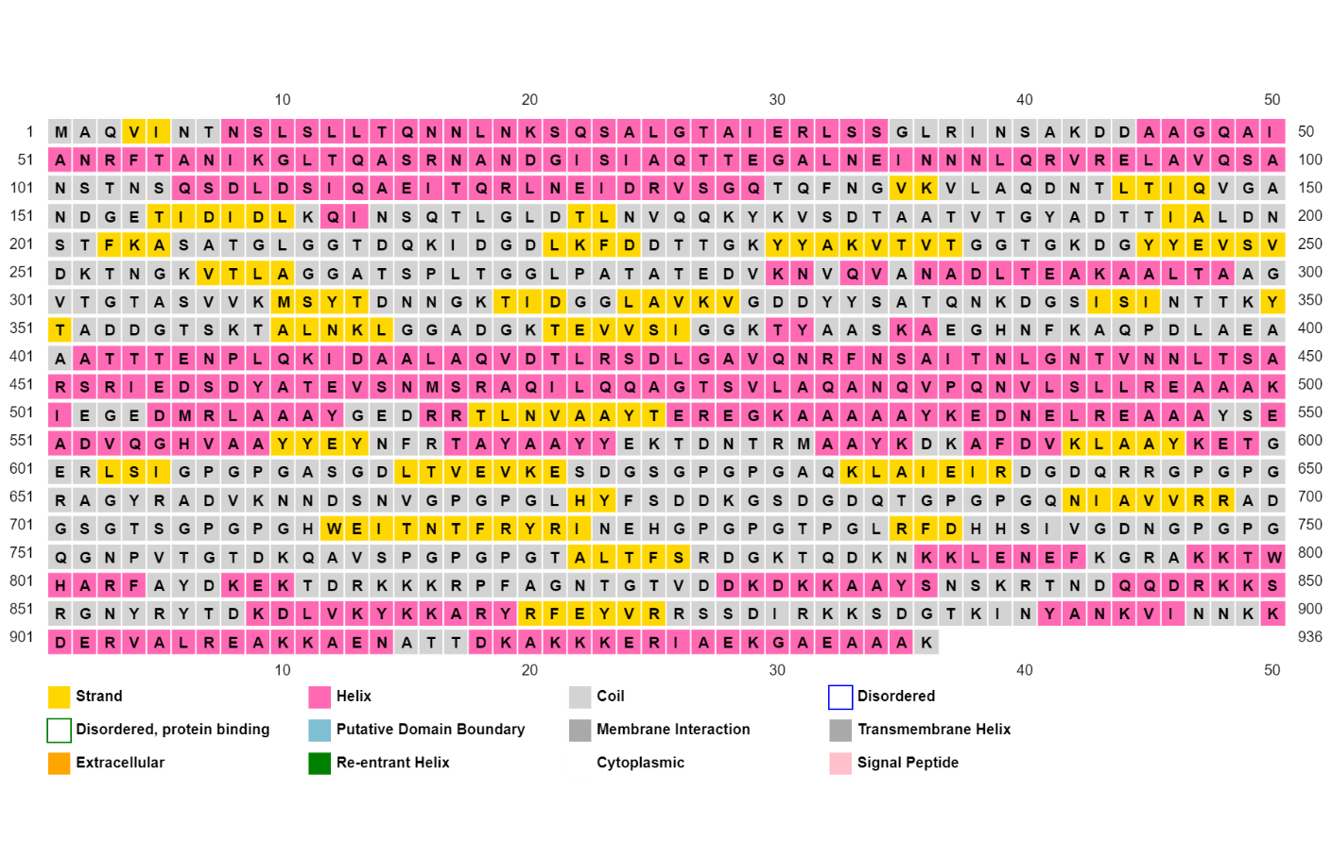
Supplementary Figure 1: Secondary structure prediction of the multiepitope vaccine construct by PSIPRED server. Graphical representation of the predicted secondary structure type for each multiepitope vaccine construct residue indicated by box fill and edge color.
Supplementary Figure 2: Molecular dynamics simulation of multiepitope vaccine construct docked to the TLR1/2 heterodimer. GROMACS pre-production run results are summarized as the: (A) potential energy of system over time, (B) RMSD (root mean square deviation) of NVT (constant number of particles, volume, and temperature) simulation over time, (C) temperature of NVT simulation over time, (D) RMSD of NPT (constant number of particles, pressure, and temperature) simulation over time, and (E) pressure of NPT simulation over time.
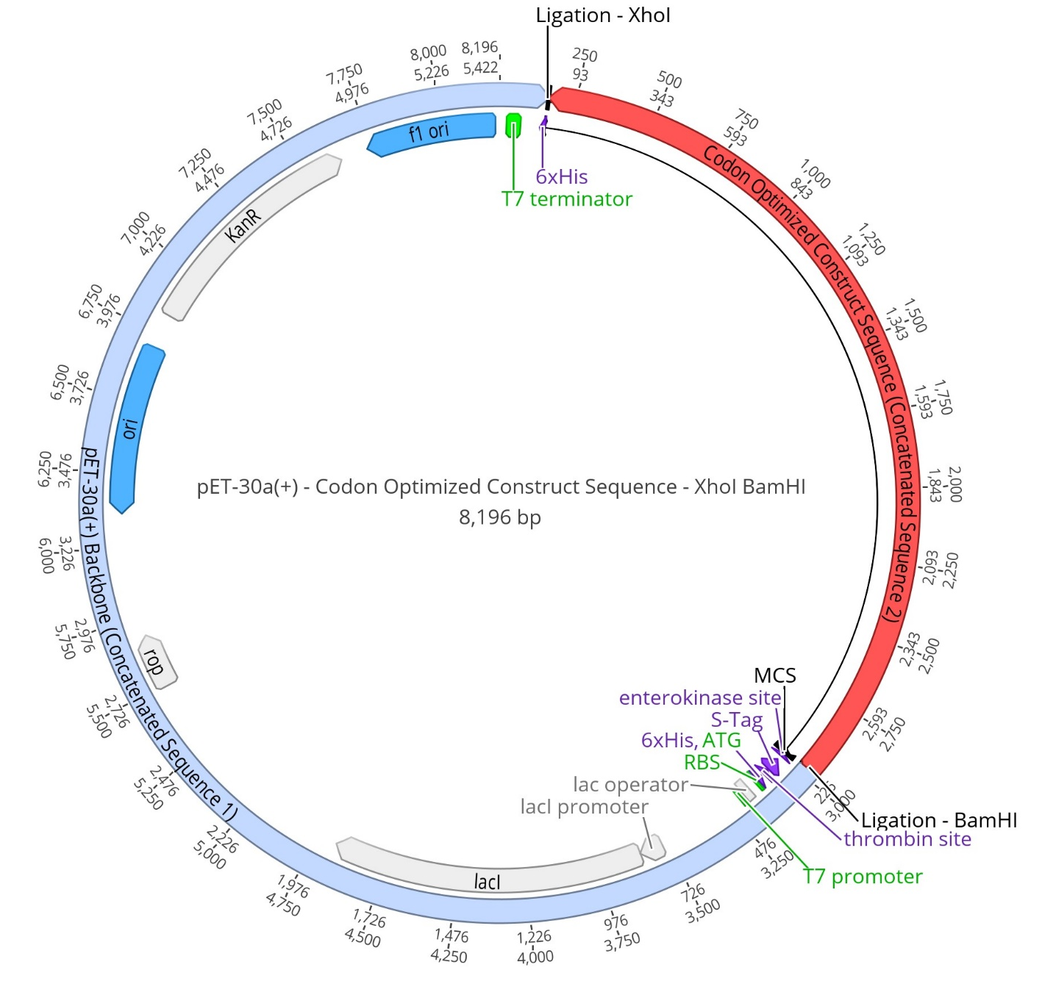
Supplementary Figure 3: In silico restriction cloning of the codon-optimized multiepitope vaccine construct. Graphical representation of the product of in silico cloning using Geneious Prime to combine the codon-optimized multiepitope vaccine construct (MEVC) sequence generated by the JCAT server with a BamHI restriction endonuclease (RE) site at the 5’ end and a XhoI RE site at the 3’ end (2,818 bp) cloned into the pET30a(+) expression vector. Red denotes the MEVC sequence, light blue denotes the vector, black denotes the multiple cloning site (MCS) relevant to in silico cloning, green denotes sequences that are relevant to the transcription and translation processes such as the promoter and ribosomal binding site (RBS), purple denotes sequences related to post-translational processing, gray indicates gene locations within the vector, and dark blue represents the origins of replication (ori).
Supplementary Figure 4: Immune simulation of MHCI HLA-B*40:06 and MHCII DRBI*13:10 alleles with the multiepitope construct. C-ImmSim server simulation was run with injections of the multiepitope vaccine construct occurring at Days 0 and 21. (A) Antigens and immunoglobin levels, (B) production of cytokine and interleukins with Simpson index D, (C) macrophage population per state, (D) dendritic cell population per state , (E) B lymphocyte population per state, (F) B lymphocyte population, (G) cytotoxic T lymphocyte (TC) population, (H) helper T lymphocyte (TH) population per state, and (I) helper T lymphocyte (TH) population.
Supplementary Figure 5: Immune simulation of MHCI HLA-B*41:03 and MHCII DRBI*13:66 alleles with the multiepitope construct. C-ImmSim server simulation was run with injections of the multiepitope vaccine construct occurring at Days 0 and 21. (A) Antigens and immunoglobin levels, (B) production of cytokine and interleukins with Simpson index D, (C) macrophage population per state, (D) dendritic cell population per state , (E) B lymphocyte population per state, (F) B lymphocyte population, (G) cytotoxic T lymphocyte (TC) population, (H) helper T lymphocyte (TH) population per state, and (I) helper T lymphocyte (TH) population.

Supplementary Figure 6: Alignment of multiepitope vaccine construct (MEVC) epitopes to PulseNet outbreak-associated proteomes by isolation source. The color gradient (100% = dark blue, 50% = purple, 0% = dark red) in the heatmap illustrates the percentage of PulseNet outbreak-associated proteomes with complete homology (100% sequence identity and coverage) to each MEVC epitope (n = 28). Percentages are provided per specified isolation source (n = 6) as well as an “Other” category that includes isolation sources that were not the focus of this study (n = 1,021 isolates). The specified isolation sources included: human- (n = 31,012), chicken- (n = 726), turkey- (n = 377), cattle/beef- (n = 270), swine/pork- (n = 260), and egg-associated (n = 6) sources. Colors on the left-hand side of the heatmap indicate the epitope type.

