Supplementary Information

Cellular prion protein exacerbates brain demyelination by activating microglia through the TREM2-TYROBP axis in cuprizone-treated animals
Qing Li^{1ǂ}, Pengcheng Huang^{1ǂ}, Jinqiong Zhan^{2ǂ}, Hancun Yi¹, Zihao Zhang¹, Pingping Shen³, Yuanjian Yang², Yanming Wang⁴, Daojun Hong¹, Jiyan Ma^{5,6*}, Xiaomu Wu^{1,7*}, Wen-Quan Zou¹
¹Institute of Neurology and Department of Neurology, The First Affiliated Hospital, Jiangxi Medical College, Nanchang University, Nanchang 330006, Jiangxi Province, China;
²Jiangxi Mental Hospital & Affiliated Mental Hospital, Jiangxi Medical College, Nanchang University, Nanchang 330029, Jiangxi, China;
³Department of Neurology, The First Hospital of Jilin University, Changchun, China.
⁴Institute of Nuclear Medicine Molecular Imaging, Binzhou Medical University Hospital, Binzhou 256603, Shandong Province, China;
⁵Beijing Institute for Brain Research, Chinese Academy of Medical Sciences & Peking Union Medical College, Beijing, 102206, China;
⁶Chinese Institute for Brain Research, Beijing, 102206, China;
⁷Jiangxi Provincial Institute of Neurology, Nanchang 330006, Jiangxi Province, China.

ǂContributed equally to this work.
*Corresponding authors: Wen-Quan Zou, E-mail: wenquanzou@ncu.edu.cn; Xiaomu Wu, E-mail: wuxm79@163.com; Jiyan Ma, E-mail: majiyan@cibr.ac.cn.

Supplementary figures and figure legends

Figure S1 PrP^{C} is up-regulated in EAE mice and in cuprizone-treated SH-SY5Y cells. (A) Schematic of the experimental timeline for EAE induction using MOG_{35–55} over 30 days. (B) and (C) Mean body weight and mean clinical disease scores, respectively, in EAE and CON mice. 7 mice/group. (D) and (E) Representative H&E staining (showing immune cell infiltration, black arrows) and LFB staining (demyelination, black arrows) of spinal cord sections from EAE and CON mice. Scale bars = 300 μm. (F) Demyelination score in lumbar spinal cords of EAE and CON mice, graded as follows: 0: normal, 1: disordered nerve fibers, 2: formation of distinct vacuoles, 3: disappearance of myelin fibers. 4 mice/group. (G) and (H) Western blot and quantitative analysis of PrP^{C} expression in lumbar spinal cord tissues 30 days after EAE induction 4 mice/group. (I) Experimental design for treating SH-SY5Y cells with cuprizone (0–100 µM, 24 hours). (J) Immunofluorescence staining of PrP^{C} (green) in cuprizone-treated SH-SY5Y cells. Nuclei were stained with DAPI (blue). Scale bars = 50 μm and 8.5 μm. (K) and (I) Western blot and quantification of PrP^{C} in SH-SY5Y cells after cuprizone treatment. 6 mice/group. Data are represented as means ± SEM. *p < 0.05; **p < 0.01; ***p < 0.001; ****p < 0.0001. Two-way ANOVA with Sidak’s multiple comparisons test was used for panels (B) and (C). Unpaired t test was used for panels (F) and (H). One-way ANOVA with Tukey’s multiple comparisons was used for (L).
Figure S2 Validation of Prnp knockout and OPR-deletion in mice at various molecular levels. (A) Schematic of mature PrP^{C} structure, illustrating the domains deleted in Prnp-OPR (aa 51–90) and Prnp-KO (entire mature PrP, aa 23–230). The red dashed line indicates the deleted region. (B) Sanger sequencing confirmation of PrP sequences in the three genotypes. Wild-type (WT): CCACCTC; Prnp-OPR^{de}: CCCGGGG; Prnp-KO: CCACGGA. (C) DNA agarose gel electrophoresis of PrP sequences across the three genotypes. (D) RT-qPCR analysis of PrP mRNA expression levels. Data are presented as means ± SEM; ns p > 0.05, **p < 0.01, ***p < 0.001 (one-way ANOVA with Tukey’s test). (E) Western blot analysis of PrP protein expression in the three genotypes.

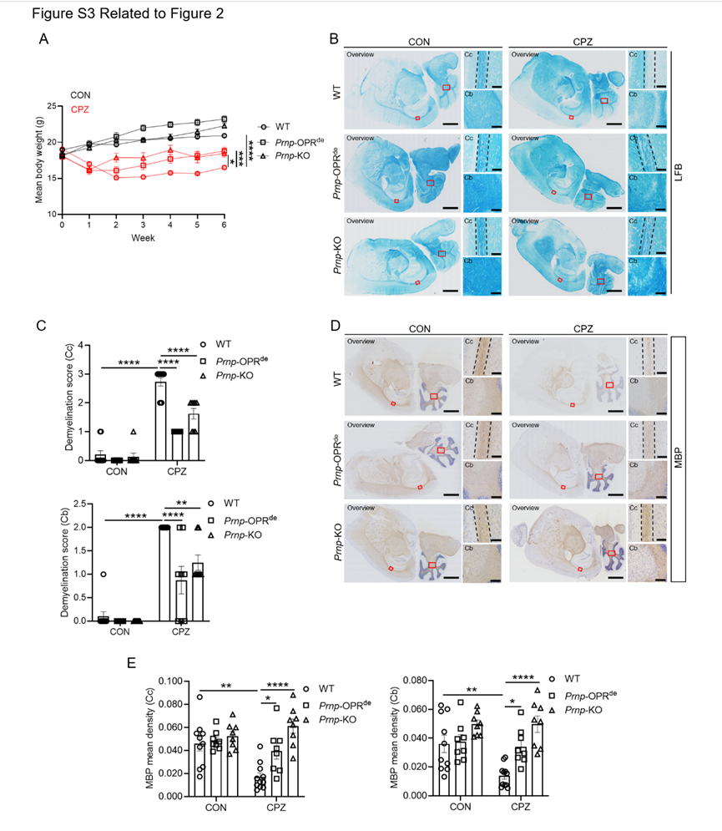
Figure S3 Knockout and OPR-deletion of Prnp ameliorates demyelination in female CPZ-treated mice. (A) Mean body weight of mice treated with CPZ or control (CON) diet. 7–26/group. Two-way ANOVA with Tukey’s multiple comparisons test was used. (B) Representative LFB staining of sagittal brain sections showing myelination in the Cc and Cb. The black dashed line outlines the Cc. Scale bars = 50 μm (Cc) and 100 μm (Cb). (C) Demyelination scores in CPZ- or CON-treated mice. 8–11 mice/group. (D) Representative immunohistochemical staining of MBP in sagittal sections of Cc and Cb. The black dashed line indicates the Cc. Scale bars = 50 μm (Cc) and 100 μm (Cb). (E) Densitometric quantification of MBP staining. 8–11 mice/group. Data are represented as means ± SEM. *p < 0.05; **p < 0.01; ***p < 0.001; ****p < 0.0001. One-way ANOVA with Tukey’s multiple comparisons test was applied to panels (C) and (E).

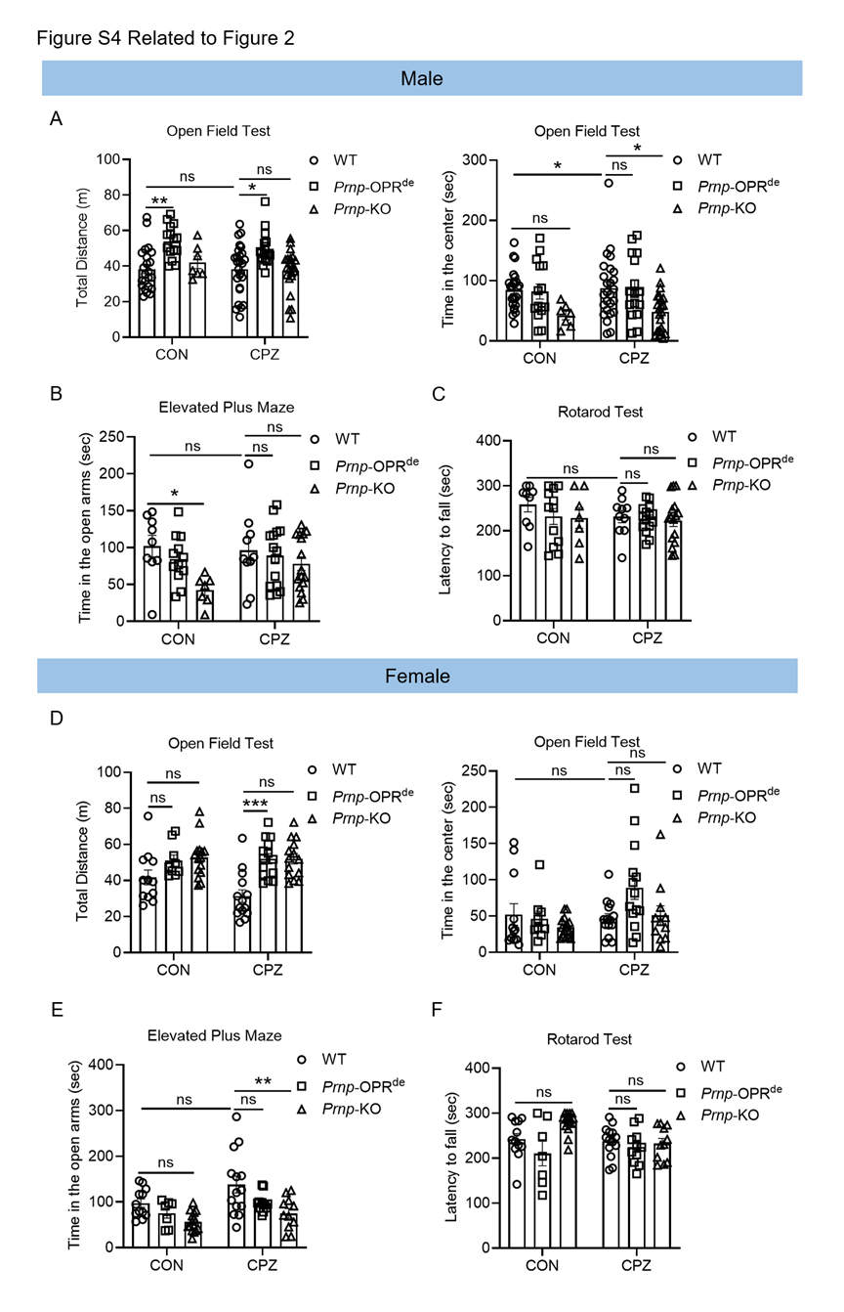
Figure S4 Behavioral assessment of anxiety and motor function. (A) and (D) Total distance traveled and time spent in the central area during the open field test for male and female mice, respectively. 7–26 mice/group. (B) and (E) Time spent in the open arms during the elevated plus maze test for male and female mice, respectively. 7–26 mice/group. (C) and (F) Latency to fall during the rotarod test for male and female mice, respectively. 7–26 mice/group. Data are represented as means ± SEM. ns p > 0.05; *p < 0.05; **p < 0.01; ***p < 0.001. One-way ANOVA with Tukey’s multiple comparisons test was used for all analyses.

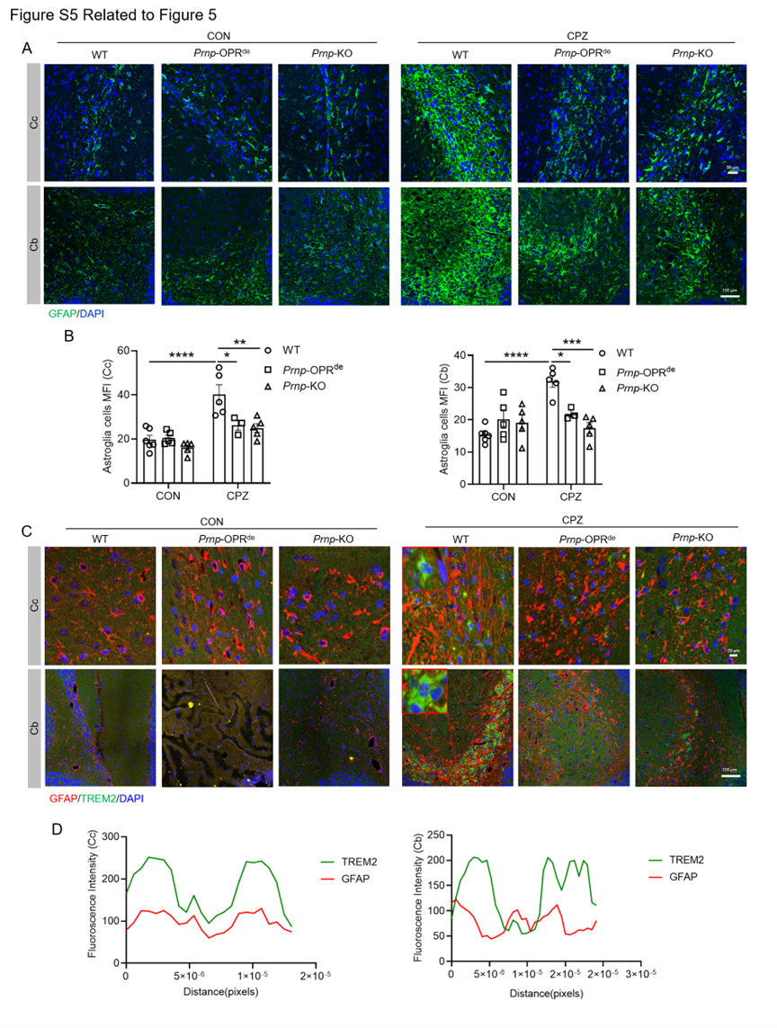
Figure S5 Inhibition of TREM2 expression via Prnp knockout or OPR deletion does not correlate with astrocyte activation in CPZ-treated mice. (A) Representative immunofluorescence image showing staining of astrocytes marker GFAP (green) in the Cc and Cb of mice. Nuclei were counterstained with DAPI. (blue). Scale bars = 20 μm (Cc) and 100 μm (Cb). (B) Quantification of MFI of GFAP MFI in Cc and Cb regions. 4–6 mice/group. Statistical analysis was performed using one-way ANOVA with Tukey’s multiple comparisons test. (C) Representative dual immunofluorescence staining of TREM2 (green) and GFAP (red) in Cc and Cb. The red rectangle highlights regions of GFAP and TREM2 co-localization. Nuclei were stained with DAPI (blue). Scale bars = 20 μm (Cc) and 100 μm (Cb). (D) In WT mice, spatial overlap of GFAP and TREM2 fluorescence peaks was observed, and co-localization was quantified using Leica confocal imaging software. Data are expressed as means ± SEM. *p < 0.05, **p < 0.01, ***p < 0.001, ****p < 0.0001.

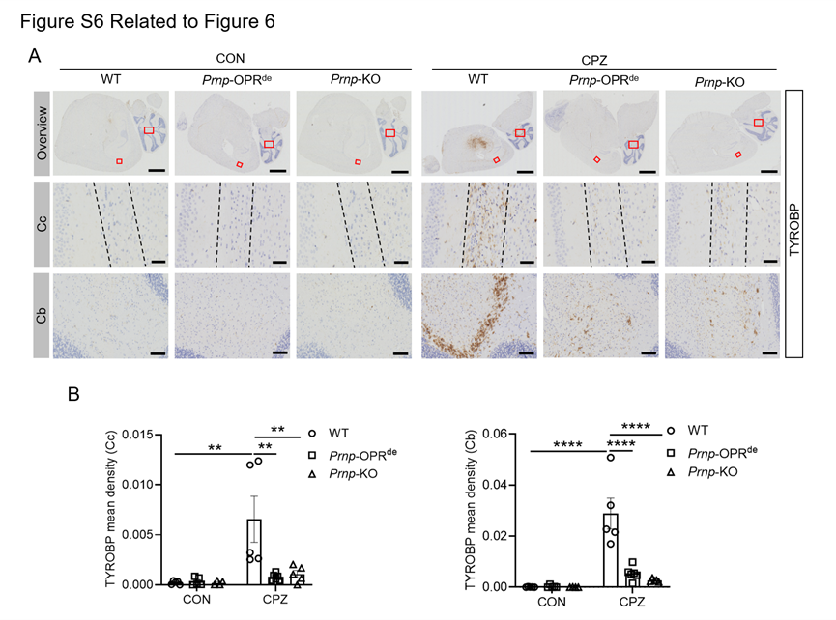
Figure S6 Upregulation of TYROBP in CPZ-treated mice is abolished by Prnp knockout and OPR deletion, as assessed by IHC. (A) Representative immunohistochemical staining of TYROBP in sagittal sections of Cc and Cb from CPZ-/CON-treated mice. The red rectangle indicates the enlarged area. The Cc is outlined with a black dashed line. Scale bars = 2 mm (Overview), 50 μm (Cc) and 100 μm (Cb). (B) Densitometric quantification of TYROBP expression. 5 mice/group. Data are represented as means ± SEM. **p < 0.01; ****p < 0.0001.

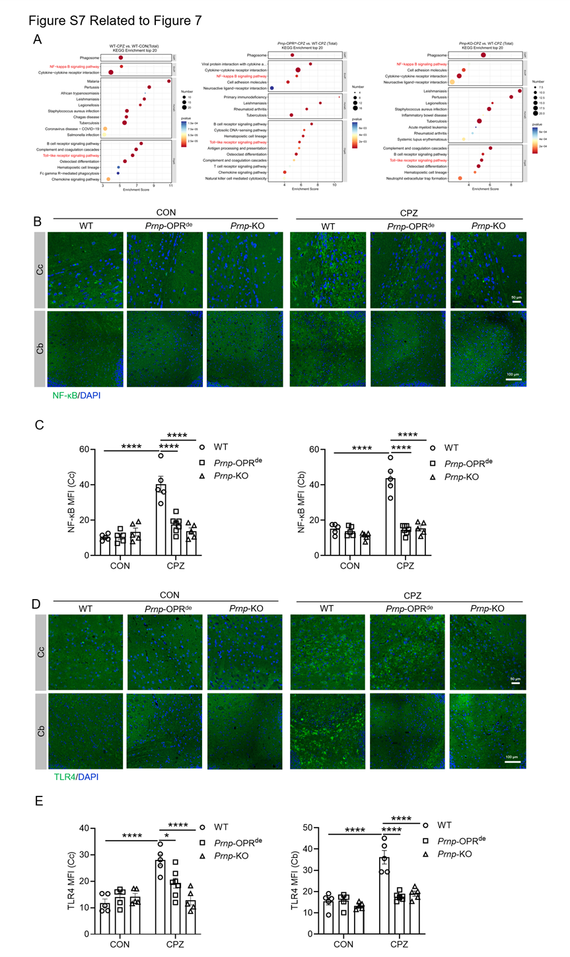
Figure S7. Knockout and OPR-deletion of Prnp inhibit activation of NF-κB and TLR4 pathways. (A) Bubble plot showing KEGG enrichment analysis of the NF-κB and TLR4 signaling pathways. (B) and (C) Representative immunofluorescence staining of NF-κB (B) and TLR4 (C) (green) in the Cc and Cb. Nuclei were counterstained with DAPI (blue). Scale bars = 50 μm (Cc) and 100 μm (Cb). Quantification of MFI of NF-κB (D) and TLR4 (E) MFI in the Cc and Cb of CPZ-/sham-treated mice. 5–7 mice/group. Data are represented as means ± SEM. *p < 0.05; **p < 0.01; ***p < 0.001; ****p < 0.0001. One-way ANOVA with Tukey’s multiple comparisons test was used for (C) and (E).

