Supplementary Information

Speciation and Radiation Stability of Cr and Ln “Grey-Phases” within Cr-doped (Ln,U)O₂ Spent Fuel Model Materials
Daniil Shirokiy^{1*}, Andrey Bukaemskiy¹, Maximilian Henkes¹, Elena F. Bazarkina^{2,3}, Christoph Hennig^{2,3}, Andrew Ryan^{1,5}, Martina Klinkenberg¹, Murat Güngör¹, Mara McCleary¹, Julien Marquardt⁶, Andrew Fitch⁴, Kristina O. Kvashnina^{2,3}, Dirk Bosbach¹ and Gabriel L. Murphy^{1*}
¹Institut of Fusion Energy and Nuclear Waste Management (IFN-2), Forschungszentrum Jülich GmbH, 52428 Jülich, Germany
²Institute of Resource Ecology, Helmholtz Zentrum Dresden-Rossendorf, 01328 Dresden, Germany
³The Rossendorf Beamline at ESRF, The European Synchrotron, CS40220, 38043, Grenoble Cedex 9, France
⁴ESRF, 71 avenue des Martyrs, CS40220, 38043 Grenoble, France
⁵Department and Chemical and Bioengineering, Princeton University, Princeton, NJ 08544, USA
⁶Institut für Geowissenschaften, Goethe-Universität Frankfurt, 60438, Frankfurt am Main, Germany
Corresponding authors: *Daniil Shirokiy (d.shirokiy@fz-juelich.de), Gabriel L. Murphy
(g.murphy@fz-juelich.de)

Supplementary Information Note 1. Laboratory X-ray Powder Diffraction
Supplementary Figure 1 display Rietveld refinement profiles for 200 ppm Cr-doped (U_{0.7}Gd_{.3})O_{2-x} and (U_{0.7}Gd_{.3})O_{2-x} samples taken using a Brucker D4 diffractometer. It was evident that all samples exhibited single phase under the $Fm\overline{3}m$ space group.
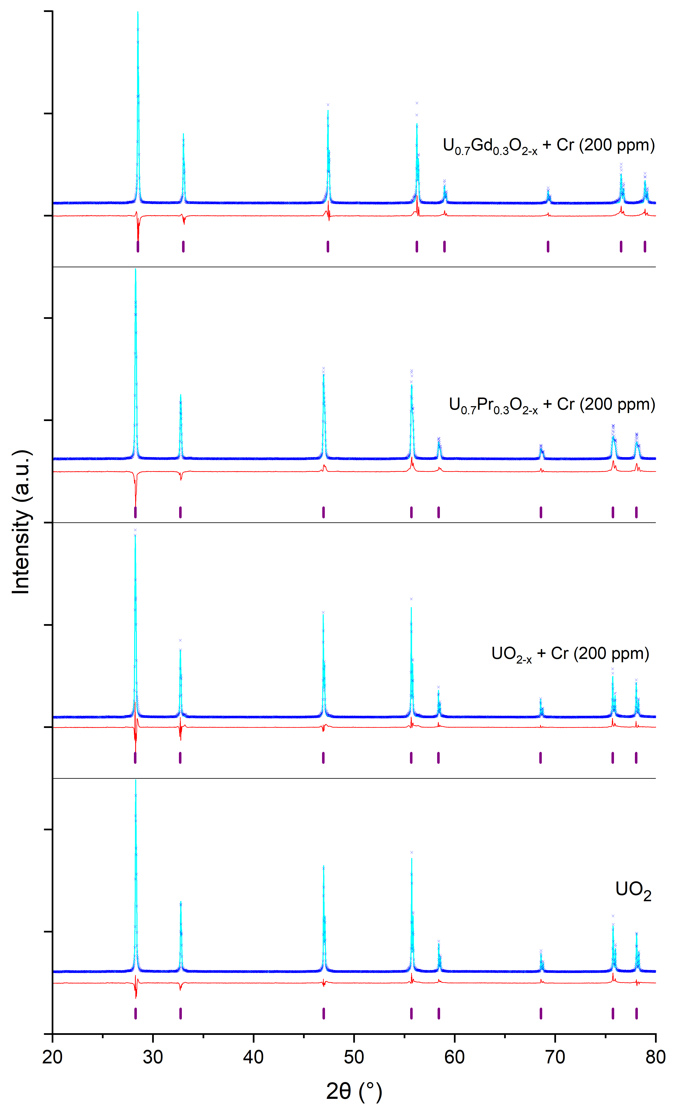
Supplementary Figure 1 – Rietveld refinement of the XRD data obtained using Brucker D4 XRD for pure UO₂, 200 ppm Cr-doped UO_{2-x} and 200 ppm Cr-doped (U_{0.7}Ln_{0.3})O_{2-x} samples, was used to confirm the formation of UO₂ fluorite lattice material. Measured data, refined models, difference curve and allowed reflections are according to the determined UO₂ $Fm\overline{3}m$ space group respectively represented by blue markers, cyan lines, red lines and purple vertical markers.

Supplementary Figure 2 display Rietveld refinement profiles for the synthesised perovskite PrCrO₃ and GdCrO₃ materials.
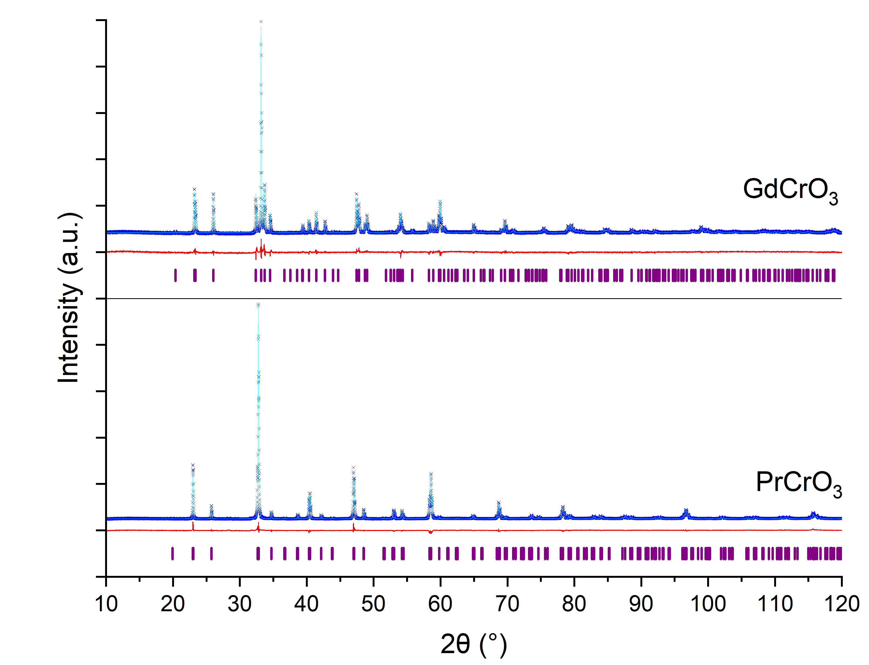
Supplementary Figure 2 – Rietveld refinement of the XRD data obtained using Brucker D4 XRD for PrCrO₃ and GdCrO₃ materials. The results confirm the synthesis of targeted LnCrO₃ perovskite material. Measured data, refined models, difference curve and allowed reflections are according to the $Pbnm$ space group respectively represented by blue markers, cyan lines, red lines and purple vertical markers.

Supplementary Information Note 2. Stopping Range of Ions in Matter Results
Supplementary Figure 3 shows the results of the SRIM calculations for the stopping range of 1.3 GeV ¹⁹⁷Au⁺ ions in the perovskite PrCrO₃ and GdCrO₃ materials.
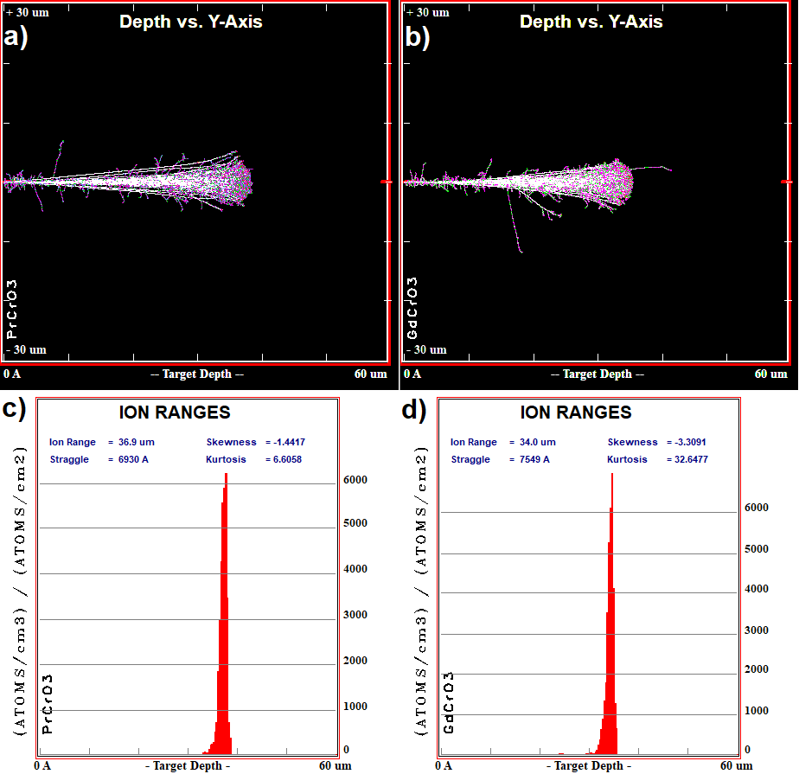
Supplementary Figure 3 – SRIM calculation results of the ¹⁹⁷Au⁺ ions stopping ranges in PrCrO₃ and GdCrO₃ materials: full damage cascades in a) PrCrO₃, b) GdCrO₃ and ion stopping ranges in c) PrCrO₃, d) GdCrO₃

Supplementary Information Note 3. X-ray Penetration Depth Calculations
Supplementary Figure 4 shows the X-ray with a wavelength of 1.0785 Å penetration depth results for the perovskite PrCrO₃ and GdCrO₃ materials for the grazing angles range used in the experiment.
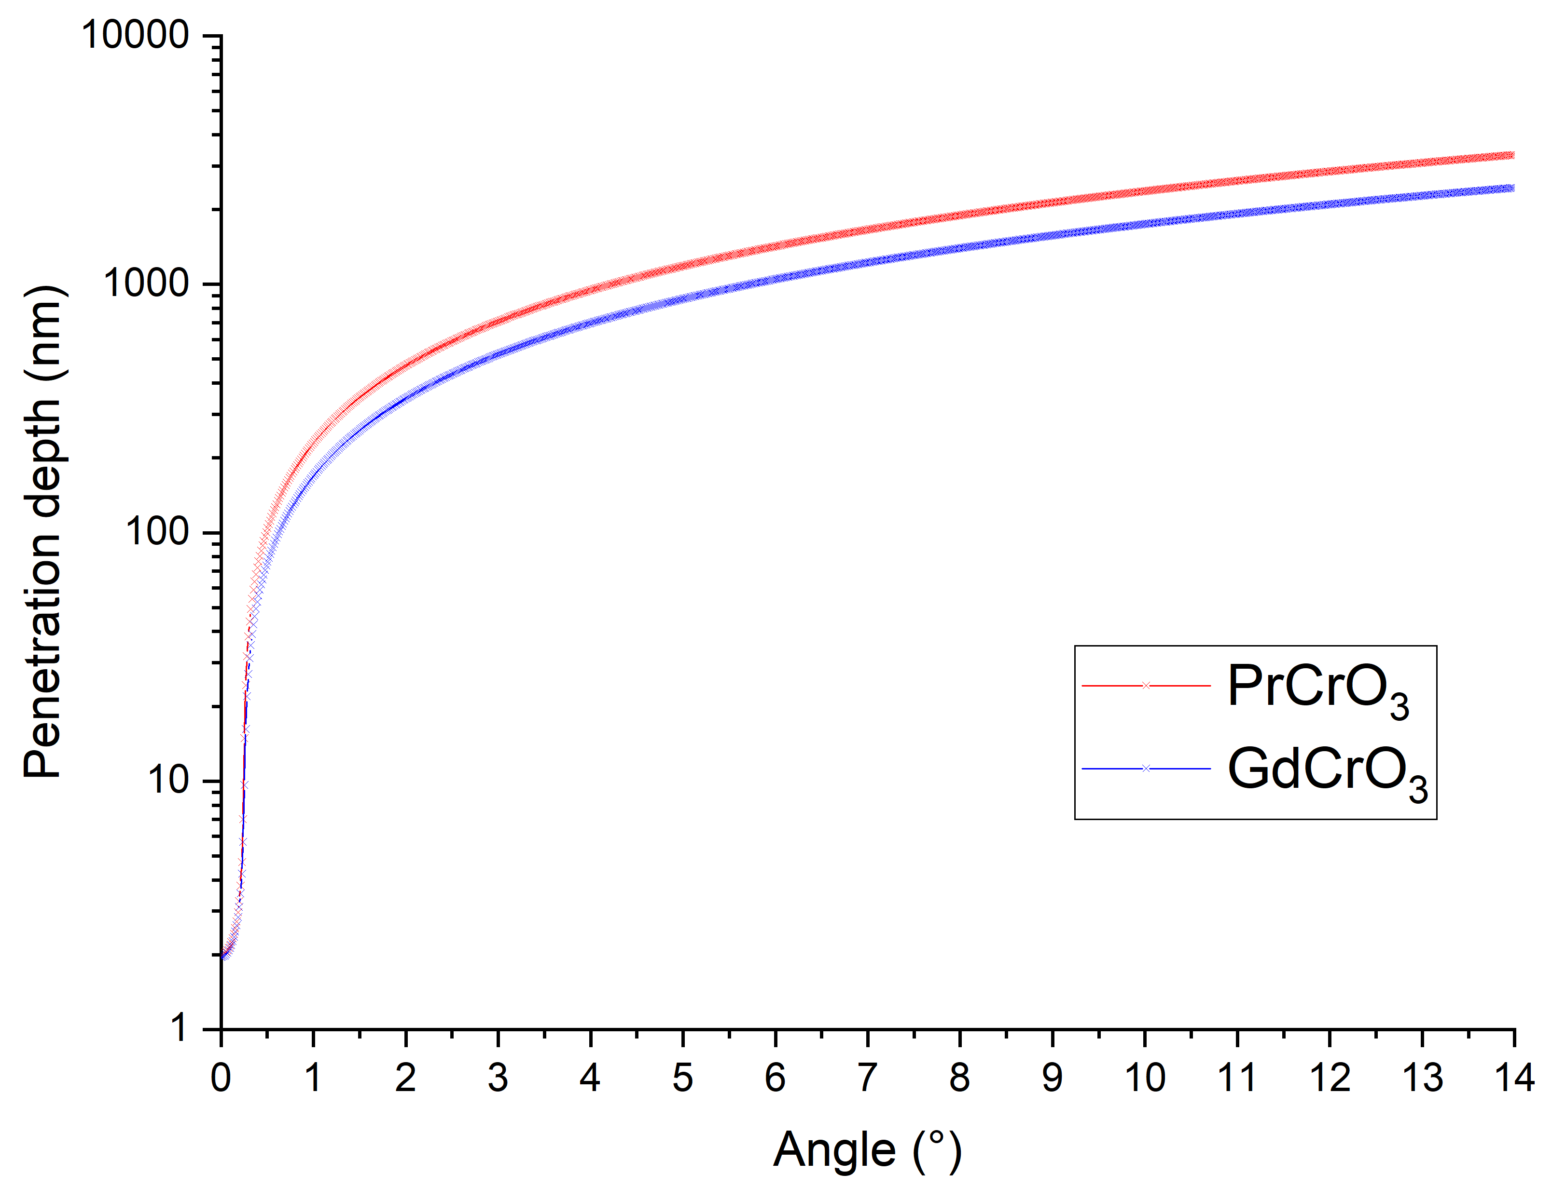
Supplementary Figure 4 – Penetration depth of the X-rays with a wavelength of 1.0785 Å calculated for PrCrO₃ (red) and GdCrO₃ (blue) materials for the grazing angles range: 0-15°.

Supplementary Information Note 4. Combined XANES Spectra
Supplementary Figure 5 shows the combined HERFD-XANES spectra for 200 ppm Cr-doped (U_{0.7}Pr_{0.3})O_{2±x} sample together with all Cr standards as well as Ln-free Cr-doped UO_{2±x} bulk sample and Cr-doped UO_{2±x} single crystal sample.
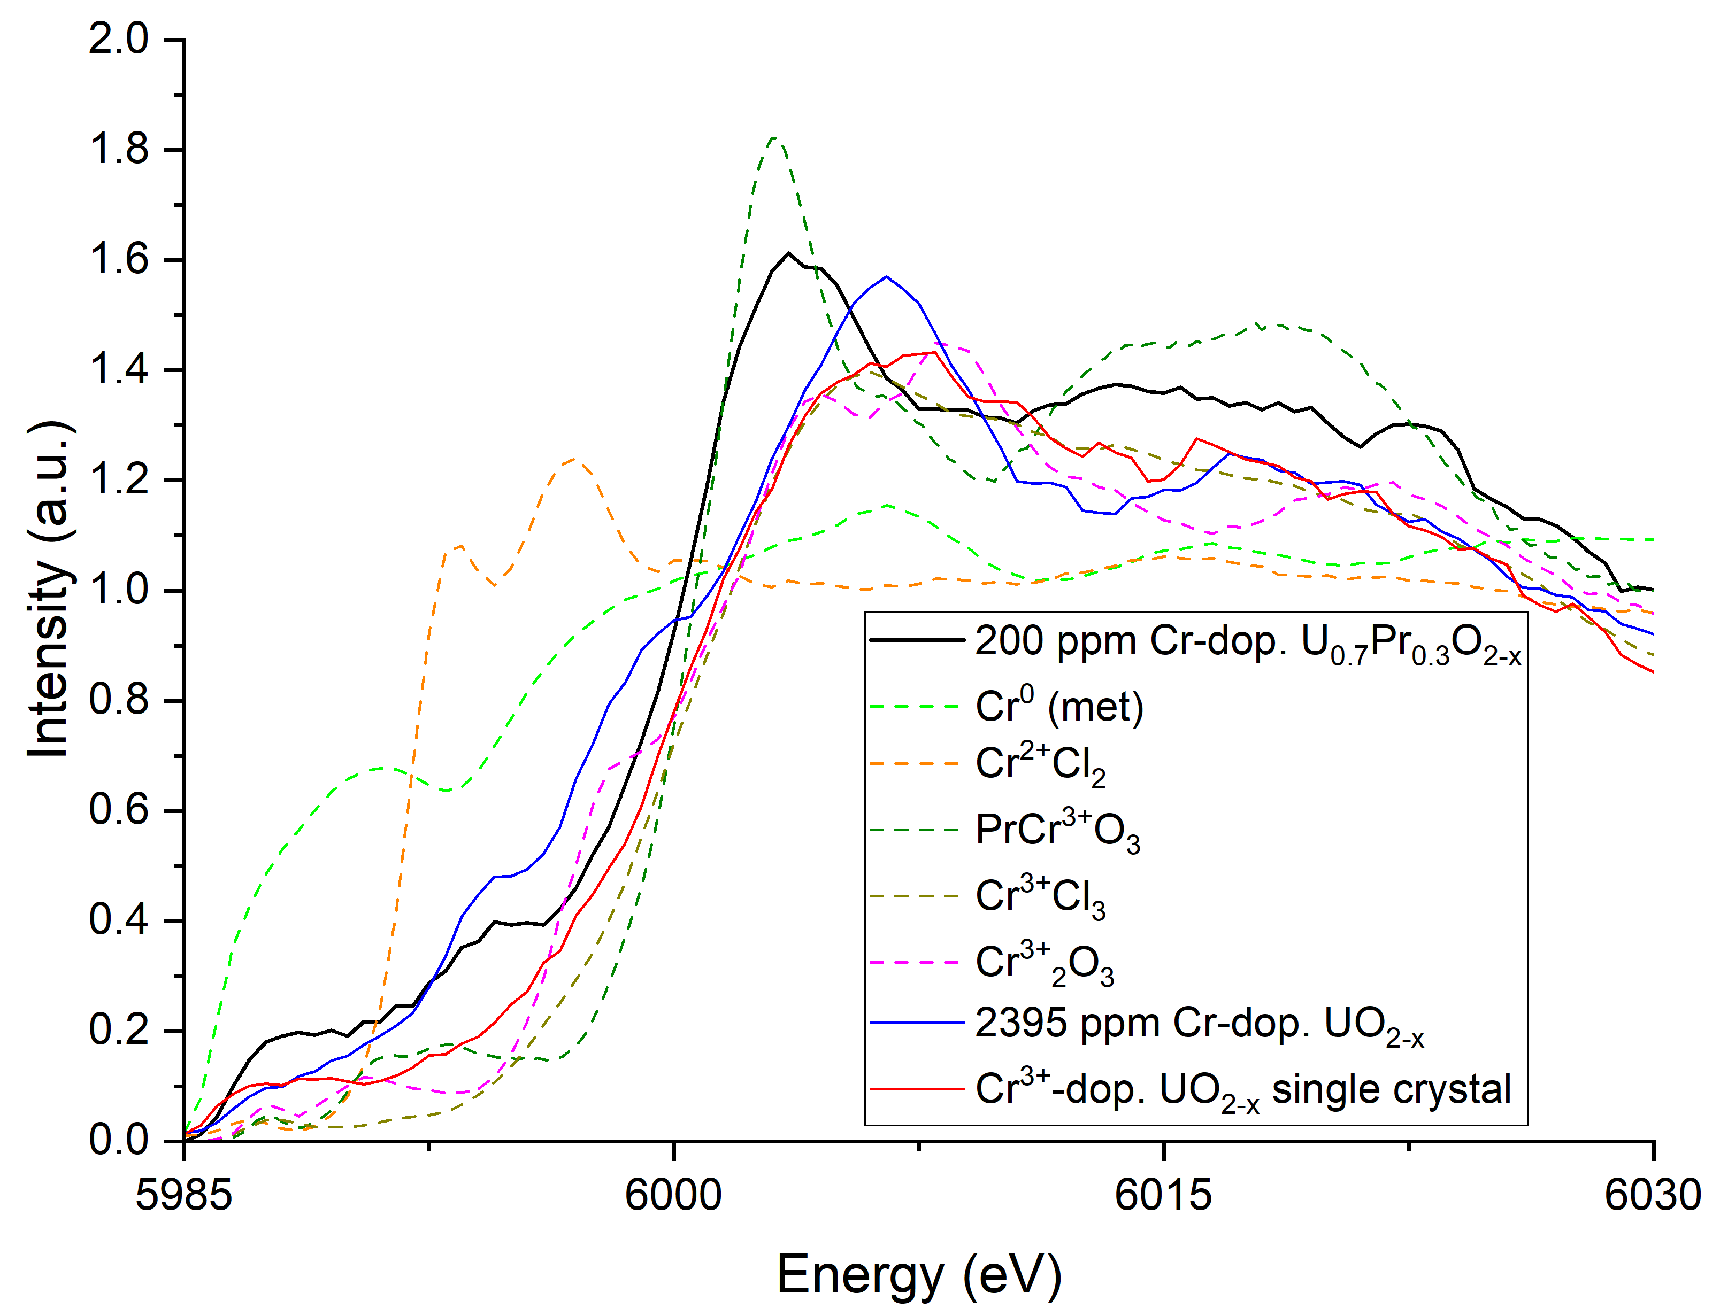
Supplementary Figure 5 – Normalised combined HERFD-XANES Cr K-edge spectra for 200 ppm Cr-doped (U_{0.7}Pr_{0.3})O_{2-x} sample compared with the all standards (dashed lines), including Cr⁰ metallic, Cr²⁺Cl₂ and Cr³⁺ standards as well as the Ln-free, Cr-doped UO₂ bulk sample (blue solid line) and Cr-doped UO₂ single crystal (red solid line)
Supplementary Figure 6 shows the combined HERFD-XANES spectra for 200 ppm Cr-doped (U_{0.7}Gd_{0.3})O_{2-x} sample together with all Cr standards as well as Ln-free Cr-doped UO_{2-x} bulk sample and Cr-doped UO_{2-x} single crystal sample.
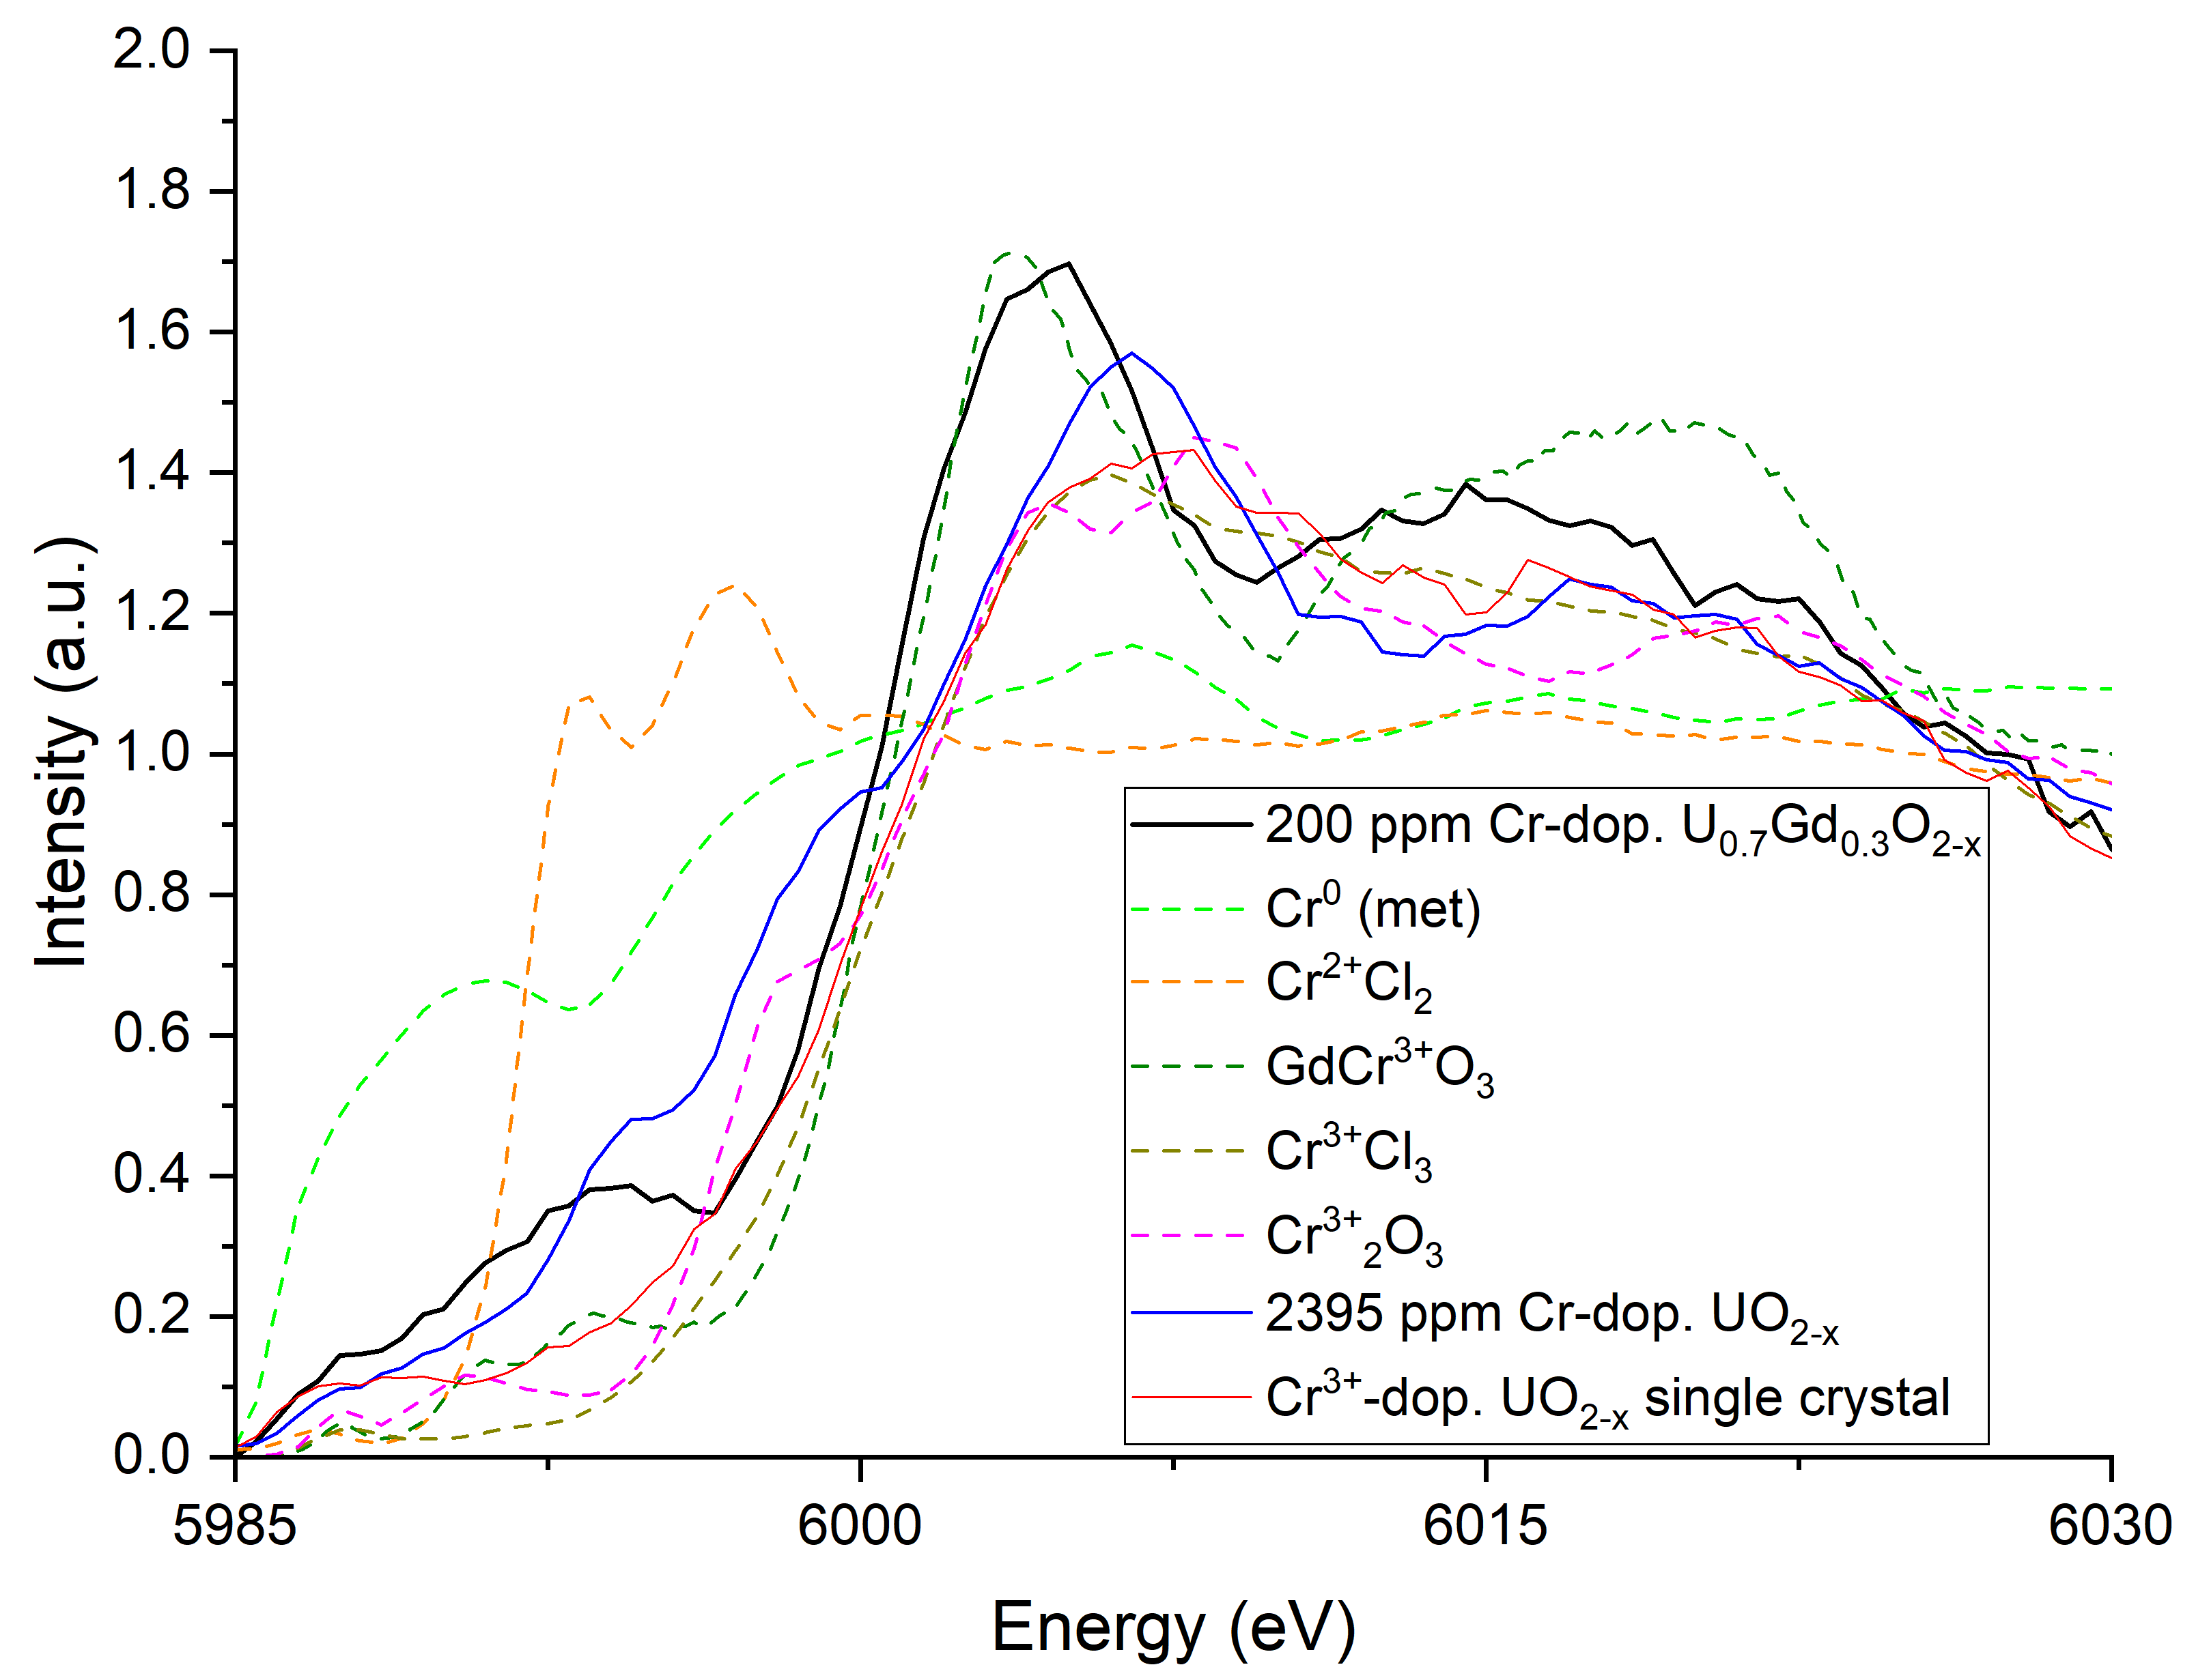
Supplementary Figure 6 – Normalised combined HERFD-XANES Cr K-edge spectra for 200 ppm Cr-doped (U_{0.7}Gd_{0.3})O_{2-x} sample compared with the all standards (dashed lines), including Cr⁰ metallic, Cr²⁺Cl₂ and Cr³⁺ standards as well as the Ln-free, Cr-doped UO_{2-x} bulk sample (blue solid line) and Cr-doped UO_{2-x} single crystal (red solid line)

Supplementary Information Note 5. Images of Irradiated Perovskite Pellets
Supplementary Figure 7 shows the photo of the perovskite PrCrO₃ and GdCrO₃ samples taken after exposure to the ion irradiation.
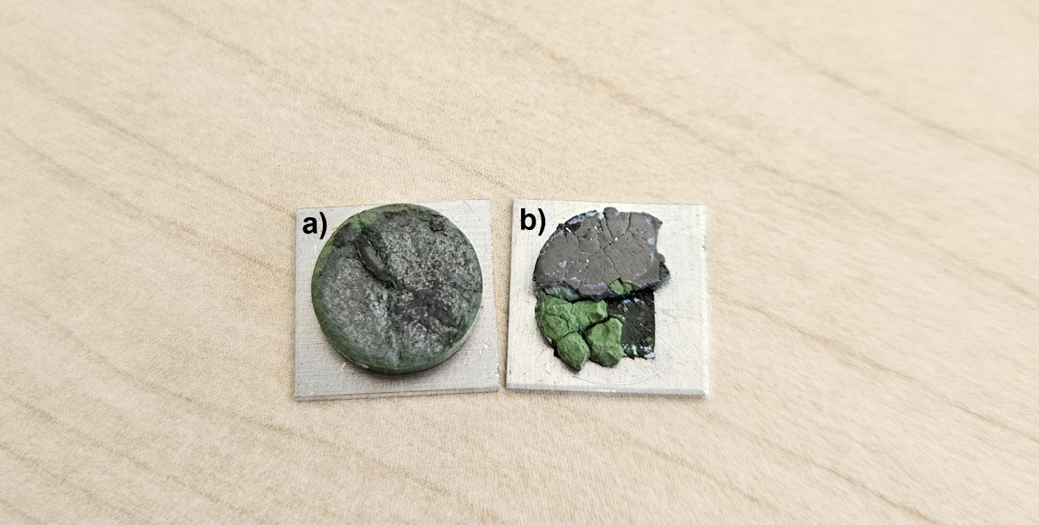
Supplementary Figure 7 – Photo of the samples: a) PrCrO₃ and b) GdCrO₃ taken after they were irradiated and then cooled. The shiny areas are the irradiated zone, while the chipped pieces expose the interior of the pellet that was not irradiated. In the case of PrCrO₃, only a narrow strip of the irradiated surface remained attached

Supplementary Information Note 6. Grazing Incidence X-ray Diffraction
The GIXRD data collected for the irradiated PrCrO₃ sample in the 2θ range of 10-70° is shown in Supplementary Figure 8.
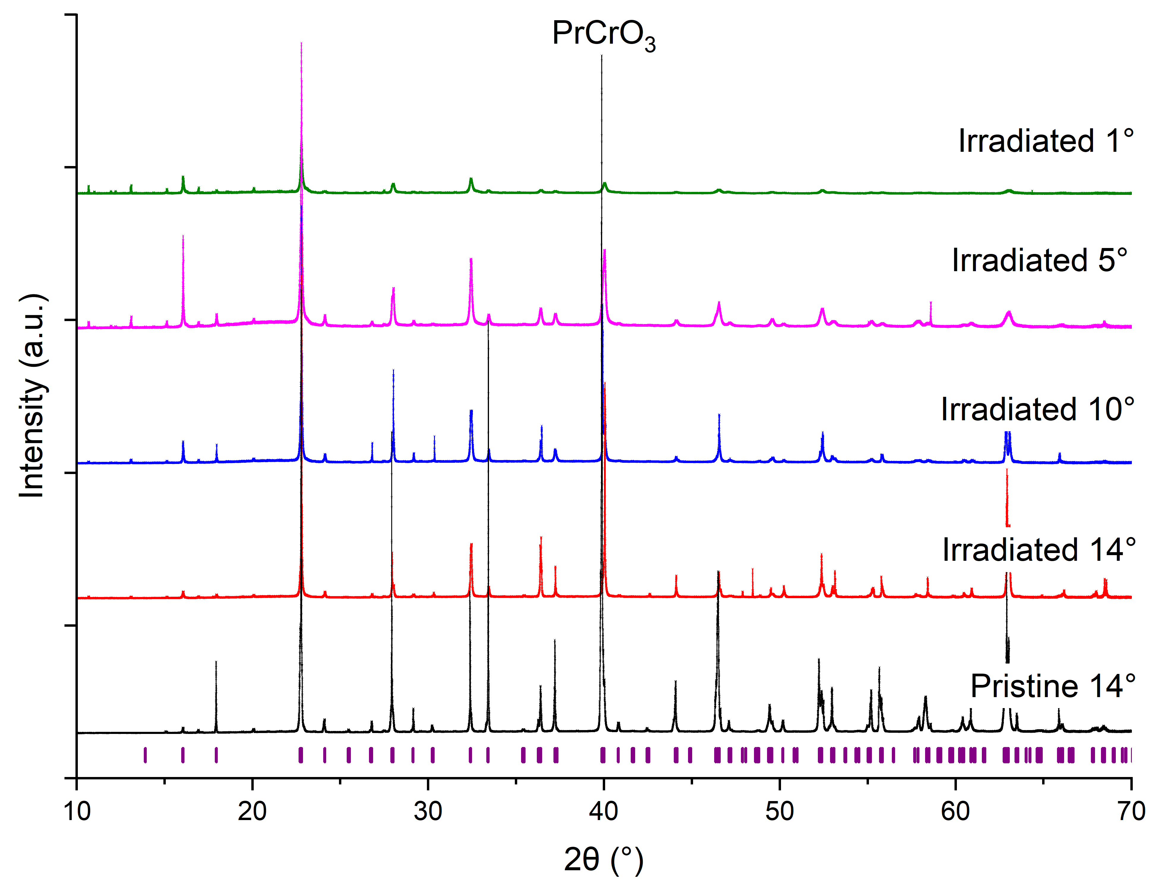
Supplementary Figure 8 – The GIXRD diffractograms collected at X-ray wavelength of 1.0785 Å for PrCrO₃ at different grazing angles are compared to those for the pristine surface. The purple marks represent the positions of the Bragg reflections.
The GIXRD data collected for the irradiated GdCrO₃ sample in the 2θ range of 10-70° is shown in Supplementary Figure 9.
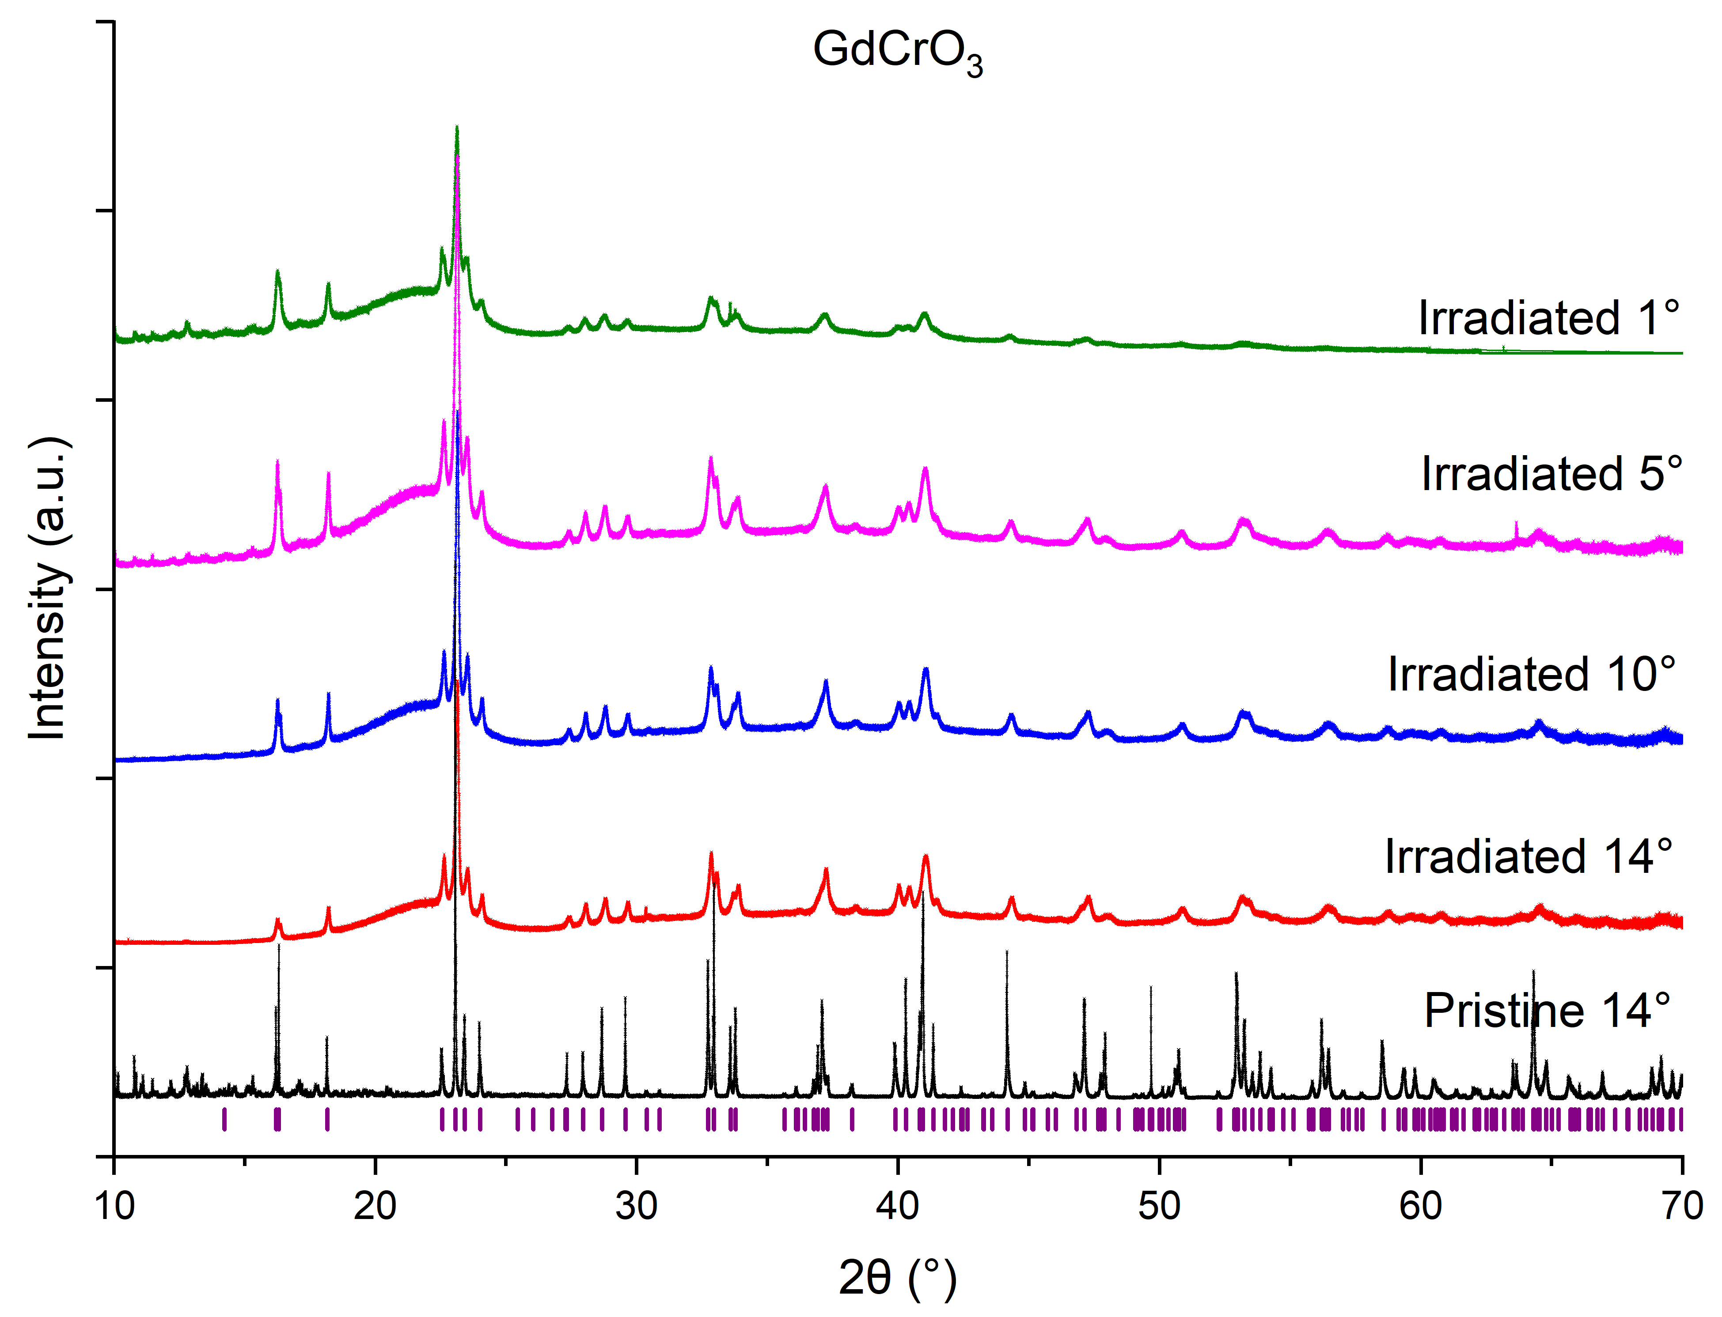
Supplementary Figure 9 – The GIXRD diffractograms collected at X-ray wavelength of 1.0785 Å for GdCrO₃ at different grazing angles are compared to those for the pristine surface. The purple marks represent the positions of the Bragg reflections.

