Figure S1. Network analysis of baseline data after randomization.
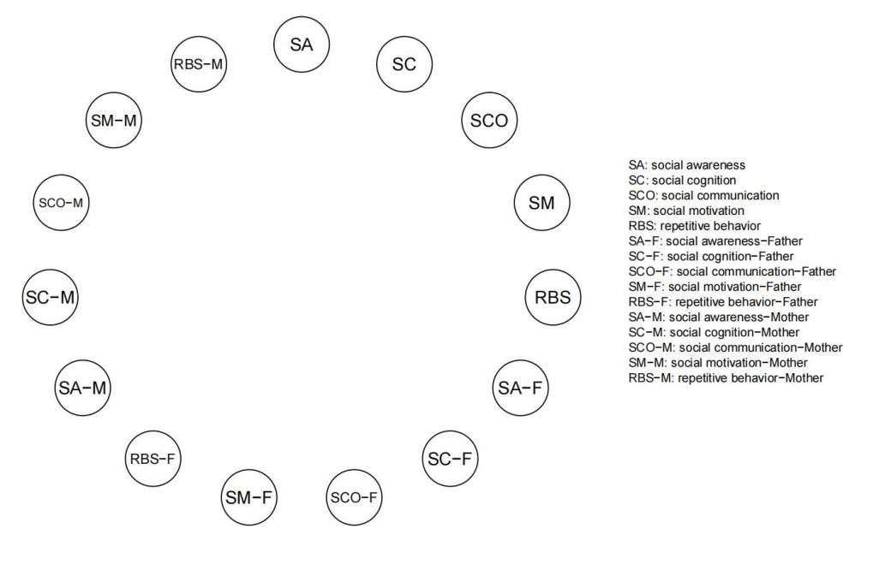
Note: A permutation test was performed by randomly shuffling the family member identifiers. The results showed that there was no significant association between the autism traits of ASD children and their parents after the randomization.

Figure S2. Centrality comparison of network structure between 3 -, 4 -, and 5-year-old ASD children and their parents in the baseline sample.
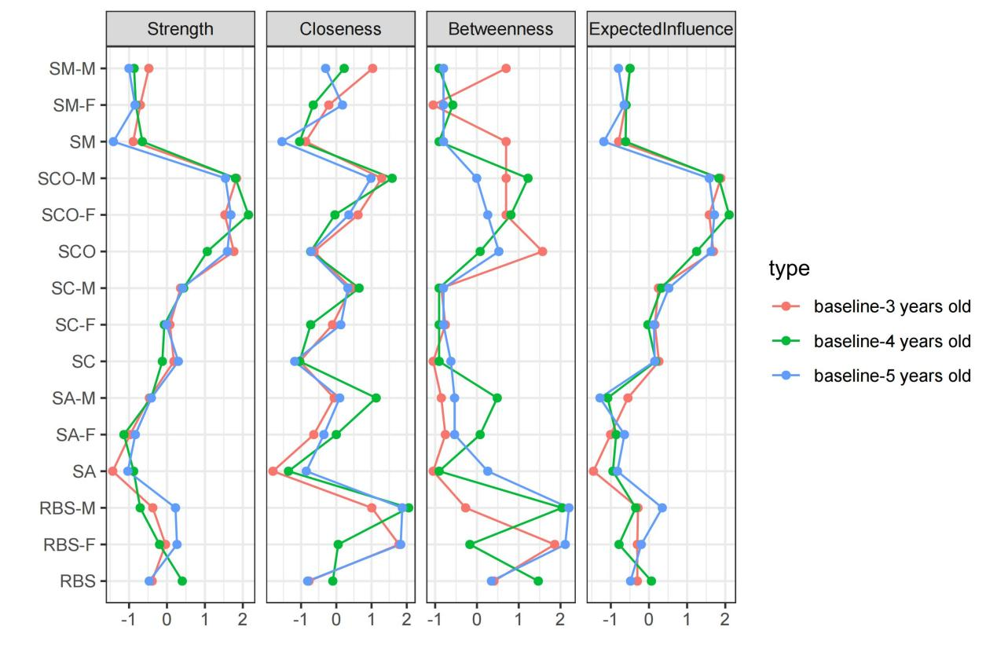
Note: Red lines represent the baseline network of ASD families with 3-year-old children; green lines represent the baseline network of ASD families with 4-year-old children; blue lines represent the baseline network of ASD families with 5-year-old children. Standardized z-scores are plotted for clarity. Higher scores indicate greater centrality (i.e., the symptom has a stronger influence in the network).

Figure S3. Centrality comparison of network structure between ASD children and their mothers in large and small samples, baseline and follow-up.
a b
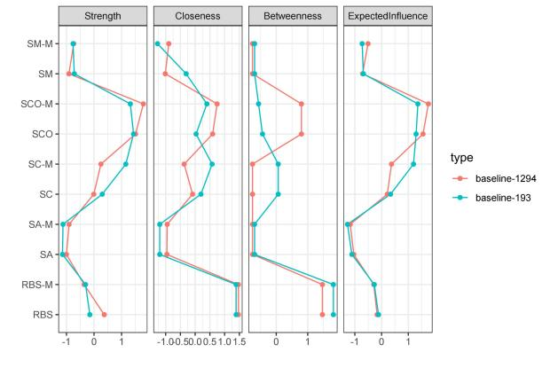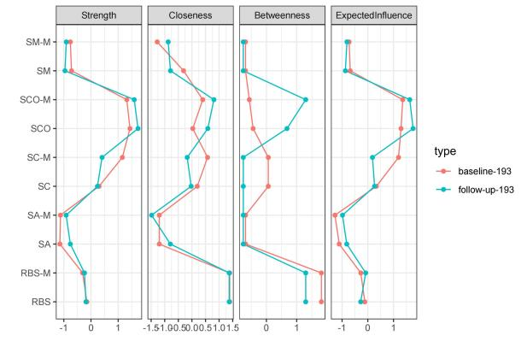
Note: a) Comparison of baseline network structures between the full sample of ASD children and their mothers (n=1294) and the smaller sample (n=193) of ASD children and their mothers who completed the follow-up test. b) Comparison of baseline and follow-up network structures for the 193 ASD children and their mothers who completed the follow-up. Standardized z-scores are plotted for clarity.

Figure S4. Stability of centrality index of network structure
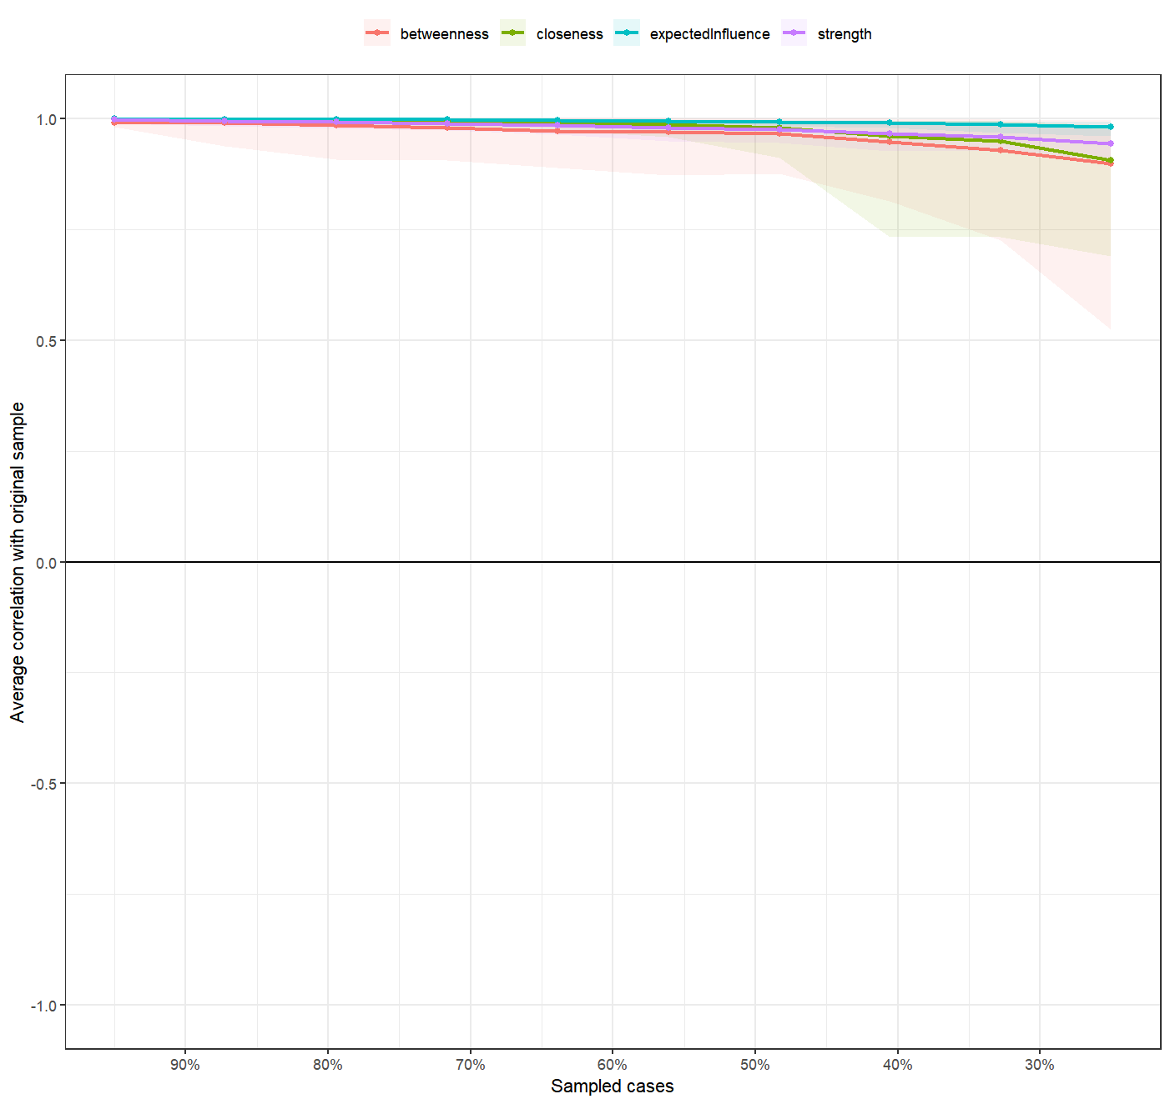
Note: The figure shows the stability of network structure centrality indicators of ASD children and parents in the baseline 1294 sample. The x-axle indicates the included portion of cases, and the y-axle indicates the correlations between the original centrality indices with the estimated centrality after dropping part of the cases. Lines with different colors represent different network properties. The shades indicate the range from the 2.5th quantile to the 97.5th quantile. The CS coefficients of strength, betweenness, closeness and expectedinfluence were 0.75, 0.672, 0.75 and 0.75, respectively.

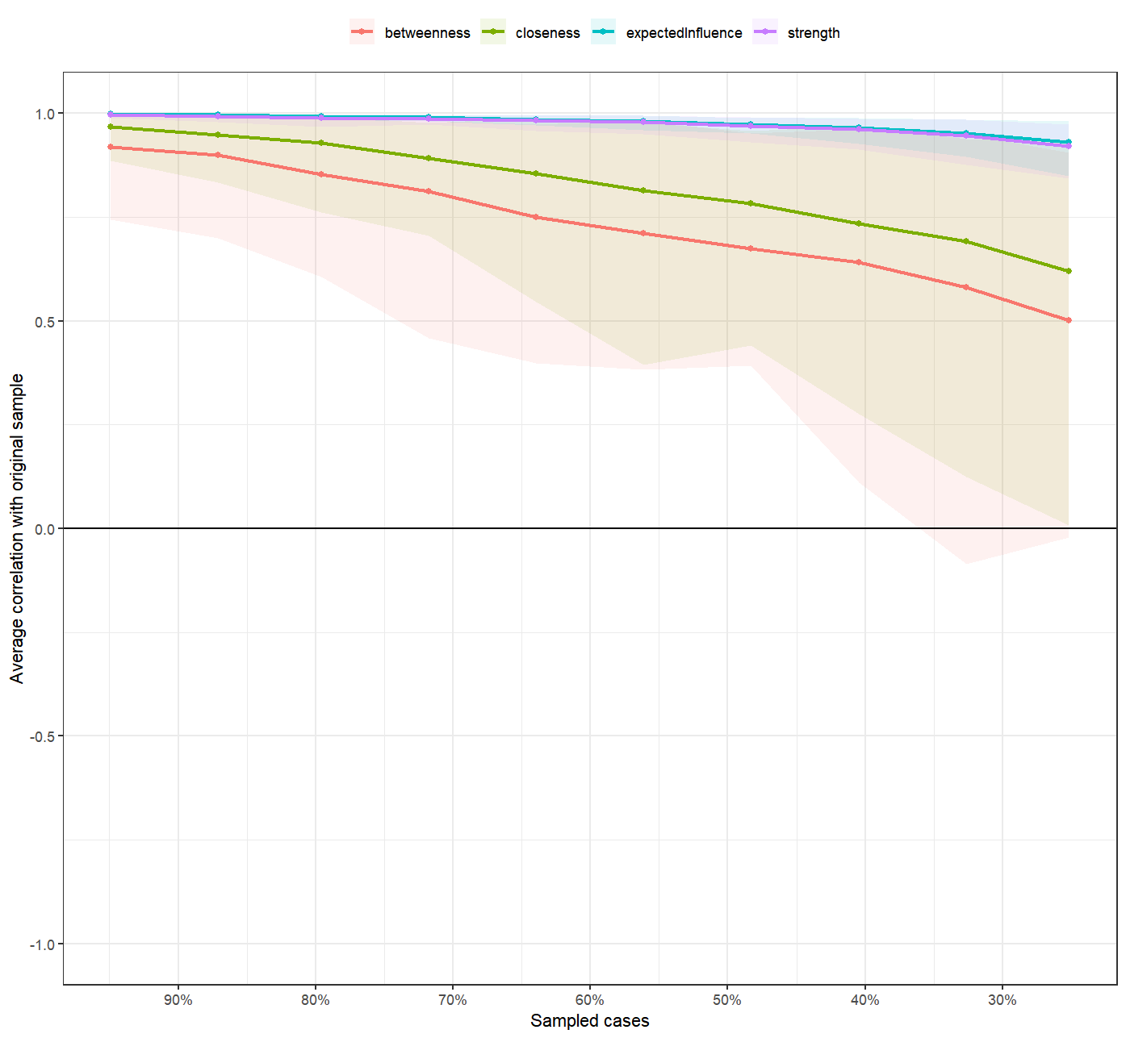
Note: The figure shows the stability of network structure centrality indicators of 3-year-old ASD children and parents in the baseline sample. The CS coefficients of strength, betweenness, closeness and expectedinfluence were 0.748, 0.129, 0.282 and 0.748, respectively.

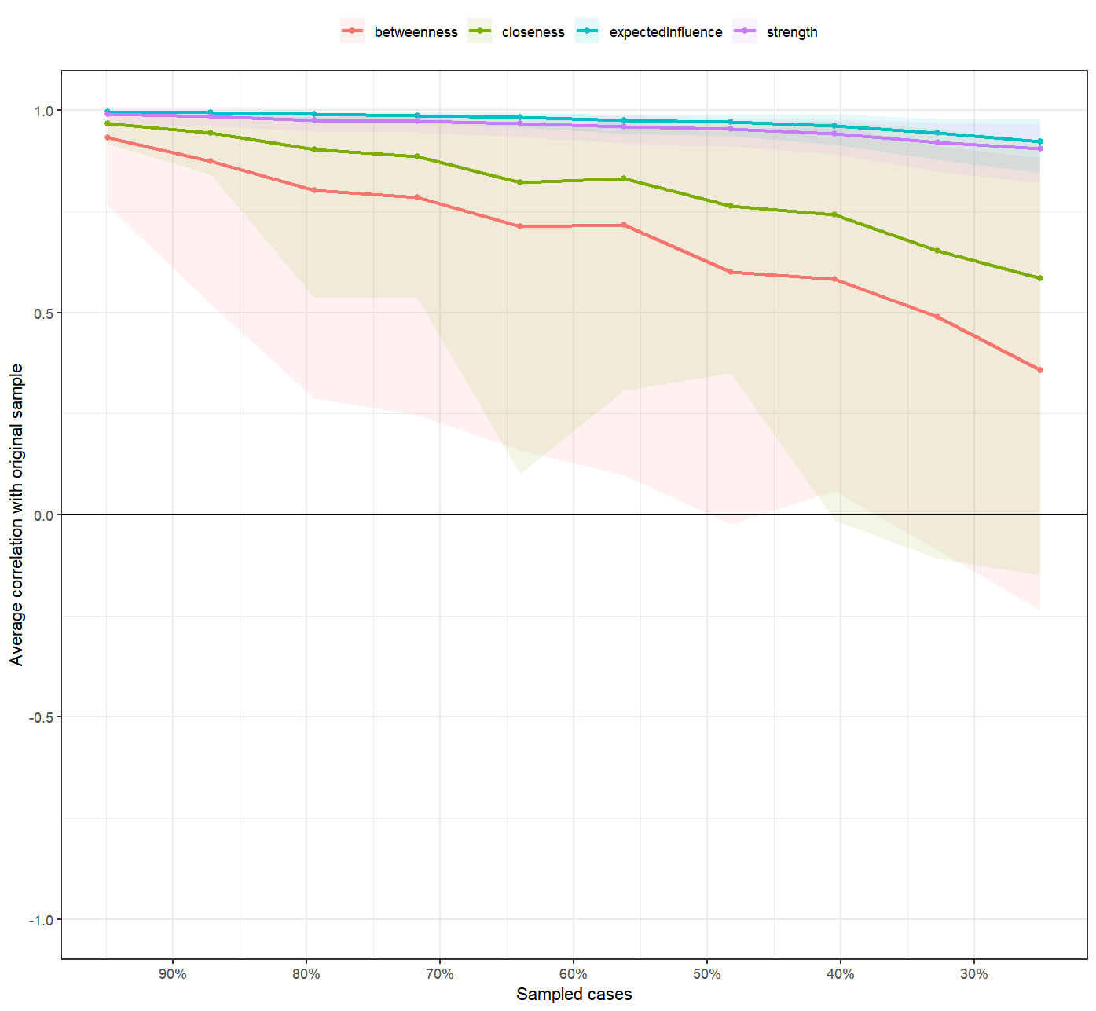
Note: The figure shows the stability of network structure centrality indicators of 4-year-old ASD children and parents in the baseline sample. The CS coefficients of strength, betweenness, closeness and expectedinfluence were 0.749, 0.051, 0.206 and 0.749, respectively.

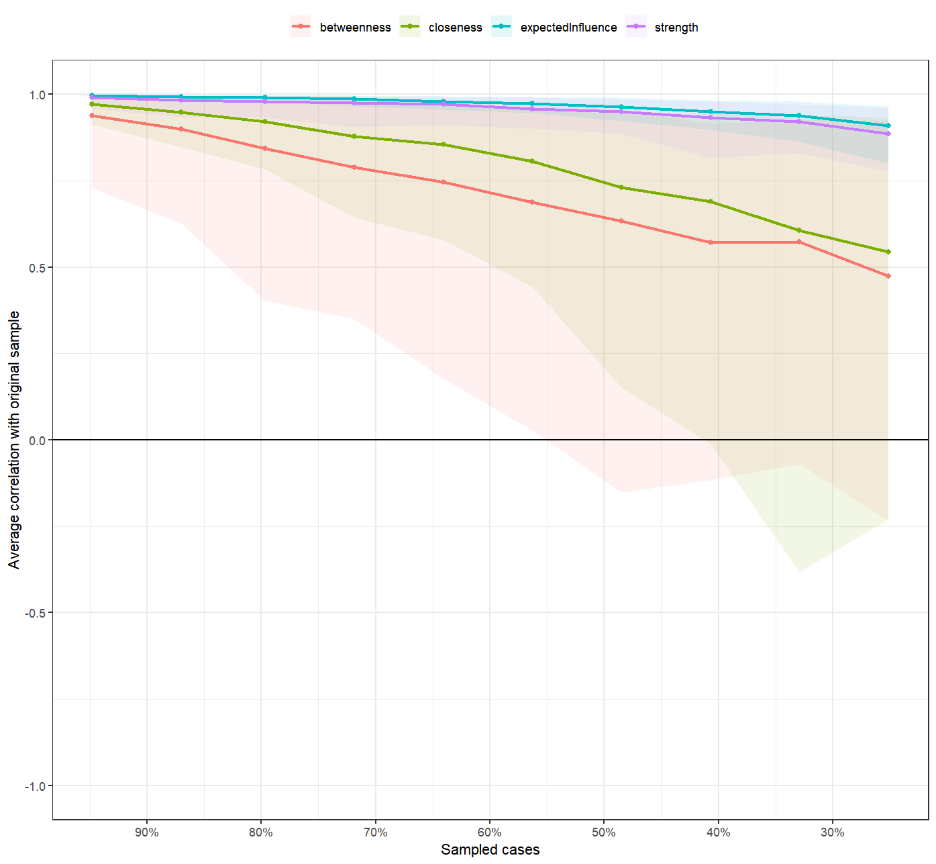
Note: The figure shows the stability of network structure centrality indicators of 5-year-old ASD children and parents in the baseline sample. The CS coefficients of strength, betweenness, closeness and expectedinfluence were 0.749, 0.13, 0.281 and 0.749, respectively.

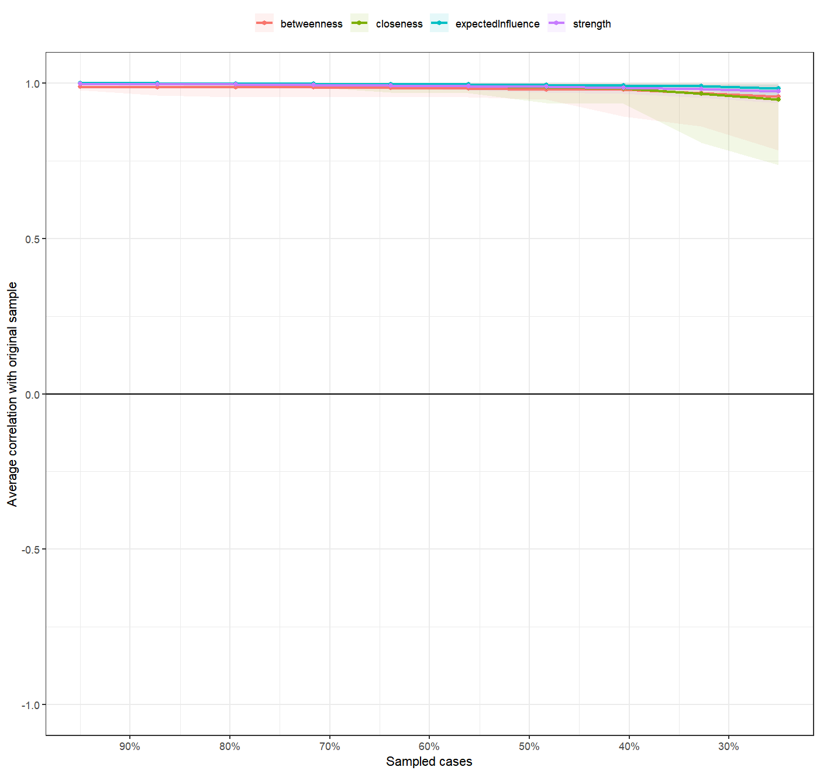
Note: The figure shows the stability of network structure centrality indicators of ASD children and mothers in the baseline 1294 samples. The CS coefficients of strength, betweenness, closeness and expectedinfluence were 0.75, 0.75, 0.75 and 0.75, respectively.
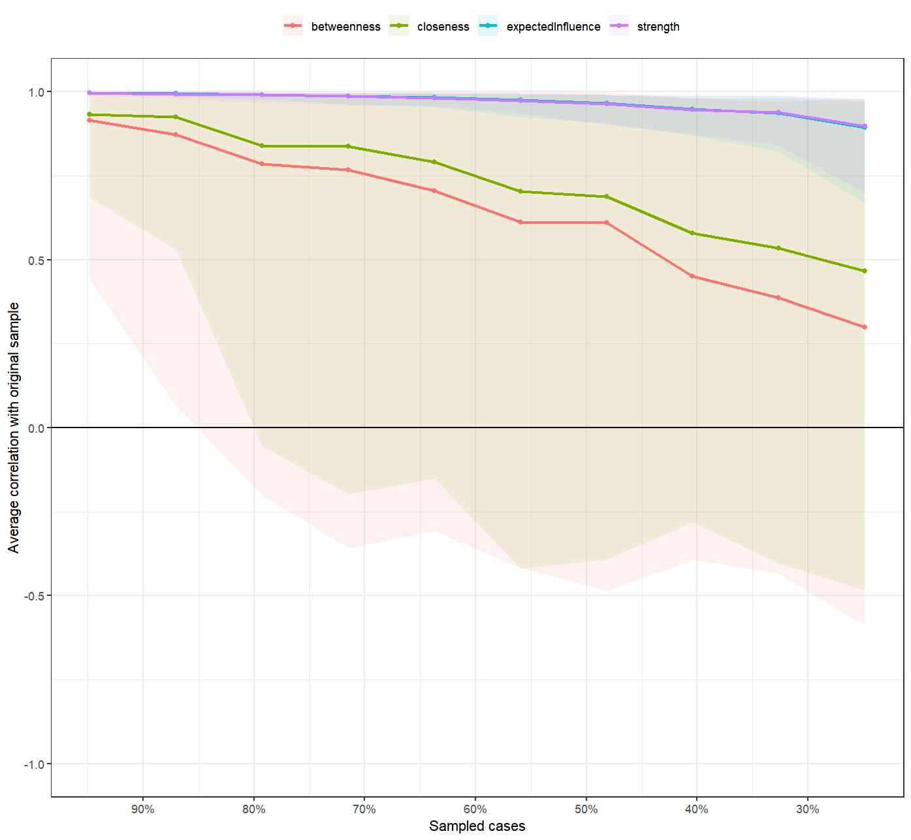
Note: The figure shows the stability of the centrality index of the network structure of 193 ASD children and mothers who completed follow-up in the baseline sample. The CS coefficients of strength, betweenness, closeness and expectedinfluence were 0.751, 0, 0.13 and 0.751, respectively.
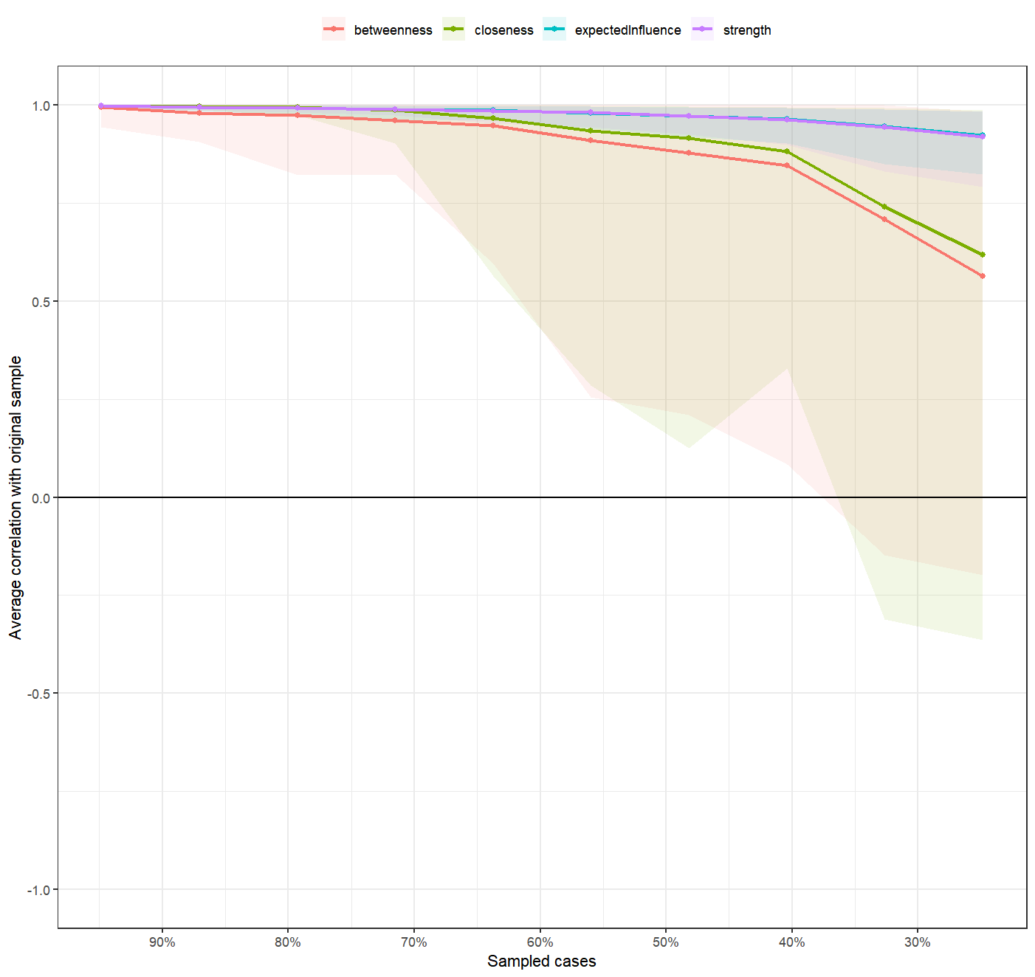
Note: The figure shows the stability of the centrality index of the network structure of ASD children and mothers in 193 follow-up samples. The CS coefficients of strength, betweenness, closeness and expectedinfluence were 0.751, 0.363, 0.518 and 0.75, respectively.
Figure S5. Nonparametric bootstrapped confidence intervals.
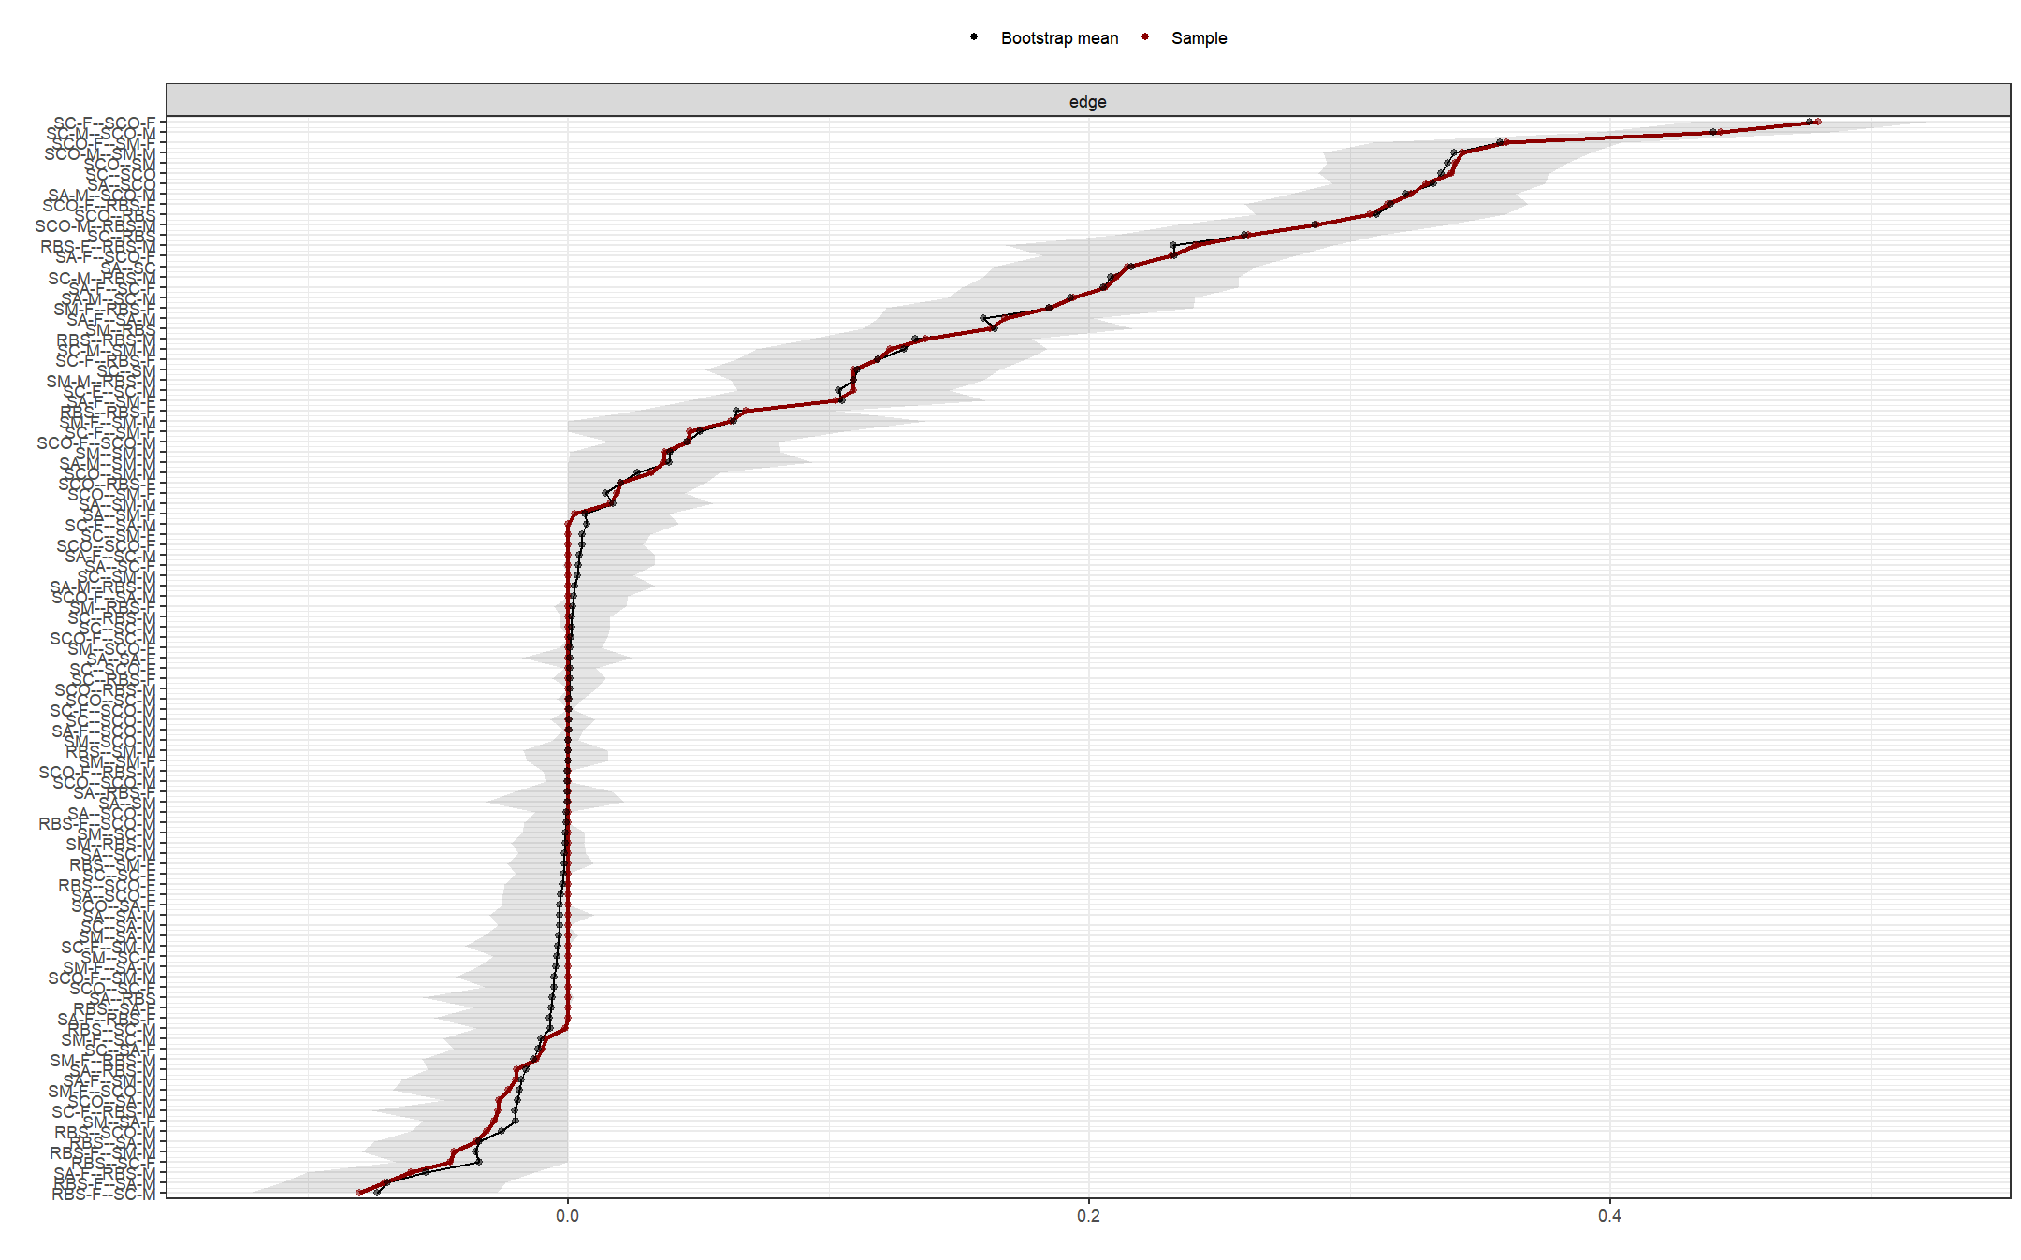
Note: This figure shows the nonparametric bootstrap confidence intervals for the estimated edge weights of the network, comprising each autism trait dimension in ASD families from the 1294 baseline sample. The x-axle indicates the edge weights and the y-axle indicates the nodes linked by the edges. The black line denote the mean value of the bootstrapped edge weights and the red line denote the edge weights from current sample. The grey area indicates the bootstrapped CIs. A narrower confidence interval indicates stronger stability and reliability of the edge across resampling.

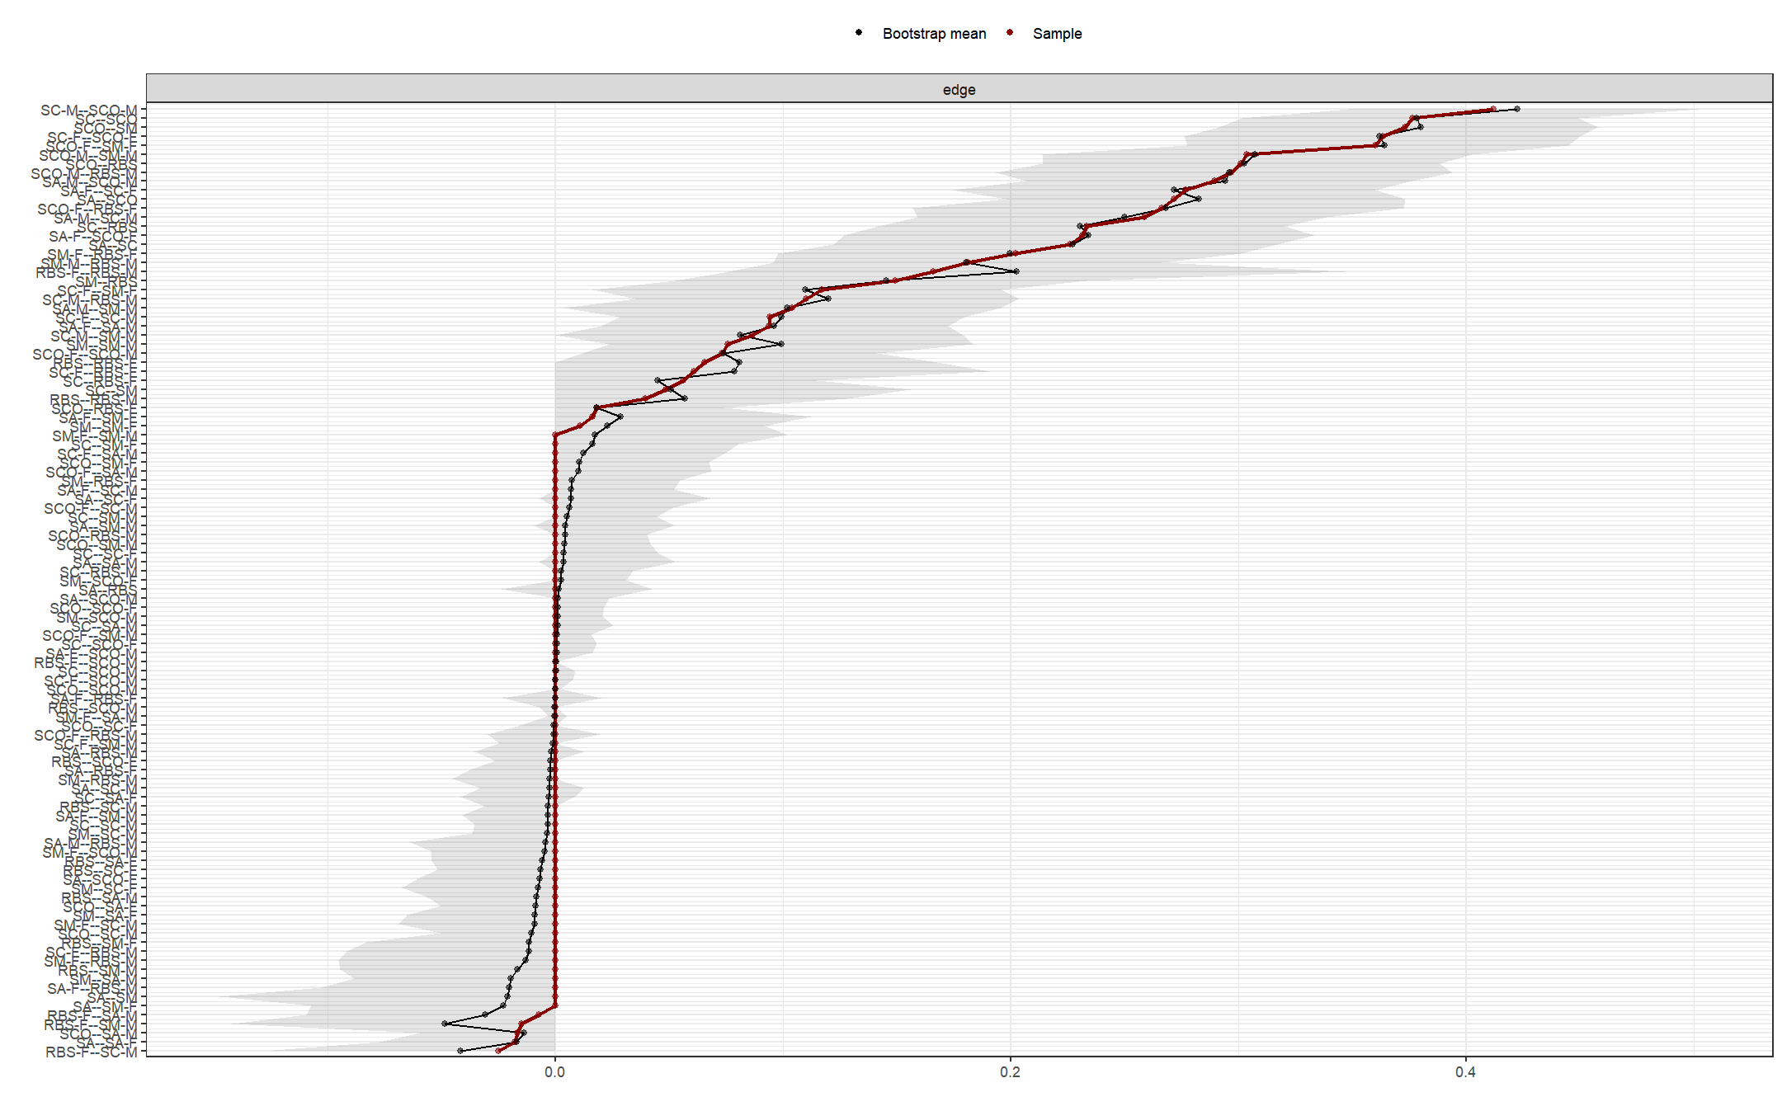
Note: This figure shows the nonparametric bootstrap confidence intervals for the estimated edge weights of the network, comprising each autism trait dimension in ASD families with 3-year-old children and their parents from the baseline sample.

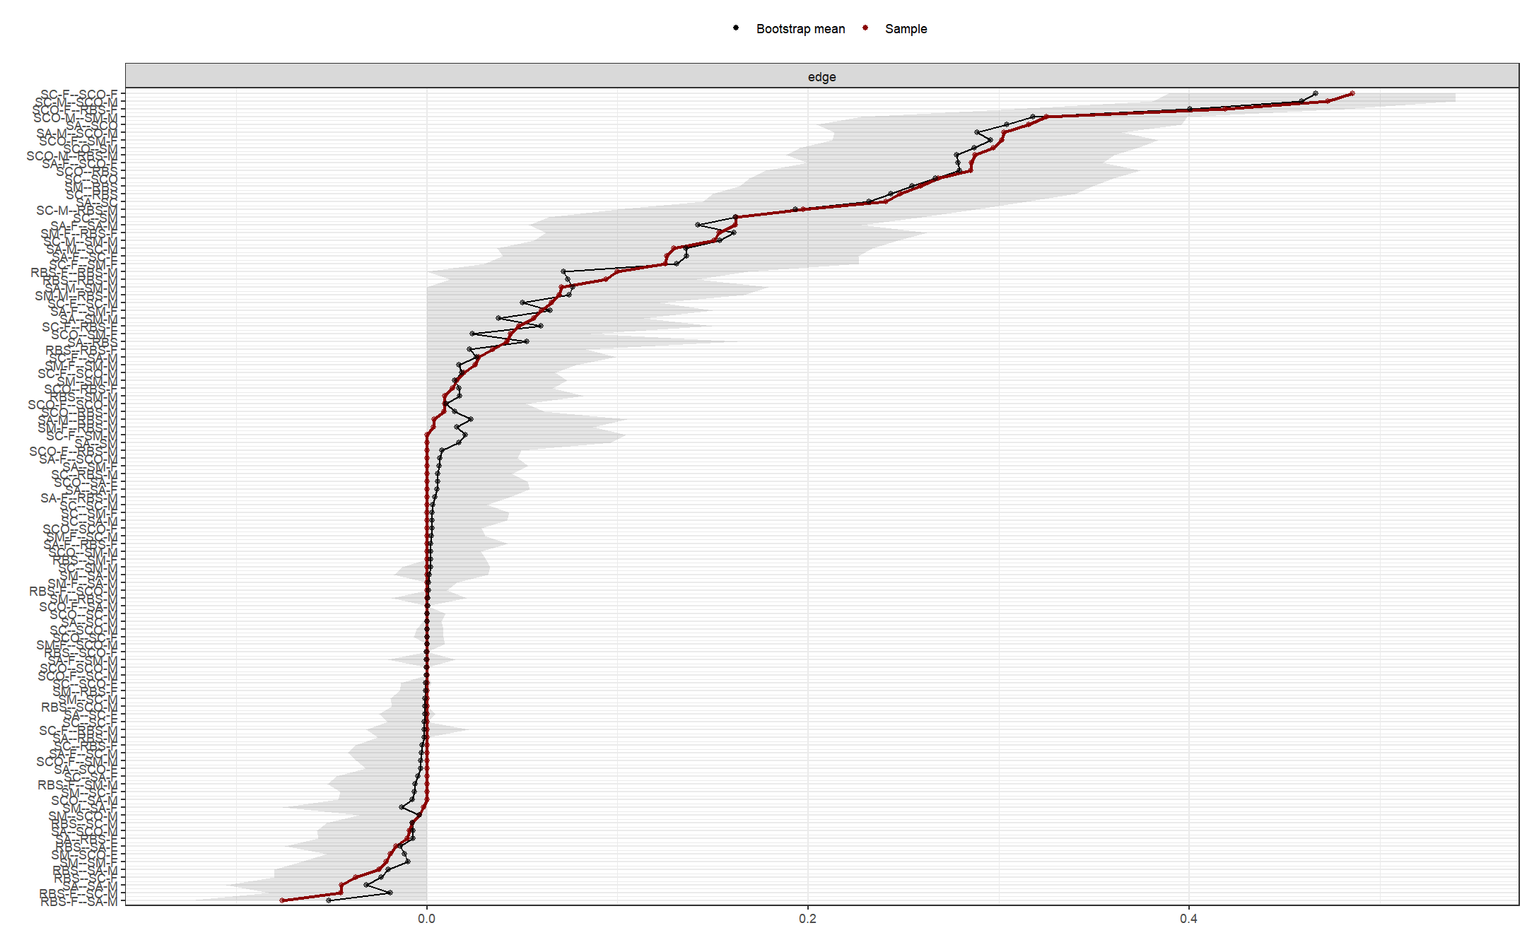
Note: This figure shows the nonparametric bootstrap confidence intervals for the estimated edge weights of the network, comprising each autism trait dimension in ASD families with 4-year-old children and their parents from the baseline sample.

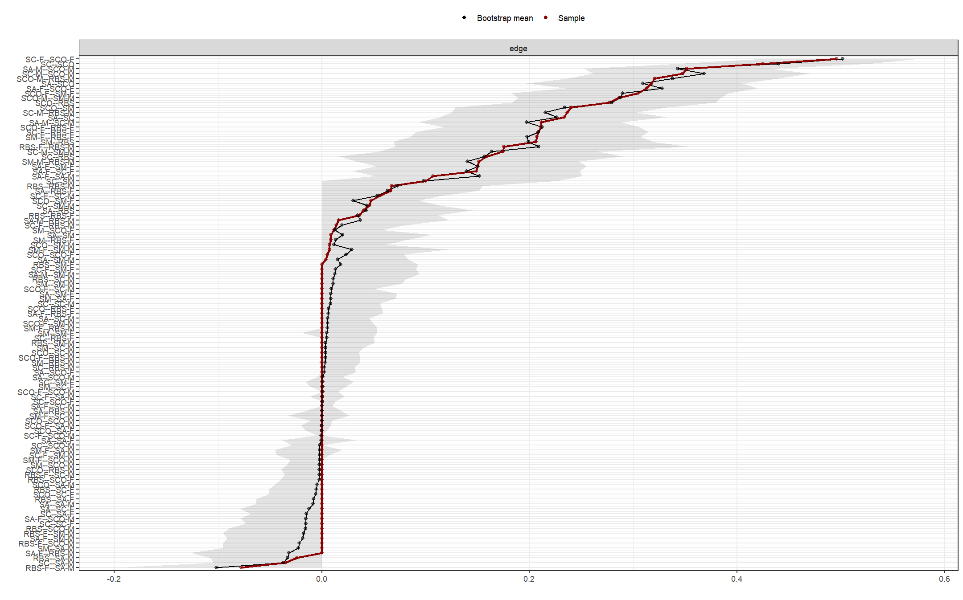
Note: This figure shows the nonparametric bootstrap confidence intervals for the estimated edge weights of the network, comprising each autism trait dimension in ASD families with 5-year-old children and their parents from the baseline sample.

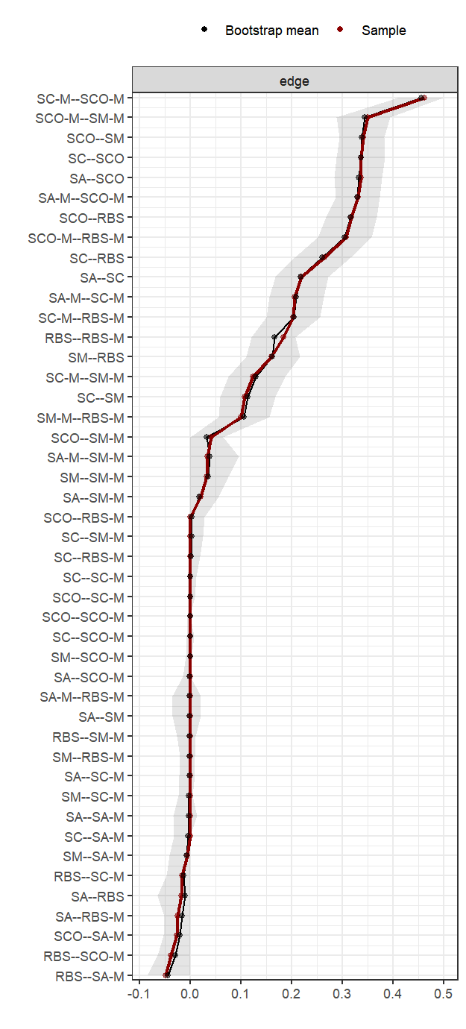
Note: This figure shows the nonparametric bootstrap confidence intervals for the estimated edge weights of the network, comprising each autism trait dimension of ASD children and their mothers in the baseline sample of 1294 ASD families.

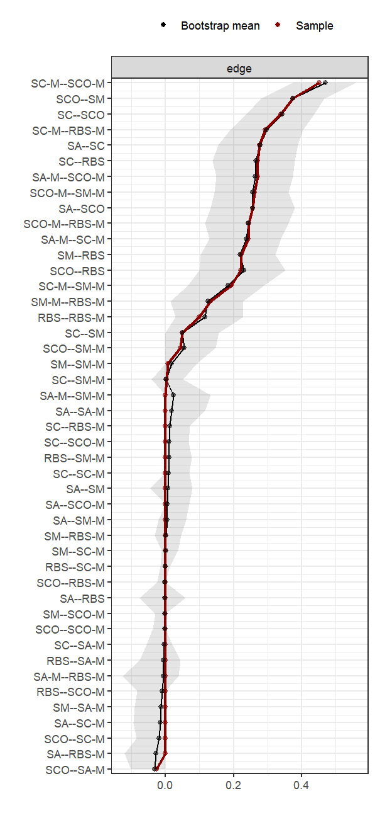
Note: This figure shows the nonparametric bootstrap confidence intervals for the estimated edge weights of the network, comprising each autism trait dimension of ASD children and their mothers in the baseline sample of 193 ASD families who completed the follow-up test.

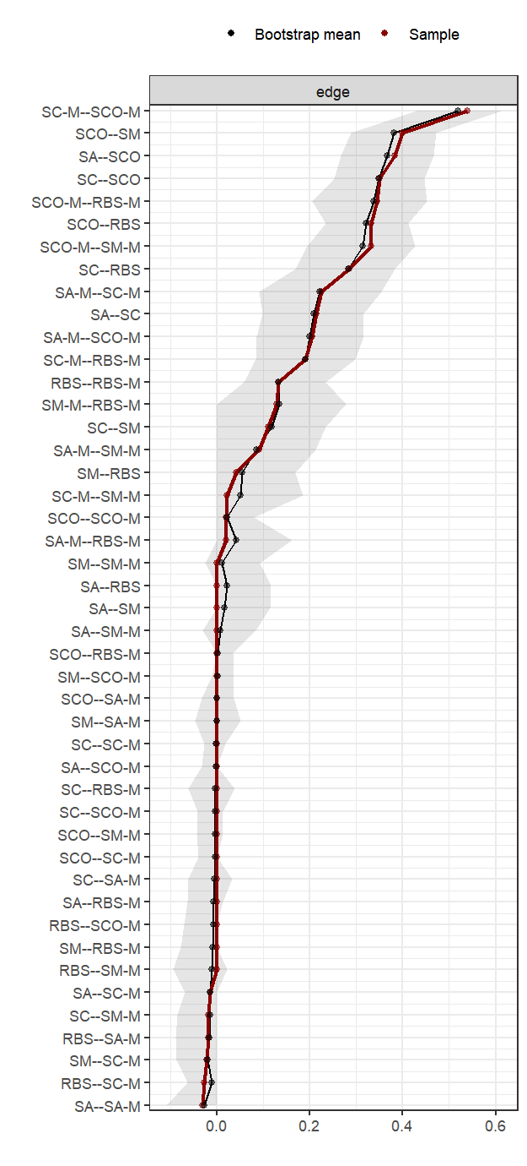
Note: This figure shows the nonparametric bootstrap confidence intervals for the estimated edge weights of the network, comprising each autism trait dimension of ASD children and their mothers in the follow-up sample of 193 ASD families.
Figure S6. The gaze patterns of children with ASD and their mothers.
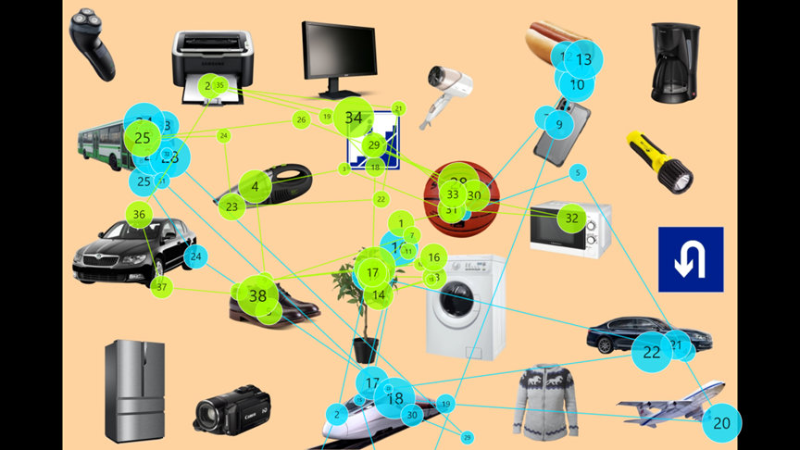

Table S1. Characteristics of the 1294 baseline samples.
Characteristic | ASD（N=1294）
Gender, n (%)
Male | 1072 (82.84)
Female | 222 (17.16)
Age, n (%)
2.00-2.99 years | 171 (13.22)
3.00-3.99 years | 315 (24.34)
4.00-4.99 years | 337 (26.04)
5.00-5.99 years | 246 (19.01)
6.00-17.99years | 225 (17.39)
Children’ age, Mean (SD) | 4.72 (1.95)
Mother’ age, Mean (SD) | 33.51 (4.27)
Father’ age, Mean (SD) | 35.21 (5.01)
Total household income, RMB, n (%)
＜30000 per year | 111 (8.58)
30000-49999 per year | 176 (13.60)
50000-69999 per year | 189 (14.61)
70000-99999 per year | 278 (21.48)
≥100000 per year | 540 (41.73)
Have siblings, n (%) | 495 (38.25)

Table S2. Baseline SRS-2 scores by symptom dimension in ASD families.
The Social Response Scale-2nd edition (SRS-2)，Mean (SD) | Children (n=1294) | Mother (n=1294) | Father  (n=1294)
Social awareness (SA) | 13.25 (3.12) | 7.32 (2.97) | 7.93 (2.84)
Social cognition (SC) | 17.40 (4.85) | 7.56 (5.21) | 7.32 (5.01)
Social communication (SCO) | 31.86 (9.14) | 12.28 (8.80) | 12.92 (8.23)
Social motivation (SM) | 14.94 (4.58) | 8.08 (4.94) | 7.55 (4.86)
Restricted interests and repetitive behavior (RRB) | 12.50 (6.53) | 3.82 (4.18) | 4.02 (4.39)
Total score | 89.94 (24.45) | 39.07 (23.57) | 39.74 (22.47)
SRS-2, The Social Response Scale-2nd edition.

Table S3. Comparison of SRS-2 symptom scores between baseline and follow-up in ASD children and their mothers.
The Social Response Scale-2nd edition (SRS-2)，Mean (SD) | Baseline  (n=193) | Follow-up (n=193) | t | P
Children
Social awareness (SA) | 13.47 (3.18) | 13.40 (3.34) | -0.28 | 0.781
Social cognition (SC) | 18.25 (4.80) | 18.36 (5.96) | 0.32 | 0.753
Social communication (SCO) | 33.12 (8.81) | 31.80 (11.35) | -2.08 | 0.039
Social motivation (SM) | 15.23 (4.69) | 14.46 (5.30) | -2.34 | 0.020
Restricted interests and repetitive behavior (RRB) | 13.27 (6.28) | 14.69 (7.00) | 3.21 | 0.002
Total score | 93.34 (23.57) | 92.72 (29.91) | -0.39 | 0.697
Mother
Social awareness (SA) | 6.80 (2.69) | 6.63 (2.73) | -0.75 | 0.452
Social cognition (SC) | 7.00 (5.37) | 6.63 (5.39) | -1.19 | 0.236
Social communication (SCO) | 11.88 (9.36) | 10.50 (8.42) | -1.98 | 0.051
Social motivation (SM) | 8.63 (5.26) | 7.61 (5.09) | -2.85 | 0.005
Restricted interests and repetitive behavior (RRB) | 4.24 (4.95) | 3.40 (4.57) | -2.21 | 0.028
Total score | 38.64 (25.06) | 34.77 (23.70) | -2.11 | 0.036
SRS-2, The Social Response Scale-2nd edition.

Table S4. Estimated edge weights of the network structure between ASD children and parents in 1294 baseline samples.
 | SA | SC | SCO | SM | RBS | SA-F | SC-F | SCO-F | SM-F | RBS-F | SA-M | SC-M | SCO-M | SM-M | RBS-M
SA | 0.00 | 0.21 | 0.33 | 0.00 | 0.00 | 0.00 | 0.00 | 0.00 | 0.00 | 0.00 | 0.00 | 0.00 | 0.00 | 0.02 | -0.02
SC | 0.21 | 0.00 | 0.34 | 0.11 | 0.26 | -0.01 | 0.00 | 0.00 | 0.00 | 0.00 | 0.00 | 0.00 | 0.00 | 0.00 | 0.00
SCO | 0.33 | 0.34 | 0.00 | 0.34 | 0.31 | 0.00 | 0.00 | 0.00 | 0.02 | 0.02 | -0.03 | 0.00 | 0.00 | 0.03 | 0.00
SM | 0.00 | 0.11 | 0.34 | 0.00 | 0.16 | -0.03 | 0.00 | 0.00 | 0.00 | 0.00 | 0.00 | 0.00 | 0.00 | 0.04 | 0.00
RBS | 0.00 | 0.26 | 0.31 | 0.16 | 0.00 | 0.00 | -0.05 | 0.00 | 0.00 | 0.07 | -0.04 | 0.00 | -0.03 | 0.00 | 0.14
SA-F | 0.00 | -0.01 | 0.00 | -0.03 | 0.00 | 0.00 | 0.21 | 0.23 | 0.10 | 0.00 | 0.17 | 0.00 | 0.00 | -0.02 | -0.06
SC-F | 0.00 | 0.00 | 0.00 | 0.00 | -0.05 | 0.21 | 0.00 | 0.48 | 0.05 | 0.12 | 0.00 | 0.11 | 0.00 | 0.00 | -0.03
SCO-F | 0.00 | 0.00 | 0.00 | 0.00 | 0.00 | 0.23 | 0.48 | 0.00 | 0.36 | 0.31 | 0.00 | 0.00 | 0.05 | 0.00 | 0.00
SM-F | 0.00 | 0.00 | 0.02 | 0.00 | 0.00 | 0.10 | 0.05 | 0.36 | 0.00 | 0.18 | 0.00 | -0.01 | -0.02 | 0.06 | -0.01
RBS-F | 0.00 | 0.00 | 0.02 | 0.00 | 0.07 | 0.00 | 0.12 | 0.31 | 0.18 | 0.00 | -0.07 | -0.08 | 0.00 | -0.04 | 0.24
SA-M | 0.00 | 0.00 | -0.03 | 0.00 | -0.04 | 0.17 | 0.00 | 0.00 | 0.00 | -0.07 | 0.00 | 0.19 | 0.32 | 0.04 | 0.00
SC-M | 0.00 | 0.00 | 0.00 | 0.00 | 0.00 | 0.00 | 0.11 | 0.00 | -0.01 | -0.08 | 0.19 | 0.00 | 0.44 | 0.12 | 0.21
SCO-M | 0.00 | 0.00 | 0.00 | 0.00 | -0.03 | 0.00 | 0.00 | 0.05 | -0.02 | 0.00 | 0.32 | 0.44 | 0.00 | 0.34 | 0.29
SM-M | 0.02 | 0.00 | 0.03 | 0.04 | 0.00 | -0.02 | 0.00 | 0.00 | 0.06 | -0.04 | 0.04 | 0.12 | 0.34 | 0.00 | 0.11
RBS-M | -0.02 | 0.00 | 0.00 | 0.00 | 0.14 | -0.06 | -0.03 | 0.00 | -0.01 | 0.24 | 0.00 | 0.21 | 0.29 | 0.11 | 0.00

Estimated edge weights of the network structure between ASD children and mothers in 1294 baseline samples:
 | SA | SC | SCO | SM | RBS | SA-M | SC-M | SCO-M | SM-M | RBS-M
SA | 0.00 | 0.22 | 0.34 | 0.00 | -0.02 | 0.00 | 0.00 | 0.00 | 0.02 | -0.03
SC | 0.22 | 0.00 | 0.34 | 0.11 | 0.26 | 0.00 | 0.00 | 0.00 | 0.00 | 0.00
SCO | 0.34 | 0.34 | 0.00 | 0.34 | 0.32 | -0.03 | 0.00 | 0.00 | 0.04 | 0.00
SM | 0.00 | 0.11 | 0.34 | 0.00 | 0.16 | -0.01 | 0.00 | 0.00 | 0.03 | 0.00
RBS | -0.02 | 0.26 | 0.32 | 0.16 | 0.00 | -0.05 | -0.02 | -0.04 | 0.00 | 0.18
SA-M | 0.00 | 0.00 | -0.03 | -0.01 | -0.05 | 0.00 | 0.21 | 0.33 | 0.03 | 0.00
SC-M | 0.00 | 0.00 | 0.00 | 0.00 | -0.02 | 0.21 | 0.00 | 0.46 | 0.12 | 0.20
SCO-M | 0.00 | 0.00 | 0.00 | 0.00 | -0.04 | 0.33 | 0.46 | 0.00 | 0.35 | 0.31
SM-M | 0.02 | 0.00 | 0.04 | 0.03 | 0.00 | 0.03 | 0.12 | 0.35 | 0.00 | 0.10
RBS-M | -0.03 | 0.00 | 0.00 | 0.00 | 0.18 | 0.00 | 0.20 | 0.31 | 0.10 | 0.00

Estimated edge weights of the network structure between 193 ASD children and mothers who completed follow-up in the baseline sample:
 | SA | SC | SCO | SM | RBS | SA-M | SC-M | SCO-M | SM-M | RBS-M
SA | 0.00 | 0.28 | 0.26 | 0.00 | 0.00 | 0.00 | 0.00 | 0.00 | 0.00 | 0.00
SC | 0.28 | 0.00 | 0.34 | 0.05 | 0.27 | 0.00 | 0.00 | 0.00 | 0.00 | 0.00
SCO | 0.26 | 0.34 | 0.00 | 0.37 | 0.22 | -0.03 | 0.00 | 0.00 | 0.04 | 0.00
SM | 0.00 | 0.05 | 0.37 | 0.00 | 0.22 | 0.00 | 0.00 | 0.00 | 0.01 | 0.00
RBS | 0.00 | 0.27 | 0.22 | 0.22 | 0.00 | 0.00 | 0.00 | 0.00 | 0.00 | 0.10
SA-M | 0.00 | 0.00 | -0.03 | 0.00 | 0.00 | 0.00 | 0.24 | 0.27 | 0.00 | 0.00
SC-M | 0.00 | 0.00 | 0.00 | 0.00 | 0.00 | 0.24 | 0.00 | 0.45 | 0.19 | 0.29
SCO-M | 0.00 | 0.00 | 0.00 | 0.00 | 0.00 | 0.27 | 0.45 | 0.00 | 0.26 | 0.25
SM-M | 0.00 | 0.00 | 0.04 | 0.01 | 0.00 | 0.00 | 0.19 | 0.26 | 0.00 | 0.13
RBS-M | 0.00 | 0.00 | 0.00 | 0.00 | 0.10 | 0.00 | 0.29 | 0.25 | 0.13 | 0.00

Estimated edge weights of the network structure between ASD children and mothers in 193 follow-up samples:
 | SA | SC | SCO | SM | RBS | SA-M | SC-M | SCO-M | SM-M | RBS-M
SA | 0.00 | 0.21 | 0.38 | 0.00 | 0.00 | -0.03 | -0.01 | 0.00 | 0.00 | 0.00
SC | 0.21 | 0.00 | 0.35 | 0.11 | 0.29 | 0.00 | 0.00 | 0.00 | -0.02 | 0.00
SCO | 0.38 | 0.35 | 0.00 | 0.40 | 0.33 | 0.00 | 0.00 | 0.02 | 0.00 | 0.00
SM | 0.00 | 0.11 | 0.40 | 0.00 | 0.04 | 0.00 | -0.02 | 0.00 | 0.00 | 0.00
RBS | 0.00 | 0.29 | 0.33 | 0.04 | 0.00 | -0.02 | -0.03 | 0.00 | 0.00 | 0.13
SA-M | -0.03 | 0.00 | 0.00 | 0.00 | -0.02 | 0.00 | 0.22 | 0.20 | 0.09 | 0.02
SC-M | -0.01 | 0.00 | 0.00 | -0.02 | -0.03 | 0.22 | 0.00 | 0.54 | 0.02 | 0.19
SCO-M | 0.00 | 0.00 | 0.02 | 0.00 | 0.00 | 0.20 | 0.54 | 0.00 | 0.33 | 0.34
SM-M | 0.00 | -0.02 | 0.00 | 0.00 | 0.00 | 0.09 | 0.02 | 0.33 | 0.00 | 0.13
RBS-M | 0.00 | 0.00 | 0.00 | 0.00 | 0.13 | 0.02 | 0.19 | 0.34 | 0.13 | 0.00

