Online Data Supplement

Effect of Noninvasive Ventilation on Tracheal Reintubation Among Patients With Hypoxemic Respiratory Failure Following Abdominal Surgery. A Bayesian post-hoc analysis of the NIVAS trial

eMethods 1. Systematic review
eMethods 2. Sensivity analysis with prior on intercept (baseline risk)
eTable 1. Detailed Characteristics of the 9 Included Studies, and Number of Patients Randomized to Included Therapies.
eTable 2. Posterior distribution and probability of treatment effect of NIV compared to oxygen therapy over day-7 reintubation in multivariate analysis
eTable 3. Posterior distribution and probability of treatment effect of NIV compared to oxygen therapy over day-7 reintubation with informative intercepts
eTable 4. Posterior distribution and probability of treatment effect of NIV compared to oxygen therapy over day-30 mortality in multivariate analysis
eTable 5. Posterior probabilities and effect estimate for later secondary endpoints under each prior
eTable 6. Posterior probabilities and effect estimate for lengths of stay under each prior
eFigure 1. Flow diagram summarizing electronic search for evidence before NIVAS study
eFigure 2. Risk of bias assessment for RCT (A) and non-interventional studies (B) according to the Cochrane risk of bias tool
eFigure 3. Posterior probability distributions for OR and ARR comparing NIV versus oxygen on reintubation to day-7 reintubation in multivariate analysis
eFigure 4. Posterior probability distributions for OR comparing NIV versus oxygen on day-7 reintubation according to each prior with intercept prior 1
eFigure 5. Posterior probability distributions for OR and ARR comparing NIV versus oxygen on reintubation to day-7 according to each prior with intercept prior 2
eFigure 6. Posterior density of treatment effect for NIV versus oxygen on reintubation to day-7 according to each prior with intercept prior 3
eFigure 7. Posterior probability distributions for OR and ARR comparing NIV versus oxygen on reintubation to day-30 mortality in multivariate analysis
eFigure 8. Posterior probability distributions for OR and ARR comparing NIV versus oxygen on day-90 mortality according to each prior
eFigure 9. Posterior probability distributions for OR and ARR comparing NIV versus oxygen on day-7 overall healthcare-associated infections according to each prior
eFigure 10. Posterior probability distributions for OR and ARR comparing NIV versus oxygen on day-7 pneumonia according to each prior
eFigure 11. Posterior probability distributions for OR and ARR comparing NIV versus oxygen on day-30 reintubation according to each prior
eFigure 12. Posterior probability distributions for OR and ARR comparing NIV versus oxygen on day-30 overall health-care associated infections according to each prior
eFigure 13. Posterior probability distributions for OR and ARR comparing NIV versus oxygen on day-30 pneumonia according to each prior
eFigure 14. Posterior estimations in the sub-group from the stratum of randomization under minimally informative prior
eFigure 15. Convergence diagnosis of Markov Chain Monte Carlo simulations for day-7 reintubation according to the No-U-Turn Sampler algorithm
eFigure 16. Convergence diagnosis of Markov Chain Monte Carlo simulations for day-7 reintubation in multivariate analysis according to the No-U-Turn Sampler algorithm
eFigure 17. Convergence diagnosis of Markov Chain Monte Carlo simulations for day-7 reintubation with informative intercept 1 according to the No-U-Turn Sampler algorithm
eFigure 18. Convergence diagnosis of Markov Chain Monte Carlo simulations for day-7 reintubation with informative prior on intercept 2 according to the No-U-Turn Sampler algorithm
eFigure 19. Convergence diagnosis of Markov Chain Monte Carlo simulations for day-7 reintubation with informative prior on intercept 3 according to the No-U-Turn Sampler algorithm
eFigure 20. Convergence diagnosis of Markov Chain Monte Carlo simulations for day-30 mortality according to the No-U-Turn Sampler algorithm
eFigure 21. Convergence diagnosis of Markov Chain Monte Carlo simulations for day-7 overall healthcare associated infection according to the No-U-Turn Sampler algorithm
eFigure 22. Convergence diagnosis of Markov Chain Monte Carlo simulations for day-30 mortality in multivariate analysis according to the No-U-Turn Sampler algorithm
eFigure 23. Convergence diagnosis of Markov Chain Monte Carlo simulations for day-7 pneumonia infection according to the No-U-Turn Sampler algorithm
eFigure 24. Convergence diagnosis of Markov Chain Monte Carlo simulations for day-30 reintubation according to the No-U-Turn Sampler algorithm
eFigure 25. Convergence diagnosis of Markov Chain Monte Carlo simulations for day-90 mortality according to the No-U-Turn Sampler algorithm
eFigure 26. Convergence diagnosis of Markov Chain Monte Carlo simulations for day-30 overall healthcare-associated infection according to the No-U-Turn Sampler algorithm
eFigure 27. Convergence diagnosis of Markov Chain Monte Carlo simulations for day-30 pneumonia infection according to the No-U-Turn Sampler algorithm

eMethods 1. Systematic review
We performed a computerized search of MEDLINE (1998 to 2016), for studies comparing noninvasive ventilation to oxygen therapy in which researchers reported reintubation rates of the patients. We included non-English publications. The keywords search strategy is described below. References in the retrieved articles were also examined for relevant publications. We identified and deleted any duplicate papers. All potential eligible papers were retrieved in full.
First, two authors (AN and JP) independently screened the retrieved studies by title and then by abstract for exclusion. They assessed the full text of the possible relevant studies for inclusion and exclusion criteria. Disagreement was resolved by discussion and arbitrated, if necessary, by a third author (NM). Data were then added to an excel database, specifically designed for this review.

Risk of bias and quality assessment:
Risk of bias was evaluated the Cochrane Bias Methods tools for RCT (RoB 2) and for Non-randomized Studies (ROBINS-I V2). eFigure 2 presents the risk of bias assessment of each included study.

Databases Searched:
- PubMed/Medline
- Web Of Science

PubMed/MEDLINE
1 | "noninvasive ventilation"[MeSH Terms] OR ("noninvasive"[All Fields] AND "ventilation"[All Fields]) OR "noninvasive ventilation"[All Fields] OR "noninvasive ventilation"[MeSH Terms] OR (("noninvasive"[All Fields] OR "noninvasively"[All Fields] OR "noninvasiveness"[All Fields]) AND ("ventilated"[All Fields] OR "ventilates"[All Fields] OR "ventilating"[All Fields] OR "ventilation"[MeSH Terms] OR "ventilation"[All Fields] OR "ventilate"[All Fields] OR "ventilations"[All Fields] OR "ventilation s"[All Fields] OR "ventilator s"[All Fields] OR "ventilators, mechanical"[MeSH Terms] OR ("ventilators"[All Fields] AND "mechanical"[All Fields]) OR "mechanical ventilators"[All Fields] OR "ventilator"[All Fields] OR "ventilators"[All Fields] OR "ventillation"[All Fields])) | 18,005
2 | "postoperative period"[MeSH Terms] OR ("postoperative"[All Fields] AND "period"[All Fields]) OR "postoperative period"[All Fields] OR ("post"[All Fields] AND "operative"[All Fields]) OR "post operative"[All Fields] OR ("postoperative period"[MeSH Terms] OR ("postoperative"[All Fields] AND "period"[All Fields]) OR "postoperative period"[All Fields] OR "postop"[All Fields] OR "postoperative"[All Fields] OR "postoperatively"[All Fields] OR "postoperatives"[All Fields]) OR ("surgery"[MeSH Subheading] OR "surgery"[All Fields] OR "surgical procedures, operative"[MeSH Terms] OR ("surgical"[All Fields] AND "procedures"[All Fields] AND "operative"[All Fields]) OR "operative surgical procedures"[All Fields] OR "general surgery"[MeSH Terms] OR ("general"[All Fields] AND "surgery"[All Fields]) OR "general surgery"[All Fields] OR "surgery s"[All Fields] OR "surgerys"[All Fields] OR "surgeries"[All Fields] | 6,207,407
3 | "reintubate"[All Fields] OR "reintubated"[All Fields] OR "reintubation"[All Fields] OR "reintubations"[All Fields] OR "intubate"[All Fields] OR "intubated"[All Fields] OR "intubates"[All Fields] OR "intubating"[All Fields] OR "intubation"[MeSH Terms] OR "intubation"[All Fields] OR "intubations"[All Fields] OR "intubator"[All Fields] OR "intubator s"[All Fields] OR "intubators"[All Fields] | 110,177
4 | #1 AND #2 AND #3 Filters: from 1998 - 2016 | 406

Web of Science
1. | ALL=(( ( positive AND pressure AND ventilation ) OR bipap OR ( face AND mask ) OR ( nasal AND cannu* ) OR ( non AND invasive AND ventilation ) ) AND ( reintub* OR intub*) AND ( abdominal surgery OR ( general AND anesth* ) OR ( post AND anesthesia ) ) ) | 712

eMethods 2. Sensivity analysis with prior on intercept (baseline risk)
Sensitivity Analysis for Intercept Priors
Sensitivity analyses examined whether incorporating prior knowledge about baseline reintubation risk could influence treatment effect estimates in our Bayesian models. In logistic regression, the relationship between predictors and the outcome is modeled as:
logit(p) = α + βX
where α represents the intercept (baseline risk in the control group, when all predictors equal zero), and β
represents treatment effect (the logarithm of the odds-ratio). In Bayesian analysis, a prior distribution on the intercept can be used to specify our knowledge about baseline risk before model fitting. Main analyses were conducted using the default intercept prior from the brms R package: a Student's t-distribution with parameters t(3, 0, 2.5), which is weakly informative and equivalent to making no strong assumptions about baseline risk. We conducted sensitivity analyses to test whether incorporating prior knowledge about baseline day-7 reintubation risk in the control group could improve coefficient estimation in our Bayesian model.

1. Prior intercept according to sample size calculation assumptions
In the sample size calculation for the original trial, it was assumed that the reintubation rate in the oxygen group would be 65%. The mean of our informative prior on the intercept was therefore defined as log(0.65/(1-0.65)) = 0.619.
For the standard deviation, we chose 0.7, which corresponds to a 95% probability that the baseline risk would fall between 35% and 95%—a reasonable assumption given the clinical context.
Prior 1: α ~ N(0.619, 0.7)
2. Other priors intercept
Since reintubation rates from our literature review ranged from 33% to 48% in populations slightly less severe than the NIVAS trial, we assessed whether more conservative priors on baseline risk would alter our estimates. We defined two alternative priors:
Prior 2: α ~ N(0, 0.7)
Baseline risk ≈ 50% (95% CI: 20-80%)
This translate the assumption that the baseline reintubation rate in the control group has a 95% probability of being between 20 and 80%.
Moderate uncertainty about exact baseline rate
Prior 3: α ~ N(0, 0.454)
Baseline risk ≈ 50% (95% CI: 30-70%)
Higher confidence in baseline risk estimate

eTable 1. Detailed Characteristics of the 9 Included Studies, and Number of Patients Randomized to Included Therapies.
Author  (Trial Name) | Year | Journal | Design | Sites | Country | Inclusion Criteria | Exclusion Criteria | Treatment Arms | Outcomes | N | Mean Age | % Male
Gao | 2002 | Clinical Medical Journal of China | RCT | 1 | China | Elderly participants with respiratory rate over 30 breaths/minute after upper abdominal surgery in an ICU | indication of endotracheal intubation PaO2 ≤ 60 mm Hg or PaCO2 ≥ 50 mm Hg under oxygen mask or NPPV with oxygen flow rate of 5 L/min | Control: routine oxygen mask with oxygen flow rate of 5 L/min  Intervention: NPPV. Assisted mechanical ventilation using an oxygen mask/ | Endotracheal intubation; ICU and hospital length of stay; incidence of pneumonia, infection, and sepsis within the first month after surgery; and hospital mortality. | 60 | 65 | 73.3
Squadrone | 2005 | JAMA | RCT | 15 | Italia | Abdominal surgery requiring laparotomy and a time of viscera exposure longer than 90 minutes, PaO2/FiO2 < 300. | NYHA>1; valvular heart disease; dilated cardiomyopathy; pacemaker; instable ischemic heart disease; surgery <3m; COPD; Asthma; infection; BMI>40; tracheostomy; emergency… | Control: Venturi mask at an FiO2 of 0.5  Intervention: oxygen at an FiO2 of 0.5 plus a CPAP of 7.5 cm H2O | Reintubation within 7days; ICU and hospital length of stay; incidence of pneumonia; infection; and sepsis within the first month after surgery2; hospital mortality | 209 | 65 | 65.2
Conti | 2007 | Respiratory Care | Prospective cohort | 2 | Italia | ARF after abdominal surgery |  | Control: face mask  Intervention: NPPV via helmet | PaO2/FiO2; intubation; intolerance; physiological parameters; | 50
Michelet | 2009 | The British Journal of Surgery | Prospective case-control study | 1 | France | ARF after oesophagectomy with severe respiratory distress with dyspnea; RR> 30 c/min; radiographic infiltrates; T>38·5°C; purulent; PaO2/FiO2 < 200 mmHg while breathing oxygen through a Venturi mask. | Early surgical complications; postoperative atelectasis >1 lobe; cardiopulmonary resuscitation; immediate intubation; coma; seizures; cardiogenic and septic shock; refusal or intolerance of NPPV; anastomotic dehiscence. | Cases: NPPV was delivered through a total facial mask  Match: Standard | Reintubation within ICU stay; anastomotic leakage; septic shock; ARDS; ICU and hospital LOS; postoperative death; pneumonia | 72 | 63 | 83.3
Narita | 2010 | Internal Medicine | Retrospective before after study | 1 | Japan | Respiratory failure or massive atelectasis after liver resection. PaO2/FiO2 < 300; atelectasis > 1 lobe. |  | Before (Control): oxygen for SpO2 > 90%; broncho  After (NPPV): NIV bilevel via full-face mask or a nasal mask. | Hospital mortality; respiratory mortality; reintubation; ICU and hospital LOS; PaO2/ FiO2; PaCO2 after 24h. | 26 | 63 | 80.7

Abbreviations: NPPV= Noninvasive Positive Pressure Ventilation; CPAP= Continuous Positive Airway Pressure; ARF= Acute Respiratory Faillure; ARDS= Acute Respiratory Distress Syndrome; LOS= Length Of Stay; ICU= Intensive Care Unit;

eTable 2. Posterior distribution and probability of treatment effect of NIV compared to oxygen therapy over day-7 reintubation in multivariate analysis
Prior Belief | Posterior Median OR (95% CrI) | P(OR < 1)% | Posterior Median ARR, % (95% CrI) | P(ARR > 2)% | P(ARR ≥5)% | P(ARR ≥10)%
Minimally informative | 0.50 (0.28 to 0.88) | 99% | 13.1% (2.5% to 23.5%) | 98% | 93% | 73%
Enthusiastic | 0.52 (0.31 to 0.86) | 99% | 13.5% (3.0% to 23.9%) | 98% | 94% | 74%
Pessimistic | 0.58 (0.36 to 0.98) | 98% | 11.1% (0.7% to 21.6%) | 96% | 87% | 58%
Skeptical | 0.68 (0.46 to 1.03) | 97% | 8.6% (-0.6% to 17.4%) | 92% | 78% | 38%

Multivariate analysis with adjustment on center, age < 60 years, COPD, surgical site (supra or submesocolic), epidural analgesia, postoperative sepsis, history of ischemic heart disease and chronic heart failure, BMI > 30
Abbreviations: OR, odds ratio; CrI, Credible interval; P, probability; ARR, absolute risk reduction; NNT = Number Needed to Treat (of patients to avoid one event)

eTable 3. Posterior distribution and probability of treatment effect of NIV compared to oxygen therapy over day-7 reintubation with informative intercepts
Prior Belief | Posterior Median OR (95% CrI) |  | P(OR < 1) |  | Posterior Median ARR, % (95% CrI) |  | P(ARR ≥2%)  NNT = 50 |  | P(ARR ≥5%)  NNT = 20 |  | P(ARR ≥10%)  NNT = 10
Intercept 1
Minimally informative | 0.59 (0.36 to 0.94) | 98% |  | 12.4% (1.3% to 23.6%) |  | 97% |  | 90% |  | 66%
Enthusiastic | 0.58 (0.37 to 0.90) | 99% |  | 13.2% (2.4% to 23.4%) |  | 98% |  | 93% |  | 71%
Pessimistic | 0.65 (0.40 to 1.00) | 97% |  | 10.4% (-0.6% to 21.0%) |  | 93% |  | 84% |  | 53%
Skeptical | 0.70 (0.48 to 1.04) | 96% |  | 8.6% (-0.8% to 17.7%) |  | 92% |  | 78% |  | 39%
Intercept 2
Minimally informative | 0.59 (0.37 to 0.96) | 98% |  | 12.5% (1.2% to 23.5%) |  | 96% |  | 90% |  | 67%
Enthusiastic | 0.58 (0.37 to 0.92) | 99% |  | 13.1% (2.2% to 23.6%) |  | 98% |  | 92% |  | 71%
Pessimistic | 0.64 (0.41 to 1.02) | 97% |  | 10.5% (-0.4% to 21.1%) |  | 94% |  | 84% |  | 54%
Skeptical | 0.70 (0.48 to 1.04) | 96% |  | 8.5% (-0.9% to 17.5%) |  | 92% |  | 77% |  | 38%
Intercept 3
Minimally informative | 0.59 (0.37 to 0.93) | 99% |  | 12.4% (1.4% to 22.9%) |  | 97% |  | 91% |  | 67%
Enthusiastic | 0.58 (0.36 to 0.90) | 99% |  | 13.1% (2.2% to 23.7%) |  | 98% |  | 93% |  | 71%
Pessimistic | 0.64 (0.40 to 1.01) | 97% |  | 10.4% (-0.5% to 21.1%) |  | 93% |  | 83% |  | 53%
Skeptical | 0.70 (0.47 to 1.03) | 96% |  | 8.6% (-0.7% to 17.7%) |  | 91% |  | 77% |  | 38%

Abbreviations: OR, odds ratio; CrI, Credible interval; P, probability; ARR, absolute risk reduction; NNT = Number Needed to Treat (of patients to avoid one event).

.

eTable 4. Posterior distribution and probability of treatment effect of NIV compared to oxygen therapy over day-30 mortality in multivariate analysis
Prior Belief | Posterior Median OR (95% CrI) | P(OR < 1) | Posterior Median ARR, % (95% CrI) | P(ARR > 2)% | P(ARR ≥5)% | P(ARR ≥10)%
Minimally informative | 0.47 (0.18 to 1.19) | 95% | 5.1% (-1.1% to 11.4%) | 83% | 51% | 6%
Skeptical | 0.82 (0.48 to 1.38) | 77% | 1.8% (-3.0% to 6.8%) | 46% | 10% | 0%

Multivariate analysis with adjustment on center , surgical site (supra or submesocolic), epidural analgesia, COPD , SOFA score, age, IGS score
Abbreviations: OR, odds ratio; CrI, Credible interval; P, probability; ARR, absolute risk reduction; NNT = Number Needed to Treat (of patients to avoid one event)

eTable 5. Posterior probabilities and effect estimate for later secondary endpoints under each prior
Prior Belief | Posterior Median OR (95% CrI) | P(OR < 1) | Posterior Median ARR, % (95% CrI) | P(ARR ≥2%)  NNT = 50 | P(ARR ≥5%)  NNT = 20 | P(ARR ≥10%)  NNT = 10
Day-30 reintubation
Minimally informative | 0.63 (0.40 to 1.02) | 97% | 11.1% (-0.2% to 22.1%) | 94% | 86% | 58%
Enthusiastic | 0.61 (0.38 to 0.95) | 98% | 12.0% (0.9% to 22.7%) | 96% | 90% | 64%
Pessimistic | 0.69 (0.43 to 1.07) | 95% | 9.2% (-1.9% to 20.0%) | 90% | 78% | 44%
Skeptical | 0.73 (0.50 to 1.08) | 95% | 7.7% (-1.6% to 16.9%) | 88% | 71% | 31%
Day-90 mortality
Minimally informative | 0.64 (0.34 to 1.13) | 93% | 6.4% (-2.2% to 15.2%) | 84% | 63% | 21%
Skeptical | 0.78 (0.49 to 1.22) | 87% | 3.7% (-3.1% to 10.5%) | 69% | 36% | 3%
Day-30 healthcare-Associated infection
Minimally informative | 0.47 (0.28 to 0.77) | 100% | 18.0% (6.2% to 29.3%) | 100% | 98% | 91%
Skeptical | 0.61 (0.40 to 0.91) | 99% | 11.9% (2.2% to 21.3%) | 98% | 92% | 65%
Day-30 pneumonia
Minimally informative | 0.40 (0.22 to 0.74) | 100% | 15.1% (5.4% to 24.7%) | 100% | 98% | 85%
Skeptical | 0.59 (0.38 to 0.93) | 99% | 8.8% (1.2% to 16.5%) | 96% | 83% | 38%

Abbreviations: OR, odds ratio; CrI, Credible interval; P, probability; ARR, absolute risk reduction; NNT = Number Needed to Treat (of patients to avoid one event).

eTable 6. Posterior probabilities and effect estimate for lengths of stay under each prior
Prior Belief | Posterior Median OR  (95% CrI) | P(OR < 1) | Posterior Median mean diffference, days (95% CrI)
ICU length of stay to day 30
Minimally informative | 0.95 (0.13 to 6.85) | 52% | 0.48 (-1.91 to 2.06)
Hospital length of stay to day 30
Minimally informative | 0.10 (0.00 to 17.63) | 81% | 2.26 (-2.77 to 7.37)

Abbreviations: OR, odds ratio; CrI, Credible interval; P, probability; ARR, absolute risk reduction; NNT = Number Needed to Treat (of patients to avoid one event).

eFigure 1. Flow diagram summarizing electronic search for evidence before NIVAS study
Identification of studies via databases and registers

1218 Records identified from*:
WOS (n =812)
PUBMED (n = 406)

Records removed before screening:
Duplicate records removed (n = 42)
Records retracted (n = 4)
Identification

Records excluded (n = 1158)
Records screened
(n = 1172)

Reports sought for retrieval
(n = 14)
Screening

Reports excluded:
No comparison of interest (n = 7)
Preventive indication (n = 1)
Posterior to NIVAS study (n = 1)
Reports assessed for eligibility
(n = 14)

Studies included in review
(n = 5)
- Interventional (n =2)
- Non interventional (n =3)

Included

. Posterior distribution and probability of treatment effect of NIV compare to oxygen therapy over day-7 reintubation in multivariate analysis

eFigure 2. Risk of bias assessment for RCT (A) and non-interventional studies (B) according to the Cochrane risk of bias tool

A
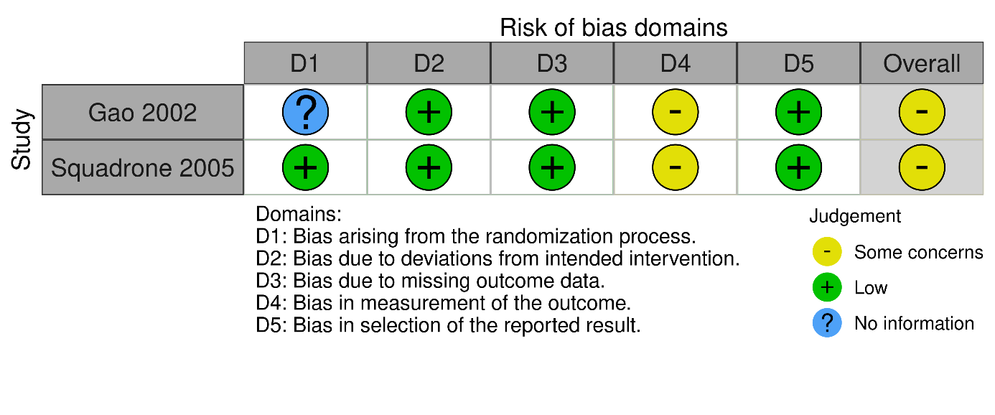
B
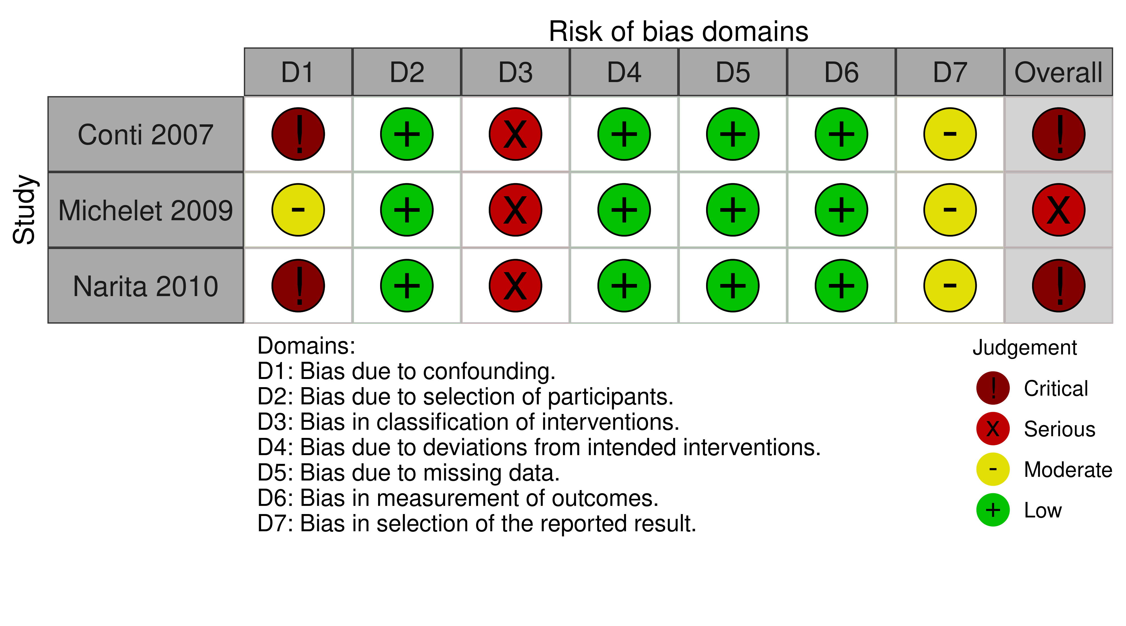

eFigure 3. Posterior probability distributions for OR and ARR comparing NIV versus oxygen on reintubation to day-7 reintubation in multivariate analysis
Multivariate analysis with adjustment on center, age < 60 years, COPD, surgical site (supra or submesocolic), epidural analgesia, postoperative sepsis, history of ischemic heart disease and chronic heart failure, BMI > 30
. Posterior distribution and probability of treatment effect of NIV compare to oxygen therapy over day-7 reintubation in multivariate analysis

eFigure 4. Posterior probability distributions for OR comparing NIV versus oxygen on day-7 reintubation according to each prior with intercept prior 1
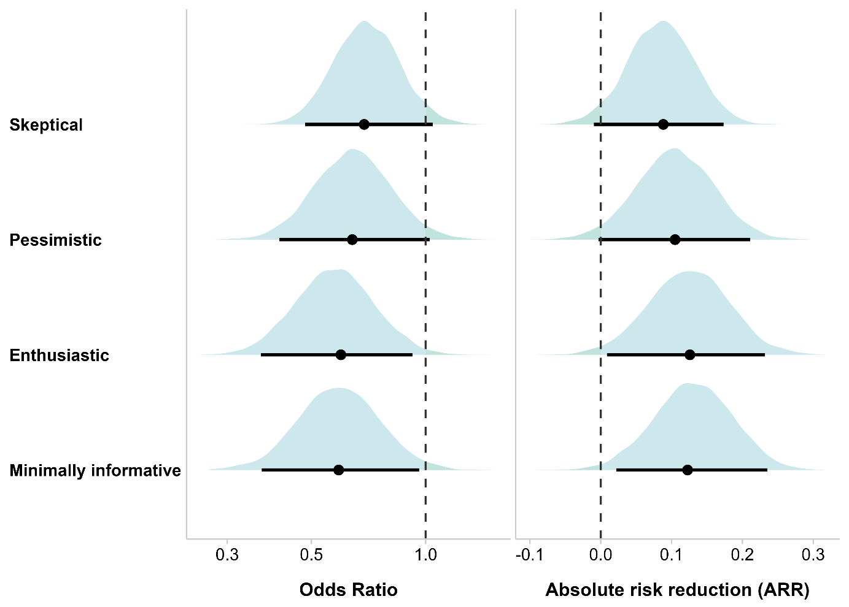

eFigure 5. Posterior probability distributions for OR and ARR comparing NIV versus oxygen on reintubation to day-7 according to each prior with intercept prior 2

eFigure 6. Posterior density of treatment effect for NIV versus oxygen on reintubation to day-7 according to each prior with intercept prior 3

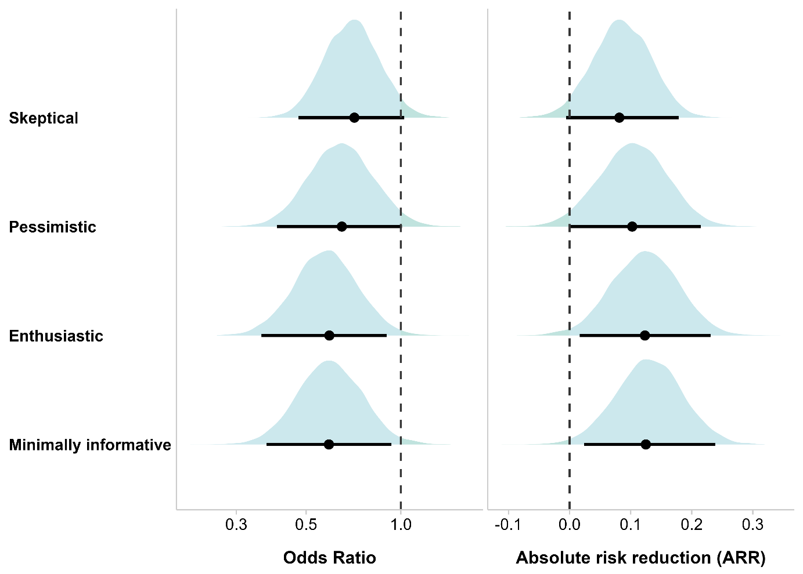

eFigure 7. Posterior probability distributions for OR and ARR comparing NIV versus oxygen on reintubation to day-30 mortality in multivariate analysis
Multivariate analysis with adjustment on center , surgical site (supra or submesocolic), epidural analgesia, COPD , SOFA score, age, IGS score

eFigure 8. Posterior probability distributions for OR and ARR comparing NIV versus oxygen on day-90 mortality according to each prior

eFigure 9. Posterior probability distributions for OR and ARR comparing NIV versus oxygen on day-7 overall healthcare-associated infections according to each prior

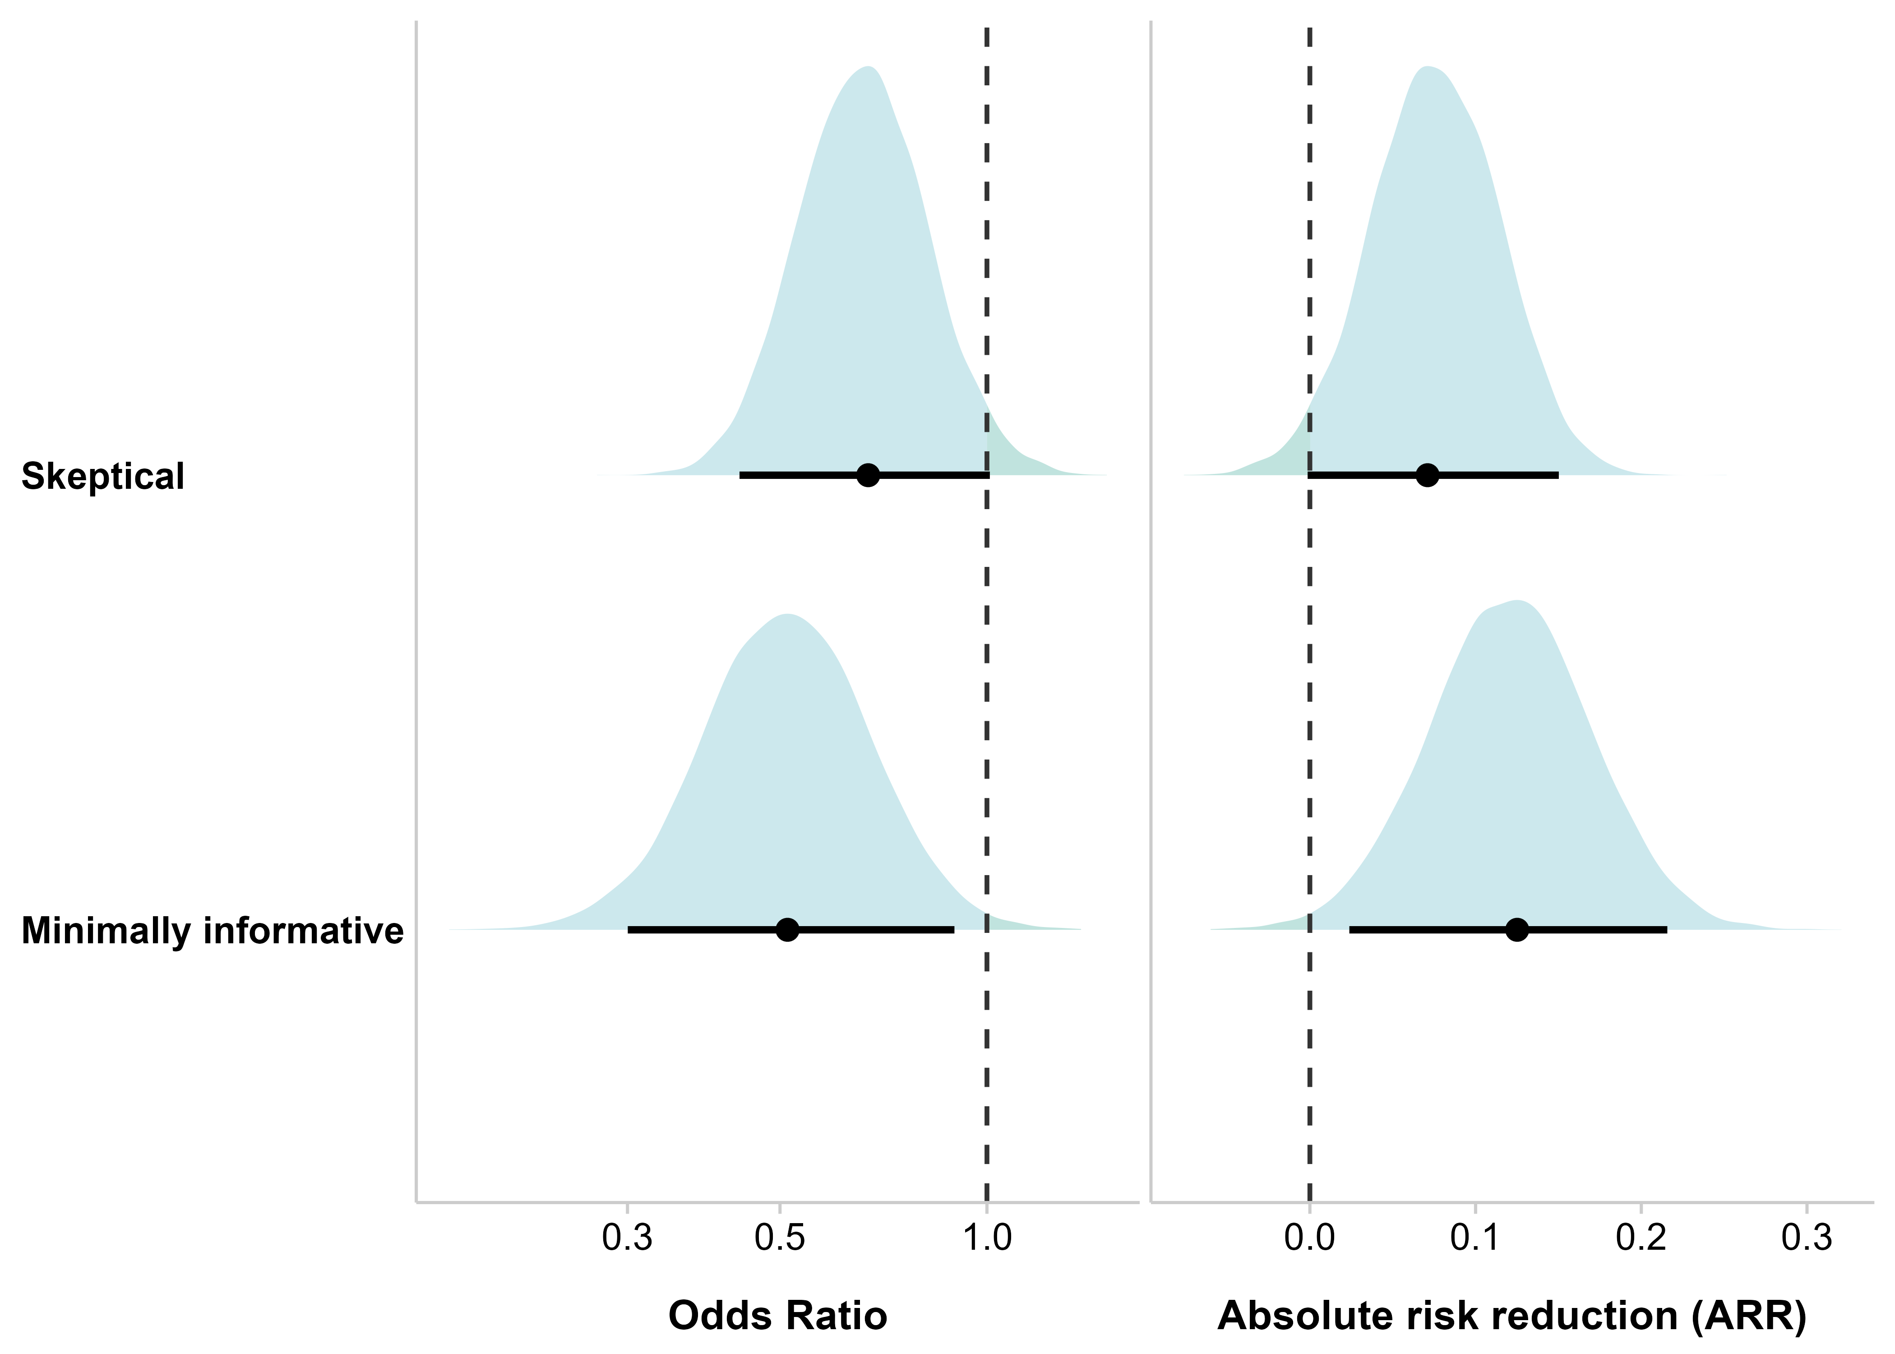

eFigure 10. Posterior probability distributions for OR and ARR comparing NIV versus oxygen on day-7 pneumonia according to each prior
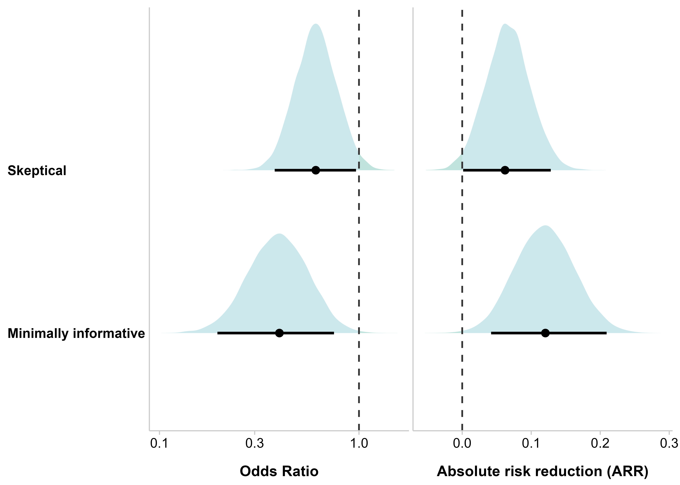

eFigure 11. Posterior probability distributions for OR and ARR comparing NIV versus oxygen on day-30 reintubation according to each prior

eFigure 12. Posterior probability distributions for OR and ARR comparing NIV versus oxygen on day-30 overall healthcare associated infections according to each prior

eFigure 13. Posterior probability distributions for OR and ARR comparing NIV versus oxygen on day-30 pneumonia according to each prior

eFigure 14. Posterior estimations in the sub-group from the stratum of randomization under minimally informative prior
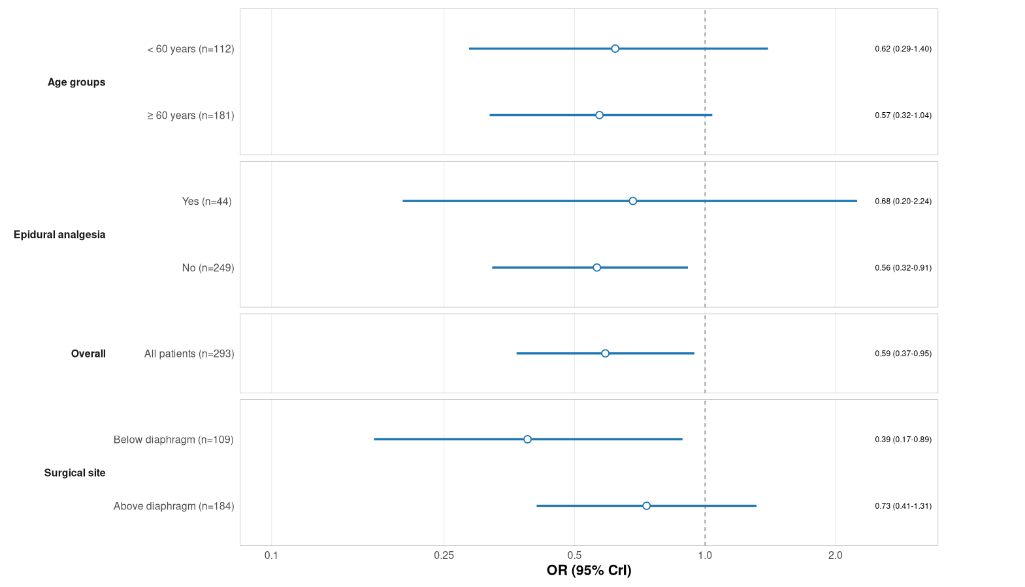

eFigure 15. Convergence diagnosis of Markov Chain Monte Carlo simulations for day-7 reintubation according to the No-U-Turn Sampler algorithm
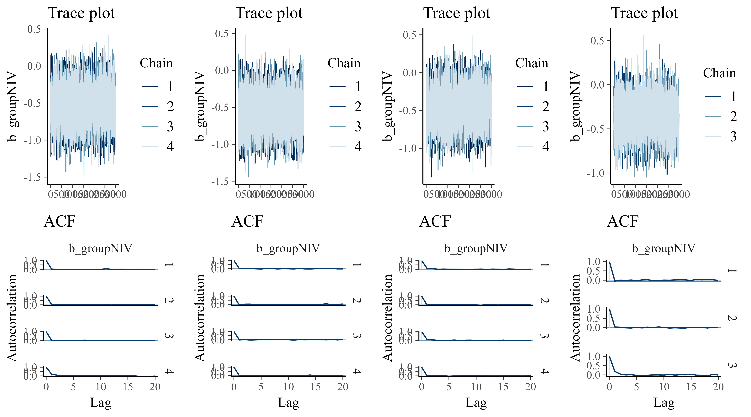
Legend: At the top, the trace plot depicts the posteriors draws from the MCMC simulations for each chain. Notes that the four chains colors are mixed, values hover around a stable level, and no drift is apparent testifying to the fact that the model has converged well. At the bottom, the autocorrelogram shows no correlation between simulation iterations beyond the 2nd iteration.

eFigure 16. Convergence diagnosis of Markov Chain Monte Carlo simulations for day-7 reintubation in multivariate analysis according to the No-U-Turn Sampler algorithm
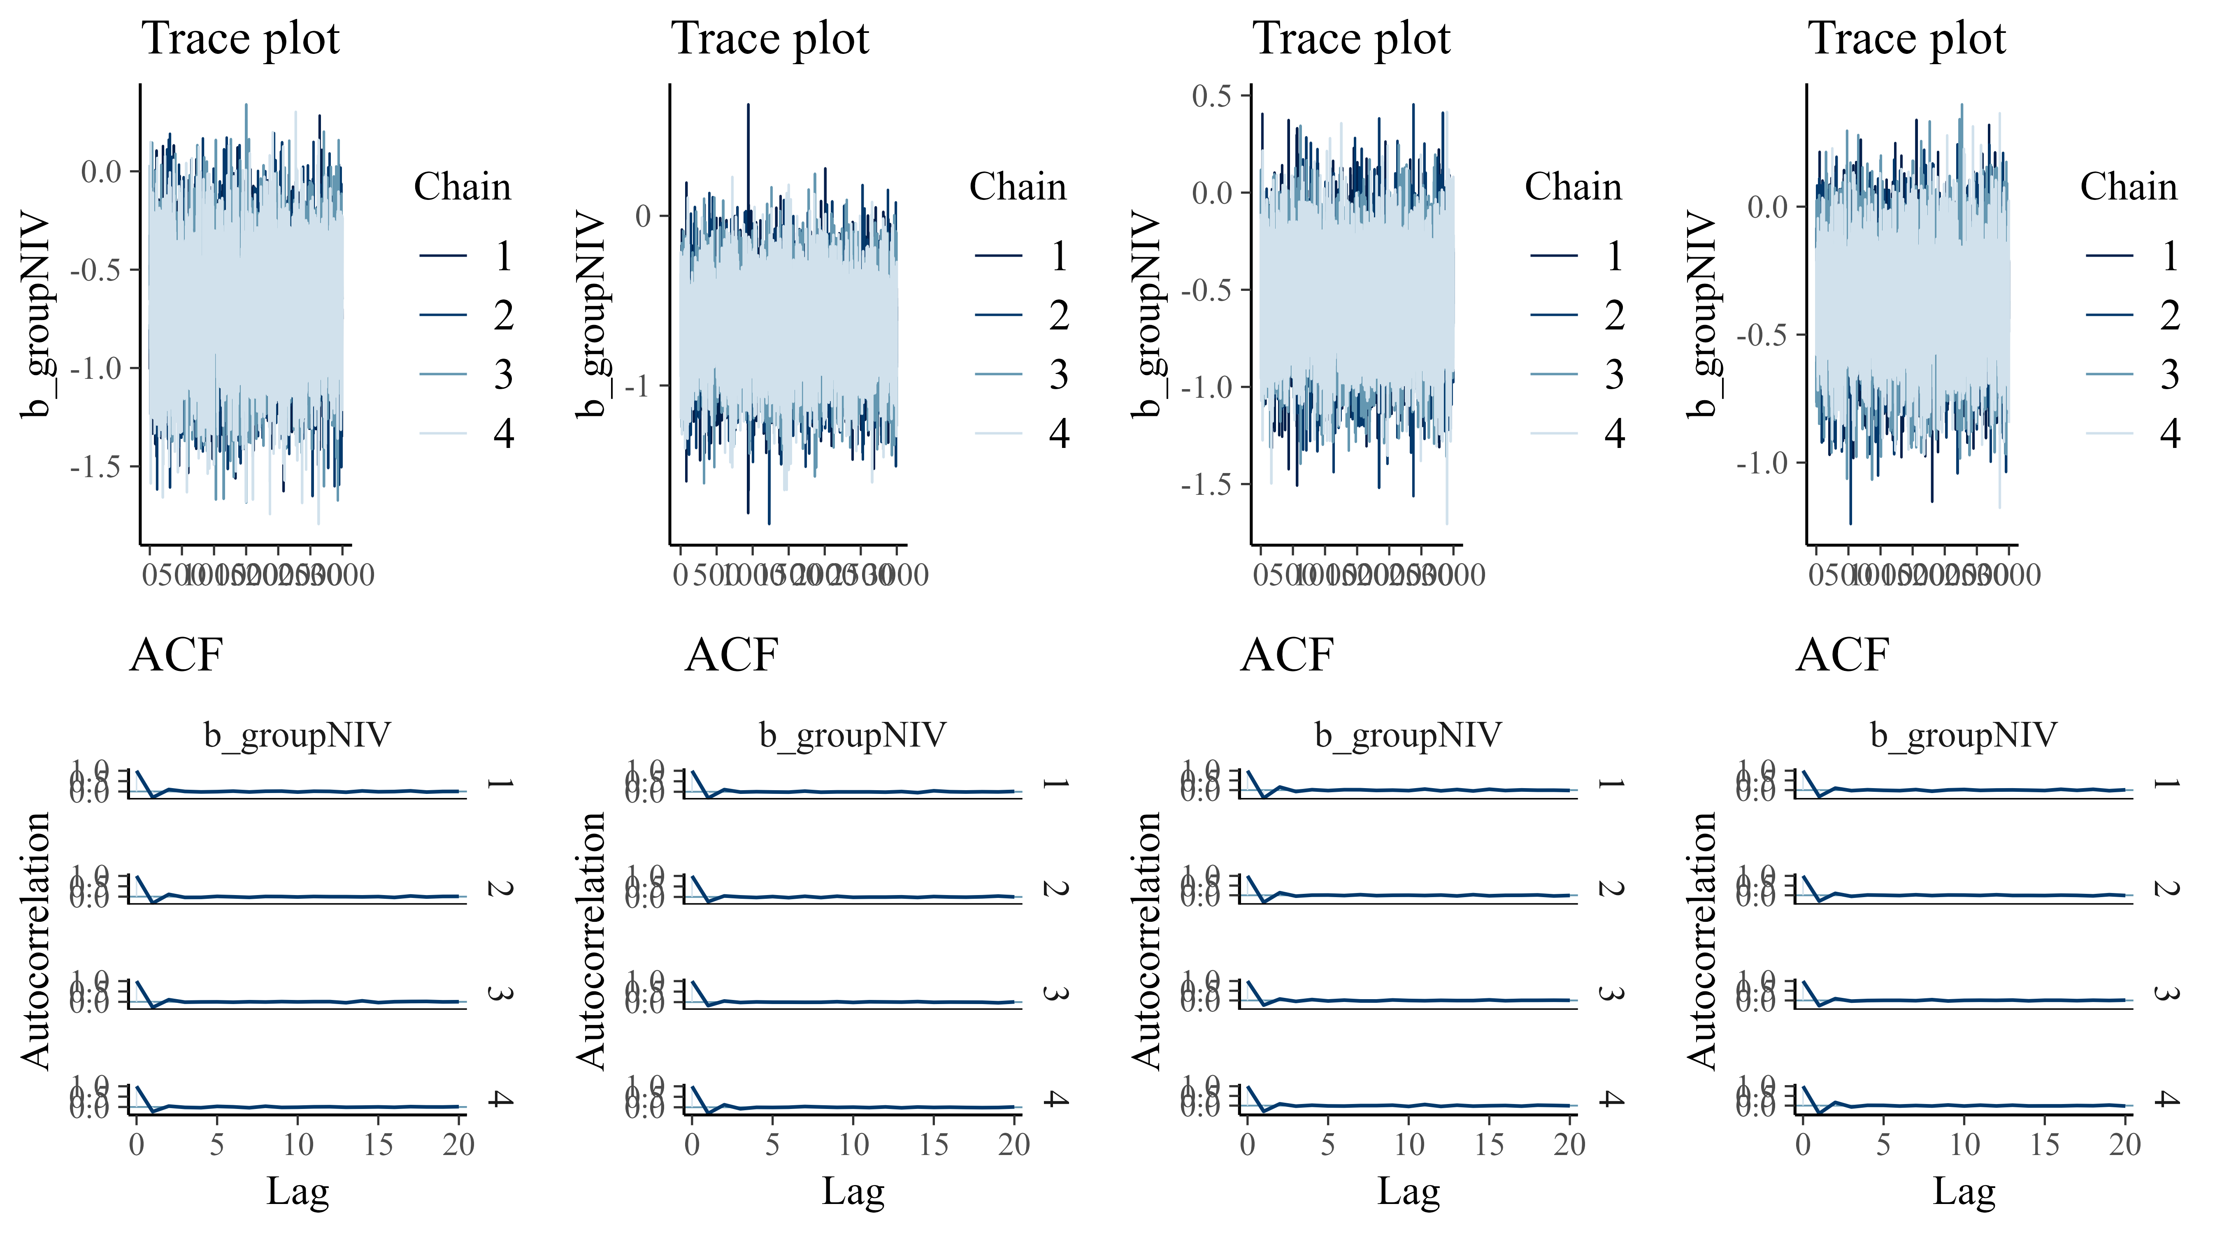

eFigure 17. Convergence diagnosis of Markov Chain Monte Carlo simulations for day-7 reintubation with informative intercept 1 according to the No-U-Turn Sampler algorithm

eFigure 18. Convergence diagnosis of Markov Chain Monte Carlo simulations for day-7 reintubation with informative prior on intercept 2 according to the No-U-Turn Sampler algorithm

eFigure 19. Convergence diagnosis of Markov Chain Monte Carlo simulations for day-7 reintubation with informative prior on intercept 3 according to the No-U-Turn Sampler algorithm

eFigure 20. Convergence diagnosis of Markov Chain Monte Carlo simulations for day-30 mortality according to the No-U-Turn Sampler algorithm
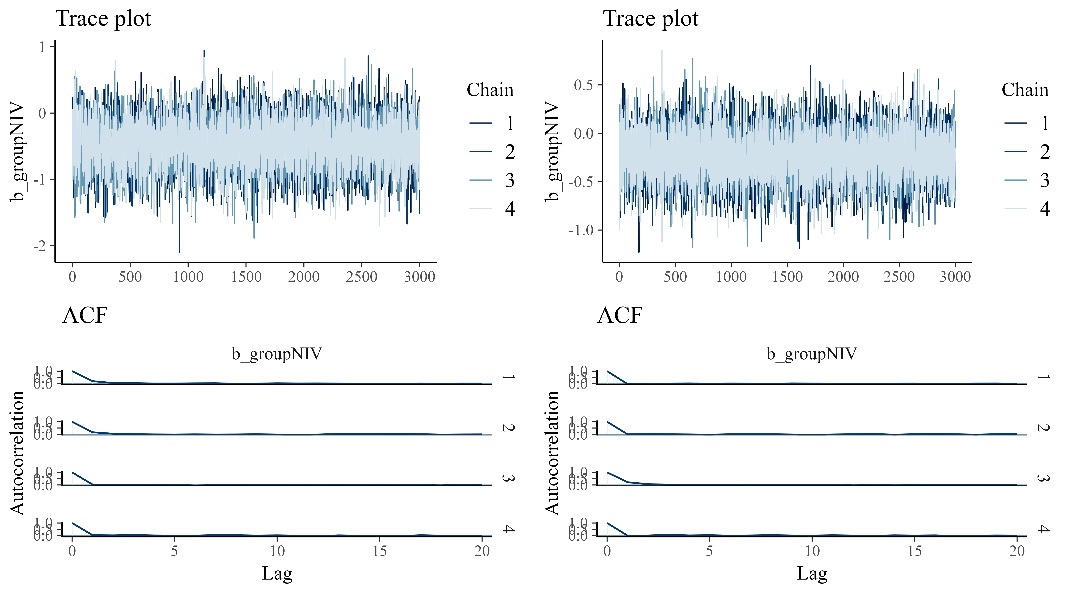

eFigure 21. Convergence diagnosis of Markov Chain Monte Carlo simulations for day-30 mortality in multivariate analysis according to the No-U-Turn Sampler algorithm

eFigure 22. Convergence diagnosis of Markov Chain Monte Carlo simulations for day-7 overall healthcare associated infection according to the No-U-Turn Sampler algorithm
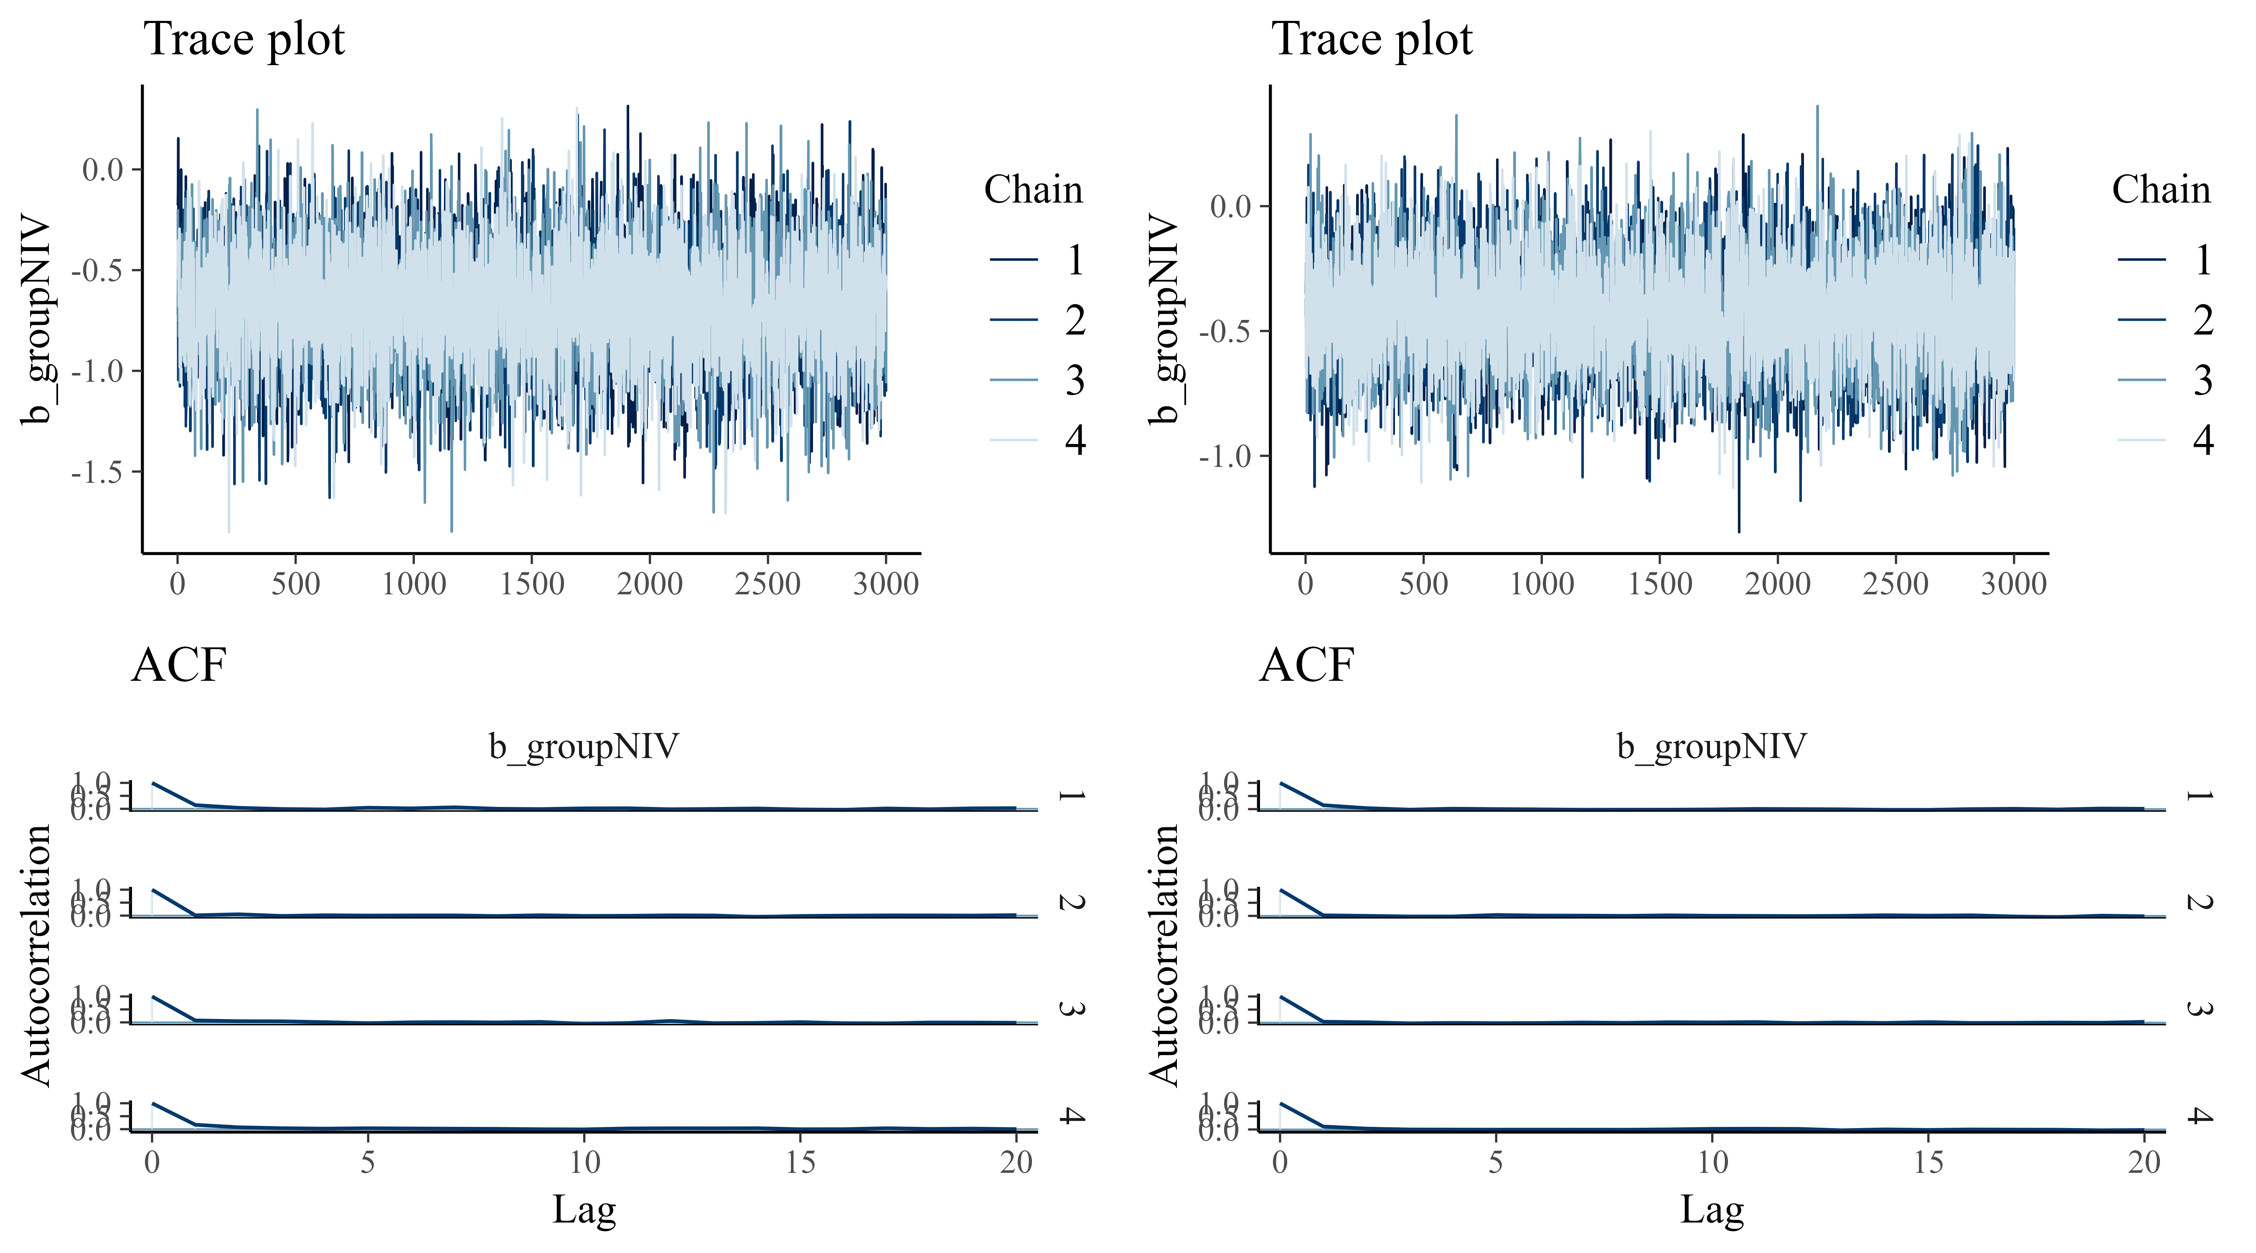

eFigure 23. Convergence diagnosis of Markov Chain Monte Carlo simulations for day-7 pneumonia infection according to the No-U-Turn Sampler algorithm
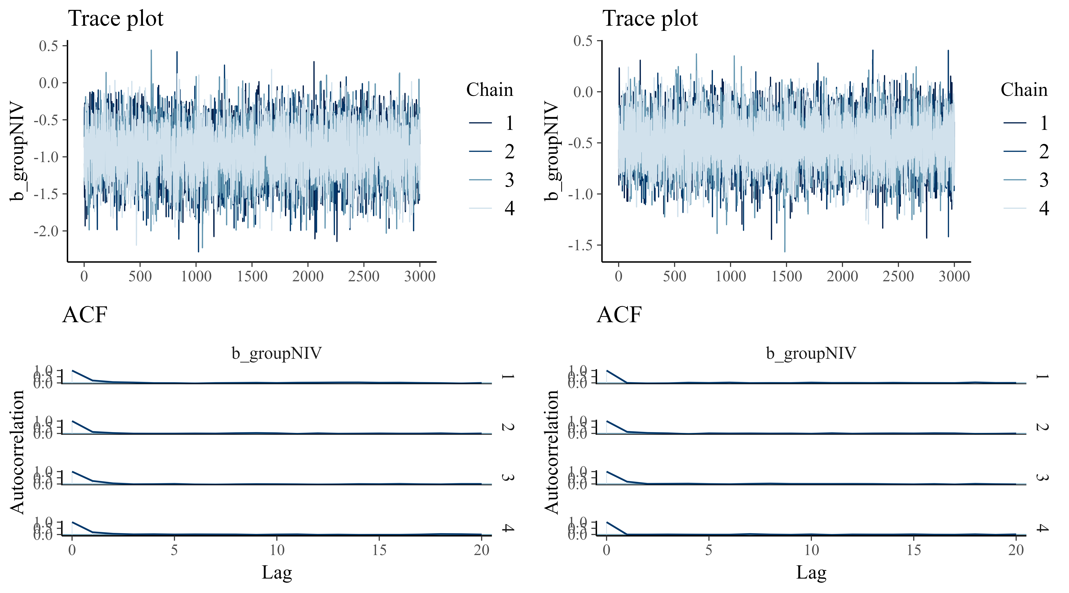

eFigure 24. Convergence diagnosis of Markov Chain Monte Carlo simulations for day-30 reintubation according to the No-U-Turn Sampler algorithm

eFigure 25. Convergence diagnosis of Markov Chain Monte Carlo simulations for day-90 mortality according to the No-U-Turn Sampler algorithm

eFigure 26. Convergence diagnosis of Markov Chain Monte Carlo simulations for day-30 overall healthcare-associated infection according to the No-U-Turn Sampler algorithm

eFigure 27. Convergence diagnosis of Markov Chain Monte Carlo simulations for day-30 pneumonia infection according to the No-U-Turn Sampler algorithm

