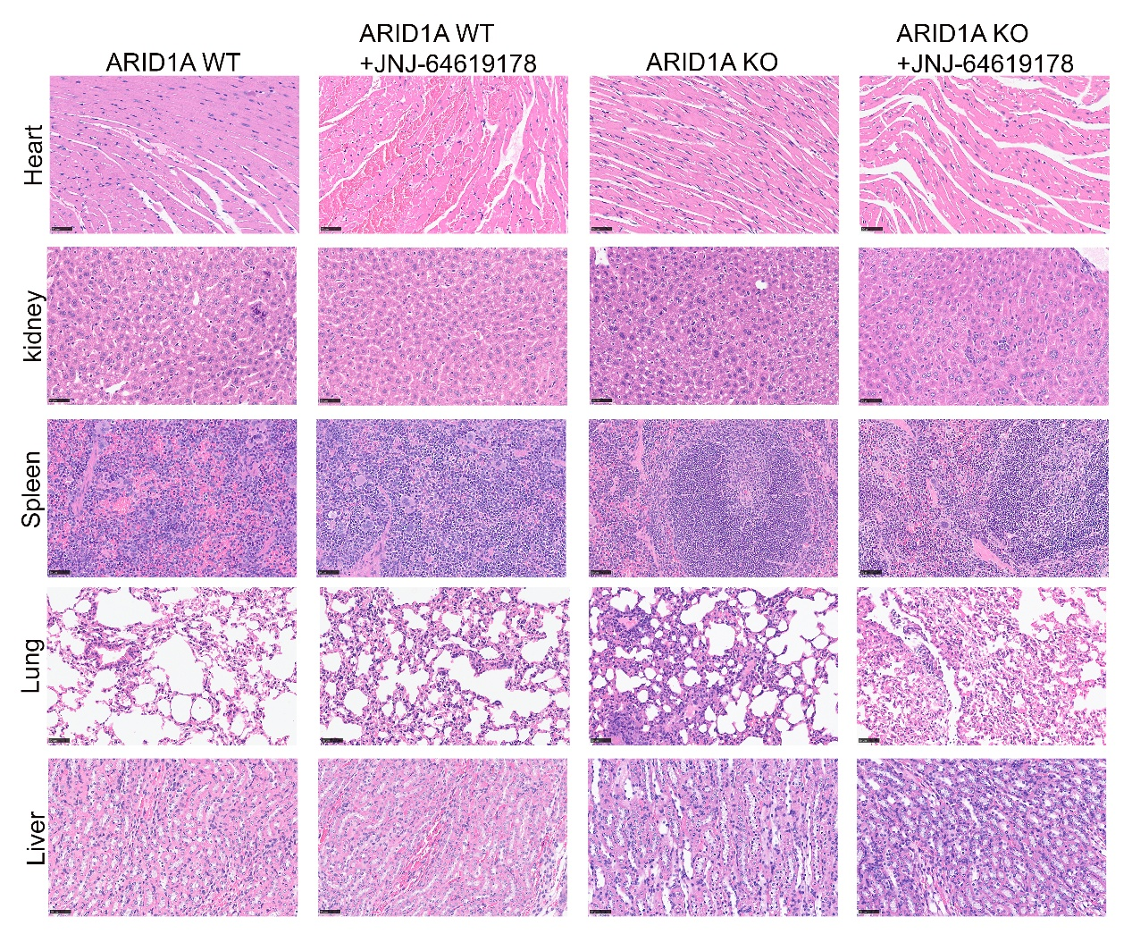
Figure S1: H&E staining of the heart, liver, spleen, lung, and kidney obtained from nude mice. Scale bar = 50 μm

Gels and blots images

