Figure S1. Distribution of individual biosurfactant-associated genes across microbial phyla and 21 ecosystem categories. Each panel represents a distinct bacterial or archaeal phylum, with bar plots showing the proportion of genomes harboring each of 18 key biosurfactant genes (e.g., rhl, wza, fen_pps) across all ecosystems. The x-axis corresponds to the 21 predefined ecosystem groups (ordered by index), while the y-axis indicates gene prevalence. Colors represent specific genes, with patterns revealing phylum-specific biases in biosurfactant gene distribution. This figure provides a granular view of gene-level functional potential, highlighting which genes are enriched in particular environments and lineages.
Figure S2. Distribution of functional biosurfactant classes across microbial phyla and 21 ecosystem categories. Each panel shows the proportion of genomes encoding at least one gene from a given biosurfactant class (e.g., Rhamnolipids, Emulsan, Surfactin) within a specific phylum. The x-axis represents the 21 ecosystem groups, and the y-axis indicates the frequency of class presence. Colors denote different biosurfactant types, allowing comparison of functional diversity across phylogenetic and environmental gradients. This visualization reveals how biosynthetic pathways are distributed across microbial communities, emphasizing the co-occurrence of multiple biosurfactant classes in certain habitats and phyla

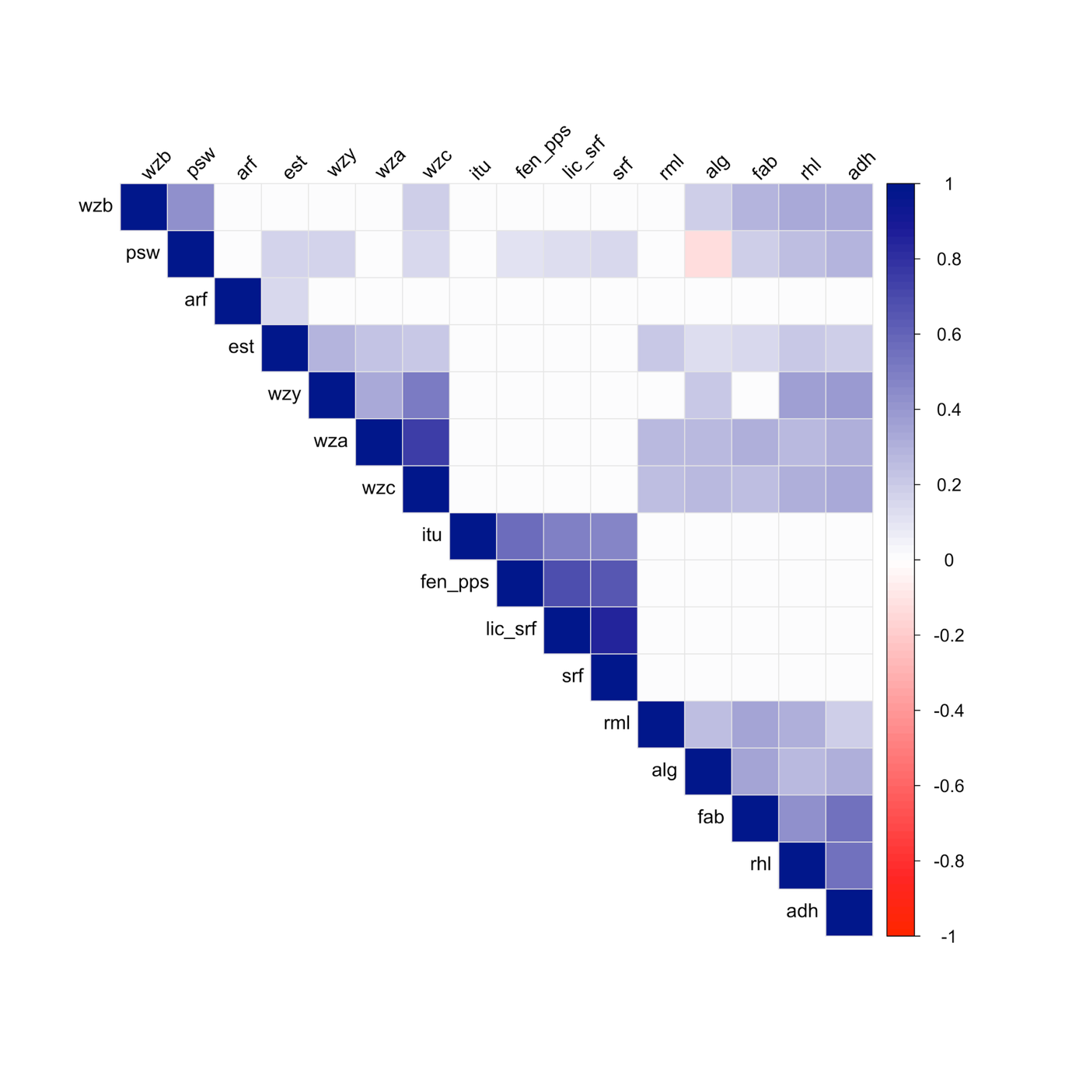
Figure S3. Heatmap of pairwise Spearman’s rank correlation coefficients for biosurfactant gene abundance profiles across microbial genomes. Cells are shaded by the degree and direction of correlation (|ρ| ≥ 0.1, p < 0.05), with hierarchical clustering revealing modular relationships. Prominent correlation blocks correspond to central biosynthetic gene clusters seen in co-occurrence network analysis, while off-diagonal signals illustrate inter-pathway integration and the broader connectivity structure underpinning biosurfactant metabolic potential.

