Appendix 1

Workshop Schedule and Session Structure
Table 4: List of all workshops conducted with participants and theme.
Date | Theme | Municipality | Participants
2023-02-20 | Workshop with young people | Lidingö | High school students from Hersby gymnasium
2023-04-04 | First look at the data | Lidingö | Officials from Lidingö
2023-05-25 | Meeting with policy makers | Lidingö | Officials from several different administrations
2023-08-14 | Collection (those who missed) | Lidingö | Head of IT and Head of Care and Social Services
2023-09-04 | Well-being of young people - data and reasoning | Both | Managers School and Social Administration, Lidingö Culture & Leisure - mixed
2023-09-11 | First look at the data | Nynäshamn | Officials from Nynäshamn
2023-10-02 | How do young people who do not continue their studies feel? | Nynäshamn | Officials from the upper secondary school, Campus Nynäshamn, social administration
2023-10-16 | School+police+social services look at young people's wellbeing using data | Nynäshamn | Officials from schools, social services and neighborhood police
2023-11-06 | Leisure activities and mental well-being of young people | Nynäshamn | Head of Leisure Centers + representative of secondary schools
2023-11-09 | Workshop with young people | Nynäshamn | Young people at the leisure center in Ösmo
2023-11-13 | School attendance and well-being | Nynäshamn | Schools, student health, social services
2023-11-20 | The role of school health in promoting the mental well-being of young people | Both | Student Health Nynäshamn and Lidingö
2023-11-30 | UVAs - Young people who are neither working nor studying | Lidingö | Social services, KAA (municipal activity responsibility), Delta ung, leisure center, school psychologist
2023-12-07 | Meaningful leisure | Lidingö | Representatives from leisure centers, libraries, the sports unit, general culture, etc.
2023-12-11 | Finalization of practical work in municipalities | Both | Managers School and Social Administration, Lidingö Culture & Leisure - mixed

Appendix 2
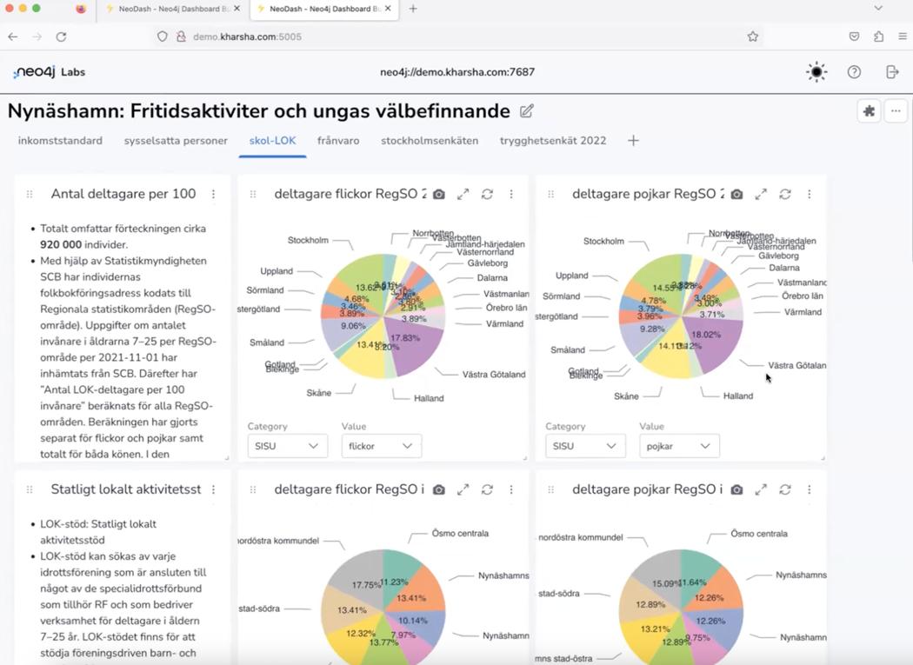
Figure 6: Visualizations of free time at Nynäshamn during a briefing session of a workshop.

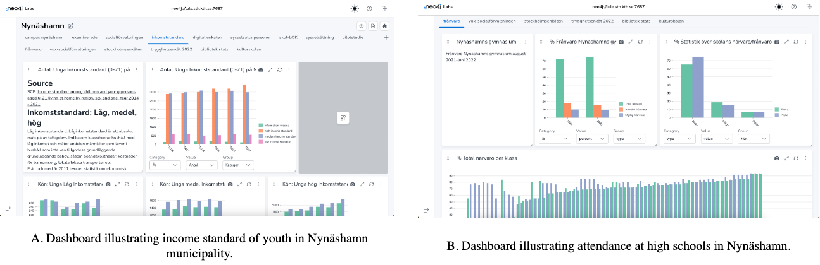
Figure 7 Dashboard illustrating income standard and high school attendance of youth in Nynäshamn municipality.

