Supplementary Material
Chemo-photothermal therapy promoting immunogenic cell death based on NIR-II light-responsive drug delivery systems
Lifeng Hang¹*#, Wuming Li^{1#}, Dandan Men^{2#}, Hua Wen¹, Xinfeng Tang³, Chunze Zhou⁴, Xiaofen Ma¹, Guihua Jiang^{1,}*
¹ The Department of Medical Imaging, Guangdong Second Provincial General Hospital, Guangzhou, 518037, P. R. China
² Jiangxi Key Laboratory of Surface Engineering, Jiangxi Science and Technology Normal University, Nanchang, 330013, P. R. China
³ Division of Molecular Medicine, Hefei National Laboratory for Physical Sciences at Microscale, the CAS Key Laboratory of Innate Immunity and Chronic Disease, School of Life Sciences, University of Science and Technology of China, Hefei, 230001, P. R. China
⁴ Interventional Radiology Department, The First Affiliated Hospital of USTC, Division of Life Sciences and Medicine, University of Science and Technology of China, Hefei 230001, P. R. China
# These authors contributed equally to this work.

Characterization.
The all samples were characterized by scanning electron microscope (SEM), energy dispersive spectrometer (EDS), transmission electron microscopy (TEM, JEM-2010) and high-resolution TEM (HRTEM). X-ray diffraction (XRD) patterns were measured on powder X-ray diffraction (PXRD; Philips X’Pert Pro) using the Cu K_{α} line (0.15419 nm). The UV−vis-NIR spectra of samples were recorded by UV−vis-NIR a spectrophotometry (Cary 500, Varian). X-ray photoelectron spectra (XPS) of samples were performed using a X-ray photoelectron spectrometer (VG ESCA2000) with a Mg K_{α} excitation source. The Zeta potential and size of samples were carried out in aqueous solution using a dynamic light scattering (DLS, Malvern ZS90) instrument. The amount of Cu element was measured by inductively coupled plasma mass spectrometry (ICP-MS).
Cell culture
EMT-6 cells (a mouse mammary cancer cell line) were obtained from American Type Culture Collection (ATCC). The EMT-6 cells were cultured in DMEM culture medium supplemented with 10% FBS and antibiotics (50 units mL⁻¹ penicillin and 50 units mL⁻¹ streptomycin) at 37°C under a moist atmosphere containing CO₂ (5%).
Animal and tumor model
Female Balb/c mice (5-7 week of age) were purchased from Vital River Laboratories (Beijing, China), and all animals received were cared in compliance with the guidelines outlined in the Guide for the Care and Use of Laboratory Animals, and all procedures were approved by the Guangdong Second Provincial General Hospital Animal Care and Use Committee. The xenograft model were established by subcutaneous injection of EMT-6 cells with 100 μL (2 × 10⁵).
Cellular Uptake of the Cu_{x}S-PEG NPs
EMT-6 cells with 5× 10⁴ cells/well in 0.5 mL of DMEM were incubated with different concentraiton of Cu_{x}S-PEG NPs (50 and 100 μg mL⁻¹) at 37 °C for 2, 4, and 6 h. Then, the DMEM was removed and the cells were collected to assess the cell phagocytosis. The harvested cells were treated with nitric acid and aqua regia, and then ICP-MS measurements were utilized to detect the copper content in solution.
In Vitro MTT Assay
The cytotoxicity of Cu_{x}S-PEG NPs against EMT-6 cells was detected by MTT assay. EMT-6 cells (3 × 10³) were seeded into 96-well plate and cultured for 24 h at 37 °C. Then, different concentrations of Cu_{x}S-PEG NPs (range from 0 to 100 μg mL⁻¹) were added into cells for further culturing 48 h. Next, 25 μL of MTT stock solution (5 mg mL⁻¹) was introduced into every well for another 4 h. Subsequently, culture medium was replaced by 100 µL of DMSO, and the was shocked for 30 min. Finally, the absorbance of plate was tested on the Microplate reader (Bio-tek) at 490 nm wavelength.
Live/Dead staining
To evaluate cell viability of cells after various treatments, EMT-6 cells were stained using the live/dead kit (Weikai, Tianjin, China) and measured by fluorescence microscope. EMT-6 cells were seeded into a 24-well plate with a density of 2 × 10⁴ cells/well. Six groups including: PBS, Cu_{x}S-PEG NPs, Dox, Dox/Cu_{x}S-PEG NPs, Cu_{x}S-PEG NPs plus laser, and Dox/Cu_{x}S-PEG NPs plus laser were applied in live/dead staining. After 4 h of incubation, the cells were washed with the PBS, and 500 µL of fresh medium was added. After 6 h post-treatment with different group, the cells in six groups were incubated with calcein-AM and propidium iodide (PI) at 37 °C for 5 min.
Detection of ATP
EMT-6 cells were seeded at 1 × 10⁵ cells per well in 24-well plates and further cultured for 24 h. The cells were treated with PBS, Cu_{x}S-PEG NPs, Dox, Dox/Cu_{x}S-PEG NPs, Cu_{x}S-PEG NPs plus laser, and Dox/Cu_{x}S-PEG NPs plus laser, following a further incubation of 12 h. Then, extracellular ATP in the conditioned media that secreted from treated cells were measured via an ATP bioluminescent assay kit (Sigma-Aldrich, St. Louis, MO, USA) by Xenogen IVIS Spectrum imaging system (Perkin Elmer, Waltham, MA, USA).
Detection of CRT
EMT-6 cells were seeded at 1 × 10⁵ cells per well in 24-well plates and further cultured for 24 h. The The cells were treated with PBS, Cu_{x}S-PEG NPs, Dox, Dox/Cu_{x}S-PEG NPs, Cu_{x}S-PEG NPs plus laser, and Dox/Cu_{x}S-PEG NPs plus laser, following a further incubation of 4 h. The treated cells were incubated with individual primary antibodies against CRT (Cell Signaling Technology, Danvers, MA, USA, #12238S) for 30 min. Then the exposure of CRT was measured by Flow cytometry (BD Bioscience, Franklin Lakes, NJ, USA) and a fluorescence microscope.
Detection of HMGB1
EMT-6 cells were seeded at 1 × 10⁵ cells per well in 24-well plates and further cultured for 24 h. The cells were treated with PBS, Cu_{x}S-PEG NPs, Dox, Dox/Cu_{x}S-PEG NPs, Cu_{x}S-PEG NPs plus laser, and Dox/Cu_{x}S-PEG NPs plus laser, following a further incubation of 12 h. The treated cells were incubated with individual primary antibodies against HMGB1 antibody (Cell Signaling Technology, #6893S) for 30 min. Then the release of HMGB1 was detected by a fluorescence microscope (Olympus).
In vitro DCs maturation
Bone-marrow-derived dendritic cells (BMDCs) were isolated from the mice bone marrow of 8~10 week-old C57 mice. Briefly, the hind legs of mice were cut away just above the hip and below the ankle. The muscle was moved away by medical gauzes and the bones were steeped in 70% ethanol for 5 min. The ends of each bone were cut away and a 1 mL syringe filled with RPMI medium without FBS was inserted into the exposed end of the bone and let the red bone marrow flush out into a 10 cm cell culture dish filled with RPMI completed medium. This step was repeated until the bone become white. For DCs activation, bone-marrow-derived monocytic cells were cultured with IL-4 (10 ng/mL) and GM-CSF (20 ng/mL) for 4 days, then non-adherent cells in the culture supernatant were harvested before further use. For in vitro DCs maturation experiments, tumor cells were seeded in 6-well plates at a density of 3 × 10⁵ per well overnight. Then the medium was refreshed with the medium containing Cu_{x}S-PEG NPs, Dox/Cu_{x}S-PEG NPs, and free Dox, for 4 h incubation. After the Dox/Cu_{x}S-PEG NPs and Cu_{x}S-PEG NPs groups were treated with laser for 24 h incubation, the tumor cells were harvested and incubated with BMDCs at ratio of 1:2 for 10 h at 37 °C. Then the non-adherent cells were collected, washed with cold PBS twice and stained with FITC-CD11c monoclonal antibodies. After washing by PBS twice, the cells were then analyzed by flow cytometry.
Pharmacokinetics and biodistribution measurements
When the tumor volumes had reached ~100 mm³, the mice were intravenously injected with Cu_{x}S-PEG NPs (10 mg kg⁻¹) for pharmacokinetics and biodistribution studies. In the pharmacokinetics study, 20 µL blood samples were collected from the mouse retro-orbital plexus at predetermined time points (0, 1, 2, 4, 6, 12, 24, and 48 h), and the concentration of Cu in the blood samples were detected by ICP-MS.
Mice were intravenously injected with Cu_{x}S-PEG NPs (10 mg kg⁻¹) to study the biological distribution. At 12, 24, and 48 h after injection, major organs including heart, liver, spleen, lung, kidney, and tumor tissue were resected from treated mice, and the Cu content was determined by using ICP-MS.
Survival experiment with different treatments
When the volumes of EMT-6 tumor were about 100 mm³, the mice were randomly divided into the following six groups (n = 10): (I) Control (PBS), (II) Cu_{x}S-PEG NPs, (III) Dox/Cu_{x}S-PEG NPs, (IV) free Dox only, (V) Cu_{x}S-PEG NPs + Laser, and (VI) Dox/Cu_{x}S-PEG NPs + Laser. Then, the survivorship curves of mice in all groups are recorded every day.
In vivo analysis of T cells
To study the immune cells in tumors, umours were harvested from mice in different groups and stained with anti-CD3-FITC (Biolegend, Clone: 17A2, Catalog: 100204), anti-CD8a-APC (Biolegend, Clone: 53-6.7, Catalog: 100712), anti-CD4-PerCP (Biolegend, Clone: GK1.5, Catalog: 100432) antibodies according to the manufacturer’s protocols. Briefly, tumour tissues were cut into small pieces and put into a glass homogenizer containing PBS (pH7.4) with 2% heat-inactivated fetal bovine serum. Then, the single-cell suspension was prepared by gentle pressure with the homogenizer without addition of digestive enzyme. Finally, cells were stained with fluorescence-labelled antibodies after the removal of red blood cells (RBC) using the RBC lysis buffer. Cytotoxic T lymphocytes and helper T cells were CD3⁺CD4⁻CD8+and CD3⁺CD4⁺CD8⁻, respectively. All these antibodies used in our experiments were diluted ~200 times.
Statistical Analysis.
Sstatistical significance of the experimental data was assessed via the two-tailed Student’s t-test. *p <0.05, **p < 0.01, ***p < 0.001 and ****p < 0.0001 were considered a statistically significant difference between groups

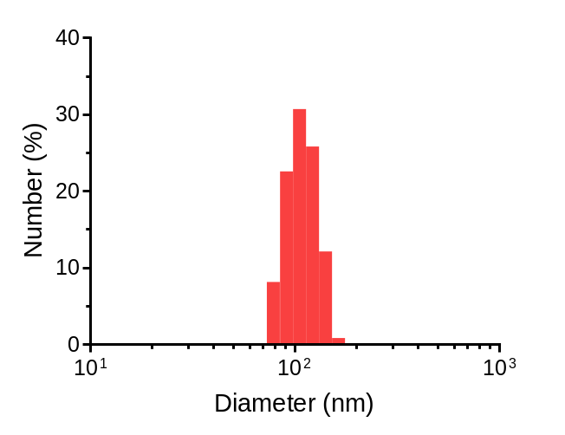
Fig. S1. Size distribution of Cu₂O NPs.


Fig. S2. SEM image of hollow Cu_{x}S-PEG NPs.

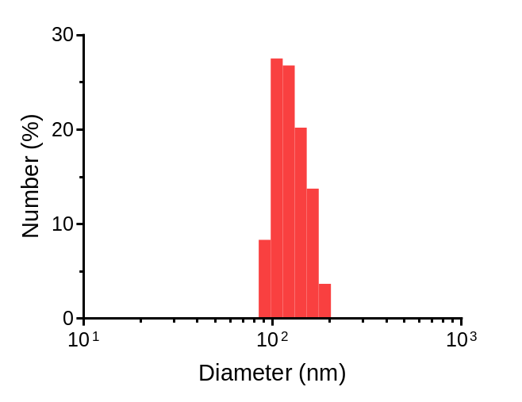
Fig. S3. Size distribution of Cu_{x}S NPs.

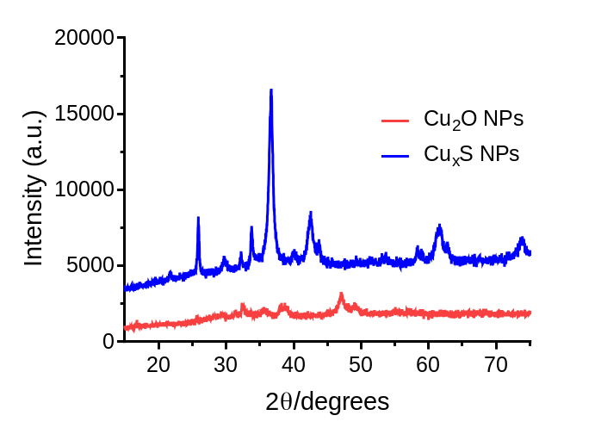
Fig. S4. XRD pattern of Cu₂O NPs and Cu_{x}S NPs.

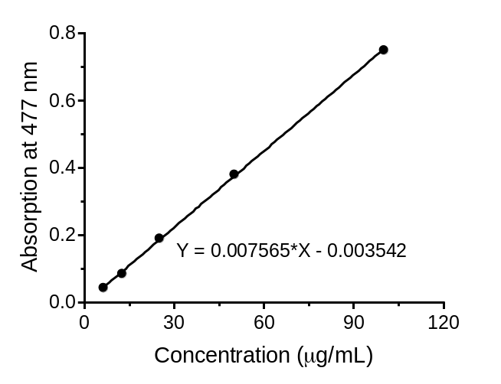
Fig. S5. The standard curve of Dox concentration vs absorption.

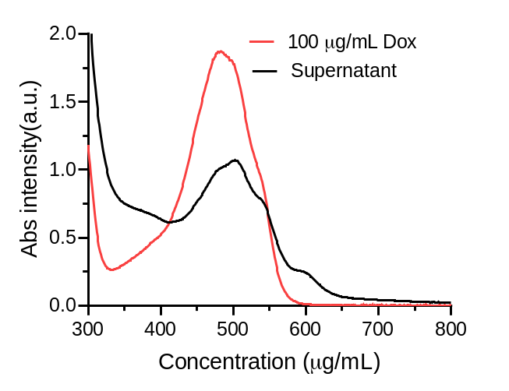
Fig. S6. The UV-vis spectra of feeding and liquid supernatant of Dox.

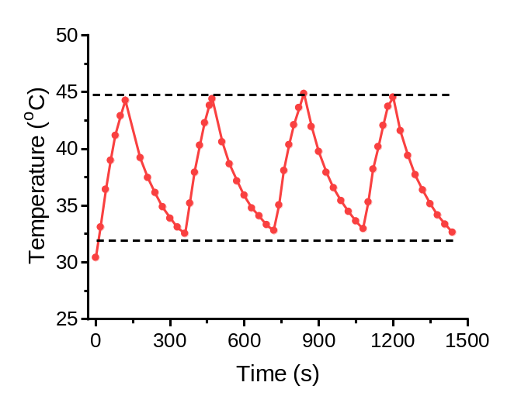
Fig. S7. The temperature changes of Cu_{x}S-PEG NPs over four cycles upon NIR laser irradiation with laser ON/OFF.

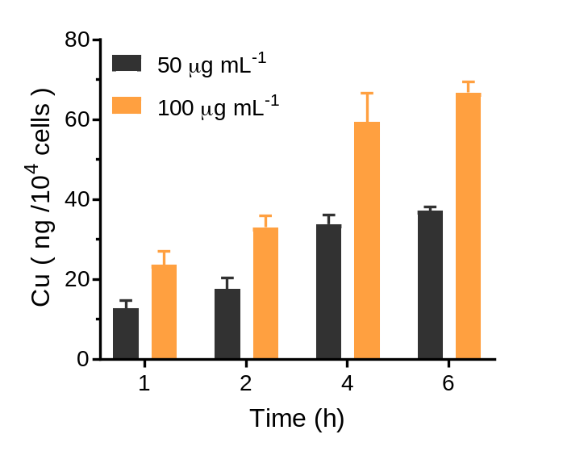
Fig. S8. Quantitative cellular uptake study of the Cu_{x}S-PEG NPs analyzed by inductively coupled plasma mass spectrometry (ICP-MS) measurement.

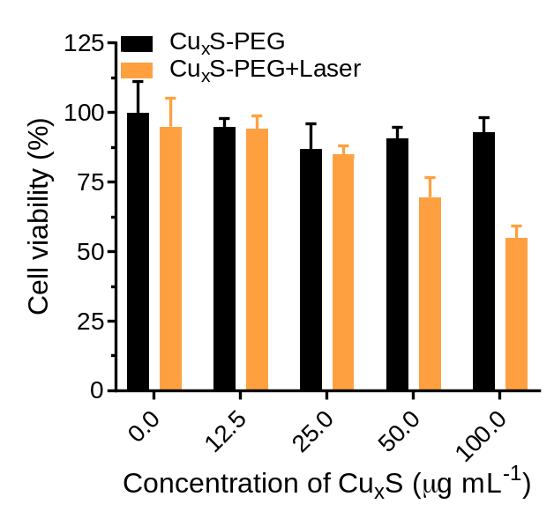
Fig. S9. Cell viability of EMT-6 cells was assessed by MTT assay after treatment with Cu_{x}S-PEG NPs and Cu_{x}S-PEG NPs+laser.

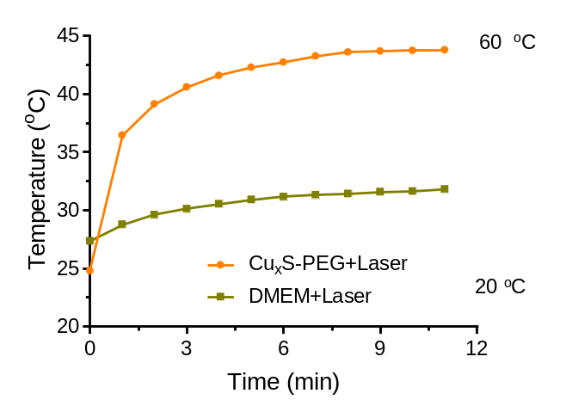
Fig. S10. The photothermal conversion properties of Cu_{x}S-PEG NPs irradiating with 1064 nm laser in the cellular level.

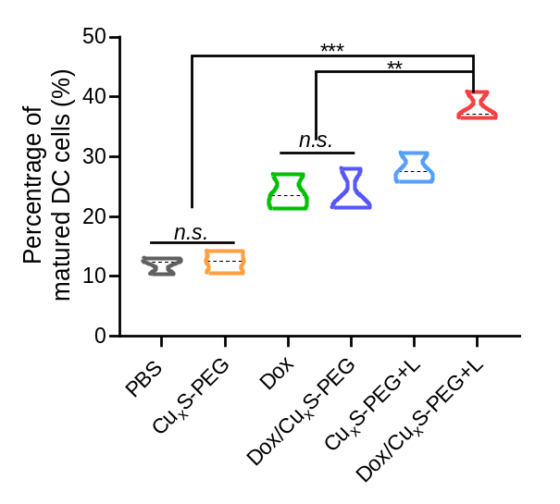
Fig. S11. The percentage of matured BMDCs cell.
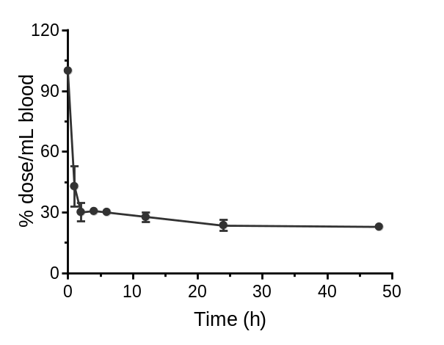
Fig. S12. Time curve of Cu_{x}S-PEG NPs in blood circulation measured by ICP-MS.

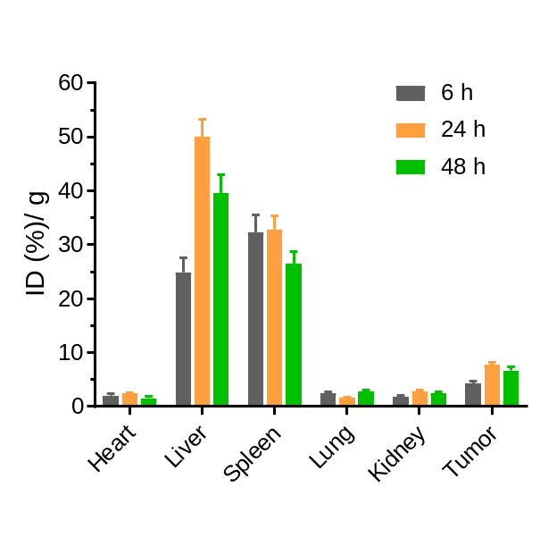
Fig. S13. After being treated with Cu_{x}S-PEG NPs for various time, the biological distribution of Cu accumulation in each organ: heart, liver, spleen, lung, kidney and tumor.

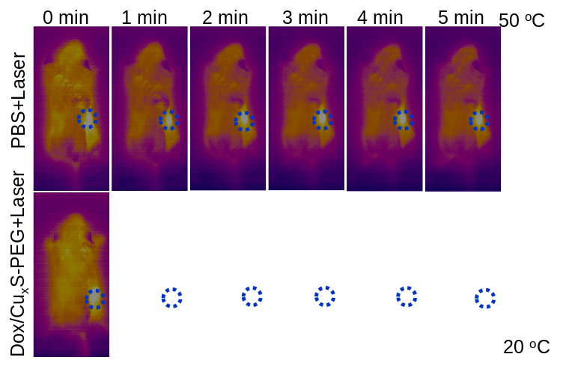
Fig. S14. The in vivo thermal images of tumor-bearing mice treated with PBS plus laser and the Dox/Cu_{x}S-PEG NPs (the dose of 10 mg·kg⁻¹) plus laser.
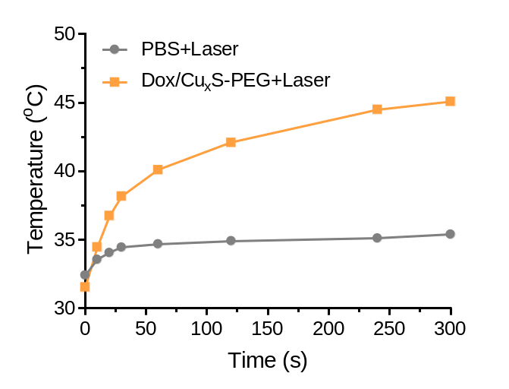
Fig. S15. Tumor-temperature variations in PBS and Dox/Cu_{x}S-PEG NPs groups.

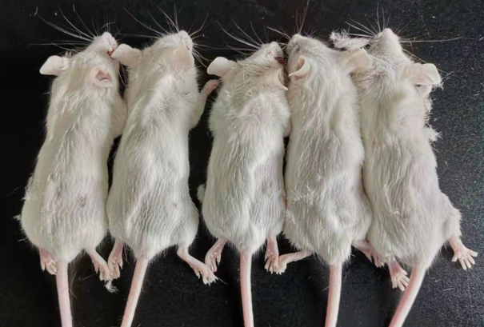
Fig. S16. Photo of mice treated with Dox/Cu_{x}S-PEG NPs +laser at the end of chemo-photothermal therapy.

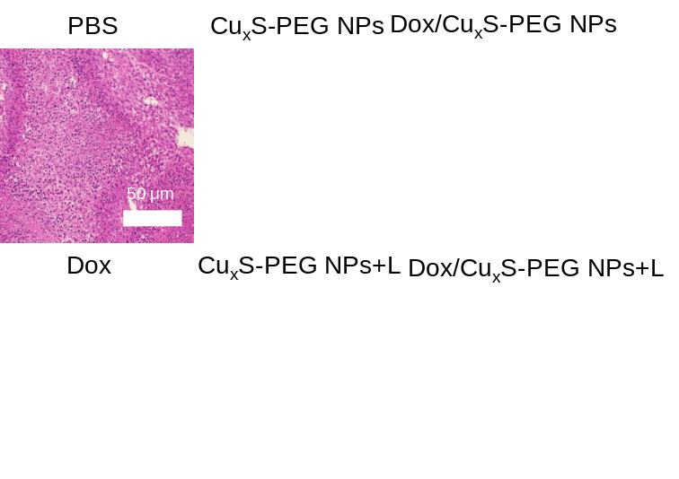
Fig. S17. H&E staining images of different groups: PBS, Cu_{x}S-PEG NPs, Dox/Cu_{x}S-PEG NPs, Dox, Cu_{x}S-PEG NPs plus laser, and Dox/Cu_{x}S-PEG NPs plus laser.
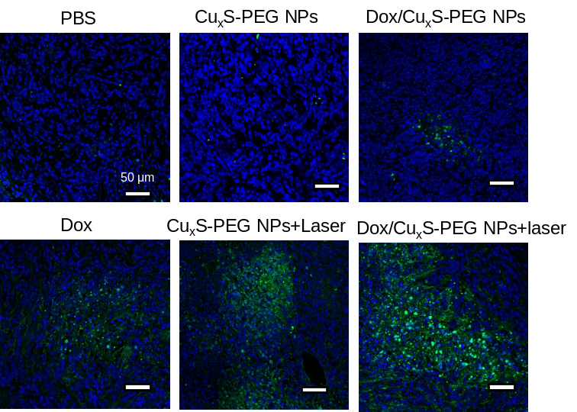
Fig. S18. TUNEL staining images of tumor tissues after different treatments: PBS, Cu_{x}S-PEG NPs, Dox/Cu_{x}S-PEG NPs, Dox, Cu_{x}S-PEG NPs plus laser, and Dox/Cu_{x}S-PEG NPs plus laser.

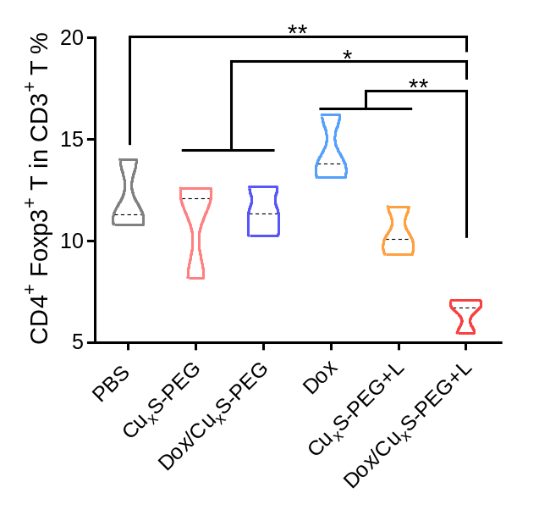
Fig. S19. Proportions of tumour-infiltrating CD⁴⁺ FoxP³⁺ regulatory T cells after treatments with different groups. PBS, Cu_{x}S-PEG NPs, Dox/Cu_{x}S-PEG NPs, Dox, Cu_{x}S-PEG NPs plus laser, and Dox/Cu_{x}S-PEG NPs plus laser. Data are shown as mean ± standard deviation *p < 0.05, **p < 0.005, ***p < 0.001.

