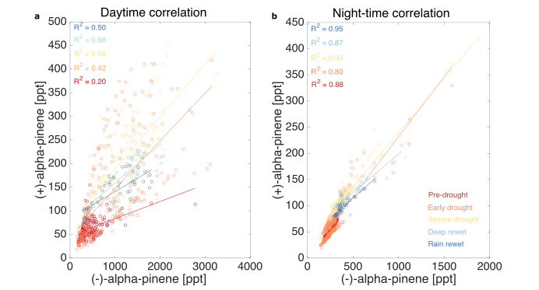
Extended Data Figure 1. Correlations of (+) and (-)-alpha-pinene during each stage of drought. a. Daytime correlation. b. nighttime correlation. Data is more correlated during nighttime, indicating that the source of the emissions is more similar than the daytime sources.

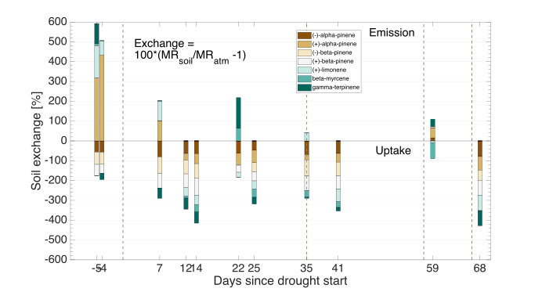
Extended Data Figure 2. Relative emission and uptake % of individual MT species from soil chambers located around the B2 TRF. Values shown are the calculated medians from 3 soil chamber outlet samples and 2-3 atmospheric sample cartridges taken at the inlet to the soil chamber.

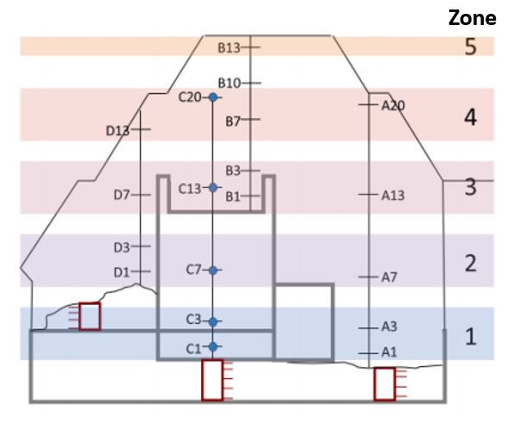
Extended Data Figure 3. Schematic of the Biosphere 2 Tropical Rainforest microbiome. The height was divided into 5 zones. A13 is the location where the atmosphere was sampled from by the GC-MS.
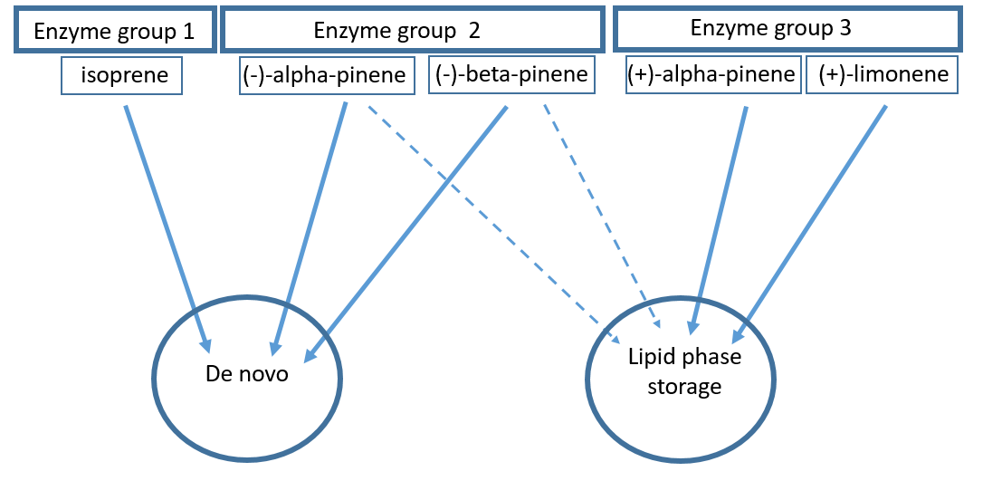
Extended Data Figure 4. Schematic representation of the 3-enzyme group model. The solid arrows represent the main emission pathway for that compound and dashed arrows represent a secondary pathway.

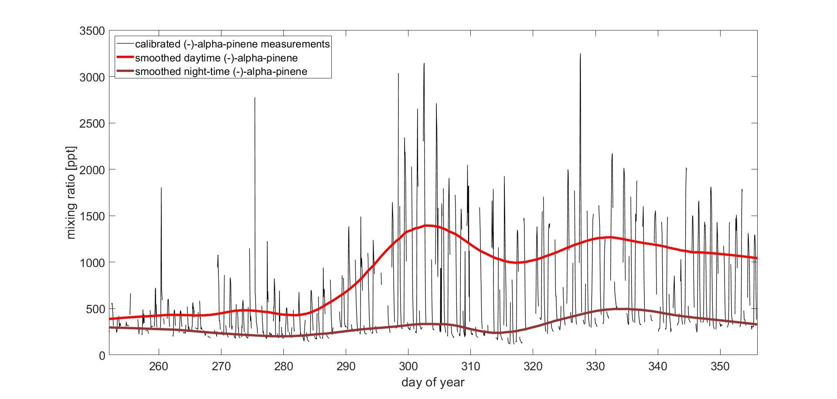
Extended Data Figure 5. Calibrated (-)-alpha-pinene measurements (black) with smoothed daytime (red) and nighttime (brown) trend lines. The smoothed lines were created by applying a savitsky-goulay filter in conjunction with moving average filter as described in the data management section.

Extended Data Table 1. Statistical information from t-test that was performed on the acquired data from the 13C labelled atmospheric samples. DoF is the degrees of freedom and n is the number of samples. PP refers to the samples taken before the 13CO2 labelling (pre-pulse) and 1st and 2nd phases refer to the first and second 13CO2 pulses, respectively.
 | (-)-α-pinene |  |  | (+)-α-pinene |  |  | β-myrcene |  |  | trans-β-ocimene |  |  | (+)-limonene
phase | PP | 1st | 2nd | PP | 1st | 2nd | PP | 1st | 2nd | PP | 1st | 2nd | PP | 1st | 2nd
n | 35 | 16 | 11 | 27 | 15 | 9 | 27 | 15 | 11 | 38 | 16 | 10 | 24 | 14 | 11
DoF | 34 | 15 | 10 | 26 | 14 | 8 | 26 | 14 | 10 | 37 | 15 | 9 | 23 | 13 | 10
t-values |  | 0.0003 | 0.0038 |  | 0.1896 | 0.4525 |  | 0.1466 | 0.0028 |  | 0.0116 | 0.0058 |  | 0.3422 | 0.0394

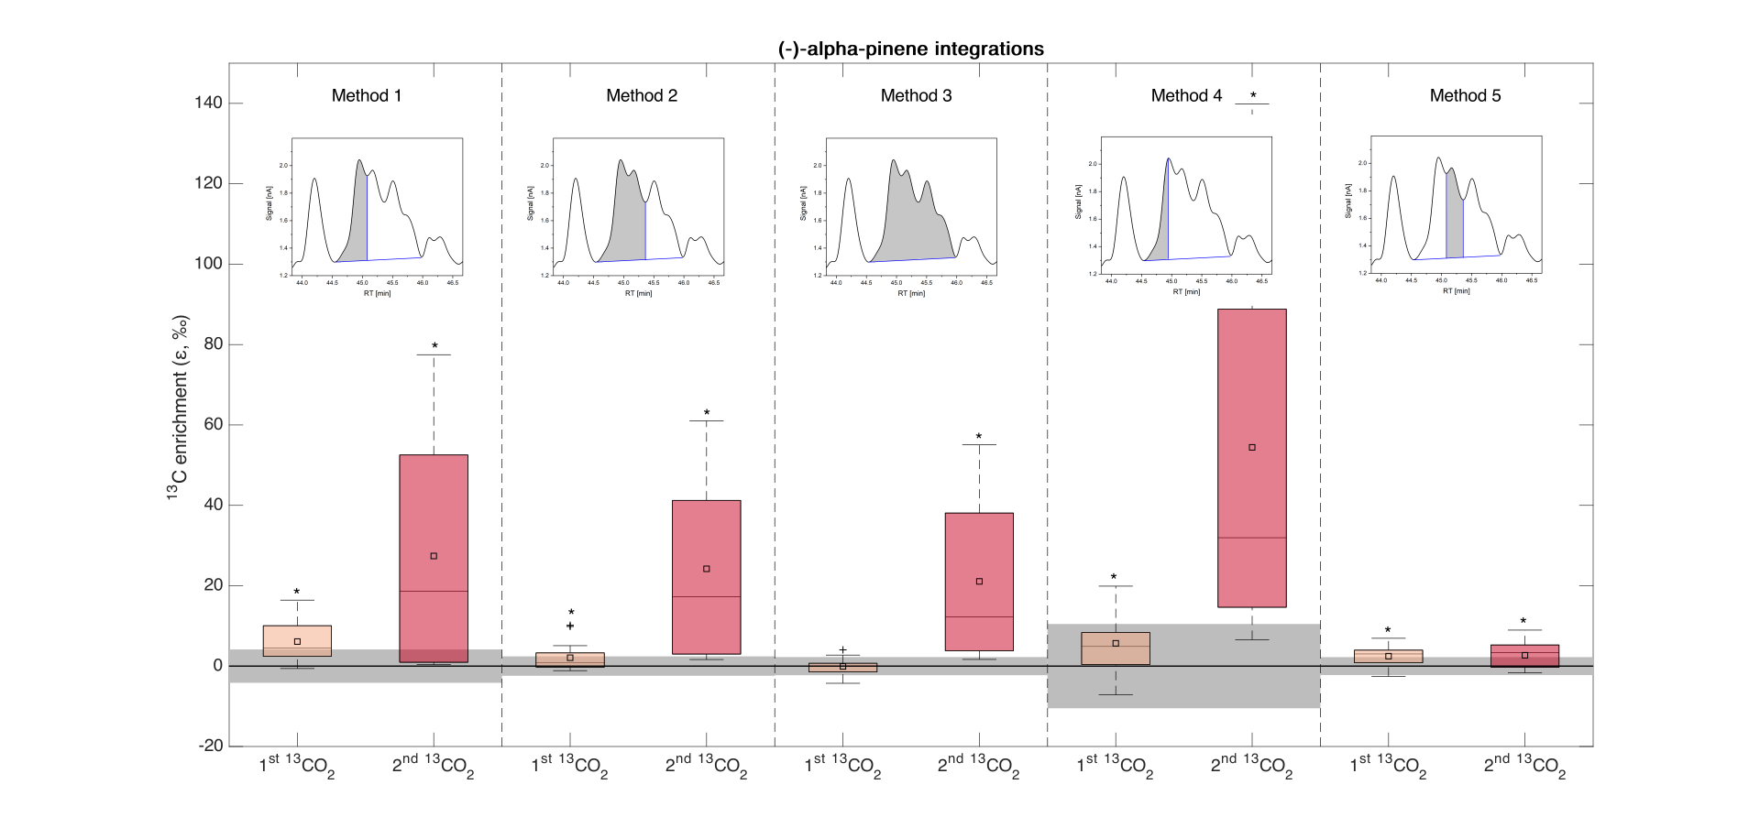
Extended Data Figure 6. Box plots representing the ¹³C enrichment of (-)-α-pinene. Each method represents a different way of integrating the (-)-α-pinene peak in the GC-IRMS chromatogram, the integration method is depicted in the sub-plot above the boxplots. The grey boxes represent the standard deviation of the ε¹³C values of the compounds in ambient air when there is no ¹³CO₂ pulse. The black line through the grey boxes represents the mean. The box plots present median, and 25th and 75th percentiles. The small squares represent the mean and the whiskers represent the maximum and minimum acquired data points that are not considered outliers. Significant results are indicated by the asterisk (*) above the box (i.e. results are significant if P ≤ 0.05). Statistical information is displayed in Ext. Data Table 2.
Extended Data Table 2. Statistical information from t-test that was performed on the acquired data from the 13C labelled atmospheric samples for the different methods of integrating (-)-alpha-pinene (Ext. Data Fig. 6). DoF is the degrees of freedom and n is the number of samples. PP refers to the samples taken before the 13CO2 labelling (pre-pulse) and 1st and 2nd phases refer to the first and second 13CO2 pulses, respectively.
 | Method 1 |  |  | Method 2 |  |  | Method 3 |  |  | Method 4 |  |  | Method 5
phase | PP | 1st | 2nd | PP | 1st | 2nd | PP | 1st | 2nd | PP | 1st | 2nd | PP | 1st | 2nd
n | 29 | 16 | 11 | 30 | 16 | 10 | 29 | 16 | 11 | 36 | 14 | 11 | 15 | 14 | 10
DoF | 28 | 15 | 10 | 29 | 15 | 9 | 28 | 15 | 10 | 35 | 13 | 10 | 14 | 13 | 9
t-values |  | 0.0003 | 0.0038 |  | 0.0221 | 0.0028 |  | 0.4502 | 0.0026 |  | 0.02 | 0.0016 |  | 0.0036 | 0.0222

Extended Data Figure 7. A section of the chromatogram obtained from the GC-IRMS showing the peaks for the identified compounds.

Extended Data Figure 8. A section of the chromatogram obtained from the GC-IRMS showing the β-myrcene peak. The integrated region is shaded in grey.

Extended Data Figure 9. A section of the chromatogram obtained from the GC-IRMS showing the trans-β-ocimene peaks. The integrated regions are shaded in grey.

