Childhood Trauma among Primary Students in Shenzhen City: Prevalence, Risk factors, and Relationship with Anxiety Symptoms

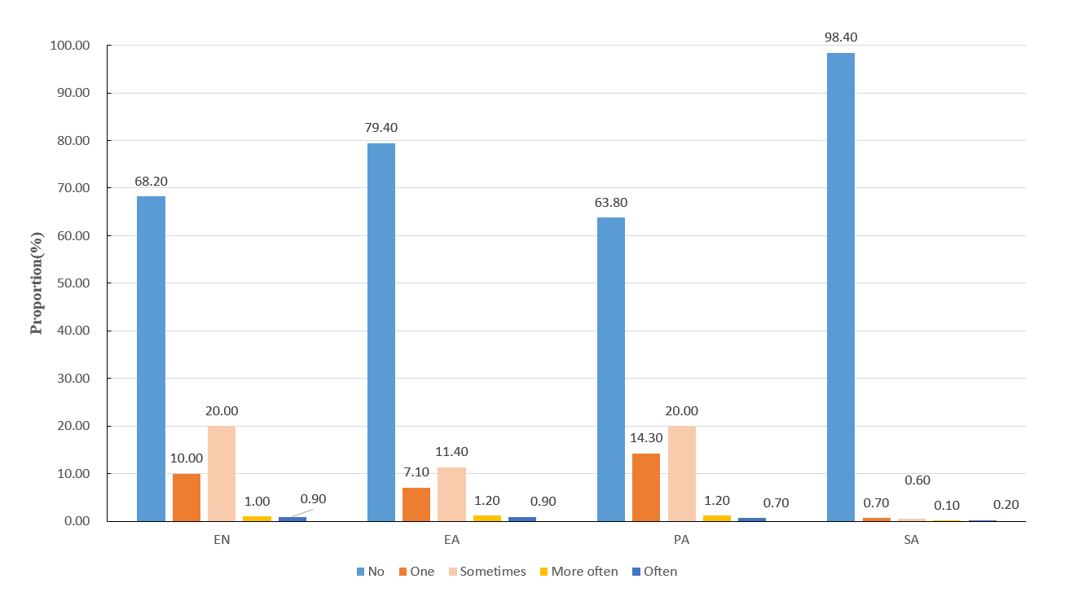

Fig. S1 Frequency distribution of different types of childhood trauma

Supplementary Table 1 Prevalence of childhood trauma.
Group |  | N | EN  n(%) | EA  n(%) | PA  n(%) | SA  n(%)
gender
 | male | 6972 | 218（31.4） | 1467（21.0） | 2757（39.5） | 133（1.9）
 | female | 5666 | 182（32.3） | 1121（19.8） | 1807（31.9） | 66（1.2）
age | 6-8 | 5328 | 1688(31.7) | 949(17.8) | 1861(34.9) | 46(0.9)
 | 9-11 | 5738 | 1815(31.6) | 1305(22.7) | 2175(37.9) | 117(2.0)
 | 12-14 | 934 | 319(34.2) | 214(22.9) | 340(36.4) | 29(3.1)
Single-child
 | Yes | 8767 | 125（32.4） | 740（19.1） | 1404（36.3） | 62(1.6)
 | No | 3867 | 276（31.6） | 1851（21.1） | 3161（36.1） | 141(1.6)
Grew up in Shenzhen
 | Yes | 7887 | 2522(32.0) | 1575(20.0) | 2798(35.5) | 118(1.5)
 | No | 4692 | 1484(31.6) | 1013(21.6) | 1747(37.2) | 83(1.8)
Family income
 | Good | 1574 | 454(28.8) | 380(24.10) | 539(34.20) | 50(3.20)
 | Average | 10273 | 3273(31.9) | 2005(19.50) | 3664(35.70) | 137(1.30)
 | Bad | 792 | 293(37.0) | 208(26.30) | 363(45.80) | 16(2.00)
Learning stress | No | 769 | 131(17.0) | 103(13.40) | 179(23.30) | 19(2.50)
 | Average | 8149 | 2372(29.1) | 1443(17.70) | 2722(33.40) | 108(1.30)
 | great | 3735 | 1524(40.8) | 1049(28.10) | 1673(44.80) | 76(2.00)
Academic performance | Good | 4282 | 1212(28.3) | 800(18.70) | 1439(33.60) | 59(1.40)
 | Average | 6175 | 1962(31.8) | 1203(19.50) | 2184(35.40) | 85(1.40)
 | Bad | 2119 | 820(38.7) | 571(26.90) | 923(43.60) | 54(2.50)
Witnessing domestic violence | No | 9669 | 2598(26.9) | 1526(15.80) | 2986(30.90) | 95(1.00)
 | Yes | 2977 | 1421(47.7) | 1063(35.70) | 1581(53.10) | 109(3.70)
Father worked away from home | No | 9082 | 2602(28.7) | 1605(17.70) | 2974(32.70) | 112(1.20)
 | ≤1 year | 2740 | 1070(39.1) | 741(27.00) | 1211(44.20) | 72(2.60)
 | ＞1years | 827 | 350(42.3) | 248(30.00) | 389(47.00) | 20(2.40)
Mother worked away from home | No | 10965 | 3271(29.8) | 2085(19.00) | 3766(34.30) | 153(1.40)
 | ≤1 year | 1265 | 569(45.0) | 386(30.50) | 588(46.50) | 42(3.30)
 | ＞1years | 410 | 176(42.9) | 120(29.30) | 211(51.50) | 9(2.20)
Criticized by teachers | No | 2506 | 495(19.8) | 315(12.60) | 553(22.10) | 17(0.70)
 | Sometimes | 9977 | 3469(34.8) | 2238(22.40) | 3942(39.50) | 176(1.80)
 | Always | 146 | 56(38.4) | 36(24.70) | 66(45.20) | 9(6.20)
relationship with classmates
 | good | 9978 | 2864(28.7) | 1839(18.40) | 3361(33.70) | 135(1.40)
 | general | 2437 | 1025(42.1) | 660(27.10) | 1066(43.70) | 54(2.20)
relationship with teacher | bad | 233 | 130(55.8) | 93(39.90) | 138(59.20) | 13(5.60)
 | good | 9400 | 2646(28.1) | 1679(17.90) | 3082(32.80) | 130(1.40)
 | general | 3082 | 1292(41.9) | 842(27.30) | 1385(44.90) | 58(1.90)
 | bad | 175 | 88(50.3) | 71(40.60) | 101(57.70) | 16(9.10)
relationship with families
 | good | 11714 | 3475(29.7) | 2202(18.80) | 4044(34.50) | 167(1.40)
 | general | 804 | 472(58.7) | 331(41.20) | 447(55.60) | 25(3.10)
 | bad | 133 | 77(57.9) | 61(45.90) | 79(59.40) | 12(9.00)

Note: N: total number of children; n: number of children reporting each type of childhood trauma; EA: emotional abuse; PA: physical abuse SA: sexual abuse; EN: emotional neglect
Supplementary Table 2 Prevalence and demographic characteristics of children who experienced different numbers of childhood trauma types.
Group |  | N | Any-trauma  n(%) | Adjusted odds ratio（95%CI） | 1 type trauma n(%) | Adjusted odds ratio（95%CI） | 2 type traumas  n(%) | Adjusted odds ratio（95%CI） | multiple types (≥3)  n(%) | Adjusted odds ratio（95%CI）
 |  | 12704 | 6720(52.9) |  |  |  |  |  | 1346（10.6）
gender
 | male | 6972 | 3814（54.7） | Reference | 1915(27.5) | Reference | 1107(15.90) | Reference | 792（11.4） | Reference
 | female | 5666 | 2862（50.5） | 0.92(0.85-0.99) | 1466(25.90) | 0.91(0.83-1.00) | 858(15.10) | 0.96(0.86-1.08) | 538（9.5） | 0.88(0.76-1.01)
age | 6-8 | 5328 | 2719（51.0） | Reference | 1416(26.60) | Reference | 796(14.90) | Reference | 507（9.5） | Reference
 | 9-11 | 5738 | 3124（54.4） | 1.04(0.96-1.13) | 1534(26.70) | 1.02(0.93-1.13) | 933(16.30) | 1.09(0.97-1.23) | 657（11.4） | 1.04(0.90-1.21)
 | 12-14 | 934 | 527（56.4） | 1.08(0.93-1.26) | 271(29.00) | 1.16(0.97-1.39) | 145(15.50) | 0.97(0.77-1.22) | 111（11.9） | 1.02(0.88-1.34)
Single-child
 | Yes | 8767 | 2038（52.7） | Reference | 1029(26.60) | Reference | 613(15.90) | Reference | 396（10.2） | Reference
 | No | 3867 | 4641（52.9） | 0.95(0.87-1.03) | 2350(26.80) | 0.95(0.86 -1.05) | 1352(15.40) | 1.00 (0.88-1.13) | 939（10.7） | 0.83(0.71-0.98)
Grew up in Shenzhen
 | Yes | 7887 | 4148（52.6） | Reference | 2120(26.90) | Reference | 1232(15.60) | Reference | 796（10.1） | Reference
 | No | 4692 | 2504（53.4） | 1.08(0.99-1.17) | 1241(26.40) | 1.03(0.93-1.13) | 728(15.50) | 1.05(0.93-1.18) | 535（11.4） | 1.32(1.14-1.53)
Family income
 | Good | 1574 | 825(52.40) | Reference | 409(26.00) | Reference | 249(15.80) | Reference | 167(10.60) | Reference
 | Average | 10273 | 5379(52.40) | 0.99(0.88-1.11) | 2770(27.00) | 1.02(0.89-1.18) | 1561(15.20) | 0.96(0.81-1.14) | 1048(10.20) | 0.95(0.78-1.21)
 | Bad | 792 | 477(60.20) | 1.10(0.90-1.34) | 203(25.60) | 1.06(0.84-1.34) | 153(19.30) | 1.11(0.84-1.46) | 121(15.30) | 1.12(0.80-1.58)
Learning stress | No | 769 | 275(35.80) | Reference | 165(21.50) | Reference | 65(8.50) | Reference | 45(5.90) | Reference
 | Average | 8149 | 4047(49.70) | 1.52(1.28-1.81) | 2192(26.90) | 1.39(1.14-1.69) | 1148(14.10) | 1.86(1.38-2.50) | 707(8.70) | 1.54(1.07-2.22)
 | great | 3735 | 2371(63.50) | 2.26(1.88-2.71) | 1031(27.60) | 1.76(1.43-2.18) | 756(20.20) | 2.95(2.17-4.00) | 584(15.60) | 3.03(2.08 -4.41)
Academic performance | Good | 4282 | 2089(48.80) | Reference | 1076(25.10) | Reference | 622(14.50) | Reference | 391(9.100 | Reference
 | Average | 6175 | 3244(52.50) | 0.91(0.83-1.00) | 1705(27.60) | 1.00(0.89-1.10) | 915(14.80) | 0.83(0.72-0.95) | 624(10.10） | 0.80(0.67-0.94)
 | Bad | 2119 | 1306(61.60) | 0.94(0.83-1.07) | 577(27.20) | 0.95(0.81-1.10) | 415(19.60) | 0.94(0.79-1.13) | 314(14.80) | 0.81(0.64-1.01)
Witnessing domestic violence | No | 9669 | 4499(46.50) | Reference | 2521(26.10) | Reference | 1272(13.20) | Reference | 706(7.30) | Reference
 | Yes | 2977 | 2181(73.30) | 2.66(2.41-2.94) | 861(28.90) | 2.05(1.82-2.30) | 691(23.20) | 2.93(2.57-3.34) | 629(21.10) | 4.39(3.80-5.10)
Father worked away from home | No | 9082 | 4439(48.90) | Reference | 2382(26.20) | Reference | 1295(14.30) | Reference | 762(8.40) | Reference
 | ≤1 year | 2740 | 1705(62.20) | 1.49(1.34-1.65) | 770(28.10) | 1.34(1.18-1.51) | 504(18.40) | 1.46(1.25-1.69) | 431(15.70) | 2.08(1.74-2.48)
 | ＞1years | 827 | 543(65.70) | 1.76(1.45-2.12) | 231(27.90) | 1.46(1.17-1.83) | 168(20.30) | 1.84(1.42-2.39) | 144(17.40) | 2.74(2.03-3.70)
Mother worked away from home | No | 10965 | 5560(50.70) | Reference | 2912(26.60) | Reference | 1623(14.80) | Reference | 1025(9.30) | Reference
 | ≤1 year | 1265 | 839(66.30) | 1.36(1.18-1.58) | 345(27.30) | 1.21(1.02-1.44) | 263(20.80) | 1.43(1.18-1.75) | 231(18.30) | 1.62(1.29-2.04)
 | ＞1years | 410 | 278(67.80) | 1.27(0.97-1.67) | 119(29.00) | 1.21(0.88-1.66) | 83(20.20) | 1.31(0.91-1.89) | 76(18.50) | 1.62(1.08-2.43)
Criticized by teachers | No | 2506 | 884(35.30) | Reference | 520(20.80) | Reference | 240(9.60) | Reference | 124(4.90) | Reference
 | Sometimes | 9977 | 5708(57.20) | 2.06(1.86-2.28) | 2831(28.40) | 1.85(1.64-2.09) | 1693(17.00) | 2.17(1.85-2.56) | 1184(11.900 | 2.65 (2.12-3.32)
 | Always | 146 | 85(58.20) | 1.78(1.21-2.60) | 32(21.90) | 1.42(0.88-2.30) | 26(17.80) | 1.91(1.10-3.32) | 27(18.50) | 2.91(1.57-5.40)
relationship with classmates
 | good | 9978 | 4966(49.80) | Reference | 2650(26.60) | Reference | 1435(14.40) | Reference | 881(8.80) | Reference
 | general | 2437 | 1535(63.00) | 1.21(1.08 -1.36) | 675(27.70) | 1.14(0.99-1.31) | 472(19.40) | 1.32(1.12-1.55) | 388(15.90) | 1.31(1.09-1.59)
relationship with teacher | bad | 233 | 179(76.80) | 2.12(1.47-3.06) | 57(24.50) | 1.83(1.17-2.85) | 56(24.00) | 2.40(1.53-3.77) | 66(28.30) | 2.23(1.36-3.67)
 | good | 9400 | 4607(49.00) | Reference | 2485(26.40) | Reference | 1348(14.30) | Reference | 774(8.20) | Reference
 | general | 3082 | 1954(63.40) | 1.26(1.13-1.40) | 865(28.10) | 1.15(1.01-1.30) | 579(18.80) | 1.22 (1.05-1.42) | 510(16.50) | 1.57(1.31-1.88)
 | bad | 175 | 126(72.00) | 1.10(0.74-1.63) | 36(20.60) | 0.88(0.53-1.45) | 38(21.70) | 0.99(0.59-1.67) | 52(29.70) | 1.83(1.07-3.14)
relationship with families
 | good | 11714 | 5975(51.00) | Reference | 3164(27.00) | Reference | 1751(14.90) | Reference | 1060(9.00) | Reference
 | general | 804 | 612(76.10) | 1.84(1.53-2.22) | 196(24.40) | 1.24(0.98-1.55) | 184(22.90) | 1.82(1.42-2.33) | 232(28.90) | 3.41(2.67-4.37)
 | bad | 133 | 99(74.40) | 1.38(0.87-2.18) | 22(16.50) | 0.64(0.33-1.22) | 33(24.80) | 1.65(0.93-2.92) | 44(33.10) | 2.54(1.43-4.51)
Note: N: total number of children; n: number of children reporting each type of childhood trauma

