Supporting Information

Enhanced Electrochemical Performance of Battery-Type Zn-Doped MoO₃ Nanoflakes for Hybrid Supercapacitor Applications
Purusottam Reddy Bª, Mohamed A. Ghanem^{b}, Boseong Sonª, Huijin Kimª, Meenakshamma Ambapuram ^{c}, Ramanadha Mangiri^{d*}, Si-Hyun Park^{a*}
ªDepartment of Electronic Engineering, Yeungnam University, 280 Daehak-ro, Gyeongsan-si, Gyeongsanbuk-do, South Korea.
^{b} Department of Chemistry, College of Science, King Saud University, P.O. Box 2455, Riyadh 11451, Saudi Arabia ^{c}Department of Humanities and Sciences, KSRM College of Engineering, Kadapa-518003, Andhra Pradesh, India.
^{d}Department of Physics and Semiconductior Science, Gachon University, 1342 Seongnamdaero, Sujeong-gu, Seongnam-si, Gyeonggi-do, 461-701, South Korea
*Email: sihyun_park@yu.ac.kr (Si-Hyun Park), ramanadh01@gmail.com (Ramanadha Mangiri)

Supporting Information
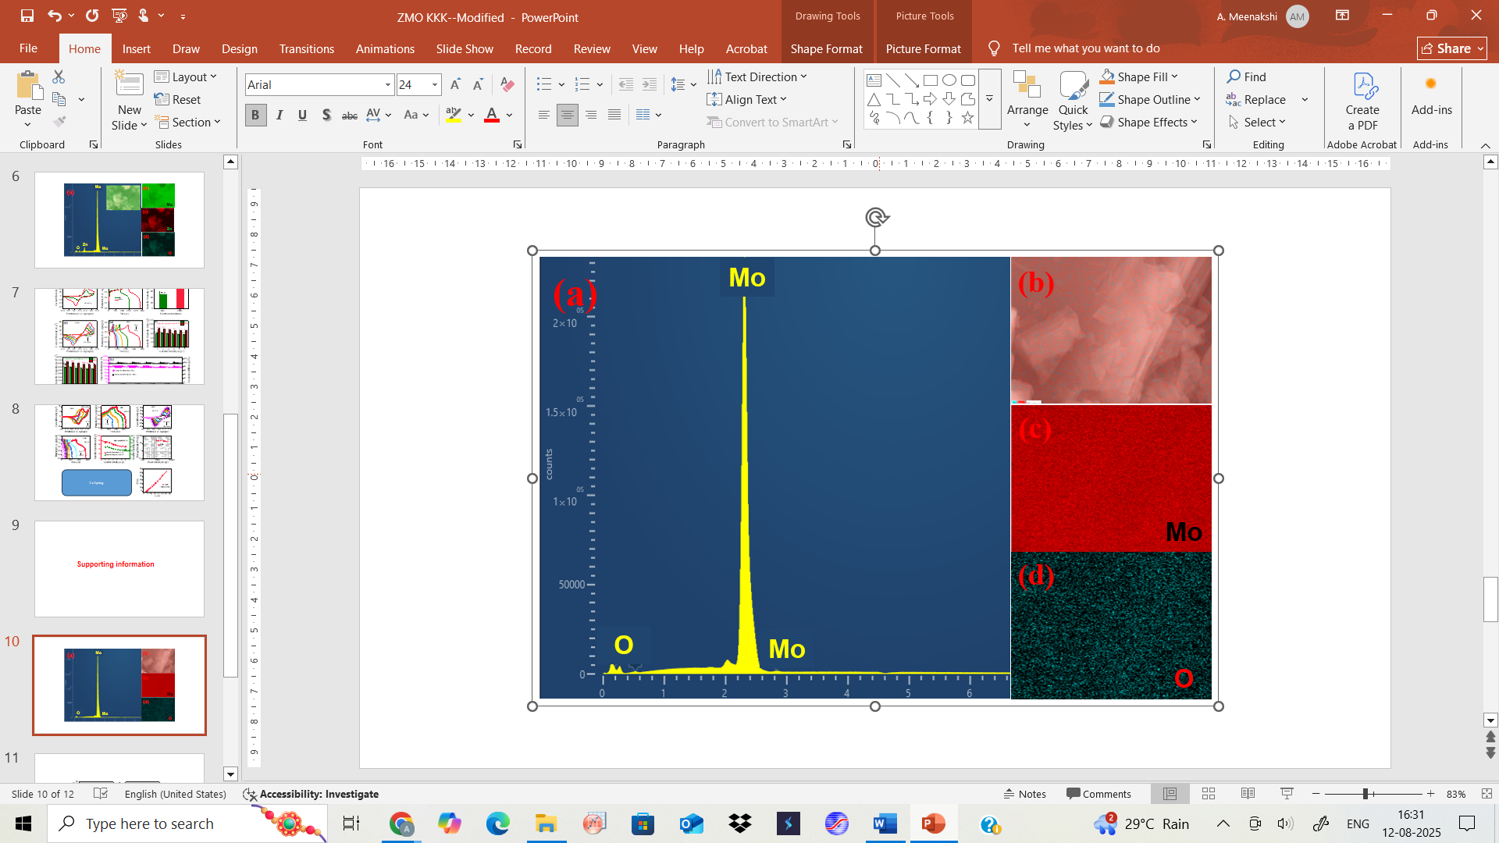
Figure S1:(a) Energy-dispersive X-ray spectroscopy (EDS) spectrum of MO, (b-d) elemental mapping of Mo, O for MO material.
.
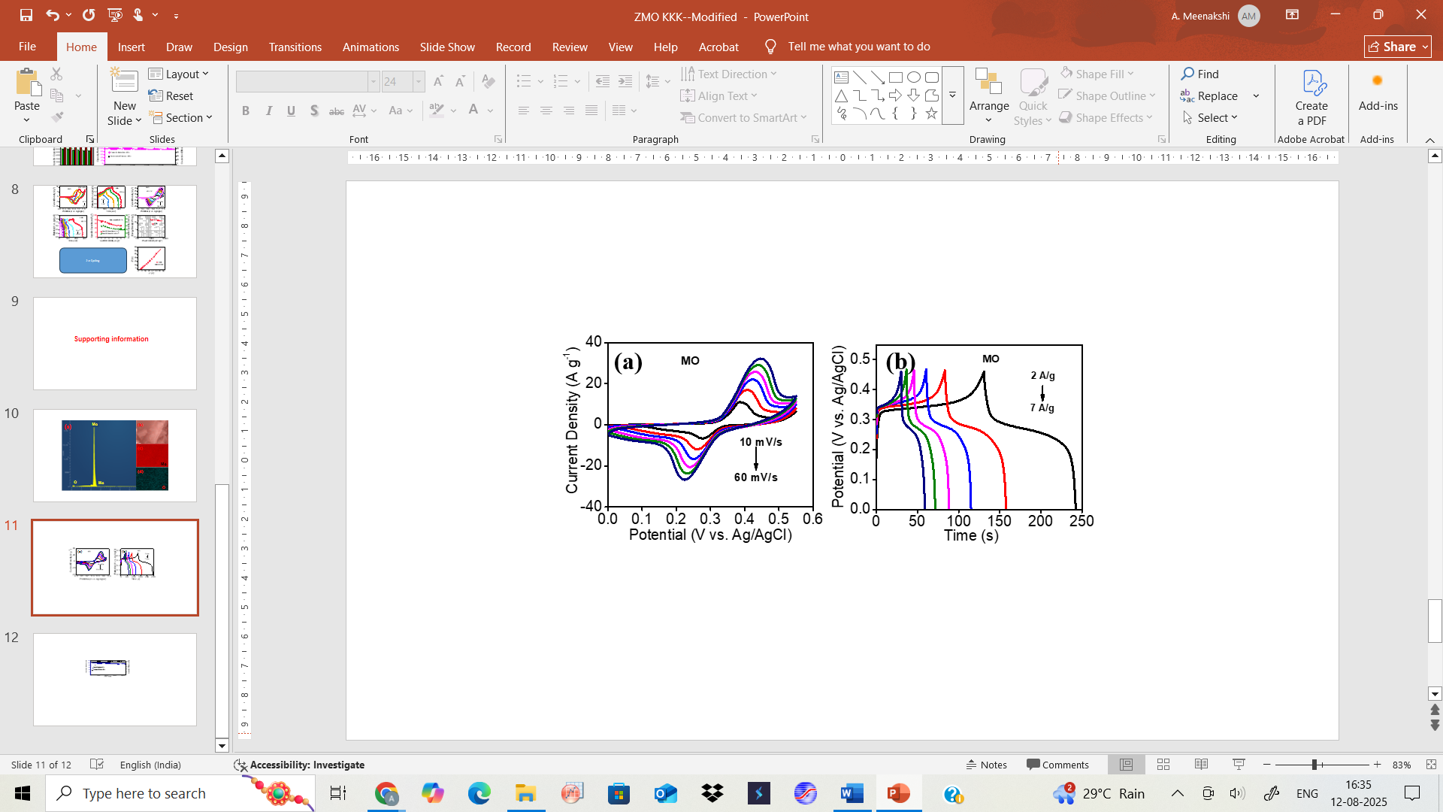
Figure S2: CV curves of the MO electrode at 10 to 60 mV/s (e) GCD profiles of the MO electrode at different current densities.

.

Table S1. Comparative E_{d}, P_{d}, and cycling stability of the fabricated Zn-MO//AC HSC with the reported works.

.
Sample | Electrolyte | E_{d} (Wh kg⁻¹) | P_{d}  (W kg⁻¹) | stability | Ref.
CoMoFN-90//CoMoFN-90 | 3 M KOH | 6.44 | 700 | 6500 cycles @ 73% at 1 A g⁻¹ | [1]
MoO₃/PPy/rGO//MoO₃/PPy/rGO | 1 mol L⁻¹ Na₂SO₄ | 19.8 | 301 | 6000 cycles @ 86.2% at 2 A g⁻¹ | [2]
N-rGO/ZnCo₂O₄ | 1 M KOH | 21 | 1500 | 5000 cycles @ 89.6% | [3]
ZnCo₂O₄@ZnWO₄//AC | 3 M KOH | 24 | 400 | 5000 cycles @ 98.5% at 100 mA cm⁻² | [4]
ZnCo₂O₄//AC ASC | 2 M KOH | 21.2 | 800 | 10000 cycles @ 100% at 5 A g⁻¹ | [5]
PANI-ZnCo₂O₄//AC HSC | 2 M KOH | 13.25 | 375 | 3000 cycles @ 90% | [6]
ZnCo₂O₄-UTCS//AC ASC | 2 M KOH | 20.31 | 855 | 5000 cycles @ 87% at 5 A g⁻¹ | [7]
Zn-MO//AC HSC | 1 M KOH | 25.65 | 5120 | 30000 cycles @ 81% at 30 mA cm⁻² | This work

References
[1] Hsiao Y-C, Yu H-Y, Lee P-Y, Yougbaré S, Lin L-Y, Wu Y-F (2022) Facile synthesis of ammonium-decorated cobalt molybdenum fluoride as electroactive material of supercapacitor. Journal of Energy Storage 56:106055.
[2] Deng H, Huang J, Hu Z, Chen X, Huang D, Jin T (2021) Fabrication of a Three-Dimensionally Networked MoO3/PPy/rGO Composite for a High-Performance Symmetric Supercapacitor. ACS Omega 6:9426-9432.
[3] Vignesh G, Ranjithkumar R, Devendran P, Nallamuthu N, Sudhahar S, Krishna Kumar M (2023) Nitrogen doped reduced graphene oxide/ZnCo2O4 nanocomposite electrode for hybrid supercapacitor application. Materials Science and Engineering: B 290:116328.
[4] Xie L, Liu Y, Bai H, Li C, Mao B, Sun L, Shi W (2018) Core-shell structured ZnCo2O4@ZnWO4 nanowire arrays on nickel foam for advanced asymmetric supercapacitors. Journal of Colloid and Interface Science 531:64-73.
[5] Eum J-H, Mandal D, Kim H (2021) A novel synthesis of 2D porous ZnCo2O4 nanoflakes using deep eutectic solvent for high-performance asymmetric supercapacitors. Journal of Electroanalytical Chemistry 892:115299.
[6] Omar FS, Numan A, Duraisamy N, Bashir S, Ramesh K, Ramesh S (2017) A promising binary nanocomposite of zinc cobaltite intercalated with polyaniline for supercapacitor and hydrazine sensor. Journal of Alloys and Compounds 716:96-105.
[7] zhou Y, Chen L, Jiao Y, Li Z, Gao Y (2019) Controllable fabrication of ZnCo2O4 ultra-thin curved sheets on Ni foam for high-performance asymmetric supercapacitors. Electrochimica Acta 299:388-394.

