Efficacy of Multifocal Spectacles for Myopia Control in Premyopic Children:
A Multicenter Real-World Study

Supplement 1. Changes in SE and AL Across MF Subtypes (DSDO/DIMS/HAL)
Factor | DSDO (95% CI) | DIMS (95% CI) | HAL (95% CI) | P all
12-mo follow-up subdataset
Number | 102 | 100 | 83 | -
Sex(female) | 52(51.0%) | 51(51.0%) | 43(51.8%) | 0.992
Age(y) | 8.68±1.54(8.37-8.98) | 8.97±1.50(8.67-9.27) | 9.04±1.88(8.62-9.45) | 0.254
Baseline SE（D） | -0.03±0.32(-0.10-0.03) | -0.16±0.25(-0.21- -0.11) | -0.20±0.24(-0.25- -0.14) | 0.001
Baseline AL（mm） | 23.61±0.71(23.47-23.75) | 23.59±0.67(23.46-23.73) | 23.58±0.64(23.44-23.72) | 0.967
△SE（D） | -0.29±0.36(-0.36- -0.22) | -0.30±0.32(-0.37- -0.24) | -0.21±0.32(-0.28--0.14) | 0.075
△AL（mm） | 0.14±0.17(0.11-0.18) | 0.16±0.16(0.13-0.20) | 0.12±0.16(0.09-0.16) | 0.185

95% CI = 95% confidence interval; MF = multifocal spectacles; DIMS = Defocus Incorporated Multiple Segments ; DSDO = Diverse Segmented Defocus Optics; HAL = Highly Aspherical Lenslets. SE = spherical equivalent; AL = axial length; D = diopters.

Effect of Low-Concentration Atropine Eyedrops vs Placebo on Myopia Incidence in Children The LAMP2 Randomized Clinical Trial
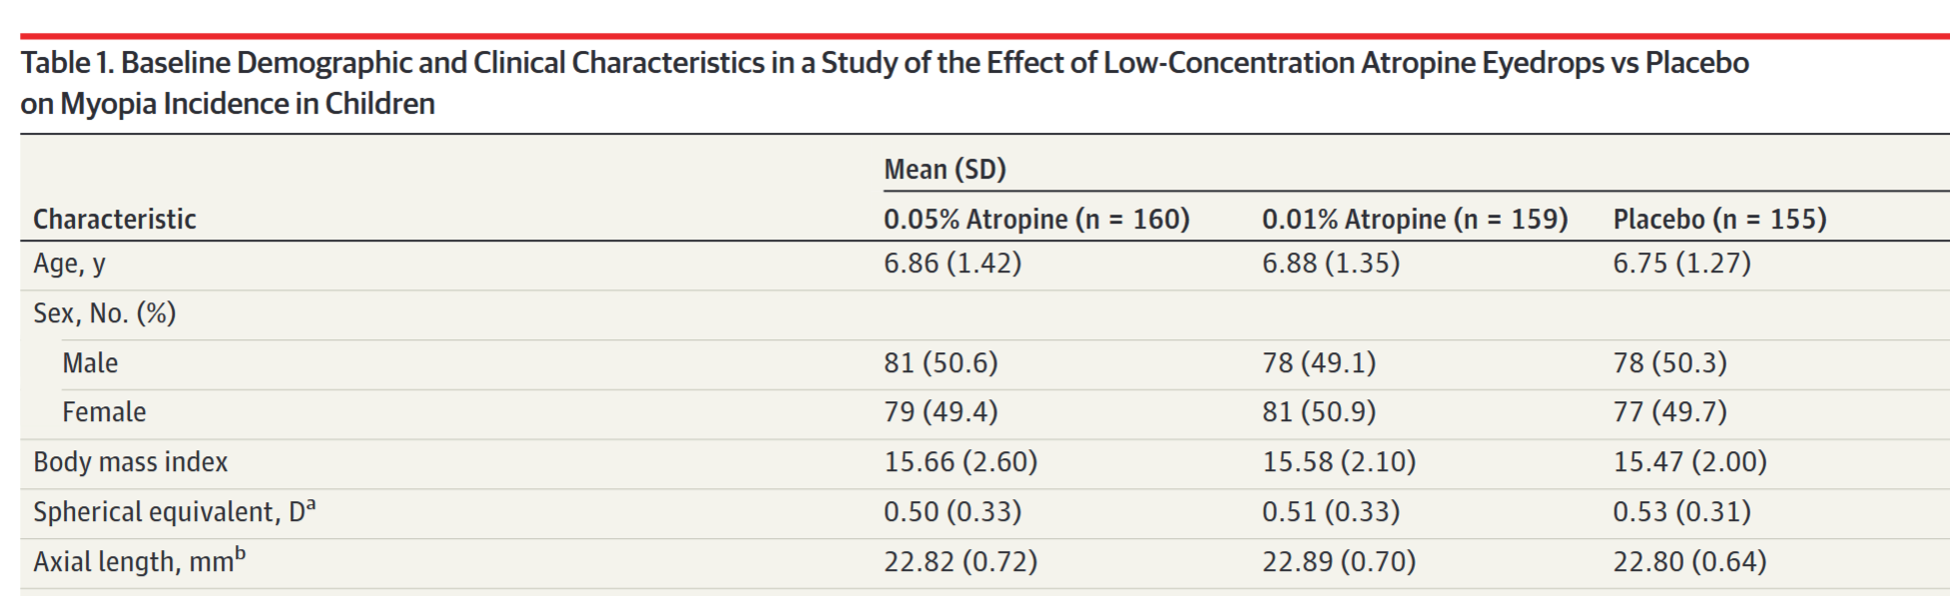
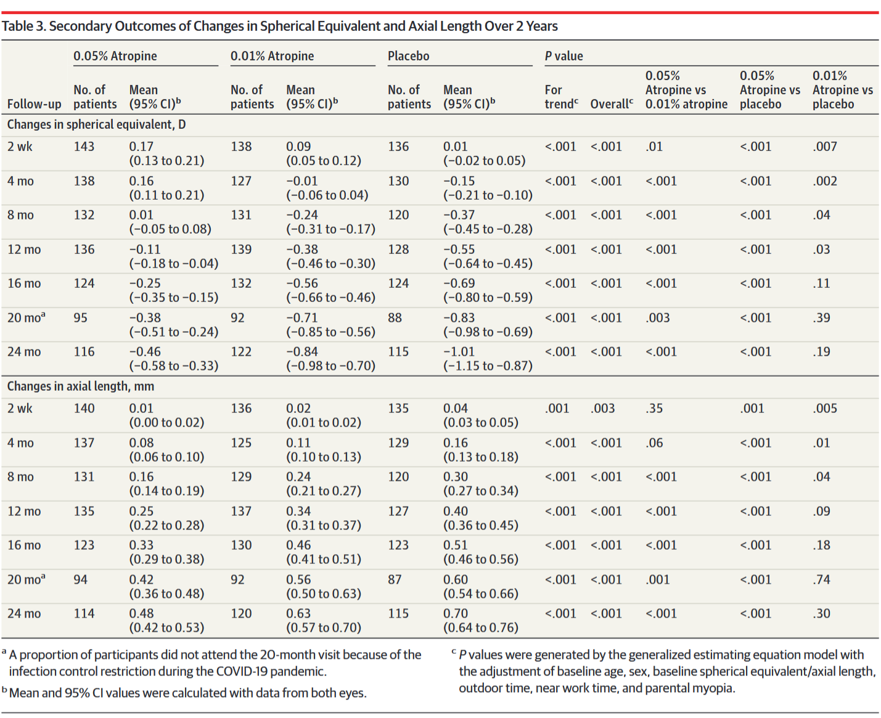

Supplement 1. The Treatment Efficacy of MF spectacles after matching for age with The LAMP2 randomized clinical trial
Factor | MF (95%CI) | SV (95%CI) | P
12-mo follow-up subdataset
Number | 152 | 159
Sex (female) | 72(47.4%) | 72(45.3%) | 0.712
Age (y) | 6.82±0.94 (6.67-6.97) | 6.82±0.99 (6.66-6.97) | 0.867
Baseline SE（D） | 0.04±0.36 (-0.01-0.10) | 0.07±0.39 (0.01-0.13) | 0.554
Baseline AL（mm） | 23.22±0.65 (23.11-23.32) | 23.18±0.64 (23.08-23.28) | 0.539
△SE（D） | -0.32±0.40 (-0.38--0.26) | -0.67±0.56 (-0.76--0.59) | ＜0.001
△AL（mm） | 0.22±0.18 (0.19-0.25) | 0.41±0.23 (0.37-0.45) | ＜0.001

95% CI = 95% confidence interval; MF = multifocal spectacles; SV= single vision spectacle lenses;SE = spherical equivalent; AL = axial length; D = diopters

Supplement 1.Treatment Efficacy of MF in Shenyang, Guangdong, and Chongqing Regions
 | MF |  |  |  | SV
Factor | Shenyang¹ (95% CI） | Guangzhou² (95% CI) | Chongqing³ (95% CI) | P all | Shenyang¹ (95% CI） | Guangzhou² (95% CI) | Chongqing³ (95% CI) | P all
12-mo follow-up subdataset
Number | 97 | 145 | 140 | - | 84 | 82 | 125 | -
Sex  (female) | 50(51.5%) | 67(46.2%) | 66(47.1%) | 0.699 | 37(44%) | 40(48.8%) | 70(56%) | 0.222
Age(y) | 8.90±1.72  (8.55-9.24) | 8.84±1.78  (8.55-9.13) | 8.96±1.82  (8.65-9.26) | 0.706 | 7.93±1.97  (7.50-8.36) | 8.04±2.67  (7.45-8.62) | 7.97±2.04  (7.61-8.33) | 0.996
Baseline  SE（D） | -0.14±0.20  (-0.18--0.10) | -0.07±0.31  (-0.12--0.02) | -0.11±0.34  (-0.17--0.50) | 0.198 | 0.15±0.35  (0.07-0.23) | 0.21±0.35  (0.13-0.29) | 0.18±0.29  (0.13-0.23) | 0.198
Baseline  AL（mm） | 23.66±0.63  (23.53-23.79) | 23.58±0.59  (23.48-23.67) | 23.64±0.70  (23.52-23.75) | 0.601 | 23.11±0.80  (22.93-23.30) | 23.15±0.69  (23.00-23.30) | 23.13±0.71  (23.00-23.26) | 0.957
△SE（D） | -0.30±0.34  (-0.37--0.23) | -0.32±0.37  (-0.38--0.25) | -0.27±0.34  (-0.33--0.22) | 0.816 | -0.54±0.50  (-0.65--0.43) | -0.53±0.51  (-0.64--0.42) | -0.62±0.51  (-0.71--0.53) | 0.326
△AL（mm） | 0.18±0.16  (0.14-0.21) | 0.17±0.17  (0.14-0.20) | 0.14±0.15  (0.12-0.17) | 0.203 | 0.33±0.20  (0.29-0.38) | 0.34±0.20  (0.30-0.38) | 0.36±0.22  (0.32-0.40) | 0.597

1.Northeastern China,2. South China,3. Southwestern Inland China ;95% CI = 95% confidence interval; MF = multifocal spectacles; SV= single vision spectacle lenses;SE = spherical equivalent; AL = axial length; D = diopters

