Fig.S1. EDX spectrum of Zr doped V₂O₅ nanoparticles
Fig. S2. PL spectrum of V₂O₅ and Zr doped V₂O₅ nanoparticles
Fig. S3 DOS plot of Zr@V₂O₅.
Fig. S4 Ramachandran plot of protein 2W9S.
Fig.S5. Zr doped V₂O₅ nanoparticles binding with Dihydrofolate reductase (DHFR) (PDB ID 2W9S) chain A protein

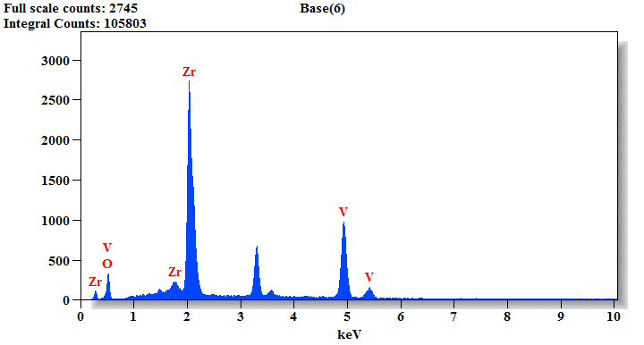
Fig.S1. EDX spectrum of Zr doped V₂O₅ nanoparticles
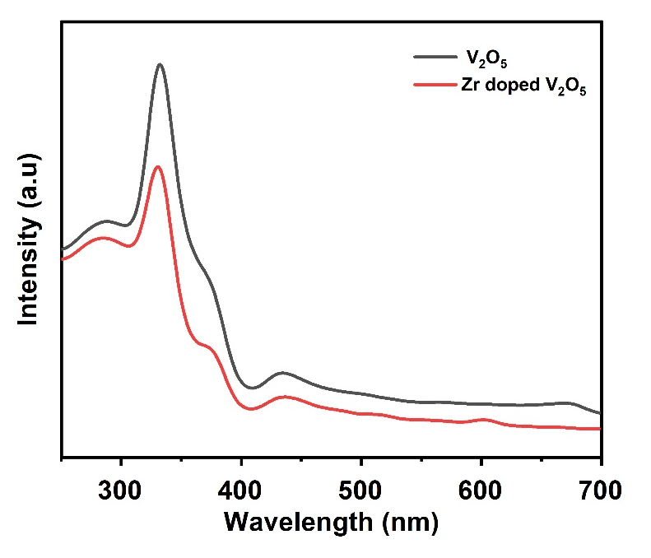
Fig. S2. PL spectrum of V₂O₅ and Zr doped V₂O₅ nanoparticles

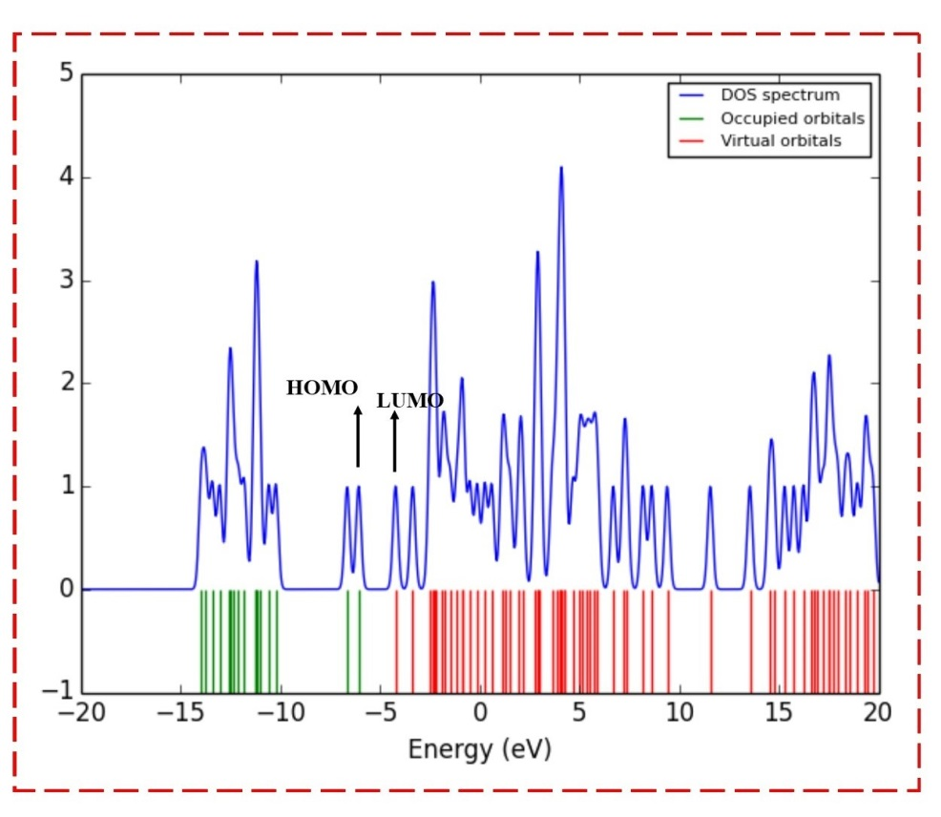
Fig. S3 DOS plot of Zr@V₂O₅.

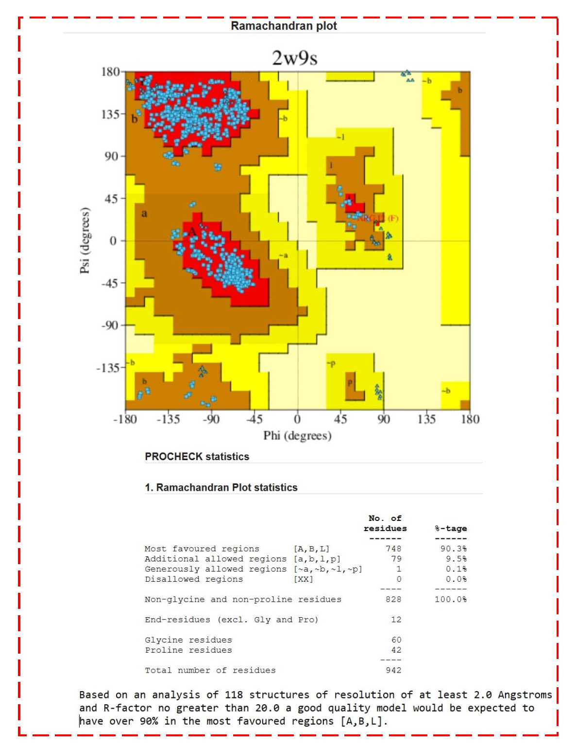
Fig. S4 Ramachandran plot of protein 2W9S

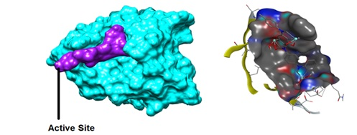
Fig. S5. Zr doped V₂O₅ nanoparticles binding with Dihydrofolate reductase (DHFR) (PDB ID 2W9S) chain A protein

