Green and Scalable Production of Nanocrystalline Cellulose Driven by a Biomass-Derived Deep Eutectic Solvent
Niuniu Dengª, Qiang Li^{*a} , Wenjie Wangª, Gengsheng Jiª
Corresponding Author: Qiang Li
a: school of Biotechnology, Jiangsu University of Science and Technology, Zhenjiang, Jiangsu Province, 212003, China

Supplementary information 1. Eutectic Solvent Synthesis Design:
Eutectic solvents are typically non-covalent molecular systems composed of hydrogen bond donors (HBD) and hydrogen bond acceptors (HBA), which lower the melting point through hydrogen bonding interactions, allowing the formation of a liquid at room temperature or lower temperatures ¹.
In the design of deep eutectic solvents (DESs), polyacids and polyols demonstrate significant potential due to their multiple functional groups, such as carboxyl (–COOH) and hydroxyl (–OH), which can serve as abundant hydrogen bond donors (HBDs) and hydrogen bond acceptors (HBAs). These functional groups substantially decrease the melting point of mixtures by forming extensive intermolecular hydrogen-bond networks. To identify the optimal polyacid–polyol combinations suitable for specific target solutes or applications, factors such as dissolution capability, viscosity, thermal stability, and environmental compatibility must be comprehensively evaluated. Common polyacids employed include citric acid, malic acid, tartaric acid, fumaric acid, succinic acid, and itaconic acid, while typical polyols comprise ethylene glycol, glycerol, 1,2-propanediol, sorbitol, xylitol, and diethylene glycol. Through comparative evaluation of various acid–alcohol combinations, citric acid (C₆H₈O₇) and ethylene glycol (C₂H₆O₂) were ultimately selected as an optimal system. Citric acid contains three carboxyl groups and one hydroxyl group, providing a total of four active hydrogen bond donor sites, which effectively disrupt cellulose hydrogen-bond networks ². Ethylene glycol, having two hydroxyl groups, acts simultaneously as an HBD and HBA ³; specifically, the oxygen atoms of its hydroxyl groups primarily accept hydrogen bonds from citric acid, creating a stable and efficient hydrogen-bond network. At a molar ratio of 1:2 (citric acid: ethylene glycol), the melting point of the resulting DES significantly decreases, producing a solvent characterized by low viscosity, high cellulose solubility, and environmental friendliness. This DES system demonstrates excellent application prospects in the preparation of nanocellulose, biomass refining, and material modification processes, providing valuable reference combinations for future deep eutectic solvent designs.
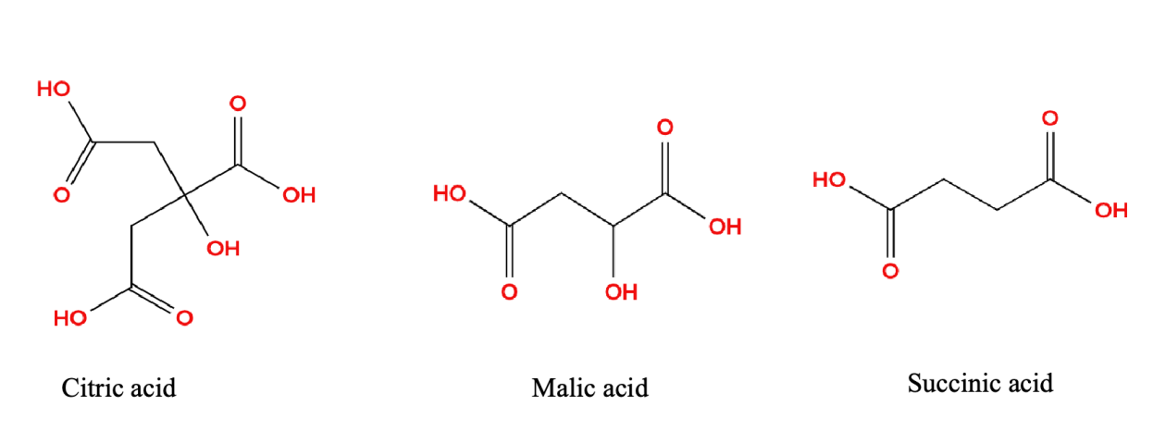
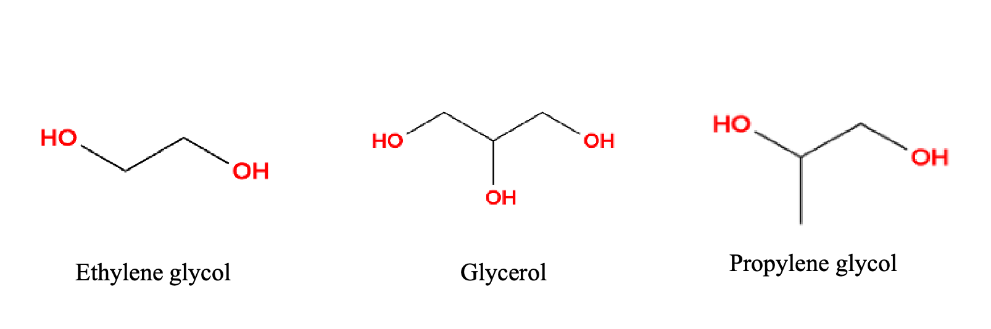
Supplementary Fig.1 Common polybasic acids and polyols
Consideration of Alternative Dicarboxylic Acids in the Initial Design
During the early stages of the design process, several alternative dicarboxylic acids, including malic acid and tartaric acid, were considered for their potential to form eutectic systems with ethylene glycol. These acids were evaluated based on their hydrogen bonding capabilities, solvation efficiency, and the physicochemical properties of the resulting mixtures. However, after careful consideration, citric acid was selected as the optimal choice due to its superior ability to dissolve cellulose and its well-established efficacy in cellulose-lignin separation. Despite this, further exploration of other dicarboxylic acids may yield valuable insights and could potentially offer additional optimization for specific applications.
Preparation steps of eutectic solvent：
The synthesis of the eutectic solvent involves a simple yet effective preparation process. First, citric acid and ethylene glycol are mixed in a 1:2 molar ratio to achieve the desired eutectic mixture. The required quantities of citric acid and ethylene glycol are weighed out to prepare a final solution concentration of 75% by weight. Under anhydrous conditions, citric acid is placed in a beaker and heated to a temperature range of 60-80°C. Ethylene glycol is then added slowly while stirring continuously with a magnetic stirrer to ensure even mixing. The stirring is maintained at the set temperature to facilitate the complete dissolution of citric acid, ensuring a homogenous and transparent liquid is formed. Once dissolved, the mixture is allowed to cool to room temperature, yielding the eutectic solvent.

Supplementary information 2.Ionic Liquid Synthesis Design:：
The synthesis of [DMIM][DMP] typically begins with the reaction of N-methylimidazole and a methylating agent (such as methyl halides or dimethyl sulfate) through an S-N2 reaction ⁴, to produce 1,3-dimethylimidazolium halide or the corresponding methyl sulfate salt. This is then subjected to an anion exchange reaction with dimethyl phosphate salt (in the form of an alkali metal or silver salt)⁵.After filtering off by-products and drying, the liquid [DMIM][DMP] is obtained. In the preparation of nanocellulose, this ionic liquid interacts with the cellulose hydroxyl groups through hydrogen bonding formed by its anion and disrupts the ordered structure of cellulose by spatially hindering its intermolecular and intramolecular hydrogen bonding network via the cation⁶. Subsequently, water or alcohols, as antisolvents, are added to the dissolution system, resulting in the regeneration of cellulose into a loose and amorphous structure, which can then undergo mechanical or enzymatic treatment to yield nanocellulose.
Preparation steps of ionic liquids：
To synthesize [DMIM][DMP], trimethyl phosphate and 1-methylimidazole are mixed in a 2:3 molar ratio in a three-neck flask ⁷. A reflux condenser is installed, a magnetic stir bar is added, and one neck is connected to a water pump for vacuum distillation. The reaction is stirred and heated at 150 °C for 10 hours in an oil bath⁸.After the reaction, the mixture is washed three times with ethyl acetate and then subjected to reduced pressure distillation at 60°C using a rotary evaporator. Finally, the product is placed in a vacuum drying oven and dried overnight.

Supplementary information 3. Nanocellulose powder diagram：
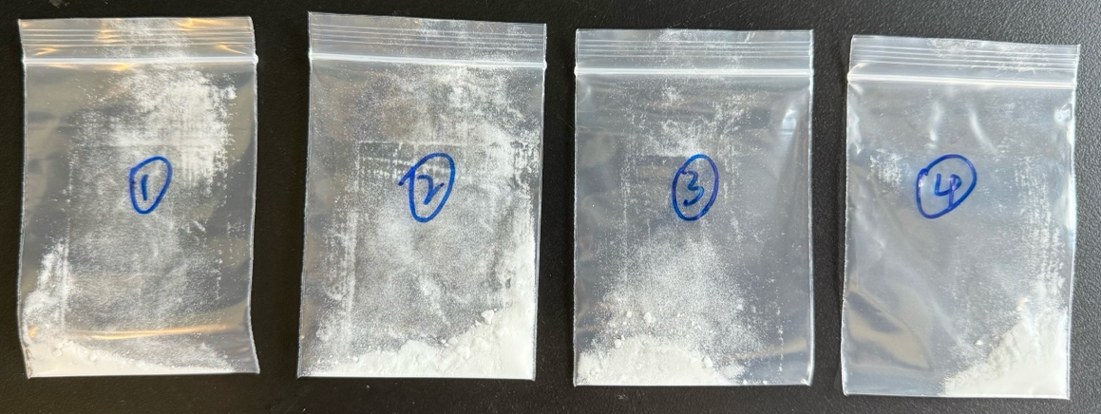
①: NCC prepared by TEMPO treatment, ②: NCC prepared by [DMIM] [DMP] treatment, ③: NCC produced by cellulase treatment, ④ NCC produced by DES treatment

Supplementary information 4. TEM Analysis of NCC Morphology：

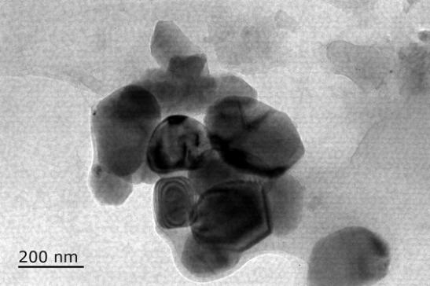 | 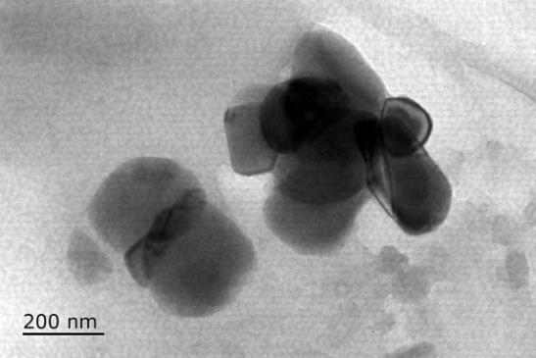

Supplementary information 5.Economic and environmental viability of NCC production
Supplementary Table S1: Price Estimation of Materials Required for the Production of 1 Ton of NCC by the DES Method. The prices have been sourced from procurement websites and are calculated based on 1 ton of raw materials.
Chemical | Purchase link | Price  (CNY/t) | Dosage  (t) | Cost(CNY/t)
Citric Acid | https://detail.1688.com/offer/826965001605.html?spm=a26352.13672862.offerlist.85.5e981e62BU6WLx&cosite=-&tracelog=p4p&_p_isad=1&clickid=ae6b09081e5c46ddbf8c07640bfa1e7b&sessionid=7c953682213f45bca048b9e5603ac223 | 3600 | 1.38 | 4968
Ethylene glyco | https://detail.1688.com/offer/520167525742.html?spm=a26352.13672862.offerlist.9.4bc51e62Pd8NBG | 432 | 1.96 | 864.7
Deionized water | https://detail.1688.com/offer/860240893553.html?spm=a26352.13672862.offerlist.125.54151e62T05upA | 1200 | 1.27 | 1524
Straw | Local market | 44 | 1.39 | 61.16
Electricity | https://zhidao.baidu.com/question/995350371455170419.html | 0.83  CNY/kWh | 1256kw | 1067.6
All-in cost | ¥8485.46/t（$1164.96）

Supplementary Table S2: Price Estimation of Materials Required for the Production of 1 Ton of NCC by the [DMIM][DMP] Method. The prices have been sourced from procurement websites and are calculated based on 1 ton of raw materials.
Chemical | Purchase link | Price  (CNY/t) | Dosage  (t) | Cost(CNY/t)
1-Methylimidazole | https://detail.1688.com/offer/669190088947.html?spm=a26352.13672862.offerlist.83.188d1e627jgdU7 | 50000 | 1.63 | 81500
Trimethyl thiophosphate | https://detail.1688.com/offer/683708465935.html?spm=a26352.13672862.offerlist.87.5fa21e627XCP4X | 40000 | 1.85 | 74000
Deionized water | https://detail.1688.com/offer/860240893553.html?spm=a26352.13672862.offerlist.125.54151e62T05upA | 1200 | 1.5 | 1800
Straw | Local market | 44 | 1.5 | 66
Electricity | https://zhidao.baidu.com/question/995350371455170419.html | 0.83  CNY/kWh | 1900kw | 1577
All-in cost | ¥158943/t（$21823.6）

Supplementary Table S3: Price Estimation of Materials Required for the Production of 1 Ton of NCC by the Cellulase Method. The prices have been sourced from procurement websites and are calculated based on 1 ton of raw materials.
Chemical | Purchase link | Price  (CNY/t) | Dosage  (t) | Cost(CNY/t)
Cellulase | https://detail.1688.com/offer/853314916078.html?spm=a26352.13672862.offerlist.14.5efb1e62XV3T3u&cosite=-&tracelog=p4p&_p_isad=1&clickid=be4199b7e4e44e6696cac0a8a0864538&sessionid=a2a5b109ca70842af6bf18562c40ed0d | 29500 | 0.95 | 28025
Deionized water | https://detail.1688.com/offer/860240893553.html?spm=a26352.13672862.offerlist.125.54151e62T05upA | 1200 | 2.9 | 3480
Straw | Local market | 44 | 1.9 | 83.6
Electricity | https://zhidao.baidu.com/question/995350371455170419.html | 0.83  CNY/kWh | 1411.8kw | 1171.8
All-in cost | ¥32760.4/t（$4498.1667）

Supplementary Table S4: Price Estimation of Materials Required for the Production of 1 Ton of NCC by the TEMPO Method. The prices have been sourced from procurement websites and are calculated based on 1 ton of raw materials.
Chemical | Purchase link | Price  (CNY/t) | Dosage  (t) | Cost(CNY/t)
TEMPO | https://detail.1688.com/offer/673573456944.html?spm=a26352.13672862.offerlist.86.42ed1e62W6NFFV | 24000 | 1.6 | 38400
NaBr | https://detail.1688.com/offer/675601713155.html?spm=a26352.13672862.offerlist.39.16c21e62FpGCrK | 18000 | 1.6 | 28800
NaClO | https://detail.1688.com/offer/745791130886.html?spm=a26352.13672862.offerlist.277.1b2f1e62E7ozML | 2600 | 0.75 | 1950
Deionized water | https://detail.1688.com/offer/860240893553.html?spm=a26352.13672862.offerlist.125.54151e62T05upA | 1200 | 2.9 | 3480
Straw | Local market | 44 | 1.8 | 79.2
Electricity | https://zhidao.baidu.com/question/995350371455170419.html | 0.83  CNY/kWh | 1600kw | 1328
All-in cost | ¥74037.2/t（$10165.67）

Supplementary Table S5: Impact of Energy Consumption in Different Processes on Carbon Emissions and Environmental Feasibility—An Estimation Based on Laboratory and Industrial Data

Method | Major energy sources | Energy consumption（MJ/t NCC） | Carbon footprint（kg CO₂-eq/t NCC）
DES (Glycol, citric acid)) | Low temperature dissolution treatment (80-120 ° C), part of the solvent can be recycled ⁹ | 5200 ¹⁰ | 360 ¹¹
[DMIM][DMP] | High temperature dissolution (>120 ° C), limited recovery efficiency ¹² | 9800 ¹³ | 820 ¹³
Cellulase | The enzymatic hydrolysis process is mild (50 ° C), and the production of enzyme has additional carbon emissions ¹⁴ | 4100 ¹⁵ | 290 ¹⁶
TEMPO | Strong oxidant consumption, high energy consumption in mixing and oxidation process ¹⁷ | 12300 | 1020 ¹⁰

Supplementary Table S6: Comparison of Solvent Requirements, Recovery Rates, and Handling Difficulties in Different NCC Production Methods
Method | Major solvent/reagent | Solvent recovery (%) | Handling difficulty
DES (Glycol, citric acid) | Glycol, citric acid | 80-90 ^{18,19} | Easy to recycle, recyclable ²⁰
[DMIM][DMP] | [DMIM][DMP] | 60-80 ²¹ | High temperature recovery is required, with large loss ²²
Cellulase | Cellulase，aqueous solution | No recycling required | Green environmental protection, solvent-free pollution
TEMPO | TEMPO, NaClO, NaBr | <50 ²³ | Large reagent consumption and complex waste liquid treatment ²⁴

Supplementary Table S7: Waste Liquid Treatment and Pollutant Emissions in Different Processes
Method | Major pollutants | Handling difficulty
DES (Glycol, citric acid) | Low amount of organic acids ²⁵ | Recyclable, low pollution
[DMIM][DMP] | Ionic liquid residue²⁶ | Difficult to recover
Cellulase | Degradable by-products ²⁷ | Green and pollution-free
TEMPO | Residual NaClO and NaBr ²⁸ | Highly toxic, requiring strict treatment

Supplementary Table S8: Comprehensive Environmental Feasibility Analysis: Evaluation of Different Methods Based on Energy Consumption, Carbon Footprint, Solvent Recovery Rate, and Waste Liquid Treatment
Method | Energy consumption | Carbon footprint | Solvent recovery | Waste liquid treatment
DES | 4 | 4 | 4 | 4
[DMIM][DMP] | 3 | 2 | 3 | 2
Cellulase | 4 | 4 | 5 | 5
TEMPO | 3 | 3 | 2 | 2

References
1 Hansen, B. B. et al. Deep eutectic solvents: A review of fundamentals and applications. Chem. Rev. 121, 1232-1285 (2021). https://doi.org:10.1021/acs.chemrev.0c00385
2 Gong, X., Zhu, L. & Zhang, R. Technical note: A theoretical study on the mechanism of citric acid-driven multi-component nucleation of sulfuric acid-base-water clusters. (2024). https://doi.org:10.5194/egusphere-2023-3113
3 Qiu, X., Deng, C., Cao, X., Gai, H. & Song, H. Green and designable deep eutectic solvents for extraction separation of oxygenated compounds in Fischer-Tropsch oil products: Hydrogen bond descriptors and structure–activity study. Sep. Purif. Technol. 330, 125540 (2024). https://doi.org:10.1016/j.seppur.2023.125540
4 Koutsoukos, S. et al. Synthesis of aprotic ionic liquids. Nat. Rev. Methods Primers 2 (2022). https://doi.org:10.1038/s43586-022-00129-3
5 Zhang, Q., De Oliveira Vigier, K., Royer, S. & Jérôme, F. Deep eutectic solvents: syntheses, properties and applications. Chem. Soc. Rev. 41, 7108 (2012). https://doi.org:10.1039/c2cs35178a
6 Li, Q. et al. Improving enzymatic hydrolysis of wheat straw using ionic liquid 1-ethyl-3-methyl imidazolium diethyl phosphate pretreatment. Bioresour. Technol. 100, 3570-3575 (2009). https://doi.org:10.1016/j.biortech.2009.02.040
7 Huddleston, J. G. et al. Characterization and comparison of hydrophilic and hydrophobic room temperature ionic liquids incorporating the imidazolium cation. Green Chem. 3, 156-164 (2001). https://doi.org:10.1039/b103275p
8 Nie, Y., Li, C., Sun, A., Meng, H. & Wang, Z. Extractive desulfurization of gasoline using imidazolium-based phosphoric ionic liquids. Energy Fuels 20, 2083-2087 (2006). https://doi.org:10.1021/ef060170i
9 Calosi, M. et al. Glycolysis of semi-interpenetrated polymer network foam based on poly(vinyl chloride) for recovery and reuse of the individual components. Waste Manag. 153, 229-239 (2022). https://doi.org:10.1016/j.wasman.2022.09.001
10 Geißlmeir, D., Jary, W. G. & Falk, H. The TEMPO/copper catalyzed oxidation of primary alcohols to aldehydes using oxygen as stoichiometric oxidant. Monatsh. Chem. 136, 1591-1599 (2005). https://doi.org:10.1007/s00706-005-0349-0
11 Zhang, R. et al. Modelling and optimization of ethane recovery process from natural gas via ZIF-8/water-glycol slurry with low energy consumption. Energy (Oxf.) 263, 125645 (2023). https://doi.org:10.1016/j.energy.2022.125645
12 Velmurugan, R. et al. Ionic liquid under alkaline aqueous conditions improves corncob delignification, polysaccharide recovery, enzymatic hydrolysis and ethanol fermentation. Biomass Bioenergy 178, 106980 (2023). https://doi.org:10.1016/j.biombioe.2023.106980
13 Greer, A. J. et al. Investigating the effect of NO on the capture of CO2 using superbase ionic liquids for flue gas applications. ACS Sustain. Chem. Eng. 7, 3567-3574 (2019). https://doi.org:10.1021/acssuschemeng.8b05870
14 Yang, H., Han, Y. & Peng, X. Efficient production of sophorose from glucose and its potentially industrial application in cellulase production. Bioresour. Technol. 412, 131402 (2024). https://doi.org:10.1016/j.biortech.2024.131402
15 Bhardwaj, N., Kumar, B., Agrawal, K. & Verma, P. Current perspective on production and applications of microbial cellulases: a review. Bioresour. Bioprocess. 8 (2021). https://doi.org:10.1186/s40643-021-00447-6
16 Matsu-ura, T. et al. Synthetic gene network with positive feedback loop amplifies cellulase gene expression in Neurospora crassa. ACS Synth. Biol. 7, 1395-1405 (2018). https://doi.org:10.1021/acssynbio.8b00011
17 Pham Le, T. & Opaprakasit, P. Halogen-free “green and mild” process to generate N-oxoammonium cations for use in oxidation of hydroxyls and its quantitative analysis technique and optimization. Chem. Eng. J. 429, 132554 (2022). https://doi.org:10.1016/j.cej.2021.132554
18 Davey, S. G. Origin of Life: Cycling citrate sans enzymes. Nat. Rev. Chem. 1 (2017). https://doi.org:10.1038/s41570-017-0038
19 Qu, Y. et al. Evaluation of recycling degumming and solvent recovery of ramie with high-boiling glycol solvent. Ind. Crops Prod. 159, 113056 (2021). https://doi.org:10.1016/j.indcrop.2020.113056
20 Yu, H., Abdalkarim, S. Y. H., Zhang, H., Wang, C. & Tam, K. C. Simple process to produce high-yield cellulose nanocrystals using recyclable citric/hydrochloric acids. ACS Sustain. Chem. Eng. 7, 4912-4923 (2019). https://doi.org:10.1021/acssuschemeng.8b05526
21 Yan, L. et al. Evaluation on the separation effect and extractant recovery efficiency of extractive distillation for separating ethyl acetate/methanol with ionic liquids as extractants. Process Saf. Environ. Prot. 167, 343-355 (2022). https://doi.org:10.1016/j.psep.2022.09.010
22 Khoo, Y. S., Tjong, T. C., Chew, J. W. & Hu, X. Techniques for recovery and recycling of ionic liquids: A review. Sci. Total Environ. 922, 171238 (2024). https://doi.org:10.1016/j.scitotenv.2024.171238
23 Chen, S. et al. Integrating direct reuse and extraction recovery of TEMPO for production of cellulose nanofibrils. Carbohydr. Polym. 294, 119803 (2022). https://doi.org:10.1016/j.carbpol.2022.119803
24 Zhang, H. et al. Abatement of organic contaminants by Mn(VII)/TEMPOs: Effects of TEMPOs structure, organic contaminant speciation, and active oxidizing species. Environ. Sci. Technol. 56, 10361-10371 (2022). https://doi.org:10.1021/acs.est.2c02098
25 Moura, L. et al. Deep eutectic solvents as green absorbents of volatile organic pollutants. Environ. Chem. Lett. 15, 747-753 (2017). https://doi.org:10.1007/s10311-017-0654-y
26 Wei, J., Gao, H., Li, Y. & Nie, Y. Research on the degradation behaviors of wood pulp cellulose in ionic liquids. J. Mol. Liq. 356, 119071 (2022). https://doi.org:10.1016/j.molliq.2022.119071
27 Hossain, M. A. et al. Effects of polyol-based deep eutectic solvents on the efficiency of rice straw enzymatic hydrolysis. Ind. Crops Prod. 167, 113480 (2021). https://doi.org:10.1016/j.indcrop.2021.113480
28 Tang, C. et al. Optimizing addition of NaClO in TEMPO-mediated oxidation of cellulose for less nanofiber degradation. Cellulose 31, 10785-10800 (2024). https://doi.org:10.1007/s10570-024-06262-4

