ADDITIONAL FILES
Additional File 1.
Figure 1. Evaluation of image quality - levels of gradability based on the proportion of the image which can be graded
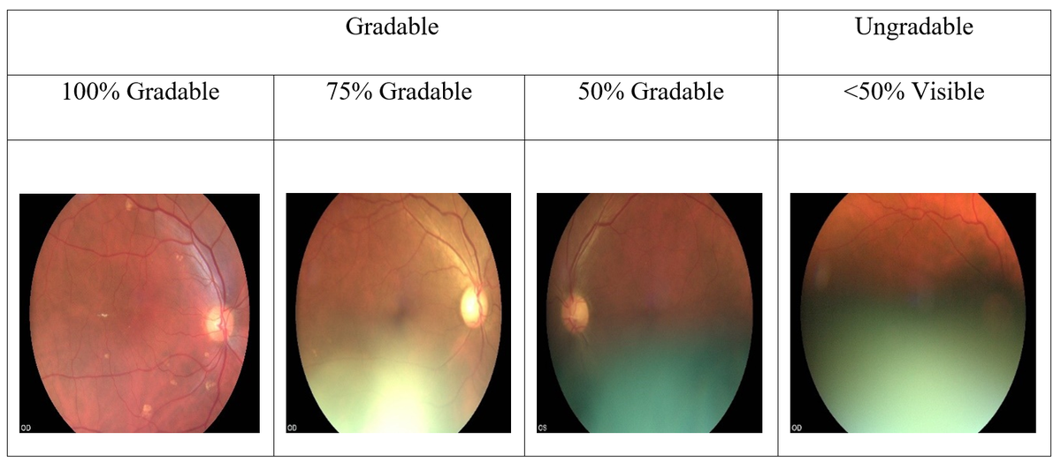
Additional File 1 - Figure 2. Two retinal images captured

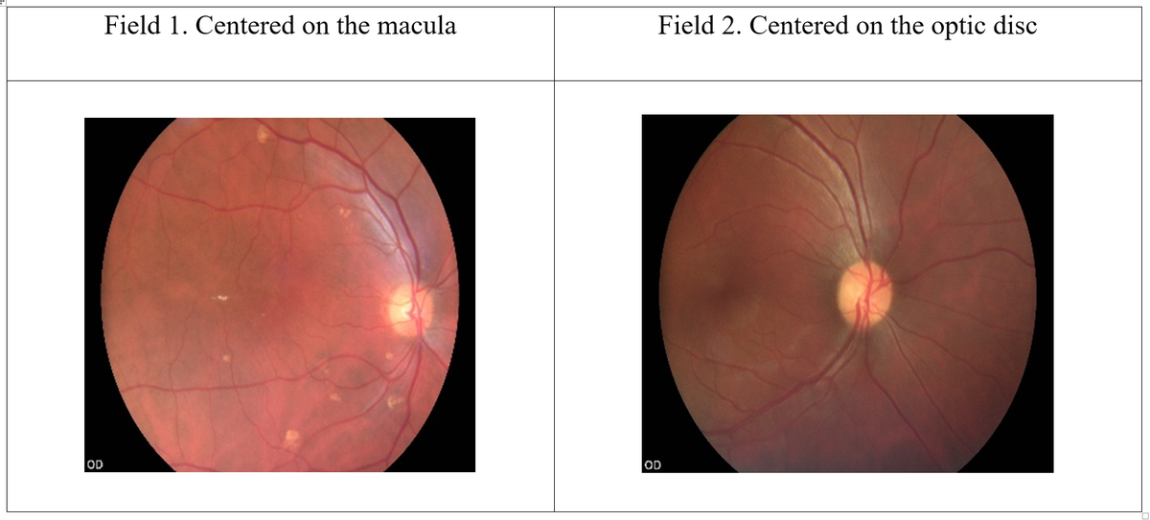

Additional File 1. DR Classification system
Table 1. Adapted diabetic retinopathy classification for the validation study
Signs | No DR (R0) | Mild BDR^{d} / NPDR^{e}  (R1) | Moderate BDR / NPDR (R2) | Severe NPDR  (R3) | Proliferative DR (PDR^{f}) (R4)
Microaneurysms | No | Few | Multiple | Multiple | Present
Hard Exudates ª | No | Few | Multiple | Multiple | Present
Cotton wool spots | No | Occasional | Multiple | Multiple | Present
Intra retinal haemorrhage ª | No | Few | >20 in 1-3 quadrants | >20 in 4 quadrants | Present
Venous beading | No | Occasional | Present in 1-2 quadrants | Present in >2 quadrants | Present
IRMA ^{b} | No | No | Present ~1 quadrant | Prominent >1 quadrant | Present
NVD ^{c} | No | No | No | No | Present
NVE ^{c} | No | No | No | No | Present
Vitreous / pre-retinal haemorrhage | No | No | No | No | Present - advanced PDR
Traction | No | No | No | No | Present - advanced PDR
Fibrosis | No | No | No | No | Present - advanced PDR
ª Not within the definition of maculopathy
^{b} Intra retinal microvascular abnormalities
^{c} Neo-vascularisations over the disc / elsewhere
^{d} Background DR, ^{e} NPDR – Non-proliferative DR, ^{f} PDR-Proliferative DR

Table 2. Macular signs classification

 | Maculopathy absent  (M0) | Maculopathy present  (M1)
Signs up to 2-disc diameters from the centre of fovea | No signs | Presence of hard exudate/s and / or blot haemorrhage/s  (Referable)

Additional File 2. Detailed flow chart of the number of participants and image sets used in the analysis
(Gr 1-Grader 1, Gr2-Grader 2, Nonmyd-Nonmydriatic, Myd-Mydriatic, DNA-did not attend, ^for any DR, DR+ any DR positive, DR- no DR, *I-Inconclusive) (According to the STARD guidelines)
Potentially eligible participants n=826
n=

Excluded n=126 (persons)
-No consent (n=69)
-Did not attend (n=57)
Reference standard
Gr 1 Nonmyd n=790
Gr 2 Nonmyd n=865

Gr1 Myd n=998
Gr 2 Myd n=1026
Final diagnosis
Gr 1 Nonmyd (DR+ 143, DR- 34)
Gr 2 Nonmyd (DR+ 142, DR- 38)

Gr1 Myd (DR+ 224, DR- 59)
Gr 2 Myd (DR+ 221, DR- 61)
Final diagnosis
Gr 1 Nonmyd (^DR+ 58, DR- 732)
Gr2 Nonmyd (DR+ 72, DR- 792)

Gr1 Myd (DR+ 70, DR- 928)
Gr 2 Myd (DR+ 73, DR- 952)
-
Final diagnosis
Gr 1 Nonmyd (DR+ 98, DR- 274, *I-37)
Gr 2 Nonmyd (DR+ 85, DR- 209, I-37)

Gr 1 Myd (DR+ 7, DR- 54, I-37)
Gr 2 Myd (DR+ 6, DR- 28, I -37)

Reference standard
Gr 1 Nonmyd n=409
Gr 2 Nonmyd n=330

Gr 1 Myd n=98
Gr 2 Myd n=70

Reference standard
Gr 1 Nonmyd n=177
Gr 2 Nonmyd n=180

Gr1 Myd n=283
Gr 2 Myd n=281

No reference test n=2-3 (image sets)
-DNA
n=12
-Reason 1 (n=)
-Reason 2 (n=)

No reference test n=1-2 (image sets)
-DNA
n=12
-Reason 1 (n=)
-Reason 2 (n=)

No reference test n=2-12 (image sets)
-DNA
n=12
-Reason 1 (n=)
-Reason 2 (n=)

Index test - Inconclusive
Gr 1 Nonmyd n=412
Gr 2 Nonmyd n=332

Gr 1 Myd n=98
Gr 2 Myd n=70

Index test - Positive
Gr 1 Nonmyd n=178
Gr 2 Nonmyd n=182

Gr 1 Myd n=283
Gr 2 Myd n=282

Index test - Negative
Gr1 Nonmyd n=802
Gr 2 NonMyd n=877

Gr1 Myd n=1000
Gr 2 Myd n=1028
Index test - Number underwent nonmydriatic screening n=700 (persons)
Grader 1 n=1392 (image sets)
Grader 2 n=1391 (image sets)

Losses n=8-20 (image sets)
-Technical errors in storage or losses track PwDM

Index test – Number underwent mydriatic screening n=700 (persons)
Grader 1 n=1381 (image sets)
Grader 2 n=1380 (image sets)

Additional File 3.
Table 1. Prevalence of lens opacity and other condition that would affect image gradability and reference test examination

 | Nonmydriatic imaging | Mydriatic imaging | Reference test -Mydriatic | Prevalence of DR and Macular signs among ungradable
 | Grader 1* | Grader 1
Number gradable | 980 (70%) | 1283 (91.6%) | 1342 (95.8%)
Number ungradable | 412 (29.4%) | 98 (7.0%) | 40 (2.8%)
Missing image files or data | 8 (0.6%) | 19 (1.4%) | 18 (1.3%)  (did not attend for reference test)
Lens status | Lens opacity 285 (69.2%)  Nuclear opalescence  NO 1 – 41  NO 2 – 60  NO 3 – 108  NO 4 – 40  NO 5 – 14  NO 6 – 8  Mature 12  Congenital 2  Posterior subcapsular opacity 218  P1 – 21  P2 – 22  P3 – 15  P4 – 5  P 5 – 4  Cortical cataract  C1 – 4  C2 – 7  C3 – 2 | Lens opacity 78 (79.6%)  Nuclear opalescence  NO 1 – 4  NO 2 – 5  NO 3 – 24  NO 4 – 16  NO 5 – 9  NO 6 – 8  Mature – 12  Posterior subcapsular opacity 58  P1 – 3  P2 – 3  P 3 – 6  P 4 – 4  P 5 – 4  Cortical cataract  C2 - 1 | Lens opacity 37 (92.5%)  Nuclear opalescence  NO 6 only – 10  NO 5 only – 3  NO 4 only – 4  Other combinations  NO5 and P2 – 2  NO4 and P4 – 4  NO 4 and P 3 – 1  NO 3 and P3 – 1  Mature cataract 12 | Prevalence of DR among the ungradable images (non-mydriatic)  R0 274 66.5%  R1 82 19.9%  R2 7 1.7%  R3 3 0.7%  R4 6 1.5%  R9 37 9.0%  Missing 3 0.7%  Prevalence of maculopathy among the ungradable images in nonmydriatic  M0 336 81.6%  M1 29 7.0%  M9 44 10.7%  Total 409 99.3%  Missing 3 0.7%
 | Lens clear 122 (29.6%)  clear phakic 40  Aphakic 2 Pseudophakik 80 | Lens clear 15 (15.3%)  Clear phakic 5  Pesudophakic 10 | N/A | Prevalence of DR among the ungradable images (mydriatic)  R0 54 55.1  R1 4 4.1  R4 3 3.1  R9 37 37.8  Prevalence of maculopathy among the ungradable images in mydriatic  M0 57 58.2  M1 1 1.0  M9 40 40.8
Posterior capsule status | PCO+  20 | PCO+  3 | PCO +  1
Corneal status | Corneal opacity 02 (minor) | No | No
Other conditions | Phthysical 1 | Phthysical 1 | Phthysical 1
 | Eviscerated 1 | Eviscerated 1 | Eviscerated 1
Mean pupil diameter | 2.01 mm  SE 0.004  (95% CI 2.007 – 2.026) mm | 6.023 mm  SE 0.032  (95% CI 5.96 – 6.08) mm
*The image set of highest ungradability proportion recorded by the grader 1 considered here.

Additional File 4.
Table 1. DTA for two step grading process - (DTA for gradable nonmydriatic images and nonmydriatic ungradable eyes classified based on mydriatic grading)

Index Test |  | Sensitivity (95% CI) (%) | Specificity  (95% CI) (%) | PPV  (95% CI) (%) | NPV  (95% CI) (%) | Kappa  (95% CI)  (%)
Any DR grading
Two Step Grading *
 | Grader 1 | 75.6  (70.8, 79.98) | 90.8  (85.6, 92.4) | 72.5  (67.7, 77.1) | 92.0  (90.2, 93.6) | 0.65  (0.61, 0.70)
 | Grader 2 | 72.5  (67.6, 77.1) | 93.5  (91.8, 94.8) | 78.1  (73.3, 82.5) | 91.4  (89.6, 92.9) | 0.68  (0.63, 0.72)
Referable DR grading ^
Two Step Grading
 | Grader 1 | 81.1  (72.9, 87.8) | 95.4  (94.2, 96.5) | 59.7  (51.6, 67.5) | 98.4  (97.6, 98.9) | 0.66  (0.59, 0.73)
 | Grader 2 | 82.1  (74.0, 88.6) | 97.1  (96.1, 97.9) | 70.2  (61.8, 77.7) | 98.5  (97.7, 99.1) | 0.73  (0.67, 0.80)
*All non-mydriatic imaging ungradable eyes were replaced by mydriatic grading. The ungradable images even after dilating pupils considered as screen positive.
^ Moderate NPDR and above. Maculopathy not considered.

Additional File 5.
Table 1. Intra-grader agreement analysis of double grading
(sample size 15% of each 100 image sets)

 | Grader 1 vs Grader 1  (1st vs 2nd) | Grader 1 vs Grader 2  (1st attempt) | Grader 2 vs Grader 2  (1st vs 2^{nd)} | Grader 2 vs Grader 1  (2nd attempt)
Binary gradability of images  (irrespective of the pupil status)  (kappa) (95% CI) | 0.48  (0.34,0.62) | 0.83  (0.71, 0.95) | 0.85  (0.72, 0.97) | 0.51  (0.37, 0.64)
Retinopathy grading agreement  (at each level of R1, 2, 3 and 4; Weighted linear kappa) (k) (95% CI) | 0.69  (0.60, 0.78) | 0.82  (0.76, 0.89) | 0.66  (0.58, 0.73) | 0.74  (0.66, 0.83)
Agreement of detection of macular signs  (k) (95% CI) | 0.58  (0.45, 0.72) | 0.75  (0.65, 0.85) | 0.71  (0.59, 0.82) | 0.75  (0.65, 0.85)

