Supplementary Materials
Scale-dependent model–observation inconsistencies in global terrestrial water storage models
Gangqiang Zhang¹, Tongren Xu¹*, Shaomin Liu¹, Liqiang Zhang², Sayed M. Bateni^{3,4}, Jianzhi Dong⁵, Wenjie Yin⁶, Qingqing Wang⁷
¹State Key Laboratory of Earth Surface Processes and Disaster Risk Reduction, Faculty of Geographical Science, Beijing Normal University, Beijing 100875, China
²State Key Laboratory of Remote Sensing and Digital Earth, Faculty of Geographical Science, Beijing Normal University, Beijing 100875, China
³Department of Civil, Environmental and Construction Engineering, and Water Resources Research Center, University of Hawaii at Manoa, Honolulu, HI, USA
⁴UNESCO-UNISA Africa Chair in Nanoscience and Nanotechnology, College of Graduate Studies, University of South Africa, Pretoria, South Africa
⁵Institute of Surface-Earth System Science, School of Earth System Science, Tianjin University, Tianjin 300072, China
⁶Satellite Application Center for Ecology and Environment, Ministry of Ecology and Environment, Beijing 100094, China
⁷Jiangsu Province Surveying & Mapping Engineering Institute, Nanjing 210019, China
* Corresponding author.
E-mail address: xutr@bnu.edu.cn (Tongren Xu)

Supplementary Fig. 1. Single-month Spearman rank correlation coefficient (CC) with GRACE satellite observations. The correlation is computed, for every month separately, between the model’s TWSA of that calendar month across all years and the corresponding GRACE TWSA.

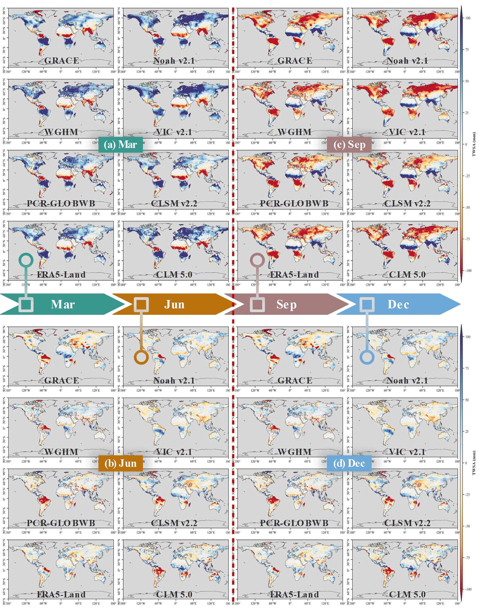
Supplementary Fig. 2. Spatial patterns of TWSA from GRACE observations and multiple model-based datasets for four representative months (March, June, September, and December), capturing seasonal hydrological variations.
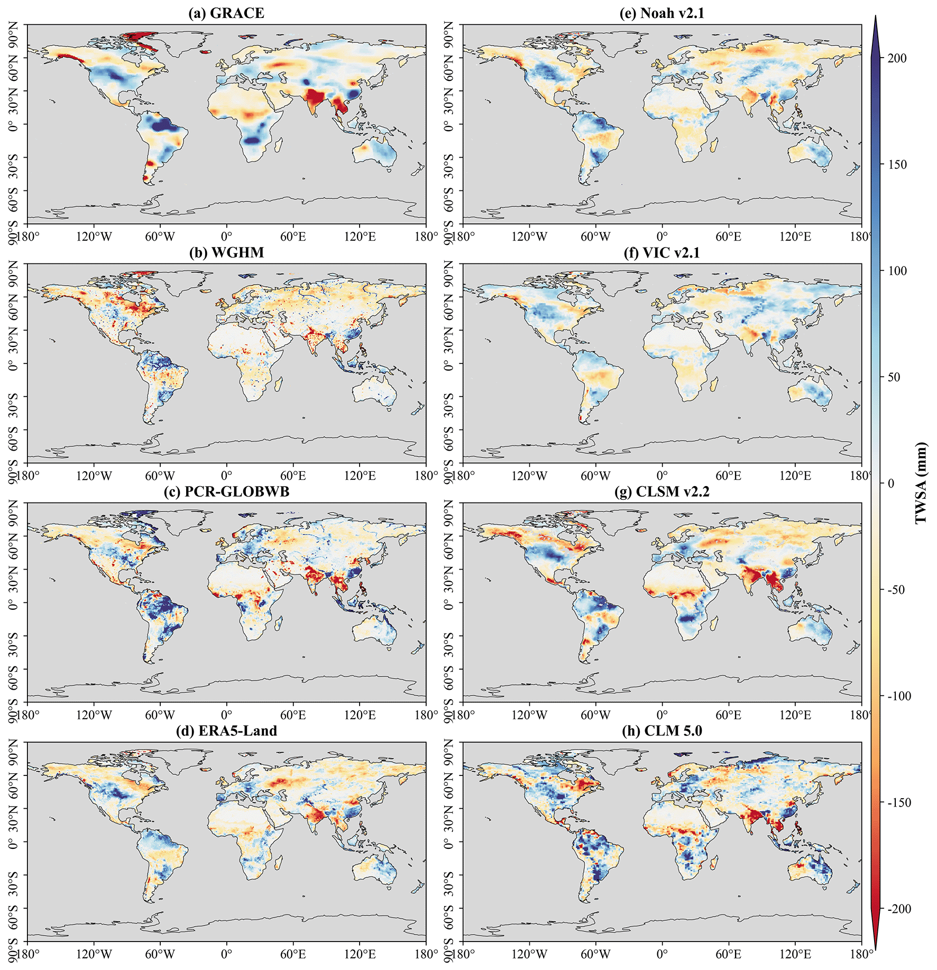
Supplementary Fig. 3. Spatial comparison of multi-source TWSA at the randomly selected month (2010-06).
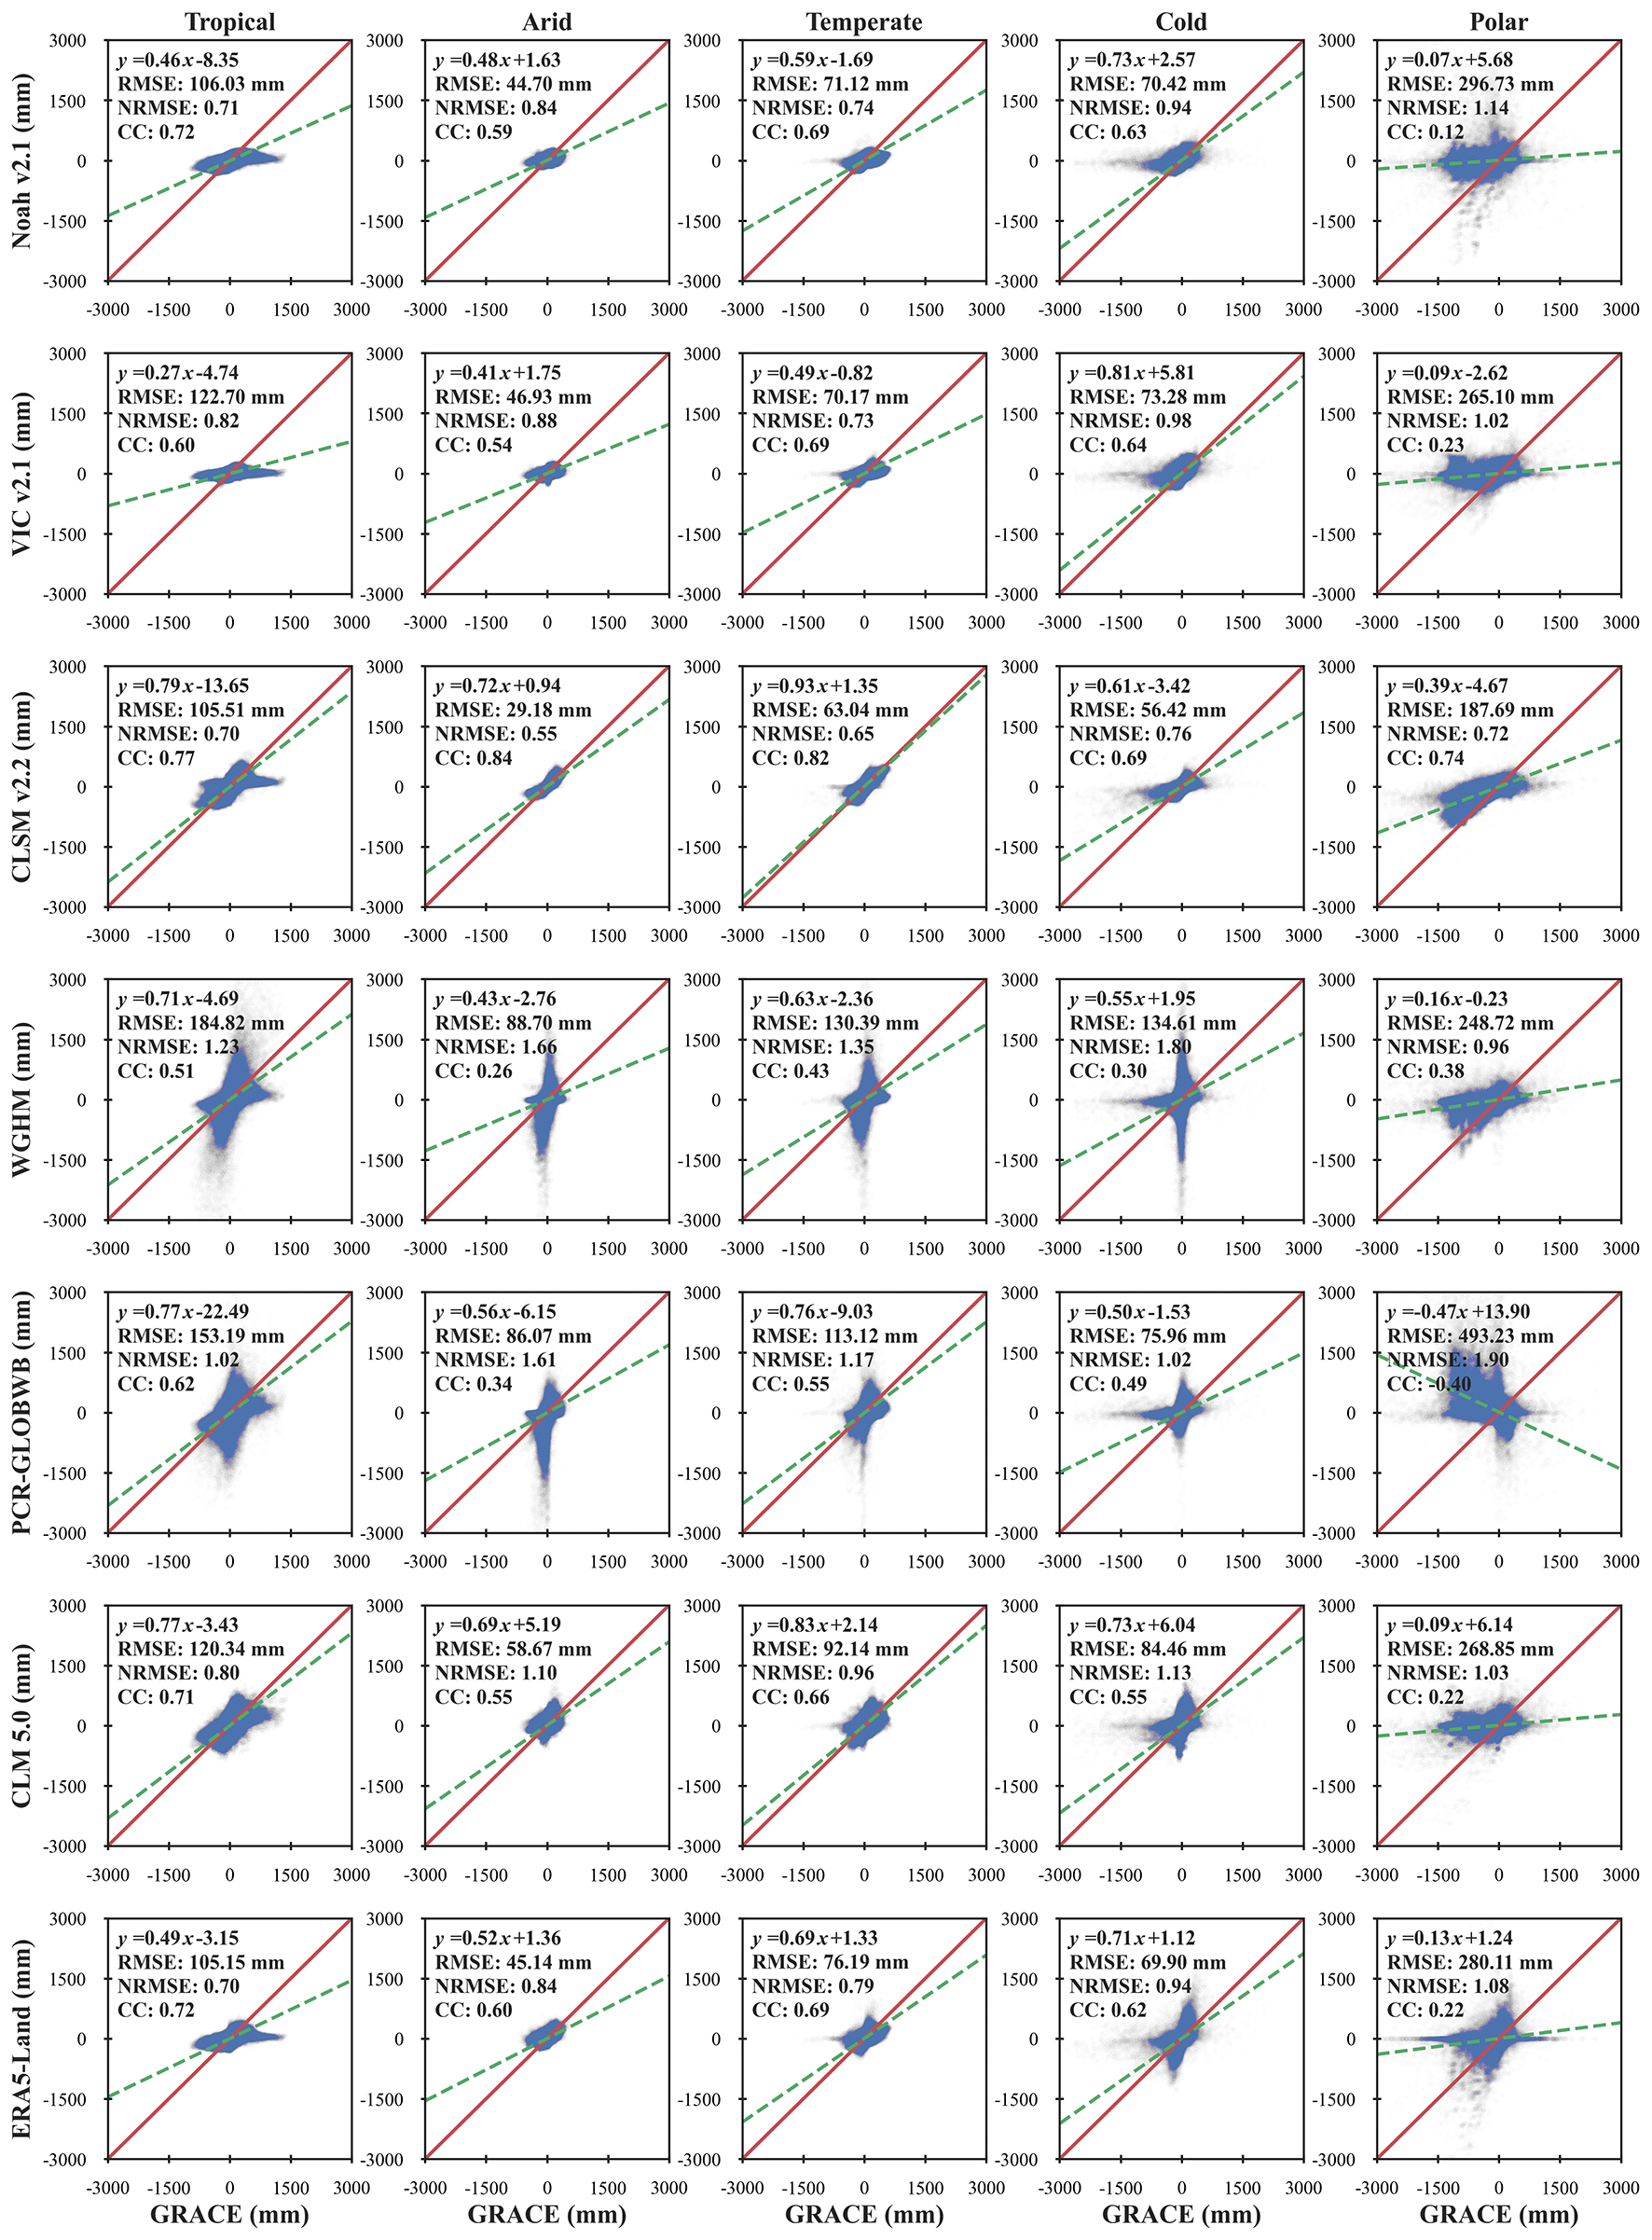
Supplementary Fig. 4. Statistical performance metrics and distributional patterns of multi-source TWSA products across climate zones.

Supplementary Fig. 5. TWSA change trends discrepancies from multi-source datasets to GRACE observations.
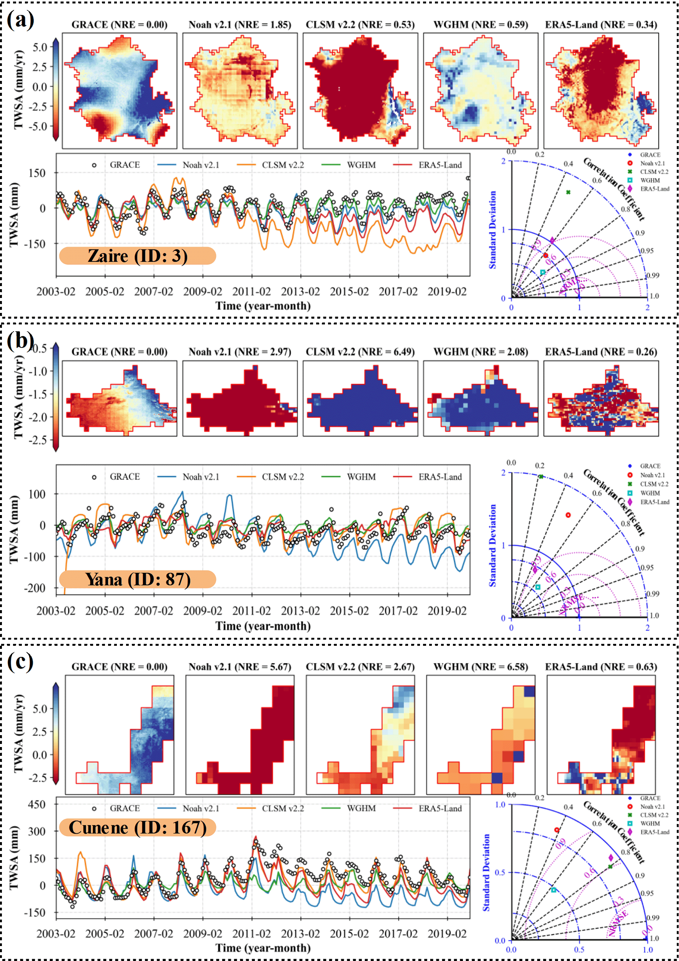
Supplementary Fig. 6. Multi-source and multi-scale comparison of TWSA in representative large (a), medium (b), and small basins (c) with poor spatiotemporal consistency.
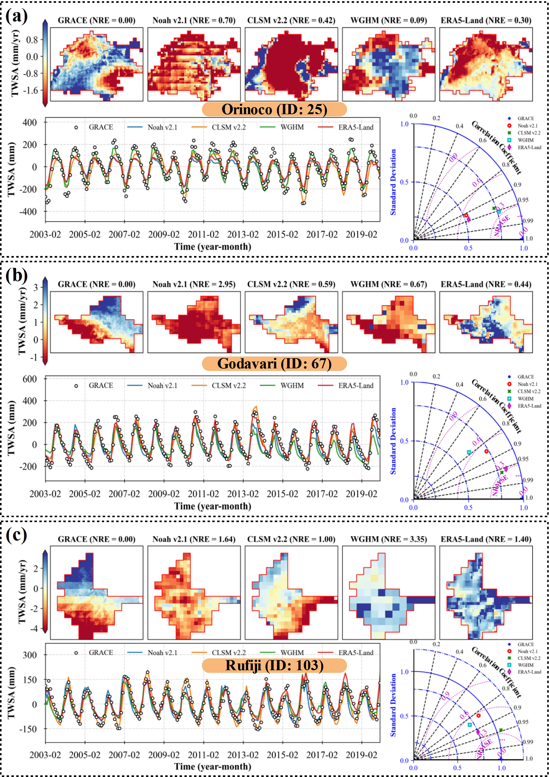
Supplementary Fig. 7. Multi-source and multi-scale comparison of TWSA in representative large (a), medium (b), and small basins (c) with poor spatial consistency but good temporal consistency.
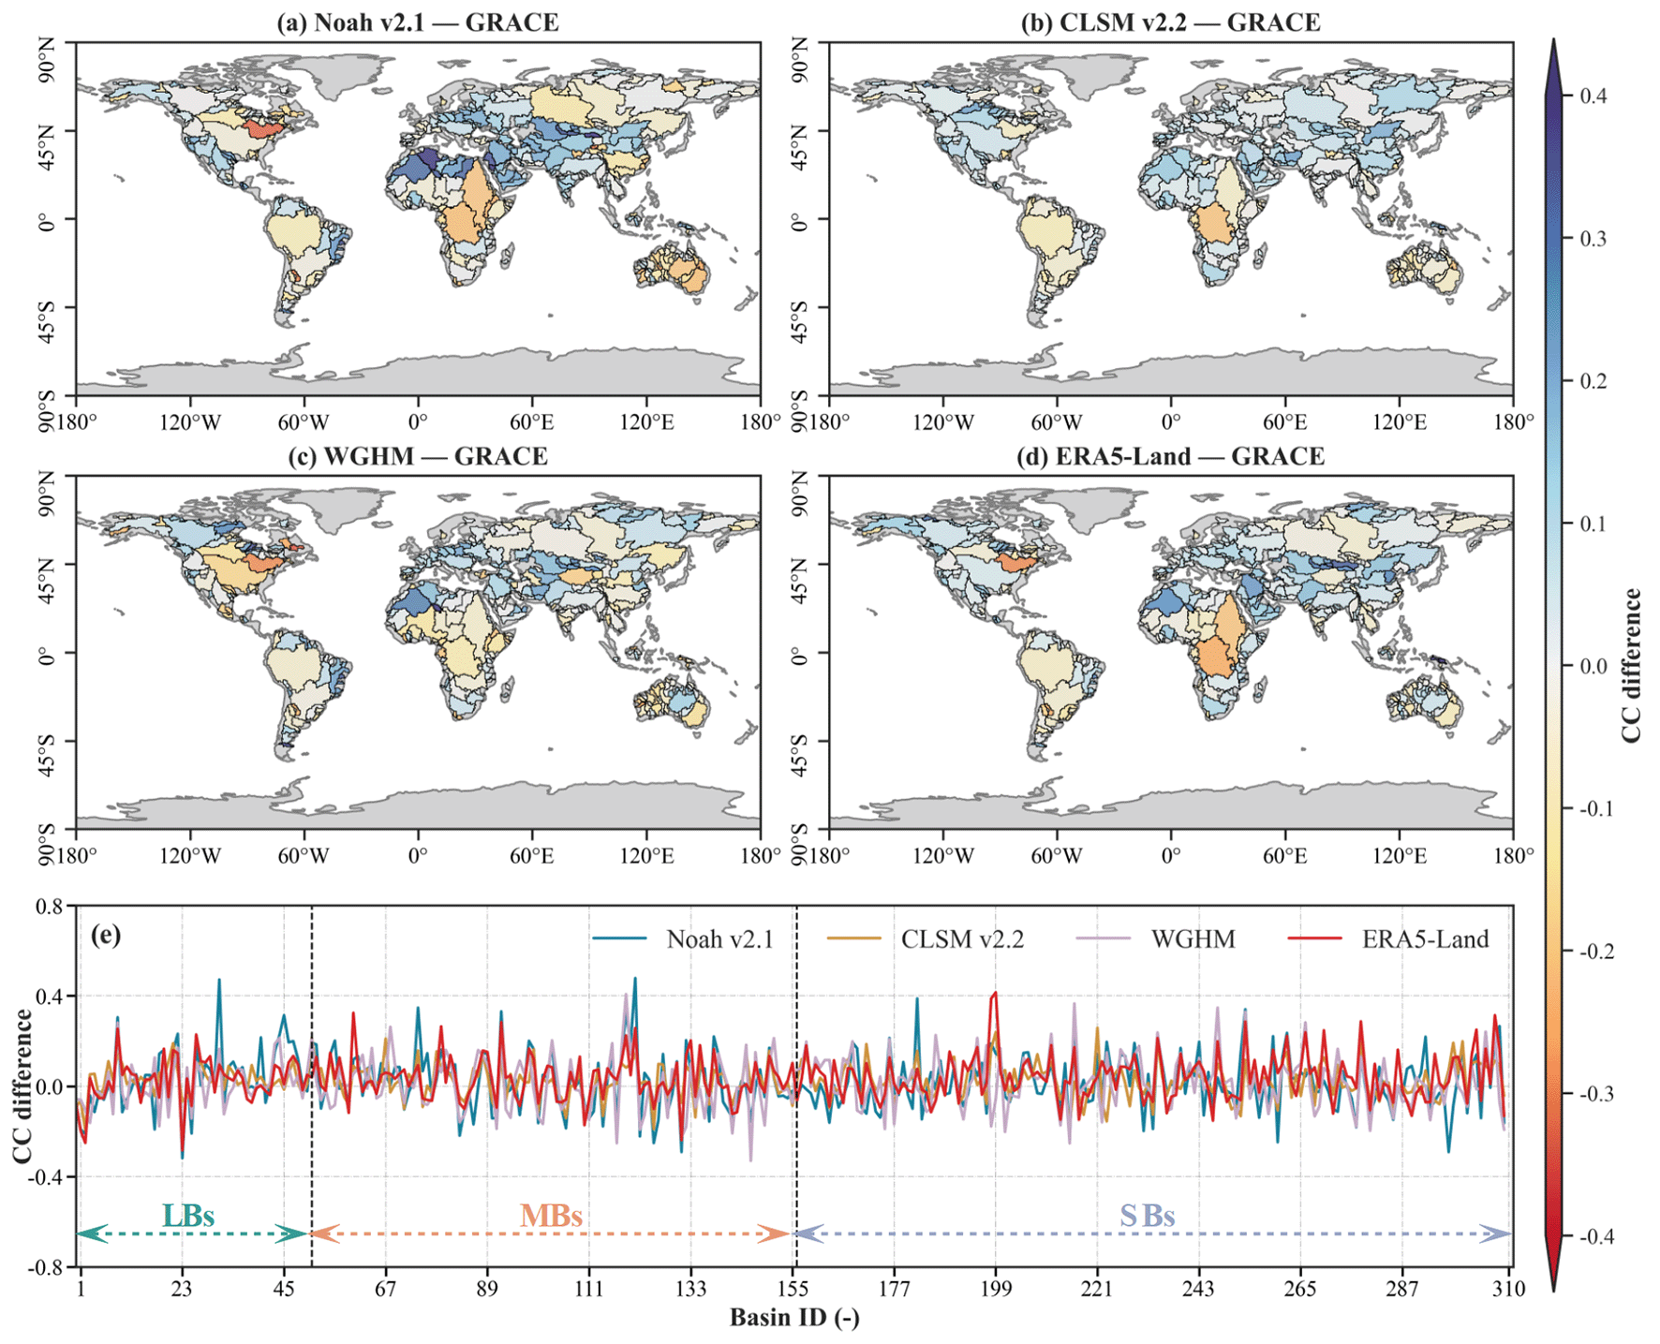
Supplementary Fig. 8. Spatial distribution of CC differences between multi-source TWSA and ENSO index relative to GRACE reference data across global multi-scale basins.
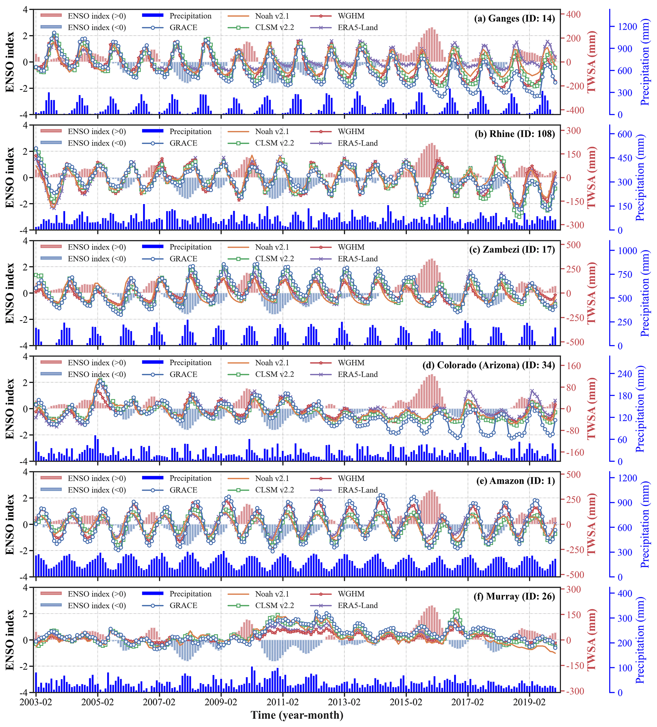
Supplementary Fig. 9. Temporal variation for ENSO index and TWSA/precipitation across six continents over out-of-phase basins (2003.02-2019.12).

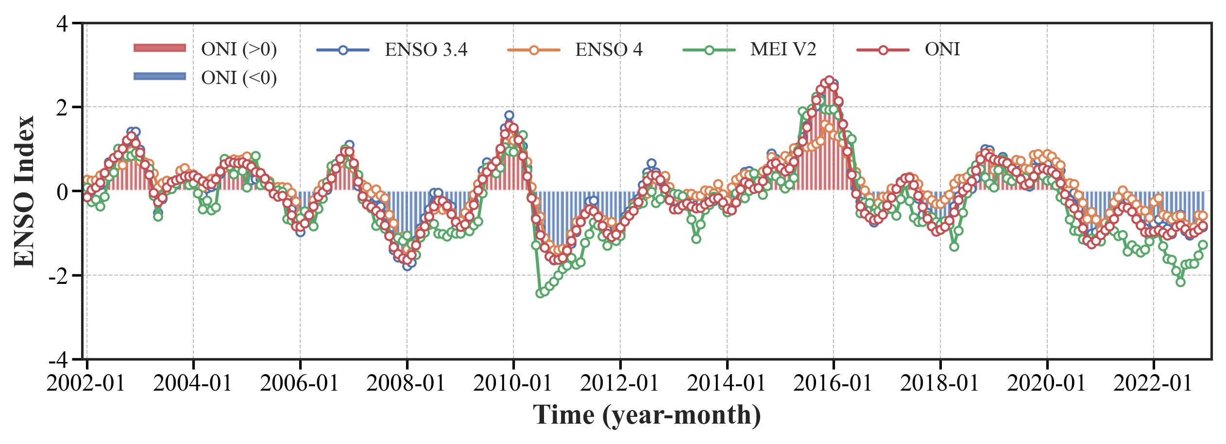
Supplementary Fig. 10. ENSO index dynamic change with date range from 2002 to 2022.

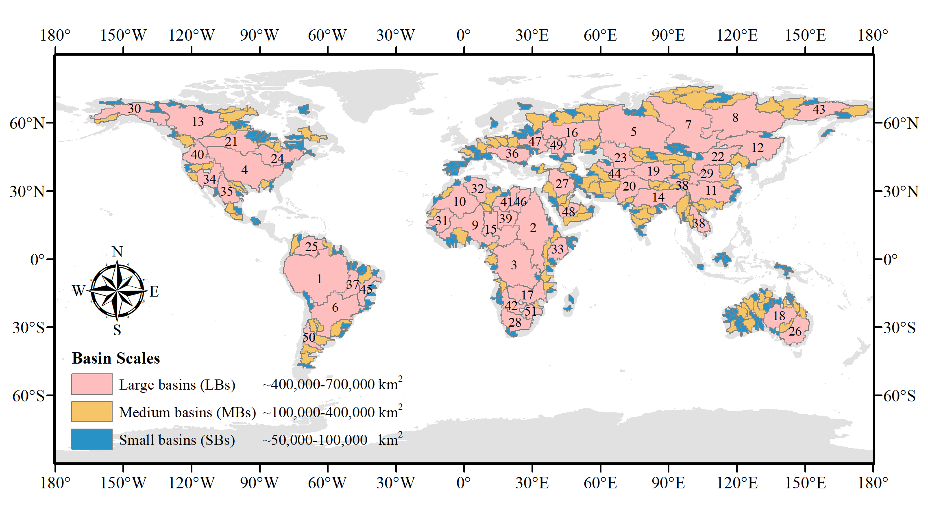
Supplementary Fig. 11. Global distribution of selected basins across multiple spatial scales (LBs, MBs, SBs), with 51 LBs numerically labeled.
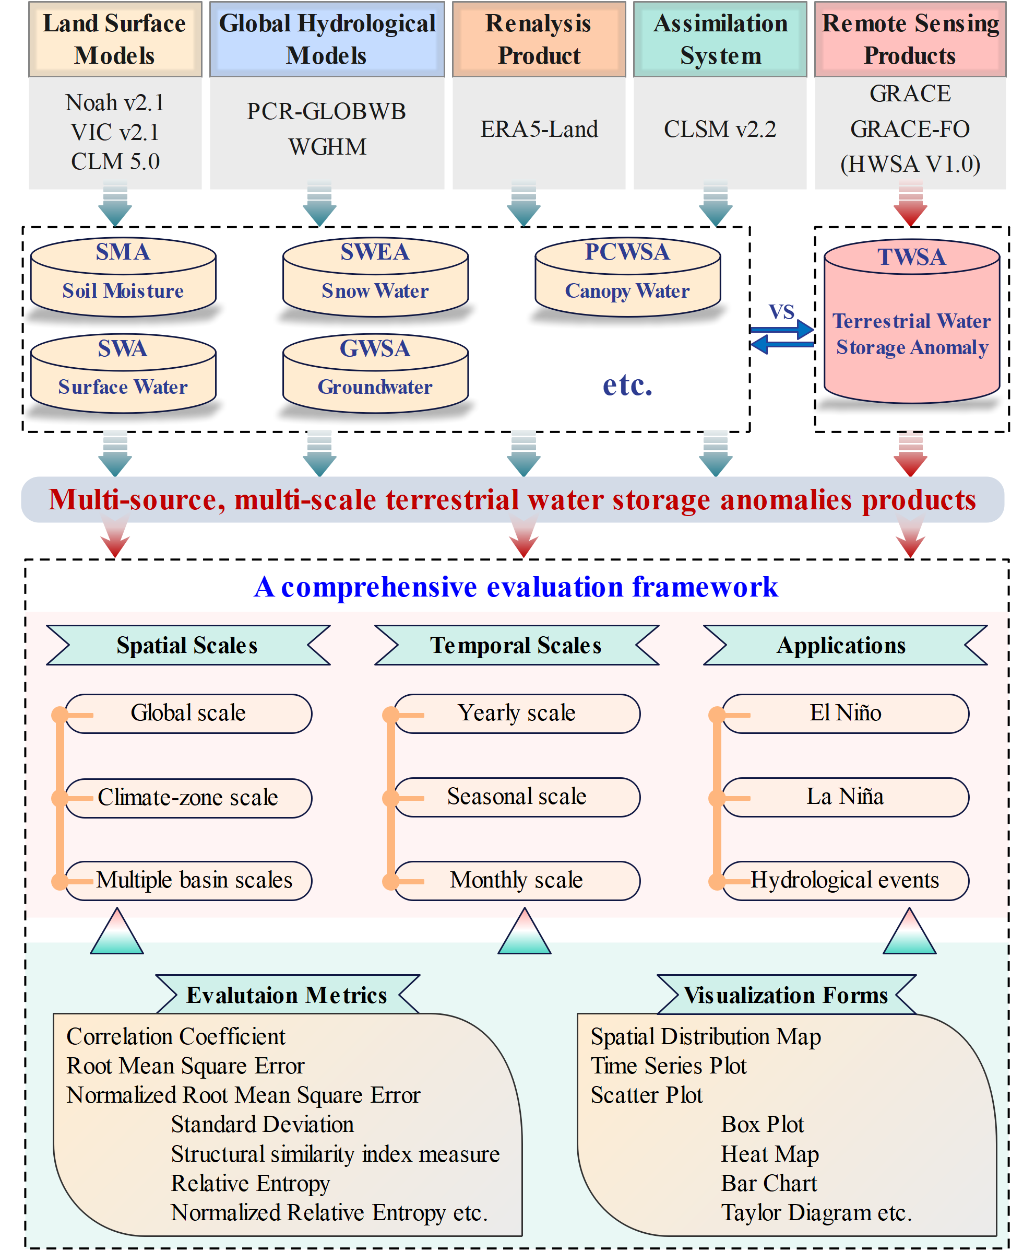
Supplementary Fig. 12. Flowchart illustrating the comprehensive evaluation framework proposed in this study.
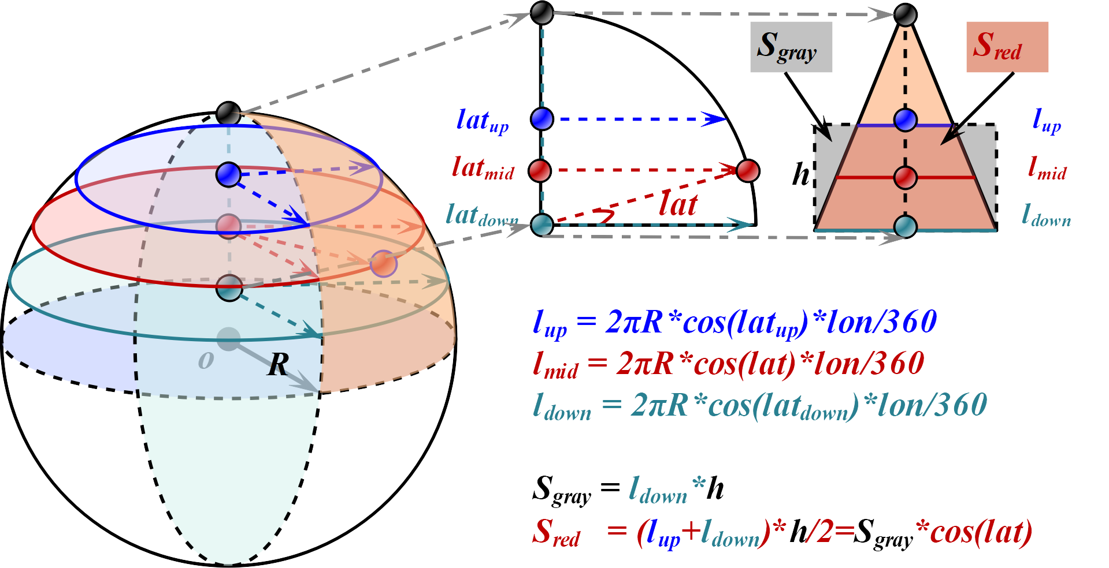
Supplementary Fig. 13. The schematic diagram of latitude weighting.

Supplementary Table 1. Statistical metrics of multi-source TWSA time series (2004.01-2014.12).
 | Max (mm) | Min (mm) | Mean (mm) | Trends (mm/yr) | Lag (month)
GRACE | 33.42 | -34.17 | -3.30 | -1.71 | -
Noah v2.1 | 47.57 | -38.42 | -2.13 | -1.60 | 1
VIC v2.1 | 43.55 | -39.40 | -1.25 | -1.37 | 1
CLSM v2.2 | 25.21 | -33.04 | -4.68 | -1.87 | 1
WGHM | 30.92 | -30.86 | -2.47 | -1.24 | 1
PCR-GLOBWB | 30.85 | -50.76 | -7.66 | -3.09 | 0
CLM 5.0 | 53.14 | -32.08 | 2.25 | 0.54 | 0
ERA5-Land | 37.05 | -28.53 | -0.89 | -0.80 | 1

Supplementary Table 2. Spatial performance metrics of multi-source TWSA trends compared with GRACE.
 | CCs | RMSE (mm/yr) | RE | SSIM
WGHM | 0.16 | 35.74 | 0.26 | 0.45
PCR-GLOBWB | 0.32 | 27.71 | 0.52 | 0.52
ERA5-Land | 0.48 | 18.75 | 0.14 | 0.60
Noah v2.1 | 0.30 | 20.54 | 0.17 | 0.53
VIC v2.1 | 0.33 | 18.42 | 0.52 | 0.57
CLSM v2.2 | 0.73 | 12.93 | 0.08 | 0.75
CLM 5.0 | 0.34 | 19.82 | 0.20 | 0.47

Supplementary Table 3. Detailed information about the datasets used in the study.
 | Products | SR | TR | Time | Variables
LSMs | Noah v2.1 | 0.25°×0.25° | monthly | 2002.04-2022.12 | SM, SWE, PCWS
LSMs | VIC v2.1 | 1.0°×1.0° | monthly | 2002.04-2022.12 | SM, SWE, PCWS
LSMs | CLM 5.0 | 0.95°×1.25° | monthly | 2002.04-2014.12 | TWSA
GHMs | WGHM | 0.50°×0.50° | monthly | 2002.04-2019.12 | TWSA
GHMs | PCR-GLOBWB | 0.083°×0.083° | monthly | 2002.04-2015.12 | TWSA
AP | CLSM v2.2 | 0.25°×0.25° | daily | 2003.02-2022.12 | TWSA
RP | ERA5-Land | 0.10°×0.10° | monthly | 2002.04-2022.12 | SM, SWE, PCWS
GRACE | CSR | 0.25°×0.25° | monthly | 2002.04-2022.12 | TWSA
GRACE | JPL | 0.50°×0.50° | monthly | 2002.04-2022.12 | TWSA
GRACE | GSFC | 0.50°×0.50° | monthly | 2002.04-2022.12 | TWSA
GRACE | HWSA V1.0 | 0.05°×0.05° | monthly | 2002.04-2022.12 | TWSA
Extreme events | ENSO index | ─ | monthly | 2002.04-2022.12 | ENSO 3.4, ENSO 4, MEI V2, ONI
Extreme events | CRU | 0.50°×0.50° | monthly | 2002.04-2022.12 | Precipitation
AD | KGCC | 0.50°×0.50° | ─ | 1991-2020 | Climate classification
Notes: SR: Spatial Resolution, TR: Temporal Resolution, LSMs: Land Surface Models, GHMs: Global Hydrological Models, AP: Assimilation Product, RP: Reanalysis Product, GRACE: Gravity Recovery and Climate Experiment, AD: Auxiliary data, SM: Soil Moisture, SWE: Snow Water Equipment, PCWS: Plant Canopy Water Storage.

