Supplementary Materials
Image preprocessing
Gaofen-2 (GF2), a new-generation satellite of China launched in August 2014, provides high-resolution images for earth observations. According to the calibration parameters given on the official website (China Centre for Resources Satellite Data and Application, 2020), we carried out radiometric calibration and atmospheric correction (FLAASH) for GF2 images (processing level: L1A) to convert the original digital number (DN) values to radiation values or reflectance. The satellite scenes were orthorectified using the digital elevation model (DEM) data. Pan-sharpened GF2 images (1 m resolution) were created by fusing multispectral GF2 images (4 m resolution) with panchromatic GF2 images (1 m resolution) using the nearest-neighbor diffusion (NNDiffuse) algorithm.
Image classification
We classified the GF2 images based on the object method and random forest (RF) algorithm (Breiman, 2001). The multi-resolution segmentation was used to segment GF2 images (1 m resolution) into objects in eCognition developer software (Benz et al., 2004). The best segmentation parameters were assessed by the scale of tree crowns. We used multiple levels of details to iteratively optimize segmentation and adjust the shape and compactness parameters. The final scale parameter was 10, and the default homogeneity criteria were 0.1 and 0.5 for shape and compactness, respectively. The overall accuracy of all categories was 81.54% (Table S1).
Landscape index calculation
First, we used the primary classification map (Fig. S1) to calculate the connectivity of Chinese pine patches in the buffering zone with a radius of 250 m around each sample plot. Then, the secondary classification map (Fig. S1) was generated by designating conifers and broad-leaved trees as forests and other categories as open habitats (non-forests). Finally, we used the secondary classification map to calculate the proportion and fragmentation degree (AI index) of forest types in the buffering zone around each sample plot. The whole process was carried out in ArcGIS 10.5 and Fragstats 4.2 software.
Table S1 Confusion matrix of GF2 images based on the object method and RF algorithm.
 | Chinese pine | Larch | Broad-leaved tree | Grassland | Farmland | Residence community | Total | UA
Chinese pine | 131 | 8 | 16 | 5 | 2 | 0 | 162 | 80.86%
Larch | 6 | 95 | 15 | 4 | 2 | 1 | 123 | 77.24%
Broad-leaved tree | 18 | 16 | 109 | 7 | 5 | 0 | 155 | 67.74%
Grassland | 5 | 7 | 7 | 205 | 10 | 2 | 236 | 86.86%
Farmland | 3 | 3 | 7 | 8 | 146 | 9 | 176 | 82.95%
Residence community | 0 | 0 | 1 | 1 | 4 | 74 | 80 | 92.50%
Total | 163 | 129 | 155 | 230 | 169 | 86 | 932
PA | 81.36% | 73.64% | 70.32% | 89.13% | 86.39% | 86.05% | OA | 81.54%
 |  |  |  |  |  |  | Kappa | 0.78
Note: UA, user’s accuracy; PA, producer’s accuracy; OA, overall accuracy; Kappa, a strict estimate of the accuracy of classification.
Figure S1 An example of primary and secondary classification maps of the buffering zone with a radius of 250 m around the sample plot.
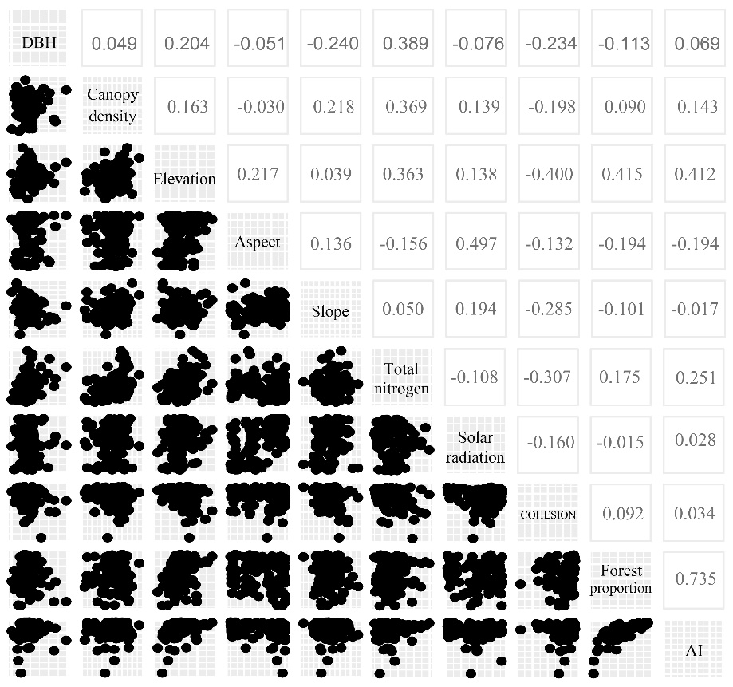
Figure S2 Pearson correlation coefficients of all predictor variables.
Reference
Benz UC, Hofmann P, Willhauck G et al (2004). Multi-resolution, object-oriented fuzzy analysis of remote sensing data for GIS-ready information. ISPRS J Photogramm 58:239-258. https://doi.org/10.1016/j.isprsjprs.2003.10.002
Breiman L (2001). Random Forests. Mach Learn 45:5-32. https://doi.org/10.1023/A:1010933404324
China Centre for Resources Satellite Data and Application (2020). http://www.cresda.com/CN/. Accessed 9 Jun 2020

