Supplementary Information
Hydrated Electron Motifs in Water Cluster Anions:
Structures and Isomer-Specific Femtosecond Real-Time Relaxation Dynamics
Sejun An and Sang Kyu Kim*
Department of Chemistry, KAIST, Daejeon (34141), Republic of Korea
*Corresponding author: sangkyukim@kaist.ac.kr

Table of Contents

2D Time-Resolved Photoelectron Spectra of Size-Selected (H₂O)ₙ⁻ Clusters and Corresponding Kinetic Fits

· Suppl. Fig. 1 Two-dimensional time-resolved photoelectron spectra and corresponding kinetic fits of water cluster anions of various sizes (n = 13–25), recorded using a pump photon energy of 0.84 eV and a probe photon energy of 1.57 eV. Plotting details, including the color scale, are the same as in Fig. 3.
· Suppl. Fig. 2 Two-dimensional time-resolved photoelectron spectra and corresponding kinetic fits of water cluster anions of various sizes (n = 13–35), recorded using a pump photon energy of 1.09 eV and a probe photon energy of 1.57 eV. Plotting details, including the color scale, are the same as in Fig. 3.
· Suppl. Fig. 3 Fitted time constants for the excited-state features observed in band C, recorded at pump photon energies of 0.84 eV and 1.09 eV.
· Suppl. Fig. 4. Fitted time constants for the slow rising component (hundreds of picoseconds) observed in band A, recorded at pump photon energies of 0.84 eV and 1.09 eV. The dashed line represents the average lifetime of 340 ps.

2D Time-Resolved Photoelectron Spectra of Size-Selected (H₂O)ₙ⁻ Clusters and Corresponding Kinetic Fits

Two-dimensional plots of time-resolved photoelectron spectra for water cluster anions with sizes ranging from n = 13–35 for pump photon energies of 0.84 eV and 1.09 eV are presented in Suppl. Fig. 1 and 2. In some clusters, spectral overlap between distinct photoelectron features was observed. While the B_{Ia} and C features were clearly resolved across all cluster sizes, the A band became challenging to separate as the cluster size increased. Moreover, in several cases, the B_{II} signal was found to spectrally overlap with a two-photon detachment signal (denoted as feature a) induced by the pump pulse, rendering independent analysis of the B_{II} dynamics infeasible. To ensure reliable isomer-specific dynamics analysis, we analyzed isomer-specific dynamics only from (H₂O)₁₄⁻, where spectral features were well-separated. Size-dependent analysis was primarily conducted on the B_{Ia} band, which remained distinct across the cluster series.
Kinetic traces were fitted using a convolution of an error function (to account for the Gaussian temporal profile of the laser pulse) and mono- or bi-exponential functions for B_{Ia}, B_{II}, and C features. The lifetimes of feature C for various cluster sizes are plotted in Suppl. Fig. 3. For the largest clusters, (H₂O)₃₀⁻ and (H₂O)₃₅⁻, an additional fast-decay component on the tens-of-picoseconds timescale was observed for band B_{Ia}. These signals were fitted using a bi-exponential function and whereas others were fitted using a single exponential function. A slow rising component with a lifetime on the hundreds-of-picoseconds timescale was fitted by adding an additional independent exponential rise function, assuming negligible interference with the dynamics within the first few picoseconds.
The slow rising component observed in the A band is attributed to delayed thermionic emission or fragmentation processes following internal conversion to the vibrationally hot ground state. This feature was consistently observed across all cluster sizes and showed little variation in lifetime as a function of cluster size, remaining within the fitting error margins. The average lifetime of this component was determined to be approximately 340 ps (Suppl. Fig. 4), indicating that vibrationally excited water cluster anions with 0.84–1.09 eV of internal energy persist for several hundred picoseconds prior to neutralization or fragmentation.

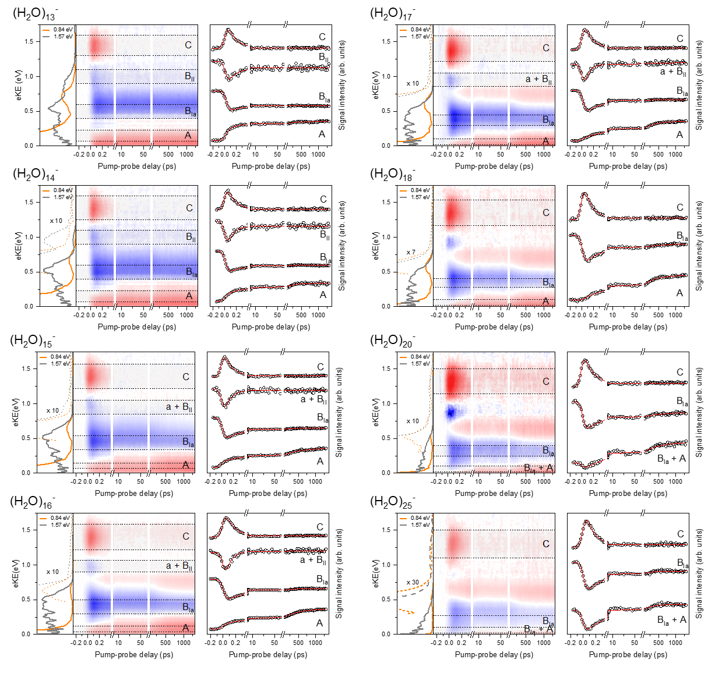
Suppl. Fig. 1 Two-dimensional time-resolved photoelectron spectra and corresponding kinetic fits of water cluster anions of various sizes (n = 13–25), recorded using a pump photon energy of 0.84 eV and a probe photon energy of 1.57 eV. Plotting details, including the color scale, are the same as in Fig. 3.

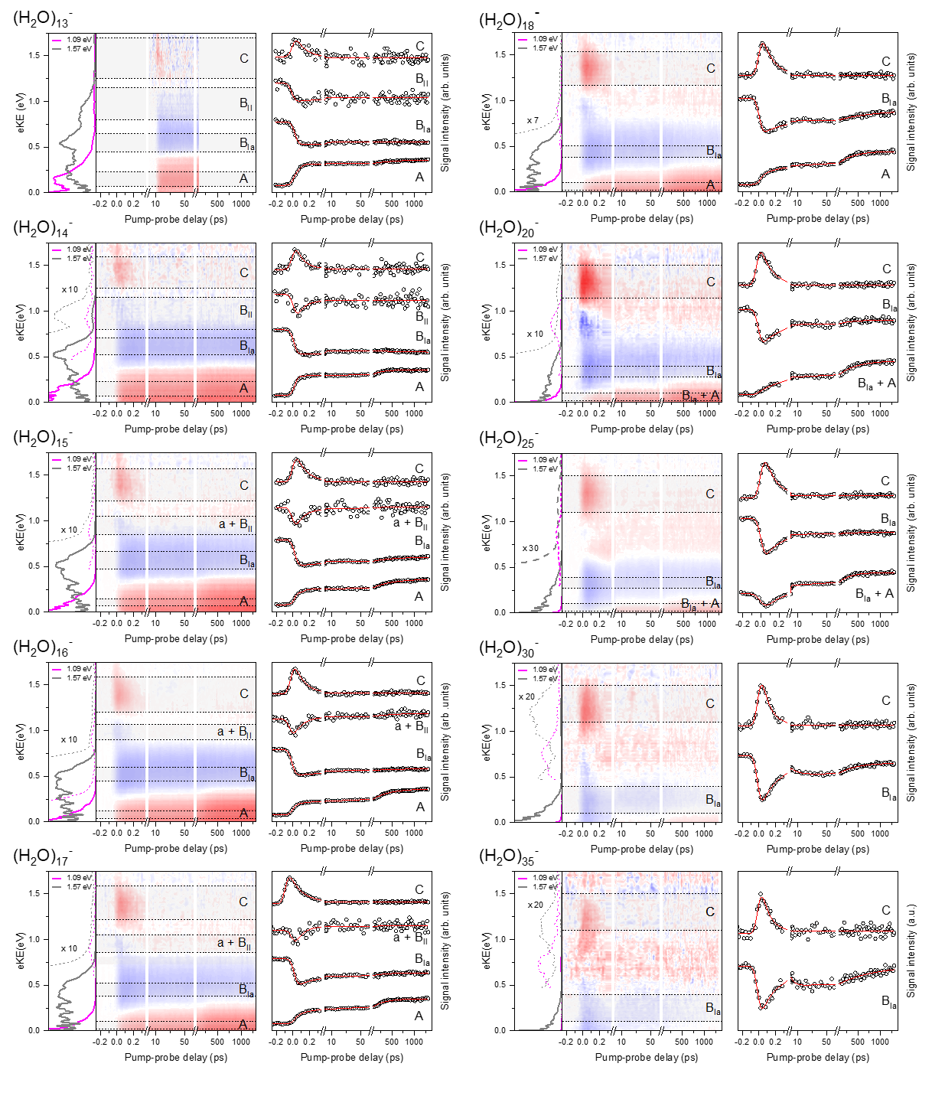
Suppl. Fig. 2 Two-dimensional time-resolved photoelectron spectra and corresponding kinetic fits of water cluster anions of various sizes (n = 13–35), recorded using a pump photon energy of 1.09 eV and a probe photon energy of 1.57 eV. Plotting details, including the color scale, are the same as in Fig. 3.

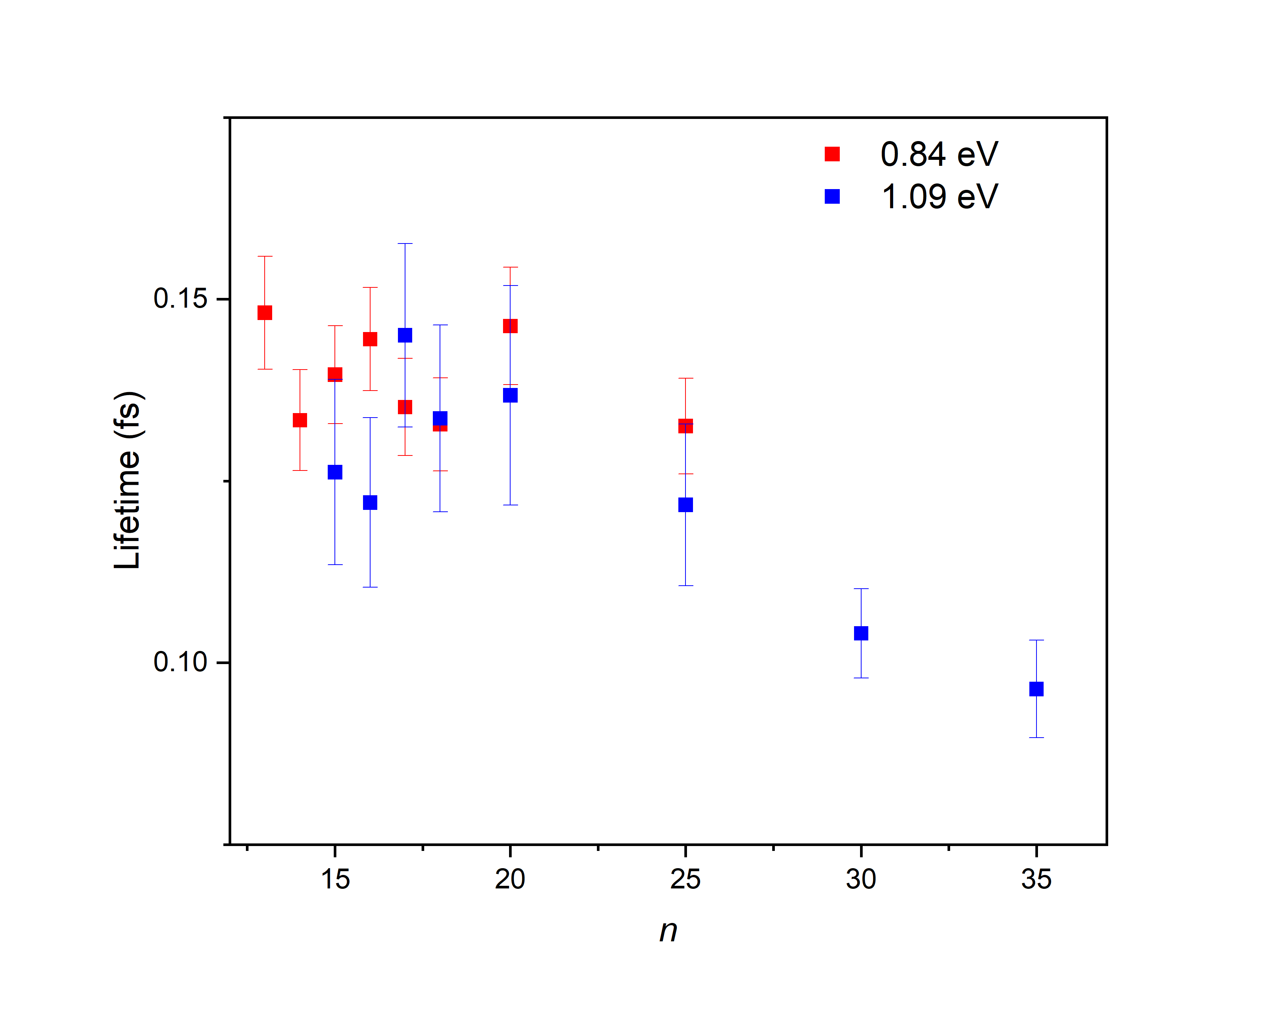
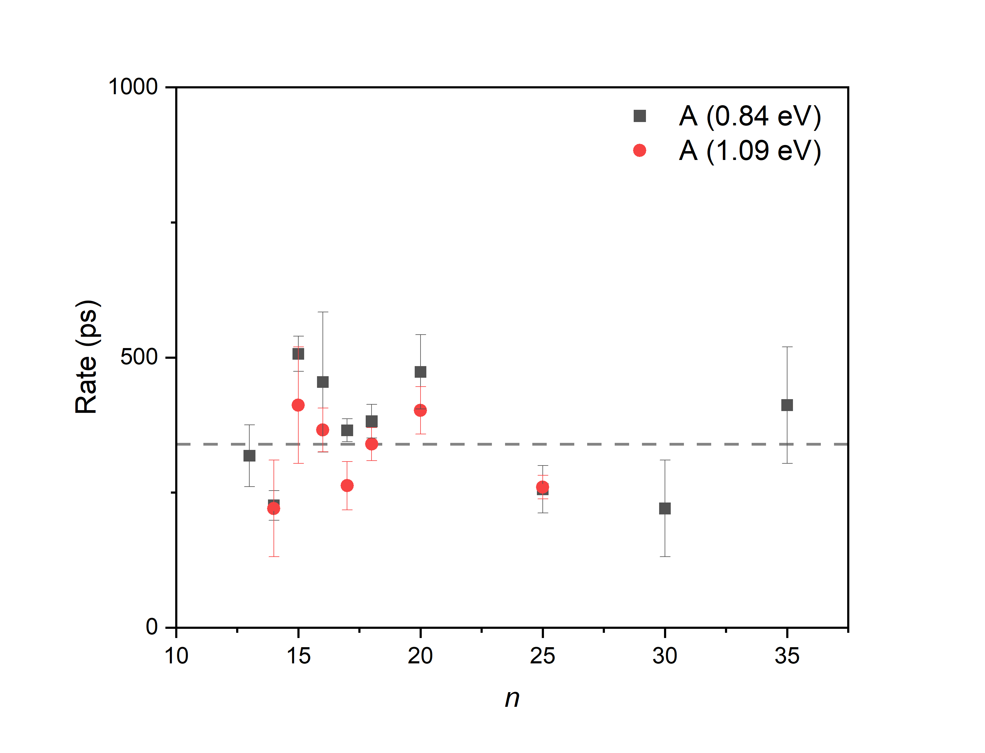
Suppl. Fig. 4 Fitted time constants for the slow rising component (hundreds of picoseconds) observed in band A, recorded at pump photon energies of 0.84 eV and 1.09 eV. The dashed line represents the average lifetime of 340 ps.
Suppl. Fig. 3 Fitted time constants for the excited-state features observed in band C, recorded at pump photon energies of 0.84 eV and 1.09 eV.

