Supplementary Information for
Key natural influences on groundwater storage changes in central and southern Arizona

Behshad Mohajer¹, †James S. Famiglietti^{1,2,3}, Hrishikesh A. Chandanpurkar², Fengwei Hung²

¹School of Sustainable Engineering and the Built Environment, Arizona State University, Tempe, US.
²School of Sustainability, Arizona State University, Tempe, US.
³Swette Center for Sustainable Food Systems, Arizona State University, Tempe, AZ, US.

†Corresponding Author (jay.famiglietti@asu.edu)

Contents:

Text S1 to S3

Figure S1 to S7

Table S1 and S2

Text S1. Detailed Methodology
The workflow consists of three primary components (Figure S2): (1) anomaly trend estimation, (2) correlation analysis between surface variables and groundwater storage, and (3) dimensionality reduction via principal component analysis (PCA) and Clustering. We begin by assembling two core datasets: (i) monthly GRACE-derived groundwater storage anomalies (GWSA) at a 0.25° grid, (ii) a suite of daily hydrological and meteorological variables from the NASA WLDAS dataset. All datasets were temporally clipped to a standard analysis window spanning January 2004 to December 2021. WLDAS variables, originally provided at ~0.01° resolution, were spatially coarsened to match the GRACE/FO grid resolution of 0.25°. To ensure temporal comparability and isolate long-term variability, all variables (both GRACE/FO GWSA and WLDAS variables) were transformed into standardized monthly anomalies. A monthly climatology was computed for each variable over a baseline period from 2004 to 2009 by averaging each calendar month (Equation 1). Anomalies were calculated by subtracting this climatology from each time step. These raw anomalies were then standardized into z-scores by removing the mean and scaling by the standard deviation of the anomalies across the whole time series at each spatial grid point (Equation 2).

$μ_{i}\left(m\right)=\frac{1}{N_{m}}\sum{t ∈t_{o}∧month\left(t\right)=m^{X_{i}(t)}}$ [1]
$A_{i}(t)= X_{i}\left(t\right)- μ_{i}\left(month\left(t\right)\right), Z_{i}\left(t\right)= \frac{A_{i}\left(t\right)- \overline{A_{i}(t)}}{σ_{i}}$ [2]
Where:
$$t:Time index \left(monthly resolution\right)$$
$$m:Calendat month index \left(1 to 12\right)$$
$$i:Index for variable\left(e.g. WLDAS predictor\right)$$
$$s:Subbasin index$$
$$j:Index for pricipal component$$
$$\left(x,y\right):Spatial grid cell coordinates$$
$$t_{t}:Set of baseline time steps (e.g., 2004-2009)$$
$$X_{i}\left(t\right):Original value of variable i at time t$$
$$μ_{i}\left(m\right):Monthly climatology \left(mean value of variable i in month m over the baseline priod\right)$$
$$A_{i}\left(t\right):Raw monthly anomaly for variable i$$
$$\overline{A_{i}(t)}:Temporal mean of anomalyA_{i}\left(t\right)$$
$$σ_{i}:Standard deviation of anomalyA_{i}\left(t\right)$$
$$Z_{i}\left(t\right):Standardized anomaly \left(Z-score\right) for variable i$$

Following anomaly transformation, ordinary least squares regression was applied to each standardized anomaly time series to estimate linear trends (Equation 3). The resulting slope values represent each variable's long-term direction and magnitude of change. These slopes were then normalized into standardized scores (Equation 4) for cross-variable and cross-location comparisons.
$Z_{i}\left(t\right)=α_{i}+ β_{i}t+ε_{t}$ [3]
$β_{i}^{'}=\frac{β_{i}-\overline{β}}{σ_{β}}$[4]

Where:
$$α_{i}:Intercept of linear regression for variable i$$
$$β_{i}:Slope \left(trend\right) of linear regression for variable i$$
$$ε_{t}:Residual error term at time t$$
$$\overline{β}:Mean slope across all grid cells or variables$$
$$σ_{β}:Standard deviation of slopes across all grid cells$$
$$β_{i}^{'}:Standardized slope for variable i$$

To assess linkages between groundwater and surface processes, Pearson correlation coefficients were computed between GRACE/FO-derived anomalies and each WLDAS variable at the coarsened grid scale (Equation 5). These pixel-wise correlations were then aggregated into basin-wide statistics using zonal means over each subbasin polygon (Equation 6), generating a subbasin-by-variable matrix of average correlation values.

$r_{i}\left(x,y\right)=corr (Z_{GRACE/FO}\left(t\right), Z_{i}\left(t\right))$ [5]
$R_{i,s}=\frac{1}{\left|Ω_{s}\right|}\sum_{\left(x,y\right)∈Ω_{s}}{r_{i}}(x,y)$ [6]
Where:

$$Z_{GRACE/FO}\left(t\right):Standardized GRACE-FO GWSA$$
$$r_{i}\left(x,y\right):Pearson correlation between GRACE-FO and WLDAS variable i at grid cell (x,y)$$
$$Ω_{s}:Set of all grid cells within subbasin s$$
$$\left|Ω_{s}\right|:Number of grid cells in subbasin s$$
$$R_{i,s}:Zonal average correlation of variable i with GRACE-FO in subbasin s$$

Principal Component Analysis (PCA) was applied to the subbasin-level correlation matrix derived from GRACE/FO groundwater storage anomalies and WLDAS land surface variables. PCA was used as a dimensionality reduction technique to extract the dominant linear variability modes that explain the hydroclimatic controls' spatial structure on groundwater storage (Abdi & Williams, 2010). This approach allowed us to identify the principal patterns mainly influencing climate–groundwater interactions and evaluate the extent to which subbasin responses are shaped by standard surface drivers such as evapotranspiration, precipitation, and runoff. (Sohoulande et al., 2020). The covariance matrix was computed (Equation 7) and subjected to eigenvalue decomposition to obtain principal directions and their associated variances (Equation 8). The resulting principal component scores (Equation 9) quantify how strongly each subbasin projects onto each principal mode (Abdi & Williams, 2010).

$C=\frac{1}{S-1}{(R-\overline{R})}^{T}(R-\overline{R})$ [7]
$CW_{j}=λ_{j}W_{j}$ [8]
$T=RW$ [9]
Where:

$$R:Matrix of zonal correlations \left(rows:subbasins, columns=variables\right)$$
$$\overline{R}:Mean of each column of matrix R$$
$$C:Covariance matrix of centered R$$
$$W_{j}:Eigenvector corresponding to the jth principal component$$
$$λ_{j}:Eigenvalue corresponding to the jth principal component$$
$$T:Matrix of principal component scores for each subbasin$$
$$W:Matrix of eigenvectors (loadings)$$

Finally, variable-specific loadings for PC1 (Equation 10) were extracted to attribute the primary hydroclimatic drivers of GRACE-observed groundwater changes.
${Loading}_{i}=w_{1,i}$ [10]
$$w_{1,i}:Loading of variable i on PC1 (indicating contribution to the first component)$$

To identify spatial patterns in hydroclimatic controls on groundwater storage, we also applied unsupervised K-means clustering to the scores from the first three principal components (PC1 to PC3, which together explain 94.3 % of variance) derived from the PCA of the subbasin-level correlation matrix. The PCA scores capture the dominant modes of variability linking GRACE/FO-derived groundwater anomalies to surface hydroclimatic variables. Subbasins were embedded in a three-dimensional feature space defined by their PC scores, which were input to the K-means algorithm. Clustering was performed using the k-means initialization method (Arthur & Vassilvitskii, 2007) to ensure stable convergence, and the number of clusters was set to four based on interpretability and explained variance. The algorithm partitions subbasins into k groups by minimizing the within-cluster sum of squared Euclidean distances:

$$\min{\sum_{i=1}^{k}{\sum_{X_{j∈C_{i}}}{{\left||X_{j}-μ_{i}|\right|}^{2}} [11]}}$$

Where$X_{j}$ is the PC1 to PC3 score vector of subbasin j. $μ_{i}$ Is the centroid of the cluster $i$, and $C_{i}$ Is the set of subbasins assigned to the cluster $i. \left(i=4\right).$
To determine the optimal number of clusters (k) for the K-means analysis, we applied two complementary tests: the elbow method (Shakhari & Banerjee, 2024) and silhouette analysis (Nourani et al., 2022). The elbow method evaluates the within-cluster sum of squares (WCSS), defined as:
$$WCSS\left(k\right)={\sum_{i=1}^{k}{\sum_{X_{j∈C_{i}}}{{\left||X_{j}-μ_{i}|\right|}^{2}} [12]}}$$

WCSS decreases as the number of clusters increases, but the optimal value is typically located at the "elbow" where additional clusters yield only marginal reductions in WCSS. Silhouette analysis was also performed to assess the cohesion and separation of clusters, where the silhouette score for each point is given by:

$$S_{j}=\frac{b_{j}-a_{j}}{\max{(a_{j},b_{j})}} [13]$$

Here, $a_{j}$ is the average distance from point j to all other points in the same cluster, and $b_{j}$ is the minimum average distance from point j to points in a different cluster. The silhouette score ranges from −1 to 1, with higher values indicating more coherent clustering. Based on the elbow inflection and one of the highest silhouette scores among tested values, while also ensuring hydroclimatic interpretability, k=4 was selected for the final clustering.

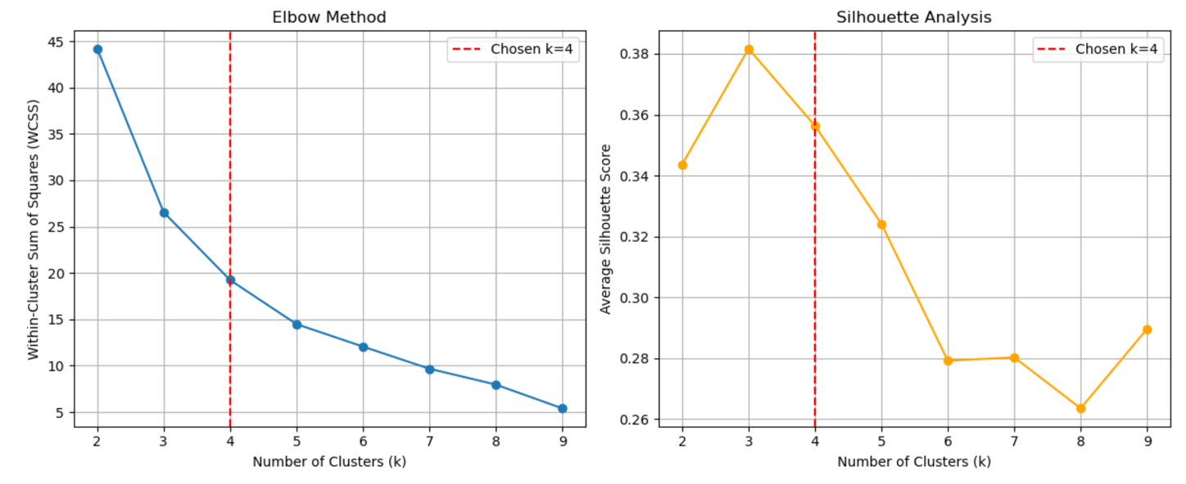
Figure S1. Elbow method results (left) and Silhouette analysis results (right)

The resulting cluster labels were mapped back to their geographic subbasin polygons and visualized to reveal regional natural influences on groundwater storage.

Text S2. Index wells analysis
To complement our assessment of groundwater storage variability, we conducted an independent analysis of in-situ groundwater level trends using well data provided by the Arizona Department of Water Resources (ADWR). This analysis focused on estimating long-term trends in depth to water (DTW) across selected groundwater subbasins in central and southern Arizona, providing a layer for our PCA and clustering analysis.

We began by compiling two datasets from ADWR's Groundwater Site Inventory (GWSI): (1) a CSV file containing time series records of depth-to-water measurements, and (2) a shapefile with the spatial locations and attributes of the corresponding well sites. These were merged using a common site identifier to link time series with geographic coordinates. We parsed all measurement dates to ensure accurate temporal representation and corrected erroneous future dates resulting from two-digit year formatting.

We restricted the analysis to index wells designated by ADWR for long-term monitoring and are less likely to reflect short-term operational influences (ADWR, 2021). To minimize the confounding effects of seasonal fluctuations, we retained only measurements taken during the winter months (November through March), when groundwater levels are typically more stable and representative of regional recharge or long-term drawdown conditions. The analysis was constrained to the 2000–2023 period. Records flagged for measurement errors or procedural concerns (e.g., codes indicating poor-quality data or dry wells) were excluded from further analysis. Each well was then spatially assigned to a groundwater subbasin using a spatial join with the Arizona Department of Water Resources' official subbasin shapefile. Subbasins were included in the analysis only if they contained sufficiently high-quality observations and had been designated as naturally or anthropogenically crucial in the main manuscript. A total of 24 subbasins were analyzed.

To control for the influence of extreme values, we removed statistical outliers in each subbasin using the interquartile range (IQR) method (Barbato et al., 2011). The cleaned dataset was then grouped by year to calculate annual mean depth-to-water values within each subbasin. These yearly averages were transformed into anomalies by subtracting each subbasin's mean value across the whole period, centering the time series, and highlighting deviations from the long-term norm. We applied the non-parametric Mann-Kendall test (Mann, 1945; Kendall, 1975; Gilbert, 1987) to detect long-term trends in each subbasin's anomaly time series. This approach is well-suited to identifying monotonic trends in hydrological time series without assuming a linear relationship or normal distribution (Yue et al., 2002).

The resulting trend estimates were spatially visualized by merging them with the original subbasin geometries. We produced a choropleth map using a diverging color scale to represent the rate of change in DTW (in feet per year) across subbasins. Red hues indicate areas experiencing groundwater depletion (increasing DTW), while blue tones represent subbasins where groundwater levels have recovered (decreasing DTW).
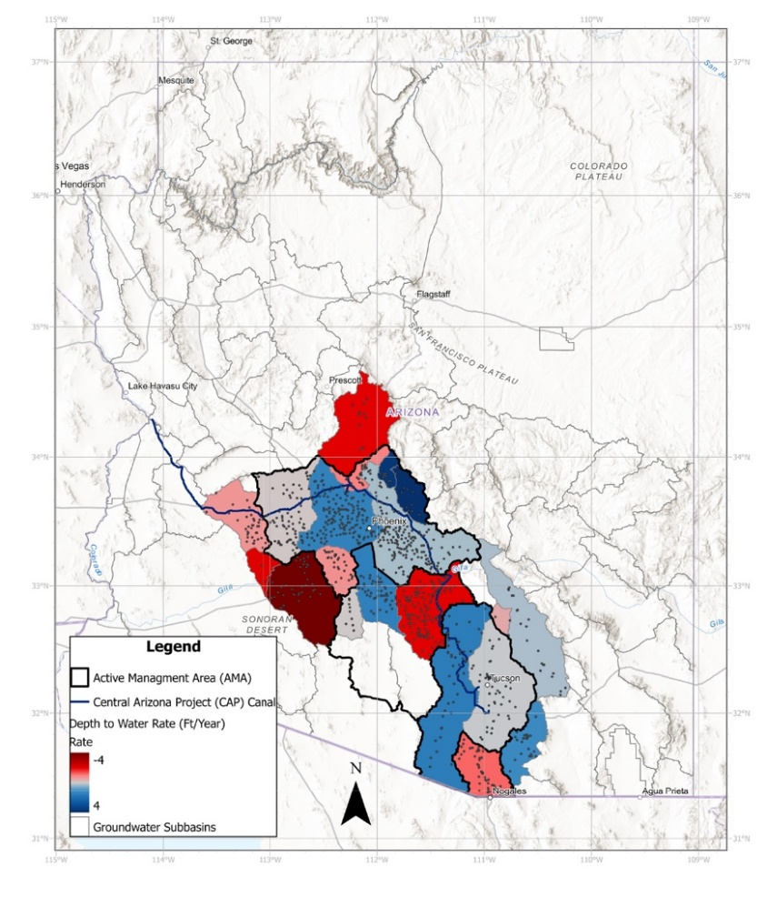
Figure S2. Spatial distribution of groundwater depth-to-water trends (ft/year) across subbasins in central and southern Arizona from 2000 to 2023, based on ADWR Index Wells. Red shades indicate declining groundwater levels, blue shades indicate rising levels, and gray areas denote limited or no trend data. Black outlines represent Active Management Areas (AMAs), and the blue line marks the Central Arizona Project (CAP) Canal

Figure S3. Trends in well-level depth to water across central and southern Arizona subbasins from 2000 to 2023, based on ADWR Index Wells. Each point represents an individual monitoring well classified by trend direction using the Mann-Kendall test: red indicates statistically significant declines, blue indicates significant rises, and black indicates stable trends. (Source: https://azwatermaps.azwater.gov/gwsiweb/ )

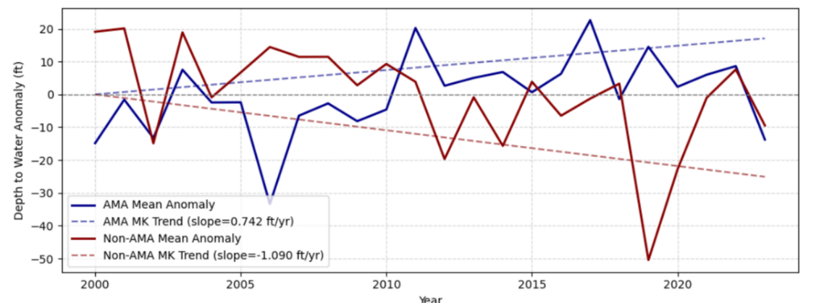
Figure S4. Time series of depth-to-water anomalies (ft) for wells in Active Management Areas (AMAs; blue) and non-AMA subbasins (red) across central and southern Arizona from 2000 to 2023. Solid lines represent annual mean anomalies, while dashed lines show Mann-Kendall (MK) trend slopes
Table S1. Principal Component Loadings
Variable | PC1 | PC2 | PC3 | PC4 | PC5 | PC6
Evapotranspiration | -0.399 | 0.587 | -0.094 | -0.091 | 0.622 | -0.303
Rain rate | -0.405 | 0.519 | -0.110 | 0.145 | -0.730 | 0.030
Soil moisture (100–200 cm) | -0.406 | -0.031 | 0.778 | 0.071 | 0.120 | 0.457
Subsurface runoff | -0.419 | -0.461 | 0.218 | 0.013 | -0.156 | -0.735
Surface runoff | -0.414 | -0.255 | -0.324 | -0.755 | -0.041 | 0.295
Vegetation transpiration | -0.407 | -0.328 | -0.470 | 0.629 | 0.199 | 0.260

Table S2. Explained Variance Ratio per PC
Principal Component | Variance Ratio | Cumulative Variance
PC1 | 0.809 | 0.809
PC2 | 0.082 | 0.892
PC3 | 0.051 | 0.943
PC4 | 0.029 | 0.972
PC5 | 0.020 | 0.992
PC6 | 0.008 | 1.000

Text S3. Lagged correlation, persistence, and significance checks

This section describes how we constructed subbasin time series, computed lagged correlations between GRACE/FO GWSA and WLDAS variables, quantified persistence, and assessed correlation significance with an effective degrees-of-freedom (DOF) adjustment.

We analyzed monthly GRACE/FO groundwater storage anomalies (GWSA) for the period 2004–2021 alongside six land-surface variables from the Western Land Data Assimilation System (WLDAS): total evapotranspiration (ET), vegetation transpiration (Tveg), precipitation (P), surface runoff (Qs), subsurface runoff (Qsb), and deep soil moisture (100–200 cm). To ensure spatial comparability, WLDAS fields were coarsened to the GRACE/FO grid (~0.25°) using block averaging, following practices commonly applied in GRACE model integration studies (Tang et al., 2021). Each variable's monthly climatology over the 2004–2009 baseline was removed, and anomalies were standardized to Z-scores to enable cross-variable comparison (Scanlon et al., 2018; Landerer & Swenson, 2012). Standardized anomalies were aggregated as zonal means over groundwater subbasin polygons, a widely adopted technique in GRACE hydrology studies (Rodell et al., 2009; Swenson & Wahr, 2006).

Hydroclimatic linkages were assessed using Pearson cross-correlations between GWSA and each WLDAS variable across integer lags τ ∈ {−3,…,+3} months, with positive τ denoting that the WLDAS variable leads GWSA. This lagged framework, frequently applied to detect delayed groundwater responses to precipitation and evapotranspiration (Pacak et al., 2020; Zhuang et al., 2017), is summarized in the correlation distributions and median lagged responses shown in Figures S7–S8. The lag-1 autocorrelation (ρ₁), with distributions across subbasins shown in Figure S6, quantified persistence in each series. To account for serial dependence, the statistical significance of zero-lag correlations was reassessed using effective degrees of freedom (Ne) derived from AR(1) adjustments based on the lag-1 autocorrelations of both series (Pyper & Peterman, 1998). We report subbasin-level correlations significant at p < 0.05 without multiple-testing correction and summarize the fraction of target subbasins meeting this criterion.

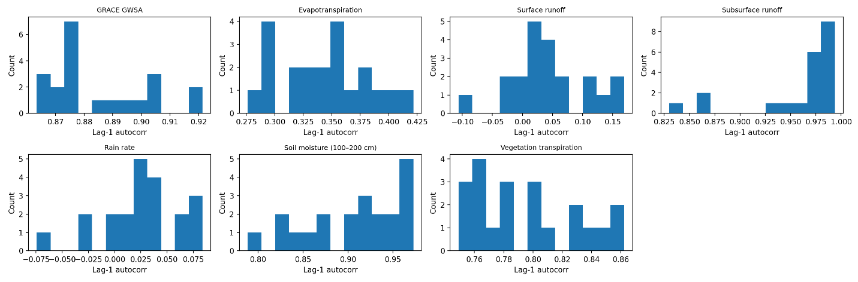

Figure S5. Distributions of lag-1 autocorrelation (ρ₁) for GRACE/FO groundwater storage anomalies (GWSA) and WLDAS variables across the 24 target subbasins (monthly standardized anomalies, 2004–2021). Each panel shows a histogram of ρ₁ values computed per subbasin for the indicated series.

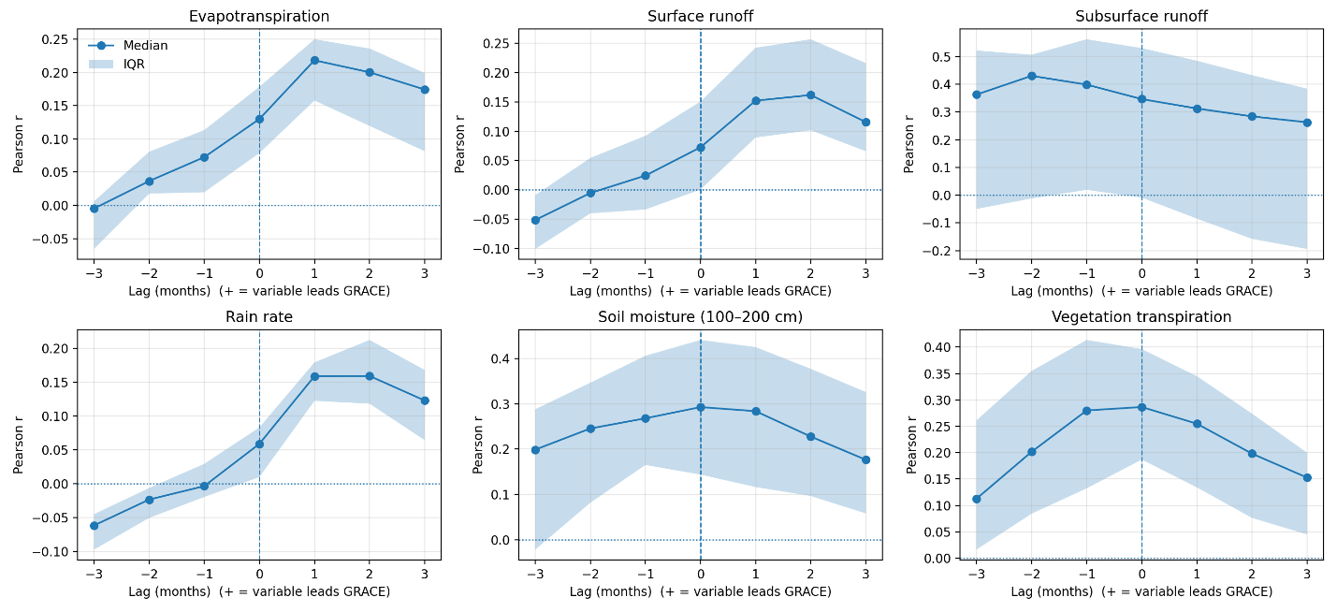

Figure S6. Median (points/lines) and interquartile range (shaded) of lagged Pearson correlations between GWSA and each WLDAS variable across the 24 target subbasins. Lags τ span -3…+3 months; positive τ indicates the WLDAS variable leads GWSA. Vertical dashed lines mark τ=0; horizontal dotted lines mark r=0. Correlations are computed on monthly standardized anomalies (2004–2021).

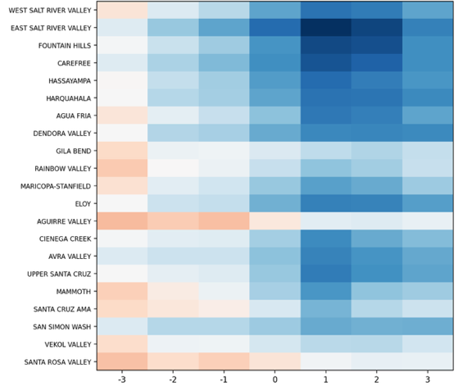  ET | 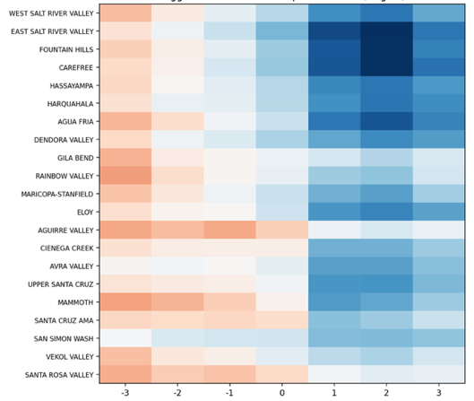  Rain Rate
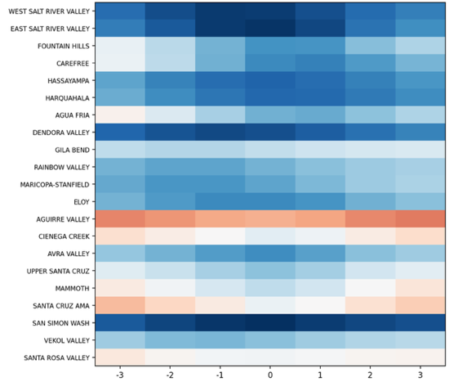  Soil Moisture | 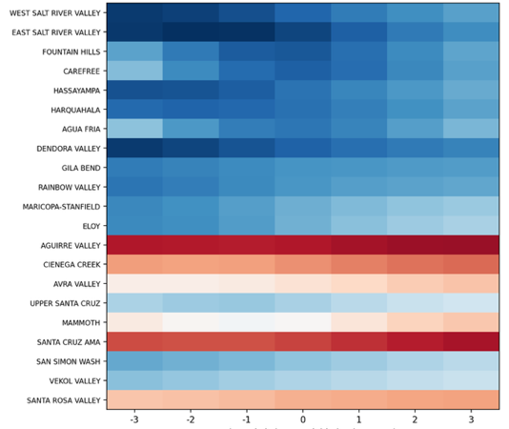  Subsurface Runoff
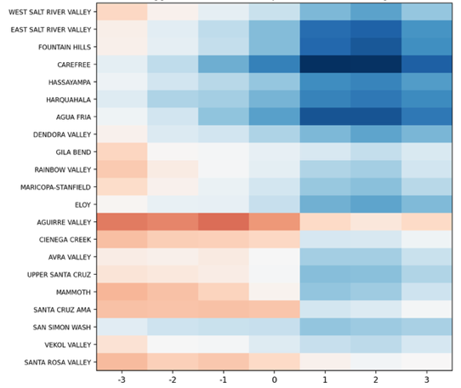  Surface Runoff | 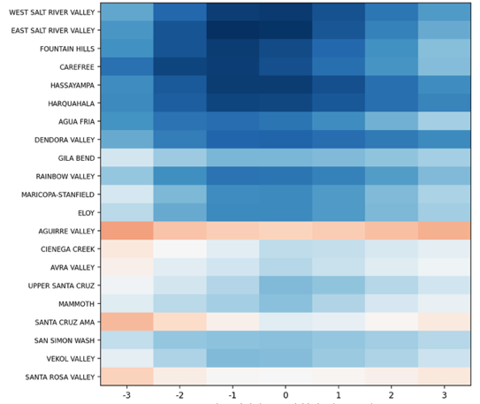  Vegetation Transpiration
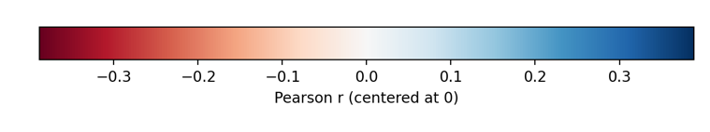
Figure S7. Lagged correlation heatmaps by subbasin (rows) and lag τ (columns) for the six WLDAS variables versus GWSA. Entries are Pearson r computed from monthly standardized anomalies (2004–2021); positive τ indicates the WLDAS variable leads GWSA. All panels share a diverging color scale centered at r=0 (color bar shown), enabling comparison across variables and lags. Subbasin ordering matches the Methods list.

Figure S7. Annual recharge deliveries from the Colorado River via the Central Arizona Project (CAP) by AMA in 2021, showing contributions from Groundwater Saving Facilities (GSF) and Underground Storage Facilities (USF) in acre-feet. Source: CAP (https://www.cap-az.com/water/water-supply/future-water-supplies/underground-storage/ )

References

Abdi, H., & Williams, L. J. (2010). Principal component analysis. In Wiley Interdisciplinary Reviews: Computational Statistics (Vol. 2, Issue 4, pp. 433–459). https://doi.org/10.1002/wics.101

Arizona Department of Water Resources. (2021). Groundwater Site Inventory (GWSI) database handbook. Hydrology Division. https://www.azwater.gov/sites/default/files/2022-12/GWSI_DatabaseHandbook2021.pdf

Barbato, G., Barini, E. M., Genta, G., & Levi, R. (2011). Features and performance of some outlier detection methods. Journal of Applied Statistics, 38(10), 2133–2149.

Gilbert, R.O. (1987). Statistical Methods for Environmental Pollution Monitoring, Wiley, NY.

Kendall, M.G. (1975). Rank Correlation Methods, 4th edition, Charles Griffin, London.

Mann, H.B. (1945). Non-parametric tests against trend, Econometrica 13:163-171.

Nourani, V., Ghaneei, P., & Kantoush, S. A. (2022). Robust clustering assesses the spatiotemporal variability of groundwater quantity and quality—Journal of Hydrology, 604, 127272.

Landerer, F. W., & Swenson, S. C. (2012). Accuracy of scaled GRACE terrestrial water storage estimates. Water Resources Research, 48(4), W04531. https://doi.org/10.1029/2011WR011453

Pyper, B. J., & Peterman, R. M. (1998). Comparison of methods to account for autocorrelation in correlation analyses of fish data. Canadian Journal of Fisheries and Aquatic Sciences, 55(9), 2127–2140.

Rodell, M., Velicogna, I., & Famiglietti, J. S. (2009). Satellite-based estimates of groundwater depletion in India. Nature, 460(7258), 999–1002. https://doi.org/10.1038/nature08238

Scanlon, B. R., Zhang, Z., Save, H., Sun, A. Y., Müller Schmied, H., van Beek, L. P. H., Wiese, D. N., Wada, Y., Long, D., Reedy, R. C., Longuevergne, L., Döll, P., & Bierkens, M. F. P.
(2018). Global models underestimate large decadal declining and rising water storage trends relative to GRACE satellite data. Proceedings of the National Academy of Sciences, 115(6), E1080–E1089. https://doi.org/10.1073/pnas.1704665115

Shakhari, S., & Banerjee, I. (2024, March). Clustering-based water quality exploration and visualization in municipal water supply. In 2024 IEEE International Conference on Interdisciplinary Approaches in Technology and Management for Social Innovation (IATMSI) (Vol. 2, pp. 1–5). IEEE.

Swenson, S., & Wahr, J. (2006). Post-processing removal of correlated errors in GRACE data. Geophysical Research Letters, 33(8), L08402. https://doi.org/10.1029/2005GL025285

Yue, S., Pilon, P., & Cavadias, G. (2002). Power of the Mann–Kendall and Spearman's rho tests for detecting monotonic trends in hydrological series. Journal of Hydrology, 259(1-4), 254–271.

Yu, Q., Wang, S., He, H., Yang, K., Ma, L., & Li, J. (2021). Reconstructing GRACE-like TWS anomalies for the Canadian landmass using deep learning and a land surface model. International Journal of Applied Earth Observation and Geoinformation, 102, 102404.

