Supplementary Figures and Tables

Collateral hypersensitivity between ZY19489 and piperaquine neutralizes PfCRT-mediated drug efflux and Plasmodium falciparum resistance.
John Okombo, Tolla Ndiaye, Tarrick Qahash, Igor M. R. Moura, Eva Gil-Iturbe, Laura M. Hagenah, Jessica L. Bridgford, Vinicius Bonatto, Kurt E. Ward, Tomas Yeo, Sunil K. Narwal, Lily V. Orta, Isla Anderson, Satish K. Dhingra, Charisse Flerida A. Pasaje, Heekuk Park, Jonathan Kim, Rafael V. C. Guido, Iñigo Angulo-Barturen, Jacquin C. Niles, Filippo Mancia, Anne-Catrin Uhlemann, Sachel Mok, Matthias Quick, Elizabeth A. Winzeler, Didier Leroy, Manuel Llinás, Vandana Thathy, and David A. Fidock

TABLE OF CONTENT
File name page

Supplementary Fig. 1. Conditional knockdown (cKD) strategy for generating PfV1-D line…………….3
Supplementary Fig. 2. In vitro drug selection chart…………...………………………………………….4
Supplementary Fig. 3. Gene editing strategies for pfcrt and pfacp10………...…………………………..5
Supplementary Fig. 4. Chemical structures of antimalarial compounds tested herein…..….....................6
Supplementary Fig. 5. MD simulations of 7G8 and 7G8+N246H protein interactions with ZY19489.....7
Supplementary Fig. 6. Heatmap of ZY19489- and ATQ-treated 3D7 and Dd2 parasites...……...............8
Supplementary Fig. 7. Inhibition of recombinant PfPKG………………………......................................9
Supplementary Fig. 8. Inhibition of cKD PfHDP Dd2 parasite lines…………………………...……….10
Supplementary Fig. 9. Inhibition of knockout (KO) falcipain 2A and 2B parasite 3D7 lines………......11
Supplementary Table 1. Haplotypes of drug resistance genes in parasite lines used herein....................12
Supplementary Table 2. In vitro activity of ZY19489 against PfV1-D cKD lines…...…………………13
Supplementary Table 3. 72-hour in vitro activity of ZY19489 against drug-selected lines………….....14
Supplementary Table 4. Genes within the amplified ~80kb locus of chromosome 5 in clone C8…...…15
Supplementary Table 5. 72-hour in vitro activity of ZY19489 against pfcrt and pfapc10 edited clones……………………………………………………………………………………………………...16
Supplementary Table 6. 72-hour in vitro activity of APC10 and ubiquitin ligase inhibitors against pfapc10 mutant………………….………………………………………..………………………….........17
Supplementary Table 7. 72-hour in vitro susceptibility of FCB and FCB-KD^{mdr1} parasites against ZY19489, mefloquine and lumefantrine……………..………………...………………………….………18
Supplementary Table 8. List of 34 genes with non-synonymous mutations between RF7 and NF54….19
Supplementary Table 9. 72-hour in vitro susceptibility of pfcrt mutant N246H lines against 7 clinically important antimalarials……………...…………………………………………………………………….23
Supplementary Table 10. 72-hour in vitro activity of ZY19489 against pfcrt and pfmdr1 mutants harboring contemporary drug-resistant alleles………………………………………………………….…24
Supplementary Table 11. 72-hour in vitro activity of ZY19489 and M5717 against M5717-resistant PfeEF2 mutant parasites recovered from humanized NSG mice…………………….................................25
Supplementary Table 12. Stage-specific activity of ZY19489, chloroquine, MMV390048 and dihydroartemisinin………………………………………………………………………………………...26
Supplementary Table 13. Mean fold change metabolite levels in atovaquone- and ZY19489-treated parasites…………………………………………………………………………………………………...27
Supplementary Table 14. Characteristic features of hemoglobin-derived peptides identified from ZY19489-treated 3D7 and Dd2 parasites………………………………………………………………….30
Supplementary Table 15. Amounts of different heme species obtained from NF54 parasites treated with different concentrations of ZY19489, chloroquine or pyrimethamine…………………….……………..31

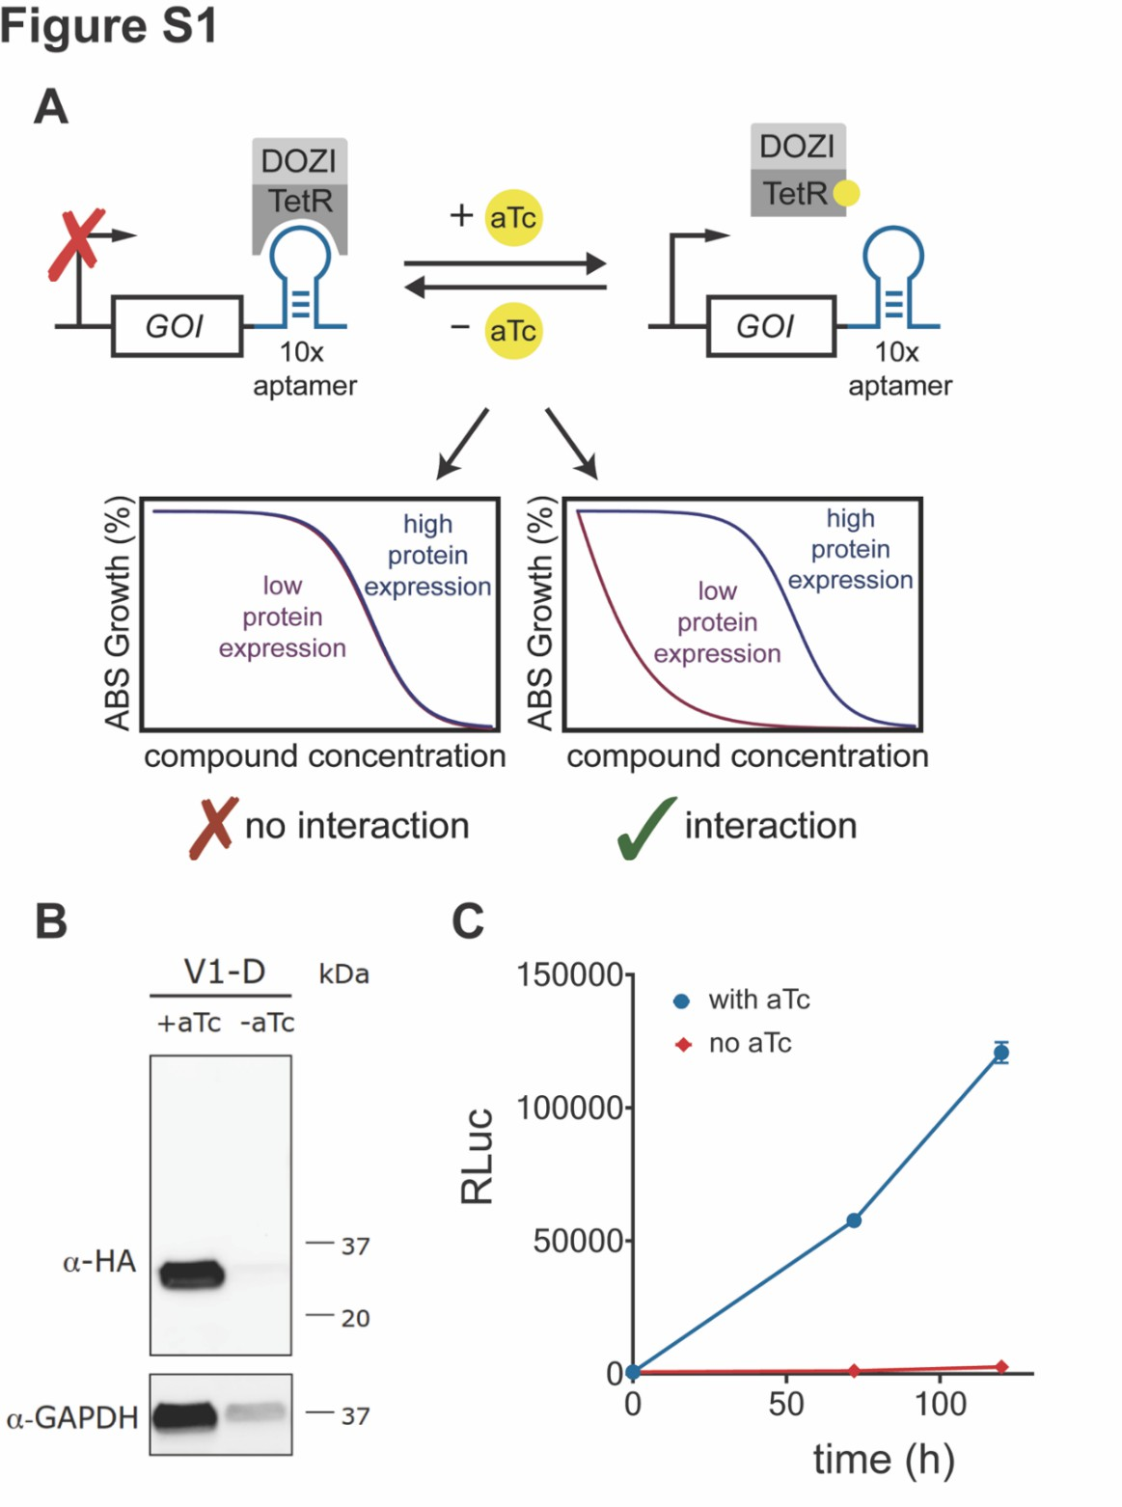
Supplementary Fig.1. Conditional knockdown (cKD) of PfV1-D. (A) Schematic representation of protein translation regulation using the TetR-DOZI-RNA aptamer module. (B) Western blot assessment of the ~28 kDa PfV1-D protein using anti-HA antibodies that target the 3×HA tag introduced together with the cKD machinery. Protein expression was maintained in the presence of 500 nM anhydrotetracycline (aTc), contrasting with undetectable levels upon aTC removal. GAPDH (PF3D7_1462800; ~37 kDa) was a loading control. (C) Renilla luciferase (RLuc) was integrated downstream of the cKD construct. The loss of its activity upon removal of aTC shows that PfV1-D expression is essential for parasite viability, contrasting with very high RLuc values in the presence of 500 nM aTc. Data were averaged from two biological repeats with technical duplicates.

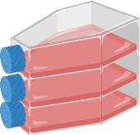
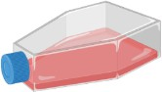
Figure S2
- 109 parasites/flask
- Hypermutable Dd2-Polδ
- 10× IC50 intermittent drug pressure

100 nM
intermittent pressure
100 nM
intermittent pressure
100 nM
intermittent pressure
100 nM
intermittent pressure
Cloning, IC50 phenotyping
and WGS
Day 0: Day 34: Day 71: Day 112: Day 136:
ZY19489 IC50 (nM):
Untreated Dd2-Polδ: 8.6 Untreated Dd2-Polδ: 9.4 Untreated Dd2-Polδ: 6.9 Untreated Dd2-Polδ: 8.2
Flask 1: 10.3 Flask 1: 8.3 Flask 1: 7.8 Flask 1: No recrudecence
Flask 2: 7.1 Flask 2: 10.4 Flask 2: 9.1 Flask 2: 96.4
Flask 3: 9.4 Flask 3: 7.3 Flask 3: 9.9 Flask 3: No recrudecence

Supplementary Fig. 2: Schematic detailing timelines and experimental approach used to select a ZY19489-resistant mutant P. falciparum line. The Dd2-Polδ clone was set up in triplicate flasks with intermittent drug pressure corresponding to 10× IC50 (100 nM) and tracked over time. Parasites in drug-pressured flasks were tested for shifts in IC50 values on days 34, 71, 112 and 136, and each time compared to untreated Dd2-Polδ parent (IC50 values highlighted in red). The final IC50 shift indicating the presence of a resistant parasite population was observed on day 136 in parasites from flask 2 and is highlighted in green. No recrudescence was observed in ZY19489-pressured flasks 1 or 3 up to day 160, at which

time selections were stopped.

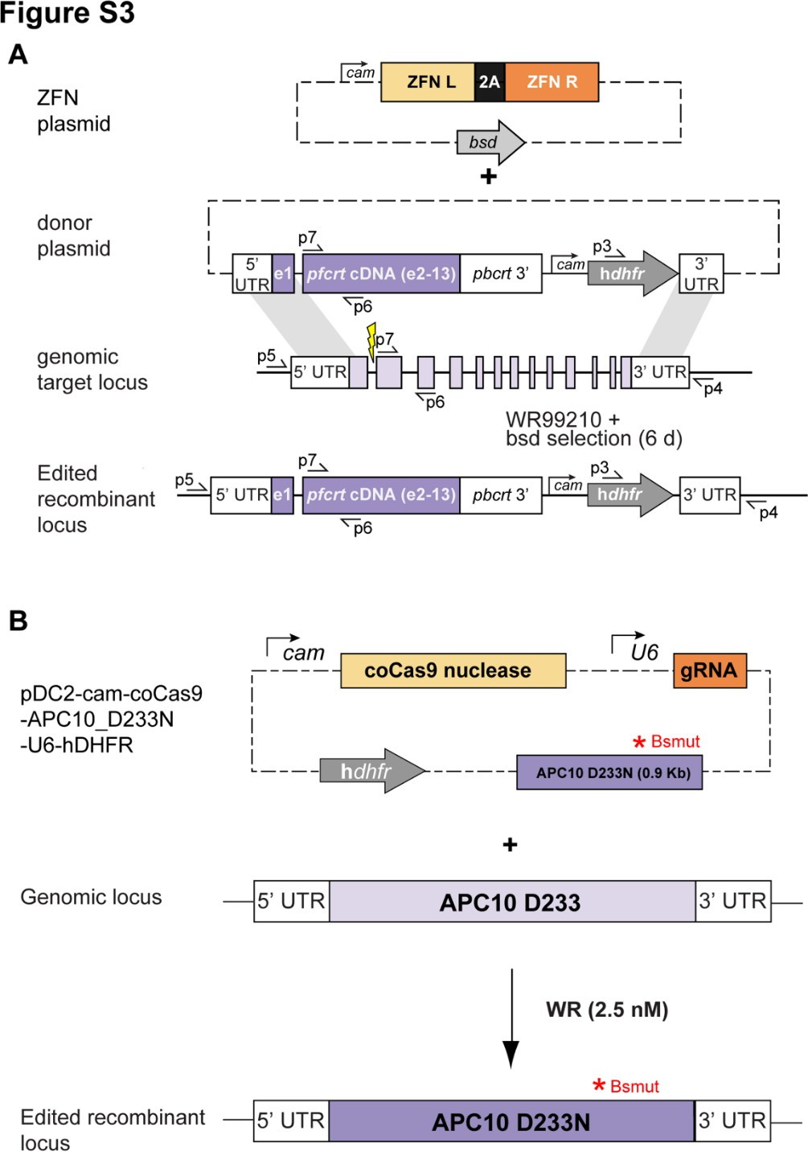

Supplementary Fig. 3: Schematic of pfcrt and pfapc10 gene editing. (A) Zinc-Finger Nuclease (ZFN)-mediated editing of pfcrt used a two-plasmid approach: one containing the donor and one containing pfcrt- specific ZFNs. Parasites were selected for expression of the human dihydrofolate reductase (hdhfr) selectable marker with 2.5 nM of the P. falciparum DHFR-specific inhibitor WR99210 and expression of the blasticidin S-deaminase selectable marker with a 6-day pulse of 2 μg/ml blasticidin hydrochloride. (B) Editing of pfapc10 was achieved using a CRISPR/Cas9 approach, including a homologous donor sequence harboring the mutant 233N codon. This donor fragment also contained synonymous mutations in the gRNA recognition site in the chromosomal locus, shown as the Bsmut site, which precluded further Cas9 editing of the edited locus.

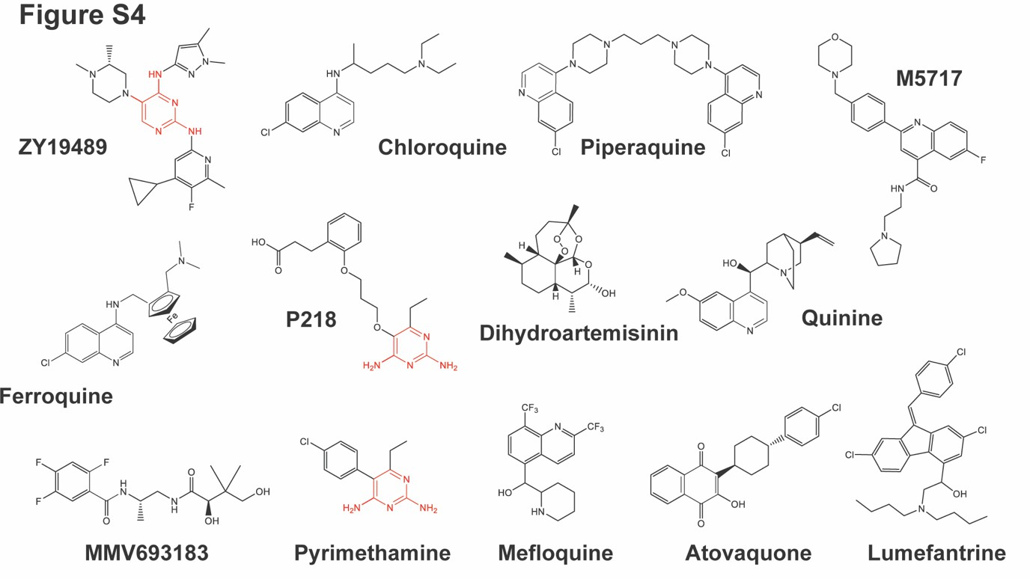
Supplementary Fig. 4: Chemical structures of antimalarial compounds included in this study. The red substructure illustrates the aminopyrimidine scaffold in ZY19489 and shared by the P. falciparum dihydrofolate reductase (DHFR) inhibitors P218 and pyrimethamine.

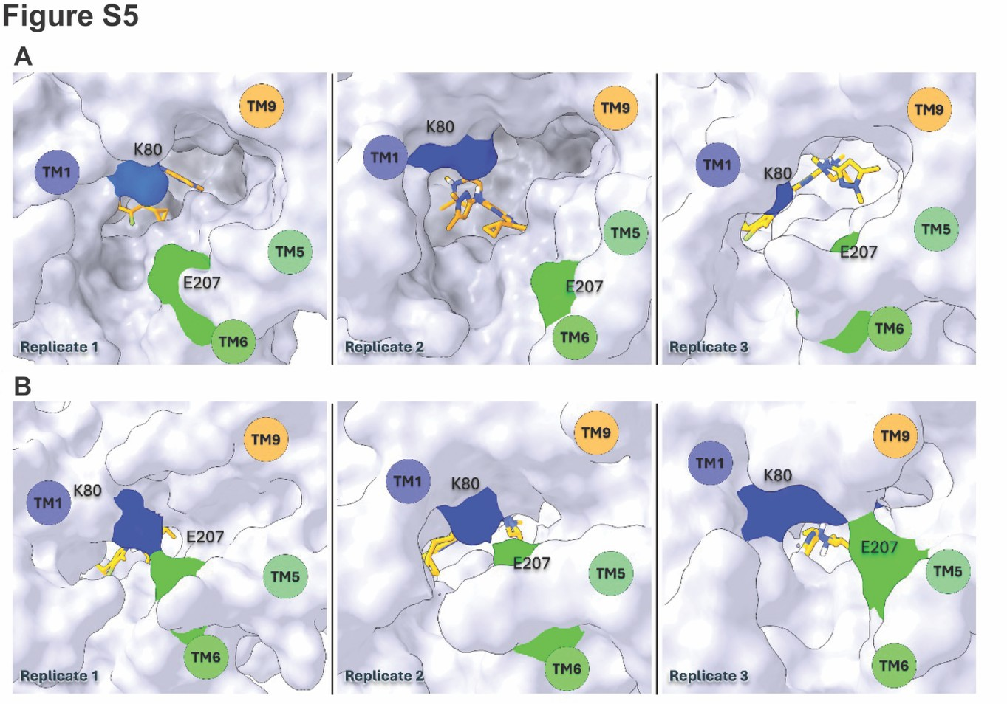
Supplementary Fig. 5: Molecular dynamics simulations showing intramolecular configurations for (A) 7G8 (wildtype) and (B) 7G8+N246H (mutant) PfCRT isoforms that differentially impact transporter interactions with ZY19489 (whose structure is shown as a stick figure). (A) Surface representations of 7G8 PfCRT, across three simulation replicates, indicate that the cavity remains open, facilitating ligand entry or exit. (B) The 7G8+N246H variant consistently transitions to a closed-to-DV conformation, marked by the formation of a salt bridge between residues K80 and E207 or nearby residues. We postulate that this modified configuration in the 7G8+N246H variant results in restricted access of ZY19489 to the drug binding and transport cavity.

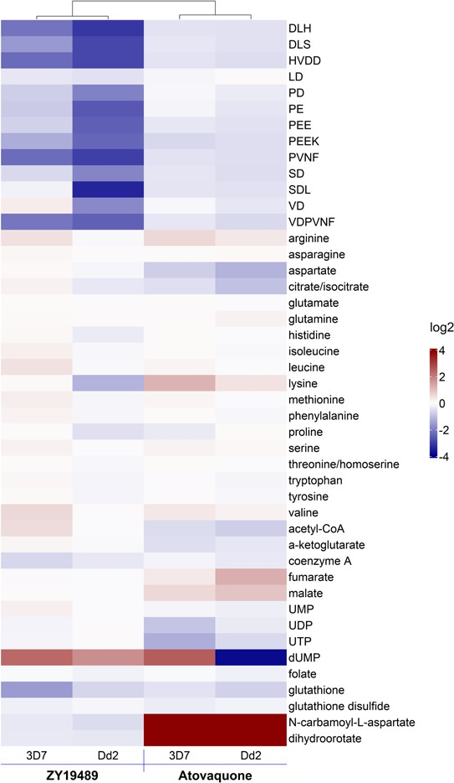
Figure S6
Supplementary Fig. 6: Metabolic profile of ZY19489- and atovaquone-treated parasites: Heatmap of log2 fold changes of 3D7 and Dd2 treated with ZY19489 or atovaquone and filtered to only include mitochondrial metabolites, peptides, amino acids, and metabolites from folate biosynthesis and central carbon metabolism. The complete list of all metabolites detected is presented in Table S12.

Figure S7

120
100
80
% Inhibition
60
40
20
0
10⁻² 10⁻¹ 10⁰ 10¹

10²

10³ 10⁴ 10⁵

ML-10 ZY19489 P218

[Drug] (nM)

Compound | Mean IC50 ± SEM (nM) | Mean IC90 ± SEM (nM)
ZY19489 | >100, 000 | NA
ML-10 | 0.09 ± 0.015 | 0.913 ± 0.35
P218 | >100, 000 | NA

Supplementary Fig. 7: Inhibition of recombinant P. falciparum cGMP-dependent protein kinase (PfPKG). Measurements of inhibition were based on the ADP-Glo Kinase Assay (Promega) that measures ADP formation. A Spectromax plate reader was used to measure luminescent signals from PfPKG protein incubated with the specific inhibitor ML-10 (black), ZY19489 (blue), or the parasite DHFR inhibitor P218 (green). Data were normalized based on the 100% activity controls (1% DMSO only) and the 100% inhibition controls (10 μM kinase inhibitor Staurosporine). Mean IC50 and IC90 values were calculated from 3 independent experiments with 4 technical repeats (N, n = 3,4). NA. not applicable.

IC50
(nM)
**
**

Supplementary Fig. 8: PfHDP expression levels do not impact ZY19489 activity against P. falciparum asexual blood stages. Prior data have suggested that PfHDP (P. falciparum hemozoin depolymerization protein) might impact production of hemozoin and by corollary, the activity of antiplasmodial compounds that interfere with heme detoxification. Using a strategy similar to that employed for PfV1-D, we generate a conditional knockdown of PfHDP (cKD PfDHP) in Dd2 parasites. These parasites were then cultured in 30 nM, 3 nM or 0 nM aTC to generate different levels of protein knockdown. 72-hour dose-response assays were performed on 4 to 5 separate occasions with technical duplicates. Results are shown as means ± SEM. The data showed no change in the ZY19489 IC₅₀ value across a range of PfHDP expression levels, consistent with this protein not impacting ZY19489 potency. Quinine showed a statistically significant increase in IC50 values as PfHDP levels were decreased, suggesting that PfHDP expression might contribute to ZY19489 activity.
Figure S8
400

300
*
ZY19489
Quinine
200
100
10
5
0
ZY19489
Quinine
Dd2
30 nM
3 nM
0 nM
Dd2
30 nM
3 nM
0 nM

IC50 (nM)




Supplementary Fig. 9: Evidence that falcipain 2A or 2B plays no part in parasite susceptibility to ZY19489. Data show mean ± SEM IC50 values for ZY19489 tested against the 3D7 parental line or isogenic lines in which falcipain 2A (FP2A) or 2B (FP2B) were deleted. As a comparator, we tested E64D, whose mode of action is thought to include falcipain 2. Here, lines deleted in FP2A or FP2B showed a gain of low-level resistance. Statistical significance was determined using Mann-Whitney U tests. *p<0.05.
15
10
5
0
400
800
ZY19489
E64D
1200
*
*
1600
Figure S9
3D7
3D7 FP2A KO
3D7 FP2B KO
3D7
3D7 FP2A KO
3D7 FP2B KO

Supplementary Table 1: Haplotypes of known drug resistance genes of the edited and control P. falciparum lines used in this study.

PfCRT haplotype PfMDR1 haplotype PfDHFR haplotype Pfpm2/3
copies
Parasite line | Origin | Edited | 72 | 74 | 75 | 76 | 145 | 220 | 246 | 271 | 326 | 343 | 356 | 371 | 86·184·1246 | Gene copies | 16·51·59·108·164
Dd2 | S.E. Asia | No | C | I | E | T | F | S | N | E | S | M | T | I | YYD | 2 | AIRNI | 1
Dd2-Polδ |  | Yes | C | I | E | T | F | S | N | E | S | M | T | I | YYD | 2 | AIRNI | 1
Dd2Dd2crt |  | Yes | C | I | E | T | F | S | N | E | S | M | T | I | YYD | 2 | AIRNI | 1
Dd2Dd2crt+N246H |  | Yes | C | I | E | T | F | S | H | E | S | M | T | I | YYD | 2 | AIRNI | 1
Dd2Dd2crt+M343L |  | Yes | C | I | E | T | F | S | N | E | S | L | T | I | YYD | 2 | AIRNI | 1
Dd2GB4crt |  | Yes | C | I | E | T | F | S | N | E | N | M | I | I | YYD | 2 | AIRNI | 1
Dd2GB4crt+N246H |  | Yes | C | I | E | T | F | S | H | E | S | M | T | I | YYD | 2 | AIRNI | 1
Dd2FCBcrt |  | Yes | C | I | E | T | F | S | N | E | S | M | I | I | YYD | 2 | AIRNI | 1
Dd2FCBcrt+N246H |  | Yes | C | I | E | T | F | S | H | E | S | M | I | I | YYD | 2 | AIRNI | 1
Dd2Dd2crt+apc10D233N |  | Yes | C | I | E | T | F | S | N | E | S | M | T | I | YYD | 2 | AIRNI | 1
Dd2HDP cKD |  | Yes | C | I | E | T | F | S | N | E | S | M | T | I | YYD | 2 | AIRNI | 1
FCB | Africa | No | C | I | E | T | F | S | N | E | S | M | I | I | SND | 2 | TNCTI | 1
FCB-KDmdr1 |  | Yes | C | I | E | T | F | S | N | E | S | M | I | I | SND | 1 | TNCTI | 1
3D7 | Africa | No | C | M | N | K | F | A | N | Q | N | M | I | R | NYD | 1 | ANCSI | 1
3D70087/N9 |  | Yes | C | M | N | K | F | A | N | Q | N | M | I | R | NYD | 1 | ANCSI | 1
NF54 | Africa | No | C | M | N | K | F | A | N | Q | N | M | I | R | NYD | 1 | ANCSI | 1
NF54V1-D cKD |  | Yes | C | M | N | K | F | A | N | Q | N | M | I | R | NYD | 1 | ANCSI | 1
RF7 | S.E. Asia | No | C | I | E | T | F | S | N | E | S | M | T | I | NFD | 1 | AIRNL | 3
7G8 | S. America | No | S | M | N | T | F | S | N | Q | D | M | L | R | NFY | 1 | AICNI | 1
7G87G8crt+F145I |  | Yes | S | M | N | T | I | S | N | Q | D | M | L | R | NFY | 1 | AICNI | 1
Cam3.II | S.E. Asia | No | C | I | E | T | F | S | N | E | S | M | T | I | NFD | 2 | AIRNI | 1
NF10 | S.E. Asia | No | C | I | E | T | F | S | N | E | S | M | T | I | YFD | 1 | AICNI | 1

Mutant residues are highlighted in bold and shaded in gray.

Supplementary Table 2: In vitro activity of ZY19489 against conditional knockdown (ckD) asexual blood- stage P. falciparum parasites expressing normal or reduced levels of subunit D of the P. falciparum vacuolar proton-transporting V-type ATPase complex (referred to as V1-D) upon culturing with 50 nM, 6 nM or 0 nM aTc.

Mean IC50 ± SEM
Compound | cKD line | (with aTc) | (low/no aTc) | IC50 fold shift | Comment
ZY19489 | V1-D | 7.2 ± 0.2 | 7.7 ± 0.1 | No shift | No interaction
 | control | 7.1 ± 1.3 | 6.7 ± 0.6 | No shift
Bafilomycin A | V1-D | 4.1 ± 0.1 | 1.7 ± 0.1 | 2.4× | Hypersensitive
Experiments were conducted on 2 independent occasions with technical duplicates.

Supplementary Table 3: In vitro 72-hour susceptibility of drug-selected bulk parasites and clones tested against ZY19489.

ZY19489
Parasite Line | IC50 (nM) | IC90 (nM)
Dd2-Polδ (parent) | 8.2 ± 0.5 | 18.4 ± 3.2
Dd2-Polδ Flask 2 (bulk) | 96.4 ± 5.8*** | 201.1 ± 12.4***
Flask 2 clone C8 (FL2-C8) | 110.6 ± 6.3** | 236.3 ± 9.9**
Flask 2 clone E3 (FL2-E3) | 107.8 ± 4.4** | 213.6 ± 12.1**
Flask 2 clone F7 (FL2-F7) | 106.8 ± 3.7** | 220.4 ± 9.7**
Flask 2 clone G2 (FL2-G2) | 104.8 ± 3.4** | 207.8 ± 13.1**
Data show mean ± SEM IC50 values, calculated from 5 to 7 independent experiments with technical duplicates. Values for the bulk resistant culture and the subsequent clones were compared against the Dd2-Polδ parent, with statistical significance determined using Mann-Whitney U tests. **p<0.01, ***p<0.005.

Supplementary Table 4: Genes located within the ~80kb amplified region of chromosome 5 in clone C8.

Gene ID | PlasmoDB annotation | FL2_C8 factor
PF3D7_0521900 | conserved Plasmodium protein, unknown function | 1.53
PF3D7_0522000 | conserved Plasmodium protein, unknown function | 1.53
PF3D7_0522100 | conserved Plasmodium protein, unknown function | 1.53
PF3D7_0522200 | transcription initiation factor TFIID subunit 10, putative | 1.53
PF3D7_0522300 | 18S rRNA (guanine-N(7))-methyltransferase, putative | 1.53
PF3D7_0522400 | conserved Plasmodium protein, unknown function | 1.53
PF3D7_0522500 | 50S ribosomal protein L17, apicoplast, putative | 1.53
PF3D7_0522600 | magnesium transporter NIPA, putative | 1.53
PF3D7_0522700 | iron-sulfur cluster assembly protein SufA | 1.53
PF3D7_0522800 | pre-mRNA-splicing factor BUD31, putative | 1.53
PF3D7_0522900 | zinc finger protein, putative | 1.53
PF3D7_0523000 | multidrug resistance protein 1 | 1.53
PF3D7_0523100 | mitochondrial-processing peptidase subunit alpha, putative | 1.53
PF3D7_0523200 | heptatricopeptide repeat-containing protein, putative | 1.53
PF3D7_0523300 | cytochrome c oxidase subunit ApiCOX18, putative | 1.53
This chromosome 5 segment is duplicated in Dd2-Polδ compared with the reference strain 3D7. The 1.53-fold amplification denoted herein is consistent with this region now being present as three tandem copies, compared with the presence of two tandem copies in parental Dd2-Polδ.

Supplementary Table 5: In vitro 72-hour susceptibility of edited parasites clones against ZY19489.

ZY19489
Parasite line/clone IC50 (nM) | IC90 (nM)
Dd2^{Dd2crt} 8.5 ± 0.4 | 16.9 ± 4.4
Dd2^{Dd2crt+N246H} clone A7 90.9 ± 4.1** | 178.1 ± 11.2**
Dd2^{Dd2crt+N246H} clone B9 89.1 ± 5.0** | 189.3 ± 9.3**
Dd2^{GB4crt} 8.6 ± 0.7 | 18.4 ± 2.1
Dd2^{GB4crt+N246H} 68.9 ± 7.1** | 138.7 ± 9.4**
Dd2^{FCBcrt} 18.5 ± 1.6 | 39.7 ± 6.7
Dd2FCBcrt+N246H 90.3 ± 8.8* | 179.7 ± 22.2*
Dd2^{Dd2apc10+D233N} clone C3 7.7 ± 0.7 | 17.6 ± 3.6
Dd2^{Dd2apc10+D233N} clone G7 8.8 ± 1.0 | 19.1 ± 1.4

Data show means ± SEM IC50 values, calculated from 4 to 6 independent experiments with technical duplicates. Significance was determined using Mann-Whitney U tests; *p<0.05, **p<0.01.

Supplementary Table 6: In vitro 72-hour potency of APC10 and ubiquitin ligase inhibitors and chloroquine as a control inhibitor against Dd2^{Dd2} and Dd2^{Dd2crt+apc10} ^{D233N} parasites.
i
 | Nutlin-3 |  | Thal | domide | pro-TA | ME | Chlo | roquine
Parasite line | IC50 (nM) | IC90 (nM) | IC50 (nM | IC90 (nM) | IC50 (nM) | IC90 (nM) | IC50 (nM) | IC90 (nM)
Dd2Dd2 | 5656 ± 511 | 9129 ± 714 | 85218 ± 5061 | 115735 ± 1111 | 58427 ± 7096 | 91019 ± 11341 | 94.6 ± 6.6 | 177.3 ± 24.1
Dd2Dd2+apc10 D233N | 5396 ± 451 | 8519 ± 866 | 88416 ± 3271 | 118591 ± 1263 | 55693 ± 2791 | 94629 ± 8497 | 84.9 ± 8.4 | 171.8 ± 31.3

Data show means ± SEM, calculated from 4 to 5 independent experiments with technical duplicates. Statistical significance was tested using Mann-Whitney U tests.

Supplementary Table 7: In vitro 72-hour susceptibility of FCB and FCB-KD^{mdr1} parasites against ZY19489, mefloquine (MFQ) and lumefantrine (LMF).

Parasite line/clone | ZY19489 IC50 (nM) IC90 (nM) | MFQ IC50 (nM IC90 (nM) | LMF IC50 (nM) IC90 (nM)
FCB | 8.7 ± 0.6 15.7 ± 0.6 | 10.0 ± 0.6 23.9 ± 3.4 | 1.9 ± 0.2 3.1 ± 0.4
FCB-KD^{mdr1} | 8.5 ± 0.8 17.4 ± 2.8 | 5.1 ± 0.4** 10.7 ± 1.1** | 1.0 ± 0.1* 1.9 ± 0.1*
Data show means ± SEM IC50 values, calculated from 4 to 6 independent experiments with technical duplicates. Significance was determined using Mann-Whitney U tests; *p<0.05, **p<0.01.
FCB has two 100-kb amplicons that each contain 1 copy of pfmdr1 whereas FCB-KD^{mdr1} expresses only one due to targeted disruption of the second copy.

Supplementary Table 8 (p1). List of 34 genes in the chromosome 7 QTL peak harboring non-synonymous mutations between RF7 and NF54
Gene | AA_change | Codon change | Description | pos | ref | alt
PF3D7_0703900 | T3212N | aCt/aAt | conserved Plasmodium membrane protein, unknown function | 156762 | G | T
PF3D7_0703900 | V3173I | Gtt/Att | conserved Plasmodium membrane protein, unknown function | 156880 | C | T
PF3D7_0703900 | S2890N | aGt/aAt | conserved Plasmodium membrane protein, unknown function | 157728 | C | T
PF3D7_0703900 | A2175S | Gct/Tct | conserved Plasmodium membrane protein, unknown function | 159874 | C | A
PF3D7_0703900 | R2174S | agA/agT | conserved Plasmodium membrane protein, unknown function | 159875 | T | A
PF3D7_0703900 | N2157H | Aat/Cat | conserved Plasmodium membrane protein, unknown function | 159928 | T | G
PF3D7_0703900 | H2102N | Cat/Aat | conserved Plasmodium membrane protein, unknown function | 160093 | G | T
PF3D7_0703900 | L1955F | ttA/ttC | conserved Plasmodium membrane protein, unknown function | 160532 | T | G
PF3D7_0703900 | M1880V | Atg/Gtg | conserved Plasmodium membrane protein, unknown function | 160759 | T | C
PF3D7_0703900 | Q1410H | caA/caT | conserved Plasmodium membrane protein, unknown function | 162167 | T | A
PF3D7_0703900 | T848I | aCt/aTt | conserved Plasmodium membrane protein, unknown function | 163854 | G | A
PF3D7_0703900 | N377K | aaC/aaA | conserved Plasmodium membrane protein, unknown function | 165266 | G | T
PF3D7_0703900 | E248K | Gaa/Aaa | conserved Plasmodium membrane protein, unknown function | 165655 | C | T
PF3D7_0704000 | K2678E | Aag/Gag | conserved Plasmodium membrane protein, unknown function | 169264 | T | C
PF3D7_0704000 | I2662M | atA/atG | conserved Plasmodium membrane protein, unknown function | 169310 | T | C
PF3D7_0704000 | Q2464K | Caa/Aaa | conserved Plasmodium membrane protein, unknown function | 169906 | G | T
PF3D7_0704000 | S1975C | Agt/Tgt | conserved Plasmodium membrane protein, unknown function | 171373 | T | A
PF3D7_0704000 | M1744I | atG/atC | conserved Plasmodium membrane protein, unknown function | 172064 | C | G
PF3D7_0704000 | K1661N | aaA/aaT | conserved Plasmodium membrane protein, unknown function | 172313 | T | A
PF3D7_0704000 | G422D | gGt/gAt | conserved Plasmodium membrane protein, unknown function | 176031 | C | T
PF3D7_0704100 | L66I | Cta/Ata | basal complex transmembrane protein 2 | 180231 | C | A
PF3D7_0704100 | E152K | Gaa/Aaa | basal complex transmembrane protein 2 | 180489 | G | A
PF3D7_0704100 | G804V | gGt/gTt | basal complex transmembrane protein 2 | 182446 | G | T
PF3D7_0704100 | S1084C | Agt/Tgt | basal complex transmembrane protein 2 | 183285 | A | T
PF3D7_0704100 | I1373N | aTt/aAt | basal complex transmembrane protein 2 | 184153 | T | A
PF3D7_0704100 | N1377I | aAt/aTt | basal complex transmembrane protein 2 | 184165 | A | T
PF3D7_0704100 | K2486N | aaG/aaT | basal complex transmembrane protein 2 | 187493 | G | T
PF3D7_0704200 | D1069H | Gat/Cat | tRNA m5C-methyltransferase, putative | 191686 | C | G
PF3D7_0704200 | Y950C | tAt/tGt | tRNA m5C-methyltransferase, putative | 192042 | T | C
PF3D7_0704200 | S713N | aGt/aAt | tRNA m5C-methyltransferase, putative | 192753 | C | T
PF3D7_0704200 | L700I | Tta/Ata | tRNA m5C-methyltransferase, putative | 192793 | A | T
PF3D7_0704300 | I1482K | aTa/aAa | conserved Plasmodium membrane protein, unknown function | 202135 | T | A
PF3D7_0704300 | I1487K | aTa/aAa | conserved Plasmodium membrane protein, unknown function | 202150 | T | A
PF3D7_0704300 | I1512K | aTa/aAa | conserved Plasmodium membrane protein, unknown function | 202225 | T | A
PF3D7_0704300 | K1527E | Aaa/Gaa | conserved Plasmodium membrane protein, unknown function | 202269 | A | G
PF3D7_0704300 | G1530D | gGt/gAt | conserved Plasmodium membrane protein, unknown function | 202279 | G | A
PF3D7_0704400 | K454N | aaG/aaT | phosphoinositide-binding protein, putative | 206079 | G | T
PF3D7_0704500 | G799V | gGa/gTa | serine/threonine protein kinase, putative | 211106 | C | A
PF3D7_0704500 | D784H | Gat/Cat | serine/threonine protein kinase, putative | 211152 | C | G
PF3D7_0704500 | S500R | agT/agA | serine/threonine protein kinase, putative | 212002 | A | T
PF3D7_0704600 | H3608P | cAt/cCt | HECT-type E3 ubiquitin ligase UT | 218066 | T | G
PF3D7_0704600 | N2311K | aaT/aaG | HECT-type E3 ubiquitin ligase UT | 221956 | A | C
PF3D7_0704600 | N2125D | Aat/Gat | HECT-type E3 ubiquitin ligase UT | 222516 | T | C
PF3D7_0704600 | P1667H | cCt/cAt | HECT-type E3 ubiquitin ligase UT | 223889 | G | T
PF3D7_0704600 | K1587E | Aaa/Gaa | HECT-type E3 ubiquitin ligase UT | 224130 | T | C
PF3D7_0704600 | E1585K | Gaa/Aaa | HECT-type E3 ubiquitin ligase UT | 224136 | C | T
PF3D7_0704600 | D1419N | Gat/Aat | HECT-type E3 ubiquitin ligase UT | 224634 | C | T
PF3D7_0704600 | Y1387F | tAt/tTt | HECT-type E3 ubiquitin ligase UT | 224729 | T | A
PF3D7_0704600 | P1384A | Cct/Gct | HECT-type E3 ubiquitin ligase UT | 224739 | G | C
PF3D7_0704600 | N1375S | aAt/aGt | HECT-type E3 ubiquitin ligase UT | 224765 | T | C
PF3D7_0704600 | Y1232C | tAt/tGt | HECT-type E3 ubiquitin ligase UT | 225194 | T | C
PF3D7_0704600 | R735K | aGg/aAg | HECT-type E3 ubiquitin ligase UT | 226685 | C | T
PF3D7_0704600 | P535L | cCa/cTa | HECT-type E3 ubiquitin ligase UT | 227285 | G | A
PF3D7_0704600 | C490S | Tgt/Agt | HECT-type E3 ubiquitin ligase UT | 227421 | A | T
PF3D7_0704700 | A804V | gCt/gTt | phosphopantetheine adenylyltransferase, putative | 235811 | C | T
PF3D7_0704700 | R1037S | agG/agT | phosphopantetheine adenylyltransferase, putative | 236511 | G | T
PF3D7_0704800 | E1059Q | Gaa/Caa | protein phosphatase PPM12, putative | 238878 | C | G
PF3D7_0704800 | N422D | Aac/Gac | protein phosphatase PPM12, putative | 240789 | T | C
PF3D7_0704800 | M421L | Atg/Ttg | protein phosphatase PPM12, putative | 240792 | T | A
PF3D7_0704800 | A419S | Gca/Tca | protein phosphatase PPM12, putative | 240798 | C | A
PF3D7_0704800 | D417N | Gac/Aac | protein phosphatase PPM12, putative | 240804 | C | T
PF3D7_0704800 | L416M | Ttg/Atg | protein phosphatase PPM12, putative | 240807 | A | T

Supplementary Table 8 (p2). List of 34 genes in the chromosome 7 QTL peak harboring non-synonymous mutations between RF7 and NF54
Gene | AA_change | Codon change | Description | pos | ref | alt
PF3D7_0704800 | H415N | Cat/Aat | protein phosphatase PPM12, putative | 240810 | G | T
PF3D7_0704800 | A414E | gCa/gAa | protein phosphatase PPM12, putative | 240812 | G | T
PF3D7_0704800 | D412N | Gac/Aac | protein phosphatase PPM12, putative | 240819 | C | T
PF3D7_0705000 | I260N | aTt/aAt | mRNA cap guanine-N7 methyltransferase, putative | 249374 | A | T
PF3D7_0705100 | I29M | atC/atG | conserved Plasmodium protein, unknown function | 252368 | C | G
PF3D7_0705100 | R564S | agG/agT | conserved Plasmodium protein, unknown function | 253973 | G | T
PF3D7_0705100 | N581K | aaT/aaA | conserved Plasmodium protein, unknown function | 254024 | T | A
PF3D7_0705100 | N585D | Aac/Gac | conserved Plasmodium protein, unknown function | 254034 | A | G
PF3D7_0705100 | G722D | gGc/gAc | conserved Plasmodium protein, unknown function | 254446 | G | A
PF3D7_0705200 | I594V | Ata/Gta | conserved Plasmodium protein, unknown function | 257865 | A | G
PF3D7_0705200 | K643Q | Aaa/Caa | conserved Plasmodium protein, unknown function | 258012 | A | C
PF3D7_0705200 | T717A | Aca/Gca | conserved Plasmodium protein, unknown function | 258234 | A | G
PF3D7_0705300 | A101T | Gcc/Acc | origin recognition complex subunit 2 | 262277 | G | A
PF3D7_0705500 | G2736D | gGc/gAc | inositol-phosphate phosphatase, putative | 270260 | C | T
PF3D7_0705500 | H2584Y | Cat/Tat | inositol-phosphate phosphatase, putative | 270957 | G | A
PF3D7_0705500 | Y1206D | Tat/Gat | inositol-phosphate phosphatase, putative | 275091 | A | C
PF3D7_0705500 | M443I | atG/atA | inositol-phosphate phosphatase, putative | 277378 | C | T
PF3D7_0706000 | K1135N | aaA/aaT | importin-7, putative | 296804 | A | T
PF3D7_0706100 | S1334R | Agc/Cgc | conserved Plasmodium protein, unknown function | 298651 | T | G
PF3D7_0706100 | N934Y | Aat/Tat | conserved Plasmodium protein, unknown function | 299971 | T | A
PF3D7_0706500 | N1364K | aaT/aaG | conserved Plasmodium protein, unknown function | 310931 | A | C
PF3D7_0706500 | Y1358N | Tat/Aat | conserved Plasmodium protein, unknown function | 310951 | A | T
PF3D7_0706500 | N436S | aAt/aGt | conserved Plasmodium protein, unknown function | 313716 | T | C
PF3D7_0706500 | S406N | aGt/aAt | conserved Plasmodium protein, unknown function | 313806 | C | T
PF3D7_0706600 | N81H | Aat/Cat | conserved Plasmodium protein, unknown function | 320488 | A | C
PF3D7_0707200 | I1025N | aTt/aAt | conserved Plasmodium protein, unknown function | 333252 | A | T
PF3D7_0707200 | I1007N | aTt/aAt | conserved Plasmodium protein, unknown function | 333306 | A | T
PF3D7_0707200 | D985G | gAt/gGt | conserved Plasmodium protein, unknown function | 333372 | T | C
PF3D7_0707200 | H983D | Cat/Gat | conserved Plasmodium protein, unknown function | 333379 | G | C
PF3D7_0707200 | C982S | Tgt/Agt | conserved Plasmodium protein, unknown function | 333382 | A | T
PF3D7_0707200 | F973L | ttT/ttA | conserved Plasmodium protein, unknown function | 333407 | A | T
PF3D7_0707200 | I942M | atT/atG | conserved Plasmodium protein, unknown function | 333500 | A | C
PF3D7_0707500 | I979M | atT/atG | conserved Plasmodium protein, unknown function | 351213 | T | G
PF3D7_0707500 | V1420I | Gta/Ata | conserved Plasmodium protein, unknown function | 352534 | G | A
PF3D7_0707700 | R237K | aGa/aAa | E3 ubiquitin-protein ligase, putative | 358409 | G | A
PF3D7_0707700 | S577G | Agt/Ggt | E3 ubiquitin-protein ligase, putative | 359428 | A | G
PF3D7_0708200 | E795D | gaA/gaT | conserved Plasmodium protein, unknown function | 374723 | T | A
PF3D7_0708200 | S526G | Agt/Ggt | conserved Plasmodium protein, unknown function | 375818 | T | C
PF3D7_0708200 | R289K | aGa/aAa | conserved Plasmodium protein, unknown function | 376528 | C | T
PF3D7_0708500 | D801N | Gat/Aat | heat shock protein 86 family protein | 385921 | C | T
PF3D7_0708500 | E466K | Gaa/Aaa | heat shock protein 86 family protein | 386926 | C | T
PF3D7_0708500 | K154N | aaG/aaT | heat shock protein 86 family protein | 387860 | C | A
PF3D7_0708700 | D200E | gaT/gaA | Cg8 protein | 391589 | A | T
PF3D7_0709000 | M74I | atG/atT | chloroquine resistance transporter | 403620 | G | T
PF3D7_0709000 | N75D | Aat/Gat | chloroquine resistance transporter | 403621 | A | G
PF3D7_0709000 | N75K | aaT/aaA | chloroquine resistance transporter | 403623 | T | A
PF3D7_0709000 | K76T | aAa/aCa | chloroquine resistance transporter | 403625 | A | C
PF3D7_0709000 | A220S | Gcc/Tcc | chloroquine resistance transporter | 404407 | G | T
PF3D7_0709000 | Q271E | Caa/Gaa | chloroquine resistance transporter | 404836 | C | G
PF3D7_0709000 | N326S | aAc/aGc | chloroquine resistance transporter | 405362 | A | G
PF3D7_0709000 | M343L | Atg/Ttg | chloroquine resistance transporter | 405560 | A | T
PF3D7_0709000 | I356T | aTa/aCa | chloroquine resistance transporter | 405600 | T | C
PF3D7_0709000 | R371I | aGa/aTa | chloroquine resistance transporter | 405838 | G | T
PF3D7_0709100 | E161D | gaA/gaC | Cg1 protein | 408697 | A | C
PF3D7_0709100 | V177I | Gtc/Atc | Cg1 protein | 408743 | G | A
PF3D7_0709100 | N608D | Aat/Gat | Cg1 protein | 410036 | A | G
PF3D7_0709100 | P676S | Cca/Tca | Cg1 protein | 410240 | C | T
PF3D7_0709100 | T732R | aCg/aGg | Cg1 protein | 410409 | C | G
PF3D7_0709100 | S740P | Tca/Cca | Cg1 protein | 410432 | T | C
PF3D7_0709100 | M828I | atG/atA | Cg1 protein | 410698 | G | A
PF3D7_0709100 | K1121N | aaA/aaC | Cg1 protein | 411577 | A | C
PF3D7_0709100 | N1122D | Aac/Gac | Cg1 protein | 411578 | A | G

Supplementary Table 8 (p3). List of 34 genes in the chromosome 7 QTL peak harboring non-synonymous mutations between RF7 and NF54
Gene | AA change | Codon change | Description | pos | ref | alt
PF3D7_0709100 | E1128V | gAa/gTa | Cg1 protein | 411597 | A | T
PF3D7_0709100 | E1128D | gaA/gaT | Cg1 protein | 411598 | A | T
PF3D7_0709200 | L124V | Ctt/Gtt | glutaredoxin-like protein | 412792 | G | C
PF3D7_0709200 | G114E | gGg/gAg | glutaredoxin-like protein | 412821 | C | T
PF3D7_0709300 | S2483N | aGt/aAt | Cg2 protein | 414302 | C | T
PF3D7_0709300 | L2379M | Ttg/Atg | Cg2 protein | 414615 | A | T
PF3D7_0709300 | G2334C | Ggt/Tgt | Cg2 protein | 414750 | C | A
PF3D7_0709300 | M2325I | atG/atA | Cg2 protein | 414775 | C | T
PF3D7_0709300 | M2325K | aTg/aAg | Cg2 protein | 414776 | A | T
PF3D7_0709300 | K2324N | aaA/aaT | Cg2 protein | 414778 | T | A
PF3D7_0709300 | M2319I | atG/atA | Cg2 protein | 414793 | C | T
PF3D7_0709300 | M2313I | atG/atA | Cg2 protein | 414811 | C | T
PF3D7_0709300 | D2205N | Gat/Aat | Cg2 protein | 415137 | C | T
PF3D7_0709300 | H2169Y | Cat/Tat | Cg2 protein | 415245 | G | A
PF3D7_0709300 | N2167S | aAt/aGt | Cg2 protein | 415250 | T | C
PF3D7_0709300 | H2074P | cAt/cCt | Cg2 protein | 415529 | T | G
PF3D7_0709300 | Q2069H | caA/caC | Cg2 protein | 415543 | T | G
PF3D7_0709300 | V2042G | gTt/gGt | Cg2 protein | 415625 | A | C
PF3D7_0709300 | S1992N | aGt/aAt | Cg2 protein | 415775 | C | T
PF3D7_0709300 | L1883V | Cta/Gta | Cg2 protein | 416103 | G | C
PF3D7_0709300 | S1426C | Agt/Tgt | Cg2 protein | 417474 | T | A
PF3D7_0709300 | M1350I | atG/atA | Cg2 protein | 417700 | C | T
PF3D7_0709300 | F989L | ttC/ttA | Cg2 protein | 418783 | G | T
PF3D7_0709300 | Y814N | Tat/Aat | Cg2 protein | 419310 | A | T
PF3D7_0709300 | Y716F | tAt/tTt | Cg2 protein | 419603 | T | A
PF3D7_0709300 | G281A | gGa/gCa | Cg2 protein | 420908 | C | G
PF3D7_0709300 | H275Q | caC/caG | Cg2 protein | 420925 | G | C
PF3D7_0709400 | Y172H | Tat/Cat | Cg7 protein | 426721 | A | G
PF3D7_0709400 | V161E | gTg/gAg | Cg7 protein | 426753 | A | T
PF3D7_0709600 | K325N | aaA/aaT | ribonucleases P/MRP protein subunit POP1, putative | 432784 | T | A
PF3D7_0709600 | D80E | gaT/gaA | ribonucleases P/MRP protein subunit POP1, putative | 433519 | A | T
PF3D7_0709700 | M261I | atG/atA | prodrug activation and resistance esterase | 435413 | C | T
PF3D7_0709900 | T368S | Act/Tct | conserved protein, unknown function | 444780 | T | A
PF3D7_0709900 | T362I | aCa/aTa | conserved protein, unknown function | 444797 | G | A
PF3D7_0709900 | H338Y | Cat/Tat | conserved protein, unknown function | 444870 | G | A
PF3D7_0709900 | S336C | tCc/tGc | conserved protein, unknown function | 444875 | G | C
PF3D7_0709900 | V267G | gTa/gGa | conserved protein, unknown function | 445082 | A | C
PF3D7_0710000 | D3098E | gaC/gaG | conserved Plasmodium protein, unknown function | 448025 | G | C
PF3D7_0710000 | D3077E | gaC/gaG | conserved Plasmodium protein, unknown function | 448088 | G | C
PF3D7_0710000 | T2583I | aCa/aTa | conserved Plasmodium protein, unknown function | 449571 | G | A
PF3D7_0710000 | L2544F | ttA/ttT | conserved Plasmodium protein, unknown function | 449687 | T | A
PF3D7_0710000 | I2543L | Ata/Tta | conserved Plasmodium protein, unknown function | 449692 | T | A
PF3D7_0710000 | D2510V | gAt/gTt | conserved Plasmodium protein, unknown function | 449790 | T | A
PF3D7_0710000 | Y2435H | Tat/Cat | conserved Plasmodium protein, unknown function | 450016 | A | G
PF3D7_0710000 | H2299N | Cat/Aat | conserved Plasmodium protein, unknown function | 450424 | G | T
PF3D7_0710000 | S2065G | Agt/Ggt | conserved Plasmodium protein, unknown function | 451126 | T | C
PF3D7_0710000 | I1962L | Ata/Tta | conserved Plasmodium protein, unknown function | 451435 | T | A
PF3D7_0710000 | K1893N | aaA/aaC | conserved Plasmodium protein, unknown function | 451640 | T | G
PF3D7_0710000 | D1881G | gAc/gGc | conserved Plasmodium protein, unknown function | 451677 | T | C
PF3D7_0710000 | Y1782N | Tat/Aat | conserved Plasmodium protein, unknown function | 451975 | A | T
PF3D7_0710000 | S1663L | tCg/tTg | conserved Plasmodium protein, unknown function | 452331 | G | A
PF3D7_0710000 | T1658K | aCa/aAa | conserved Plasmodium protein, unknown function | 452346 | G | T
PF3D7_0710000 | E1519Q | Gag/Cag | conserved Plasmodium protein, unknown function | 452764 | C | G
PF3D7_0710000 | I909L | Ata/Tta | conserved Plasmodium protein, unknown function | 455550 | T | A
PF3D7_0710000 | M883I | atG/atT | conserved Plasmodium protein, unknown function | 455626 | C | A
PF3D7_0710000 | M755I | atG/atC | conserved Plasmodium protein, unknown function | 456232 | C | G
PF3D7_0710000 | Q655H | caA/caC | conserved Plasmodium protein, unknown function | 456532 | T | G

The following progeny harbor the RF7 parental sequence: HapN (msX1_msX1LR_RF7_HapN); HapG (msX1_msX1LR_46056_25_C3_HapG); HapI (msX1_nxX1_46056_4_F2_A8_HapI); HapO
(msX1_nxX1_46056_0618_mdCQ_B7_HapO); HapQ (msX1_nxX1_46056_1117_PPQ_1F2_HapQ); HapR (msX1_nxX1_46056_1117_PPQ_1F3_HapR); HapS (msX1_nxX1_46056_1117_PPQ_1F9_HapS2); HapU (msX1_nxX1_46056_1117_PPQ_2E9_HapU); HapV (msX1_nxX1_46056_1117_PPQ_2G8_HapV); HapW (msX1_nxX1_46056_1117_PYM_A4_HapW); HapX (msX1_nxX1_46056_1117_PYM_B4_HapX); HapZ (msX1_nxX1_46056_1117_PYM_C3_HapZ); Hap8 (msX1_nxX1_46056_1117_mdCQ_1G6_Hap8); Hap9
(msX1_nxX1_46056_1117_mdCQ_2A6_Hap9); Hap7 (msX1_nxX1_46056_1117_mdCQ_2E3_Hap7); Hap10 (msX1_nxX1_46056_1117_mdCQ_3D2_Hap10).

The following progeny harbor the NF54 parental sequence: HapA (msX1_msX1LR_NF54_HapA); HapH
(msX1_msX1LR_45915_5_F5_HapH); HapF (msX1_msX1LR_46033_3_D4_HapF); HapJ (msX1_nsX1LR_10B3_HapJ); HapL (msX1_nsX1LR_7G4_HapL); HapB (msX1_nxX1_46033_1_E6_HapB); HapE (msX1_nxX1_46033_5_D9_G7_HapE); HapK (msX1_nxX1_46033_mdCQ_5_HapK); HapD ()msX1_nxX1_46056_8_D11_G3_HapD); HapM
(msX1_nxX1_46056_9_E12_E5_HapM); HapC (msX1_nxX1_46056_DHAx2_4_6_HapC); HapP
(msX1_nxX1_46056_0618_mdCQ_G8_HapP); HapT (msX1_nxX1_46056_1117_PPQ_1D8_HapT); HapY (msX1_nxX1_46056_1117_PYM_B6_HapY); Hap1 (msX1_nxX1_46056_1117_PYM_C6_Hap1); Hap2 (msX1_nxX1_46056_1117_PYM_E3_Hap2); Hap3 (msX1_nxX1_46056_1117_PYM_F3_Hap3); Hap4 (msX1_nxX1_46056_1117_PYM_F4_Hap4); Hap5 (msX1_nxX1_46056_1117_PYM_G11_Hap5); Hap6 (msX1_nxX1_46056_1117_PYM_G7_Hap6).

Supplementary Table 9: In vitro 72-hour susceptibility of Dd2^{Dd2crt}, Dd2^{Dd2crt} ^{N246H} , Dd2^{GB4crt} and Dd2^{GB4crtN246H} against ferroquine (FQ), chloroquine (CQ), piperaquine (PPQ), mono-desethylamodiaquine (DEAQ), lumefantrine (LMF), atovaquone (ATQ) and dihydroartemisinin (DHA).

 |  |  |  |  |  | DEAQ | DEAQ | LMF |  | ATQ | ATQ | DHA | DHA
Parasite line FQ IC50 | FQ IC90 | CQ IC50 | CQ IC90 | PPQ IC50 | PPQ IC90 | IC50 | IC90 | IC50 | LMF IC90 | IC50 | IC90 | IC50 | IC90
Dd2Dd2crt 18.4 ± 1.2 | 39.1 ± 2.3 | 103.5 ± 5.7 | 217.4 ± 11.3 | 12.0 ± 1.0 | 22.3 ± 4.6 | 43.8 ± 5.9 | 78.7 ± 8.8 | 6.0 ± 1.2 | 11.2 ± 1.8 | 2.5 ± 0.4 | 5.3 ± 0.7 | 2.6 ± 0.2 | 4.7 ± 0.6
Dd2Dd2crt+N246H 6.6 ± 0.8* | 17.2 ± 1.4 | 10.9 ± 2.1* | 23.8 ± 1.7 | 3.7 ± 0.5* | 9.3 ± 1.4 | 7.7 ± 0.5** | 16.2 ± 1.7 | 4.9 ± 0.7 | 9.3 ± 1.2 | 2.6 ± 0.2 | 4.4 ± 0.4 | 3.0 ± 0.2 | 6.2 ± 0.5
Dd2GB4crt 21.1 ± 2.1 | 37.8 ± 4.4 | 79.8 ± 5.6 | 137.4 ± 9.8 | 9.4 ± 1.2 | 16.3 ± 2.9 | 36.9 ± 4.0 | 67.9 ± 9.4 | 3.4 ± 0.5 | 7.2 ± 1.2 | 1.9 ± 0.3 | 4.1 ± 0.6 | 2.2 ± 0.2 | 3.9 ± 0.3
Dd2GB4crt+N246H 7.3 ± 0.8* | 13.9 ± 2.7 | 7.2 ± 0.7* | 15.3 ± 1.4 | 2.9 ± 0.4* | 4.7 ± 0.8 | 5.6 ± 0.7** | 11.82 ± 1.3 | 2.8 ± 0.4 | 5.3 ± 0.9 | 2.3 ± 0.3 | 3.9 ± 0.8 | 1.7 ± 0.3 | 3.5 ± 0.6
Data show means ± SEM IC50 values, calculated from 4 to 6 independent experiments with technical duplicates. Significance was determined using Mann- Whitney U tests; *p<0.05, **p<0.01.

Supplementary Table 10: In vitro 72-hour susceptibility of edited and drug-selected PfCRT and PfMDR1 mutants tested against ZY19489. The mutations studied herein represent some of the currently circulating alleles in the field.

ZY19489
Parasite line/clone | IC50 (nM) | IC90 (nM)
Dd2Dd2crt | 10.2 ± 0.8 | 19.8 ± 1.1
Dd23D7crt | 7.1 ± 0.8 | 15.8 ± 1.2
Dd2Dd2crt+T93S | 9.5 ± 0.7 | 20.5 ± 1.5
Dd2Dd2crt+H97Y | 9.4 ± 1.0 | 21.7 ± 1.6
Dd2Dd2crt+F145I | 11.5 ± 1.1 | 22.3 ± 2.3
Dd2Dd2crt+I218F | 8.3 ± 0.6 | 18.5 ± 2.1
Dd2Dd2crt+M343L | 9.4 ± 0.7 | 21.4 ± 1.7
Dd2Dd2crt+G353V | 13.7 ± 0.9 | 20.7 ± 1.7
7G87G8crt | 13.6 ± 0.7 | 18.6 ± 1.4
7G87G8crt+C350R | 14.0 ± 0.7 | 17.9 ± 1.3
Cam3.II C580Y | 15.9 ± 1.3 | 34.4 ± 1.4
Cam3.II C580Y^{S784Lmdr1} | 17.0 ± 1.4 | 35.9 ± 3.2
Dd2 (B2 clone) | 10.2 ± 0.8 | 22.8 ± 1.7
Dd2F1072Lmdr1 | 31.3 ± 1.5** | 49.4 ± 2.3
Dd2S1075Imdr1 | 29.6 ± 1.7** | 48.0 ± 2.7
NF10 | 19.0 ± 1.3 | 39.5 ± 2.4
NF10A750Tmdr1 | 18.4 ± 1.8 | 39.9 ± 2.7
NF54 | 8.3 ± 0.6 | 21.2 ± 1.1
NF54M841I+M924Imdr1 | 9.9 ± 0.7 | 22.0 ± 1.8
Data show means ± SEM, calculated from 4 to 6 independent experiments with technical duplicates. Significance was determined using Mann-Whitney U tests; *p<0.05, **p<0.01.

Supplementary Table 11: 72-hour in vitro activity of ZY19489 and M5717 against M5717-resistant PfeEF2 mutant parasites recovered from humanized NSG mice.

Parasite line | M5717  treatment | N | PfeEF2 genotype (% mutant) | IC50 ± SEM (nM) | IC90 ± SEM (nM) | IC50 FC | IC90 FC
ZY19489
TAD_022 | - | 3 | Wildtype | 7.2 ± 0.9 | 17.1 ± 1.1 | 1.0 | 1.0
TAD_470 | 1 × 6 mg/kg | 3 | I183M (80%) | 8.7 ± 1.1 | 18.2 ± 1.4 | 1.2 | 1.1
TAD_462 | 1 × 12 mg/kg | 3 | P754S (100%) | 8.5 ± 0.7 | 18.7 ± 0.9 | 1.2 | 1.1
TAD_464 | 1 × 40 mg/kg | 3 | I182T (100%) | 7.9 ± 0.4 | 17.5 ± 1.3 | 1.1 | 1.0
M5717
TAD_022 | - | 4 | Wildtype | 0.4 ± 0.01 | 0.8 ± 0.1 | 1.0 | 1.0
TAD_470 | 1 × 6 mg/kg | 4 | I183M (80%) | 1.7 ± 0.2 | 6.4 ± 0.3 | 4.5*** | 8.4****
TAD_462 | 1 × 12 mg/kg | 4 | P754S (100%) | 56.4 ± 2.3 | 198.9 ± 8.2 | 150.5**** | 261.7****
TAD_464 | 1 × 40 mg/kg | 4 | I182T (100%) | 97.3 ± 7.8 | 321.5 ± 19.1 | 259.4**** | 423.0****

IC50 and IC90 values were measured against the untreated, drug-sensitive P. falciparum 3D7^{0087/N9} parental line (TAD_022) and recrudescent lines (TAD_470, TAD_462, TAD_464) from 3D7^{0087/N9}-infected mice treated with a single M5717 dose of 6, 12, or 40 mg/kg, respectively. PfeEF2 genotypes and estimated variant allele frequencies (shown in parentheses) were determined by targeted amplicon sequencing of the PfeEF2 (PF3D7_1451100) locus. Fold-changes (FC) in IC50 and IC90 values for each recrudescent line relative to the parental strain are also reported IC50 and IC90 values represent means ± SEM from 3 (ZY19489) to 4 (M5717) independent experiments (N), each performed in duplicate. Statistical significance was assessed relative to the TAD_022 control using two-tailed unpaired t-tests (GraphPad Prism 9) where ***p < 0.001, ****p < 0.0001.

Supplementary Table 12: Stage-specific activity against 3D7 parasites of ZY19489 and control antimalarial compounds, chloroquine, MMV390048 and dihydroartemisinin after 12-hour incubation intervals and after 72 hours.

Rings (0-12hrs) Trophozoites (16-30hrs) Schizonts (30-42hrs) Overall (72hrs) Peak activity
Compound | IC50 | IC90 | IC50 | IC90 | IC50 | IC90 | IC50 | IC90
ZY19489 | 9.0 ± 0.6 | 15.3 ± 0.9 | 28.3 ± 1.8 | 85.5 ± 4.3 | 12.8 ± 1.4 | 32.9 ± 2.9 | 6.0 ± 0.5 | 16.5 ± 0.6 | Rings and schizonts
Dihydroartemisinin | 1.7 ± 0.3 | 3.1 ± 0.4 | 2.9 ± 0.5 | 4.6 ± 0.4 | 10.7 ± 1.2 | 23.1 ± 2.0 | 1.2 ± 0.2 | 2.7 ± 0.4 | Rings and trophozoites
Chloroquine | 16.1 ± 1.9 | 31.6 ± 2.5 | 12.3 ± 1.6 | 24.8 ± 2.2 | 54.6 ± 2.9 | 101.8 ± 5.4 | 9.4 ± 1.1 | 17.9 ± 1.3 | Rings and trophozoites
MMV390048 | 96.7 ± 4.1 | 154.3 ± 8.9 | 65.6 ± 4.3 | 117.1 ± 4.7 | 24.4 ± 3.0 | 43.6 ± 3.0 | 25.1 ± 2.4 | 46.3 ± 3.7 | Schizonts

Data show means ± SEM, calculated from 4-5 independent experiments with technical duplicates. 3D7 parasites were tightly synchronized and drugs washed off after every stage-specific 12hours of incubation. Gray shadings highlight the most potent in vitro activity window of each compound.

Supplementary Table 13: Averaged log2 fold change of the baseline metabolite levels in synchronized trophozoite stage 3D7 and Dd2 parasites treated for 2.5 hours with 10× atovaquone or 10× ZY19489 IC50 compared to untreated controls. The heatmap shows increases and decreases of metabolites in drug- treated versus untreated controls in shades of red and blue, respectively.

Metabolic product (Dd2) Dd2 Metabolic product (3D7) 3D7

ATQ-
ZY19489-
ATQ-
ZY19489-

treated treated treated treated
1_3-Bisphosphoglyceric acid | -0.3272 | -0.0963 | 2_3-Diphosphoglyceric acid | -0.0951 | -0.3226
2-Hydroxy-2-methylbutanedioic acid | -0.4708 | -0.0226 | 2-dehydro-D-gluconate | -0.0558 | 0.0708
3-phosphoglycerate | -0.3441 | -0.0436 | 3-phosphoglycerate | -0.1427 | -0.0291
3-phospho-serine | -0.2172 | -0.4865 | 3-phospho-serine | -0.1177 | -0.3124
4-aminobutyrate | 0.2720 | 0.1718 | 4-aminobutyrate | -0.1012 | -0.0738
4-phosphopantetheine | -0.4340 | -0.5138 | 4-phosphopantetheine | -0.0486 | -0.2079
4-phosphopantothenate | -0.3974 | 0.0002 | 4-phosphopantothenate | -0.4316 | -0.0821
4-Pyridoxic acid | -0.1898 | -0.1843 | 4-Pyridoxic acid | -0.3992 | -0.3104
6-phospho-D-gluconate | 0.6896 | -0.1172 | 5-phosphoribosyl-1-pyrophosphate | -0.5018 | -0.0986
acetyl-aspartate | -0.3376 | -0.1279 | 6-phospho-D-gluconate | -0.0787 | -0.1876
acetyl-CoA | -0.7570 | -0.0134 | acetyl-aspartate | -0.3469 | -0.0153
Acetyl lysine | -0.2491 | -2.4881 | acetyl-CoA | -0.5165 | -0.2056
acetyl phosphate | -0.7704 | -0.2035 | acetyl phosphate | 0.3325 | 0.0576
Aconitate | -0.8591 | -0.1055 | aconitate | -0.8859 | 0.0070
ADP-D-glucose | -0.1690 | -0.0640 | ADP-D-glucose | -0.1547 | -0.1794
a-ketoglutarate | -0.3756 | -0.0880 | a-ketoglutarate | -0.2010 | 0.0548
alanine/sarcosine | -0.2520 | -1.2736 | alanine/sarcosine | -0.4831 | -0.1614
Arginine | 0.3590 | -0.1009 | arginine | -0.0165 | 0.1299
Asparagine | 0.0900 | 0.0195 | asparagine | -0.1198 | 0.0895
Aspartate | -1.1864 | -0.1320 | aspartate | -0.7996 | -0.0147
cCMP | -0.2489 | 0.1433 | CDP | -0.4866 | 0.3909
CDP | -0.1422 | 0.1397 | CDP-choline | -0.1001 | -0.1720
CDP-choline | -0.1064 | -0.2612 | CDP-ethanolamine | -0.3218 | -0.2372
CDP-ethanolamine | -0.3325 | -0.0093 | citrate/isocitrate | -0.9798 | 0.0831
cGMP | -0.3311 | -2.9972 | CMP | 0.0484 | 0.0946
Citraconic acid | -0.5210 | -0.1302 | coenzyme A | -0.3216 | -0.3346
citrate/isocitrate | -0.9566 | -0.3548 | creatine | -0.6825 | -0.2860
CMP | 0.2013 | -0.0056 | CTP | -0.7666 | -0.1376
coenzyme A | -0.3348 | -0.3528 | cyclic-AMP | -0.4402 | -0.4176
Creatine | -0.4211 | 0.0945 | cytidine | -0.0568 | 0.0819
CTP | -0.3631 | 0.1043 | dAMP | 0.1941 | 0.1277
cyclic-AMP | -0.1580 | -0.2333 | dATP | 0.2711 | -0.2869
Cytidine | -0.0105 | 0.0984 | dCMP | 0.1698 | 0.2900
DAL | -1.0114 | -2.7374 | dCTP | -0.3735 | -0.1201
dAMP | -0.5029 | -0.1569 | Decanoyl-CoA | 0.0892 | 0.3054
dATP | -0.3282 | -0.0475 | D-erythrose-4-phosphate | 0.1589 | -0.3197
dCDP | 0.0598 | -0.1657 | dGDP/ADP | 0.1487 | 0.1094
dCMP | -0.0901 | -0.1988 | dGMP/AMP | 0.1448 | 0.2427
dCTP | -0.2409 | 0.0218 | dGTP/ATP | -0.0731 | -0.2634
Decanoyl-CoA | 0.3139 | -0.1432 | dihydroorotate | 4.6234 | -0.5563
D-erythrose-4-phosphate | 0.8567 | 0.1837 | dihydroxy-acetone-phosphate | -0.0700 | -0.3236
dGDP/ADP | -0.0296 | -0.0062 | DLH | -0.3769 | -1.2731
D-gluconate | -0.2042 | -0.1517 | D-sedoheptulose-1/7-phosphate | -0.0350 | -0.0600
D-glucosamine-1/6-phosphate | -1.1396 | -0.3518 | dTDP | -0.8208 | 0.3405
dGMP/AMP | 0.1348 | -0.0038 | dTMP | 0.2509 | 0.6598

dGTP/ATP | -0.2069 | -0.0939 | dTTP | -1.3274 | -0.1930
dihydroorotate | 5.6624 | -0.3708 | FAD | -0.0394 | -0.1680
dihydroxy-acetone-phosphate | -0.0851 | 0.0129 | FMN | -0.4187 | -0.3229
DLH | -0.4598 | -3.1293 | folate | -0.1144 | -0.0951
DL-Pipecolic Acid | -0.1460 | -1.3477 | fructose-1-6-bisphosphate | -0.1621 | -0.0103
DLS | -0.4635 | -2.8879 | fumarate | -0.0714 | 0.1781
D-sedoheptulose-1/7-phosphate | 0.3576 | 0.0697 | GDP | 0.3518 | 0.1869
dTDP | -0.5650 | -0.0658 | glucono-lactone | -0.2295 | -0.1109
dTMP | -0.0109 | -0.1897 | glucose-1-phosphate | -0.1576 | -0.3136
dTTP | -0.7274 | -0.0829 | glutamate | -0.0015 | -0.1519
dUMP | -3.8344 | 1.7642 | glutamine | -0.1971 | 0.0015
FAD | -0.0841 | -0.1184 | glutathione | -0.4977 | -1.0004
FMN | -0.6773 | -0.0180 | glutathione disulfide | -0.2493 | -0.3142
folate | -0.2235 | -0.2118 | GMP | 0.3089 | -0.0372
fructose-1-6-bisphosphate | -0.3183 | -0.0303 | GTP | 0.1364 | -0.2495
fumarate | 1.2540 | -0.0155 | guanine | 0.0368 | 0.1063
GDP | -0.0283 | 0.0024 | Hexose | -0.1782 | -0.0410
glucono-lactone | -0.3946 | -0.1772 | hexose-phosphate | -0.2317 | -0.1161
glucose-1-phosphate | 0.0392 | -0.0760 | histidine | -0.2672 | -0.2136
glutamate | -0.0163 | -0.0140 | HVDD | -0.6157 | -1.1691
glutamine | 0.2159 | 0.0342 | hydroxyproline/Aminolevulinate | -0.2287 | -0.0147
glutathione | -0.7243 | -0.6486 | Hypoxanthine | 0.0014 | -0.1271
glutathione disulfide | -0.1892 | -0.1351 | IDP | -0.2450 | -0.0158
GMP | 0.0950 | -0.0287 | IDS | -0.4989 | -1.2237
GTP | -0.0315 | 0.0026 | IMP | 0.0209 | -0.1892
guanine | 0.0773 | -0.0097 | Isoleucine | -0.2336 | -0.0046
Hexose | -0.0225 | -0.1435 | L-arginino-succinate | 0.2240 | 0.3623
hexose-phosphate | -0.1953 | 0.0102 | LD | -0.3057 | -1.0124
histidine | -0.0452 | -0.3009 | Leucine | -0.1934 | 0.0351
HVDD | -0.5244 | -2.8921 | Lysine | 0.7929 | -0.0404
hydroxyproline/Aminolevulinate | -0.0480 | 0.0427 | Malate | -0.0575 | -0.1384
hypoxanthine | -0.1274 | -0.1451 | maleic acid | -0.0418 | -0.1292
IMP | -0.2290 | -0.1346 | Methionine | -0.0829 | 0.0835
Indole | -0.1437 | -0.2422 | myo-inositol | 0.1228 | 0.6391
isoleucine | -0.1050 | -0.1176 | Myristoyl/tetradecanoyl-CoA | -0.2599 | -0.4436
isovaleryl/2-methylbutyryl-CoA | -1.2656 | -0.0693 | N-acetyl-glucosamine-1/6-phosphate | 0.3104 | -0.3262
lactate | 0.5245 | 0.6554 | N-acetyl-glutamate | -0.1090 | -0.0997
L-arginino-succinate | 0.3572 | 0.3078 | N-Acetyl-L-alanine | 0.0349 | 0.1224
LD | 0.0234 | -0.4516 | NAD+ | -0.0874 | -0.1673
leucine | -0.0189 | -0.0991 | NADH | -0.1828 | -0.2288
lysine | 0.4461 | -1.1746 | NADP+ | -0.2019 | -0.2017
malate | 0.9375 | -0.0132 | NADPH | -0.4285 | -0.3220
maleic acid | 0.9315 | -0.0157 | N-carbamoyl-L-aspartate | 3.8307 | -0.3967
methionine | -0.0510 | -0.1369 | Nicotinate | 0.1609 | 0.0067
myo-inositol | -0.2575 | -0.1349 | Nicotinic acid mononucleotide | -0.1612 | -0.2264
Myristoyl/tetradecanoyl-CoA | -0.3392 | 0.1435 | Octulose 8/1P | -0.7437 | -0.4702
N-acetyl-glucosamine-1/6-phosphate | -0.0202 | -0.1338 | Octulose Bisphosphate | -0.2573 | 0.3247
N-acetyl-glutamate | -0.4040 | -0.1251 | PD | -0.0288 | -0.5647
N-acetyl-glutamine | -0.1070 | 0.3276 | PE | -0.0968 | -0.5701
N-Acetyl-L-alanine | -0.1720 | -0.2203 | PEE | -0.5147 | -0.4867
N-acetyl-L-ornithine | -0.2575 | -2.4330 | PEEK | -0.5594 | -0.6722
NAD+ | -0.2848 | -0.1136 | phenylalanine | 0.0233 | -0.0237
NADH | 0.5491 | -0.0753 | phosphoenolpyruvate | -0.1055 | -0.1070

NADP+ | -0.2020 | -0.1602 | PVNF | -0.6692 | -1.5201
NADPH | -0.2528 | -0.0370 | pyridoxine | -0.6954 | 0.0237
N-carbamoyl-L-aspartate | 5.5000 | -0.5314 | Pyroglutamic acid | 0.0421 | -0.0951
nicotinate | 0.1273 | 0.1468 | Pyrophosphate | -0.2375 | -0.2430
Nicotinic acid mononucleotide | -0.3029 | -0.0728 | Riboflavin | 0.0613 | -0.0886
Octulose Bisphosphate | -0.1682 | 0.0682 | Ribose | -0.3286 | -0.0894
Ornithine | 0.0410 | -0.0706 | Ribose-5-phosphate | -0.1510 | -0.3203
PD | -0.3040 | -1.9694 | ribose-phosphate | -0.2025 | -0.1906
PE | -0.3940 | -2.6082 | ribulose-5-phosphate | -0.0263 | -0.1485
PEE | -0.4550 | -2.5010 | S-adenosyl-L-homocysteine | -0.0198 | -0.0610
PEEK | -0.5019 | -2.4020 | SD | -0.4686 | -0.7035
phenylalanine | -0.1135 | -0.1396 | Sedoheptulose bisphosphate | -0.1832 | 0.4685
phosphoenolpyruvate | -0.5260 | -0.0435 | Serine | -0.1533 | -0.0647
Proline | 0.0595 | -0.4741 | SID | -0.7511 | -0.4964
PTT | -0.4503 | -3.7081 | sn-glycerol-3-phosphate | 0.0799 | -0.2584
PVNF | -0.5072 | -3.0000 | succinate/Methylmalonic acid | -0.6777 | -0.1980
Pyridoxine | -0.1496 | -0.1892 | succinyl-CoA/methylmalonyl-CoA | -0.5613 | -0.1313
Pyroglutamic acid | -0.1453 | -0.1297 | Thiamine | -0.1359 | -0.1947
Pyrophosphate | 0.0457 | 0.1068 | Thiamine pyrophosphate | -0.1160 | -0.1722
Riboflavin | -0.3562 | -0.1536 | threonine/homoserine | -0.2862 | -0.2238
Ribose | -0.0438 | -0.1587 | Tryptophan | -0.0198 | -0.1234
Ribose-5-phosphate | -0.0834 | -0.2265 | Tyrosine | -0.1378 | -0.0488
ribose-phosphate | -0.0611 | -0.1582 | UDP | -1.1218 | 0.2583
ribulose-5-phosphate | -0.2718 | -0.1123 | UDP-D-glucose | -0.1496 | -0.1005
S-adenosyl-L-homocysteine | 0.2087 | 0.2147 | UDP-D-glucuronate | -0.1360 | -0.1302
SD | -0.5277 | -1.9277 | UDP-N-acetyl-glucosamine | -0.3075 | -0.1333
SDL | -0.4644 | -3.4225 | UMP | -0.5236 | 0.0523
Sedoheptulose bisphosphate | 0.0022 | 0.0281 | UTP | -1.6485 | -0.2821
Serine | 0.1141 | -0.0145 | Valine | -0.3153 | -0.5067
S-methyl-5'-thioadenosine | -0.0968 | -0.1983 | VD | -0.2839 | -0.1492
sn-glycerol-3-phosphate | 0.4525 | -0.1163 | VDPVNF | -0.6914 | -1.5966
succinate/Methylmalonic acid | 0.1629 | -0.1356 | xanthosine-5-phosphate | -0.2363 | 0.0646
Taurine | -0.6973 | -0.1420
Thiamine | -0.2124 | -0.1570
Thiamine pyrophosphate | -0.0202 | 0.0054
threonine/homoserine | -0.0344 | -0.1271
Tryptophan | -0.1665 | -0.1670
Tyrosine | -0.1113 | -0.1571
UDP | -0.3196 | 0.0327
UDP-D-glucose | -0.2140 | -0.0170
UDP-D-glucuronate | -0.2204 | -0.1414
UDP-N-acetyl-glucosamine | -0.2189 | -0.0746
UMP | -0.2589 | -0.0250
Uridine | 0.1114 | 0.4098
UTP | -0.5680 | -0.0005
Valine | 0.2112 | 0.0148
VD | -0.3822 | -1.8524
VDPVNF | -0.5923 | -2.4857
Xanthosine | -0.8788 | 0.0718
xanthosine-5-phosphate | -0.2870 | -0.0487

Supplementary Table 14: Characteristic features of the short hemoglobin (Hb)-derived peptides identified from synchronized trophozoite stage 3D7 and Dd2 parasites treated for 2.5 hours with 10× ZY19489 IC50 (100 nM).

Strain Peptide ID Amino acid Net charge Isoelectric
length point
 |  |  | pH 5.5 | pH 7.4
3D7 and Dd2 | DLH | 3 | -0.22 | -0.97 | 5.08
3D7 and Dd2 | SD | 2 | -0.98 | -1.00 | 4.30
3D7 and Dd2 | VDPVNF | 6 | -0.98 | -1.00 | 4.05
3D7 and Dd2 | PVNF | 4 | 0.00 | -0.01 | 5.95
3D7 and Dd2 | PEEK | 4 | -0.89 | -1.00 | 4.53
3D7 and Dd2 | PE | 2 | -0.95 | -1.00 | 4.60
3D7 and Dd2 | PD | 2 | -0.98 | -1.00 | 4.30
3D7 and Dd2 | LD | 2 | -0.98 | -1.00 | 4.30
3D7 and Dd2 | HVDD | 4 | -1.19 | -1.97 | 4.51
3D7 and Dd2 | VD | 2 | -0.98 | -1.00 | 4.30
3D7 and Dd2 | PEE | 3 | -1.89 | -2.00 | 4.24
Dd2 | SDL | 3 | -0.98 | -1.00 | 4.05
Dd2 | DLS | 3 | -0.98 | -1.00 | 4.05
Dd2 | DAL | 3 | -0.98 | -1.00 | 4.05
Dd2 | PTT | 3 | 0.00 | -0.01 | 5.95

Supplementary Table 15: Hemoglobin, ‘free’ heme and hemozoin levels in synchronized NF54 parasites treated for 30 hours with various concentrations of ZY19489, chloroquine (CQ) and pyrimethamine (PYR).

ZY19489 treatment | Amount of hemoglobin (fg/cell) | Amount of free heme (fg/cell) | Amount of hemozoin (fg/cell)
No drug control | 0.91 ± 0.1 | 5.63 ± 0.2 | 65.86 ± 1.0
0.5× IC50 (4 nM) | 1.09 ± 0.1 | 5.96 ± 0.2 | 64.46 ± 1.7
1.0× IC50 (8 nM) | 1.95 ± 0.2 | 6.10 ± 0.2 | 62.68 ± 1.1
1.5× IC50 (12 nM) | 2.04 ± 0.3* | 6.01 ± 0.2 | 62.40 ± 1.4*
2.0× IC50 (16 nM) | 1.97 ± 0.3* | 5.94 ± 0.3 | 60.92 ± 1.7*
2.5× IC50 (20 nM) | 2.46 ± 0.4* | 5.96 ± 0.1 | 55.71 ± 0.9***
CQ treatment | Amount of | Amount of free heme | Amount of hemozoin
 | hemoglobin (fg/cell) | (fg/cell) | (fg/cell)
No drug control | 1.23 ± 0.1 | 5.55 ± 0.2 | 65.38 ± 1.9
0.5× IC50 (5 nM) | 1.15 ± 0.1 | 5.92 ± 0.2 | 57.55 ± 1.7
1.0× IC50 (10 nM) | 1.31 ± 0.1 | 6.88 ± 0.3* | 55.92 ± 2.3
1.5× IC50 (15 nM) | 2.05 ± 0.2** | 7.34 ± 0.2* | 53.38 ± 1.6*
2.0× IC50 (20 nM) | 1.85 ± 0.2* | 8.17 ± 0.2* | 51.81 ± 1.9*
2.5× IC50 (25 nM) | 0.91 ± 0.1** | 8.32 ± 0.3* | 49.60 ± 0.5*
PYR treatment | Amount of | Amount of free heme | Amount of hemozoin
 | hemoglobin (fg/cell) | (fg/cell) | (fg/cell)
No drug control | 1.55 ± 0.1 | 4.40 ± 0.3 | 66.98 ± 5.1
0.5× IC50 (4 nM) | 1.89 ± 0.2 | 4.91 ± 0.3 | 56.12 ± 2.1
1.0× IC50 (8 nM) | 1.70 ± 0.3 | 3.12 ± 0.4 | 61.06 ± 2.4
1.5× IC50 (12 nM) | 2.23 ± 0.2 | 4.41 ± 0.2 | 62.22 ± 2.2
2.0× IC50 (16 nM) | 2.05 ± 0.2 | 3.46 ± 0.3 | 61.75 ± 3.1
2.5× IC50 (20 nM) | 1.92 ± 0.3 | 5.72 ± 0.2 | 65.36 ± 2.5

Mean ± SEM amounts of hemoglobin, free heme and hemozoin are represented as fg/cell. The amounts of different heme species were determined by the heme fractionation assay (see Methods). NF54 parasites were treated for 30 hours with increasing concentrations of ZY19489, CQ or PYR (at different multiples of their IC50 values) and hemoglobin, free heme and hemozoin amounts measured in mature harvested trophozoites. Data were calculated from 4 to 8 values per concentration. Statistical comparisons of the drug-treated lines to their untreated controls were performed using two-tailed Mann-Whitney U tests. *p<0.05;
**p<0.01; ***p<0.001.

