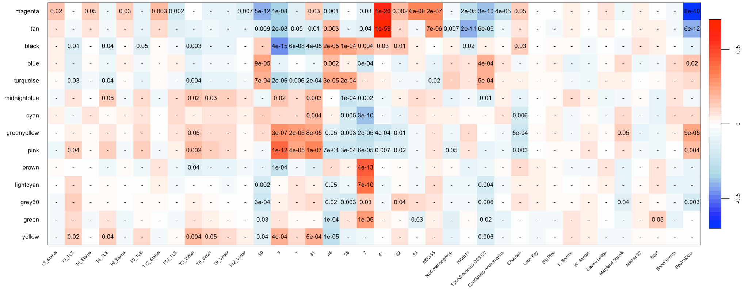
Figure S1: Heat map indicating correlations between module eigengenes and growth and survival (where status is dead or alive), genotype (ordered from high to low restoration value), five most abundant microbes, shannon diversity, site, and restoration value (represented as the sum of a genets interstitial space at T12).

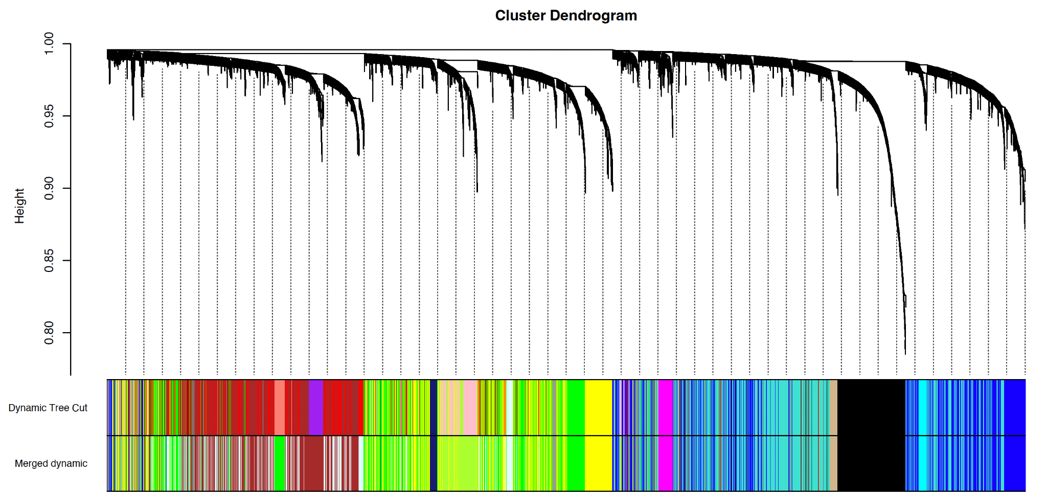
Figure S2: Cluster dendrogram of clustering of module eigengenes with a MEDissThresh = 0.18.

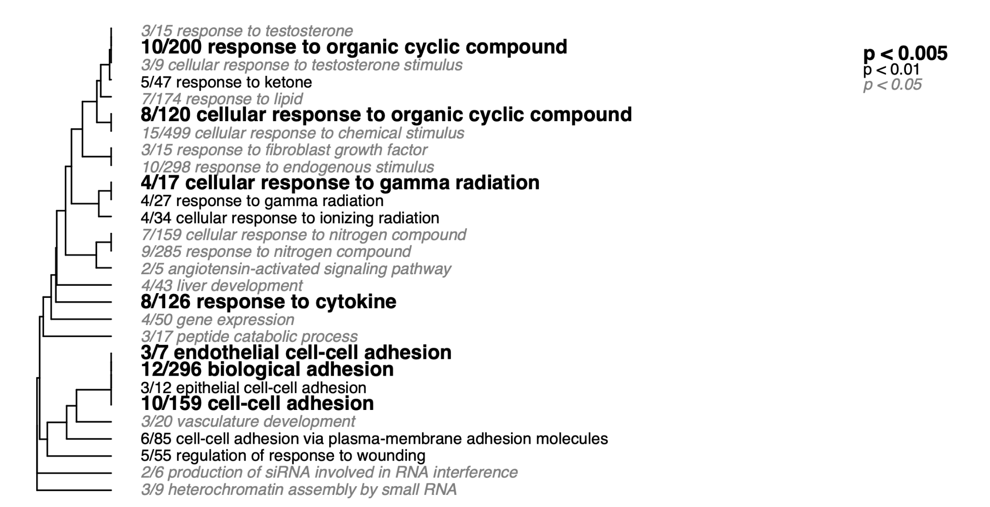
Figure S3: Magenta module Fisher’s Exact Test gene ontology enrichment.

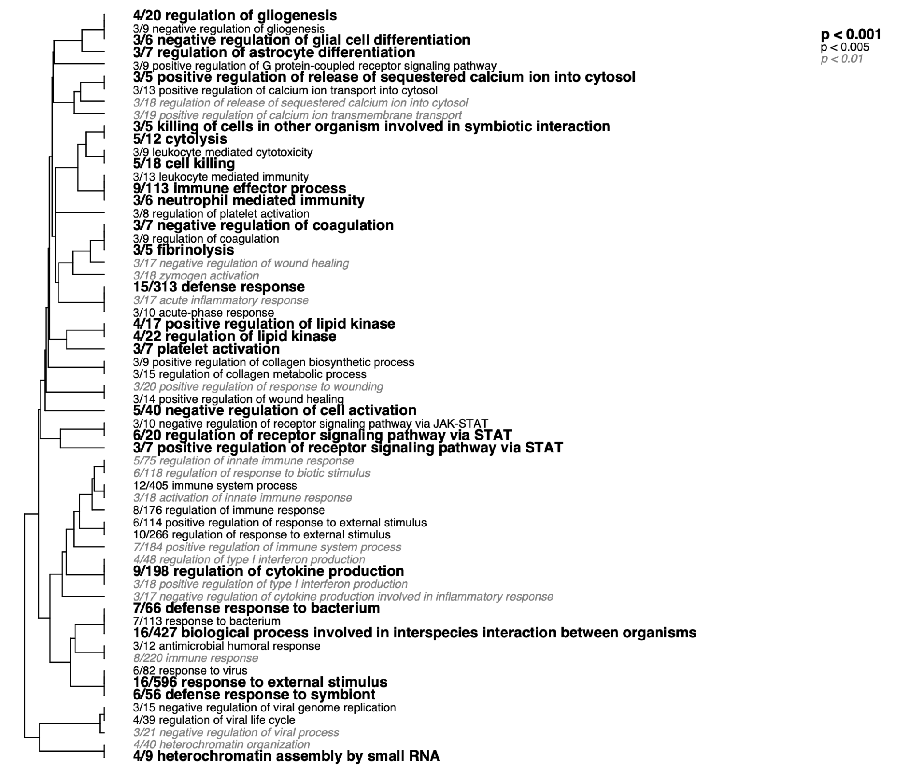

Figure S4: Tan module Fisher’s Exact Test gene ontology enrichment.

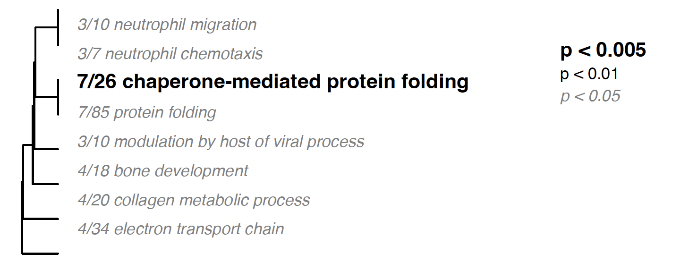
Figure S5: Greenyellow module Fisher’s Exact Test gene ontology enrichment.

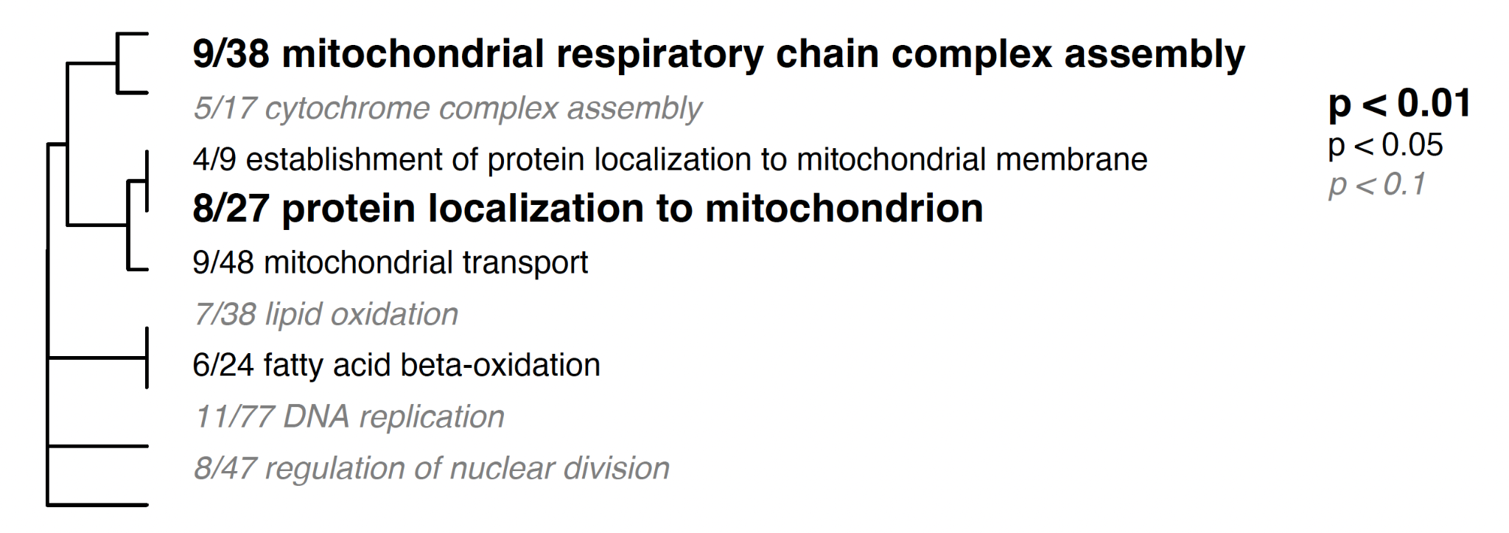
Figure S6: Pink module Fisher’s Exact Test gene ontology enrichment.

Table S1: Tukey’s HSD showing pairwise differences in magenta module eigengene expression between genotypes.

genotypes | diff | lwr | upr | p adj
3-50 | 0.01452684 | -0.010768300 | 0.039821979 | 7.136484E-01
1-50 | 0.053045734 | 0.027533740 | 0.078557727 | 8.457108E-09
31-50 | 0.096274640 | 0.071557792 | 0.120991488 | 1.315614E-13
44-50 | 0.038221219 | 0.012478343 | 0.063964095 | 1.522215E-04
36-50 | 0.069404936 | 0.043152250 | 0.095657621 | 3.373968E-13
7-50 | 0.047979451 | 0.021726766 | 0.074232137 | 7.233499E-07
41-50 | 0.184169723 | 0.158180498 | 0.210158948 | 1.305622E-13
62-50 | 0.114908078 | 0.087003466 | 0.142812691 | 1.305622E-13
13-50 | 0.130859133 | 0.105563994 | 0.156154273 | 1.305622E-13
1-3 | 0.038518894 | 0.013458762 | 0.063579027 | 7.136000E-05
31-3 | 0.081747800 | 0.057497625 | 0.105997975 | 2.038369E-13
44-3 | 0.02369438 | -0.001600760 | 0.048989519 | 8.782890E-02
36-3 | 0.054878096 | 0.029064303 | 0.08069189 | 3.548447E-09
7-3 | 0.033452612 | 0.007638818 | 0.059266405 | 1.922750E-03
41-3 | 0.169642883 | 0.144097076 | 0.19518869 | 1.305622E-13
62-3 | 0.100381239 | 0.072889134 | 0.127873344 | 1.451061E-13
13-3 | 0.116332294 | 0.091492960 | 0.141171628 | 1.305622E-13
31-1 | 0.043228906 | 0.018752617 | 0.067705195 | 2.011152E-06
44-1 | -0.01482451 | -0.040336508 | 0.010687479 | 6.994754E-01
36-1 | 0.016359202 | -0.009667124 | 0.042385528 | 5.954954E-01
7-1 | -0.00506628 | -0.031092608 | 0.020960044 | 9.998117E-01
41-1 | 0.131123989 | 0.105363438 | 0.15688454 | 1.305622E-13
62-1 | 0.061862345 | 0.034170585 | 0.089554104 | 4.529158E-10
13-1 | 0.077813400 | 0.052753267 | 0.102873532 | 2.241540E-13
44-31 | -0.05805342 | -0.08277027 | -0.03333657 | 4.754097E-11
36-31 | -0.0268697 | -0.05211709 | -0.00162232 | 2.679754E-02
7-31 | -0.04829519 | -0.07354257 | -0.0230478 | 1.676833E-07
41-31 | 0.087895083 | 0.062921763 | 0.112868403 | 1.698641E-13
62-31 | 0.018633439 | -0.008327539 | 0.045594416 | 4.554735E-01
13-31 | 0.034584494 | 0.010334318 | 0.058834669 | 3.458749E-04
36-44 | 0.031183717 | 0.004931031 | 0.057436402 | 7.056322E-03
7-44 | 0.009758232 | -0.016494453 | 0.036010918 | 9.739043E-01
41-44 | 0.145948503 | 0.119959278 | 0.171937729 | 1.305622E-13
62-44 | 0.076686859 | 0.048782246 | 0.104591472 | 2.321476E-13
13-44 | 0.092637914 | 0.067342774 | 0.117933054 | 1.429967E-13
7-36 | -0.02142549 | -0.048178266 | 0.005327297 | 2.443317E-01
41-36 | 0.114764787 | 0.088270492 | 0.141259081 | 1.305622E-13
62-36 | 0.045503142 | 0.017127532 | 0.073878752 | 2.637434E-05
13-36 | 0.061454197 | 0.035640404 | 0.087267991 | 2.514744E-11
41-7 | 0.136190271 | 0.109695977 | 0.162684566 | 1.305622E-13
62-7 | 0.066928627 | 0.038553017 | 0.095304237 | 3.901357E-11
13-7 | 0.082879682 | 0.057065889 | 0.108693475 | 2.250422E-13
62-41 | -0.06926164 | -0.09739368 | -0.04112961 | 4.989786E-12
13-41 | -0.05331059 | -0.0788564 | -0.02776478 | 7.346184E-09
13-62 | 0.015951055 | -0.011541050 | 0.04344316 | 7.013159E-01

Table S2: Tukey’s HSD showing pairwise differences in tan module eigengene expression between genotypes.

genotypes | dif | lwr | upr | p adj
1-36 | -0.0018884 | -0.0269757176 | 0.02319886 | 1.000000E+00
50-36 | -0.0099146 | -0.0352200409 | 0.01539093 | 9.632062E-01
3-36 | -0.0397779 | -0.0646603 | -0.0148954 | 2.844330E-05
44-36 | 0.052146792 | 0.0268413078 | 0.07745228 | 1.190154E-08
7-36 | -0.0042594 | -0.0300469163 | 0.02152816 | 9.999526E-01
31-36 | -0.0056489 | -0.0299853681 | 0.01868754 | 9.992074E-01
13-36 | 0.01335832 | -0.0115241025 | 0.03824075 | 7.870093E-01
62-36 | 0.039713388 | 0.0123615749 | 0.0670652 | 2.418455E-04
41-36 | 0.167499856 | 0.1419614803 | 0.19303823 | 1.305622E-13
50-1 | -0.0080261 | -0.0326176470 | 0.01656539 | 9.893573E-01
3-1 | -0.0378894 | -0.0620454 | -0.0137335 | 4.476001E-05
44-1 | 0.054035218 | 0.0294437017 | 0.07862673 | 9.172476E-10
7-1 | -0.002371 | -0.0274582450 | 0.02271634 | 9.999996E-01
31-1 | -0.0037605 | -0.0273536680 | 0.01983269 | 9.999650E-01
13-1 | 0.01524675 | -0.0089092077 | 0.03940271 | 5.896132E-01
62-1 | 0.041601814 | 0.0149091779 | 0.06829445 | 5.194134E-05
41-1 | 0.169388282 | 0.1445571770 | 0.19421939 | 1.305622E-13
3-50 | -0.0298633 | -0.0542458 | -0.0054808 | 4.584667E-03
44-50 | 0.062061349 | 0.0372472804 | 0.08687542 | 2.362555E-12
7-50 | 0.00565518 | -0.0196503065 | 0.03096066 | 9.994161E-01
31-50 | 0.00426564 | -0.0195594167 | 0.0280907 | 9.999064E-01
13-50 | 0.02327288 | -0.0011096049 | 0.04765537 | 7.537240E-02
62-50 | 0.049627945 | 0.0227301356 | 0.07652575 | 5.384451E-07
41-50 | 0.177414413 | 0.1523628841 | 0.20246594 | 1.305622E-13
44-3 | 0.091924645 | 0.0675421583 | 0.11630713 | 1.347811E-13
7-3 | 0.035518473 | 0.0106360464 | 0.0604009 | 3.397513E-04
31-3 | 0.034128939 | 0.0107537144 | 0.05750416 | 2.158869E-04
13-3 | 0.053136177 | 0.0291930511 | 0.0770793 | 6.015677E-10
62-3 | 0.079491241 | 0.0529910560 | 0.10599143 | 2.245981E-13
41-3 | 0.207277709 | 0.1826535997 | 0.23190182 | 1.305622E-13
7-44 | -0.0564062 | -0.0817117 | -0.0311007 | 4.984417E-10
31-44 | -0.0577957 | -0.0816208 | -0.0339707 | 1.020883E-11
13-44 | -0.0387885 | -0.063171 | -0.014406 | 3.201108E-05
62-44 | -0.0124334 | -0.0393312131 | 0.01446441 | 9.007598E-01
41-44 | 0.115353064 | 0.0903015353 | 0.14040459 | 1.305622E-13
31-7 | -0.0013895 | -0.0257259881 | 0.02294692 | 1.000000E+00
13-7 | 0.0176177 | -0.0072647225 | 0.04250013 | 4.190142E-01
62-7 | 0.043972768 | 0.0166209549 | 0.07132458 | 2.478760E-05
41-7 | 0.171759236 | 0.1462208604 | 0.19729761 | 1.305622E-13
13-31 | 0.01900724 | -0.0043679856 | 0.04238246 | 2.252510E-01
62-31 | 0.045362302 | 0.0193740815 | 0.07135052 | 2.819481E-06
41-31 | 0.173148770 | 0.1490764922 | 0.19722105 | 1.305622E-13
62-13 | 0.02635506 | -0.0001451215 | 0.05285525 | 5.260529E-02
41-13 | 0.154141532 | 0.1295174222 | 0.17876564 | 1.305622E-13
41-62 | 0.127786468 | 0.1006694395 | 0.1549035 | 1.305622E-13

Table S3: Tukey’s HSD showing pairwise differences in pink module eigengene expression between genotypes.

genotypes | dif | lwr | upr | p adj
3-50 | 0.0789453968 | 0.040619379 | 0.11727142 | 1.208937E-08
1-50 | 0.0499662980 | 0.011311713 | 0.08862088 | 2.003652E-03
31-50 | 0.0583362629 | 0.020886446 | 0.09578608 | 5.258759E-05
44-50 | -0.0318778 | -0.070882173 | 0.00712664 | 2.190259E-01
36-50 | -0.0356182 | -0.075395010 | 0.00415868 | 1.232216E-01
7-50 | -0.0403429 | -0.0801197 | -0.000566 | 4.374016E-02
41-50 | -0.0248113 | -0.064188963 | 0.01456636 | 5.920742E-01
62-50 | -0.0252133 | -0.067493059 | 0.01706648 | 6.668383E-01
13-50 | -0.0039853 | -0.042311333 | 0.0343407 | 9.999991E-01
1-3 | -0.0289791 | -0.066949045 | 0.00899085 | 3.091113E-01
31-3 | -0.0206091 | -0.057351870 | 0.0161336 | 7.408937E-01
44-3 | -0.1108232 | -0.1491492 | -0.0724971 | 2.248202E-13
36-3 | -0.1145636 | -0.1536754 | -0.0754517 | 2.268186E-13
7-3 | -0.1192883 | -0.1584002 | -0.0801764 | 2.232659E-13
41-3 | -0.1037567 | -0.1424625 | -0.0650509 | 2.747802E-13
62-3 | -0.1041587 | -0.1458134 | -0.0625039 | 2.385536E-12
13-3 | -0.0829307 | -0.1205661 | -0.0452953 | 8.141776E-10
31-1 | 0.0083699649 | -0.028715369 | 0.0454553 | 9.993676E-01
44-1 | -0.0818441 | -0.1204986 | -0.0431895 | 4.168510E-09
36-1 | -0.0855845 | -0.1250183 | -0.0461506 | 1.534779E-09
7-1 | -0.0903092 | -0.1297431 | -0.0508753 | 1.514348E-10
41-1 | -0.0747776 | -0.1138088 | -0.0357464 | 1.592398E-07
62-1 | -0.0751796 | -0.1171369 | -0.0332223 | 1.316409E-06
13-1 | -0.0539516 | -0.0919216 | -0.0159817 | 3.717460E-04
44-31 | -0.090214 | -0.1276638 | -0.0527642 | 1.429978E-11
36-31 | -0.0939544 | -0.1322081 | -0.0557008 | 5.604517E-12
7-31 | -0.0986792 | -0.1369328 | -0.0604255 | 6.404877E-13
41-31 | -0.0831476 | -0.120986 | -0.0453092 | 9.150263E-10
62-31 | -0.0835496 | -0.1243996 | -0.0426995 | 1.578290E-08
13-31 | -0.0623216 | -0.0990643 | -0.0255788 | 6.239345E-06
36-44 | -0.0037404 | -0.043517245 | 0.03603645 | 9.999996E-01
7-44 | -0.0084651 | -0.048241978 | 0.03131172 | 9.996075E-01
41-44 | 0.0070664662 | -0.032311198 | 0.04644413 | 9.999046E-01
62-44 | 0.0066644769 | -0.035615293 | 0.04894425 | 9.999682E-01
13-44 | 0.0278924508 | -0.010433567 | 0.06621847 | 3.779329E-01
7-36 | -0.0047247 | -0.045259302 | 0.03580984 | 9.999977E-01
41-36 | 0.0108068638 | -0.029336058 | 0.05094979 | 9.974564E-01
62-36 | 0.0104048745 | -0.032588529 | 0.05339828 | 9.988942E-01
13-36 | 0.0316328485 | -0.007479009 | 0.07074471 | 2.319122E-01
41-7 | 0.0155315970 | -0.024611325 | 0.05567452 | 9.660626E-01
62-7 | 0.0151296077 | -0.027863796 | 0.05812301 | 9.819680E-01
13-7 | 0.0363575816 | -0.002754276 | 0.07546944 | 9.328076E-02
62-41 | -0.000402 | -0.043026344 | 0.04222237 | 1.000000E+00
13-41 | 0.0208259846 | -0.017879833 | 0.0595318 | 7.848022E-01
13-62 | 0.0212279739 | -0.020426784 | 0.06288273 | 8.340800E-01

Table S4: Tukey’s HSD showing pairwise differences in greenyellow module eigengene expression between genotypes.

genotypes | dif | lwr | upr | p adj
3-50 | 0.03790532 | -0.004377443 | 0.08018808 | 1.222269E-01
1-50 | 0.02963413 | -0.013011114 | 0.07227938 | 4.472549E-01
31-50 | 0.02368541 | -0.017630692 | 0.06500151 | 7.157598E-01
44-50 | -0.0377897 | -0.080820876 | 0.00524149 | 1.409718E-01
36-50 | -0.0499968 | -0.0938802 | -0.0061135 | 1.215923E-02
7-50 | -0.0652294 | -0.1091128 | -0.0213461 | 1.485793E-04
41-50 | -0.0558527 | -0.0992956 | -0.0124097 | 2.186347E-03
62-50 | -0.0496956 | -0.0963403 | -0.0030509 | 2.648780E-02
13-50 | -0.0208699 | -0.063152704 | 0.02141281 | 8.588981E-01
1-3 | -0.0082712 | -0.050161109 | 0.03361874 | 9.997881E-01
31-3 | -0.0142199 | -0.054755929 | 0.02631611 | 9.823545E-01
44-3 | -0.075695 | -0.1179778 | -0.0334122 | 1.351924E-06
36-3 | -0.0879022 | -0.1310519 | -0.0447524 | 1.830656E-08
7-3 | -0.1031348 | -0.1462845 | -0.059985 | 2.081268E-11
41-3 | -0.093758 | -0.1364597 | -0.0510562 | 9.469637E-10
62-3 | -0.0876009 | -0.1335561 | -0.0416458 | 1.882650E-07
13-3 | -0.0587753 | -0.1002961 | -0.0172544 | 3.999550E-04
31-1 | -0.0059487 | -0.046862713 | 0.03496526 | 9.999841E-01
44-1 | -0.0674238 | -0.1100691 | -0.0247786 | 3.710648E-05
36-1 | -0.079631 | -0.123136 | -0.036126 | 6.901600E-07
7-1 | -0.0948636 | -0.1383686 | -0.0513586 | 1.264162E-09
41-1 | -0.0854868 | -0.1285475 | -0.0424261 | 4.670499E-08
62-1 | -0.0793298 | -0.1256186 | -0.0330409 | 4.706520E-06
13-1 | -0.0505041 | -0.092394 | -0.0086142 | 5.742541E-03
44-31 | -0.0614751 | -0.1027912 | -0.020159 | 1.454431E-04
36-31 | -0.0736822 | -0.1158852 | -0.0314793 | 2.800783E-06
7-31 | -0.0889148 | -0.1311178 | -0.0467119 | 5.068859E-09
41-31 | -0.0795381 | -0.1212829 | -0.0377933 | 1.911875E-07
62-31 | -0.073381 | -0.1184484 | -0.0283137 | 1.808014E-05
13-31 | -0.0445554 | -0.0850914 | -0.0040193 | 1.870695E-02
36-44 | -0.0122071 | -0.056090514 | 0.03167623 | 9.967314E-01
7-44 | -0.0274397 | -0.071323119 | 0.01644362 | 6.028484E-01
41-44 | -0.018063 | -0.061505948 | 0.02538 | 9.465921E-01
62-44 | -0.0119059 | -0.058550623 | 0.03473876 | 9.983176E-01
13-44 | 0.01691975 | -0.025363013 | 0.05920251 | 9.579162E-01
7-36 | -0.0152326 | -0.059951924 | 0.02948671 | 9.856088E-01
41-36 | -0.0058558 | -0.050143067 | 0.03843141 | 9.999930E-01
62-36 | 0.00030121 | -0.047130787 | 0.04773321 | 1.000000E+00
13-36 | 0.02912689 | -0.014022838 | 0.07227662 | 4.910123E-01
41-7 | 0.00937678 | -0.034910461 | 0.05366402 | 9.996237E-01
62-7 | 0.01553382 | -0.031898182 | 0.06296582 | 9.890944E-01
13-7 | 0.0443595 | 0.001209768 | 0.08750922 | 3.832476E-02
62-41 | 0.00615704 | -0.040867809 | 0.05318189 | 9.999936E-01
13-41 | 0.03498272 | -0.007719049 | 0.07768449 | 2.161453E-01
13-62 | 0.02882568 | -0.017129478 | 0.07478083 | 5.984311E-01

Table S5: ModulePreservation Zsummary results.

Module | Size | Zsummary.pres
pink | 471 | 33.147353
blue | 500 | 32.415257
tan | 122 | 27.997696
greenyellow | 128 | 25.221227
green | 500 | 23.015702
black | 500 | 22.919534
yellow | 500 | 22.258162
cyan | 100 | 22.109055
magenta | 172 | 16.913981
lightcyan | 500 | 15.335848
brown | 500 | 15.203768
grey60 | 44 | 14.095446
gold | 100 | 11.499374
turquoise | 500 | 9.689597
midnightblue | 85 | 8.973514

Table S6: Tukey’s HSD showing pairwise differences in magenta module eigengene expression between genotypes after twelve months using preserved module assignments.

genotype | dif | lwr | upr | p adj
3-50 | 0.05237498 | 0.0228599149 | 0.08189004 | 2.342224E-06
1-50 | 0.08470988 | 0.0514917712 | 0.11792799 | 2.706169E-12
31-50 | 0.12551322 | 0.0944835872 | 0.15654284 | 3.441691E-14
44-50 | 0.04341414 | 0.0138990805 | 0.07292921 | 2.085033E-04
36-50 | 0.08275582 | 0.0521539491 | 0.11335769 | 2.609024E-13
7-50 | 0.0418831 | 0.0092993562 | 0.07446685 | 2.313511E-03
41-50 | 0.25944924 | 0.2268654888 | 0.29203298 | 3.408385E-14
62-50 | 0.11026078 | 0.0770426752 | 0.14347889 | 1.113554E-13
13-50 | 0.13563587 | 0.1030521208 | 0.16821962 | 3.419487E-14
1-3 | 0.0323349 | -0.0008832067 | 0.06555301 | 6.359293E-02
31-3 | 0.07313824 | 0.0421086093 | 0.10416786 | 9.957002E-11
44-3 | -0.0089608 | -0.0384758974 | 0.02055423 | 9.934050E-01
36-3 | 0.03038084 | -0.0002210288 | 0.06098271 | 5.342109E-02
7-3 | -0.0104919 | -0.0430756217 | 0.02209187 | 9.899009E-01
41-3 | 0.20707426 | 0.1744905109 | 0.23965801 | 3.408385E-14
62-3 | 0.05788581 | 0.0246676973 | 0.09110391 | 3.862713E-06
13-3 | 0.08326089 | 0.0506771429 | 0.11584464 | 2.460809E-12
31-1 | 0.04080334 | 0.0062325174 | 0.07537416 | 7.908699E-03
44-1 | -0.0412957 | -0.074513843 | -0.0080776 | 3.838635E-03
36-1 | -0.0019541 | -0.0361414575 | 0.03223334 | 1.000000E+00
7-1 | -0.0428268 | -0.078799047 | -0.0068545 | 7.046845E-03
41-1 | 0.17473936 | 0.1387670860 | 0.21071163 | 3.408385E-14
62-1 | 0.0255509 | -0.0109969603 | 0.06209877 | 4.334232E-01
13-1 | 0.05092599 | 0.0149537180 | 0.08689826 | 4.394926E-04
44-31 | -0.0820991 | -0.113128699 | -0.0510694 | 5.334622E-13
36-31 | -0.0427574 | -0.074822537 | -0.0106923 | 1.275147E-03
7-31 | -0.0836301 | -0.117591846 | -0.0496684 | 1.386580E-11
41-31 | 0.13393602 | 0.0999742866 | 0.16789776 | 3.519407E-14
62-31 | -0.0152524 | -0.0498232507 | 0.01931839 | 9.214680E-01
13-31 | 0.01012265 | -0.0238390814 | 0.04408439 | 9.942418E-01
36-44 | 0.03934167 | 0.0087398056 | 0.06994354 | 2.307923E-03
7-44 | -0.001531 | -0.0341147873 | 0.03105271 | 1.000000E+00
41-44 | 0.21603509 | 0.1834513452 | 0.24861884 | 3.408385E-14
62-44 | 0.06684664 | 0.0336285317 | 0.10006475 | 4.693421E-08
13-44 | 0.09222173 | 0.0596379772 | 0.12480547 | 1.375566E-13
7-36 | -0.0408727 | -0.074444071 | -0.0073014 | 5.180613E-03
41-36 | 0.17669342 | 0.1431220613 | 0.21026478 | 3.408385E-14
62-36 | 0.02750497 | -0.0066824317 | 0.06169236 | 2.359000E-01
13-36 | 0.05288005 | 0.0193086933 | 0.08645141 | 4.792779E-05
41-7 | 0.21756613 | 0.1821788151 | 0.25295345 | 3.408385E-14
62-7 | 0.06837768 | 0.0324054077 | 0.10434995 | 3.050557E-07
13-7 | 0.09375277 | 0.0583654471 | 0.12914008 | 5.105916E-13
62-41 | -0.1491885 | -0.185160725 | -0.1132162 | 3.419487E-14
13-41 | -0.1238134 | -0.159200686 | -0.0884261 | 7.638334E-14
13-62 | 0.02537509 | -0.0105971860 | 0.06134736 | 4.200025E-01

Table S7: Tukey’s HSD showing pairwise differences in tan module eigengene expression between genotypes after twelve months using preserved module assignments.

genotypes | diff | lwr | upr | p adj
1-36 | 0.032474241 | -0.009891345 | 0.074839827 | 2.996212E-01
50-36 | -0.010397829 | -0.048320169 | 0.027524512 | 9.969245E-01
3-36 | 0.01742333 | -0.020499011 | 0.055345671 | 9.012209E-01
44-36 | 0.036641324 | -0.001281017 | 0.074563664 | 6.776522E-02
7-36 | -0.013299491 | -0.054901671 | 0.028302689 | 9.904093E-01
31-36 | 0.011617446 | -0.028118204 | 0.051353097 | 9.950096E-01
13-36 | 0.039927883 | -0.001674296 | 0.081530063 | 7.170947E-02
62-36 | 0.038582162 | -0.003783424 | 0.080947748 | 1.082473E-01
41-36 | 0.23009177 | 0.188489591 | 0.27169395 | 3.408385E-14
50-1 | -0.04287207 | -0.084036497 | -0.001707643 | 3.377920E-02
3-1 | -0.015050911 | -0.056215338 | 0.026113516 | 9.756793E-01
44-1 | 0.004167083 | -0.036997344 | 0.04533151 | 9.999993E-01
7-1 | -0.045773732 | -0.090351165 | -0.0011963 | 3.888594E-02
31-1 | -0.020856795 | -0.063697524 | 0.021983934 | 8.651475E-01
13-1 | 0.007453642 | -0.037123790 | 0.052031075 | 9.999443E-01
62-1 | 0.006107921 | -0.039182796 | 0.051398637 | 9.999912E-01
41-1 | 0.197617529 | 0.153040097 | 0.242194962 | 3.408385E-14
3-50 | 0.027821159 | -0.008754395 | 0.064396712 | 3.102926E-01
44-50 | 0.047039152 | 0.010463599 | 0.083614706 | 2.294331E-03
7-50 | -0.002901662 | -0.043279980 | 0.037476655 | 1.000000E+00
31-50 | 0.022015275 | -0.016437151 | 0.060467702 | 7.121865E-01
13-50 | 0.050325712 | 0.009947395 | 0.09070403 | 3.696905E-03
62-50 | 0.04897999 | 0.007815563 | 0.090144417 | 7.101740E-03
41-50 | 0.240489599 | 0.200111282 | 0.280867917 | 3.408385E-14
44-3 | 0.019217994 | -0.017357559 | 0.055793547 | 8.031196E-01
7-3 | -0.030722821 | -0.071101138 | 0.009655496 | 3.098796E-01
31-3 | -0.005805883 | -0.044258310 | 0.032646543 | 9.999766E-01
13-3 | 0.022504553 | -0.017873764 | 0.062882871 | 7.430583E-01
62-3 | 0.021158832 | -0.020005595 | 0.062323259 | 8.227859E-01
41-3 | 0.212668441 | 0.172290123 | 0.253046758 | 3.408385E-14
7-44 | -0.049940815 | -0.090319132 | -0.009562497 | 4.136253E-03
31-44 | -0.025023877 | -0.063476304 | 0.013428549 | 5.401463E-01
13-44 | 0.00328656 | -0.037091758 | 0.043664877 | 9.999999E-01
62-44 | 0.001940838 | -0.039223589 | 0.043105265 | 1.000000E+00
41-44 | 0.193450447 | 0.153072129 | 0.233828764 | 3.408385E-14
31-7 | 0.024916938 | -0.017169005 | 0.06700288 | 6.708395E-01
13-7 | 0.053227374 | 0.009374827 | 0.097079922 | 5.406917E-03
62-7 | 0.051881653 | 0.007304220 | 0.096459085 | 9.491451E-03
41-7 | 0.243391262 | 0.199538714 | 0.287243809 | 3.408385E-14
13-31 | 0.028310437 | -0.013775505 | 0.070396379 | 4.911454E-01
62-31 | 0.026964715 | -0.015876014 | 0.069805444 | 5.882065E-01
41-31 | 0.218474324 | 0.176388382 | 0.260560266 | 3.408385E-14
62-13 | -0.001345722 | -0.045923154 | 0.043231711 | 1.000000E+00
41-13 | 0.190163887 | 0.146311339 | 0.234016435 | 3.408385E-14
41-62 | 0.191509609 | 0.146932176 | 0.236087041 | 3.408385E-14

Table S8: Tukey’s HSD showing pairwise differences in Interferon regulatory factor 2 isogroupDN72717_c4_g1 expression between genotypes.
genotypes | diff | lwr | upr | P adjf
3-50 | -0.68923282 | -0.97419607 | -0.404269565 | 1.177847E-11
1-50 | -0.280299198 | -0.56770543 | 0.007107031 | 6.269940E-02
31-50 | 0.149093561 | -0.12935493 | 0.427542049 | 7.895949E-01
44-50 | -0.009854628 | -0.29986187 | 0.280152615 | 1.000000E+00
36-50 | 0.256641723 | -0.03910880 | 0.552392242 | 1.526030E-01
7-50 | -0.154710231 | -0.45046075 | 0.141040288 | 8.115046E-01
41-50 | 1.075281781 | 0.78249929 | 1.368064276 | 1.422196E-13
62-50 | 0.378188642 | 0.06382828 | 0.692549003 | 5.918846E-03
13-50 | 0.634634696 | 0.34967144 | 0.91959795 | 5.174230E-10
1-3 | 0.408933621 | 0.12661785 | 0.691249394 | 2.537849E-04
31-3 | 0.838326381 | 0.56513521 | 1.111517551 | 2.252643E-13
44-3 | 0.679378191 | 0.39441494 | 0.964341446 | 2.349698E-11
36-3 | 0.945874542 | 0.65506838 | 1.236680705 | 2.194911E-13
7-3 | 0.534522589 | 0.24371643 | 0.825328752 | 6.061049E-07
41-3 | 1.7645146 | 1.47672745 | 2.052301752 | 1.305622E-13
62-3 | 1.067421461 | 0.75770822 | 1.377134702 | 1.848521E-13
13-3 | 1.323867515 | 1.04403915 | 1.603695876 | 1.305622E-13
31-1 | 0.42939276 | 0.15365430 | 0.705131222 | 5.295742E-05
44-1 | 0.27044457 | -0.01696166 | 0.557850799 | 8.469518E-02
36-1 | 0.536940921 | 0.24374046 | 0.830141379 | 6.794918E-07
7-1 | 0.125588968 | -0.16761149 | 0.418789426 | 9.360609E-01
41-1 | 1.355580979 | 1.06537462 | 1.645787335 | 1.305622E-13
62-1 | 0.65848784 | 0.34652538 | 0.970450299 | 4.708850E-09
13-1 | 0.914933894 | 0.63261812 | 1.197249667 | 2.198242E-13
44-31 | -0.15894819 | -0.43739668 | 0.119500299 | 7.207809E-01
36-31 | 0.107548162 | -0.17687710 | 0.391973422 | 9.707796E-01
7-31 | -0.303803792 | -0.58822905 | -0.019378532 | 2.576716E-02
41-31 | 0.92618822 | 0.64485044 | 1.207526004 | 2.154943E-13
62-31 | 0.229095081 | -0.07463473 | 0.532824888 | 3.257976E-01
13-31 | 0.485541134 | 0.21234996 | 0.758732305 | 1.674109E-06
36-44 | 0.266496351 | -0.02925417 | 0.56224687 | 1.178168E-01
7-44 | -0.144855602 | -0.44060612 | 0.150894916 | 8.644340E-01
41-44 | 1.085136409 | 0.79235391 | 1.377918905 | 1.394440E-13
62-44 | 0.38804327 | 0.07368291 | 0.702403631 | 4.089146E-03
13-44 | 0.644489324 | 0.35952607 | 0.929452579 | 2.644539E-10
7-36 | -0.411351954 | -0.71273632 | -0.109967586 | 7.904408E-04
41-36 | 0.818640058 | 0.52016768 | 1.117112432 | 2.344791E-13
62-36 | 0.121546919 | -0.19811948 | 0.441213315 | 9.696960E-01
13-36 | 0.377992973 | 0.08718681 | 0.668799136 | 1.830880E-03
41-7 | 1.229992012 | 0.93151964 | 1.528464385 | 1.305622E-13
62-7 | 0.532898873 | 0.21323248 | 0.852565268 | 9.887287E-06
13-7 | 0.789344926 | 0.49853876 | 1.080151089 | 2.515765E-13
62-41 | -0.697093139 | -1.01401557 | -0.380170712 | 8.783977E-10
13-41 | -0.440647085 | -0.72843424 | -0.152859933 | 7.781361E-05
13-62 | 0.256446054 | -0.05326719 | 0.566159295 | 2.034796E-01

Table S9: Tukey’s HSD showing pairwise differences in E-selectin (isogroupDN74671_c2_g1) expression between genotypes.

3-50 | -0.49360648 | -1.01056496 | 0.023352 | 7.515152E-02
1-50 | -0.29036143 | -0.81175176 | 0.2310289 | 7.488397E-01
31-50 | 0.22108071 | -0.28405918 | 0.7262206 | 9.273696E-01
44-50 | -0.07441146 | -0.60052035 | 0.4516974 | 9.999875E-01
36-50 | 1.11365463 | 0.57712673 | 1.6501825 | 9.034385E-09
7-50 | -0.0692872 | -0.60581510 | 0.4672407 | 9.999943E-01
41-50 | 1.51248886 | 0.98134532 | 2.0436324 | 2.254863E-13
62-50 | 1.45183892 | 0.88155047 | 2.0221274 | 1.073142E-12
13-50 | 2.12275789 | 1.60579942 | 2.6397164 | 1.305622E-13
1-3 | 0.20324505 | -0.30891057 | 0.7154007 | 9.600750E-01
31-3 | 0.71468719 | 0.21908472 | 1.2102897 | 2.775951E-04
44-3 | 0.41919502 | -0.09776346 | 0.9361535 | 2.286731E-01
36-3 | 1.60726111 | 1.07970288 | 2.1348193 | 2.245981E-13
7-3 | 0.42431928 | -0.10323895 | 0.9518775 | 2.388808E-01
41-3 | 2.00609534 | 1.48401397 | 2.5281767 | 1.321165E-13
62-3 | 1.94544540 | 1.38358740 | 2.5073034 | 1.844080E-13
13-3 | 2.61636437 | 2.10872123 | 3.1240075 | 1.305622E-13
31-1 | 0.51144214 | 0.01121857 | 1.0116657 | 4.045060E-02
44-1 | 0.21594997 | -0.30544036 | 0.7373403 | 9.478445E-01
36-1 | 1.40401606 | 0.87211428 | 1.9359178 | 3.479439E-13
7-1 | 0.22107423 | -0.31082755 | 0.752976 | 9.467148E-01
41-1 | 1.80285029 | 1.27638018 | 2.3293204 | 1.910694E-13
62-1 | 1.74220035 | 1.17626199 | 2.3081387 | 2.239320E-13
13-1 | 2.41311932 | 1.90096370 | 2.9252749 | 1.305622E-13
44-31 | -0.29549217 | -0.80063205 | 0.2096477 | 6.912505E-01
36-31 | 0.89257392 | 0.37659144 | 1.4085564 | 3.633898E-06
7-31 | -0.29036791 | -0.80635040 | 0.2256146 | 7.372026E-01
41-31 | 1.29140816 | 0.78102673 | 1.8017896 | 1.387002E-12
62-31 | 1.23075821 | 0.67975490 | 1.7817615 | 4.555057E-10
13-31 | 1.90167719 | 1.40607472 | 2.3972797 | 1.323386E-13
36-44 | 1.18806609 | 0.65153819 | 1.724594 | 6.611852E-10
7-44 | 0.00512426 | -0.53140364 | 0.5416522 | 1.000000E+00
41-44 | 1.58690032 | 1.05575678 | 2.1180439 | 2.285949E-13
62-44 | 1.52625038 | 0.95596193 | 2.0965388 | 2.807754E-13
13-44 | 2.19716935 | 1.68021088 | 2.7141278 | 1.305622E-13
7-36 | -1.18294183 | -1.72969023 | -0.6361934 | 1.744046E-09
41-36 | 0.39883423 | -0.14263145 | 0.9402999 | 3.601761E-01
62-36 | 0.33818429 | -0.24172997 | 0.9180985 | 6.950820E-01
13-36 | 1.00910326 | 0.48154503 | 1.5366615 | 1.679702E-07
41-7 | 1.58177606 | 1.04031038 | 2.1232417 | 2.214895E-13
62-7 | 1.52112612 | 0.94121187 | 2.1010404 | 3.944622E-13
13-7 | 2.19204509 | 1.66448686 | 2.7196033 | 1.305622E-13
62-41 | -0.06064994 | -0.63558630 | 0.5142864 | 9.999990E-01
13-41 | 0.61026903 | 0.08818766 | 1.1323504 | 8.750173E-03
13-62 | 0.67091897 | 0.10906097 | 1.232777 | 6.564471E-03

Table S10: Tukey’s HSD showing pairwise differences in Allograft inflammatory factor 1 (isogroupDN57704_c0_g1) expression between genotypes.

genotypes | diff | lwr | upr | p adj
3-50 | -0.094541903 | -0.31858618 | 0.12950237 | 9.415612E-01
1-50 | 0.004277981 | -0.22168701 | 0.23024298 | 1.000000E+00
31-50 | 0.235742520 | 0.01682029 | 0.45466475 | 2.358076E-02
44-50 | -0.088468029 | -0.31647800 | 0.13954194 | 9.654384E-01
36-50 | 0.360973229 | 0.12844777 | 0.59349869 | 5.690271E-05
7-50 | 0.165522821 | -0.06700264 | 0.39804828 | 4.109482E-01
41-50 | 0.546740199 | 0.31654827 | 0.77693213 | 2.808098E-11
62-50 | 0.329119213 | 0.08196230 | 0.57627613 | 1.220298E-03
13-50 | 0.552063574 | 0.32801930 | 0.77610785 | 4.791612E-12
1-3 | 0.098819885 | -0.12314288 | 0.32078265 | 9.197770E-01
31-3 | 0.330284424 | 0.11549562 | 0.54507323 | 7.067288E-05
44-3 | 0.006073875 | -0.21797040 | 0.23011815 | 1.000000E+00
36-3 | 0.455515133 | 0.22687704 | 0.68415323 | 4.117420E-08
7-3 | 0.260064724 | 0.03142663 | 0.48870282 | 1.240926E-02
41-3 | 0.641282103 | 0.41501762 | 0.86754659 | 2.240430E-13
62-3 | 0.423661116 | 0.18015787 | 0.66716437 | 3.090082E-06
13-3 | 0.646605477 | 0.42659837 | 0.86661259 | 2.235989E-13
31-1 | 0.231464539 | 0.01467299 | 0.44825608 | 2.588491E-02
44-1 | -0.09274601 | -0.31871101 | 0.13321898 | 9.506799E-01
36-1 | 0.356695248 | 0.12617470 | 0.58721579 | 6.132284E-05
7-1 | 0.161244839 | -0.06927570 | 0.39176538 | 4.373347E-01
41-1 | 0.542462218 | 0.31429570 | 0.77062873 | 2.680145E-11
62-1 | 0.324841231 | 0.07956960 | 0.57011287 | 1.338893E-03
13-1 | 0.547785593 | 0.32582282 | 0.76974836 | 4.444889E-12
44-31 | -0.324210549 | -0.54313277 | -0.10528832 | 1.606667E-04
36-31 | 0.125230709 | -0.09839058 | 0.348852 | 7.426702E-01
7-31 | -0.070219699 | -0.29384099 | 0.15340159 | 9.919414E-01
41-31 | 0.310997679 | 0.08980383 | 0.53219153 | 4.556192E-04
62-31 | 0.093376692 | -0.14542225 | 0.33217564 | 9.636666E-01
13-31 | 0.316321054 | 0.10153225 | 0.53110986 | 1.805810E-04
36-44 | 0.449441258 | 0.21691580 | 0.68196671 | 1.182071E-07
7-44 | 0.253990850 | 0.02146539 | 0.48651631 | 2.009475E-02
41-44 | 0.635208228 | 0.40501630 | 0.86540016 | 2.343681E-13
62-44 | 0.417587241 | 0.17043032 | 0.66474416 | 6.929227E-06
13-44 | 0.640531603 | 0.41648733 | 0.86457588 | 2.274847E-13
7-36 | -0.195450408 | -0.43240532 | 0.0415045 | 2.079920E-01
41-36 | 0.185766970 | -0.04889847 | 0.42043241 | 2.593788E-01
62-36 | -0.031854017 | -0.28318265 | 0.21947462 | 9.999952E-01
13-36 | 0.191090345 | -0.03754775 | 0.41972844 | 1.927104E-01
41-7 | 0.381217378 | 0.14655194 | 0.61588282 | 1.915144E-05
62-7 | 0.163596392 | -0.08773224 | 0.41492503 | 5.450795E-01
13-7 | 0.386540753 | 0.15790266 | 0.61517885 | 6.813653E-06
62-41 | -0.217620987 | -0.46679226 | 0.03155028 | 1.462546E-01
13-41 | 0.005323375 | -0.22094111 | 0.23158786 | 1.000000E+00
13-62 | 0.222944361 | -0.02055889 | 0.46644761 | 1.047748E-01

Table S11: Tukey’s HSD showing pairwise differences in Tyrosine-protein kinase receptor Tie-1 (isogroupDN74674_c1_g3) expression between genotypes.
genotypes | dif | lwr | upr | p adj
3-50 | 0.22238312 | -0.057054886 | 0.5018211 | 2.524754E-01
1-50 | 0.016064265 | -0.265769349 | 0.2978979 | 1.000000E+00
31-50 | 0.5714230904 | 0.298373533 | 0.8444726 | 6.587475E-09
44-50 | 0.142402714 | -0.141981482 | 0.4267869 | 8.480939E-01
36-50 | 0.162238287 | -0.127777826 | 0.4522544 | 7.438659E-01
7-50 | 0.4675244980 | 0.177508385 | 0.7575406 | 2.318016E-05
41-50 | 0.7319416775 | 0.444836039 | 1.0190473 | 1.011746E-12
62-50 | 0.6015029540 | 0.293237831 | 0.9097681 | 8.550913E-08
13-50 | 0.5717381837 | 0.292300177 | 0.8511762 | 1.556732E-08
1-3 | -0.206318856 | -0.483160714 | 0.070523 | 3.430969E-01
31-3 | 0.3490399700 | 0.081145794 | 0.6169341 | 1.760834E-03
44-3 | -0.079980406 | -0.359418413 | 0.1994576 | 9.959430E-01
36-3 | -0.060144833 | -0.345312458 | 0.2250228 | 9.996354E-01
7-3 | 0.245141378 | -0.040026248 | 0.530309 | 1.621497E-01
41-3 | 0.5095585571 | 0.227351406 | 0.7917657 | 1.046006E-06
62-3 | 0.3791198336 | 0.075411726 | 0.6828279 | 3.459060E-03
13-3 | 0.3493550633 | 0.074952388 | 0.6237577 | 2.553286E-03
31-1 | 0.5553588258 | 0.284966748 | 0.8257509 | 1.347935E-08
44-1 | 0.12633845 | -0.155495164 | 0.4081721 | 9.165499E-01
36-1 | 0.146174023 | -0.141341474 | 0.4336895 | 8.360350E-01
7-1 | 0.4514602334 | 0.163944737 | 0.7389757 | 4.365072E-05
41-1 | 0.7158774129 | 0.431297965 | 1.0004569 | 1.805778E-12
62-1 | 0.5854386894 | 0.279524975 | 0.8913524 | 1.651915E-07
13-1 | 0.5556739191 | 0.278832061 | 0.8325158 | 3.150180E-08
44-31 | -0.429020376 | -0.702069933 | -0.1559708 | 4.299851E-05
36-31 | -0.409184803 | -0.688095247 | -0.1302744 | 1.955236E-04
7-31 | -0.103898592 | -0.382809036 | 0.1750119 | 9.735238E-01
41-31 | 0.160518587 | -0.115364245 | 0.4364014 | 6.978829E-01
62-31 | 0.030079864 | -0.267760825 | 0.3279206 | 9.999993E-01
13-31 | 0.000315093 | -0.267579082 | 0.2682093 | 1.000000E+00
36-44 | 0.019835573 | -0.270180540 | 0.3098517 | 1.000000E+00
7-44 | 0.3251217836 | 0.035105670 | 0.6151379 | 1.482438E-02
41-44 | 0.5895389631 | 0.302433325 | 0.8766446 | 1.360710E-08
62-44 | 0.4591002397 | 0.150835117 | 0.7673654 | 1.425982E-04
13-44 | 0.4293354693 | 0.149897463 | 0.7087735 | 7.202761E-05
7-36 | 0.3052862108 | 0.009745485 | 0.6008269 | 3.653414E-02
41-36 | 0.5697033903 | 0.277018197 | 0.8623886 | 9.304112E-08
62-36 | 0.4392646668 | 0.125796390 | 0.7527329 | 4.855453E-04
13-36 | 0.4094998965 | 0.124332271 | 0.6946675 | 3.019393E-04
41-7 | 0.26441718 | -0.028268014 | 0.5571024 | 1.156339E-01
62-7 | 0.133978456 | -0.179489821 | 0.4474467 | 9.368879E-01
13-7 | 0.104213686 | -0.180953940 | 0.3893813 | 9.767005E-01
62-41 | -0.130438724 | -0.441216236 | 0.1803388 | 9.434350E-01
13-41 | -0.160203494 | -0.442410645 | 0.1220037 | 7.272304E-01
13-62 | -0.02976477 | -0.333472878 | 0.2739433 | 9.999995E-01

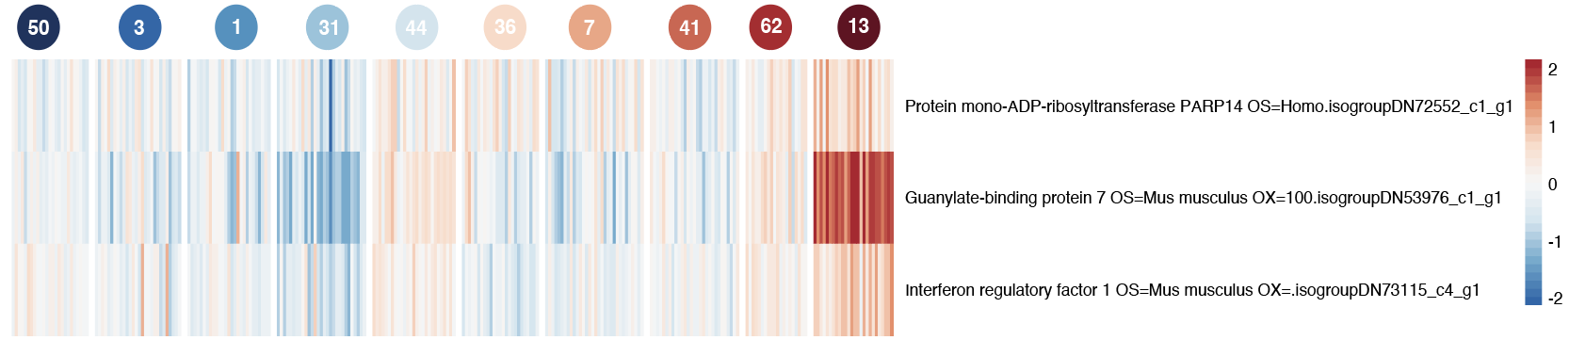

Figure S7: Significantly enriched isogroups from the tan module GO term “negative regulation of receptor signaling pathway via JAK-STAT” (GO:0046426;GO:1904893). This GO term was a child term for the GO term “regulation of receptor signaling pathway via STAT” (GO:1904893), and the exact isogroups were enriched in the parent term in addition to two others. However, for the sake of clarity, we chose to report expression of guanylate-binding protein 7, and interferon regulatory factor 1.

Table S12: Tukey HSD showing pairwise differences in Guanylate-binding protein 7 (isogroupDN53976_c1_g) expression between genotypes.

genotypes | dif | lwr | upr | p adj
1-36 | -0.21990274 | -0.59417882 | 0.1543733 | 6.857793E-01
50-36 | -0.14978663 | -0.52731791 | 0.2277446 | 9.601322E-01
3-36 | -0.80826492 | -1.17948463 | -0.4370452 | 1.343604E-09
44-36 | 0.56736058 | 0.18982931 | 0.9448919 | 1.174520E-04
7-36 | -0.04456993 | -0.42929293 | 0.3401531 | 9.999978E-01
31-36 | -0.20747355 | -0.57054792 | 0.1556008 | 7.195476E-01
13-36 | -0.02355878 | -0.39477849 | 0.3476609 | 1.000000E+00
62-36 | 0.42332397 | 0.01526361 | 0.8313843 | 3.499030E-02
41-36 | 1.88306477 | 1.50205899 | 2.2640705 | 1.305622E-13
50-1 | 0.07011611 | -0.29676351 | 0.4369957 | 9.998384E-01
3-1 | -0.58836218 | -0.94874374 | -0.2279806 | 1.690509E-05
44-1 | 0.78726333 | 0.42038370 | 1.154143 | 2.440161E-09
7-1 | 0.17533281 | -0.19894326 | 0.5496089 | 8.931695E-01
31-1 | 0.01242919 | -0.33955631 | 0.3644147 | 1.000000E+00
13-1 | 0.19634397 | -0.16403759 | 0.5567255 | 7.721713E-01
62-1 | 0.64322671 | 0.24500058 | 1.0414528 | 2.208422E-05
41-1 | 2.10296751 | 1.73251347 | 2.4734216 | 1.305622E-13
3-50 | -0.65847829 | -1.02223942 | -0.2947172 | 9.689765E-07
44-50 | 0.71714721 | 0.34694734 | 1.0873471 | 1.095668E-07
7-50 | 0.10521670 | -0.27231458 | 0.482748 | 9.966842E-01
31-50 | -0.05768692 | -0.41313182 | 0.297758 | 9.999592E-01
13-50 | 0.12622785 | -0.23753327 | 0.489989 | 9.836275E-01
62-50 | 0.57311060 | 0.17182350 | 0.9743977 | 3.363576E-04
41-50 | 2.03285140 | 1.65910886 | 2.4065939 | 1.305622E-13
44-3 | 1.37562551 | 1.01186438 | 1.7393866 | 1.344480E-13
7-3 | 0.76369499 | 0.39247528 | 1.1349147 | 1.267516E-08
31-3 | 0.60079137 | 0.25205754 | 0.9495252 | 4.073438E-06
13-3 | 0.78470615 | 0.42749981 | 1.1419125 | 9.265094E-10
62-3 | 1.23158889 | 0.83623393 | 1.6269439 | 2.197131E-13
41-3 | 2.69132969 | 2.32396381 | 3.0586956 | 1.305622E-13
7-44 | -0.61193052 | -0.98946179 | -0.2343992 | 2.025352E-05
31-44 | -0.77483414 | -1.13027903 | -0.4193892 | 1.279237E-09
13-44 | -0.59091936 | -0.95468048 | -0.2271582 | 1.916426E-05
62-44 | -0.14403661 | -0.54532371 | 0.2572505 | 9.793620E-01
41-44 | 1.31570419 | 0.94196165 | 1.6894467 | 1.694200E-13
31-7 | -0.16290362 | -0.52597798 | 0.2001707 | 9.161168E-01
13-7 | 0.02101116 | -0.35020855 | 0.3922309 | 1.000000E+00
62-7 | 0.46789390 | 0.05983354 | 0.8759543 | 1.121948E-02
41-7 | 1.92763470 | 1.54662892 | 2.3086405 | 1.305622E-13
13-31 | 0.18391478 | -0.16481905 | 0.5326486 | 8.040563E-01
62-31 | 0.63079752 | 0.24308053 | 1.0185145 | 1.844579E-05
41-31 | 2.09053832 | 1.73140518 | 2.4496715 | 1.305622E-13
62-13 | 0.44688275 | 0.05152778 | 0.8422377 | 1.340971E-02
41-13 | 1.90662355 | 1.53925766 | 2.2739894 | 1.305622E-13
41-62 | 1.45974080 | 1.05518317 | 1.8642984 | 1.518785E-13

Table S13: Tukey HSD showing pairwise differences in Interferon regulatory factor 1 (isogroupDN73115_c4_g1) between genotypes.
genotype | diff | lwr | upr | p adj
1-36 | -0.187540681 | -0.484408065 | 0.1093267 | 5.883701E-01
50-36 | -0.216488578 | -0.515937916 | 0.08296076 | 3.877901E-01
3-36 | -0.549207198 | -0.843650343 | -0.25476405 | 3.817266E-07
44-36 | 0.163581477 | -0.135867861 | 0.46303081 | 7.694181E-01
7-36 | -0.431477583 | -0.73663123 | -0.12632394 | 4.087477E-04
31-36 | -0.230193548 | -0.518175988 | 0.05778889 | 2.467947E-01
13-36 | -0.155065026 | -0.449508171 | 0.13937812 | 8.053587E-01
62-36 | 0.154714223 | -0.168950097 | 0.47837854 | 8.808156E-01
41-36 | 0.639278377 | 0.337073144 | 0.94148361 | 4.322431E-09
50-1 | -0.028947897 | -0.319948587 | 0.26205279 | 9.999994E-01
3-1 | -0.361666517 | -0.647513087 | -0.07581995 | 2.813963E-03
44-1 | 0.351122157 | 0.060121467 | 0.64212285 | 5.678270E-03
7-1 | -0.243936902 | -0.540804287 | 0.05293048 | 2.125287E-01
31-1 | -0.042652868 | -0.321839868 | 0.23653413 | 9.999757E-01
13-1 | 0.032475655 | -0.253370915 | 0.31832222 | 9.999981E-01
62-1 | 0.342254904 | 0.026390871 | 0.65811894 | 2.200667E-02
41-1 | 0.826819058 | 0.532983221 | 1.12065489 | 2.281508E-13
3-50 | -0.33271862 | -0.621245782 | -0.04419146 | 1.043684E-02
44-50 | 0.380070055 | 0.086435821 | 0.67370429 | 1.960650E-03
7-50 | -0.214989005 | -0.514438343 | 0.08446033 | 3.981629E-01
31-50 | -0.013704971 | -0.295635889 | 0.26822595 | 1.000000E+00
13-50 | 0.061423552 | -0.227103610 | 0.34995071 | 9.996065E-01
62-50 | 0.371202801 | 0.052910876 | 0.68949473 | 9.018421E-03
41-50 | 0.855766955 | 0.559322760 | 1.15221115 | 2.262635E-13
44-3 | 0.712788674 | 0.424261512 | 1.00131584 | 4.230505E-12
7-3 | 0.117729615 | -0.176713530 | 0.41217276 | 9.581274E-01
31-3 | 0.319013649 | 0.042405799 | 0.5956215 | 1.042012E-02
13-3 | 0.394142172 | 0.110814123 | 0.67747022 | 5.571151E-04
62-3 | 0.703921421 | 0.390334736 | 1.01750811 | 3.675108E-10
41-3 | 1.188485575 | 0.897099198 | 1.47987195 | 1.305622E-13
7-44 | -0.59505906 | -0.894508397 | -0.29560972 | 4.513025E-08
31-44 | -0.393775025 | -0.675705944 | -0.11184411 | 5.166832E-04
13-44 | -0.318646503 | -0.607173665 | -0.03011934 | 1.770348E-02
62-44 | -0.008867253 | -0.327159178 | 0.30942467 | 1.000000E+00
41-44 | 0.475696901 | 0.179252706 | 0.7721411 | 2.594598E-05
31-7 | 0.201284034 | -0.086698405 | 0.48926647 | 4.384911E-01
13-7 | 0.276412557 | -0.018030588 | 0.5708557 | 8.631392E-02
62-7 | 0.586191806 | 0.262527486 | 0.90985613 | 9.542317E-07
41-7 | 1.070755960 | 0.768550727 | 1.37296119 | 1.647571E-13
13-31 | 0.075128522 | -0.201479328 | 0.35173637 | 9.972770E-01
62-31 | 0.384907772 | 0.077379352 | 0.69243619 | 3.322961E-03
41-31 | 0.869471926 | 0.584615576 | 1.15432828 | 2.262635E-13
62-13 | 0.309779249 | -0.003807436 | 0.62336593 | 5.593142E-02
41-13 | 0.794343403 | 0.502957027 | 1.08572978 | 2.433609E-13
41-62 | 0.484564154 | 0.163678120 | 0.80545019 | 1.057546E-04

Table S14: Tukey HSD showing pairwise differences in Protein mono-ADP-ribosyltransferase (isogroupDN72552_c1_g1) between genotypes.
genotype | diff | lwr | upr | p adj
1-36 | 0.099002789 | -0.281886512 | 0.47989209 | 9.980615E-01
50-36 | -0.065395968 | -0.449597989 | 0.31880605 | 9.999389E-01
3-36 | -0.204019745 | -0.581798678 | 0.17375919 | 7.811159E-01
44-36 | 0.373209187 | -0.010992834 | 0.75741121 | 6.492203E-02
7-36 | 0.327742199 | -0.063778612 | 0.71926301 | 1.909151E-01
31-36 | 0.14415889 | -0.225330774 | 0.51364855 | 9.641825E-01
13-36 | -0.011056798 | -0.388835731 | 0.36672214 | 1.000000E+00
62-36 | 0.379542175 | -0.035728357 | 0.79481271 | 1.061623E-01
41-36 | 0.787250761 | 0.399512847 | 1.17498867 | 2.070761E-08
50-1 | -0.164398757 | -0.537760922 | 0.20896341 | 9.247535E-01
3-1 | -0.303022535 | -0.669771817 | 0.06372675 | 2.059948E-01
44-1 | 0.274206398 | -0.099155767 | 0.64756856 | 3.644865E-01
7-1 | 0.22873941 | -0.152149891 | 0.60962871 | 6.577068E-01
31-1 | 0.045156101 | -0.313048764 | 0.40336097 | 9.999954E-01
13-1 | -0.110059587 | -0.476808869 | 0.2566897 | 9.942210E-01
62-1 | 0.280539386 | -0.124723156 | 0.68580193 | 4.530401E-01
41-1 | 0.688247972 | 0.311248233 | 1.06524771 | 7.482510E-07
3-50 | -0.138623777 | -0.508812336 | 0.23156478 | 9.725916E-01
44-50 | 0.438605155 | 0.061864078 | 0.81534623 | 9.225974E-03
7-50 | 0.393138167 | 0.008936147 | 0.77734019 | 4.012902E-02
31-50 | 0.209554858 | -0.152170532 | 0.57128025 | 7.031725E-01
13-50 | 0.05433917 | -0.315849388 | 0.42452773 | 9.999827E-01
62-50 | 0.444938143 | 0.036560547 | 0.85331574 | 2.068627E-02
41-50 | 0.852646729 | 0.472300392 | 1.23299307 | 3.893772E-10
44-3 | 0.577228932 | 0.207040374 | 0.94741749 | 5.137808E-05
7-3 | 0.531761945 | 0.153983012 | 0.90954088 | 4.457907E-04
31-3 | 0.348178635 | -0.006717106 | 0.70307438 | 5.949890E-02
13-3 | 0.192962948 | -0.170555000 | 0.5564809 | 7.979450E-01
62-3 | 0.583561920 | 0.181221280 | 0.98590256 | 2.470714E-04
41-3 | 0.991270506 | 0.617413494 | 1.36512752 | 3.189671E-13
7-44 | -0.045466987 | -0.429669008 | 0.33873503 | 9.999973E-01
31-44 | -0.229050297 | -0.590775687 | 0.13267509 | 5.850298E-01
13-44 | -0.384265985 | -0.754454543 | -0.01407743 | 3.477802E-02
62-44 | 0.006332988 | -0.402044608 | 0.41471058 | 1.000000E+00
41-44 | 0.414041574 | 0.033695237 | 0.79438791 | 2.088819E-02
31-7 | -0.18358331 | -0.553072973 | 0.18590635 | 8.540110E-01
13-7 | -0.338798997 | -0.716577930 | 0.03897994 | 1.218917E-01
62-7 | 0.051799975 | -0.363470556 | 0.46707051 | 9.999958E-01
41-7 | 0.459508561 | 0.071770648 | 0.84724647 | 7.280484E-03
13-31 | -0.155215688 | -0.510111429 | 0.19968005 | 9.276674E-01
62-31 | 0.235383285 | -0.159184428 | 0.629951 | 6.663700E-01
41-31 | 0.643091871 | 0.277613069 | 1.00857067 | 2.239893E-06
62-13 | 0.390598973 | -0.011741667 | 0.79293961 | 6.525446E-02
41-13 | 0.798307559 | 0.424450546 | 1.17216457 | 2.974018E-09
41-62 | 0.407708586 | -0.003997326 | 0.8194145 | 5.469749E-02

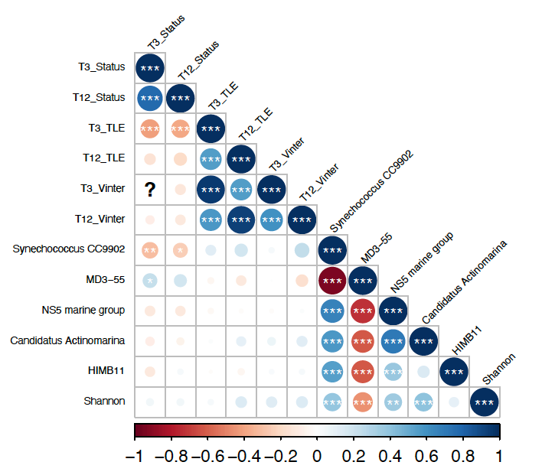
Figure S8: Correlation plot with key growth (total linear extension and interstitial space) at the first and last time point (T3, T12), and survival traits and five most abundant microbes. Growth traits are correlated with other growth traits as found in Million et al., 2022, and microbial abundances are correlated with each other as well. However, there is no strong correlation between growth/survival traits and microbial abundances.

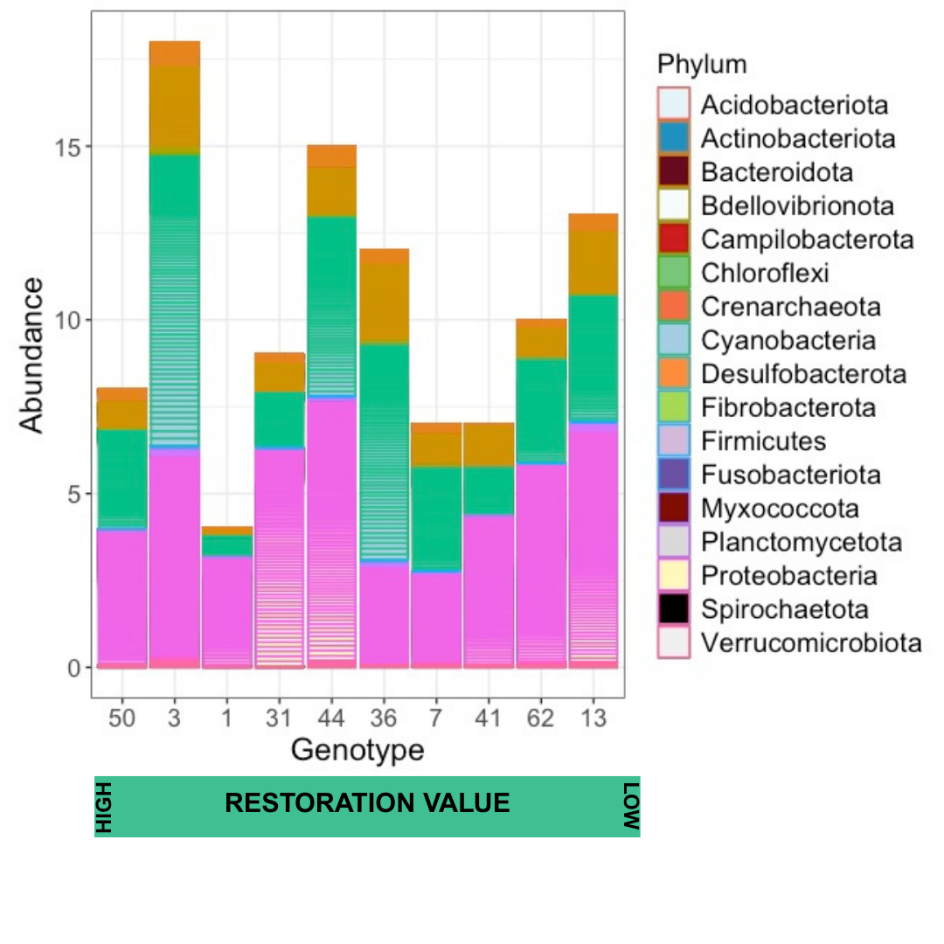 Figure S9: Abundance of top 100 genera between genotypes. The X-axis is ordered from high restoration value (G50) to low restoration value (G13).

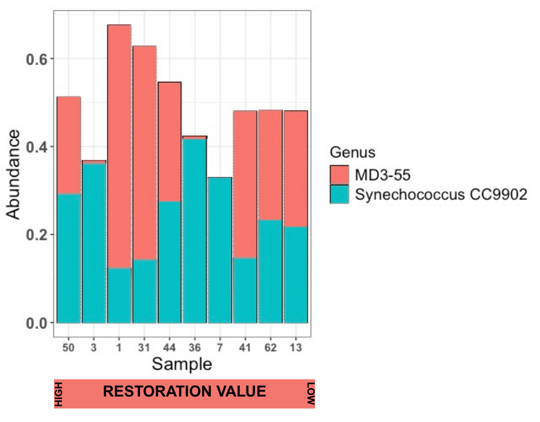
Figure S10: Relative abundance of MD3-55 and Synechococcus and CC9902 from highest to lowest ranked genotype by restoration value.

Table S15: Tukey HSD showing pairwise differences in alpha diversity between genotypes.
genotype | diff | lwr | upr | p adj
13-1 | 0.867551695 | 0.120728961 | 1.61437443 | 1.036790E-02
3-1 | 0.672908973 | -0.049095408 | 1.39491335 | 8.943550E-02
31-1 | 0.167650612 | -0.617250902 | 0.95255213 | 9.995027E-01
36-1 | 0.640785238 | -0.113323743 | 1.39489422 | 1.679825E-01
41-1 | 0.819914 | 0.001237984 | 1.63859002 | 4.932890E-02
44-1 | 0.566771716 | -0.168242799 | 1.30178623 | 2.824234E-01
50-1 | 0.740878492 | -0.058974870 | 1.54073185 | 9.370280E-02
62-1 | 1.009424259 | 0.236692498 | 1.78215602 | 2.093700E-03
7-1 | 0.732942189 | -0.085733828 | 1.5516182 | 1.197312E-01
3-13 | -0.194642722 | -0.670052007 | 0.28076656 | 9.447102E-01
31-13 | -0.699901083 | -1.266287918 | -0.13351425 | 4.663500E-03
36-13 | -0.226766457 | -0.749646957 | 0.29611404 | 9.224269E-01
41-13 | -0.047637695 | -0.659972637 | 0.56469725 | 9.999999E-01
44-13 | -0.300779979 | -0.795724419 | 0.19416446 | 6.217372E-01
50-13 | -0.126673203 | -0.713605108 | 0.4602587 | 9.994592E-01
62-13 | 0.141872564 | -0.407525320 | 0.69127045 | 9.977692E-01
7-13 | -0.134609506 | -0.746944448 | 0.47772544 | 9.993727E-01
31-3 | -0.505258361 | -1.038493935 | 0.02797721 | 7.867390E-02
36-3 | -0.032123734 | -0.518898989 | 0.45465152 | 1.000000E+00
41-3 | 0.147005027 | -0.434802683 | 0.72881274 | 9.981148E-01
44-3 | -0.106137256 | -0.562772921 | 0.35049841 | 9.990208E-01
50-3 | 0.067969519 | -0.487039663 | 0.6229787 | 9.999955E-01
62-3 | 0.336515286 | -0.178639221 | 0.85166979 | 5.201417E-01
7-3 | 0.060033216 | -0.521774494 | 0.64184093 | 9.999990E-01
36-31 | 0.473134626 | -0.102825622 | 1.04909487 | 2.044475E-01
41-31 | 0.652263388 | -0.005976896 | 1.31050367 | 5.419790E-02
44-31 | 0.399121104 | -0.151602229 | 0.94984444 | 3.682425E-01
50-31 | 0.57322788 | -0.061449402 | 1.20790516 | 1.126011E-01
62-31 | 0.841773647 | 0.241636808 | 1.44191049 | 6.636000E-04
7-31 | 0.565291577 | -0.092948707 | 1.22353186 | 1.573667E-01
41-36 | 0.179128762 | -0.442071883 | 0.80032941 | 9.948634E-01
44-36 | -0.074013522 | -0.579885206 | 0.43185816 | 9.999789E-01
50-36 | 0.100093254 | -0.496082242 | 0.69626875 | 9.999322E-01
62-36 | 0.368639021 | -0.190623168 | 0.92790121 | 5.069973E-01
7-36 | 0.09215695 | -0.529043695 | 0.7133576 | 9.999763E-01
44-41 | -0.253142284 | -0.851018712 | 0.34473414 | 9.324968E-01
50-41 | -0.079035508 | -0.755034980 | 0.59696396 | 9.999970E-01
62-41 | 0.189510259 | -0.454169987 | 0.83319051 | 9.940123E-01
7-41 | -0.086971811 | -0.785141064 | 0.61119744 | 9.999947E-01
50-44 | 0.174106776 | -0.397724672 | 0.74593822 | 9.923509E-01
62-44 | 0.442652543 | -0.090583032 | 0.97588812 | 1.927259E-01
7-44 | 0.166170472 | -0.431705956 | 0.7640469 | 9.960970E-01
62-50 | 0.268545767 | -0.351017983 | 0.88810952 | 9.226763E-01
7-50 | -0.007936303 | -0.683935775 | 0.66806317 | 1.000000E+00
7-62 | -0.27648207 | -0.920162316 | 0.36719818 | 9.266066E-01

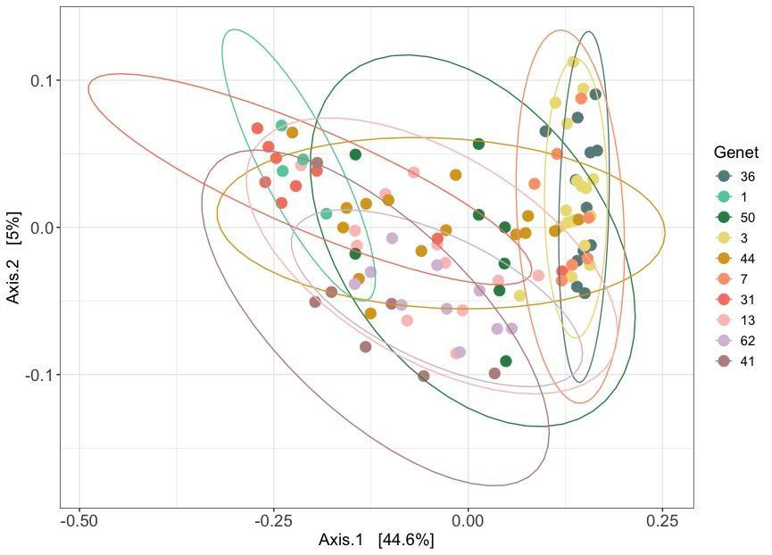
Figure S11: Beta diversity between genotypes.

Table S17: Tukey’s HSD showing pairwise differences in beta diversity (PERMANOVA) between genotypes.

genotypes | SumOfSqs | F.Model | R2 | p val | p adj
13 vs 1 | 1 0.45776657 | 3.7609649 | 0.20046756 | 0.007 | 0.315
13 vs 31 | 1 0.45892129 | 3.4527791 | 0.14722260 | 0.015 | 0.675
13 vs 36 | 1 1.23543012 | 9.078328 | 0.28300502 | 0.001 | 0.045 .
13 vs 3 | 1 1.38843888 | 9.0583315 | 0.23801179 | 0.001 | 0.045 .
13 vs 41 | 1 0.38993677 | 2.9977117 | 0.14276373 | 0.003 | 0.135
13 vs 44 | 1 0.17163179 | 1.1933244 | 0.04388299 | 0.213 | 1.000
13 vs 50 | 1 0.17281364 | 1.2589095 | 0.06214103 | 0.159 | 1.000
13 vs 62 | 1 0.21771095 | 1.7197819 | 0.07569535 | 0.052 | 1.000
13 vs 7 | 1 0.86916515 | 5.733063 | 0.24156440 | 0.001 | 0.045 .
1 vs 31 | 1 0.07894618 | 0.7952471 | 0.06742098 | 0.620 | 1.000
1 vs 36 | 1 1.57234493 | 14.0774395 | 0.50137903 | 0.002 | 0.090
1 vs 3 | 1 1.59281606 | 11.0659306 | 0.35620792 | 0.001 | 0.045 .
1 vs 41 | 1 0.34169894 | 3.9674394 | 0.30595396 | 0.008 | 0.360
1 vs 44 | 1 0.47453240 | 3.7120317 | 0.17922103 | 0.008 | 0.360
1 vs 50 | 1 0.54816825 | 5.2612214 | 0.34474445 | 0.003 | 0.135
1 vs 62 | 1 0.52400050 | 5.757395 | 0.32422520 | 0.001 | 0.045 .
1 vs 7 | 1 1.26525354 | 9.7944274 | 0.52113465 | 0.002 | 0.090
31 vs 36 | 1 2.08204444 | 16.5087186 | 0.46492015 | 0.001 | 0.045 .
31 vs 3 | 1 2.29150948 | 15.4359517 | 0.38173831 | 0.001 | 0.045 .
31 vs 41 | 1 0.35895061 | 3.1258211 | 0.18252095 | 0.016 | 0.720
31 vs 44 | 1 0.47842920 | 3.5017561 | 0.13731431 | 0.016 | 0.720
31 vs 50 | 1 0.56358283 | 4.5099927 | 0.23116322 | 0.013 | 0.585
31 vs 62 | 1 0.58609156 | 5.176665 | 0.23342847 | 0.003 | 0.135
31 vs 7 | 1 1.53299927 | 10.7569586 | 0.43450243 | 0.001 | 0.045 .
36 vs 3 | 1 0.21947119 | 1.4690817 | 0.04985163 | 0.006 | 0.270
36 vs 41 | 1 1.55255493 | 12.6929696 | 0.42747390 | 0.001 | 0.045 .
36 vs 44 | 1 1.14952565 | 8.2641208 | 0.24843948 | 0.001 | 0.045 .
36 vs 50 | 1 0.68602992 | 5.2633315 | 0.22625012 | 0.001 | 0.045 .
36 vs 62 | 1 1.16166827 | 9.6950971 | 0.32648814 | 0.001 | 0.045 .
36 vs 7 | 1 0.23797008 | 1.6399285 | 0.08797933 | 0.004 | 0.180
3 vs 41 | 1 1.74507352 | 11.8241984 | 0.33953972 | 0.001 | 0.045 .
3 vs 44 | 1 1.31483249 | 8.5048476 | 0.21528618 | 0.001 | 0.045 .
3 vs 50 | 1 0.74212972 | 4.8647973 | 0.16853738 | 0.001 | 0.045 .
3 vs 62 | 1 1.24884661 | 8.7485282 | 0.25176687 | 0.001 | 0.045 .
3 vs 7 | 1 0.18784914 | 1.1424082 | 0.04731956 | 0.140 | 1.000
41 vs 44 | 1 0.45094047 | 3.354094 | 0.14361910 | 0.001 | 0.045 .
41 vs 50 | 1 0.44477240 | 3.7121912 | 0.22212474 | 0.004 | 0.180
41 vs 62 | 1 0.35108250 | 3.2753485 | 0.17922222 | 0.003 | 0.135
41 vs 7 | 1 1.23376543 | 8.8214981 | 0.42367259 | 0.001 | 0.045 .
44 vs 50 | 1 0.12768892 | 0.9072293 | 0.04141233 | 0.417 | 1.000
44 vs 62 | 1 0.23366115 | 1.787871 | 0.07212685 | 0.068 | 1.000
44 vs 7 | 1 0.83561440 | 5.432431 | 0.21360250 | 0.001 | 0.045 .
50 vs 62 | 1 0.15884878 | 1.3557908 | 0.07811749 | 0.118 | 1.000
50 vs 7 | 1 0.54315032 | 3.6301649 | 0.21828797 | 0.001 | 0.045 .
62 vs 7 | 1 0.80306385 | 6.0370551 | 0.28697244 | 0.001 | 0.045 .
.

