Supplementary materials
Supplementary Material 1: Method to Determine Amount of Water Required for Well-Watered and Water Deficit.
Manipulation of the amount of water needed for the water deficit and well water treatments. We combined Bodner et al. (2017) and Cassel & Nielsen (1986) methods into comprehensive procedure to measure soil and water requirements to induce well-watered and water deficit effects on the plants.
Step I: Determine the weight of topsoil and mason sand to achieve the 70% topsoil and 30% mason sand by volume.
- Fill the air-dried topsoil into a beaker until it reaches 350 ml and measure the weight.
- Add the air-dried mason sand into a beaker until it meets 150 ml and measure the weight.
Before going into further steps, we will need to understand the definition of field capacity (FC), permanent wilting point (PWP) and plant available water (PAW) . The definition of FC is the maximum of water content that can be held against gravity (Raveendra et al. 2017), which means the amount of water content remained in the soil at 33 kpa of hydraulic head (Raveendra et al. 2017). Permanent wilting point is the when the plant will not be able to uptake water from the soil since the soil matrix held the water firmly. The physical definition of PWP is depending on the plant variety, but 1500kPa of hydraulic head is used as a standard to identify the amount water held in the soil matrix (Raveendra et al. 2017). Plant available water is the differences between FC and PWP. The value will provide us the amount of water that is available for the plant to uptake water from the soil (Raveendra et al. 2017).
Step II: Determine the field capacity of soil mixture (Bodner et al. 2017; Cassel & Nielsen, 1986)
- Place the ceramic plate on a round bowl plate. Then add the deionized water into the round bowl plate until the deionized water saturated the whole ceramic plate. Leave them overnight.
- After the soaking, place the ceramic plate on another dry round bowl plate.
- Place three rubber rings on the ceramic plate; each rubber ring will fill with the soil mixture. The three rubber rings indicate three replications. Then add deionized water to the ceramic plate until the water cover ¼ of the rubber ring. Cover the round bowl plate with a lid to avoid evaporation. Note adding deionized water might require a few times since the deionized water level might not cover 1/4 of the rubber ring in a single application.
- Put the ceramic plate and three rubber rings into the pressure plate. Close the pressure plate chamber with the chamber lid and set the pressure to 8 kpa. The reason of setting 8 kpa was due to the height of the rhizobox.
- Take the ceramic plate and three rubber rings out from the pressure plate once the water from the pressure plate stops dripping from the outlet port. This indicates that the soil samples have reached equilibrium at the desired pressure. The water dripping from the outlet port might stop in three days.
- Immediately allocate each soil mixture from the rubber ring to an aluminium weight dish to measure the initial soil weight at field capacity.
- Place three aluminium weight dishes with soil mixture into an oven for a day and set the temperature to 105 C.
- The next day, measure each aluminium weight dish with a soil mixture to obtain the weight of oven-dry soil. Average the weight of oven-dry soil.
- From 10 to 12 are all about the calculation.
- Determine the average gravimetric moisture content of the soil in field capacity. Let’s assume the initial soil weight is 26.65 g.

$$ω= \frac{M_{initial soil weight in FC}-M_{oven dry soil}}{M_{oven dry soil} }$$

$ω= \frac{26.65 g-22.11 g}{22.11 g}= 0.206 g$/$g$

- Determine bulk density of the soil mixture. Soil bulk density defined as the mass of the soil per unit of volume. Fill up the iron ring (πr²h = 144.21 cm³) with the air-dried soil mixture (The 70% topsoil and 30% mason sand by volume = 152.51g) to measure the bulk density of the soil mixture.

$$ρ_{d}=\frac{M_{air dry soil}}{volume}=\frac{M_{air dry soil }}{V_{beaker}}$$

$$ρ_{d}=\frac{152.51g}{144.21 {cm}^{3}}=1.06 g{/cm}^{3}$$

- Determine volumetric moisture content of field capacity. WD= Water density (1g/1cm³ at room temperature).

$$Ө_{FC}= ω×\frac{ρ_{d}}{WD}$$

$$Ө_{FC}= 0.206 ×\frac{1.06 }{1}=0.219 {{cm}^{3}/cm}^{3}$$

Step III: Determine the permanent wilting point of soil mixture.
- The method to manipulate the soil moisture content of PWP is same as FC. The only difference are the calculation values and setting the pressure to 1500 kpa.
- From 3 to 5 are all about the calculation.
- Determine the gravimetric moisture content of the soil in field capacity.

$$ω= \frac{M_{initial soil weight in FC}-M_{oven dry soil}}{M_{oven dry soil} }$$

$$ω= \frac{24.68 g-21.92 g}{21.92 g}= 0.126 g/g$$

- Determine bulk density of the soil mixture.

$$ρ_{d}=\frac{M_{air dry soil}}{volume}=\frac{M_{air dry soil }}{V_{ring}}$$

$$ρ_{d}=\frac{152.51g}{144.21 {cm}^{3}}=1.06 g{/cm}^{3}$$

- Determine volumetric moisture content of field capacity. WD= Water density (1g/1cm³ at room temperature)

$$Ө_{pwp}= ω×\frac{ρ_{d}}{WD}$$

$$Ө_{pwp}= 0.126 ×\frac{1.06}{1}=0.134 {{cm}^{3}/cm}^{3}$$

Step V: Determine the plant available water in dry soil.
The formula I am using is slightly different from the common formula of PAW since the air-dry soil mixture has been placed in a ventilation room for two days and the air-dry soil mixture might lose all the water moisture content of PWP. Therefore, I need to add the water moisture content of PWP to my formula. However, the common formula of PAW has been used widely since the field soil still contains the water moisture content of PWP, so it is not necessary to add the water moisture content of PWP into the formula. The well water treatment will be at 100% PAW and the water deficit treatment will be at 50% PAW.
$$Ө_{AWC at \%}=\%{(Ө}_{FC}-Ө_{PWP})+ Ө_{PWP}$$

$Ө_{AWC at 80\%}=1.0 \left(0.219-0.134\right)+0.134= 0.219 {{cm}^{3}/cm}^{3}$

$$Ө_{AWC at 50\%}=0.5 \left(0.219-0.134\right)+0.134= 0.176 {{cm}^{3}/cm}^{3}$$
Step 5: Determine the amount of water required for water deficit and well water treatment.
Let’s assume we have a 3122 cm³ of soil in the rhizobox. The volume of water can convert from cm³ to gram since the density of water is 1.0 g/cm³ at 20 °C
$$Amount of water needed for well water =0.219 ×3122 {cm}^{3}=773.6 {cm}^{3}or g$$
$$Amount of water needed for water deficit=0.134 ×3122 {cm}^{3}=577.7 {cm}^{3} or g$$

Run | Block | # Rhizobox after plant mortaility | % Plant mortality | Average temp °C record in the day & night time | Max temp  °C | Shade cloth
1 | 1 | 4 e.u (CC) | 33% | 23.6 | 33.4 | NO
1 | 2 | 4 e.u (CC) | 33% | 23.6 | 33.4
2 | 3 | 4 e.u (CC) | 0% | 23.2 | 35.4 | NO
3 | 4 | 2 e.u (WW,PI) 1 e.u (WD, PI) | 50% | 22.4 | 34.0 | NO
3 | 5 | 2 e.u (WW,PI) | 50% | 22.4 | 34.0
4 | 6 | 3 e.u (WW,PI), 1 e.u (WD,Ca) | 0% | 23.8 | 36 | YES
5 | 7 | 3 e.u (WD,Ca), 2 e.u (WD,PI) | 0% | 24 | 36 | YES
Supplementary Material 2. Layout of the experimental design. The experimental run, the greenhouse temperature all day and the percentage of chile pepper plants mortality per run. CC refers to a complete combination, meaning all accessions and treatments were included in a block. PI and Ca represent PI 586666 and Ca0045. Number (treatment combination) refer to number of treatment combination (e.g. 2 (WW,PI) means 2 sets of PI586666 in well-watered treatment). Experimental unit (e.u.). Supplementary Material 1

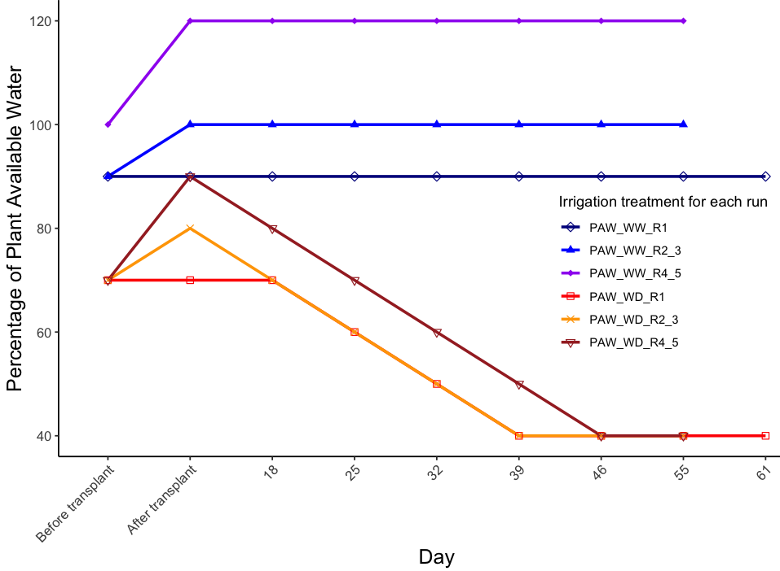
Supplementary Material 3. Irrigation treatments adjustment for well-watered and water deficit in all runs. Before and after transplantation happened on the same day. Before transplanting, refer to when the soil mixture was mixed with water before being added to the rhizobox. After transplanting, the seedling was transplanted in the rhizobox. Each color of the line represents the percentage of plant available water in either well-watered or water deficit treatments for each run. R refers to run.

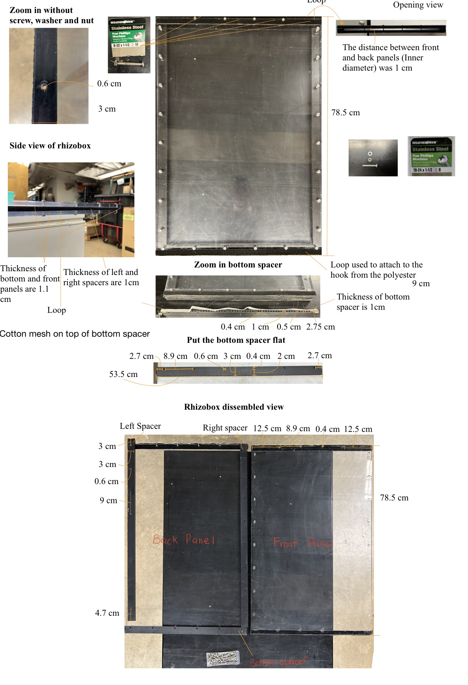
Supplementary Material 4. Rhizobox design (assembly view). The dimensions of four carriage bolts near the opening area of the rhizobox were 8/32 inches (diameter) and 1.5 inches (length). The remaining carriage bolts were 10/24 inches (diameter) and 1.5 inches (length).

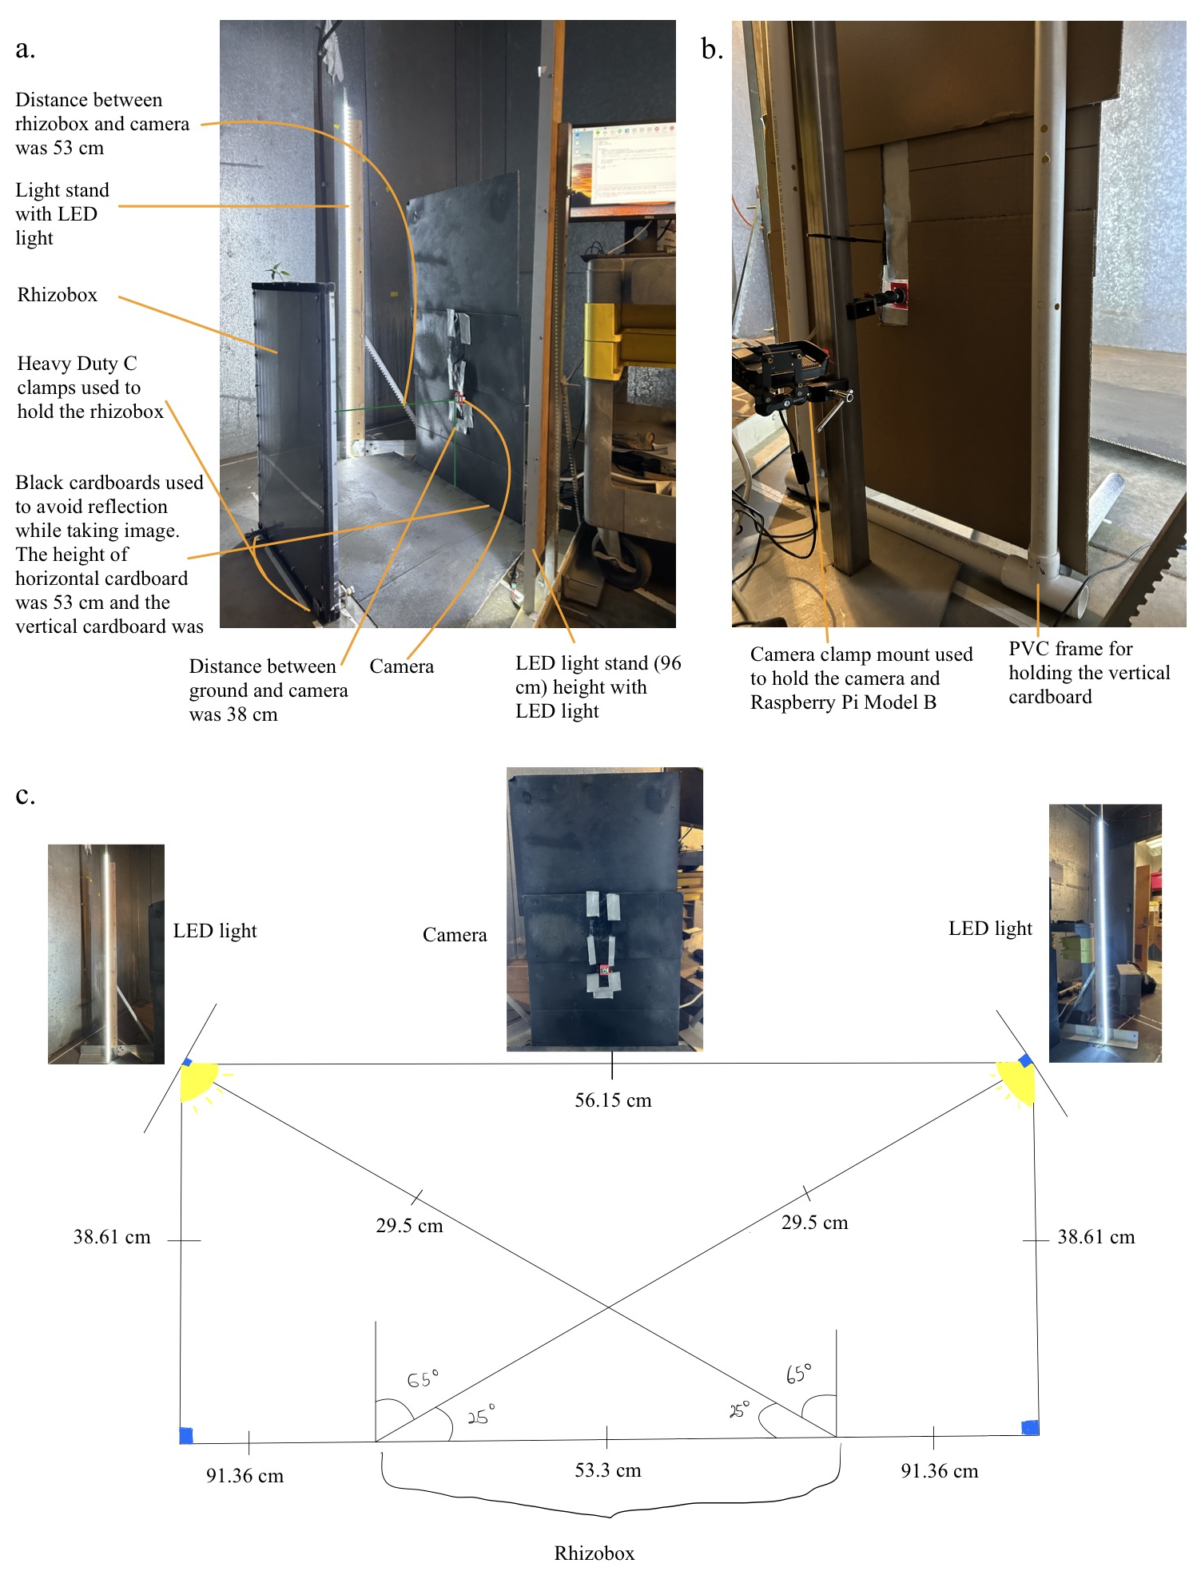
Supplementary Material 5. (a) image station (side view) in a dark room. (b) Image station (behind camera view) in a dark room. (c) Above two dimensions views for the image station. This image provides an overview of the materials allocation for the image station.

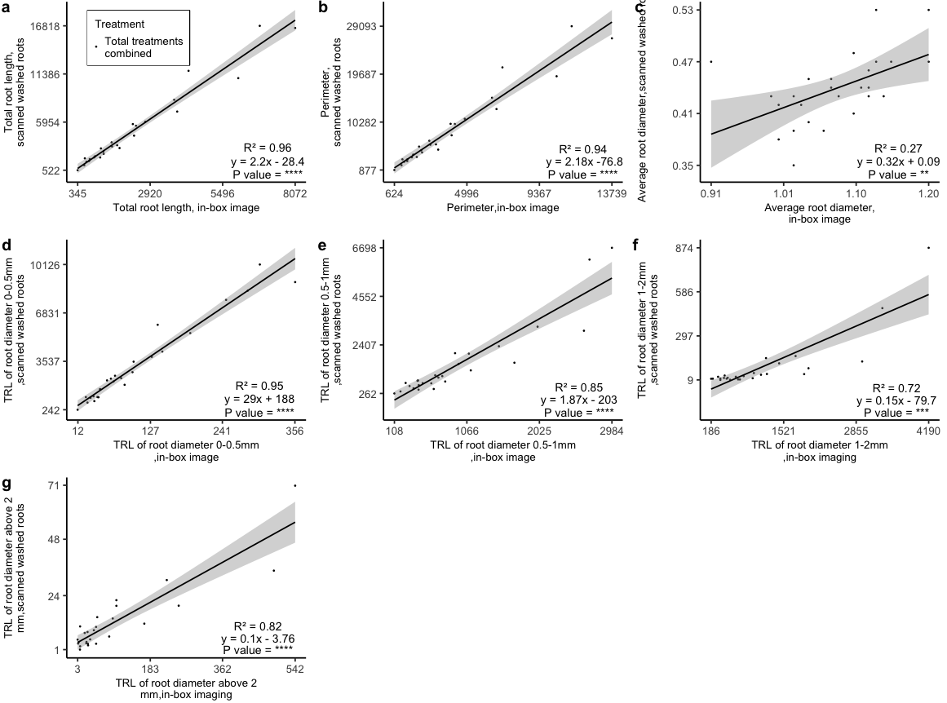
Supplementary Material 6. Linear regression analysis for seven root traits with their regression equation from in-box imaging and scanning washed root with their regression. Y represented response variable and predictor denoted as X. The black dots, line, and confidence interval represent data from both treatments combined.

Supplementary Material 7:
Measure the root image’s pixels per mm and determine the image thresholding level in RhizoVision Explorer.
First, I placed the rhizobox in the same setting (same camera, lens, focus and distance between camera to rhizobox) as when the root image was captured. Then, the ruler was allocated in the middle of the rhizobox. Once the camera had taken the ruler image, I moved it into the RhizoVision Explorer, and I drew a region of interest of between 400 to 200 mm of the ruler. The ROI manager on the right of side RhizoVision Explorer showed a width of 2264, which would be in pixels. Then, I converted it to pixel per mm by 2264 pixels over 200 mm. Once I knew the pixel per mm, in the image preprocessing, the analysis mode was set to whole root with 11.32. The image thresholding level was set at 200 and all the boxes remained blank. In the feature extraction the root pruning threshold set at 1 with four different root diameter ranges.

