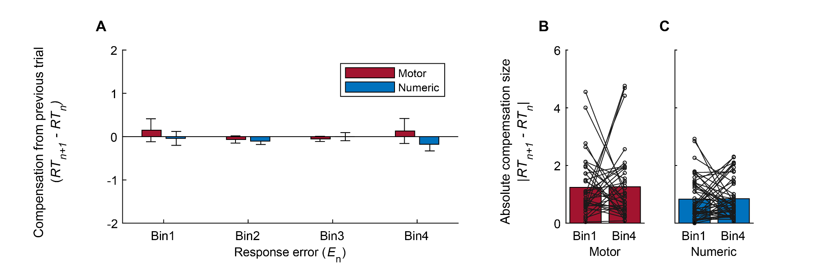Figure S1. Surrogate analysis of trial-by-trial compensation.
The same analyses as in Figure 3 were performed using surrogate datasets, shuffled 10,000 times within each participant, to confirm that the observed difference between the motor and numeric tasks in trial-by-trial compensation was driven by sequential dynamics.
(A) The average compensation size plotted against the magnitude of the response error from the previous trial in the surrogate datasets (10,000 iterations per participant). A two-way repeated-measures ANOVA revealed no significant main effects or interaction (Bin: F(3, 331) = 0.24, p = 0.866, η² = 0.002; Task: F(1, 331) = 1.09, p = 0.297, η² = 0.003; Interaction: F(3, 331) = 0.48, p = 0.697, η² = 0.004).
(B) Individual surrogate data for the motor aiming task. The absolute value of the average compensation size in Bin 4 did not differ significantly from that in Bin 1 (t(35) = -0.1577, p = 0.876, η² = 7.10 × 10⁻⁴, paired t-test).
(C) The same surrogate analysis as in (B) was performed for the numeric aiming task. No significant difference was found between the absolute values of the average compensation size in Bin 1 and Bin 4 (t(47) = -0.1176, p = 0.907, η² = 2.94 × 10⁻⁴, paired t-test).

