In Silico Development and Structural Evaluation of a Broad-Spectrum Chimeric Multi-Epitope Vaccine against Co-Infection by Human Metapneumovirus, Respiratory Syncytial Virus, and Influenza A Virus
Lu Li^{1, #}, Yong Chen^{2, #}, Chunyan Wu¹, Junhong Xie¹, Abdullah Shah³, Xin Xie¹, Junyin Tan¹, Yudie Qin¹, Yuanlei Zeng¹, Amin Ullah Jan^{4,*}, Tianci Yang^{5,*}, and Sadeeq Ullah^{1, *}
¹ Guangdong Provincial Key Laboratory of Medical Immunology and Molecular Diagnostics, The Second Affiliated Hospital, School of Medical Technology, Guangdong Medical University, Dongguan 523808, China
² Department of Medical Laboratory, Affiliated Cancer Hospital of Chengdu Medical College, Chengdu Seventh People's Hospital, Chengdu 610231, China
³ Faculty of Bio Sciences, Department of Biochemistry, University of Veterinary and Animal sciences Swat (UVAS-Swat), Swat 01923, Pakistan
⁴ Department of Biotechnology, Shaheed Benazir Bhutto University Sheringal Dir Upper, Sheringal 18300, Pakistan
⁵ Institute of Infectious Disease, School of Medicine, Xiamen University, Xiamen 361102, China

# These authors contributed equally to this work.
* Correspondence:
Sadeeq Ullah, anjum_sadiq@yahoo.com
Amin Ullah Jan, aminjan@sbbu.edu.pk
Tianci Yang, yangtianci@xmu.edu.cn

Supplementary figures:
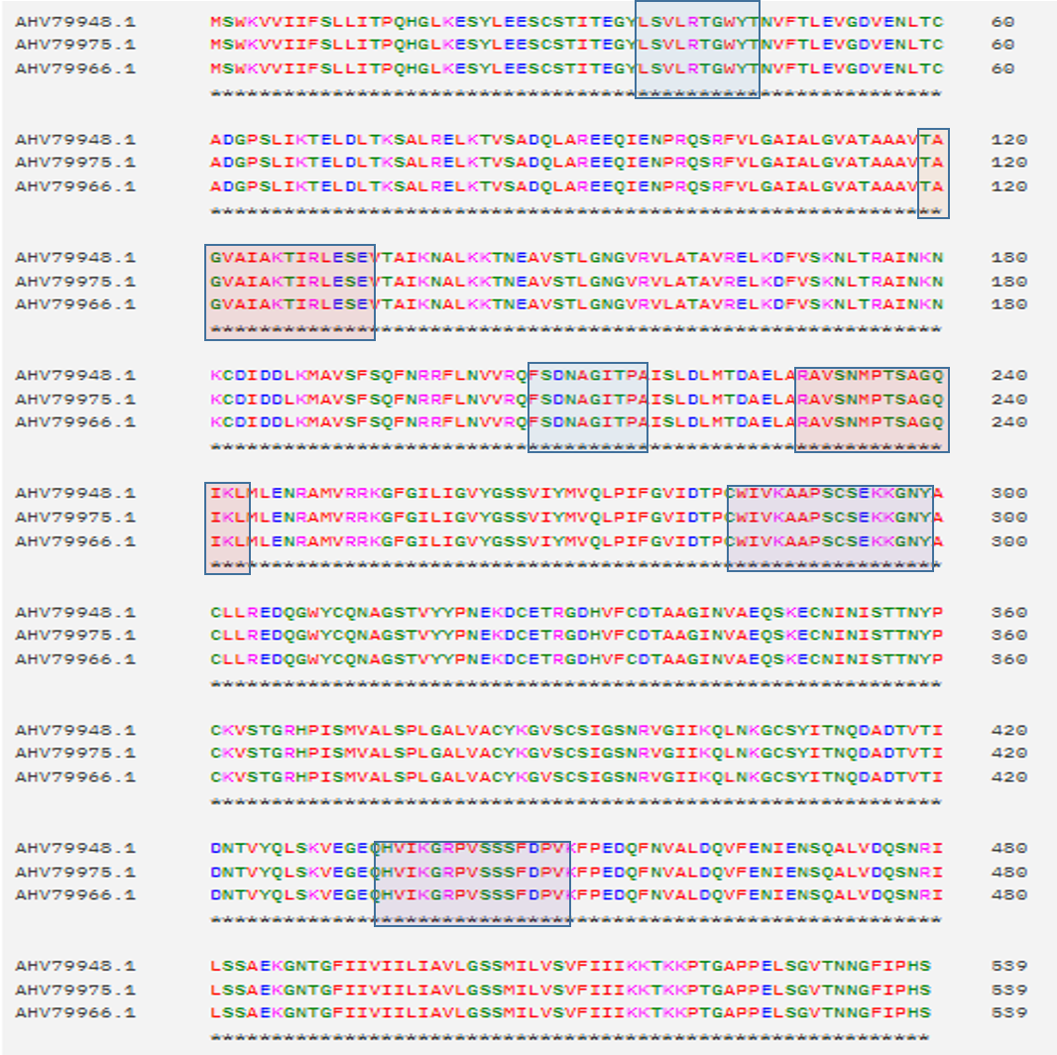
Figure S1: Shows the CTL, HTL and BCL epitopes in h
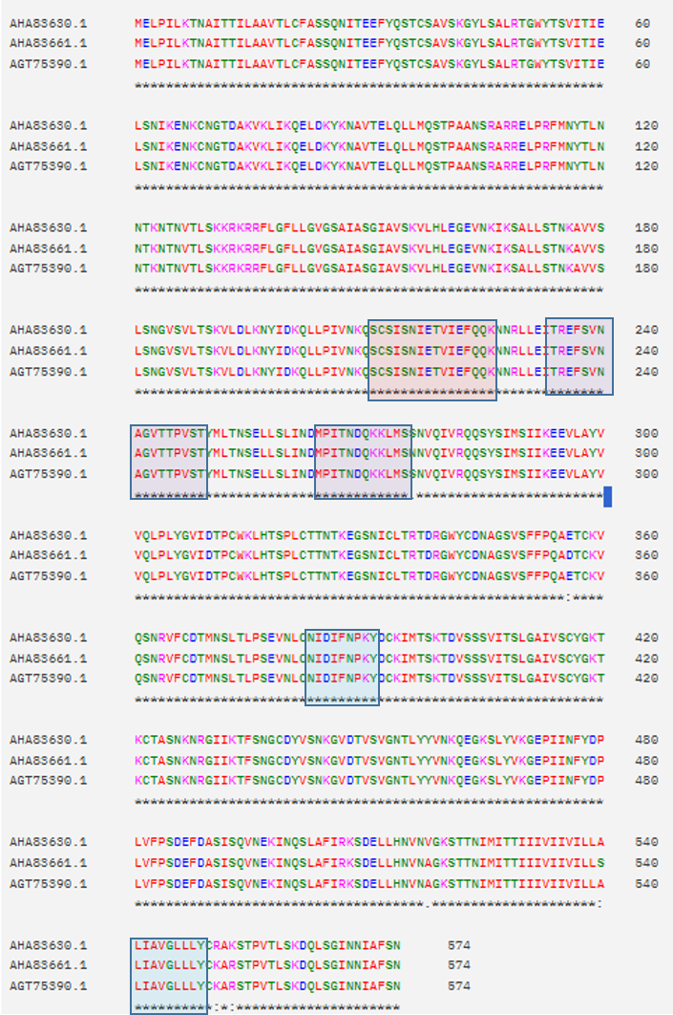
Figure S2: Shows the CTL, HTL and BCL epitopes in RSV

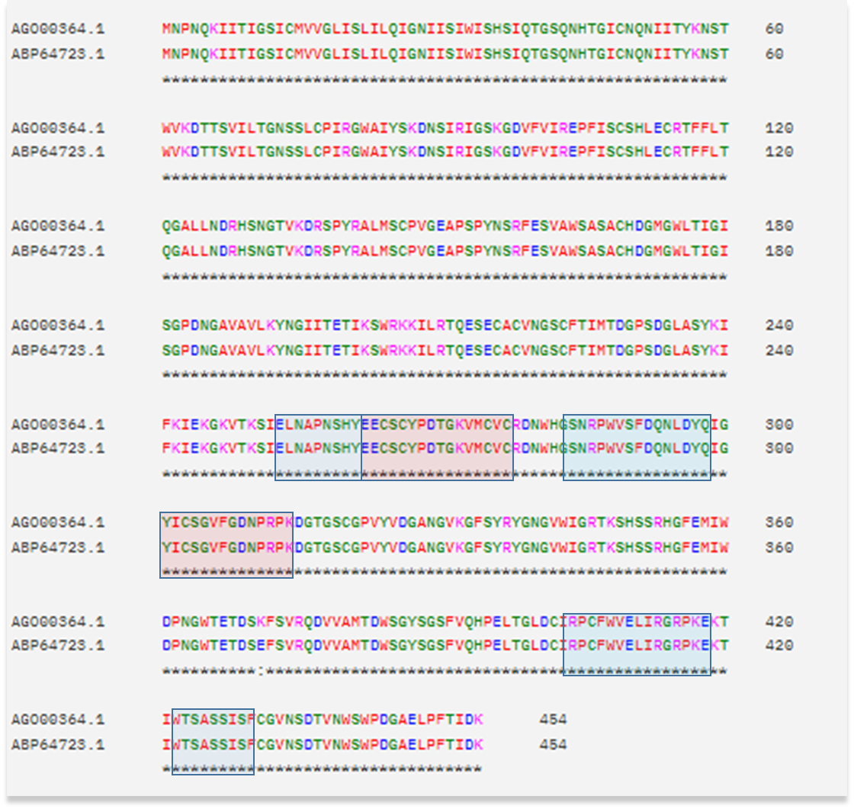
Figure S3: Shows the CTL, HTL and BCL epitopes in influenza A virus

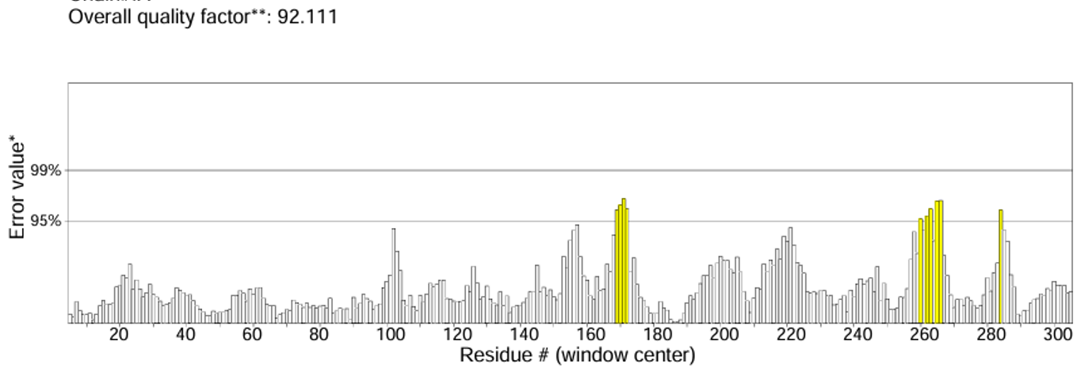

Figure S4: shows overall quality of the construct

Table S1: Different protein from hMPV, RSV and influenza A virus.
Virus | Protein | Antigenic value | Antigenicity
Human Metapneumovirus (hMPV) | N | 0.5243 | Antigenic
Human Metapneumovirus (hMPV) | P | 0.5131 | Antigenic
Human Metapneumovirus (hMPV) | M | 0.3939 | Non- Antigenic
Human Metapneumovirus (hMPV) | F | 0.4775 | Antigenic
Human Metapneumovirus (hMPV) | M2-1 | 0.4212 | Antigenic
Human Metapneumovirus (hMPV) | M2-2S | 0.4285 | Antigenic
Human Metapneumovirus (hMPV) | SH | 0.3756 | Non- Antigenic
Human Metapneumovirus (hMPV) | G | 0.6768 | Antigenic
Human Metapneumovirus (hMPV) | L | 0.471 | Antigenic
Respiratory syncytial virus (RSV) | NS1 | 0.3602 | Non- Antigenic
Respiratory syncytial virus (RSV) | NS2 | 0.5592 | Antigenic
Respiratory syncytial virus (RSV) | N | 0.4307 | Antigenic
Respiratory syncytial virus (RSV) | P | 0.5066 | Antigenic
Respiratory syncytial virus (RSV) | M | 0.5250 | Antigenic
Respiratory syncytial virus (RSV) | SH | 0.6297 | Antigenic
Respiratory syncytial virus (RSV) | G | 0.4949 | Antigenic
Respiratory syncytial virus (RSV) | F | 0.5219 | Antigenic
Respiratory syncytial virus (RSV) | M2 | 0.4669 | Antigenic
Respiratory syncytial virus (RSV) | L | 0.4440 | Antigenic
Influenza A Virus | PB1 | 0.4910 | Antigenic
Influenza A Virus | PA | 0.5121 | Antigenic
Influenza A Virus | hemagglutinin | 0.5471 | Antigenic
Influenza A Virus | PB2 | 0.7418 | Antigenic
Influenza A Virus | nucleocapsid protein | 0.6080 | Antigenic
Influenza A Virus | matrix protein 2 | 0.4644 | Antigenic
Influenza A Virus | hemagglutinin | 0.4466 | Non- Antigenic
Influenza A Virus | neuraminidase | 0.5024 | Antigenic
Influenza A Virus | matrix protein 2 | 0.6037 | Antigenic
Influenza A Virus | nuclear export protein | 0.4252 | Antigenic
Influenza A Virus | nonstructural protein 1 | 0.3328 | Non- Antigenic
Influenza A Virus | matrix protein 1 | 0.4828 | Antigenic
Influenza A Virus | nucleocapsid protein | 0.7694 | Antigenic
Influenza A Virus | nonstructural protein 1 | 0.3611 | Non- Antigenic

Table S2. Predicted HTL epitopes. The table shows the specific allele against which the HTL epitopes are predicted. Furthermore, it also shows the methods and percentile rank of each peptide. The HTL epitopes shown in bold are finally selected epitopes for chimeric multi-epitopes vaccine constructed.

Virus | Protein | Allele | Start | End | Peptide Sequence | Percentile  Rank | Antigenicity  Score
Human Metapneumovirus | Fusion protein | HLA-DRB1*07:01 | 229 | 243 | RAVSYMPTSAGQIKL | 0.06 | 0.8830
Human Metapneumovirus | Fusion protein | HLA-DRB1*15:01 | 119 | 133 | TAGIAIAKTIRLESE | 0.12 | 0.8439
Human Metapneumovirus | Fusion protein | HLA-DRB5*01:01 | 131 | 145 | ESEVNAIKGALKTTN | 0.13 | 0.4978
Human Metapneumovirus | Fusion protein | HLA-DRB1*15:01 | 162 | 176 | VRELKEFVSKNLTSA | 0.13 | -0.0826
Human Metapneumovirus | Fusion protein | HLA-DRB4*01:01 | 63 | 77 | GPSLIKTELDLTKSA | 0.18 | 0.5887
Human Metapneumovirus | Fusion protein | HLA-DRB1*03:01 | 415 | 429 | ADTVTIDNTVYQLSK | 0.26 | 0.0778
Human Metapneumovirus | Fusion protein | HLA-DRB1*03:01 | 218 | 232 | SLDLMNDAELARAVS | 0.26 | 0.4532
Human Metapneumovirus | Fusion protein | HLA-DRB4*01:01 | 200 | 214 | FLNVVRQFSDNAGIT | 0.30 | 0.0926
Human Metapneumovirus | Fusion protein | HLA-DRB5*01:01 | 152 | 166 | GNGVRVLATAVRELK | 0.33 | 0.3485
Human Metapneumovirus | Fusion protein | HLA-DRB1*07:01 | 231 | 245 | VSYMPTSAGQIKLML | 0.60 | 0.5663
Respiratory syncytial virus | Fusion protein | HLA-DRB3*02:02 | 234 | 248 | TREFSVNAGVTTPVS | 0.04 | 0.2788
Respiratory syncytial virus | Fusion protein | HLA-DRB1*03:01 | 263 | 277 | DMPITNDQKKLMSN | 0.04 | 0.2076
Respiratory syncytial virus | Fusion protein | HLA-DRB3*02:02 | 238 | 252 | GCDYVSNKGVDTVSV | 0.11 | 0.6006
Respiratory syncytial virus | Fusion protein | HLA-DRB3*02:02 | 270 | 284 | QKKLMSNNVQIVRQQ | 0.12 | 0.2284
Respiratory syncytial virus | Fusion protein | HLA-DRB1*15:01 | 80 | 94 | KQELDKYKSAVTELQ | 0.13 | -0.2571
Respiratory syncytial virus | Fusion protein | HLA-DRB4*01:01 | 75 | 89 | KVKLIKQELDKYKSA | 0.16 | -0.7015
Respiratory syncytial virus | Fusion protein | HLA-DRB3*02:02 | 269 | 283 | DQKKLMSNNVQIVRQ | 0.16 | 0.0835
Respiratory syncytial virus | Fusion protein | HLA-DRB4*01:01 | 392 | 406 | DCKIMTSKTDVSSSV | 0.23 | 0.1144
Respiratory syncytial virus | Fusion protein | HLA-DRB1*15:01 | 472 | 486 | EPIINFYDPLVFPSD | 0.29 | -0.0213
Respiratory syncytial virus | Fusion protein | HLA-DRB3*02:02 | 436 | 450 | SNGCDYVSNKGVDTV | 0.32 | 0.3386
Influenza A Virus | neuraminidase | HLA-DRB1*15:01 | 162 | 176 | SDGLASYKIFKIEKG | 0.04 | 0.1598
Influenza A Virus | neuraminidase | HLA-DRB3*01:01 | 12 | 26 | WAIYSKDNSIRIGSK | 0.10 | 1.1726
Influenza A Virus | neuraminidase | HLA-DRB3*01:01 | 249 | 263 | SCGPVYVDGANGVKG | 0.17 | 0.2163
Influenza A Virus | neuraminidase | HLA-DRB3*02:02 | 178 | 192 | VTKSIELNAPNSHYE | 0.28 | 0.3843
Influenza A Virus | neuraminidase | HLA-DRB1*15:01 | 116 | 130 | GAVAVLKYNGIITET | 0.41 | 0.4093
Influenza A Virus | neuraminidase | HLA-DRB3*02:02 | 180 | 194 | KSIELNAPNSHYEEC | 0.66 | 0.1576
Influenza A Virus | neuraminidase | HLA-DRB3*01:01 | 216 | 230 | RPWVSFDQNLDYQIG | 0.78 | 0.6706
Influenza A Virus | neuraminidase | HLA-DRB1*07:01 | 44 | 58 | CRTFFLTQGALLNDR | 0.90 | 0.4648
Influenza A Virus | neuraminidase | HLA-DRB1*07:01 | 119 | 133 | AVLKYNGIITETIKS | 1.20 | 0.1688
Influenza A Virus | neuraminidase | HLA-DRB3*01:01 | 214 | 228 | SNRPWVSFDQNLDYQ | 1.30 | 0.6043
Influenza A Virus | neuraminidase | HLA-DRB5*01:01 | 334 | 348 | RPCFWVELIRGRPKE | 2.20 | 0.9819

Table S3. Predicted HTL epitopes. The table shows the specific allele against which the HTL epitopes are predicted. Furthermore, it also shows the methods and percentile rank of each peptide. The HTL epitopes shown in bold are finally selected epitopes for chimeric multi-epitopes vaccine constructed.

Virus | Protein | Allele | Start | End | Peptide Sequence | Percentile  Rank | Antigenicity  Score
Human Metapneumovirus | Fusion protein | HLA-DRB1*07:01 | 229 | 243 | RAVSYMPTSAGQIKL | 0.06 | 0.8830
Human Metapneumovirus | Fusion protein | HLA-DRB1*15:01 | 119 | 133 | TAGIAIAKTIRLESE | 0.12 | 0.8439
Human Metapneumovirus | Fusion protein | HLA-DRB5*01:01 | 131 | 145 | ESEVNAIKGALKTTN | 0.13 | 0.4978
Human Metapneumovirus | Fusion protein | HLA-DRB1*15:01 | 162 | 176 | VRELKEFVSKNLTSA | 0.13 | -0.0826
Human Metapneumovirus | Fusion protein | HLA-DRB4*01:01 | 63 | 77 | GPSLIKTELDLTKSA | 0.18 | 0.5887
Human Metapneumovirus | Fusion protein | HLA-DRB1*03:01 | 415 | 429 | ADTVTIDNTVYQLSK | 0.26 | 0.0778
Human Metapneumovirus | Fusion protein | HLA-DRB1*03:01 | 218 | 232 | SLDLMNDAELARAVS | 0.26 | 0.4532
Human Metapneumovirus | Fusion protein | HLA-DRB4*01:01 | 200 | 214 | FLNVVRQFSDNAGIT | 0.30 | 0.0926
Human Metapneumovirus | Fusion protein | HLA-DRB5*01:01 | 152 | 166 | GNGVRVLATAVRELK | 0.33 | 0.3485
Human Metapneumovirus | Fusion protein | HLA-DRB1*07:01 | 231 | 245 | VSYMPTSAGQIKLML | 0.60 | 0.5663
Respiratory syncytial virus | Fusion protein | HLA-DRB3*02:02 | 234 | 248 | TREFSVNAGVTTPVS | 0.04 | 0.2788
Respiratory syncytial virus | Fusion protein | HLA-DRB1*03:01 | 263 | 277 | DMPITNDQKKLMSN | 0.04 | 0.2076
Respiratory syncytial virus | Fusion protein | HLA-DRB3*02:02 | 238 | 252 | GCDYVSNKGVDTVSV | 0.11 | 0.6006
Respiratory syncytial virus | Fusion protein | HLA-DRB3*02:02 | 270 | 284 | QKKLMSNNVQIVRQQ | 0.12 | 0.2284
Respiratory syncytial virus | Fusion protein | HLA-DRB1*15:01 | 80 | 94 | KQELDKYKSAVTELQ | 0.13 | -0.2571
Respiratory syncytial virus | Fusion protein | HLA-DRB4*01:01 | 75 | 89 | KVKLIKQELDKYKSA | 0.16 | -0.7015
Respiratory syncytial virus | Fusion protein | HLA-DRB3*02:02 | 269 | 283 | DQKKLMSNNVQIVRQ | 0.16 | 0.0835
Respiratory syncytial virus | Fusion protein | HLA-DRB4*01:01 | 392 | 406 | DCKIMTSKTDVSSSV | 0.23 | 0.1144
Respiratory syncytial virus | Fusion protein | HLA-DRB1*15:01 | 472 | 486 | EPIINFYDPLVFPSD | 0.29 | -0.0213
Respiratory syncytial virus | Fusion protein | HLA-DRB3*02:02 | 436 | 450 | SNGCDYVSNKGVDTV | 0.32 | 0.3386
Influenza A Virus | Neuraminidase | HLA-DRB1*15:01 | 162 | 176 | SDGLASYKIFKIEKG | 0.04 | 0.1598
Influenza A Virus | Neuraminidase | HLA-DRB3*01:01 | 12 | 26 | WAIYSKDNSIRIGSK | 0.10 | 1.1726
Influenza A Virus | Neuraminidase | HLA-DRB3*01:01 | 249 | 263 | SCGPVYVDGANGVKG | 0.17 | 0.2163
Influenza A Virus | Neuraminidase | HLA-DRB3*02:02 | 178 | 192 | VTKSIELNAPNSHYE | 0.28 | 0.3843
Influenza A Virus | Neuraminidase | HLA-DRB1*15:01 | 116 | 130 | GAVAVLKYNGIITET | 0.41 | 0.4093
Influenza A Virus | Neuraminidase | HLA-DRB3*02:02 | 180 | 194 | KSIELNAPNSHYEEC | 0.66 | 0.1576
Influenza A Virus | Neuraminidase | HLA-DRB3*01:01 | 216 | 230 | RPWVSFDQNLDYQIG | 0.78 | 0.6706
Influenza A Virus | Neuraminidase | HLA-DRB1*07:01 | 44 | 58 | CRTFFLTQGALLNDR | 0.90 | 0.4648
Influenza A Virus | Neuraminidase | HLA-DRB1*07:01 | 119 | 133 | AVLKYNGIITETIKS | 1.20 | 0.1688
Influenza A Virus | Neuraminidase | HLA-DRB3*01:01 | 214 | 228 | SNRPWVSFDQNLDYQ | 1.30 | 0.6043
Influenza A Virus | Neuraminidase | HLA-DRB5*01:01 | 334 | 348 | RPCFWVELIRGRPKE | 2.20 | 0.9819

Table S4. Predicted linear B-Cell epitopes for the virus polypeptide. The predicted score for each peptide is given against each B-cell epitope.
Virus | Protein | Start Position | Epitope | Score | Antigenicity Score
Human Metapneumovirus | Fusion protein | 510 | IIIIIKKTRKPAGAPP | 0.92 | 1.0870
Human Metapneumovirus | Fusion protein | 283 | CWIIKAAPSCSEKDGN | 0.92 | 0.8104
Human Metapneumovirus | Fusion protein | 301 | CLLREDQGWYCKNAGS | 0.89 | 0.5101
Human Metapneumovirus | Fusion protein | 238 | AGQIKLMLENRAMVRR | 0.89 | 0.0882
Human Metapneumovirus | Fusion protein | 92 | EEQIENPRQSRFVLGA | 0.88 | 0.2275
Human Metapneumovirus | Fusion protein | 434 | QHVIKGRPVSNSFDPI | 0.88 | 0.9931
Human Metapneumovirus | Fusion protein | 363 | VSTGRHPISMVALSPL | 0.87 | 0.9390
Human Metapneumovirus | Fusion protein | 312 | KNAGSTVYYPNEKDCE | 0.87 | 0.4609
Human Metapneumovirus | Fusion protein | 125 | AKTIRLESEVNAIKGA | 0.87 | 0.3283
Human Metapneumovirus | Fusion protein | 409 | YITNQDADTVTIDNTV | 0.86 | 0.3534
Respiratory syncytial virus | Fusion protein | 479 | DPLVFPSDEFDASISQ | 0.92 | 0.0842
Respiratory syncytial virus | Fusion protein | 106 | RARRELPRFMNYTLNN | 0.92 | -0.0128
Respiratory syncytial virus | Fusion protein | 306 | YGVIDTPCWKLHTSPL | 0.91 | 0.5064
Respiratory syncytial virus | Fusion protein | 383 | NIDIFNPKYDCKIMTS | 0.89 | 0.7806
Respiratory syncytial virus | Fusion protein | 334 | TFSNGCDYVSNKGVDT | 0.88 | 0.3822
Respiratory syncytial virus | Fusion protein | 329 | GSNICLTRTDRGWYCD | 0.87 | 0.8391
Respiratory syncytial virus | Fusion protein | 23 | ASSQNITEEFYQTTCS | 0.86 | 0.2400
Respiratory syncytial virus | Fusion protein | 211 | SCSISNIETVIEFQQK | 0.86 | 1.0332
Respiratory syncytial virus | Fusion protein | 196 | KNYIDKQLLPIVNKQS | 0.86 | 0.3791
Respiratory syncytial virus | Fusion protein | 54 | TSVITIELSNIKENKCd | 0.86 | 0.6166
Influenza A Virus | neuraminidase | 223 | CFTIMTDGPSDGLASY | 0.94 | -0.2483
Influenza A Virus | neuraminidase | 315 | DGTGSCGPVYVDGANG | 0.93 | -0.1810
Influenza A Virus | neuraminidase | 282 | HGSNRPWVSFDQNLDY | 0.93 | 0.2757
Influenza A Virus | neuraminidase | 356 | FEMIWDPNGWTETDSK | 0.92 | 0.1997
Influenza A Virus | neuraminidase | 35 | SHSIQTGSQNHTGICN | 0.92 | 0.6373
Influenza A Virus | neuraminidase | 299 | IGYICSGVFGDNPRPK | 0.91 | 0.5897
Influenza A Virus | neuraminidase | 273 | VMCVCRDNWHGSNRPW | 0.91 | 0.1602
Influenza A Virus | neuraminidase | 261 | EECSCYPDTGKVMCVC | 0.91 | 0.4128
Influenza A Virus | neuraminidase | 329 | NGVKGFSYRYGNGVWI | 0.90 | 0.3707
Influenza A Virus | neuraminidase | 131 | NGTVKDRSPYRALMSC | 0.89 | 0.6479
Influenza A Virus | neuraminidase | 251 | SIELNAPNSHYEECSC | 0.88 | 0.2283

Table S5. Key Hydrogen Bonds Between TLR4 and Vaccine Construct During MD Simulation.

TLR4 Residues | Vaccine Residues | Frames Observed | Bond Life | Average Distance (Å) | Standard Deviation (Å)
459-ND2 | 876-O | 6261 | 62.60% | 2.82 | 0.09
357-O | 855-NH1 | 3808 | 38.10% | 2.84 | 0.09
458-OE1 | 875-NZ | 3486 | 34.90% | 2.82 | 0.10
412-OE1 | 817-NH1 | 2851 | 28.50% | 2.80 | 0.09
455-OG | 877-OD1 | 2221 | 22.20% | 2.77 | 0.13
409-OE1 | 817-NH1 | 2027 | 20.30% | 2.81 | 0.09
433-NH2 | 877-OD1 | 457 | 4.57% | 2.86 | 0.10
455-CB | 877-OD1 | 204 | 2.04% | 2.94 | 0.05
433-NH2 | 876-OD2 | 173 | 1.73% | 2.81 | 0.10
433-NH1 | 876-OD2 | 167 | 1.67% | 2.84 | 0.09
361-NZ | 834-O | 160 | 1.60% | 2.81 | 0.10

