Supplement files

Exclusion Criteria: 2
Adverse event defined: 3
Figure S1: Flow chart of study 7
Figure S2: Visual Analogue Scale 8
TableS1 Comparison of haemodynamic and respiratory inedexs at different time points. 9
TableS2 Vital signs within 24h of different continuous dose. 10
TableS3 Blood concentrations of hydromorphone and metabolites within 30min after infusion. 12

Exclusion Criteria:
- Pregnant females or females suspected of being pregnant.
- Proven or suspected acute primary brain lesion such as traumatic brain injury, intracranial haemorrhage, stroke, or hypoxic brain injury.
- Proven or suspected spinal cord injury or other pathology that may result in permanent or prolonged weakness
- A mean arterial blood (MAP) pressure that is less than 50 mmHg.
- Heart rate less than 55 beats per minute unless the patient is being treated with a beta-blocker or a high grade atrio-ventricular block in the absence of a functioning pacemaker.
- Any injury or disorder affecting the ability to assess level of analgesia or collect data.
- a history of alcohol abuse, and a history of clinically significant abuse of opioid or sedative-containing substances
- a contraindication or history of allergic hypersensitivity to any of the study medications

Adverse event defined:
An adverse event refers to any undesirable medical occurrence in a patient or subject after the administration of a drug, which does not necessarily have a causal relationship with the treatment. Therefore, an adverse event can be any unfavorable sign (including abnormal laboratory results), symptom, or disease temporally associated with the use of the investigational drug, regardless of whether a causal relationship with the drug is considered.
A.Specific Respiratory-Related Events: | Occurred and one or more of the following interventions were taken (record the highest level if multiple interventions were used):  Interventions include:  1. Verbal or tactile stimulation  2. Airway repositioning or suctioning  3. Supplemental or increased oxygen delivery  4. Nasopharyngeal/oropharyngeal airway  5. Positive pressure via mask without assisted ventilation  6. Non-invasive positive pressure ventilation (NPPV) or nasal high-flow oxygen therapy (NFNC)  7. Administration of naloxone to reverse respiratory depression (Note: specify if naloxone was used due to oversedation)  8. Endotracheal intubation or tracheostomy  9. Advanced life support such as ECMO (Extracorporeal Membrane Oxygenation)
1. Hypoventilation | Occurrence of respiratory rate < 8 breaths per minute on 3 or more occasions.
2. Apnea (Asphyxia) | An event characterized by the cessation or pause of breathing lasting ≥ 10 seconds.
3. Decreased oxygen saturation  Hypercapnia due to insufficient ventilation: | Presence of 3 or more oxygen desaturations (defined as pulse oximetry <90%, with or without nasal cannula)  Hypercapnia due to insufficient ventilation: presence of PaCO2 > 50 mmHg that was not present in the first place
4.Pain-sedation mismatch | RASS score -3 to -5 and pain numeric score >5
B. Respiratory depression or excessive sedation requiring naloxone treatment
C. Failed extubation and re-tracheal intubation | Failed extubation is defined as a patient with a planned extubation requiring reintubation after extubation (document in detail the reason for reintubation and the time of reintubation)
D. Other respiratory-related adverse events
1. Partial airway obstruction | Manifested by one or more of the following: (a) stridor (b) snoring and/or (c) inward retraction of the chest wall or sternum and Relief of airway obstruction by one or more of the following: (a) repositioning of the airway (b) suctioning (c) supplemental or increased oxygen delivery (d) nasopharyngeal/oropharyngeal airway (e) positive pressure by mask without assisted ventilation.
2. Complete airway obstruction | Effortless ventilation without gas exchange with the following manifestations: (a) absence of the upper airway (e.g. wheezing or snoring) and absence of breath sounds on auscultation (b) loss of the CO2 waveform (when end-expiratory CO2 is monitored) and one or more of the following interventions to alleviate complete airway obstruction: (a) airway repositioning (b) suctioning manoeuvres (c) nasopharyngeal/oral pharyngeal airway insertion (d) positive airway pressure through a mask but without (d) Positive pressure by mask without assisted ventilation (CPAP) (e) Mask with assisted ventilation (f) Endotracheal intubation or tracheotomy (g) Administration of sedative-analgesic medications (h) Administration of neuromuscular blockers
3. Laryngeal spasm | Complete airway obstruction and oxygen desaturation due to involuntary and persistent glottal closure preventing effective airway ventilation, requiring positive pressure ventilation (with or without inotropic medication).
4. Clinically present pulmonary aspiration/aspiration pneumonia | Suspected or confirmed presence of oropharyngeal or gastric contents in the trachea and the presence of previously absent respiratory signs and symptoms, the new sign or symptom must be present during the intervention. The patient must have one or more of the following three sign/symptom categories: (a) Signs: cough, wet rhonchi/bubbles, decreased breath sounds, shortness of breath, wheezing/rumbling, snoring, respiratory distress (b) Oxygen demand: oxygen saturation decreased from baseline requiring supplemental oxygen (c) Chest X-ray: localised infiltrates or solid shadows
E. Circulation-related adverse events:
1. Low blood pressure | There is a non-existent decrease in blood pressure: systolic blood pressure 20 mmHg below baseline or mean arterial pressure 10 mmHg below baseline and one or more interventions to raise blood pressure. Interventions include: (a) intravenous fluid augmentation (b) chest compressions (c) vasoactive medications.
2. Bradycardia | A slowing of the heart rate that would not otherwise be present: a decrease to <60 beats/min in patients with a basal heart rate of 60-100 beats/min or a decrease to <50 beats/min in patients with a basal heart rate of less than 60 beats/min. and One or more interventions to increase heart rate and cardiac output. Interventions include: (a) Tactile stimulation (b) Supplemental oxygen (c) Positive but not continuous positive airway pressure (CPAP) by mask (d) Endotracheal intubation (e) Chest compressions (f) Use of vasoactive/cardiotonic drugs.
3. Cardiac insufficiency | Clinician or investigator determines the presence of cardiac insufficiency that was not otherwise present. One or more interventions to increase cardiac output: (a) volume management (b) positive but not continuous positive airway pressure (CPAP) by mask (c) endotracheal intubation (d) chest compressions (e) use of vasoactive/cardiac medications (f) use of advanced supportive therapy such as IBAP or ECMO
F. Gastrointestinal-related adverse events
1. Nausea, vomiting | Vomiting is defined as the elimination of gastric contents through the oral or nasal cavity. If vomiting results in clinically suspected or confirmed pulmonary aspiration, this adverse event must also be recorded. Among these, the nausea and vomiting score was recorded for postoperative nausea and vomiting (PONV)
2. Constipation, postoperative intestinal paralysis, paralytic intestinal obstruction | Postoperative intestinal paralysis: Except for mechanical intestinal obstruction and other conditions that can lead to postoperative abdominal distension and decreased bowel movement, the history of risk factors for postoperative intestinal paralysis and the presence of the following signs or symptoms persisting for more than 3-5 days. Symptoms include (a) abdominal distention, bloating, and flatulence (b) diffuse persistent abdominal pain (c) nausea and/or vomiting (d) delayed or inability to pass gas (e) inability to tolerate oral intake or enteral nutrition. Signs include abdominal distension and varying degrees of diminished tympanic and bowel sounds, which may be accompanied by mild diffuse tenderness.  Paralytic intestinal obstruction: constipation and intolerance of oral intake for more than 3-5 days, except for mechanical intestinal obstruction and other conditions that can lead to postoperative abdominal distension and decreased bowel movement.  This adverse event must also be documented in the presence of acute gastrointestinal impairment grade III or higher.
G. Delirium and the ICU syndrome | Presence of delirium or ICU syndrome not otherwise present (delirium is defined by the investigator or clinician according to CAM_ICU criteria)
H. Opioid-related nociceptive hypersensitivity and tolerance
1. Opioid-induced nociceptive hypersensitivity | Sensitivity to hurtful feelings, with greater sensitivity to painful stimuli
2. Acute tolerance to opioids and withdrawal reactions | Acute tolerance: a short period of opioid use results in a gradual decrease in effect.  Withdrawal reactions: usually begin 6-12h after stopping opioids and usually peak 24-48h. Symptoms include: (a) restlessness and agitation (b) rhinorrhea and tearing (c) myalgia and arthralgia (d) nausea, vomiting, abdominal cramps and diarrhoea. Signs: dilated pupils (pupil dilation), yawning, increased bowel sounds, and raised hair. If the patient is very distressed, there may be an increased heart rate, increased blood pressure and increased respiratory rate. Hypotension may occur in cases of insufficient circulating volume due to vomiting and diarrhoea. The patient's temperature is normal, as is his or her mental status unless the condition is particularly severe. The Clinical Opioid Withdrawal Scale can be used to help determine the presence of signs and symptoms consistent with opioid withdrawal and the severity of withdrawal.
I. Other adverse reactions:
1. Itching
2. Urinary retention
3. Myoclonic/ventilator jerks | Refers to an involuntary, short-term contraction of a group of muscles or of muscles throughout the body that results in an observable transient movement of the corresponding body part. Usually the event does not exceed 1/10th of a second and requires intervention, medication or surgical intervention.
4. Epilepsy | A temporary abnormal electrophysiological phenomenon in the brain manifested by involuntary or paroxysmal voluntary contractions of random muscles. These include persistent contractions (tonic seizures) or repetitive contractions (tonic-clonic seizures). Often the extreme form of tonicity with tremor can resemble a seizure, and the diagnosis can be confirmed by electroencephalography (EEG).
5. Skeletal muscle (chest wall) ankylosis | Manifestations of involuntary muscle tonus or chest wall rigidity (including apnoea, high resistance to pressurised ventilation and poor chest rise and fall) require intervention or treatment with neuromuscular blocking or analgesic drug reversal medication.

Figure S1: Flow chart of study

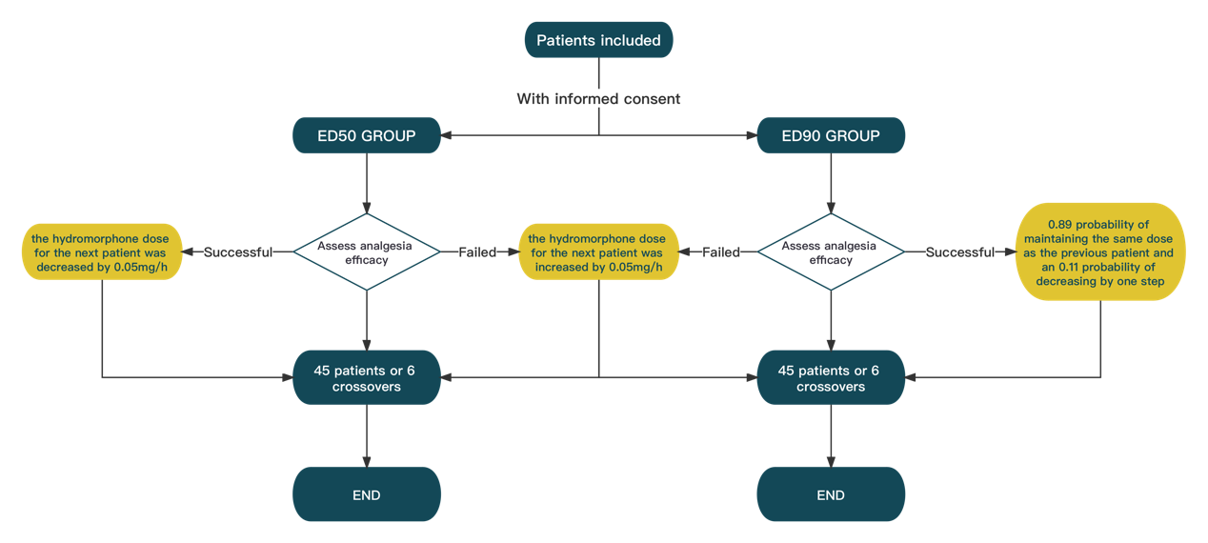

Figure S2: Visual Analogue Scale

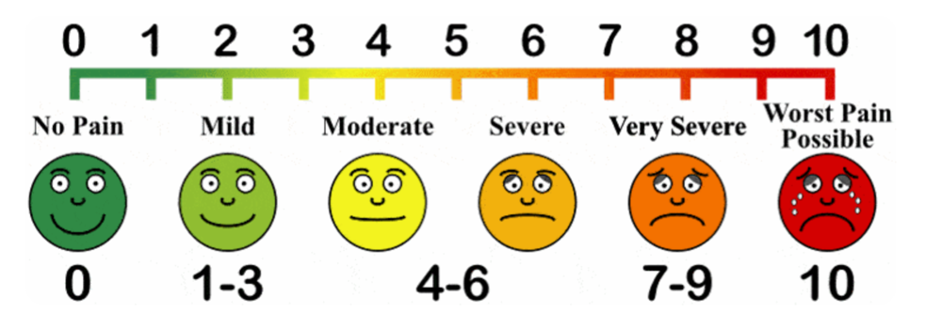

TableS1 Vital signs within 30 min after loading dose
 | Total（N=60） | Time effct
 | Total（N=60） | F vaule | P value
HR |  | 9.330* | 0.000*
0min | 90.36±19.19
1min | 89.61±19.29
5min | 89.06±17.28
10min | 91.03±17.32
30min | 91.10±18.30
NBP |  | 1.420* | 0.248*
0min | 73.93±12.56
1min | 72.07±11.62
5min | 70.63±11.63
10min | 70.55±13.01
30min | 69.46±10.40
SBP |  | 0.930* | 0.425*
0min | 144.36±20.75
1min | 142.25±19.16
5min | 140.38±18.00
10min | 140.68±20.47
30min | 141.31±19.79
RR |  | 4.760* | 0.003*
0min | 17.46±4.47
1min | 15.57±4.13
5min | 16.62±3.42
10min | 18.00±4.24
30min | 18.13±4.82
Abbreviations: HR, Heart rate; NBP, ; SBP, Systolic blood pressure; RR, Respiratory rate .
*The study was analysed by one-way repeated measures ANOVA with Greenhouse-Geisser's correction

TableS2 Vital signs within 24h of different continuous dose.
 | 0.05mg/h | 0.10mg/h | 0.15mg/h | 0.20mg/h | group | Intervention Effect | Time effect | Interaction effect
 | (n=7) | (n=24) | (n=17) | (n=12) | group | P value | P value | P value
HR (/min) |  |  |  |  |  | 0.023 | 0.014 | 0.394
0h | 100.14±9.96 | 92.96±18.86 | 91.24±14.73 | 89.17±21.81 | 92.55±17.49
1h | 101.14±12.97 | 91.42±19.34 | 93.59±15.61 | 88.92±16.41 | 92.67±17.07
2h | 108.14±15.33 | 90.38±19.06 | 89.71±13.71 | 84.67±15.88 | 91.12±17.53
4h | 106.29±15.38 | 87.42±15.17 | 89.59±15.11 | 80.92±16.60 | 88.93±16.64
6h | 109.14±9.65 | 87.33±15.91 | 90.00±10.20 | 80.33±15.18 | 89.23±15.62
12h | 100.43±15.57 | 86.29±11.86 | 87.18±12.51 | 79.17±16.60 | 86.77±14.40
24h | 96.14±8.01 | 85.17±13.94 | 87.41±13.16 | 82.83±11.81 | 86.62±13.05
MAP(mmHg) |  |  |  |  |  | 0.943 | 0.000 | 0.001
0h | 85.86±7.56 | 90.13±10.20 | 83.47±9.19 | 92.00±13.39 | 88.12±10.69
1h | 85.29±4.96 | 87.79±12.82 | 86.82±9.09 | 86.17±9.88 | 86.90±10.39
2h | 83.71±8.16 | 85.46±10.83 | 84.59±11.58 | 83.17±10.96 | 84.55±10.58
4h | 80.43±11.06 | 83.92±13.60 | 86.06±11.77 | 83.00±8.14 | 83.93±11.72
6h | 79.86±15.53 | 85.63±14.08 | 86.82±11.23 | 79.67±9.62 | 84.10±12.75
12h | 77.00±15.94 | 83.38±12.32 | 82.76±9.11 | 82.42±10.16 | 82.27±11.43
24h | 94.14±3.02 | 85.42±10.17 | 83.47±9.08 | 86.58±9.61 | 86.12±9.52
RR (/min) |  |  |  |  |  | 0.000 | 0.006 | 0.004
0h | 19.00±7.62 | 16.83±3.86 | 18.29±2.49 | 13.58±2.31 | 16.85±4.21
1h | 25.00±4.00 | 16.71±3.21 | 19.24±3.61 | 15.50±2.91 | 18.15±4.52
2h | 23.86±4.60 | 16.71±3.46 | 18.18±3.45 | 16.08±2.68 | 17.83±4.11
4h | 21.14±2.48 | 16.08±3.88 | 19.06±2.82 | 14.00±1.95 | 17.10±3.84
6h | 24.14±2.48 | 16.33±3.55 | 18.65±5.01 | 13.83±1.80 | 17.4±4.67
12h | 17.14±3.02 | 17.33±3.96 | 18.59±4.47 | 14.25±4.27 | 17.05±4.26
24h | 17.86±5.49 | 17.29±4.42 | 18.41±5.48 | 15.58±3.73 | 17.33±4.73

TableS3 Blood concentrations of hydromorphone and metabolites within 30min after infusion.
 | Analgesic outcome | blood concentration（ng/ml） | P
HYD | Successful | 1.510(1.298,1.923) | 0.024
 | Failed | 1.070(0.745,1.550) | 0.024
3-GLU-HYD | Successful | 6.755(3.885,11.448) | 0.655
 | Failed | 6.940(5.538,8.418)
3-GLU-DiHYD | Successful | 13.575(8.213,28.693) | 0.293
 | Failed | 9.940(7.060,17.400)

