Arthrospira platensis Mediated the Green Biosynthesis of Silver Nanoparticles as Breast Cancer Controlling agent: In-vitro and In-vivoSafety Approach.

Nehal M. EL-Deeb^{1,2}, Mai A. Abo-Eleneen³, Omyma A. Awad³ and Atef M. Abo-Shady³.

¹ Biopharmaceutical products research department, Genetic Engineering and Biotechnology Research Institute, City of Scientific Research and Technological Applications, New Borg El-Arab City 21934, Alexandria, Egypt.
² Department of biology and biotechnology program, Indiana University, Bloomington,47405, Indiana, United States.
³ Faculty of Science, Tanta University, Botany and Microbiology Department, Egypt.

*Correspondence:
Nehal M. El- Deeb
nmohamm@iu.edu.
nehalmohammed83@gmail.com.

Fig. S1: Algal growth phases
The algal species growth was measured as optical density (O.D) every two days upon culturing the algal species for 16 days on modified Zarrouk medium and BG11to indicated the optimum growth conditions of a) A. platensis, b) C.vulgaris and c) M. aeruginosa.

Fig S2: safety pattern of the bio-AgNPs on PBMC cells.
The cellular viability of PBMCs cells was quantified using MTS after cellular treatment with different concentrations of AgNPs that biosynthesized by C. vulgaris, M. aeruginosa and A. platensis.

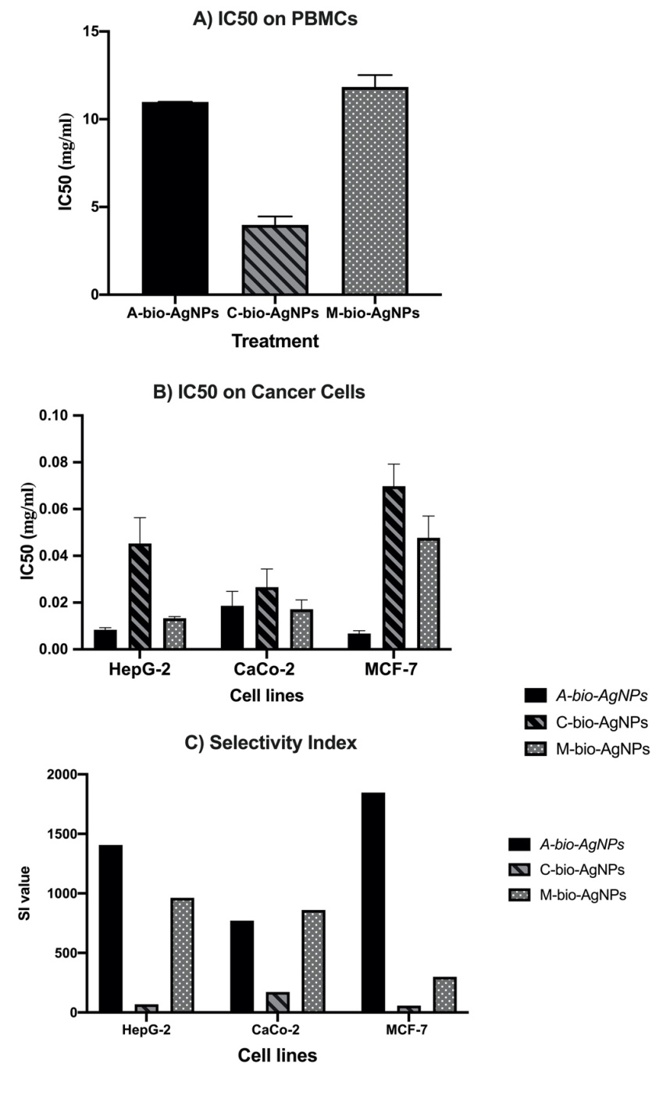
Fig S3: IC50 and selectivity index values of the bio-AgNPs on cancer cell lines.
Serial dilutions of the bio-AgNPs that synthesized with algal filtrates were tested on different cancer cell lines and normal cells to detect the IC50 values (a) and SI value (b).
Fig S4: Morphological changes of MCF-7 cells after AgNPs treatment
MCF7 cancer cells were treated with Arthrospira bio-AgNPs IC50 concentration, the changes in cellular morphological characters were visualized under phase contrast microscope; Arrows indicate apoptotic cells.
Fig.S5. Cell cycle pattern changes of cancer cells after Arthrospira bio-AgNPs treatment.
The cell cycle pattern of cancer cells A) HepG-2 cell B) CaCO-2 Cell cycle and C) MCF-7 Cell were quantified using PI and flowcytometry after MIC50 Arthrospira bio-AgNPs treatment
Table S.T.1: Primers sequences used for determination of gene regulation by different synthesized AgNPs.
Bcl2-forward | 5’-TATAAGCTGTCGCAGAGGGGCTA3’
Bcl2-reverse | 5’-GTACTCAGTCATCCACAGGGCGAT3’
P53-forward | 5'-AACGGTACTCCGCCACC-3'
P53-reverse | 5'-CGTGTCACCGTCGTGGA-3'
Survivin-forward | 5'-TGCCCCGACGTTGCC-3
Survivin-reverse | 5'-CAGTTCTTGAATGTAGAGATGCGGT-3'
TGF- forward | 5’- CAAGGGCTACCATGCCAACT-3’
TGF reverse | 5’-AGGGCCAGGACCTTGCTG-3’
Β actin forward | 5’- GTGGGGCGCCCCAGGCACCA-3’
Β actin reverse | 5’- CTCCTTAATGTCACGCACGATTTC-3’
MM7 forward | 5’- GATGGTAGCAGTCTAGGGATTAACTTC-3’
MMp7 reverse | 5’- GGAATGTCCCATACCCAAAGAA-3’

