Supplementary data:
Optimization of PEG concentration

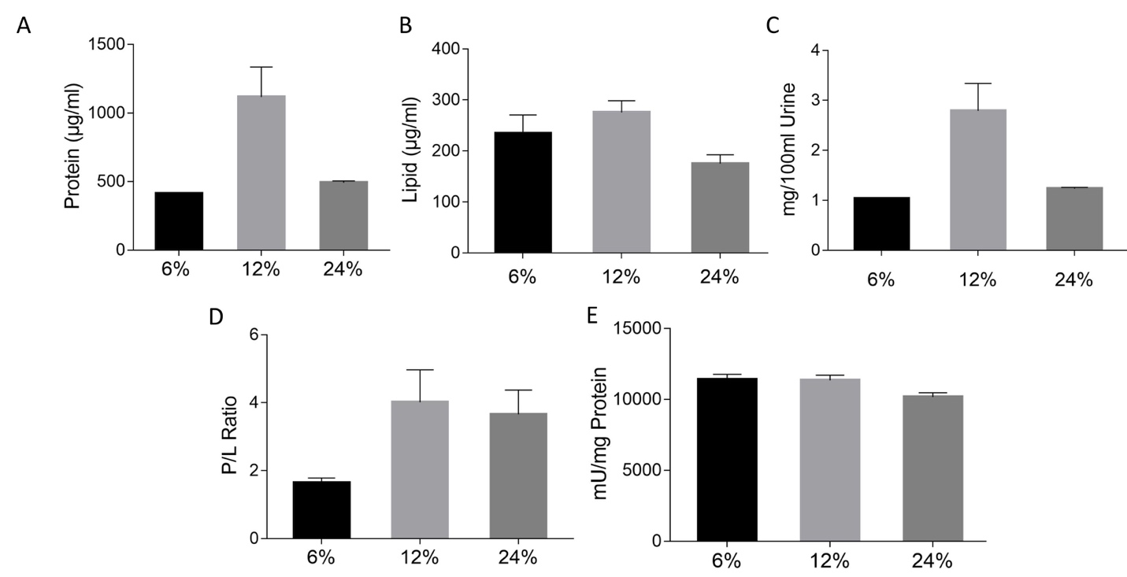
Fig. S1 (A) One-way ANOVA comparison of the total protein content of UEVs extracted using various concentrations of PEG MW6000 (n=3), p = 0.0009. (B) Lipid content of the isolated UEVs using Phospho Vanillin Assay, p = 0.0105 (C) Total EV yield per 100ml urine sample, p = 0.0009. (D) Protein to Lipid ratio of the UEV, p = 0.0120 (E) Acetylcholinesterase assay of UEV confirms the presence of the exosome in UEV fraction, p= 0.086. All data are represented as Mean ± SEM, n=3.

