Appendix

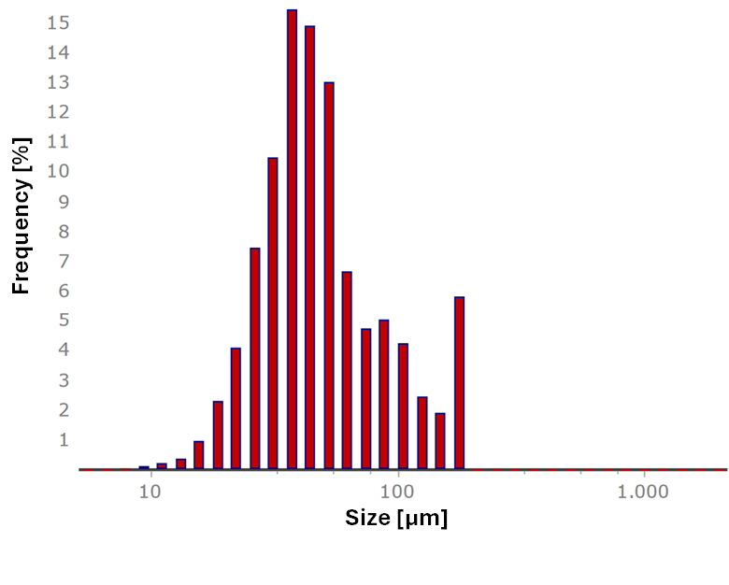
Fig. A1 Size distribution of PS microplastic particles.
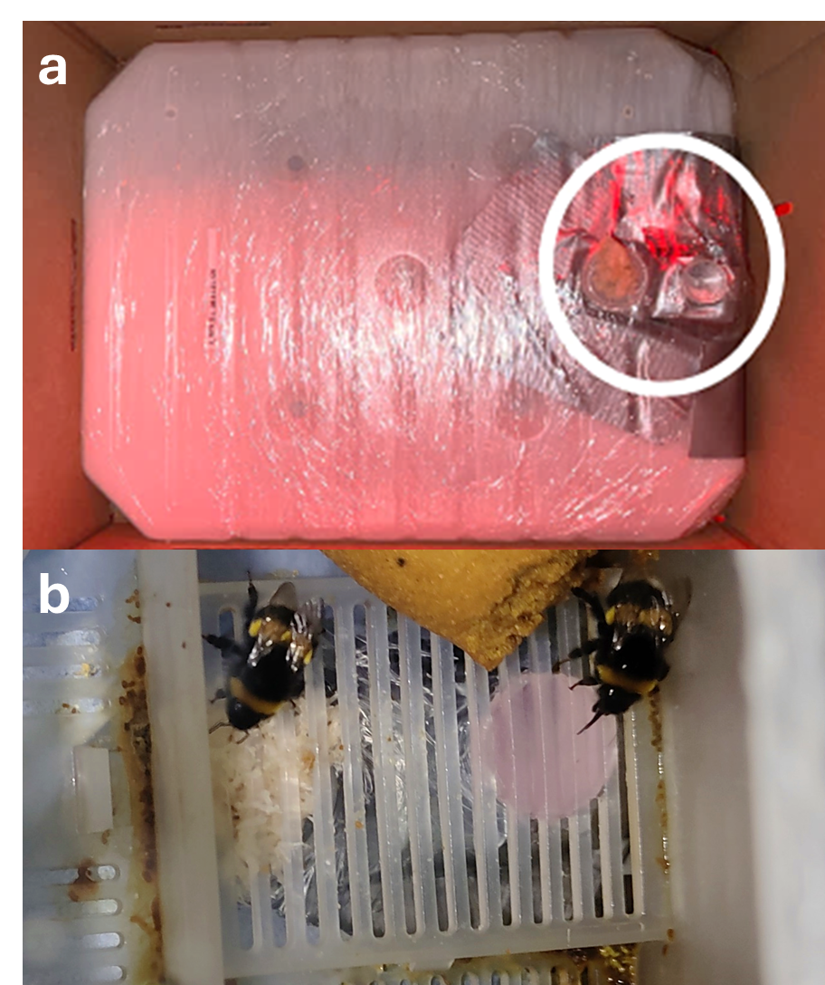Fig. A2 Experimental setup for bumblebees, with a) the modified sugar water tank with the reservoir taped next to the drinking wick (circled in white) and b) two bumblebee workers simultaneously drinking from the wick (left) and the reservoir (right, providing fluorescent microplastics suspension).
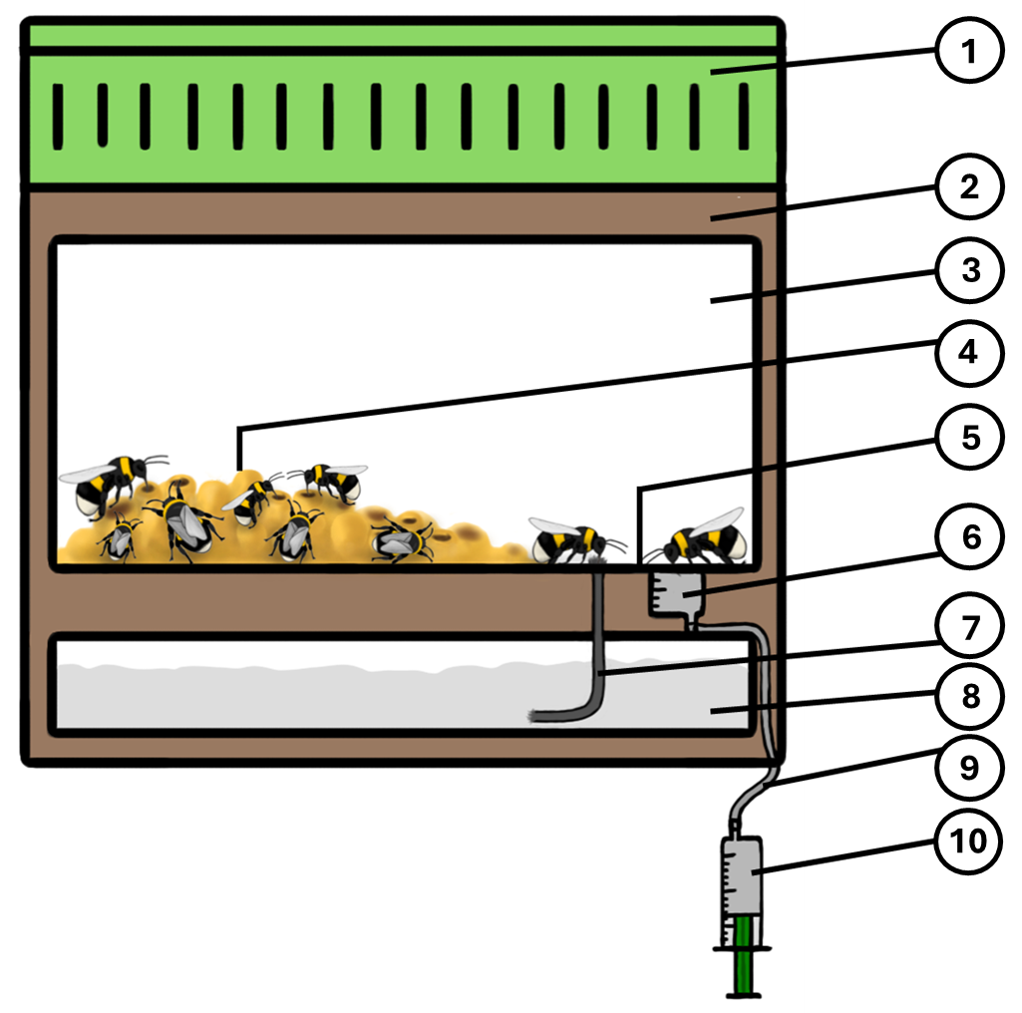
Fig. A3 Schematic drawing of the bumblebee colony set up for microplastics exposure. The set up consists of the 1) roof of colony box with air holes, 2) delivery box, 3) colony box, 4) hive area, 5) drinking area with grid-bottom, 6) reservoir for providing the treatment solutions/suspensions made from a piece of tube of 10-ml syringes (Omnifix, B. Braun SE), 7) drinking wick for sugar water from the sugar water tank, 8) sugar water tank, 9) tube (PVC, inner diameter: 4 mm, wall thickness: 1 mm, ZEUS GmbH & Co. KG, Soltau, Germany) to connect the reservoir with the syringe (for refilling the reservoir without disturbing the colony), and 10) a 20-ml syringe (Omnifix, B. Braun SE) containing the treatment solutions/suspensions.
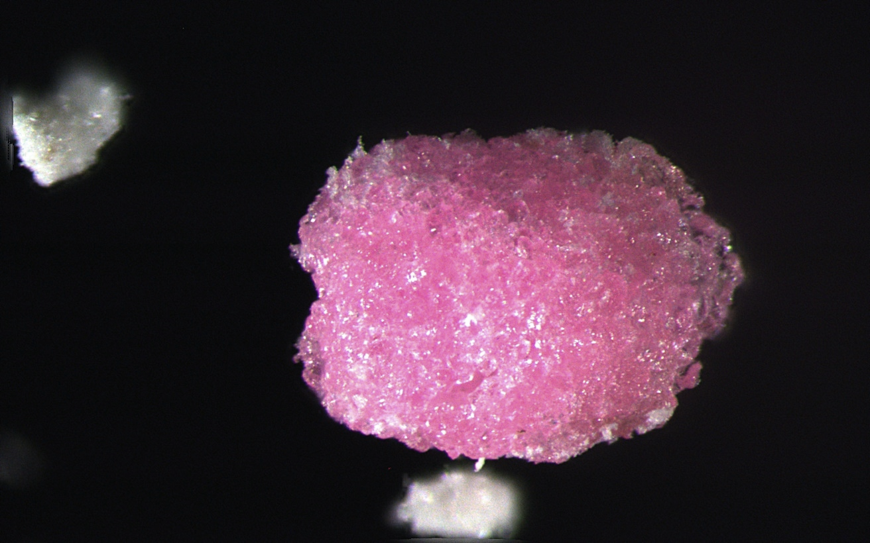
250 µm
Fig. A4 Example of a MP pellet from the infrabuccal pocket of a Camponotus japonicus worker.

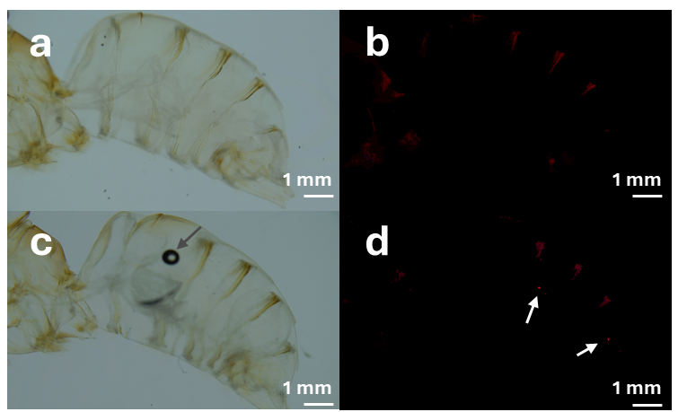
Fig. A5 Tissue cleared abdomen of Bombus terrestris workers fed with control solution (a, b) or fluorescent microplastics (MP) suspension (c, d). From each specimen a picture was taken with light (a, c) and fluorescent (b, d) microscopy, to detect fluorescent MP particles. For better visibility, fluorescent MP particles are indicated by white arrows (d). The dark spot visible in picture c is an air bubble trapped in the tissue, that occasionally cannot be prevented. The air bubble is indicated by a grey arrow. Less bright and less sharply defined fluorescence, which can also be seen on the image without fluorescent MP particles (b), is caused by autofluorescence of the individuals' own body structures. To improve the visibility of non-MP structures on the fluorescence images, the brightness of image b) was increased by 90 % and the brightness of image d) was increased by 91 %.
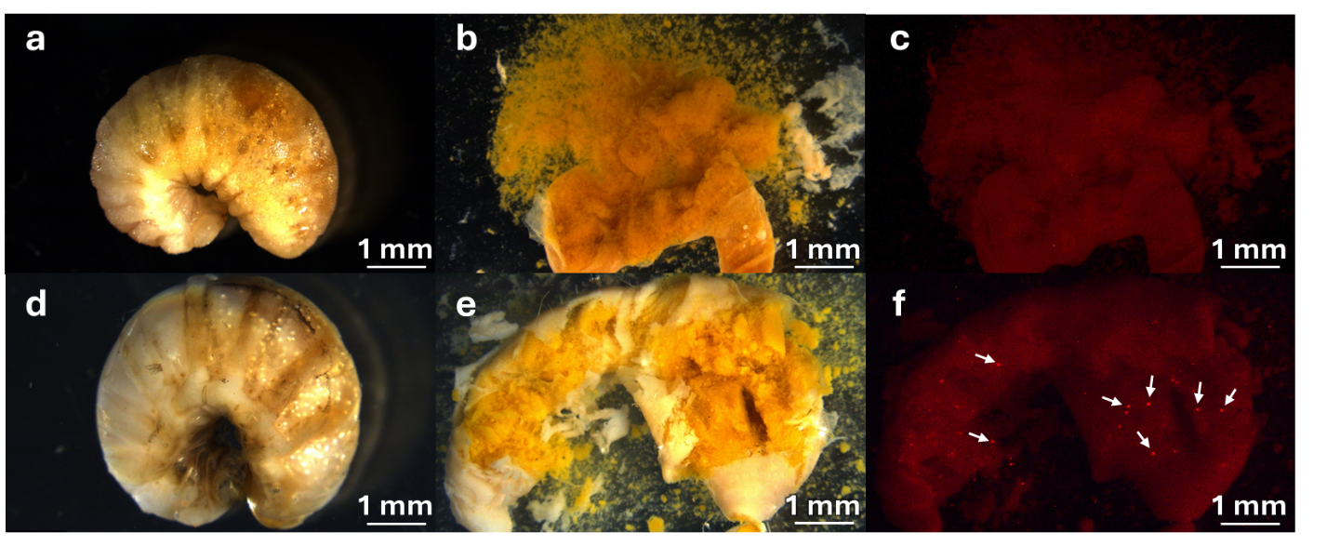
Fig. A6 Bombus terrestris larva from colonies fed with control solution (a, b, c) or fluorescent microplastics (MP) suspension (d, e, f). Pictures were taken from the intact body (a, d) and from the opened digestive system (b, c, e, f). Pictures from the opened digestive systems were taken with light (b, e) and fluorescent (c, f) microscopy, to detect fluorescent MP particles. For better visibility, particles are indicated by white arrows. Less bright and less sharply defined fluorescence, which can also be seen on the image without fluorescent MP particles, is caused by autofluorescence of the individuals' own body structures. To improve the visibility of non-MP structures on the fluorescence images, the brightness of images c) and f) was increased by 70 %, respectively.

