Appendix

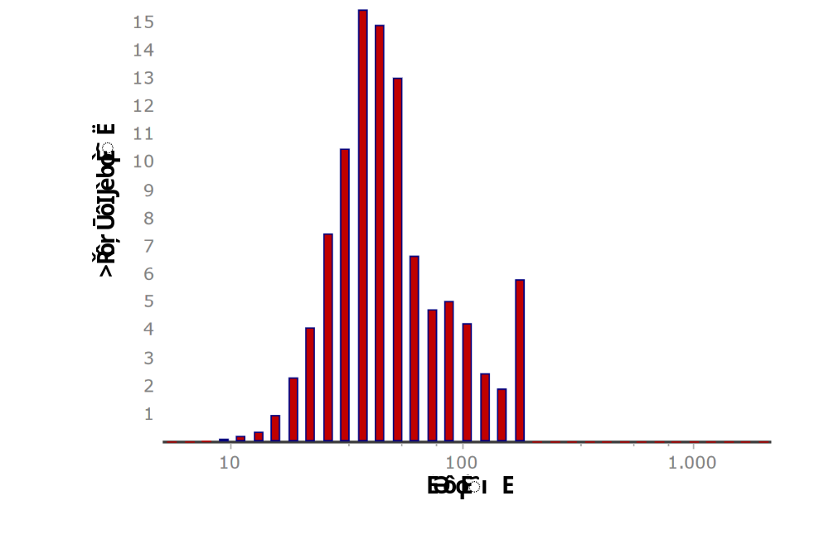
Fig. A1 Size distribution of fine microplastic particles
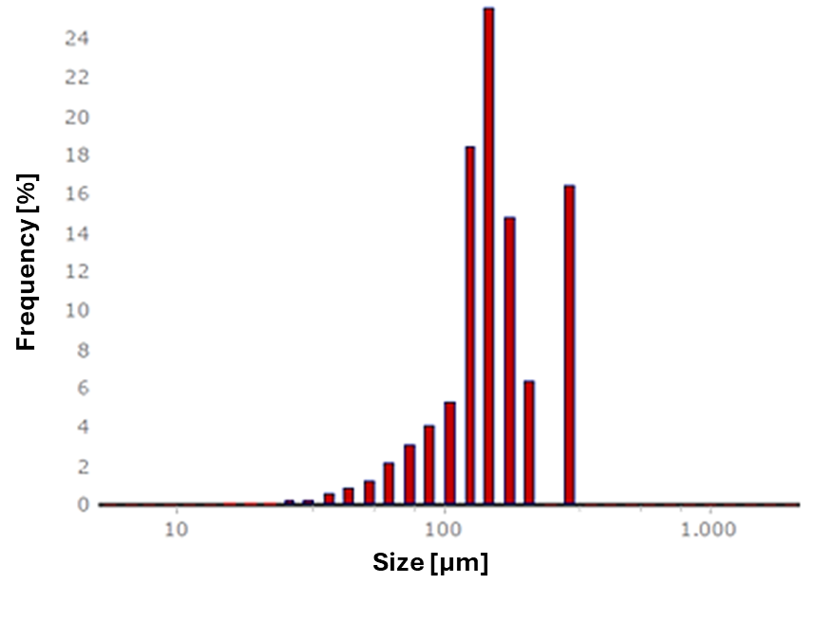
Fig. A2 Size distribution of coarse microplastic particles

Tab. A3 Composition of ingredients of the tire wear used. PassCar = passenger car (type of tire), phr = parts per hundred rubber
Ingredient | PassCar in phr
Natural rubber | 10
Styrene-butadiene-rubber | 90
Silica | 95
Mineral oil softener | 35
Anti-aging component | 4
Zinc oxide | 2.5
Stearic acid | 2.5
Silane | 6.7
Vulcanisation system | 6

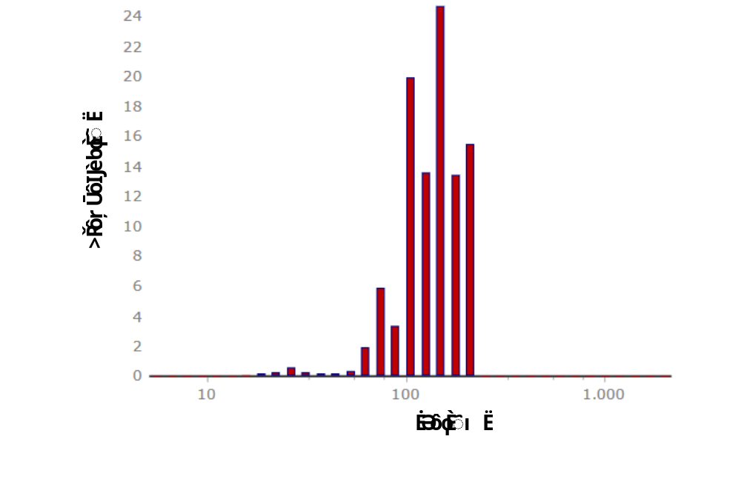
Fig. A4 Size distribution of tire wear particles
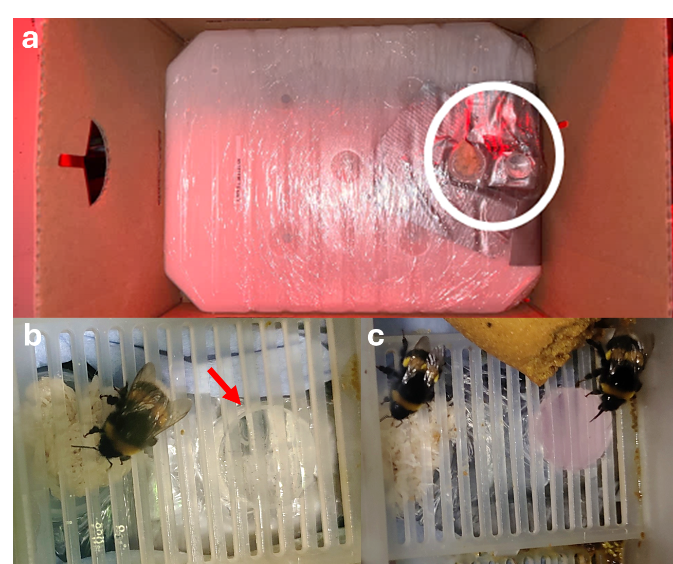
Fig. A5 Experimental setup for bumblebees, with a) the modified sugar water tank with the reservoir taped next to the drinking wick (circled in white), b) a bumblebee worker drinking from the wick through the grid-bottom of the colony with the reservoir (providing tire wear particle suspension) next to it (indicated by a red arrow), and c) two bumblebee workers simultaneously drinking from the wick (left) and the reservoir (right, providing fine fluorescent microplastic suspension)

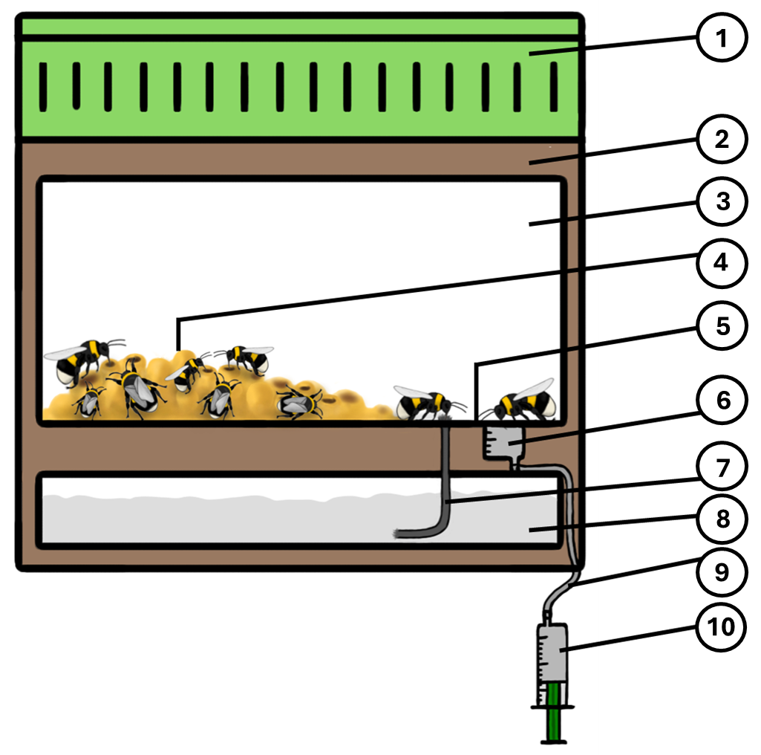
Fig. A6 Schematic drawing of the bumblebee colony set up for microplastic exposure. The set up consists of the 1) roof of colony box with air holes, 2) delivery box, 3) colony box, 4) hive area, 5) drinking area with grid-bottom, 6) reservoir for providing the treatment solutions/suspensions made from a piece of tube of 10-ml syringes (Omnifix, B. Braun SE), 7) drinking wick for sugar water from the sugar water tank, 8) sugar water tank, 9) tube (PVC, inner diameter: 4 mm, wall thickness: 1 mm, ZEUS GmbH & Co. KG, Soltau, Germany) to connect the reservoir with the syringe (for refilling the reservoir without disturbing the colony), and 10) a 20-ml syringe (Omnifix, B. Braun SE) containing the treatment solutions/suspensions
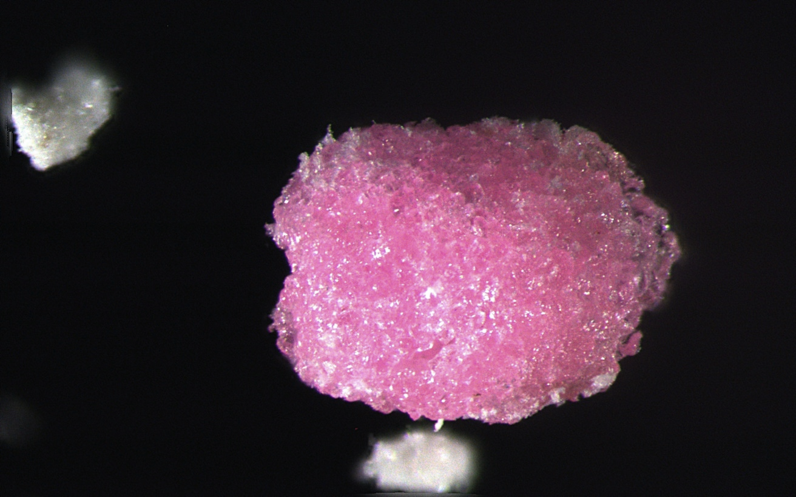
250 µm
Fig. A7 Example of a MP pellet from the infrabuccal pocket of a Camponotus japonicus worker

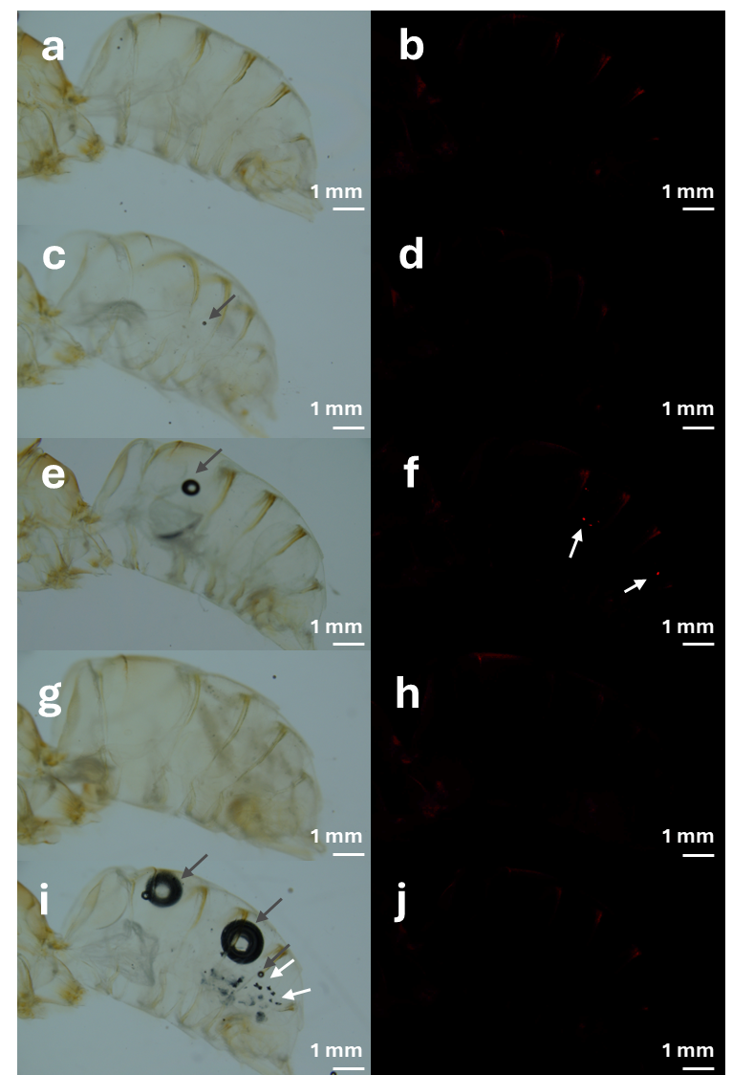
Fig. A8 Tissue cleared abdomen of Bombus terrestris workers fed with control solution (a, b), solvent control solution (c, d), fine fluorescent microplastic (MP) suspension (e, f), coarse fluorescent MP suspension (g, h), and tire wear particle suspension (i, j). From each specimen a picture was taken with light (a, c, e, g, i) and fluorescent (b, d, f, h, j) microscopy, to detect fluorescent MP particles. For better visibility, particles are indicated by white arrows (f, i). Dark spots are air bubbles trapped in the tissue, that occasionally cannot be prevented. The air bubbles are indicated by grey arrows. Less bright and less sharply defined fluorescence, which can also be seen on images without fluorescent MP particles, is caused by autofluorescence of the individuals' own body structures
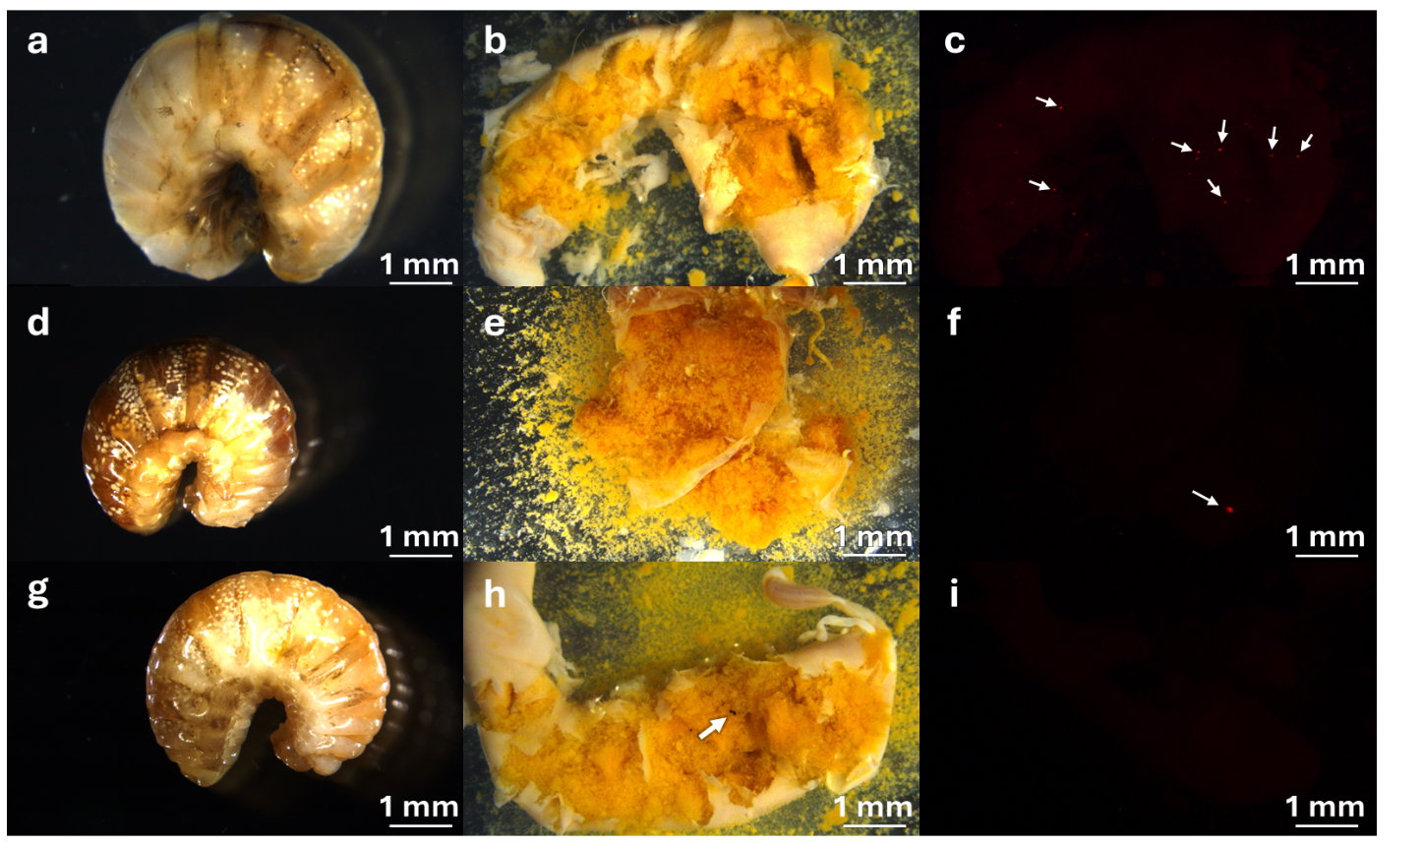 Fig. A9 Bombus terrestris larvae from colonies fed with fine fluorescent microplastic (MP) suspension (a, b, c), coarse fluorescent MP suspension (d, e, f), and tire wear particle suspension (g, h, i). From each individual pictures were taken from the intact body (a, d, g) and from the opened digestive system (b, c, e, f, h, i). Pictures from the opened digestive systems were taken with light (b, e, h) and fluorescent (c, f, i) microscopy, to detect fluorescent MP particles. For better visibility, particles are indicated by white arrows. Less bright and less sharply defined fluorescence, which can also be seen on images without fluorescent MP particles, is caused by autofluorescence of the individuals' own body structures

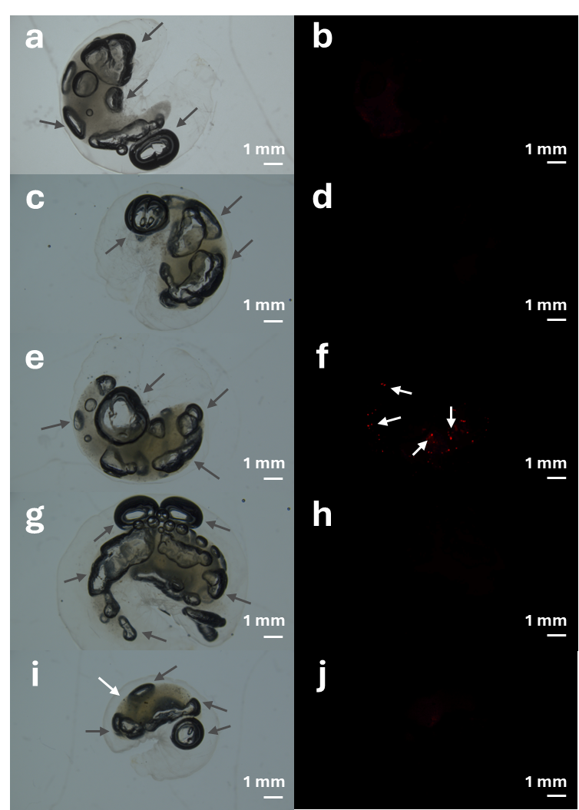
Fig. A10 Tissue cleared Bombus terrestris larvae from colonies fed with control solution (a, b), solvent control solution (c, d), fine fluorescent microplastic (MP) suspension (e, f), coarse fluorescent MP suspension (g, h), and tire wear particle suspension (i, j). From each specimen a picture was taken with light (a, c, f, g, i) and fluorescent (b, d, f, h, j) microscopy, to detect fluorescent MP particles. For better visibility, particles are indicated by white arrows (f, i). The air bubbles are indicated by grey arrows. Dark spots are air bubbles trapped in the tissue, that occasionally cannot be prevented. Less bright and less sharply defined fluorescence, which can also be seen on images without fluorescent MP particles, is caused by autofluorescence of the individuals' own body structures
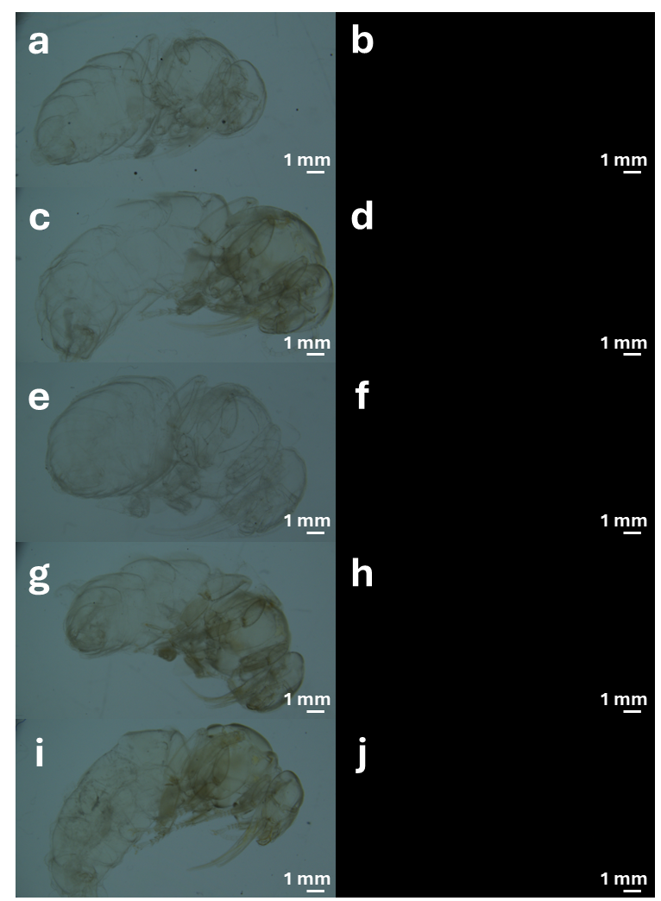
Fig. A11 Tissue cleared Bombus terrestris pupae from colonies fed with control solution (a, b), solvent control solution (c, d), fine fluorescent microplastic (MP) suspension (e, f), coarse fluorescent MP suspension (g, h), and tire wear particle suspension (i, j). From each specimen a picture was taken with light (a, c, e, g, i) and fluorescent (b, d, f, h, j) microscopy, to detect fluorescent MP particles. Less bright and less sharply defined fluorescence, which can also be seen on images without fluorescent MP particles, is caused by autofluorescence of the individuals' own body structures
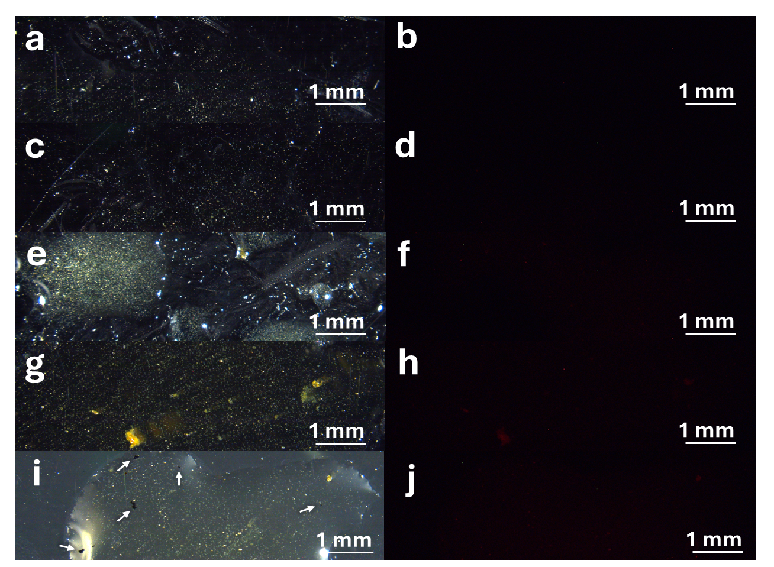
Fig. A12 Honey samples from colonies fed with control solution (a, b), solvent control solution (c, d), fine fluorescent microplastic (MP) suspension (e, f), coarse fluorescent MP suspension (g, h), and tire wear particle suspension (i, j). From each sample a picture was taken with light (a, c, e, g, i) and fluorescent (b, d, f, h, j) microscopy, to detect fluorescent MP particles. For better visibility, detected particles are indicated by white arrows (i)

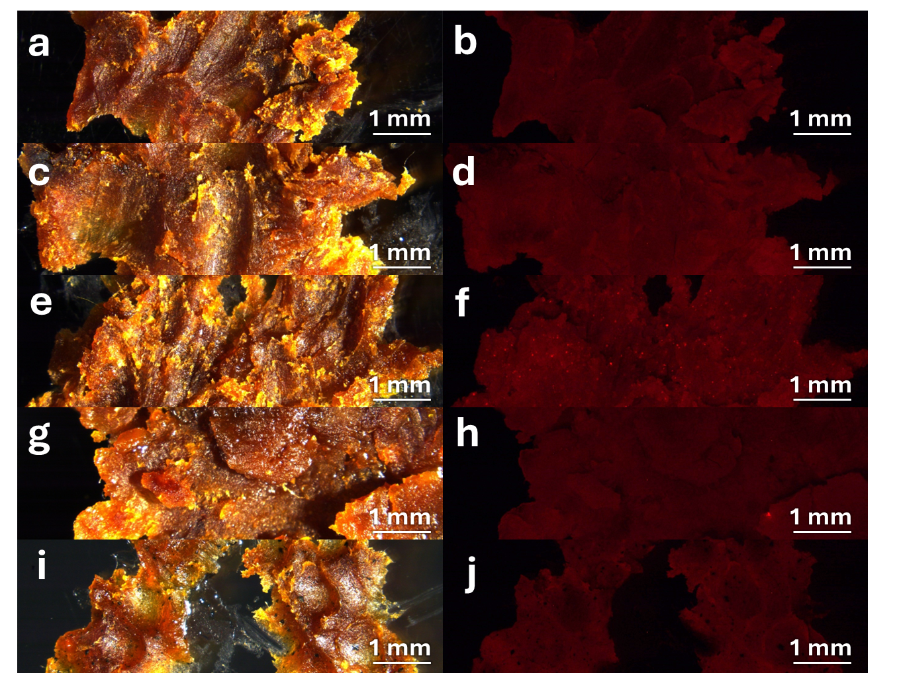
Fig. A13 Wax samples from colonies fed with control solution (a, b), solvent control solution (c, d), fine fluorescent microplastic (MP) suspension (e, f), coarse fluorescent MP suspension (g, h), and tire wear particle suspension (i, j). From each sample a picture was taken with light (a, c, e, g, i) and fluorescent (b, d, f, h, j) microscopy, to detect fluorescent MP particles. For better visibility, some particles are indicated by white arrows. Less bright and less sharply defined fluorescence, which can also be seen on images without fluorescent MP particles, is caused by autofluorescence of the wax

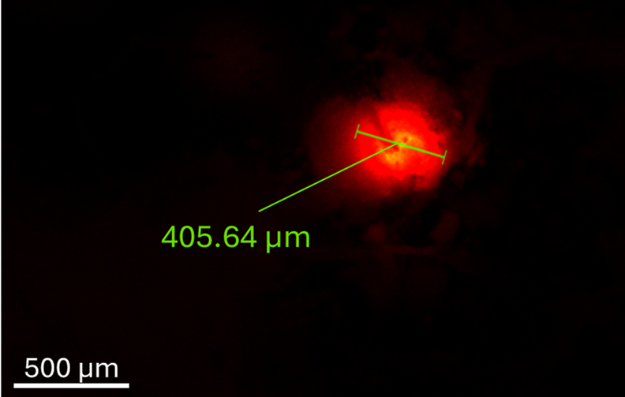
Fig. A14 Fluorescent microscopic image of an opened Bombus terrestris digestive system containing a rhodamine-b (λ_{max} = 544 nm) tagged polystyrene fragment
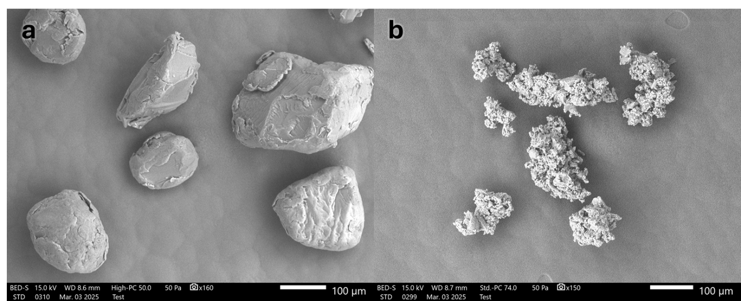
Fig. A15 Elektron microscopic images of a) coarse microplastic particles (fluorescence rhodamine-b (λ_{max} = 544 nm) tagged polystyrene fragments, d₁₀ = 95.74 µm, d₉₀ = 303.6 µm) and b) tire wear particles (passenger car, provided by Continental Reifen Deutschland GmbH, Hannover; d₁₀ = 94.41µm, d₉₀ = 214.6 µm). Images were taken (A: High-PC: 50.0, B: Std.-PC: 74.0; 15.0 kV) at A) 160x and B) 150x magnification with a JSM-IT500 SEM (JEOL, Akishima, Japan)

