Table S1. Cloned oligos and sequence primer
 |  | Sequence
rs223426 (G) | sense | 5’- AAAATAGCGGCCGCTAGTATCTGTAATCACCGGCTATTTCTAT-3’
rs223426 (G) | antisense | 5’- CTAGATAGAAATAGCCGGTGATTACAGATACTAGCGGCCGCTATTTT-3’
rs223426 (A) | sense | 5’- AAAATAGCGGCCGCTAGTATCTGTAATCACCAGCTATTTCTAT-3’
rs223426 (A) | antisense | 5’- CTAGATAGAAATAGCTGGTGATTACAGATACTAGCGGCCGCTATTTT-3’
Sequence primer |  | 5’- TTACAACCGCCAAGAAGCTG-3’

Table S2. miRDB results for 3’- UTR sequence of TREM1 when considering rs2234246
Target Rank | Target Score | miRNA Name | Target Rank | Target Score | miRNA Name
rs2234246 (G) |  |  | rs2234246 (A)
1 | 85 | hsa-miR-6721-5p | 1 | 85 | hsa-miR-6721-5p
2 | 79 | hsa-miR-4649-3p | 2 | 79 | hsa-miR-4649-3p
3 | 73 | hsa-miR-4760-3p | 3 | 77 | hsa-miR-138-5p
4 | 69 | hsa-miR-6752-3p | 4 | 73 | hsa-miR-4760-3p
5 | 68 | hsa-miR-877-5p | 5 | 69 | hsa-miR-6752-3p
6 | 64 | hsa-miR-185-3p | 6 | 68 | hsa-miR-877-5p
7 | 62 | hsa-miR-365b-3p | 7 | 64 | hsa-miR-185-3p
8 | 62 | hsa-miR-365a-3p | 8 | 62 | hsa-miR-365b-3p
9 | 56 | hsa-miR-3125 | 9 | 62 | hsa-miR-365a-3p
10 | 51 | hsa-miR-6504-3p | 10 | 56 | hsa-miR-3125
11 | 51 | hsa-miR-10399-5p | 11 | 51 | hsa-miR-6504-3p
12 | 50 | hsa-miR-6859-5p | 12 | 51 | hsa-miR-10399-5p
13 | 50 | hsa-miR-3916 | 13 | 50 | hsa-miR-6859-5p
 |  |  | 14 | 50 | hsa-miR-3916
UTR, untranslated region

Table S3. Correlation TREM1 protein, mRNA, miR-138-5p expressions with demographic parameters
Parameters |  | Age | Sex | MMSE
mbTREM1 protein | Control | P = 0.212, r = 0.204 | P = 0.096 | P = 0.032, r = 0.345
mbTREM1 protein | AD | P = 0.979, r = -0.004 | P = 0.013 | P = 0.814, r = -0.039
whole TREM1 mRNA | Control | P = 0.039, r = 0.328 | P = 0.026 | P = 0.398, r = 0.137
whole TREM1 mRNA | AD | P = 0.410, r = -0.136 | P = 0.404 | P = 0.165, r = 0.227
mbTREM1 mRNA | Control | P = 0.008, r = 0.414 | P = 0.645 | P = 0.767, r = 0.048
mbTREM1 mRNA | AD | P = 0.295, r = -0.170 | P = 0.078 | P = 0.633, r = 0.078
TREM1sv mRNA | Control | P = 0.069, r = 0.294 | P = 0.266 | P = 0.682, r = 0.068
TREM1sv mRNA | AD | P = 0.430, r = -0.130 | P = 0.399 | P = 0.164, r = 0.227
miR-138-5p | Control | P = 0.749, r = 0.056 | P = 0.378 | P = 0.270, r = -0.184
miR-138-5p | AD | P = 0.447, r = 0.125 | P = 0.024 | P = 0.279, r = 0.178
AD, Alzheimer’s disease; MMSE, Mini-Mental State Examination

Table S4. Multiple regression analysis for hippocampus volume with rs234246 genotype
 | Control (n=181) |  |  |  | AD (n=53)
Parameters | Left hippocampus |  | Right hippocampus |  | Left hippocampus |  | Right hippocampus
 | β | P-value | β | P-value | β | P-value | β | P-value
Age | -0.663 | < 0.001 | -0.630 | < 0.001 | -0.017 | 0.920 | -0.203 | 0.182
Sex | -0.066 | 0.427 | -0.058 | 0.512 | -0.049 | 0.840 | 0.013 | 0.950
BMI | -0.101 | 0.046 | -0.036 | 0.505 | -0.057 | 0.740 | -0.075 | 0.622
Education | 0.044 | 0.427 | 0.051 | 0.391 | -0.266 | 0.083 | -0.116 | 0.386
Hypertension | -0.022 | 0.661 | -0.103 | 0.055 | 0.084 | 0.593 | 0.178 | 0.202
Diabetes Mellitus | -0.006 | 0.912 | -0.044 | 0.414 | 0.179 | 0.287 | 0.211 | 0.160
Serum total cholesterol | 0.017 | 0.752 | 0.011 | 0.854 | -0.056 | 0.742 | -0.181 | 0.234
History of brain attack | -0.064 | 0.209 | 0.015 | 0.776 | 0.205 | 0.237 | 0.094 | 0.537
Current smoker | -0.041 | 0.440 | -0.021 | 0.715 | 0.290 | 0.114 | 0.250 | 0.124
Current drinker | -0.011 | 0.864 | 0.001 | 0.992 | 0.230 | 0.162 | 0.222 | 0.129
Chronic kidney disease | 0.012 | 0.820 | -0.002 | 0.974 | -0.110 | 0.526 | -0.083 | 0.588
Regular exercise | -0.061 | 0.229 | 0.010 | 0.859 | -0.166 | 0.353 | -0.184 | 0.246
ECG abnormalities | -0.106 | 0.039 | -0.153 | 0.005 | -0.202 | 0.236 | -0.070 | 0.640
MMSE | 0.066 | 0.211 | 0.094 | 0.097 | 0.477 | 0.008 | 0.404 | 0.011
eTIV | 0.219 | 0.003 | 0.141 | 0.066 | -0.079 | 0.753 | -0.074 | 0.941
rs223426 (G/G: G/A: A/A) | -0.014 | 0.779 | -0.082 | 0.127 | -0.011 | 0.946 | -0.387 | 0.010
BMI, body mass index; ECG, Electrocardiogram; eTIV, estimated total intracranial volume; MMSE, Mini-Mental State Examination
Table S5. Multiple regression analysis for hippocampus volume with rs234246 dominant model
 | Control (n=181) |  |  |  | AD (n=53)
Parameters | Left hippocampus |  | Right hippocampus |  | Left hippocampus |  | Right hippocampus
 | β | P-value | β | P-value | β | P-value | β | P-value
Age | -0.662 | < 0.001 | -0.629 | < 0.001 | -0.032 | 0.851 | -0.192 | 0.235
Sex | -0.065 | 0.439 | -0.051 | 0.563 | -0.041 | 0.866 | 0.077 | 0.728
BMI | -0.103 | 0.042 | -0.044 | 0.417 | -0.078 | 0.646 | -0.125 | 0.428
Education | 0.043 | 0.435 | 0.054 | 0.363 | -0.264 | 0.084 | -0.104 | 0.454
Hypertension | -0.023 | 0.645 | -0.107 | 0.048 | 0.069 | 0.660 | 0.165 | 0.260
Diabetes Mellitus | -0.006 | 0.912 | -0.047 | 0.385 | 0.187 | 0.273 | 0.170 | 0.281
Serum total cholesterol | 0.017 | 0.751 | 0.011 | 0.852 | -0.060 | 0.720 | -0.224 | 0.156
History of brain attack | -0.064 | 0.205 | 0.013 | 0.808 | 0.212 | 0.212 | 0.146 | 0.352
Current smoker | -0.741 | 0.460 | -0.018 | 0.758 | 0.276 | 0.140 | 0.269 | 0.121
Current drinker | -0.010 | 0.880 | 0.002 | 0.972 | 0.225 | 0.174 | 0.268 | 0.083
Chronic kidney disease | 0.012 | 0.815 | -0.002 | 0.975 | -0.104 | 0.552 | -0.114 | 0.480
Regular exercise | -0.062 | 0.226 | 0.007 | 0.903 | -0.161 | 0.367 | -0.175 | 0.291
ECG abnormalities | -0.107 | 0.038 | -0.156 | 0.004 | -0.185 | 0.281 | -0.063 | 0.690
MMSE | 0.069 | 0.196 | 0.095 | 0.094 | 0.474 | 0.008 | 0.377 | 0.021
eTIV | 0.220 | 0.002 | 0.147 | 0.054 | -0.074 | 0.767 | -0.025 | 0.913
rs223426 (G/G: G/A + A/A) | -0.027 | 0.593 | -0.088 | 0.098 | 0.042 | 0.791 | -0.304 | 0.046
BMI, body mass index; ECG, Electrocardiogram; eTIV, estimated total intracranial volume; MMSE, Mini-Mental State Examination

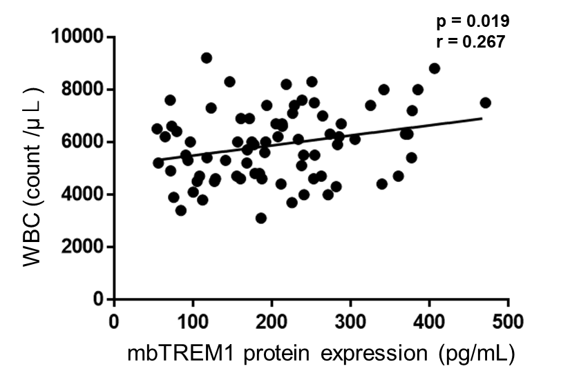
Figure S1. The correlation between mbTREM1 protein expression and WBC counts.

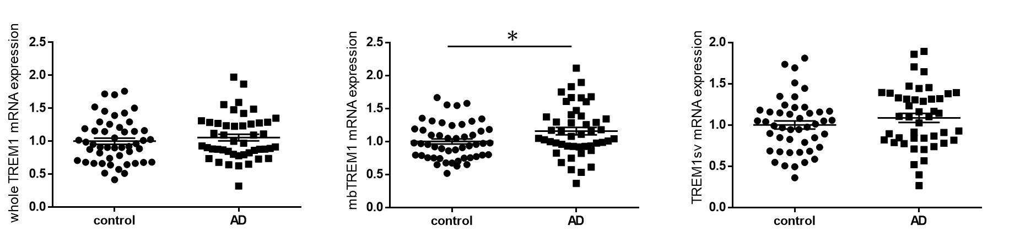
Figure S2. Whole TREM1, mbTREM1, and TREM1sv expressions in control and AD subjects of our previous study.

