Fe₂O₃/SiO₂ composite aerogels powders for high-temperature thermal insulation based on EDTA chelated aqueous precursor

Yuan Qi^{a,b}, Jinmin Wang^{a*}, Xingxing Zhang^{b}, Yongqing Wu^{b}, Xiangdong Gao^{b*}
^{a.}School of Materials and Chemistry, University of Shanghai for Science and Technology, 516 Jungong Road, Shanghai, 200093, P.R. China.
^{b.}Shanghai Institute of Ceramics, Chinese Academy of Sciences, No. 1295 Dingxi Road, Shanghai, 200050, P.R. China.

Fig. S1 XPS spectra of FSA7 and SA: (a) survey spectra of SA; (b) Si 2p of SA; (c) survey spectra of SA; (d) Si 2p of SA.
Fig. S2 FTIR spectra of FSA7 and SA.
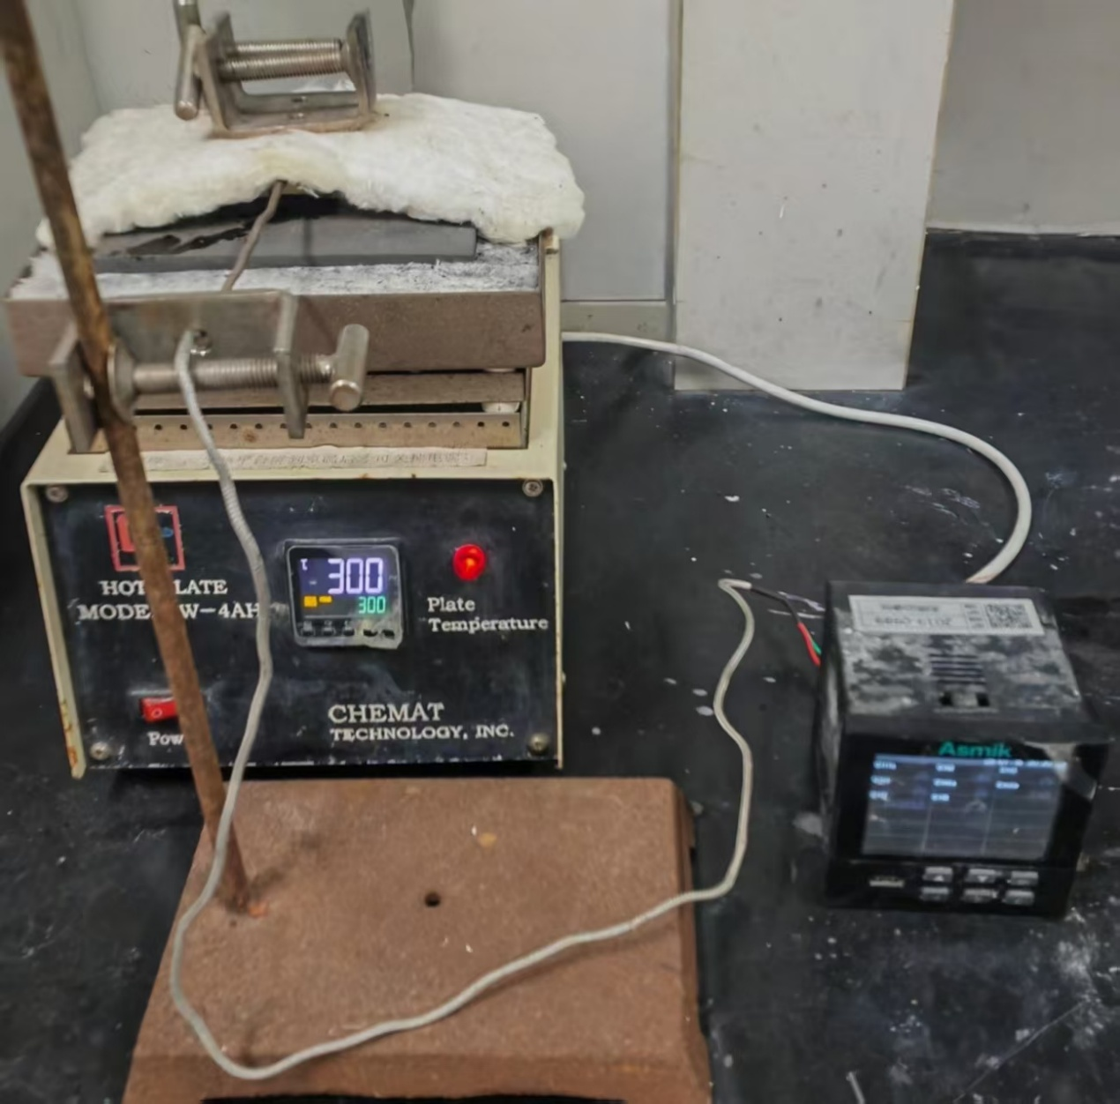
Fig. S3 Homemade single-side heater.

Fig. S4 SEM image of FSA7 for EDS elemental analysis.

