Effect of Sonication and Graphene Nanoplatelets Concentration on Rheological and Filtration Properties of Water-based Mud

Supplementary Tables
Table S1 Types of polymeric additives used and the functions in drilling fluids
Polymeric additives used | Functions/ Effectiveness | References
Tapioca Starch | Improve the rheological and filtration properties of WBMs | [1]
XC and PAC | Filtration loss control and mud cake optimization | [2]
Arabic Gum | Filtration loss control and mud cake optimization, outperforming PAC R and XC at 212°F | [3]
Konjac Gum | Demonstrates a high gel strength and yield point at 120°F | [3]
Arabic Gum | Green swelling inhibitor and fluid loss controller in WBMs | [4]

Table S2 Summary of Graphene sonication parameters and observations details
Nano particles | Sonication parameters |  |  |  | Observations | References
 | Time | Frequency | Power | Temperature control
Graphene oxide (GO) | 1h | 40kHz | 185W |  | 0.75 wt.% of GO added shows improvement in rheological properties and reduce the HPHT fluid loss from 27.2ml to 21.6 ml | [5]
Multi-walled carbon nanotube | - | - | - | - | 0.1g of MWCNT shows improvement in PV, YP, and GS | [6]
Graphene nanoplatelets (GNPs) | 1h | 25kHz | 450W | - | 0.5g of GNPs yields a 13.7% increase in YP, 12.4% reduce in HPHT mud cake, and 47.98% reduce in fluid loss. | [7]
Graphene nanoplatelets (GNPs) | - | - | - | - | 0.3ppb GNPs improve PV by 11% while 0.5ppb GNPs reduce 62% filtrate loss | [8]

Table S3 Mud Compositions of WBMs with GNPs
Water-based Muds (WBMs) with GNPs
Additives | SG | ppg | ppb | Function
Drill Water | 1 | 8.33 | 330.54 | -
Soda Ash | 2.53 | 21.07 | 0.20 | Treat calcium contamination in water
API Bentonite | 2.4 | 20.00 | 5.00 | Colloidal properties and wellbore stability
NaOH (Caustic Soda) | 2.1 | 17.49 | 0.20 | Increase the pH and alkalinity of the drilling mud
Potassium Chloride (KCL) | 2 | 16.66 | 12.02 | Inhibit shale swelling and maintain wellbore stability
Hydro-PAC-LV | 1.5 | 12.50 | 1.50 | Fluid loss control
PAC-HP | 1.5 | 12.50 | 1.00 | Fluid loss control and viscosity effect
Xanthan Gum (XC) | 1.5 | 12.50 | 0.80 | Viscosity effect
Sodium Carboxymethyl Cellulose (CMC-LV) | 2.4 | 20.00 | 0.25 | Viscosity effect and surfactants of GNPs
OPTASTAR | 1.5 | 12.50 | 1.00 | Fluid loss control
Calcium Carbonate (CaCO3) | 2.7 | 22.50 | 10.02 | Bridging and weighing agents
Barite | 4.2 | 35.00 | 17.03 | Weighing agents
Graphene Nanoplatelets | 2 | 16.66 | 0.0 – 0.5 | HPHT fluid loss control and YP enhancement

Table S4 Mixing Order and Mixing Time for WBMs with as-received and sonicated GNPs.
Functional Materials | Base Mud | As received GNPs | Sonicated GNPs | Mixing Order | Time, min
Drill Water, ml | 330 | 230 | 230 | 1 | 5
Soda Ash, ppb | 0.20 | 0.20 | 0.20 | 2 | 5
API Bentonite, ppb | 5.00 | 5.00 | 5.00 | 3 | 5
NaOH (Caustic Soda), ppb | 0.20 | 0.20 | 0.20 | 4 | 5
Potassium Chloride (KCL), ppb | 12.02 | 12.02 | 12.02 | 5 | 5
Hydro-PAC-LV, ppb | 1.50 | 1.50 | 1.50 | 6 | 5
PAC-HP, ppb | 1.00 | 1.00 | 1.00 | 7 | 5
Xanthan Gum (XC), ppb | 0.80 | 0.80 | 0.80 | 8 | 5
CMC-LV, ppb | 0.25 | 0.25 | 0.25 | 9 | 5
OPTASTAR, ppb | 1.00 | 1.00 | 1.00 | 10 | 5
Calcium Carbonate (CaCO3), ppb | 10.02 | 10.02 | 10.02 | 11 | 15
Barite, ppb | 17.03 | 17.03 | 17.03 | 12 | 25
Graphene Nanoplatelets, ppb with 100ml drill water | - | 0.5 | 0.5 | 13 | 15

Table S5 Mixing Order and Mixing Time for WBMs with varying concentration of GNPs
Functional Materials | 0.026 wt.% | 0.053 wt.% | 0.079 wt.% | 0.105 wt.% | 0.132 wt.% | Mixing Order | Time, min
Drill Water, ml | 230 | 230 | 230 | 230 | 230 | 1 | 5
Soda Ash, ppb | 0.20 | 0.20 | 0.20 | 0.20 | 0.20 | 2 | 5
API Bentonite, ppb | 5.00 | 5.00 | 5.00 | 5.00 | 5.00 | 3 | 5
NaOH (Caustic Soda), ppb | 0.20 | 0.20 | 0.20 | 0.20 | 0.20 | 4 | 5
Potassium Chloride (KCL), ppb | 12.02 | 12.02 | 12.02 | 12.02 | 12.02 | 5 | 5
Hydro-PAC-LV, ppb | 1.50 | 1.50 | 1.50 | 1.50 | 1.50 | 6 | 5
PAC-HP, ppb | 1.00 | 1.00 | 1.00 | 1.00 | 1.00 | 7 | 5
Xanthan Gum (XC), ppb | 0.80 | 0.80 | 0.80 | 0.80 | 0.80 | 8 | 5
CMC-LV, ppb | 0.25 | 0.25 | 0.25 | 0.25 | 0.25 | 9 | 5
OPTASTAR, ppb | 1.00 | 1.00 | 1.00 | 1.00 | 1.00 | 10 | 5
Calcium Carbonate (CaCO3), ppb | 10.02 | 10.02 | 10.02 | 10.02 | 10.02 | 11 | 15
Barite, ppb | 17.03 | 17.03 | 17.03 | 17.03 | 17.03 | 12 | 25
Graphene Nanoplatelets, ppb with 100ml drill water | 0.1 | 0.2 | 0.3 | 0.4 | 0.5 | 13 | 15

Table S6 Sonicated and as-received GNPs performance compared to base mud.
 | Reduction in fluid loss |  | Reduction in mud cake thickness
LPLT | BHR | AHR | BHR | AHR
Sonicated GNPs | 5.51% | 4.00% | 9.83% | 21.38%
As-received GNPs | +1.35% | 1.33% | 7.27% | 7.88%
HPHT | BHR | AHR | BHR | AHR
Sonicated GNPs | 21.26% | 13.64% | 35.89% | 36.70%
As-received GNPs | 13.39% | 4.55% | 14.36% | 10.31%

Table S7 Recommended rheological properties of WBMs at high temperature conditions [9]
Rheological property | Specification | 0.4g GNPs (Experimental)
Plastic viscosity, cp | <30 | 13
Yield point, | 10-25 | 15
Gel strength (10s) | <15 | 3
Gel strength (10min) | <35 | 4

Table S8 Recommended filtration properties of WBMs at high temperature conditions [9]
Filtration properties | Specification | 0.4g GNPs (Experimental)
API fluid loss, cc/30min | <15 | 7
API mud cake thickness, mm | <3 | 0.597
HPHT fluid loss, cc/30min | <25 | 18.4
HPHT mud cake thickness, mm | <10 | 3.81

Table S9 Experiment data for sonicated and as-received GNPs test
Mud Properties | Based Mud | Base Mud + As Received GNPs | Base Mud + Sonicated GNPs
 | Before Hot Roll (BHR)
Calculated Mud Density, ppg | 9.05 | 9.05 | 9.05
Measured Mud Density, ppg | 9.00 | 9.00 | 9.00
Rheological properties’ temperature, °F | 75 | 75 | 75
600 rpm | 60 | 57 | 70
300 rpm | 42 | 40 | 49
200 rpm | 34 | 31 | 40
100 rpm | 24 | 22 | 28
6 rpm | 7 | 6 | 8
3 rpm | 5 | 4 | 5
PV, cP | 18 | 17 | 21
YP, lb/100$ft²$ | 24 | 23 | 28
10s GS, lb/100${ft}^{2}$ | 5 | 5 | 6
10min GS, lb/100${ft}^{2}$ | 11 | 9 | 9
LPLT filtrate loss | 7.4 | 7.5 | 7.0
LPLT mud cake thickness | 0.780 | 0.727 | 0.703
HPHT filtrate loss | 25.4 | 22.0 | 20
HPHT mud cake thickness | 4.040 | 3.463 | 2.59
AHR Properties | Based Mud | Base Mud + As Received GNPs | Base Mud + Sonicated GNPs
 | After Hot Roll (AHR)
Hot rolled temperature | 250 °F | 250 °F | 250 °F
Hot rolled duration | 16h | 16h | 16h
Calculated Mud Density, ppg | 9.05 | 9.05 | 9.05
Measured Mud Density, ppg | 8.92 | 9.00 | 9.00
Rheological properties’ temperature, °F | 75 | 75 | 75
600 rpm | 35 | 47 | 37
300 rpm | 23 | 33 | 25
200 rpm | 18 | 26 | 20
100 rpm | 13 | 18 | 14
6 rpm | 4 | 5 | 4
3 rpm | 3 | 4 | 3
PV, cP | 12 | 14 | 12
YP, lb/100${ft}^{2}$ | 11 | 19 | 13
10s GS, lb/100${ft}^{2}$ | 3 | 5 | 4
10min GS, lb/100${ft}^{2}$ | 3 | 6 | 4
LPLT filtrate loss | 7.5 | 7.4 | 7.2
LPLT mud cake thickness | 0.720 | 0.663 | 0.567
HPHT filtrate loss | 22.0 | 21.0 | 19.0
HPHT mud cake thickness | 4.850 | 4.353 | 3.07

Table S10 Experiment data for varying concentrations of GNPs test
Mud Properties | Based Mud | 0.026 wt.% | 0.053 wt.% | 0.079 wt.% | 0.105 wt.% | 0.132 wt.%
 | Before Hot Roll (BHR)
Calculated Mud Density, ppg | 9.05 | 9.05 | 9.05 | 9.05 | 9.05 | 9.05
Measured Mud Density, ppg | 9.00 | 9.00 | 9.01 | 9.00 | 9.00 | 9.00
Rheological properties’ temperature, °F | 75 | 75 | 75 | 75 | 75 | 75
600 rpm | 60 | 65 | 67 | 67 | 67 | 70
300 rpm | 42 | 46 | 47 | 47 | 47 | 49
200 rpm | 34 | 37 | 39 | 38 | 38 | 40
100 rpm | 24 | 26 | 28 | 27 | 27 | 28
6 rpm | 7 | 7 | 8 | 7 | 7 | 8
3 rpm | 5 | 5 | 6 | 5 | 5 | 5
PV, cP | 18 | 19 | 20 | 20 | 20 | 21
YP, lb/100$ft²$ | 24 | 27 | 27 | 27 | 27 | 28
10s GS, lb/100${ft}^{2}$ | 5 | 4 | 5 | 5 | 6 | 6
10min GS, lb/100${ft}^{2}$ | 11 | 8 | 8 | 8 | 9 | 9
LPLT filtrate loss | 7.4 | 7.0 | 7.2 | 7.0 | 7.0 | 7.0
LPLT mud cake thickness | 0.780 | 0.733 | 0.723 | 0.72 | 0.730 | 0.703
HPHT filtrate loss | 25.4 | 24.5 | 4.0 | 25.0 | 24.0 | 20
HPHT mud cake thickness | 4.04 | 3.80 | 1.10 | 3.46 | 2.84 | 2.59
AHR Properties | Based Mud | 0.026 wt.% | 0.053 wt.% | 0.079 wt.% | 0.105 wt.% | 0.132 wt.%
 | After Hot Roll (AHR)
Hot rolled temperature | 250 °F | 250 °F | 250 °F | 250 °F | 250 °F | 250 °F
Hot rolled duration | 16h | 16h | 16h | 16h | 16h | 16h
Calculated Mud Density, ppg | 9.05 | 9.05 | 9.05 | 9.05 | 9.05 | 9.05
Measured Mud Density, ppg | 8.92 | 9.00 | 9.00 | 9.00 | 8.98 | 9.00
Rheological properties’ temperature, °F | 75 | 75 | 75 | 75 | 75 | 75
600 rpm | 35 | 38 | 39 | 40 | 40 | 37
300 rpm | 23 | 26 | 27 | 27 | 27 | 25
200 rpm | 18 | 20 | 21 | 22 | 21 | 20
100 rpm | 13 | 14 | 15 | 15 | 15 | 14
6 rpm | 4 | 5 | 5 | 5 | 4 | 4
3 rpm | 3 | 3 | 3 | 3 | 3 | 3
PV, cP | 12 | 12 | 12 | 13 | 13 | 12
YP, lb/100${ft}^{2}$ | 11 | 14 | 14 | 14 | 15 | 13
10s GS, lb/100${ft}^{2}$ | 3 | 3 | 3 | 4 | 4 | 4
10min GS, lb/100${ft}^{2}$ | 3 | 4 | 4 | 4 | 4 | 4
LPLT filtrate loss | 7.5 | 7.3 | 7.4 | 7.0 | 7.0 | 7.2
LPLT mud cake thickness | 0.720 | 0.683 | 0.667 | 0.637 | 0.597 | 0.567
HPHT filtrate loss | 22.0 | 24.4 | 21.6 | 19.6 | 18.4 | 19.0
HPHT mud cake thickness | 4.850 | 4.710 | 4.540 | 4.257 | 3.810 | 3.070

Supplementary Images
(b)
(a)
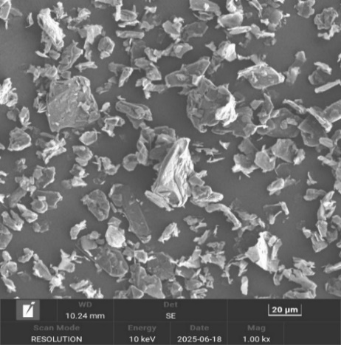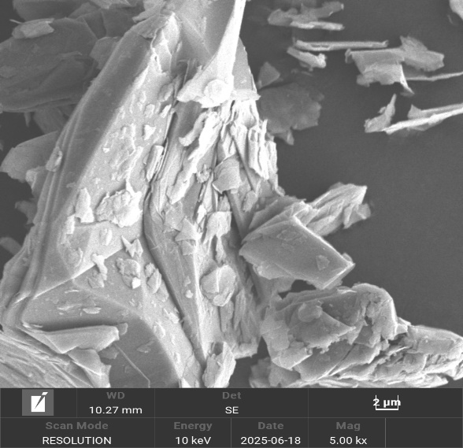
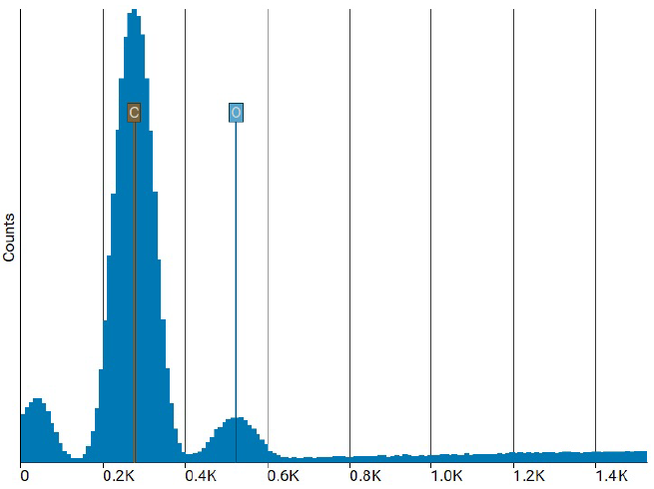
(c)
Figure S1 (a) 20 µm (b) 2 µm SEM image and (c) EDX analysis of GNPs received from Nanografi

Figure S2 Density of WBMs with 2.5% error

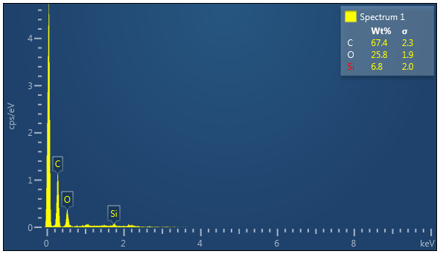
(a)v
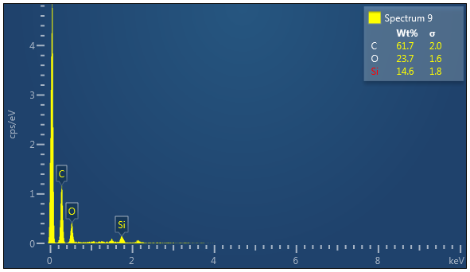
(b)v
Figure S3 EDX analysis of LPLT mud cake with (a) as-received GNPs and (b) sonicated GNPs

Figure S4 Density of WBMs at different concentrations of sonicated GNPs with 2.5% error

Figure S5 The effect of varying concentrations of GNPs on rheological properties (BHR)

References
[1] I. Ali, M. Ahmad, and T. Ganat, “Development of a new formulation for enhancing the rheological and filtration characteristics of low-solids WBMs,” J Pet Sci Eng, vol. 205, Oct. 2021, doi: 10.1016/j.petrol.2021.108921.
[2] R. Saadi, H. Hamidi, and D. Wilkinson, “Optimizing filtration properties of water-based drilling fluids: Performance of PAC variants and synergistic effects,” Colloids Surf A Physicochem Eng Asp, vol. 715, Jun. 2025, doi: 10.1016/j.colsurfa.2025.136590.
[3] E. U. Akpan, “Utilizing environmentally friendly polymers as rheological control and fluid loss additives in water-based drilling muds,” Nov. 01, 2024, Elsevier B.V. doi: 10.1016/j.geoen.2024.213195.
[4] M. Murtaza et al., “Improving Water-Based Drilling Mud Performance Using Biopolymer Gum: Integrating Experimental and Machine Learning Techniques,” Molecules, vol. 29, no. 11, Jun. 2024, doi: 10.3390/molecules29112512.
[5] J. Aramendiz and A. Imqam, “Water-based drilling fluid formulation using silica and graphene nanoparticles for unconventional shale applications,” J Pet Sci Eng, vol. 179, pp. 742–749, Aug. 2019, doi: 10.1016/j.petrol.2019.04.085.
[6] A. Razak Ismail et al., “The Application of Nanoparticles to Enhance the Rheological Behaviour of Drilling Fluids at High Temperature The application of MWCNT to enhance the rheological behavior of drilling fluids at high temperature,” 2016. [Online]. Available: https://www.researchgate.net/publication/316554967
[7] M. Ahmad, I. Ali, M. S. Bins Safri, M. A. I. Bin Mohammad Faiz, and A. Zamir, “Synergetic effects of graphene nanoplatelets/tapioca starch on water-based drilling muds: Enhancements in rheological and filtration characteristics,” Polymers (Basel), vol. 13, no. 16, Aug. 2021, doi: 10.3390/polym13162655.
[8] A. H. Arain, S. Ridha, S. U. Ilyas, M. E. Mohyaldinn, and R. R. Suppiah, “Evaluating the influence of graphene nanoplatelets on the performance of invert emulsion drilling fluid in high-temperature wells,” J Pet Explor Prod Technol, vol. 12, no. 9, pp. 2467–2491, Sep. 2022, doi: 10.1007/s13202-022-01501-5.
[9] A. Katende et al., “Improving the performance of oil based mud and water based mud in a high temperature hole using nanosilica nanoparticles,” Sep. 20, 2019, Elsevier B.V. doi: 10.1016/j.colsurfa.2019.05.088.

