Table 1. Copolymerization of ethylene with metal carbonyls using palladium complexesª
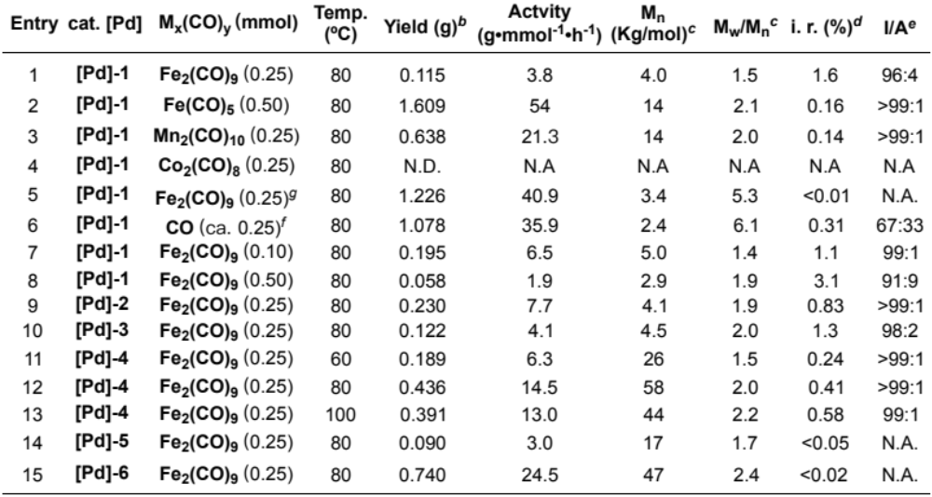
ªA mixture of the catalyst (10 μmol) and M_{x}(CO)_{y} in toluene (10 mL) was stirred in a glass tube under an ethylene atmosphere (3.0 MPa) for 3 h in a 50 mL autoclave. ^{b}Yields of isolated product after precipitation with methanol (80 mL). ^{c}Molecular weights determined by size-exclusion chromatography using polystyrene standards corrected by universal calibration. ^{d}CO incorporation ratio (i. r.) in mol% determined by ¹H NMR analysis. ^{e}The I/A ratio was determined by ¹H NMR analysis. I/A = Isolated carbonyls/Alternating carbonyls. ^{g}Fe₂(CO)₉ was added outside the glass tube along with toluene (1.0 mL). ^{f}Ethylene containing about 0.3 mol% CO was used. Dip = 2,6-diisopropylphenyl; Lut = 2,6-lutidine.
