Supplementary Figures
Supplement to: Berrell N, Tan C, Kilgallon A, … et al. Spatial multi-omic predictors of clinical outcomes in adjuvant chemotherapy treated NSCLC

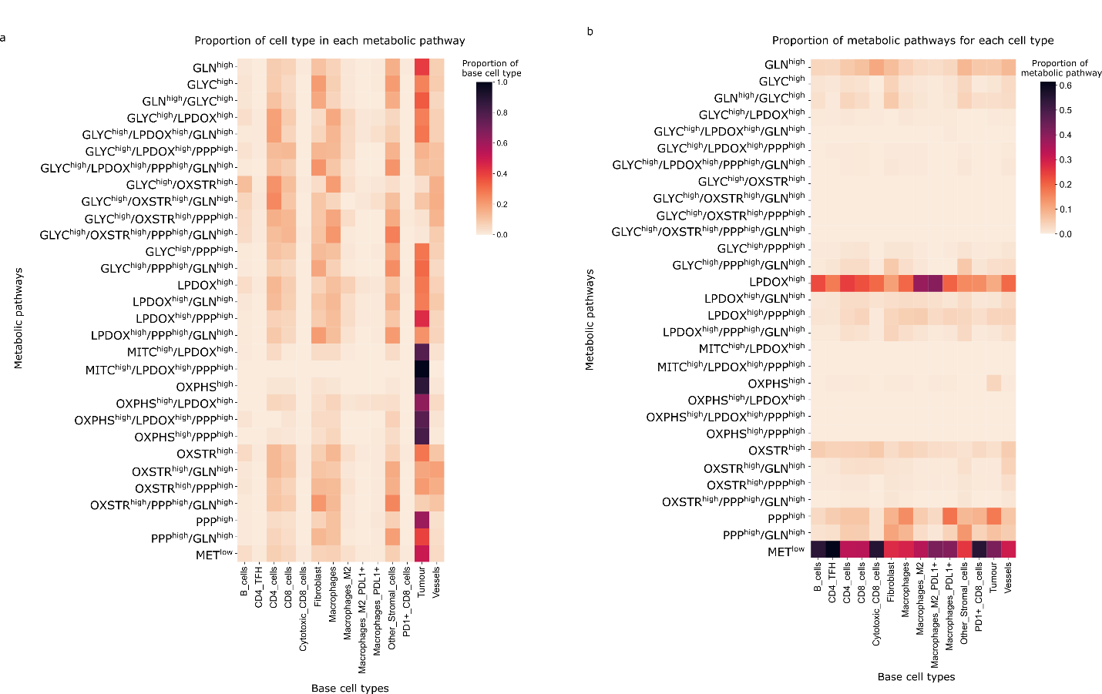
Supplemental figure 1: Heatmaps based on the relationship between base cell types and metabolic pathways. a) Heatmap showing the proportion of cell types across the cohort for a given metabolic phenotype. b) Heatmap showing the proportion of metabolic pathways that contribute to each cell type.
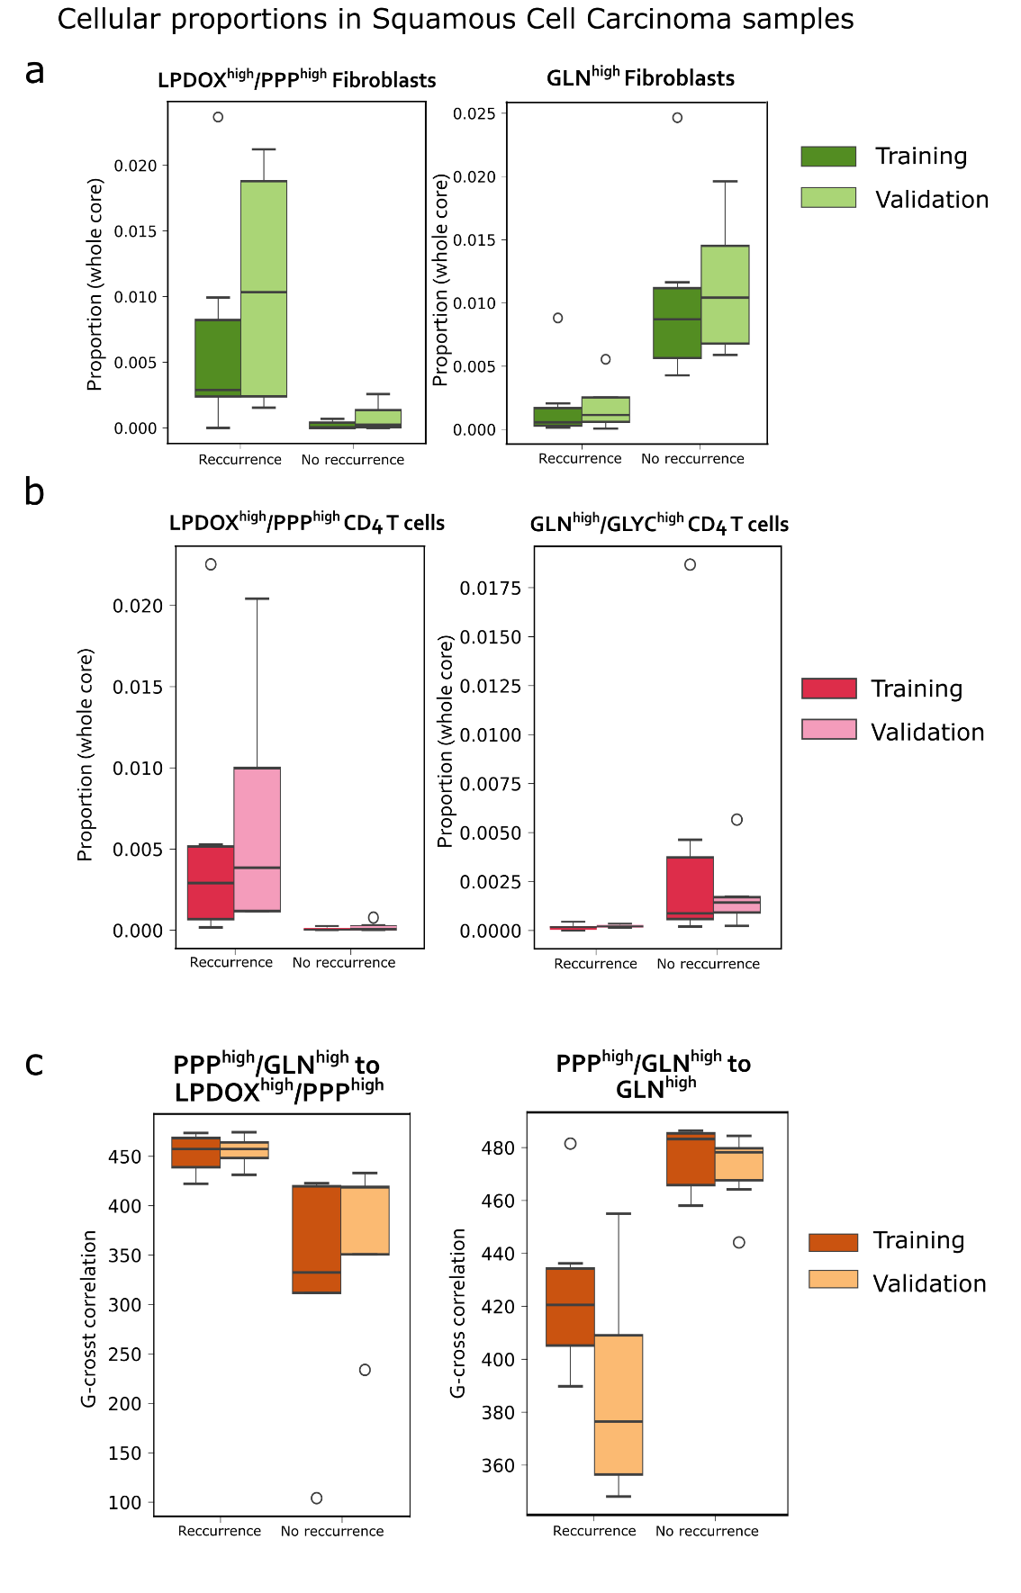
Supplemental Figure 2. Robust features identified by Mann-Whitney U-test for LUSC samples. a-b) Box plots of immune + metabolic cell proportions across whole cores for LUSC patients, highlighting metabolic differences between relapse and no-relapse patients. c) Box plot of the proximity of two cell types based on metabolic pathways.

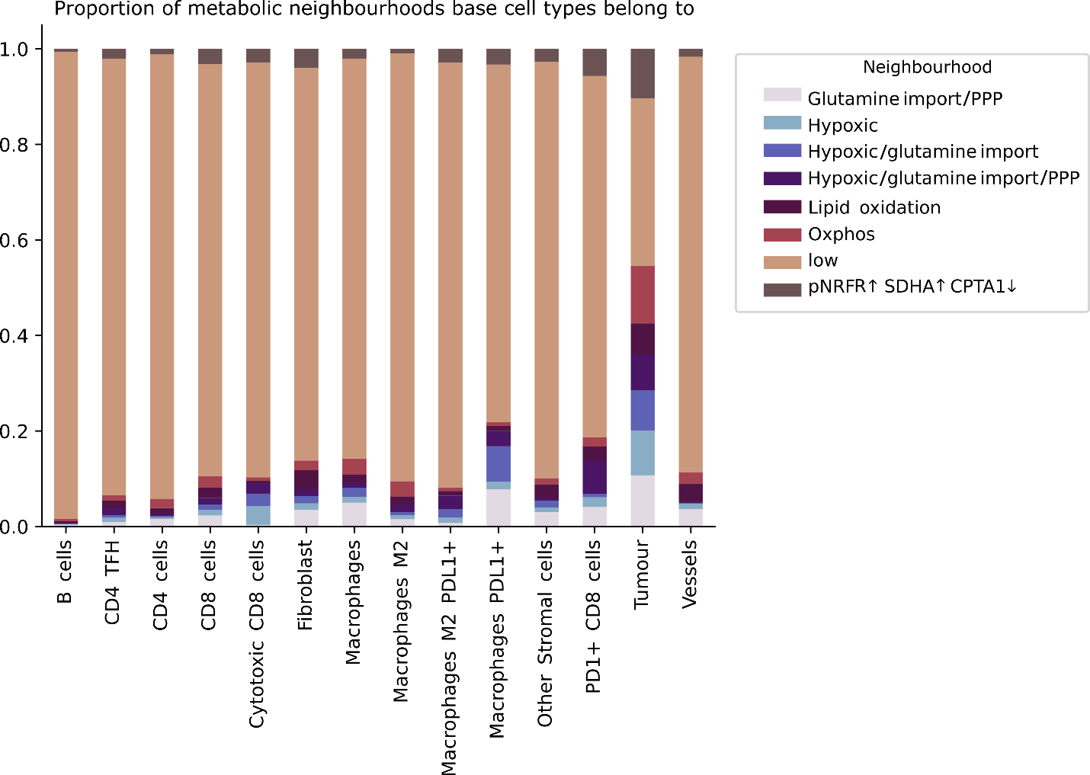
Supplemental figure 3: Bar graph showing which metabolic neighborhoods each cell is found in.
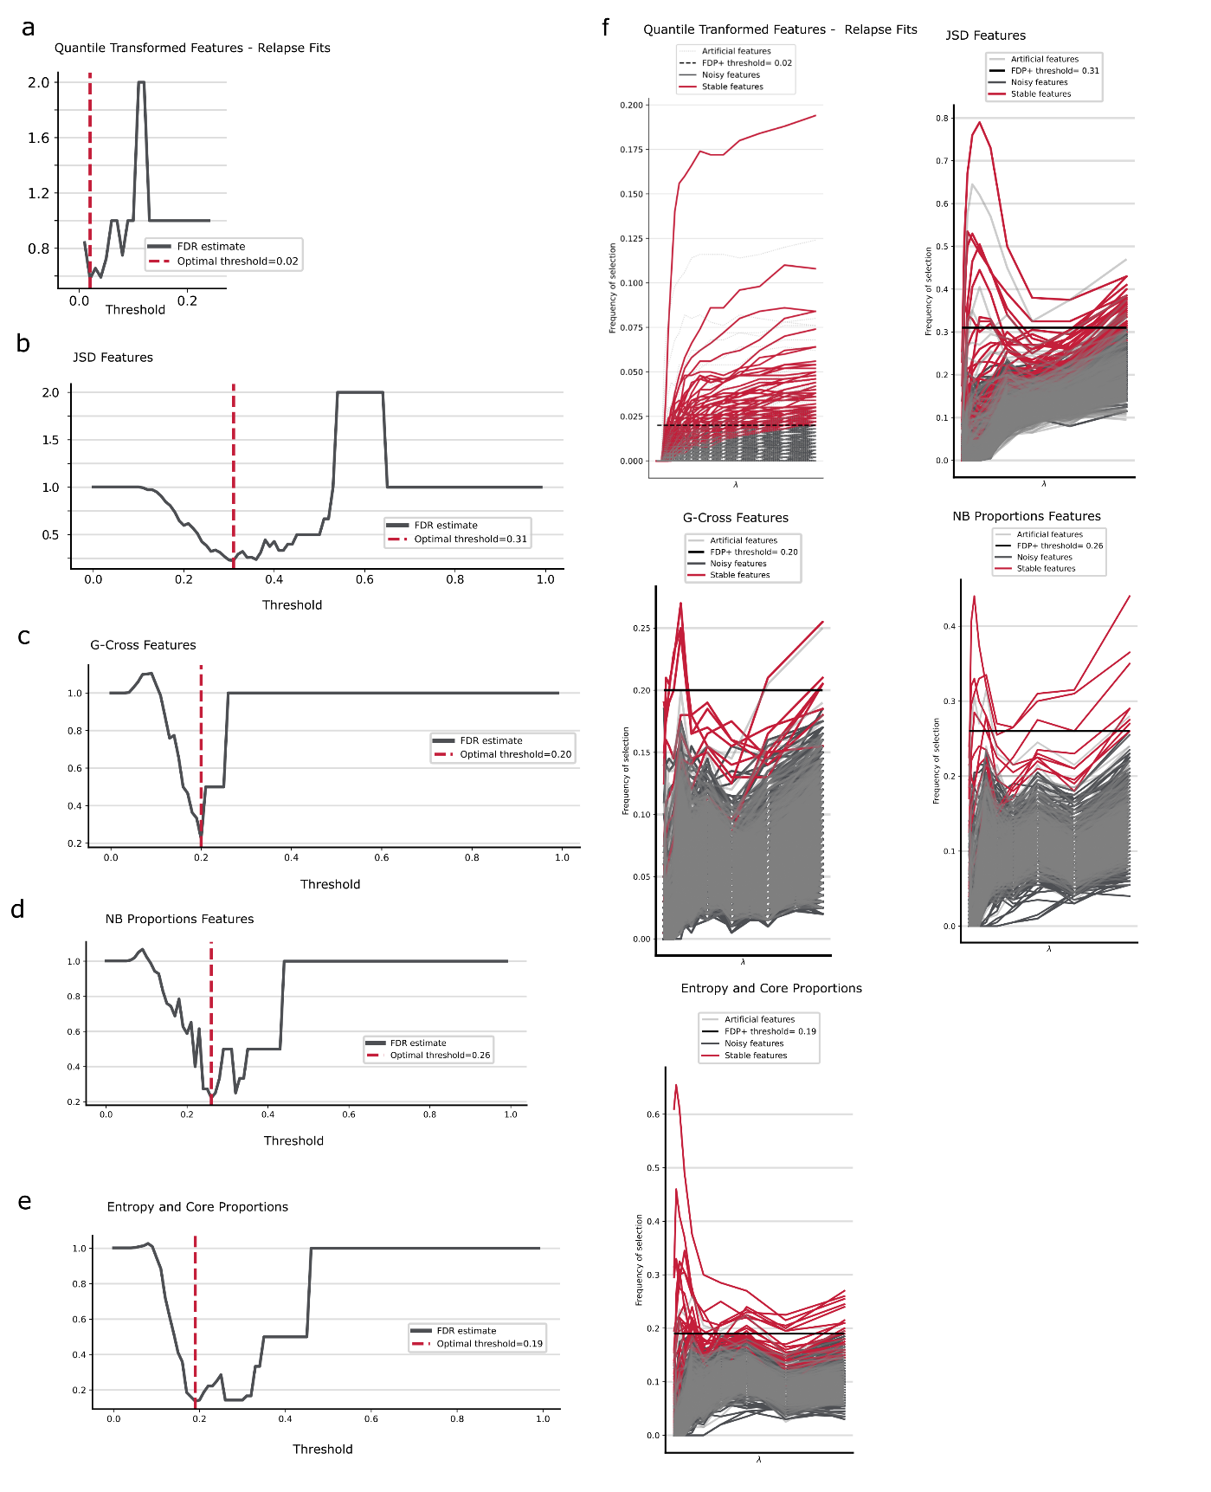
Supplementary Figure 4: Stabl feature selection results. a) Estimated false-discovery proportions (left) and regularisation paths (right) for quantile-transformed features when fitting to relapse status. b-e) Estimated false-discovery proportions (left) and regularisation paths (right) for JSD-family features, G-Cross AUC-family features, neighbourhood proportion-family features, and entropy / whole core proportion features, when fit to relapse-free-survival time.
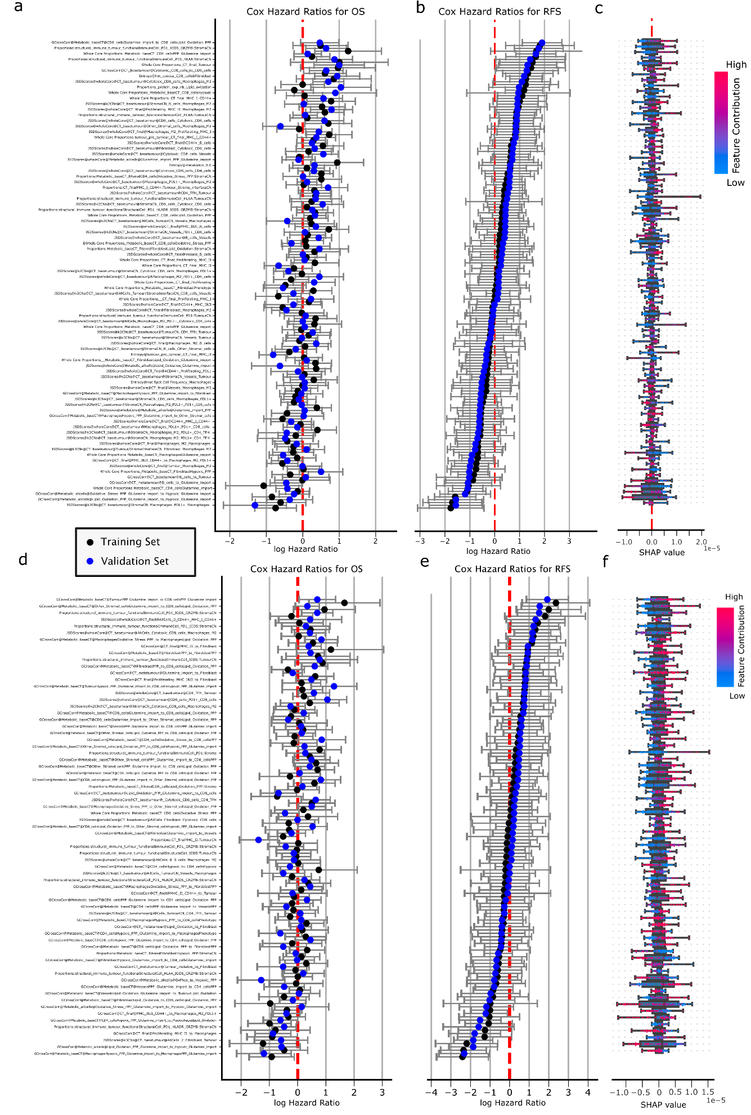
Supplementary Figure 5: Modelling of relapse and relapse-free-survival time of the selected features from the multivariable feature selection. a) Cox Proportional Hazards (CoxPH) model Hazard Ratios (HRs) for features selected to model relapse status are shown sorted by their median HR for overall survival OS. b) Hazard ratios for CoxPH fits to model relapse status are sorted by HR for relapse-free survival (RFS). c) Shapley values are shown for each feature to highlight the feature importance in modeling RFS using a fit BoostedCoxModel. d) HRs for OS of a CoxPH fit using features selected to model RFS are similarly shown, sorted by RFS HR. e) Hazard ratios for CoxPH fits to model RFS are sorted by HR for RFS. f) Shapley values are shown for each feature to highlight the feature importance in modelling RFS using a fit BoostedCoxModel.

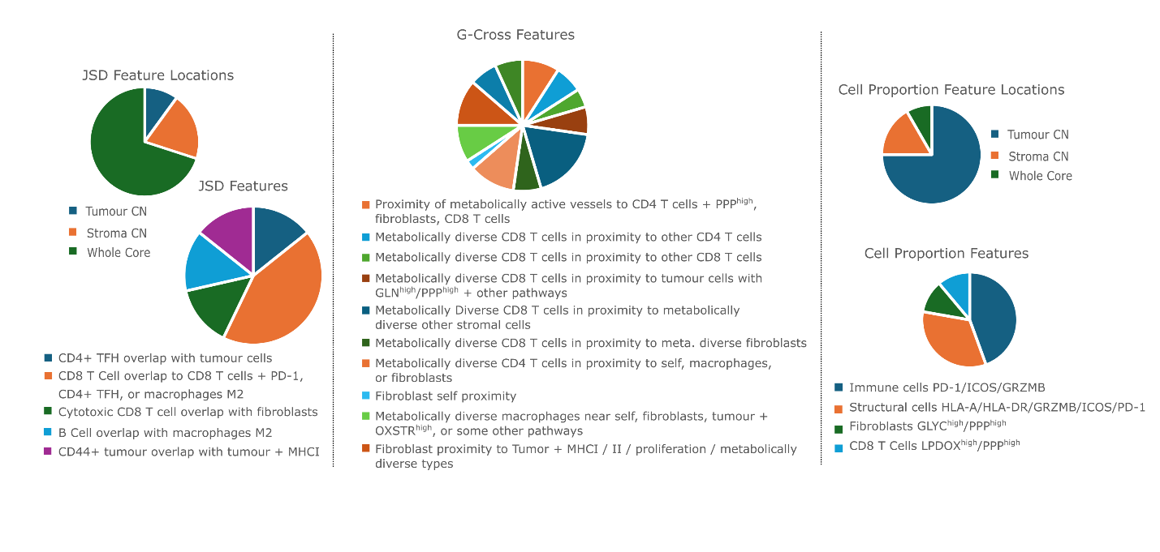
Supplementary Figure 6: A qualitative assessment of the features selected to model relapse, indicating that across JSD, G-Cross AUC, and proportion features, proximity of CD8+ T Cells to tumor cells with a range of metabolic profiles are the primary features selected. Additional features included proximity and existence of CD4+ T Cells with metabolically diverse profiles, macrophages with diverse functional and metabolic states, and the presence of anti-gen expressing tumor cells.

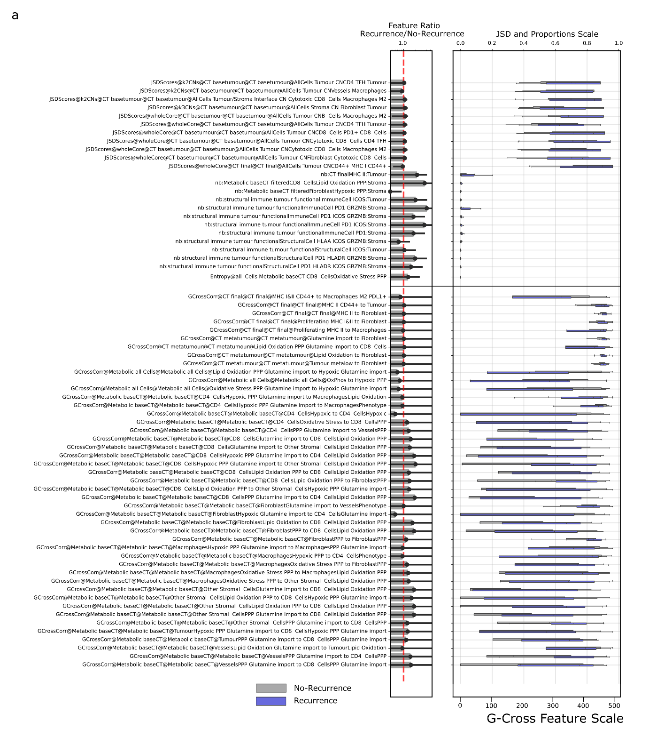
Supplementary Figure 7: A profile of the feature distributions (right subpanel) for features selected to model relapse status, grouped by JSD family (top), neighbourhood proportions (middle), whole core proportions (middle), and then G-Cross AUC (bottom). Ratios between the feature median values for patients who relapsed versus those that did not relapse are down in the left subpanel.

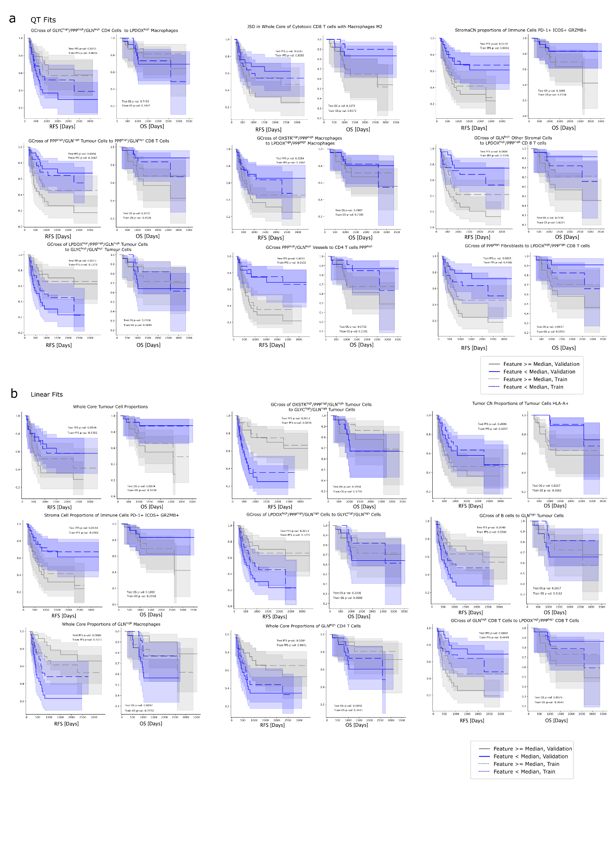Supplementary Figure 8: Kaplan Meier (KM) curves for some selected features from the Stabl feature selection pipeline to model a) binary relapse or b) relapse-free-survival. Each grouping shows KM curves for relapse-free-survival (left subpanels) and overall survival (right subpanels). KM curves are split by median values, showing high (grey) and low (blue) groups, for validation sets (solid lines) and training sets (dashed lines).

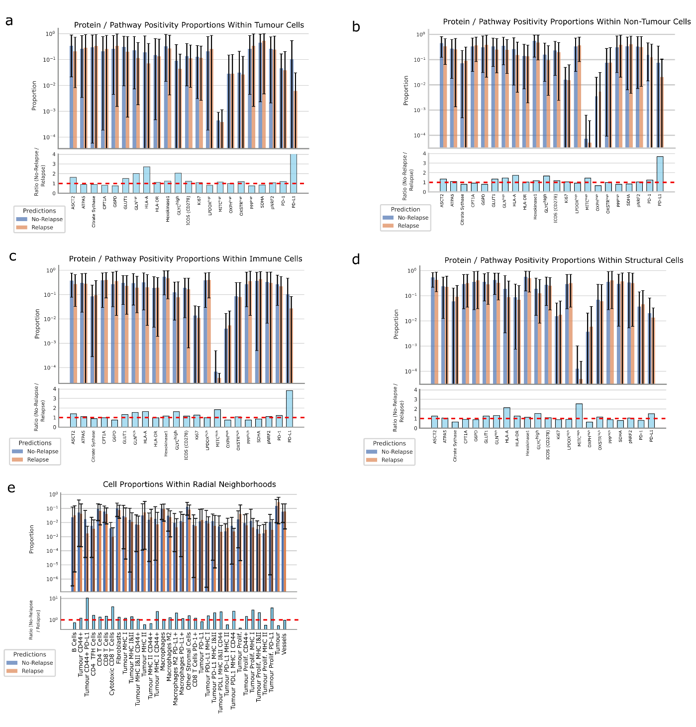
Supplementary Figure 9: Agglomerated proportions within relapse-like and non relapse-like regions profiled by the geometric contrastive learning. a-d) Protein and metabolic pathway positivity mean proportions for tumour cells, non-tumour cells, immune cells, and structural cells, respectively. e) Mean marker positivity proportions in radial neighbourhoods surrounding each cell, with labels defined by the subgraph classifications.

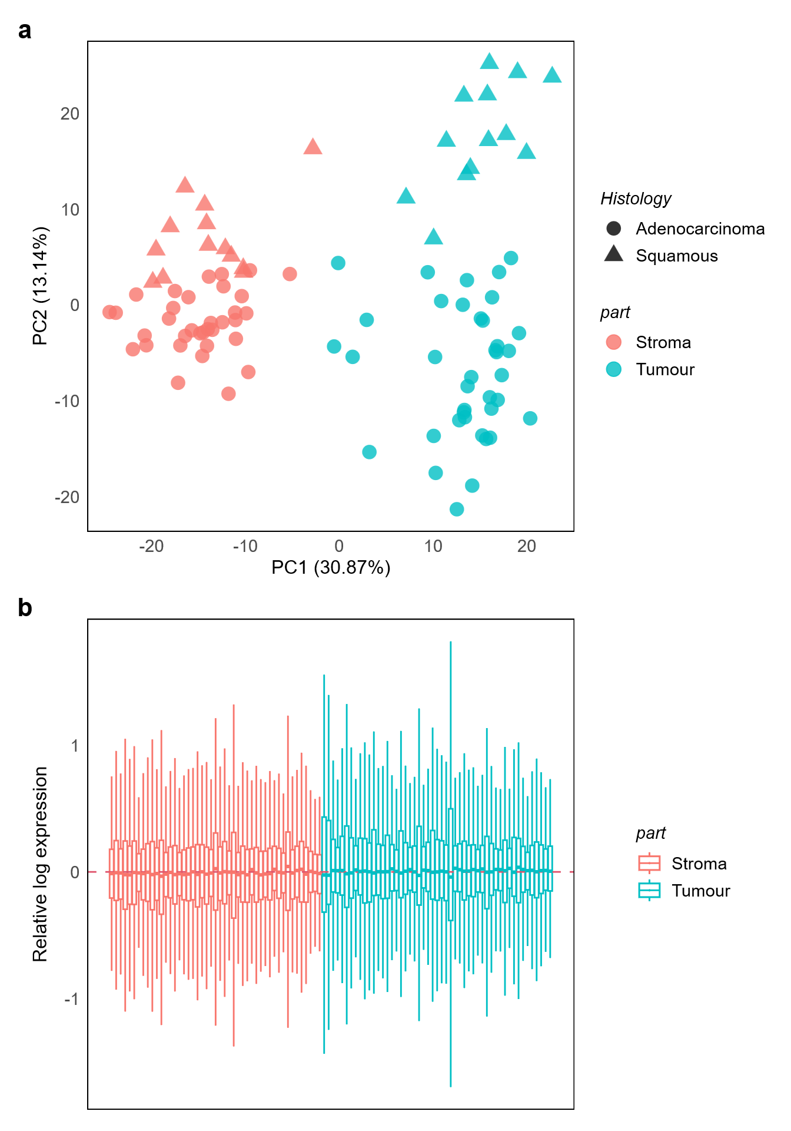
Supplemental Figure 10. RNA analysis quality control and variation assessment. a) Principal Component Analysis (PCA) plot stratified by segment (part) and histology, indicating that tumour-stroma variations are accounted for along PC1, while PC2 separate adenocarcinoma and squamous cell carcinoma samples. b) Assessment of data normalisation using relative log expression (RLE) plot. Log expressions of the data are successfully centred after applying the TMM scaling method.

