Daikenchuto ameliorates dextran sulfate sodium-induced acute and chronic ulcerative colitis by regulating gut microbiota-derived indoles to activate AhR signaling

Rui Liang^{a,b†}, Xue Liu^{a,b†}, Qinhua Chen^{c†}, Menggai Zhang^{a,b}, Yinyue Xu^{a,b}, Hehe Shi^{a,b}, Sicen Wang^{a,b}, Wanghui Jing^{a,b*}
ªSchool of Pharmacy, Health Science Center, Xi’an Jiaotong University, Xi’an 710061, China
^{b}Shaanxi Engineering Research Center of Cardiovascular Drugs Screening & Analysis, Xi’an 710061, China
^{c}Shenzhen Baoan Authentic TCM Therapy Hospital, Shenzhen, China

* Corresponding authors.

Email address:

jingwanghui1987@163.com

†These authors made equal contributions to this work

Method

Identification of main compounds in DKT by UPLC-Q-TOF-MS
The lyophilized DKT powder and the main compounds in DKT, including ginsenoside Rb₁, ginsenoside Rg₁, ginsenoside Re, 6-Shogaol, skimmianine and 6-gingerol were dissolved in methanol and filtered through a 0.22-μm organic solvent-resistant membrane, and subsequently analyzed by UPLC-Q-TOF-MS.
UPLC-Q-TOF-MS analysis: Chromatographic separation was achieved on an on an ACQUITY UPLC BEH C18 column (2.1 × 100 mm, 1.7 μm; Waters) with the following gradient program: mobile phase A (0.1% formic acid in water, v/v), mobile phase B (acetonitrile): 0–2 min, 5%–15% B; 2–10 min, 15%–30% B; 10–13 min, 30%–50% B; 13–21 min, 50%–63% B; 21–26 min, 63%–95%; 26–28 min, 95%–5% B; 28–30 min, 5% B. The separations were performed with a constant flow of 0.2 mL/min. The column oven was set at 30℃. The sample injection volume was 2 μL. The electrospray MS detection was performed in both positive and negative ion modes with the orifice voltage set to 40 V. Nitrogen was used as the sheath gas and auxiliary gas with a flow rate of 800 and 50. The mass spectrum scanning range was m/z 50–1500 Da. The capillary voltage was 1.5 kV, the source temperature was 120 ℃. The collision energy was set at 6 eV, with a collision energy spreading of 20–45 eV for mass detection.
Table S1 Sequences of the gene-specific primer
Gene | Forward Primer | Reverse Primer
Zo1 | TTTTTGACAGGGGGAGTGG | TGCTGCAGAGGTCAAAGTTCAAG
Ocln | ATGTCCGGCCGATGCTCTC | TTTGGCTGCTCTTGGGTCTGTAT
Gene | Forward Primer | Reverse Primer
Cldn2 | CAACTGGTGGGCTACATCCTA | CCCTTGGAAAAGCCAACCG
Ahr | AGCCGGTGCAGAAAACAGTAA | AGGCGGTCTAACTCTGTGTTC
Il22 | CATGCAGGAGGTGGTGCCTT | CAGACGCAAGCATTTCTCAG
Reg3β | TCCCAGGCTTATGGCTCCTA | GCAGGCCAGTTCTGCATCA
Reg3γ | TTCCTGTCCTCCATGATCAAAA | CATCCACCTCTGTTGGGTTCA
Gapdh | TGCACCACCAACTGCTTAG | AGAGGCAGGGATGATGTTC
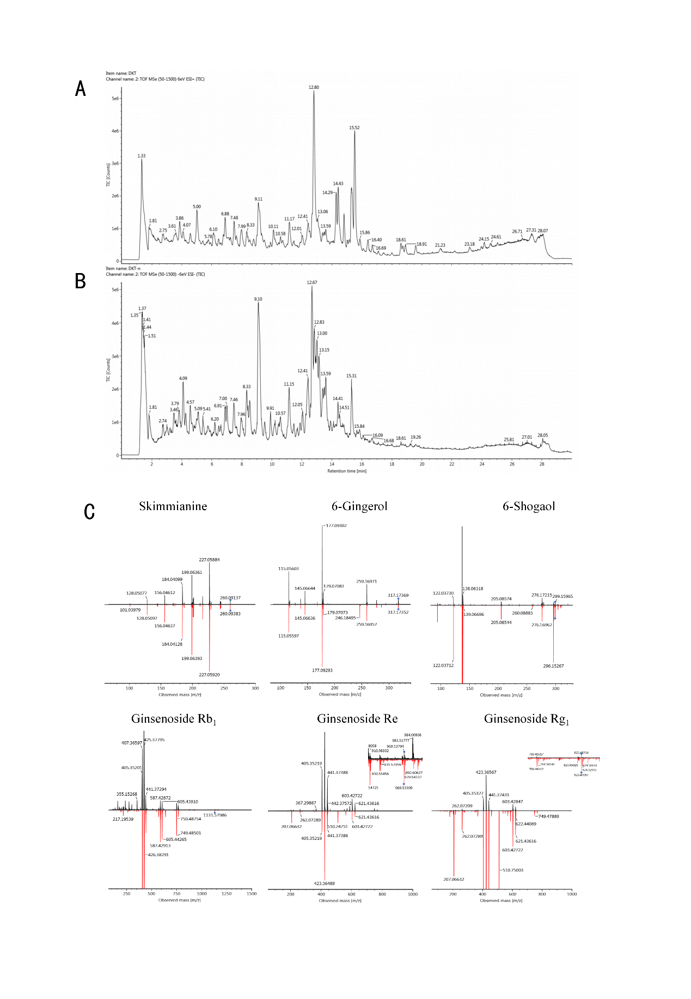
Fig. S1 Identification of 6 core chemical compounds of DKT by UPLC-Q-TOF-MS. (A) The total ion chromatogram in positive ion mode. (B) The total ion chromatogram in negative ion mode. (C) The MS/MS spectra of 6 chemical features in DKT and the corresponding MS/MS spectra of reference compounds (red). 1. Skimmianine, 2. 6-Gingerol, 3. 6-Shogaol, 4. Ginsenoside Rb₁, 5. Ginsenoside Re, 6. Ginsenoside Rg₁.
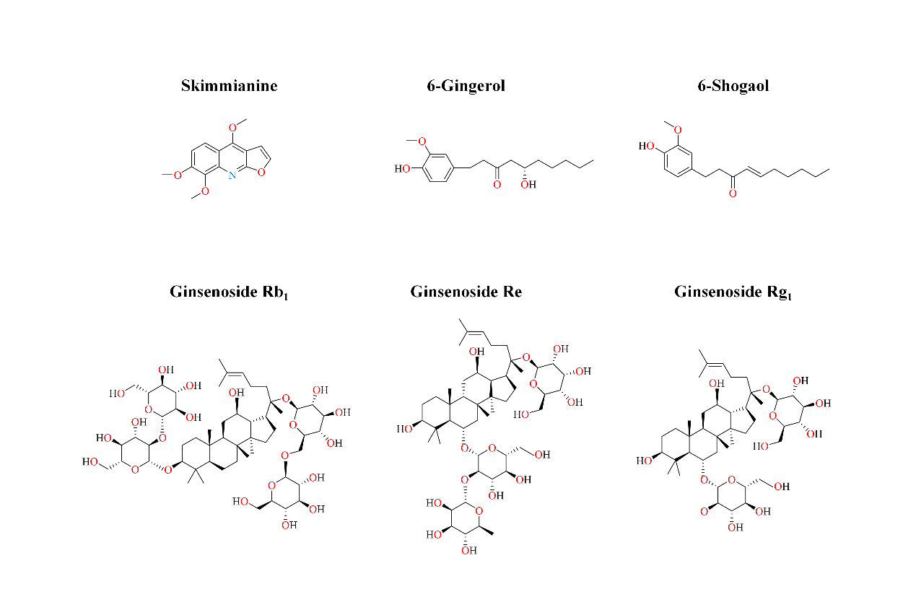
Fig. S2 The chemical structures of six components in DKT. 1. Skimmianine, 2. 6-Gingerol, 3. 6-Shogaol, 4. Ginsenoside Rb₁, 5. Ginsenoside Re, 6. Ginsenoside Rg₁.
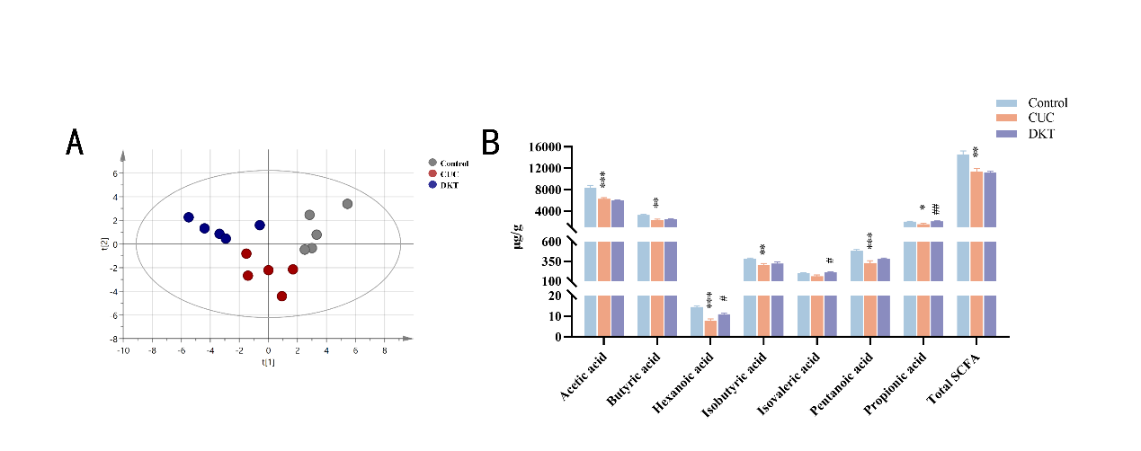
Fig. S3 DKT reversed the metabolic disorder in mice with CUC. (A) PLS-DA analysis of targeted SCFAs metabolites. (B) Fecal levels of 7 SCFAs and total SCFAs in the indicated groups. Data are presented as the mean ± SEM (n=5). Statistical significance was determined using one-way or two-way ANOVA with Dunnett’s test for multiple-group comparisons. *P < 0.05, **P < 0.01, and ***P < 0.001 vs. control group; #P < 0.05 and ##P < 0.01 vs. model group.
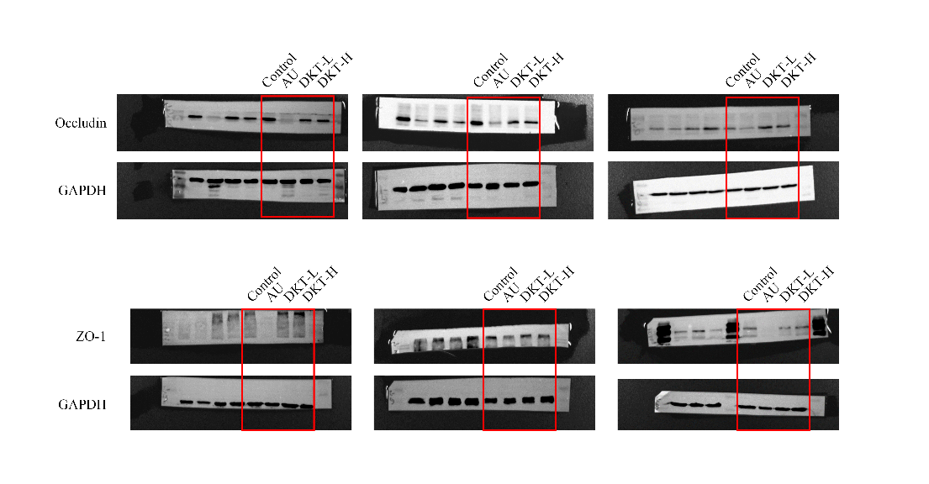
Fig. S4 Original Western blot membranes corresponding to Fig. 1G.
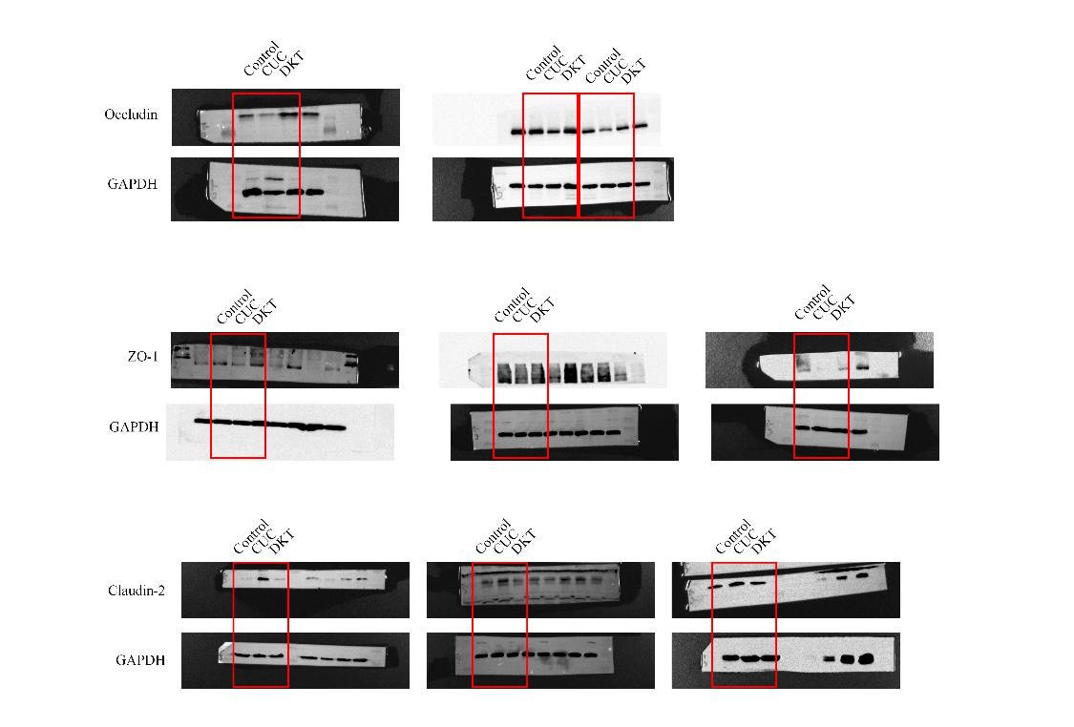
Fig. S5 Original Western blot membranes corresponding to Fig. 4C.
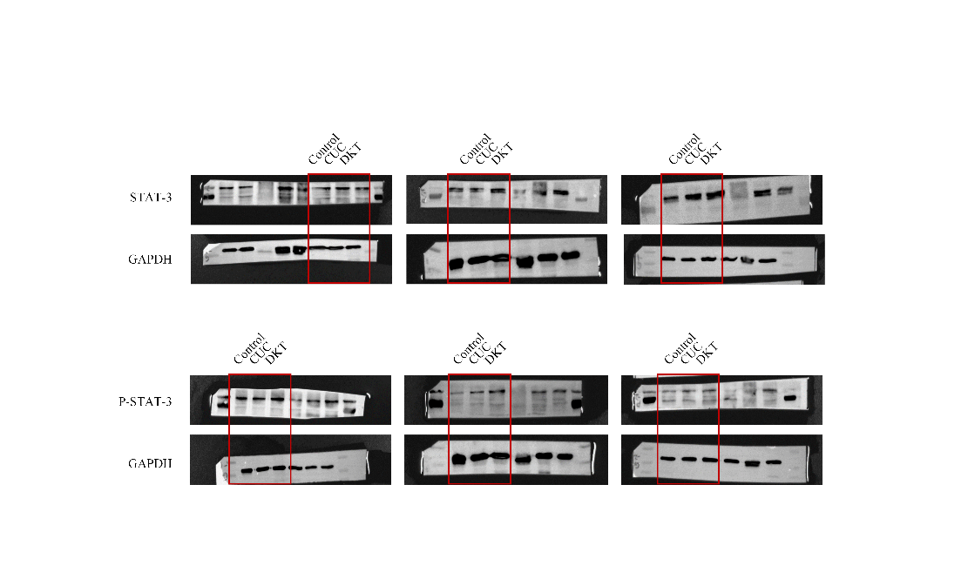
Fig. S6 Original Western blot membranes corresponding to Fig. 8C.

