Table S.1: ANOVA results for the optimization of the dispersive magnetic solid-phase extraction method in phenol recovery
Source | Sum of Squares | df | Mean Square | F-value | p-value
Model | 1.624E+08 | 20 | 8.122E+06 | 19.00 | < 0.0001 | significant
A-Sample volume | 95082.47 | 1 | 95082.47 | 0.2225 | 0.6413
B-Adsorbent amount | 1.488E+07 | 1 | 1.488E+07 | 34.82 | < 0.0001
C-Desorption solution volume | 6.928E+07 | 1 | 6.928E+07 | 162.09 | < 0.0001
D-Adsorption time | 2.691E+05 | 1 | 2.691E+05 | 0.6297 | 0.4349
E-Desorption time | 1.087E+06 | 1 | 1.087E+06 | 2.54 | 0.1234
AB | 1.110E+06 | 1 | 1.110E+06 | 2.60 | 0.1196
AC | 6.401E+05 | 1 | 6.401E+05 | 1.50 | 0.2324
AD | 3.629E+06 | 1 | 3.629E+06 | 8.49 | 0.0074
AE | 1.391E+06 | 1 | 1.391E+06 | 3.25 | 0.0833
BC | 7.313E+06 | 1 | 7.313E+06 | 17.11 | 0.0003
BD | 1.480E+05 | 1 | 1.480E+05 | 0.3462 | 0.5616
BE | 4.122E+05 | 1 | 4.122E+05 | 0.9645 | 0.3355
CD | 1.208E+07 | 1 | 1.208E+07 | 28.27 | < 0.0001
CE | 1.173E+06 | 1 | 1.173E+06 | 2.74 | 0.1101
DE | 1.368E+06 | 1 | 1.368E+06 | 3.20 | 0.0857
A² | 1.846E+06 | 1 | 1.846E+06 | 4.32 | 0.0481
B² | 1.047E+07 | 1 | 1.047E+07 | 24.50 | < 0.0001
C² | 1.937E+05 | 1 | 1.937E+05 | 0.4533 | 0.5070
D² | 8.304E+05 | 1 | 8.304E+05 | 1.94 | 0.1756
E² | 1.465E+05 | 1 | 1.465E+05 | 0.3427 | 0.5635
Residual | 1.069E+07 | 25 | 4.274E+05
Lack of Fit | 7.301E+06 | 22 | 3.319E+05 | 0.2942 | 0.9642 | not significant
Pure Error | 3.384E+06 | 3 | 1.128E+06
Cor Total | 1.731E+08 | 45

Table S.2: ANOVA results for the optimization of the dispersive magnetic solid-phase extraction method in chlorophenol recovery
Source | Sum of Squares | df | Mean Square | F-value | p-value
Model | 2.506E+08 | 20 | 1.253E+07 | 39.25 | < 0.0001 | significant
A-Sample volume | 4.186E+06 | 1 | 4.186E+06 | 13.11 | 0.0013
B-Adsorbent amount | 2.728E+06 | 1 | 2.728E+06 | 8.54 | 0.0073
C-Desorption solution volume | 1.083E+06 | 1 | 1.083E+06 | 3.39 | 0.0774
D-Adsorption time | 4.659E+06 | 1 | 4.659E+06 | 14.59 | 0.0008
E-Desorption time | 2.965E+05 | 1 | 2.965E+05 | 0.9286 | 0.3445
AB | 8.503E+06 | 1 | 8.503E+06 | 26.63 | < 0.0001
AC | 97130.28 | 1 | 97130.28 | 0.3042 | 0.5862
AD | 5.676E+06 | 1 | 5.676E+06 | 17.78 | 0.0003
AE | 3.804E+06 | 1 | 3.804E+06 | 11.91 | 0.0020
BC | 3894.03 | 1 | 3894.03 | 0.0122 | 0.9129
BD | 8.649E+05 | 1 | 8.649E+05 | 2.71 | 0.1123
BE | 8679.03 | 1 | 8679.03 | 0.0272 | 0.8704
CD | 1.745E+05 | 1 | 1.745E+05 | 0.5465 | 0.4666
CE | 9.136E+05 | 1 | 9.136E+05 | 2.86 | 0.1032
DE | 9.922E+06 | 1 | 9.922E+06 | 31.08 | < 0.0001
A² | 4.928E+06 | 1 | 4.928E+06 | 15.44 | 0.0006
B² | 6.760E+06 | 1 | 6.760E+06 | 21.17 | 0.0001
C² | 8.869E+05 | 1 | 8.869E+05 | 2.78 | 0.1081
D² | 5.986E+05 | 1 | 5.986E+05 | 1.87 | 0.1831
E² | 3.302E+06 | 1 | 3.302E+06 | 10.34 | 0.0036
Residual | 7.982E+06 | 25 | 3.193E+05
Lack of Fit | 7.848E+06 | 22 | 3.567E+05 | 8.00 | 0.0557 | not significant
Pure Error | 1.338E+05 | 3 | 44592.92
Cor Total | 2.586E+08 | 45

Table S.3: ANOVA results for the optimization of the dispersive magnetic solid-phase extraction method in o-cresol recovery
Source | Sum of Squares | df | Mean Square | F-value | p-value
Model | 1.097E+09 | 20 | 5.484E+07 | 34.70 | < 0.0001 | significant
A-Sample volume | 2.320E+06 | 1 | 2.320E+06 | 1.47 | 0.2370
B-Adsorbent amount | 1.522E+07 | 1 | 1.522E+07 | 9.63 | 0.0047
C-Desorption solution volume | 2.212E+08 | 1 | 2.212E+08 | 139.94 | < 0.0001
D-Adsorption time | 6.956E+05 | 1 | 6.956E+05 | 0.4401 | 0.5131
E-Desorption time | 2.642E+05 | 1 | 2.642E+05 | 0.1672 | 0.6861
AB | 1.896E+06 | 1 | 1.896E+06 | 1.20 | 0.2838
AC | 4.807E+06 | 1 | 4.807E+06 | 3.04 | 0.0934
AD | 7.463E+06 | 1 | 7.463E+06 | 4.72 | 0.0394
AE | 3.346E+05 | 1 | 3.346E+05 | 0.2117 | 0.6494
BC | 6.116E+05 | 1 | 6.116E+05 | 0.3870 | 0.5395
BD | 3.519E+06 | 1 | 3.519E+06 | 2.23 | 0.1481
BE | 7.831E+06 | 1 | 7.831E+06 | 4.96 | 0.0353
CD | 7.069E+05 | 1 | 7.069E+05 | 0.4473 | 0.5098
CE | 1.308E+07 | 1 | 1.308E+07 | 8.28 | 0.0081
DE | 5.848E+05 | 1 | 5.848E+05 | 0.3701 | 0.5485
A² | 2.074E+07 | 1 | 2.074E+07 | 13.12 | 0.0013
B² | 5.484E+07 | 1 | 5.484E+07 | 34.70 | < 0.0001
C² | 1.099E+07 | 1 | 1.099E+07 | 6.95 | 0.0142
D² | 8.175E+05 | 1 | 8.175E+05 | 0.5173 | 0.4787
E² | 32474.93 | 1 | 32474.93 | 0.0205 | 0.8872
Residual | 3.951E+07 | 25 | 1.580E+06
Lack of Fit | 3.815E+07 | 22 | 1.734E+06 | 3.84 | 0.1470 | not significant
Pure Error | 1.356E+06 | 3 | 4.520E+05
Cor Total | 1.136E+09 | 45

Table S.4: ANOVA results for the optimization of the dispersive magnetic solid-phase extraction method in aniline recovery
Source | Sum of Squares | df | Mean Square | F-value | p-value
Model | 6.709E+08 | 20 | 3.355E+07 | 54.49 | < 0.0001 | significant
A-Sample volume | 8.963E+07 | 1 | 8.963E+07 | 145.59 | < 0.0001
B-Adsorbent amount | 1.391E+07 | 1 | 1.391E+07 | 22.59 | < 0.0001
C-Desorption solution volume | 1.063E+08 | 1 | 1.063E+08 | 172.63 | < 0.0001
D-Adsorption time | 6.883E+06 | 1 | 6.883E+06 | 11.18 | 0.0026
E-Desorption time | 2.470E+07 | 1 | 2.470E+07 | 40.12 | < 0.0001
AB | 3.534E+05 | 1 | 3.534E+05 | 0.5741 | 0.4557
AC | 3.803E+06 | 1 | 3.803E+06 | 6.18 | 0.0200
AD | 7.872E+06 | 1 | 7.872E+06 | 12.79 | 0.0015
AE | 7.036E+05 | 1 | 7.036E+05 | 1.14 | 0.2953
BC | 3.551E+07 | 1 | 3.551E+07 | 57.67 | < 0.0001
BD | 6.077E+06 | 1 | 6.077E+06 | 9.87 | 0.0043
BE | 7.499E+06 | 1 | 7.499E+06 | 12.18 | 0.0018
CD | 6.208E+06 | 1 | 6.208E+06 | 10.08 | 0.0039
CE | 8.071E+06 | 1 | 8.071E+06 | 13.11 | 0.0013
DE | 8.565E+06 | 1 | 8.565E+06 | 13.91 | 0.0010
A² | 4.710E+07 | 1 | 4.710E+07 | 76.51 | < 0.0001
B² | 4.212E+06 | 1 | 4.212E+06 | 6.84 | 0.0149
C² | 1.629E+07 | 1 | 1.629E+07 | 26.47 | < 0.0001
D² | 4.595E+05 | 1 | 4.595E+05 | 0.7463 | 0.3959
E² | 4.589E+06 | 1 | 4.589E+06 | 7.45 | 0.0114
Residual | 1.539E+07 | 25 | 6.156E+05
Lack of Fit | 1.271E+07 | 22 | 5.775E+05 | 0.6452 | 0.7702 | not significant
Pure Error | 2.685E+06 | 3 | 8.950E+05
Cor Total | 6.863E+08 | 45

Table S.5: R² and Adjusted R² results related to the ANOVA test for four analytes: phenol, chlorophenol, o-cresol, and aniline
 | Phenol | Chlorophenol | O-cresol | Aniline
R² | 0.9383 | 0.9691 | 0.9652 | 0.9776
Adjusted R² | 0.8889 | 0.9444 | 0.9374 | 0.9596
Predicted R² | 0.8164 | 0.8826 | 0.8756 | 0.9334
Adeq Precision | 14.6752 | 19.7333 | 18.0710 | 27.1196

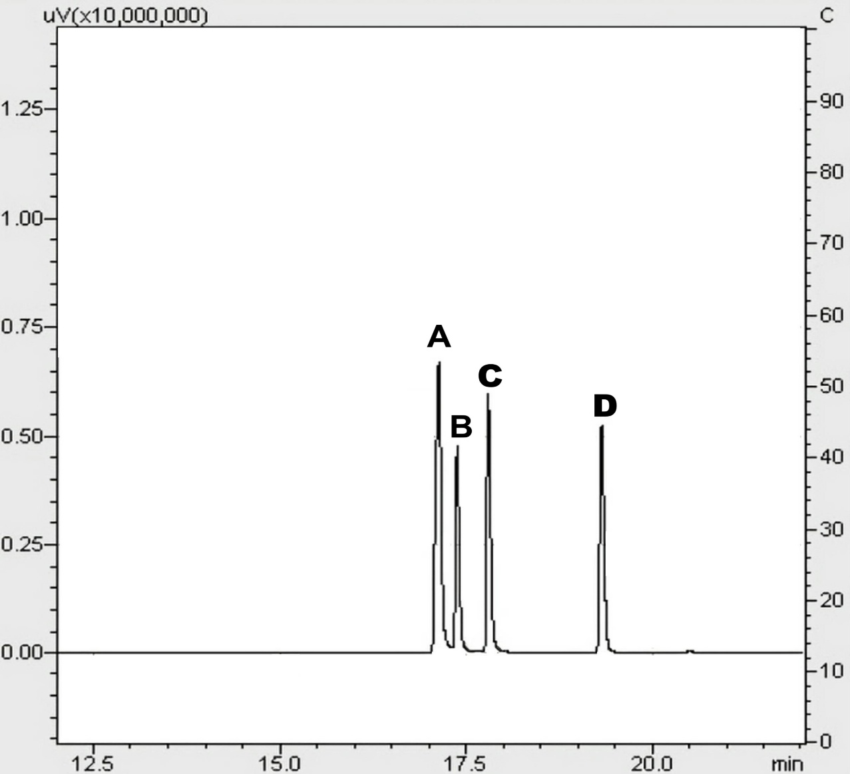
Figure S.1: Chromatogram obtained using the magnetic dispersive solid-phase extraction method with magnetic silica aerogel adsorbent at a standard concentration of 5 μg/mL: (A) aniline, (B) chlorophenol, (C) phenol, and (D) o-cresol

