SUPPLEMENTARY TABLES AND FIGURES
Supplementary Figure 1: Hourly Variation of Wet-Bulb Globe Temperature (WBGT) In Copper Bell Workshops (Coal-Fired Furnace Units)

Supplementary Figure 2: Graphical representation for octave band analysis at Unit 1 in line with standard NC curves
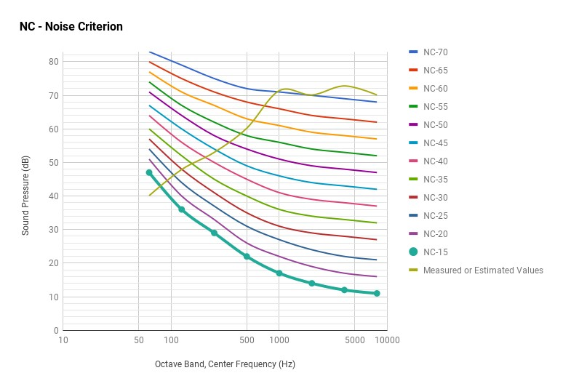
Supplementary Figure 3: Graphical Representation for Octave Band Analysis at Unit 2 in Line with Standard NC Curves
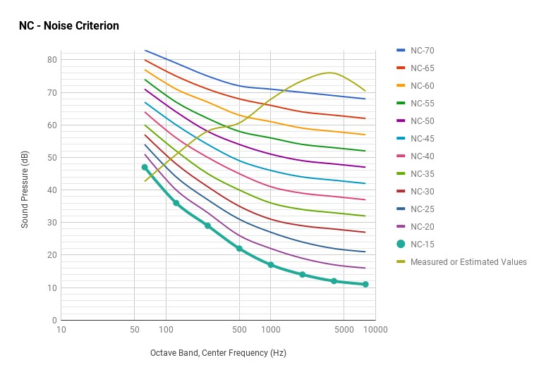
Supplementary Figure 4: Graphical Representation for Octave Band Analysis at Unit 3 in Line with Standard NC Curves

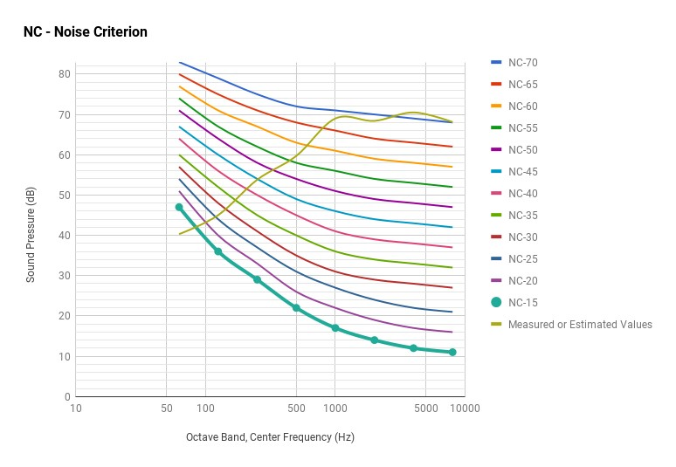
Supplementary Figure 5: Graphical Representation for Octave Band Analysis at Unit 1 in Line with Standard NR Curves
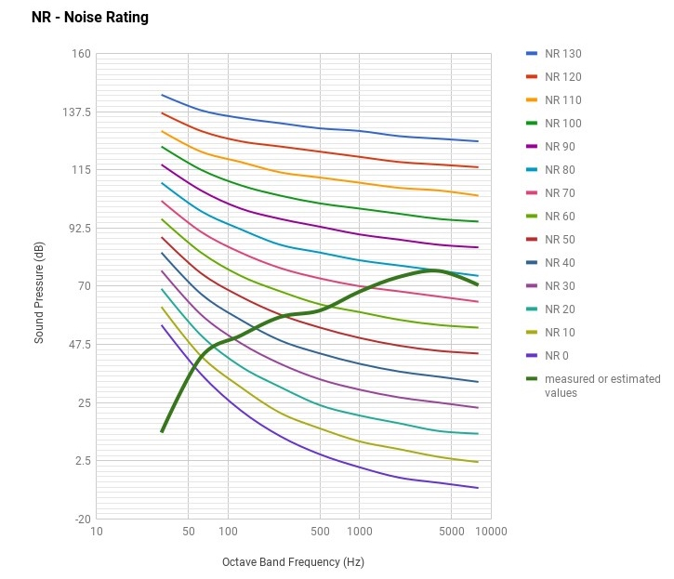
Supplementary Figure 6: Graphical Representation for Octave Band Analysis at Unit 2 in Line with Standard NR Curves
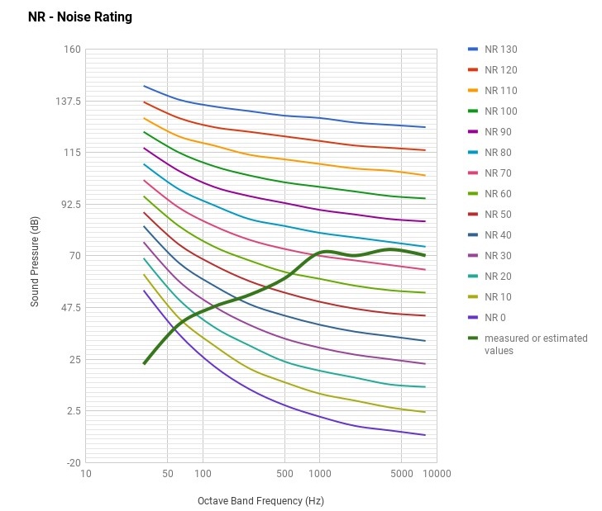
Supplementary Figure 7: Graphical Representation for Octave Band Analysis at Unit 3 in Line with Standard NR Curves
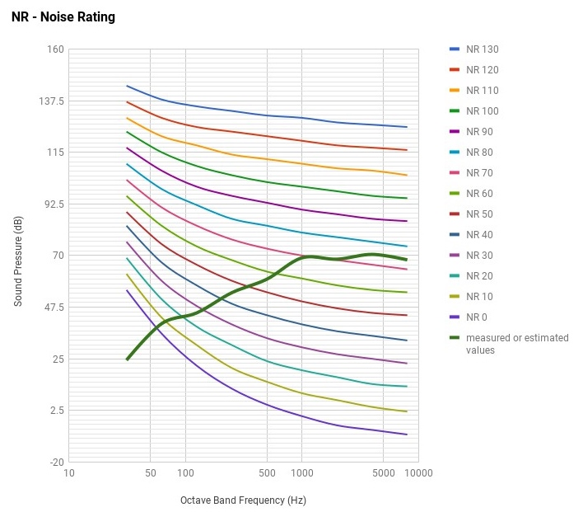
Supplementary Figure 8: Musculoskeletal Pain in Copper Bell Makers (N=89)

Supplementary Figure 9: Self-Reported Symptoms in Different Work Profile of Copper Bell Makers (N=89)

Supplementary Table 1: Noise Dosimetry (N=9) at Bell Workshops
No | Parameter for hammering activity | Measured/observed value/range
1. | Lmin | 65.0 dB(A)
2. | Lmax | 119.8 dB(A)
3. | Lpeak | 148.2 dB(Z)
4. | TWA | 79.08 ± 2.89 dB(A)

