Supplementary Figures for:

REDIAL-2020: A suite of machine learning models to estimate Anti-SARS-CoV-2 activities
Govinda KC^{1,2⧪}, Giovanni Bocci^{3⧪}, Srijan Verma^{2,4}, Md Mahmudulla Hassan⁵, Jayme Holmes³, Jeremy J. Yang³, Suman Sirimulla^{1,2,5,*}, and Tudor I. Oprea^{3,6,7,8,*}
¹ Computational Science Program, The University of Texas at El Paso, Texas 79968, USA.
² Department of Pharmaceutical Sciences, School of Pharmacy, The University of Texas at El Paso, Texas 79902, USA.
³ Translational Informatics Division, Department of Internal Medicine; and
⁶ Autophagy Inflammation and Metabolism Center of Biomedical Research Excellence, University of New Mexico Health Sciences Center, Albuquerque, NM, USA
⁴ Department of Pharmacy, Birla Institute of Technology and Science, Pilani, Pilani Campus, Rajasthan, 333031, India.
⁵ Department of Computer Science, The University of Texas at El Paso, Texas 79968, USA.
⁷ Department of Rheumatology and Inflammation Research, Institute of Medicine, Sahlgrenska Academy at University of Gothenburg, Gothenburg, Sweden;
⁸ Novo Nordisk Foundation Center for Protein Research, Faculty of Health and Medical Sciences, University of Copenhagen, Copenhagen, Denmark.

Manuscript Tracking Number: NATMACHINTELL-PI20082284A

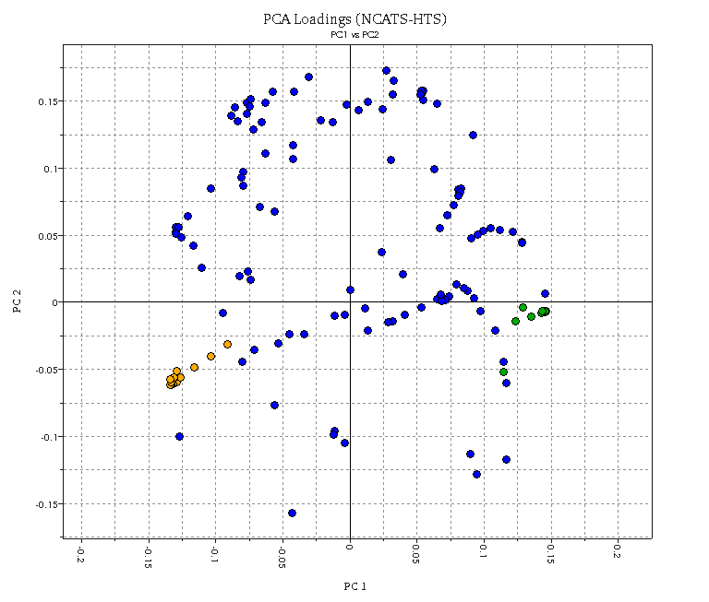
Figure SI1: PCA loadings plot of the compounds tested in NCATS SARS-CoV-2 experiments based on VolSurf+ descriptors. logP/logD descriptors are highlighted in green. logS descriptors are highlighted in orange.

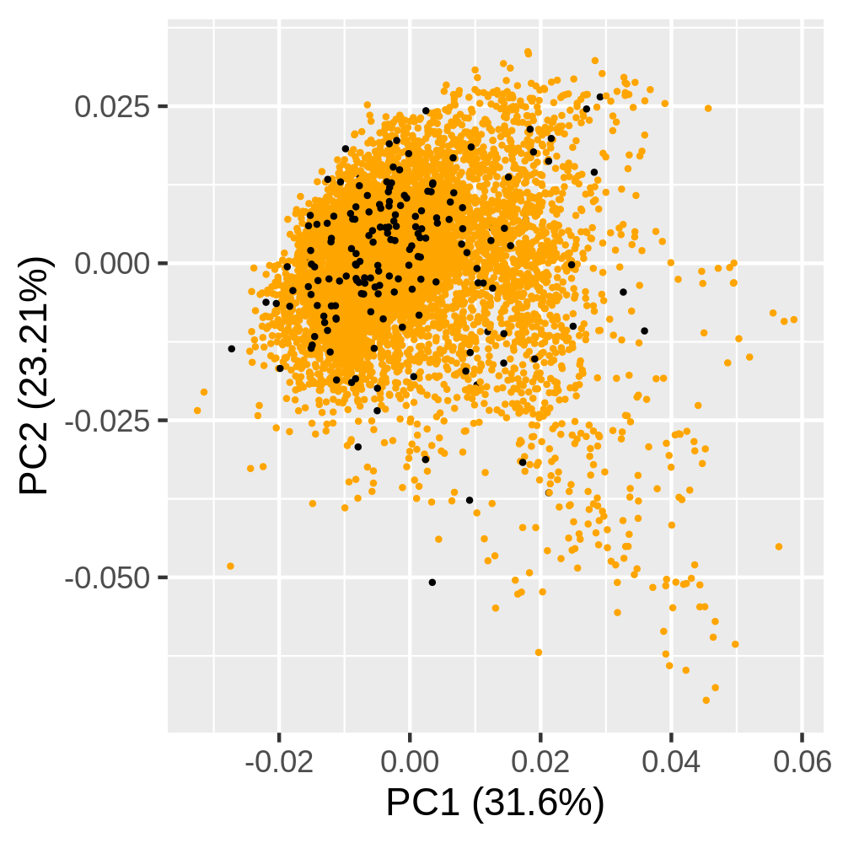
Figure SI2: PCA scores plot of the compounds tested in NCATS 3CL inhibition assay based on VolSurf+ descriptors. HIGH/MODERATE activity compounds are highlighted in black. LOW activity compounds are highlighted in orange.

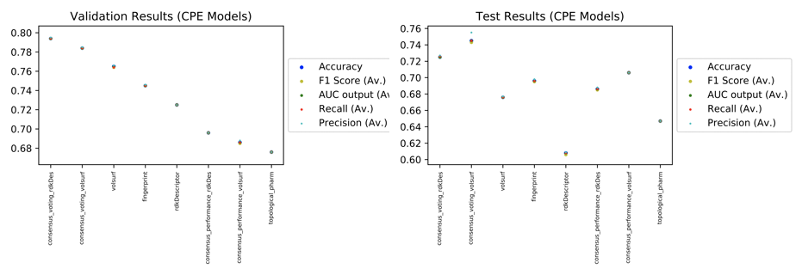
Figure SI3: validation scores obtained for the different CPE models.

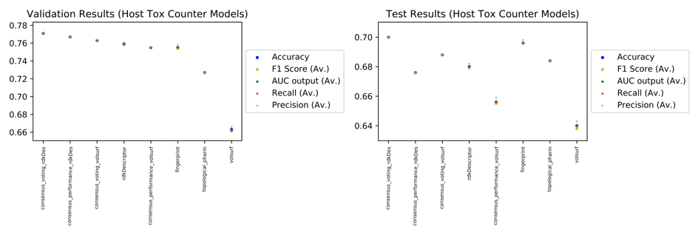
Figure SI4: validation scores obtained for the different cytotox models.

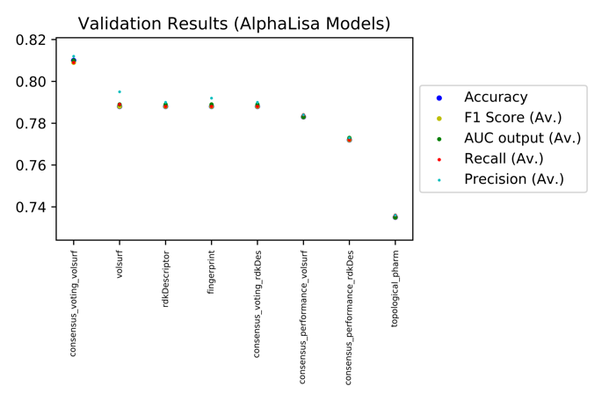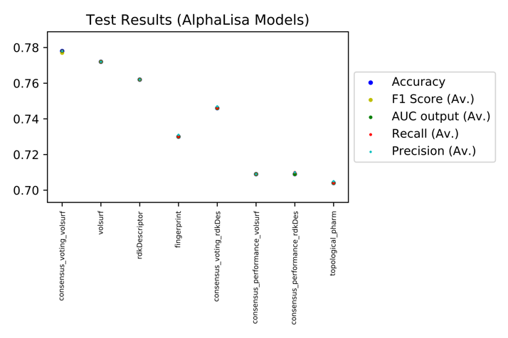

Figure SI5: validation scores obtained for the different AlphaLISA models.
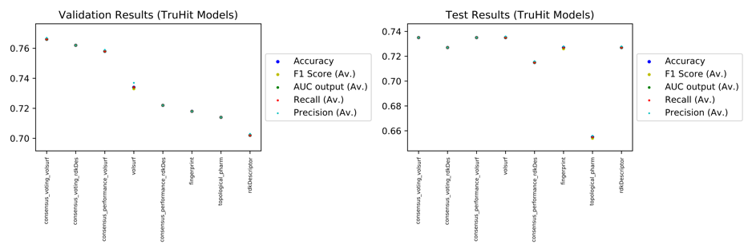

Figure SI6: validation scores obtained for the different TruHit models.

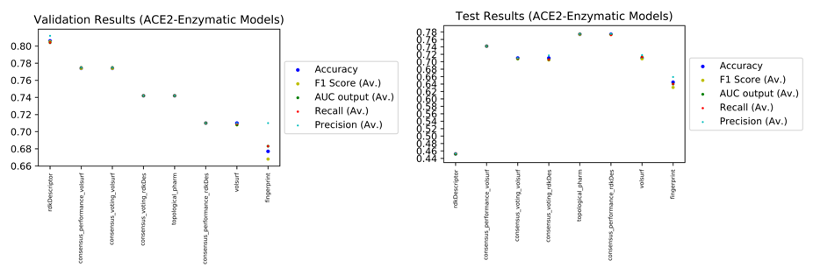
Figure SI7: validation scores obtained for the different ACE2 models.

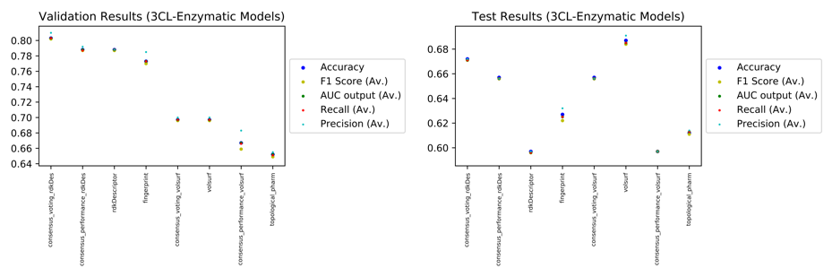
Figure SI8: validation scores obtained for the different 3CL models.

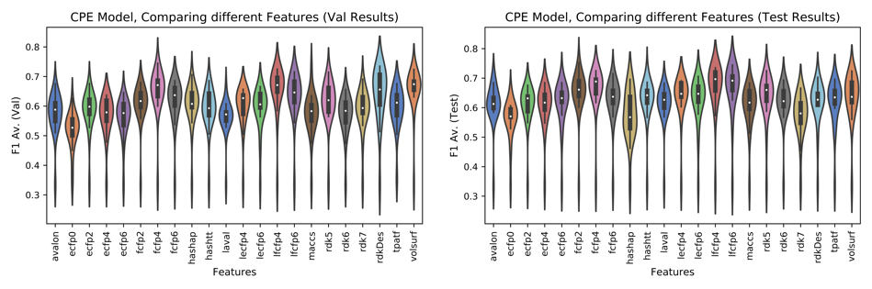

Figure SI9: plot showing the comparison of different features for the CPE model.
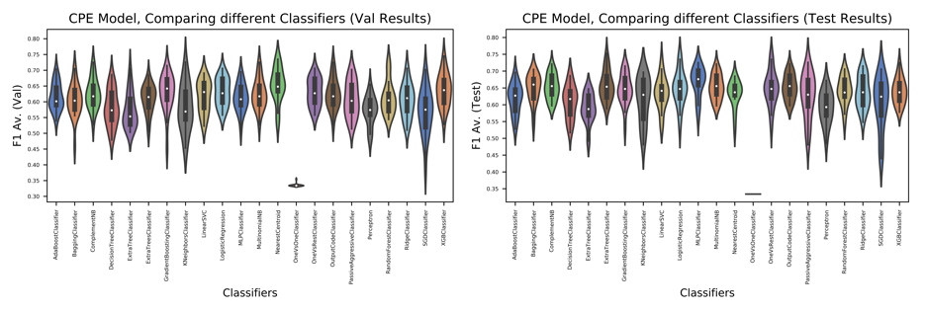Figure SI10: plot showing the comparison of different ML algorithms for the CPE model.

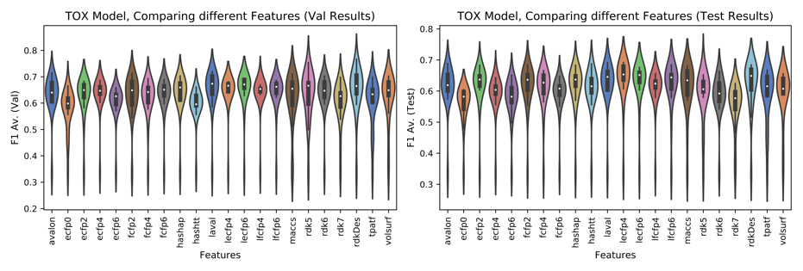Figure SI11: plot showing the comparison of different features for the cytotox model.

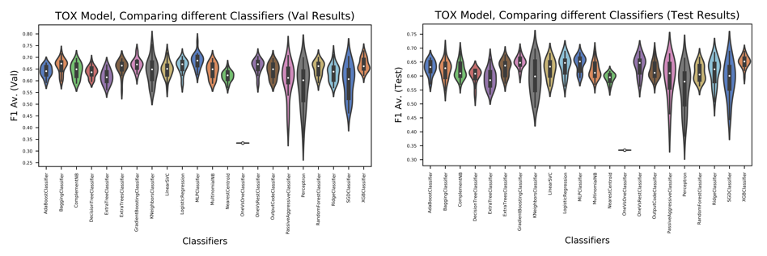
Figure SI12: plot showing the comparison of different ML algorithms for the cytotox model.

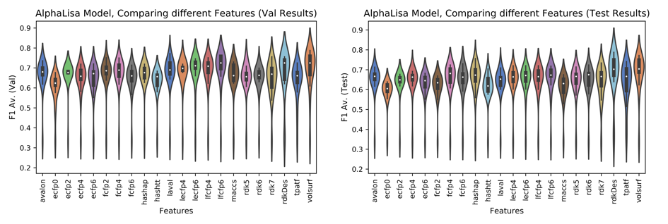Figure SI13: plot showing the comparison of different features for the AlphaLISA model.
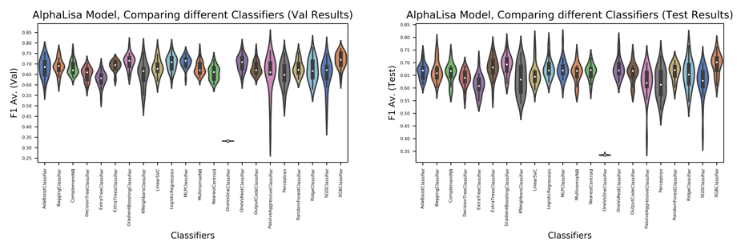
Figure SI14: plot showing the comparison of different ML features for the AlphaLISA model.
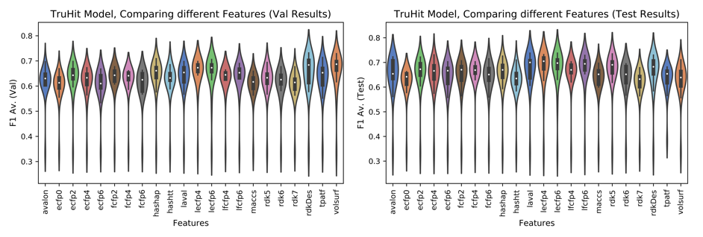Figure SI15: plot showing the comparison of different features for the TruHit model.

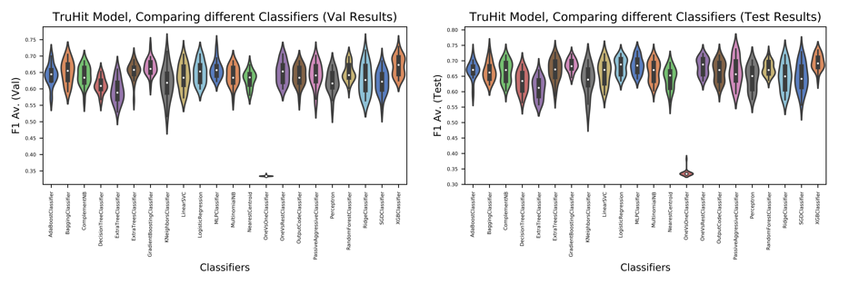
Figure SI16: plot showing the comparison of different ML algorithms for the TruHit model.

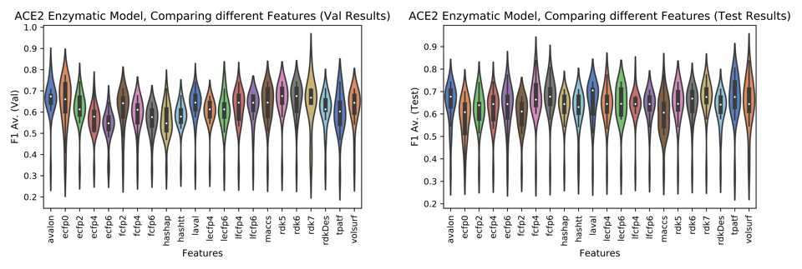Figure SI17: plot showing the comparison of different features for the ACE2 model.

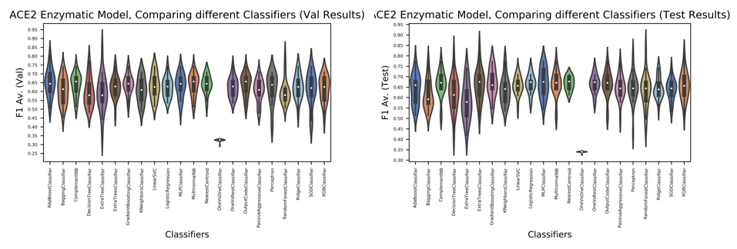Figure SI18: plot showing the comparison of different ML algorithms for the ACE2 model.
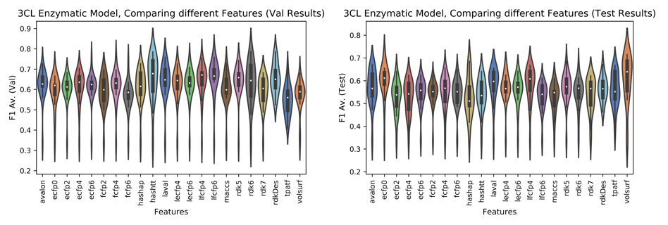
Figure SI9: plot showing the comparison of different features for the 3CL model.
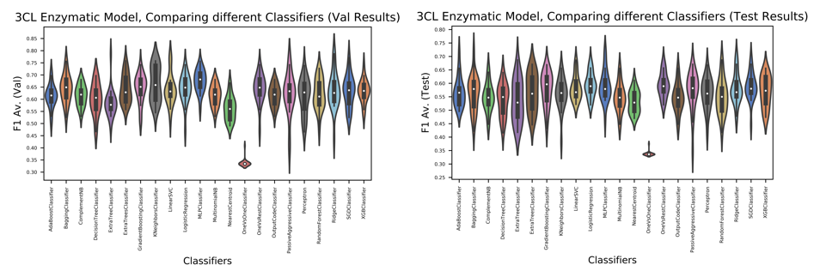
Figure SI20: plot showing the comparison of different ML algorithms for the 3CL model.

