Continuous Prediction Results

- day 4
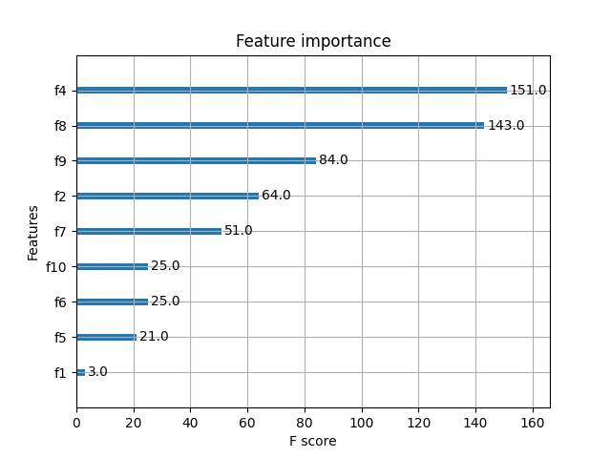
selected_columns = ['Height', ' ave', '0', 'Age', 'CTV Volume (cm³)', '1', 'BMI'] (the first seven features)
Feature Engineering
4 | train_acc |  | test_acc |  | test_precision |  | test_f1 |  | test_recall | Thresh
n=4 | 90.63 |  | 56.25 |  | 60.00 |  | 46.15 |  | 37.5 | 0.128
n=5 | 70.31 |  | 50.00 |  | 50.00 |  | 20.00 |  | 12.5 | 0.092
n=6 | 92.19 |  | 56.25 |  | 57.14 |  | 53.33 |  | 50.00 | 0.084
n=7 | 71.88 |  | 50.00 |  | 50.00 |  | 20.00 |  | 12.50 | 0.080
n=6
decisionTree | 71.88 |  | 50.00 |  | 50.00 |  | 20.00 |  | 12.50
svc | 64.06 |  | 50.00 |  | 50.00 |  | 42.86 |  | 37.50

- day 4-5（Quoted in the text）
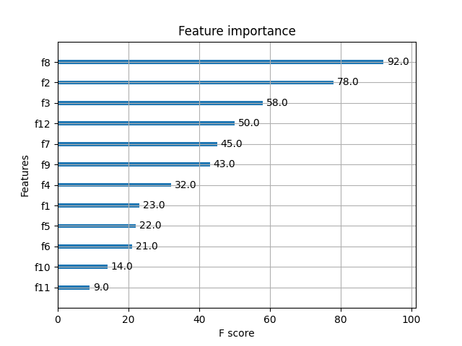
selected_columns = [' ave', 'Age', 'Left/Right', 'Days', 'CTV Volume (cm³)', '0', 'Height', 'Treatment Method'] (the first eight features)
Feature Engineering
days 4-5 | train_acc |  | test_acc |  | test_precision |  | test_f1 |  | test_recall | Thresh
n=5 | 68.75 |  | 65.63 |  | 100.00 |  | 42.11 |  | 26.67 | 0.071
n=6 | 72.66 |  | 71.88 |  | 100.00 |  | 57.14 |  | 40.00 | 0.069
n=7 | 73.44 |  | 65.63 |  | 100.00 |  | 42.11 |  | 26.67 | 0.067
n=8 | 77.34 |  | 65.63 |  | 100.00 |  | 42.11 |  | 26.67 | 0.063
n=6
decisionTree | 71.88 |  | 62.50 |  | 61.54 |  | 57.14 |  | 53.33
svc | 69.53 |  | 59.38 |  | 60.00 |  | 48.00 |  | 40.00

- day 4-6
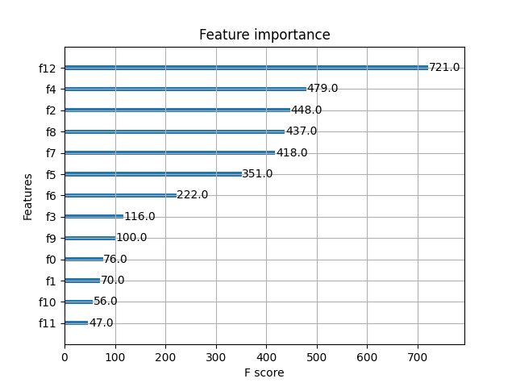

selected_columns = ['Days', 'Height', 'Age', ' ave', 'CTV Volume (cm³)', 'Weight', 'BMI', 'Left/Right', '0', 'Membrane Method (1 for membrane, 0 for no membrane)', 'Treatment Method'] (the first eleven features)
Feature Engineering
days 4-6 | train_acc |  | test_acc |  | test_precision |  | test_f1 |  | test_recall | Thresh
n=8 | 65.10 |  | 58.33 |  | 83.33 |  | 33.33 |  | 20.83 | 0.067
n=9 | 90.63 |  | 68.75 |  | 76.47 |  | 63.41 |  | 51.17 | 0.059
n=10 | 90.10 |  | 70.83 |  | 81.25 |  | 65.00 |  | 54.17 | 0.057
n=11 | 90.63 |  | 64.58 |  | 88.89 |  | 48.48 |  | 33.33 | 0.053
n=10
decisionTree | 63.54 |  | 54.17 |  | 57.14 |  | 42.11 |  | 33.00
svc | 76.56 |  | 66.67 |  | 70.00 |  | 63.64 |  | 58.33

- day 4-7
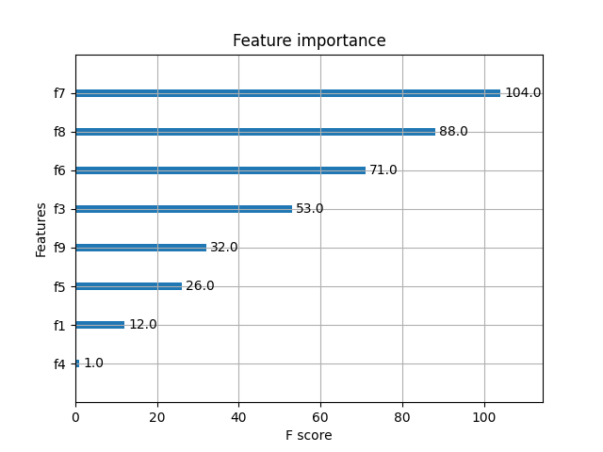

selected_columns = ['CTV Volume (cm³)', ' ave', 'BMI', 'Left/Right', '0', 'Weight', 'Treatment Method', 'Height'] (the first eight features)
Feature Engineering
days 4-7 | train_acc |  | test_acc |  | test_precision |  | test_f1 |  | test_recall | Thresh
n=4 | 64.45 |  | 56.25 |  | 75.00 |  | 39.13 |  | 26.47 | 0.105
n=5 | 64.45 |  | 56.25 |  | 75.00 |  | 39.13 |  | 26.47 | 0.082
n=6 | 65.23 |  | 56.25 |  | 87.50 |  | 33.33 |  | 20.59 | 0.081
n=7 | 66.02 |  | 56.25 |  | 87.50 |  | 33.33 |  | 20.59 | 0.076
n=8 | 66.02 |  | 56.25 |  | 87.50 |  | 33.33 |  | 20.59 | 0.062
n=7
decisionTree | 69.14 |  | 62.5 |  | 63.89 |  | 65.71 |  | 67.65
svc | 59.77 |  | 50 |  | 75 |  | 15.79 |  | 8.82

- day 4-8
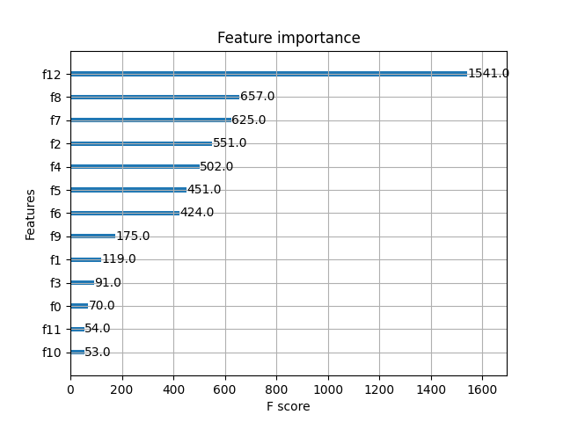

selected_columns = ['Days', ' ave', 'CTV Volume (cm³)', 'Age', 'Height', 'Weight', 'BMI', '0', 'Treatment Method'] (the first eight features)
Feature Engineering
days 4-8 | train_acc |  | test_acc |  | test_precision |  | test_f1 |  | test_recall | Thresh
n=4 | 65.00 |  | 57.50 |  | 64.00 |  | 48.48 |  | 39.02 | 0.086
n=5 | 65.00 |  | 57.50 |  | 65.22 |  | 46.87 |  | 36.59 | 0.082
n=6 | 97.19 |  | 56.25 |  | 59.38 |  | 52.05 |  | 46.34 | 0.081
n=7 | 65.00 |  | 57.50 |  | 64.00 |  | 48.48 |  | 39.02 | 0.079
n=8 | 66.56 |  | 57.50 |  | 73.33 |  | 39.29 |  | 26.83 | 0.071
n=9 | 83.13 |  | 53.75 |  | 58.33 |  | 43.08 |  | 34.15 | 0.071
n=8
decisionTree | 64.38 |  | 50.00 |  | 53.33 |  | 28.57 |  | 19.51
svc | 59.38 |  | 56.25 |  | 60.00 |  | 50.70 |  | 43.90

- day 4-9
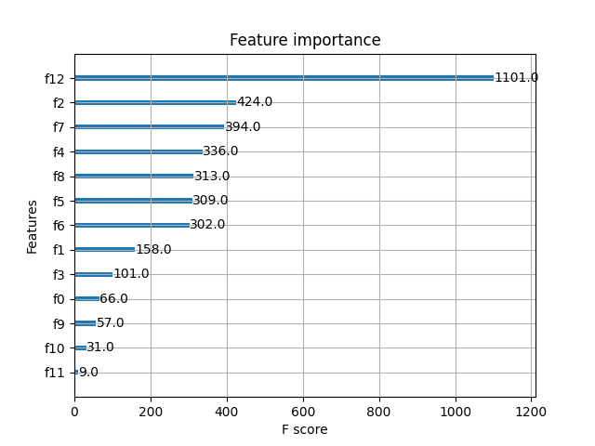
selected_columns = ['Days', 'Age', 'CTV Volume (cm³)', 'Height', ' ave', 'Weight', 'BMI', 'Treatment Method', 'Left/Right'] (the first nine features)
Feature Engineering
days 4-9 | train_acc |  | test_acc |  | test_precision |  | test_f1 |  | test_recall | Thresh
n=4 | 73.96 |  | 38.54 |  | 31.03 |  | 23.38 |  | 18.75 | 0.085
n=5 | 73.96 |  | 55.21 |  | 58.62 |  | 44.16 |  | 35.42 | 0.084
n=6 | 74.22 |  | 55.21 |  | 58.62 |  | 44.16 |  | 35.42 | 0.082
n=7 | 86.20 |  | 55.21 |  | 56.76 |  | 49.41 |  | 43.75 | 0.076
n=8 | 67.97 |  | 54.17 |  | 56.67 |  | 43.59 |  | 35.42 | 0.065
n=9 | 80.99 |  | 55.21 |  | 56.76 |  | 49.41 |  | 43.75 | 0.062
n=7
decisionTree | 64.32 |  | 54.17 |  | 60.00 |  | 35.29 |  | 25.00
svc | 63.02 |  | 59.38 |  | 65.52 |  | 49.35 |  | 39.58

- day 4-10
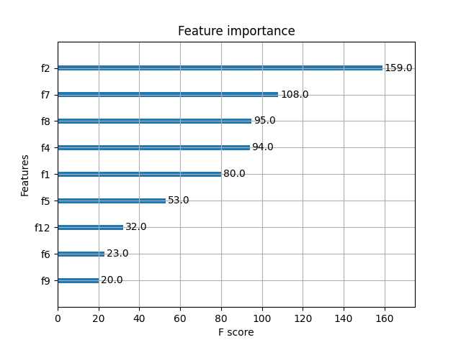
selected_columns = ['Age', 'CTV Volume (cm³)', ' ave', 'Height', 'Treatment Method', 'Weight', 'Days', 'BMI', '0']
Feature Engineering
days 4-10 | train_acc |  | test_acc |  | test_precision |  | test_f1 |  | test_recall | Thresh
n=4 | 70.54 |  | 54.46 |  | 57.14 |  | 52.34 |  | 48.28 | 0.118
n=5 | 66.07 |  | 56.25 |  | 62.86 |  | 47.31 |  | 37.93 | 0.097
n=6 | 66.07 |  | 53.57 |  | 60.71 |  | 39.53 |  | 29.31 | 0.092
n=7 | 77.23 |  | 50.89 |  | 54.05 |  | 42.11 |  | 34.48 | 0.085
n=8 | 66.96 |  | 53.57 |  | 60.71 |  | 39.53 |  | 29.31 | 0.030
n=9 | 66.74 |  | 53.57 |  | 60.71 |  | 39.53 |  | 29.31 | 0.024
n=5
decisionTree | 61.16 |  | 51.79 |  | 64.29 |  | 25.00 |  | 15.00
svc | 62.28 |  | 53.57 |  | 71.43 |  | 27.78 |  | 17.24

- day 4-11
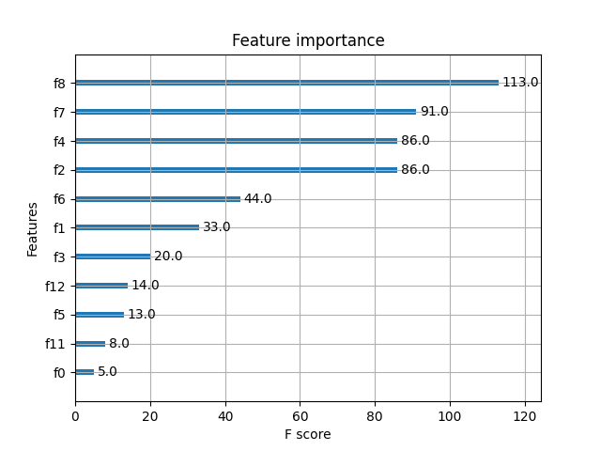

selected_columns = [' ave', 'CTV Volume (cm³)', 'Height', 'Age', 'BMI', 'Treatment Method', 'Left/Right', 'Days', 'Weight', '2', 'Membrane Removal Method (1 for removal, 0 for no removal)']
Feature Engineering
days 4-11 | train_acc |  | test_acc |  | test_precision |  | test_f1 |  | test_recall | Thresh
n=4 | 64.84 |  | 57.03 |  | 60.00 |  | 46.60 |  | 38.10 | 0.086
n=5 | 65.23 |  | 57.03 |  | 60.00 |  | 46.60 |  | 38.10 | 0.068
n=6 | 68.75 |  | 53.91 |  | 54.17 |  | 46.85 |  | 41.27 | 0.066
n=7 | 68.75 |  | 57.03 |  | 60.00 |  | 46.60 |  | 38.10 | 0.057
n=8 | 67.19 |  | 57.81 |  | 60.47 |  | 49.06 |  | 41.27 | 0.051
n=9 | 66.41 |  | 55.47 |  | 59.38 |  | 40.00 |  | 30.16 | 0.035
n=8
decisionTree | 62.11 |  | 53.91 |  | 75.00 |  | 16.90 |  | 9.52
svc | 62.89 |  | 60.16 |  | 68.75 |  | 46.32 |  | 34.92

- day 4-12
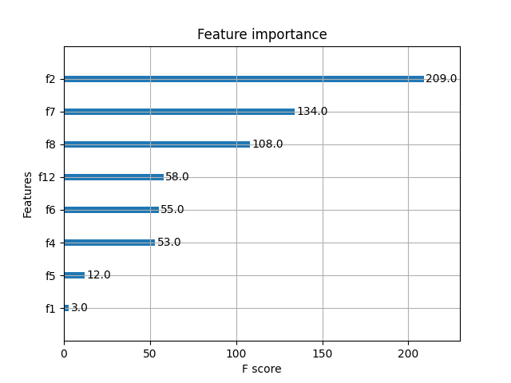

selected_columns = ['Age', 'CTV Volume (cm³)', ' ave', 'Days', 'BMI', 'Height', 'Weight', 'Treatment Method']
Feature Engineering
days 4-12 | train_acc |  | test_acc |  | test_precision |  | test_f1 |  | test_recall | Thresh
n=4 | 67.36 |  | 54.17 |  | 55.56 |  | 47.62 |  | 41.67 | 0.098
n=5 | 68.58 |  | 57.64 |  | 61.70 |  | 48.74 |  | 40.28 | 0.089
n=6 | 66.49 |  | 57.64 |  | 62.22 |  | 47.86 |  | 38.89 | 0.087
n=7 | 67.19 |  | 55.56 |  | 61.11 |  | 40.74 |  | 30.56 | 0.059
n=8 | 67.19 |  | 55.56 |  | 61.11 |  | 40.74 |  | 30.56 | 0.004
n=5
decisionTree | 66.15 |  | 57.64 |  | 62.22 |  | 47.86 |  | 38.89
svc | 62.67 |  | 63.19 |  | 71.11 |  | 54.70 |  | 44.44

- day 4-13
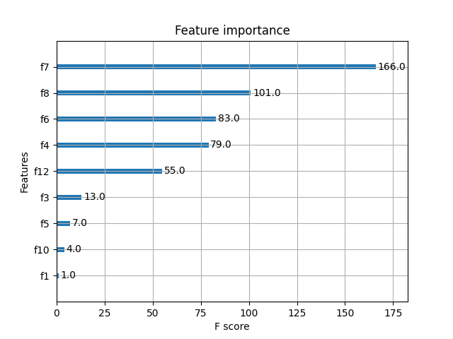

selected_columns = ['CTV Volume (cm³)', ' ave', 'BMI', 'Height', 'Days', 'Left/Right', 'Weight', '1']
Feature Engineering
days 4-13 | train_acc |  | test_acc |  | test_precision |  | test_f1 |  | test_recall | Thresh
n=4 | 68.44 |  | 53.75 |  | 54.29 |  | 50.67 |  | 47.5 | 0.103
n=5 | 65.94 |  | 53.75 |  | 55.00 |  | 47.14 |  | 41.25 | 0.095
n=6 | 65.94 |  | 53.75 |  | 55.00 |  | 47.14 |  | 41.25 | 0.074
n=7 | 65.94 |  | 53.75 |  | 55.00 |  | 47.14 |  | 41.25 | 0.051
n=8 | 65.94 |  | 53.75 |  | 55.00 |  | 47.14 |  | 41.25 | 0.029
n=4
decisionTree | 61.56 |  | 53.75 |  | 54.50 |  | 38.33 |  | 28.75
svc | 62.50 |  | 63.75 |  | 72.00 |  | 55.38 |  | 45.00

- day 4-14

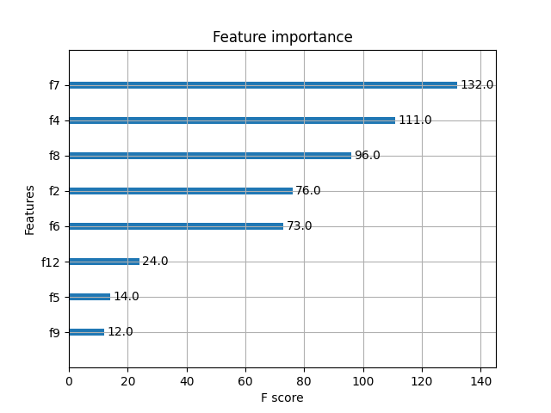
selected_columns = ['CTV Volume (cm³)', 'Height', ' ave', 'Age', 'BMI', 'Days', 'Weight', '0']
Feature Engineering
days 4-14 | train_acc |  | test_acc |  | test_precision |  | test_f1 |  | test_recall | Thresh
n=4 | 68.32 |  | 53.98 |  | 54.55 |  | 47.06 |  | 41.38 | 0.092
n=5 | 68.32 |  | 53.98 |  | 54.55 |  | 47.06 |  | 41.38 | 0.090
n=6 | 65.48 |  | 53.98 |  | 54.55 |  | 47.06 |  | 41.38 | 0.068
n=7 | 65.48 |  | 53.98 |  | 54.55 |  | 47.06 |  | 41.38 | 0.056
n=8 | 65.48 |  | 53.98 |  | 54.55 |  | 47.06 |  | 41.38 | 0.023
n=5
decisionTree | 62.78 |  | 53.98 |  | 63.64 |  | 25.69 |  | 16.00
svc | 62.64 |  | 63.64 |  | 70.91 |  | 54.93 |  | 44.83

- day 4-15
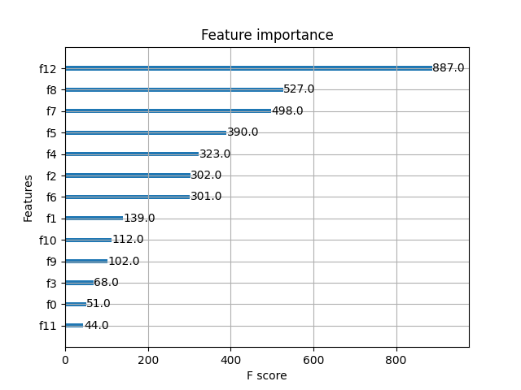

selected_columns = ['Days', 'Average', 'CTV Volume (cm³)', 'Weight', 'Height', 'Age', 'BMI', 'Treatment Method', '1', '0', 'Left/Right', 'Membrane Retraction Method (1 for retraction, 0 for no retraction)', '2']
Feature Engineering
days 4-15 | train_acc |  | test_acc |  | test_precision |  | test_f1 |  | test_recall | Thresh
n=7 | 71.22 |  | 54.17 |  | 54.22 |  | 50.56 |  | 47.37 | 0.053
n=8 | 69.40 |  | 53.65 |  | 54.17 |  | 46.71 |  | 41.05 | 0.049
n=9 | 69.40 |  | 53.65 |  | 54.17 |  | 46.71 |  | 41.05 | 0.045
n=10 | 69.40 |  | 55.21 |  | 56.92 |  | 46.25 |  | 38.95 | 0.044
n=11 | 69.40 |  | 55.21 |  | 56.92 |  | 46.25 |  | 38.95 | 0.042
n=12 | 69.40 |  | 55.21 |  | 56.92 |  | 46.25 |  | 38.95 | 0.038
n=13 |  |  |  |  |  |  |  |  |  | 0.034
n=10
decisionTree | 64.32 |  | 53.65 |  | 62.5 |  | 25.21 |  | 15.79
svc | 60.42 |  | 56.77 |  | 60.00 |  | 46.45 |  | 37.89

Individual Prediction
（1）
selected_columns = ['Height', 'ave', '0', 'Age', 'CTV Volume (cm³)', '1', 'BMI']
Feature Engineering
4 | train_acc |  | test_acc |  | test_precision |  | test_f1 |  | test_recall | Thresh
n=4 | 90.63 |  | 56.25 |  | 60.00 |  | 46.15 |  | 37.5 | 0.128
n=5 | 70.31 |  | 50.00 |  | 50.00 |  | 20.00 |  | 12.5 | 0.092
n=6 | 92.19 |  | 56.25 |  | 57.14 |  | 53.33 |  | 50.00 | 0.084
n=7 | 71.88 |  | 50.00 |  | 50.00 |  | 20.00 |  | 12.5 | 0.080
n=6
decisionTree | 71.88 |  | 50.00 |  | 50.00 |  | 20.00 |  | 12.50
svc | 64.06 |  | 50.00 |  | 50.00 |  | 42.86 |  | 37.50

（2）
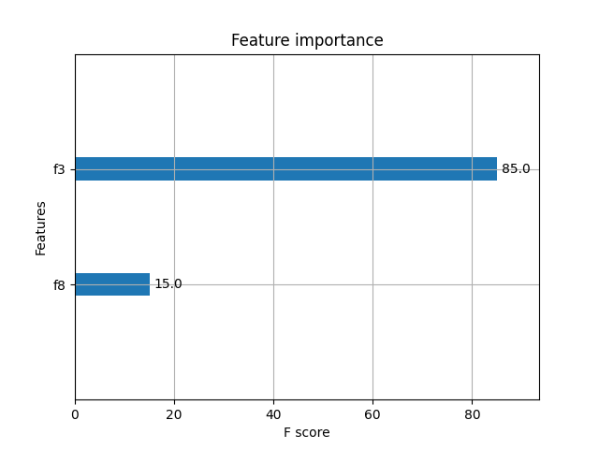
selected_columns = ['Left/Right', ' 'ave']
Feature Engineering
5 | train_acc |  | test_acc |  | test_precision |  | test_f1 |  | test_recall | Thresh
n=1 | 70.31 |  | 43.75 |  | 37.50 |  | 40.00 |  | 42.86 | 0.63
n=2 | 78.13 |  | 56.25 |  | 50.00 |  | 22.22 |  | 14.29 | 0.37
n=2
decisionTree | 70.31 |  | 43.75 |  | 37.50 |  | 40.00 |  | 42.86
svc | 60.94 |  | 56.25 |  | 0.00 |  | 0.00 |  | 0.00

（3）
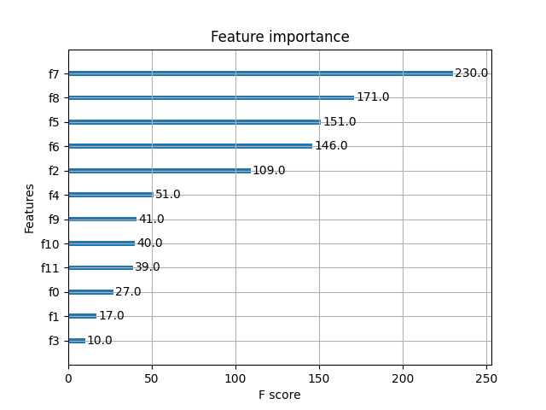
selected_columns = ['CTV Volume (cm³)', ' 'ave', 'Weight', 'BMI', 'Age', 'Height', '0', '1', '2', 'Membrane Retraction Method (1 for retraction, 0 for no retraction)', 'Treatment Method', 'Left/Right']
Feature Engineering
6 | train_acc |  | test_acc |  | test_precision |  | test_f1 |  | test_recall | Thresh
n=3 | 73.44 |  | 56.25 |  | 75.00 |  | 46.15 |  | 33.33 | 0.121
n=4 | 85.94 |  | 56.25 |  | 75.00 |  | 46.15 |  | 33.33 | 0.104
n=5 | 82.81 |  | 56.25 |  | 75.00 |  | 46.15 |  | 33.33 | 0.091
n=6 | 90.63 |  | 43.75 |  | 50.00 |  | 30.77 |  | 22.22 | 0.085
n=7 | 89.06 |  | 43.75 |  | 50.00 |  | 30.77 |  | 22.22 | 0.075
n=4
decisionTree | 65.63 |  | 56.25 |  | 75.00 |  | 46.15 |  | 33.33
svc | 68.75 |  | 56.25 |  | 100.00 |  | 36.36 |  | 22.22

（4）
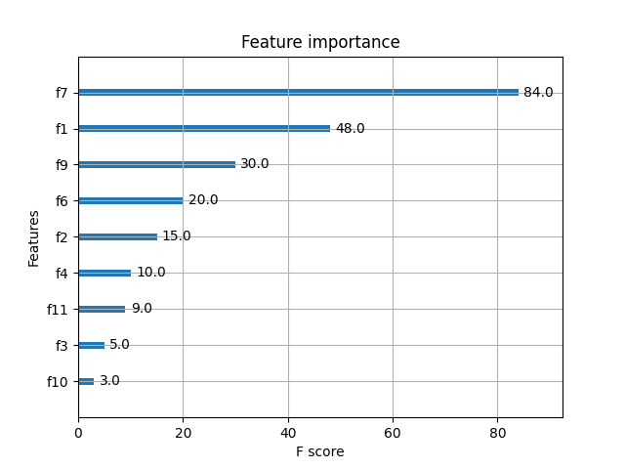
selected_columns = ['CTV Volume (cm³)', 'Treatment Method', '0', 'BMI', 'Age', 'Height', '2', 'Left/Right', '1']
Feature Engineering
7 | train_acc |  | test_acc |  | test_precision |  | test_f1 |  | test_recall | Thresh
n=5 | 59.38 |  | 37.50 |  | 0.00 |  | 0.00 |  | 0.00 | 0.1
n=6 | 98.44 |  | 43.75 |  | 60.00 |  | 40.00 |  | 30.00 | 0.085
n=7 | 89.06 |  | 43.75 |  | 100.00 |  | 18.18 |  | 10.00 | 0.076
n=8 | 89.06 |  | 43.75 |  | 66.67 |  | 30.77 |  | 20.00 | 0.073
n=9 | 89.06 |  | 43.75 |  | 100.00 |  | 18.18 |  | 10.00 | 0.046
n=8
decisionTree | 70.31 |  | 37.50 |  | 0.00 |  | 0.00 |  | 0.00
svc | 59.38 |  | 37.50 |  | 0.00 |  | 0.00 |  | 0.00

（5）
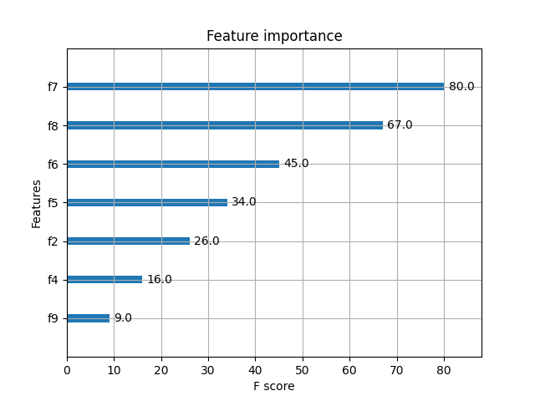
selected_columns = ['CTV Volume (cm³)', ' ave', 'BMI', 'Weight', 'Age', 'Height', '0']
Feature Engineering
8 | train_acc |  | test_acc |  | test_precision |  | test_f1 |  | test_recall | Thresh
n=3 | 87.5 |  | 43.75 |  | 40.00 |  | 47.06 |  | 57.14 | 0.126
n=4 | 89.06 |  | 43.75 |  | 33.33 |  | 30.77 |  | 28.57 | 0.118
n=5 | 92.19 |  | 56.25 |  | 50.00 |  | 53.33 |  | 57.14 | 0.099
n=6 | 98.44 |  | 50.00 |  | 44.44 |  | 50.00 |  | 57.14 | 0.090
n=7 | 96.88 |  | 56.25 |  | 50.00 |  | 58.82 |  | 71.43 | 0.067
n=7
decisionTree | 64.06 |  | 62.50 |  | 66.67 |  | 40.00 |  | 28.57
svc | 64.06 |  | 56.25 |  | 50.00 |  | 46.15 |  | 42.86

（6）
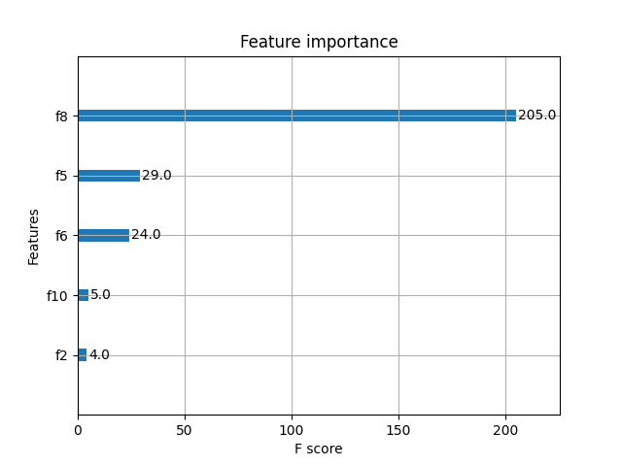
selected_columns = [' ave', 'Weight', 'BMI', '1', 'Age']
Feature Engineering
9 | train_acc |  | test_acc |  | test_precision |  | test_f1 |  | test_recall | Thresh
n=1 | 81.25 |  | 31.25 |  | 30 |  | 35.29 |  | 42.86 | 0.474
n=2 | 76.56 |  | 37.50 |  | 33.33 |  | 37.50 |  | 42.86 | 0.165
n=3 | 71.88 |  | 37.50 |  | 33.33 |  | 37.50 |  | 42.86 | 0.152
n=4 | 71.88 |  | 37.50 |  | 33.33 |  | 37.50 |  | 42.86 | 0.109
n=5 | 71.88 |  | 37.50 |  | 33.33 |  | 37.50 |  | 42.86 | 0.099
n=2
decisionTree | 51.56 |  | 56.25 |  | 50.00 |  | 22.22 |  | 14.29
svc | 51.56 |  | 43.75 |  | 43.75 |  | 60.87 |  | 100.00

（7）
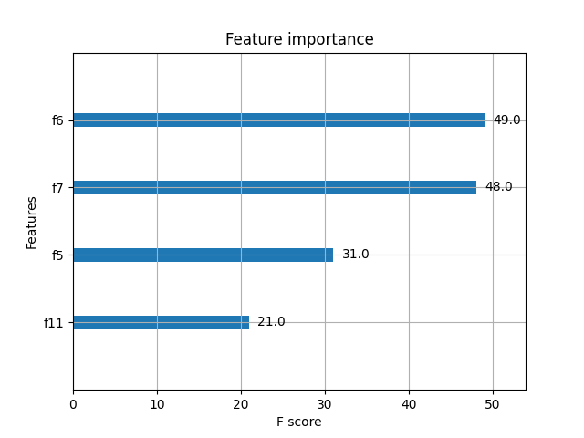
selected_columns = ['BMI', 'CTV Volume (cm³)', 'Weight', '2']
Feature Engineering
10 | train_acc |  | test_acc | test_precision |  | test_f1 |  | test_recall | Thresh
n=1 | 71.88 |  | 56.25 | 63.64 |  | 66.67 |  | 70.00 | 0.306
n=2 | 81.25 |  | 50.00 | 62.50 |  | 55.56 |  | 50.00 | 0.287
n=3 | 75.00 |  | 37.50 | 50.00 |  | 37.50 |  | 30.00 | 0.217
n=4 | 67.19 |  | 43.75 | 54.14 |  | 47.06 |  | 40.00 | 0.191
n=1
decisionTree | 56.25 |  | 37.50 | 0.00 |  | 0.00 |  | 0.00
svc | 56.25 |  | 37.50 | 0.00 |  | 0.00 |  | 0.00

（8）
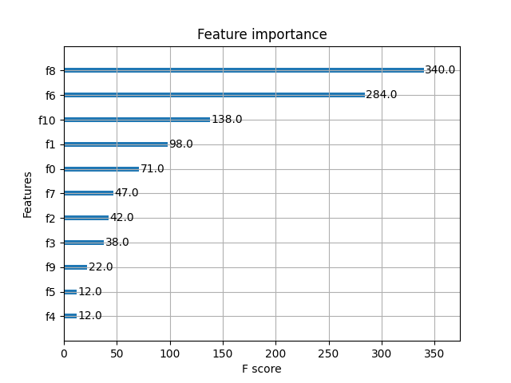
selected_columns = [' ave', 'BMI', '1', 'Treatment Method', 'Membrane Removal Method (1 for removal, 0 for no removal)', 'CTV Volume (cm³)', 'Age', 'Left/Right', '0', 'Weight', 'Height']
Feature Engineering
11 | train_acc |  | test_acc |  | test_precision |  | test_f1 |  | test_recall | Thresh
n=3 | 76.56 |  | 68.75 |  | 50.00 |  | 28.57 |  | 20.00 | 0.139
n=4 | 79.69 |  | 75.00 |  | 66.67 |  | 50.00 |  | 40.00 | 0.095
n=5 | 89.06 |  | 68.75 |  | 50.00 |  | 44.44 |  | 40.00 | 0.077
n=6 | 87.50 |  | 75.00 |  | 66.67 |  | 50.00 |  | 40.00 | 0.072
n=7 | 87.50 |  | 75.00 |  | 66.67 |  | 50.00 |  | 40.00 | 0.063
n=6
decisionTree | 78.13 |  | 68.75 |  | 50.00 |  | 28.57 |  | 20.00
svc | 70.31 |  | 62.50 |  | 40.00 |  | 40.00 |  | 40.00

（9）
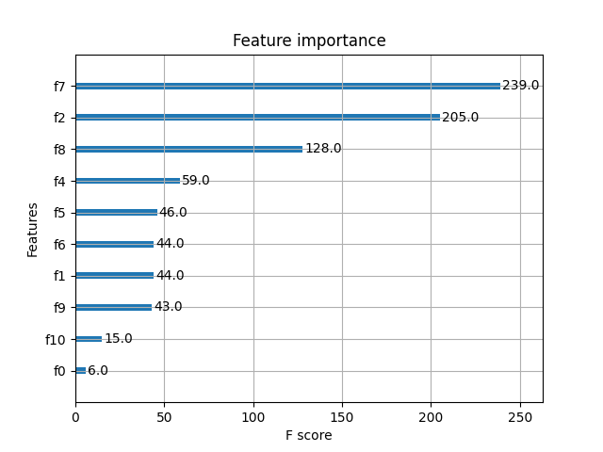
selected_columns = ['CTV Volume (cm³)', 'Age', ' ave', 'Height', 'Weight', 'BMI', 'Treatment Method', '0', '1', 'Membrane Removal Method (1 for removal, 0 for no removal)']
Feature Engineering
12 | train_acc |  | test_acc |  | test_precision |  | test_f1 |  | test_recall | Thresh
n=3 | 75.00 |  | 62.50 |  | 100.00 |  | 50.00 |  | 33.33 | 0.146
n=4 | 78.13 |  | 62.50 |  | 100.00 |  | 50.00 |  | 33.33 | 0.125
n=5 | 68.75 |  | 56.25 |  | 100.00 |  | 36.36 |  | 22.22 | 0.121
n=6 | 68.75 |  | 56.25 |  | 100.00 |  | 36.36 |  | 22.22 | 0.013
n=7 | 82.81 |  | 56.25 |  | 66.67 |  | 53.33 |  | 44.44 | 0.096
n=8 | 82.81 |  | 56.25 |  | 66.67 |  | 53.33 |  | 44.44 | 0.041
n=4
decisionTree | 68.75 |  | 56.25 |  | 66.67 |  | 53.33 |  | 44.44
svc | 71.88 |  | 68.75 |  | 100.00 |  | 61.54 |  | 44.44

（10）
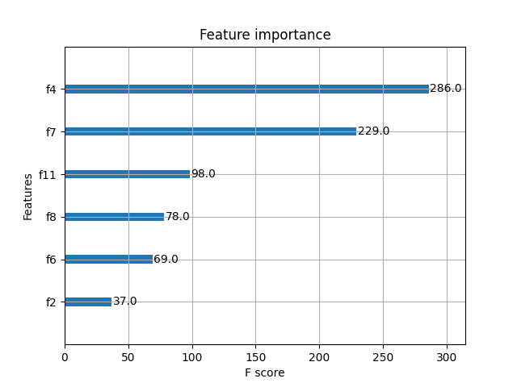
selected_columns = ['Height', 'CTV Volume (cm³)', '2', ' ave', 'BMI', 'Age']
Feature Engineering
13 | train_acc |  | test_acc |  | test_precision |  | test_f1 |  | test_recall | Thresh
n=1 | 76.56 |  | 68.75 |  | 63.64 |  | 73.68 |  | 87.50 | 0.473
n=2 | 79.69 |  | 62.50 |  | 58.33 |  | 70.00 |  | 87.50 | 0.389
n=3 | 78.13 |  | 50.00 |  | 50.00 |  | 60.00 |  | 75.00 | 0.056
n=4 | 100.00 |  | 62.50 |  | 60.00 |  | 66.67 |  | 75.00 | 0.044
n=5 | 98.44 |  | 62.50 |  | 60.00 |  | 66.67 |  | 75.00 | 0.023
n=6 | 81.25 |  | 68.75 |  | 71.43 |  | 66.67 |  | 62.50 | 0.016
n=6
decisionTree | 70.31 |  | 56.25 |  | 60.00 |  | 46.15 |  | 37.50
svc | 73.44 |  | 62.50 |  | 66.67 |  | 57.14 |  | 50.00

（11）
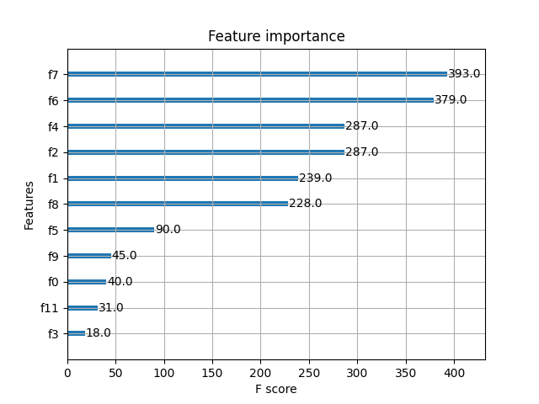
selected_columns = ['CTV Volume (cm³)', 'BMI', 'Height', 'Age', 'Treatment Method', ' ave', 'Weight', '0', 'Membrane Removal Method (1 for removal, 0 for no removal)', '2', 'Left/Right']
Feature Engineering
14 | train_acc |  | test_acc |  | test_precision |  | test_f1 |  | test_recall | Thresh
n=1 | 73.44 |  | 43.75 |  | 37.50 |  | 40.00 |  | 42.86 | 0.218
n=2 | 85.94 |  | 43.75 |  | 37.50 |  | 40.00 |  | 42.86 | 0.176
n=3 | 100.00 |  | 56.25 |  | 50.00 |  | 58.82 |  | 71.43 | 0.102
n=4 | 78.13 |  | 43.75 |  | 37.50 |  | 40.00 |  | 42.86 | 0.100
n=5 | 82.81 |  | 37.50 |  | 38.46 |  | 50.00 |  | 71.43 | 0.08
n=6 | 82.81 |  | 37.50 |  | 38.46 |  | 50.00 |  | 71.43 | 0.079
n=7 | 100.00 |  | 50.00 |  | 45.45 |  | 55.56 |  | 71.43 | 0.075
n=8 | 100.00 |  | 43.75 |  | 40.00 |  | 47.06 |  | 57.14 | 0.070
n=9 | 98.44 |  | 43.75 |  | 40.00 |  | 47.06 |  | 57.14 | 0.057
n=3
decisionTree | 62.50 |  | 43.75 |  | 25.00 |  | 18.18 |  | 14.29
svc | 71.88 |  | 43.75 |  | 40.00 |  | 47.06 |  | 57.14

（12）
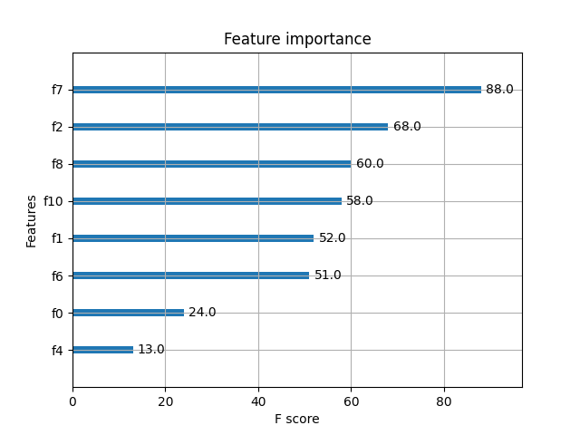
selected_columns = ['CTV Volume (cm³)', 'Age', ' ave', '1', 'Treatment Method', 'BMI', 'Membrane Removal Method (1 for removal, 0 for no removal)', 'Height']
Feature Engineering
15 | train_acc |  | test_acc |  | test_precision |  | test_f1 |  | test_recall | Thresh
n=1 | 73.44 |  | 50.00 |  | 50.00 |  | 55.56 |  | 62.50 | 0.237
n=2 | 73.44 |  | 56.25 |  | 55.56 |  | 58.82 |  | 62.50 | 0.219
n=3 | 81.25 |  | 56.25 |  | 55.56 |  | 58.82 |  | 62.50 | 0.166
n=4 | 84.38 |  | 68.75 |  | 66.67 |  | 70.59 |  | 75.00 | 0.110
n=5 | 75.00 |  | 50.00 |  | 50.00 |  | 66.67 |  | 100.00 | 0.099
n=6 | 89.06 |  | 56.25 |  | 53.85 |  | 66.67 |  | 87.50 | 0.092
n=7 | 87.50 |  | 50.00 |  | 50.00 |  | 63.64 |  | 87.50 | 0.047
n=8 | 84.38 |  | 56.25 |  | 53.33 |  | 69.57 |  | 100.00 | 0.029
n=4
decisionTree | 67.19 |  | 68.75 |  | 80.00 |  | 61.54 |  | 50.00
svc | 67.19 |  | 68.75 |  | 80.00 |  | 61.54 |  | 50.00

