Supplementary data

Discovery of Potential Novel Stenotrophomonas Species Based on Whole-Genome Phylogeny and Comparative Genomics

Table S1. Genomic features of ten putative novel Stenotrophomonas species
Isolate code | No of Contigs  (≥ 200 bp) | Largest contigs | Total length | N50 | L50 | GC(%) | No of CDS | No of gene
PSU-St7 | 43 | 764333 | 4825965 | 438616 | 5 | 66.18 | 4493 | 4493
PSU-St10 | 15 | 3451753 | 4357180 | 3451753 | 1 | 66.62 | 4475 | 4475
PSU-St15 | 14 | 3290482 | 4484310 | 3290482 | 1 | 66.52 | 4158 | 4158
PSU-St19 | 28 | 613718 | 4584980 | 365739 | 5 | 66.44 | 4178 | 4178
PSU-St22 | 54 | 731392 | 5021672 | 261484 | 7 | 66.02 | 4750 | 4750
PSU-St83 | 20 | 1055045 | 4110911 | 707856 | 3 | 66.84 | 3707 | 3707
PSU_St99 | 34 | 897578 | 4624572 | 474764 | 4 | 66.47 | 4238 | 4238
PSU_St103 | 58 | 539539 | 4731594 | 264952 | 7 | 66.13 | 4443 | 4443
PSU_St142 | 46 | 825518 | 4972963 | 368399 | 5 | 66.05 | 4679 | 4679
PSU_St154 | 42 | 928099 | 5050955 | 462045 | 4 | 66.09 | 4720 | 4720

Table S2. Degree of biofilm production of potential novel Stenotrophomonas strains
Isolate code | Mean OD | Biofilm level
PSU-St7 | 0.2944 | Strong
PSU-St10 | 0.1718 | Moderate
PSU-St15 | 0.2671 | Strong
PSU-St19 | 0.2552 | Strong
PSU-St22 | 0.5679 | Strong
PSU-St83 | 0.1637 | Moderate
PSU-St99 | 0.2238 | Moderate
PSU-St103 | 0.2058 | Moderate
PSU-St142 | 0.3274 | Strong
PSU-St154 | 0.2913 | Strong
(OD_{c} (Mean+3SD): 0.059, 2*OD_{c} :0.118, 4* OD_{c} : 0.236)

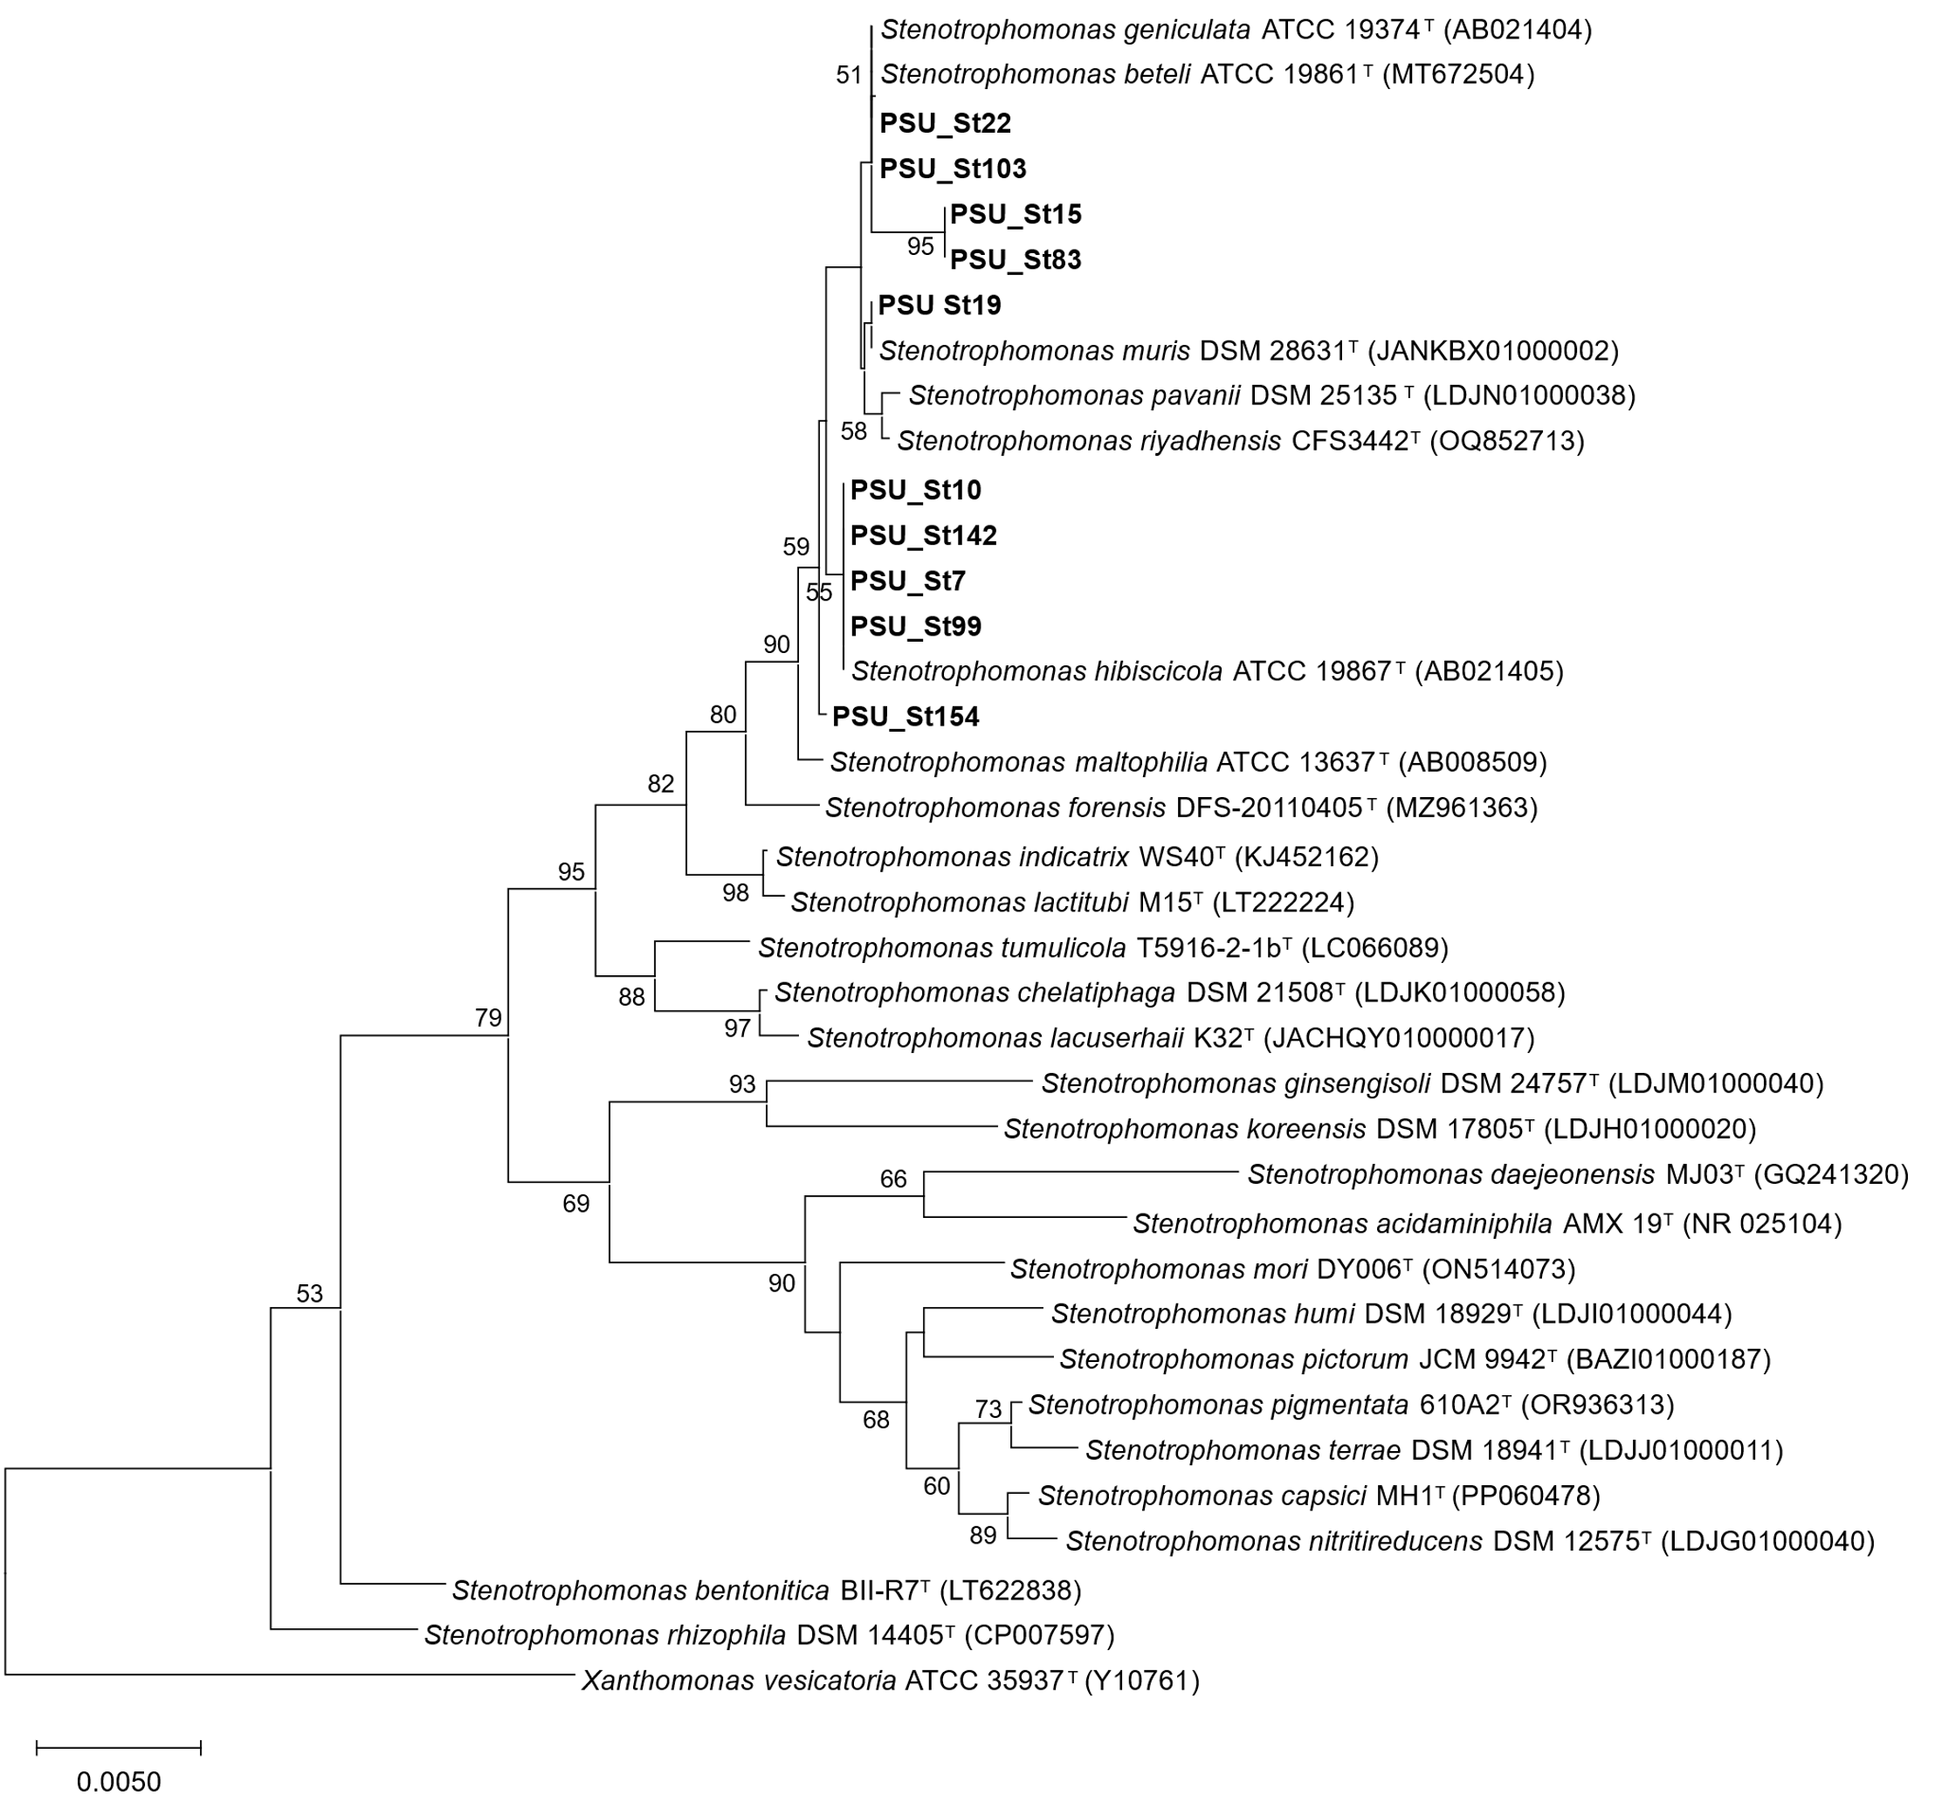
Figure S1 Neighbour-joining tree based on 16S rRNA gene sequences showing the relationship between PSU strains and closely related Stenotrophomonas. All positions containing gaps and missing data were eliminated. There were a total of 1334 positions in the final dataset. Bootstrap values (>50 %) based on 1000 replicates are shown at branch nodes. Xanthomonas vesicatoria ATCC 35937^{T} was used as the outgroup. Bar, 0.005 nucleotide substitution rate (Knuc) units.

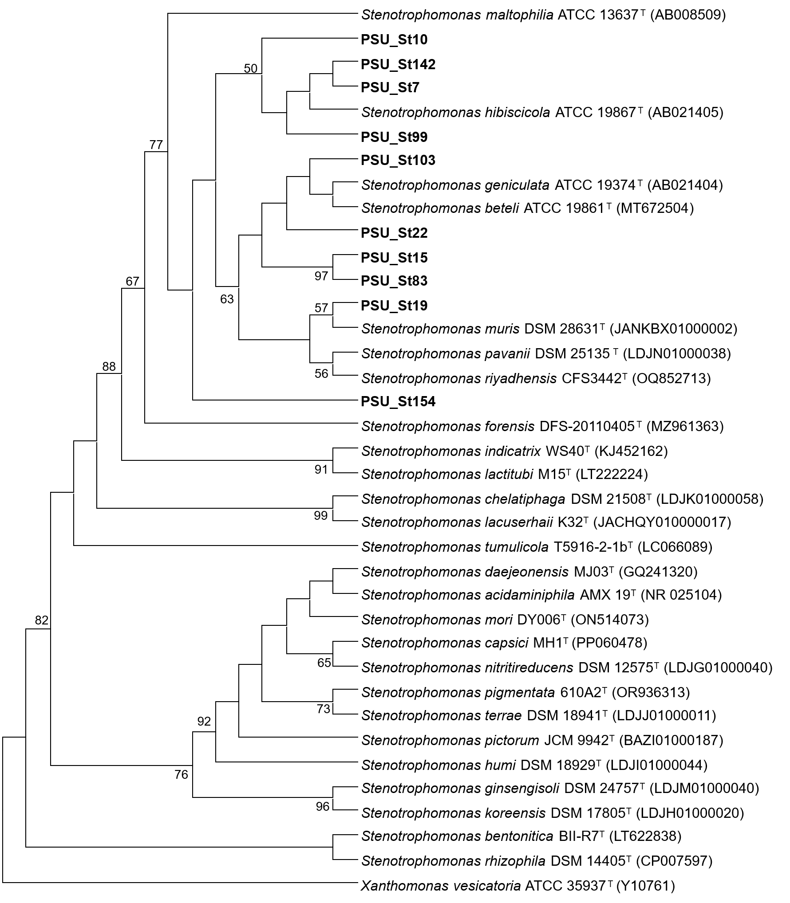
Figure S2 Maximum-parsimony phylogenetic tree based on 16S rRNA gene sequences showing the relationship between PSU strains and closely related Stenotrophomonas species. All positions containing gaps and missing data were eliminated. There were a total of 1334 positions in the final dataset. Xanthomonas vesicatoria ATCC 35937^{T} was used as an outgroup. Bootstrap values >50 % (based on 1000 replications) are shown at branch points.

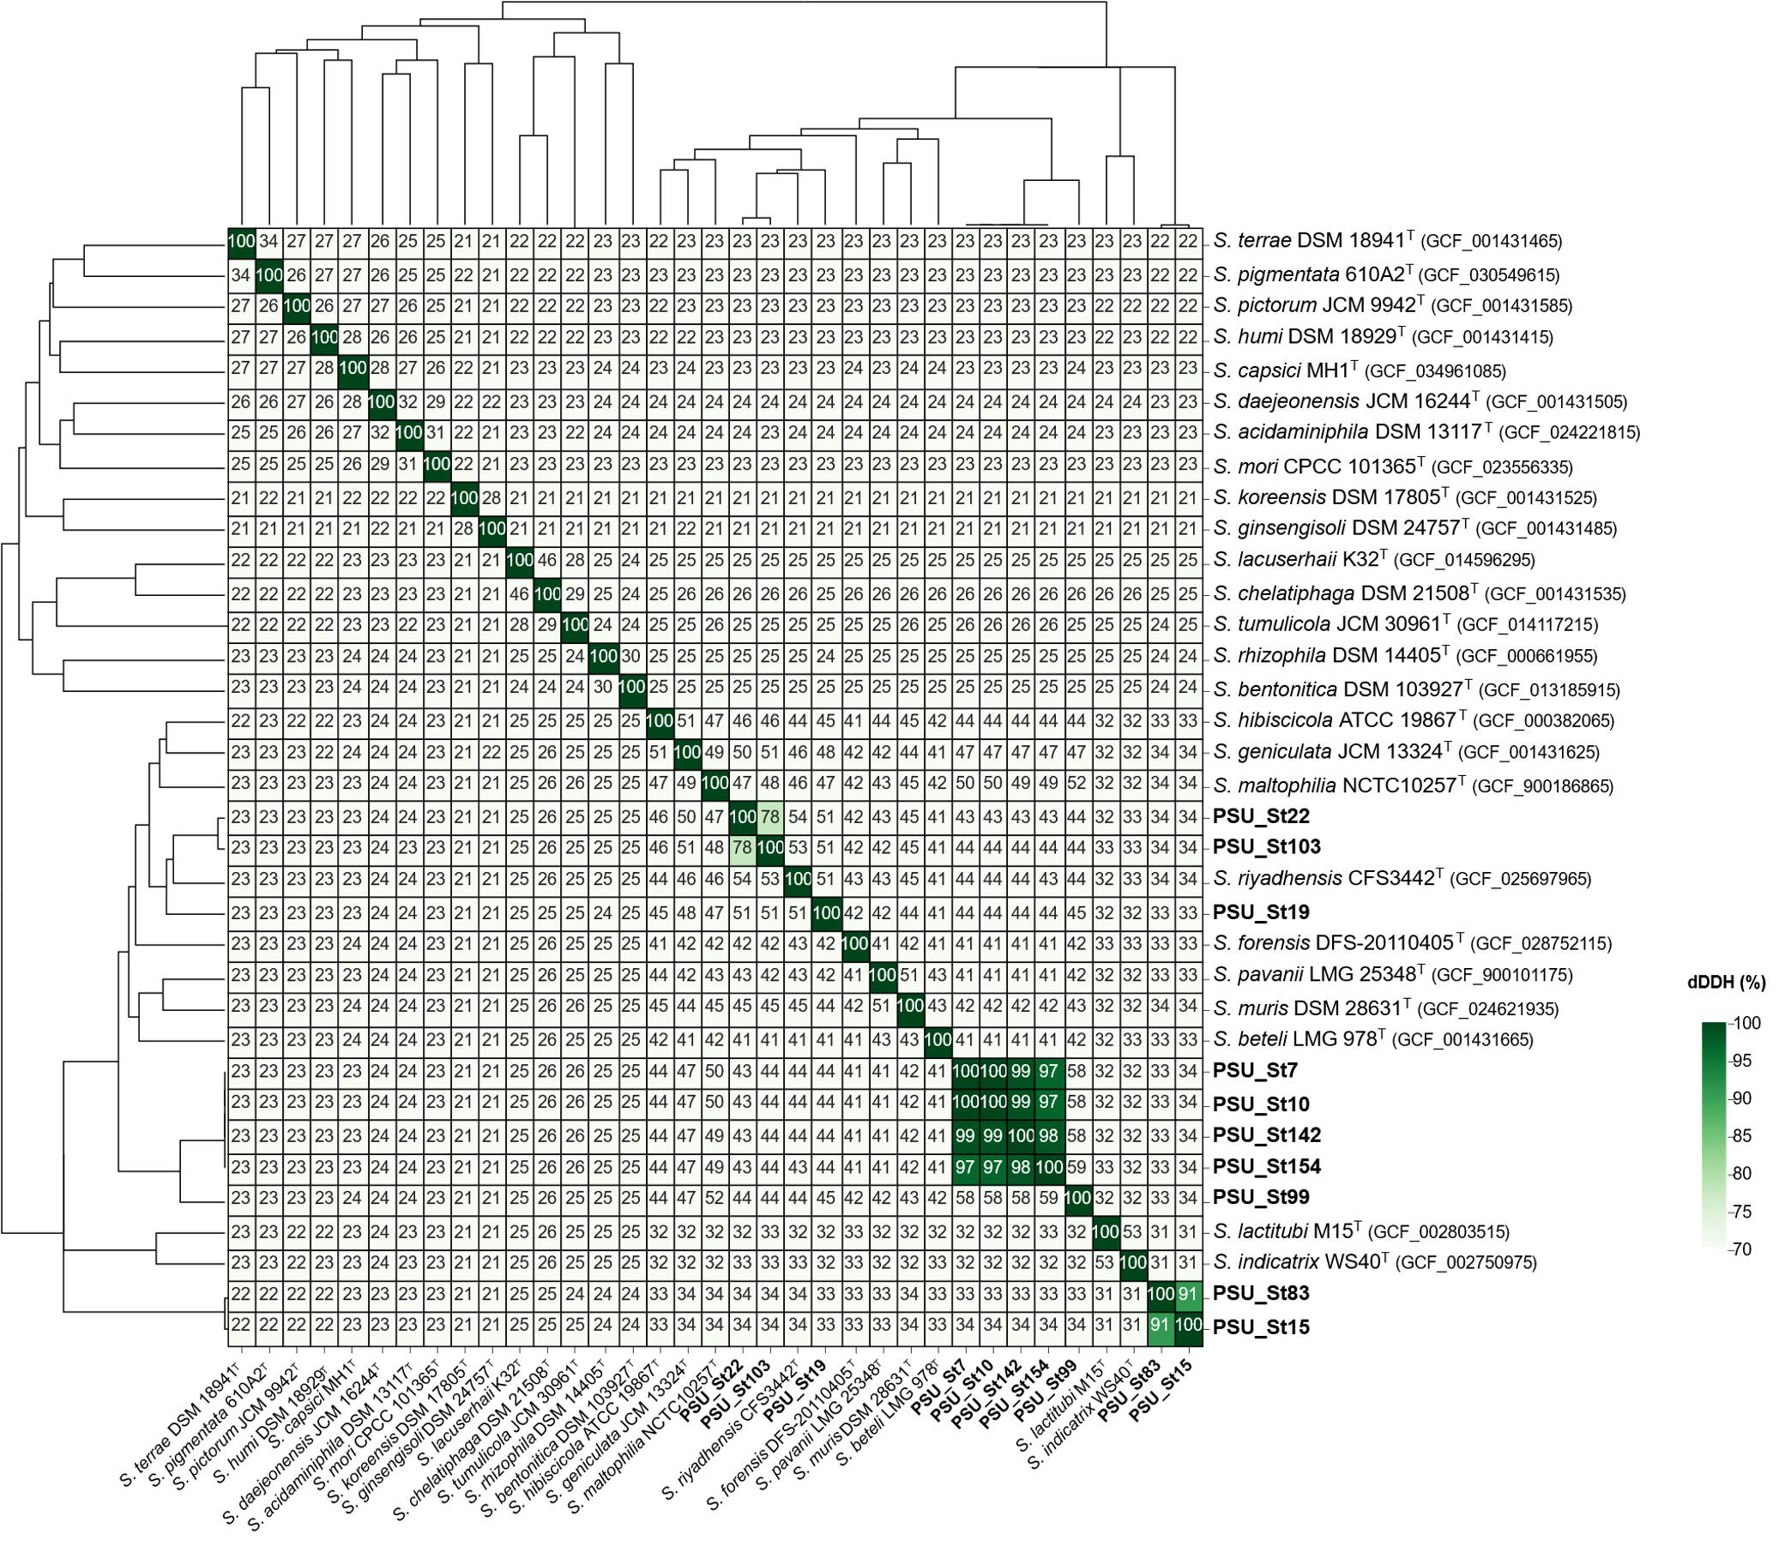
Figure S3 Digital DNA-DNA hybridization (dDDH) pairwise comparison heatmap.

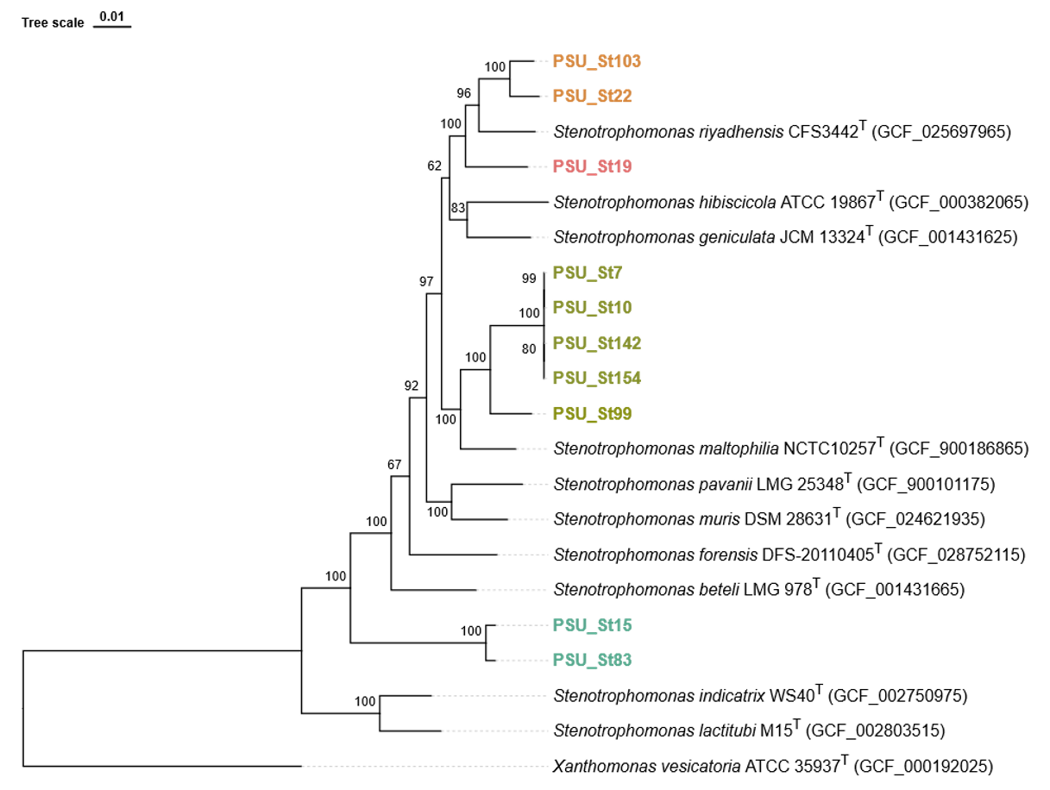
Figure S4 Phylogenetic analysis between PSU strains and closely related Stenotrophomonas species. The phylogenetic tree was constructed using multi-locus sequence alignment generated based on 100 housekeeping genes using autoMLST. The Bootstrap values above 70 were indicated above the branch points. The scale bar corresponded to 1% genetic variation for the length of the scale.

Figure S5 COG distribution of genes classified by BPGA between PSU strains and closely related Stenotrophomonas species.

