Supplementary
Supplementary Figures
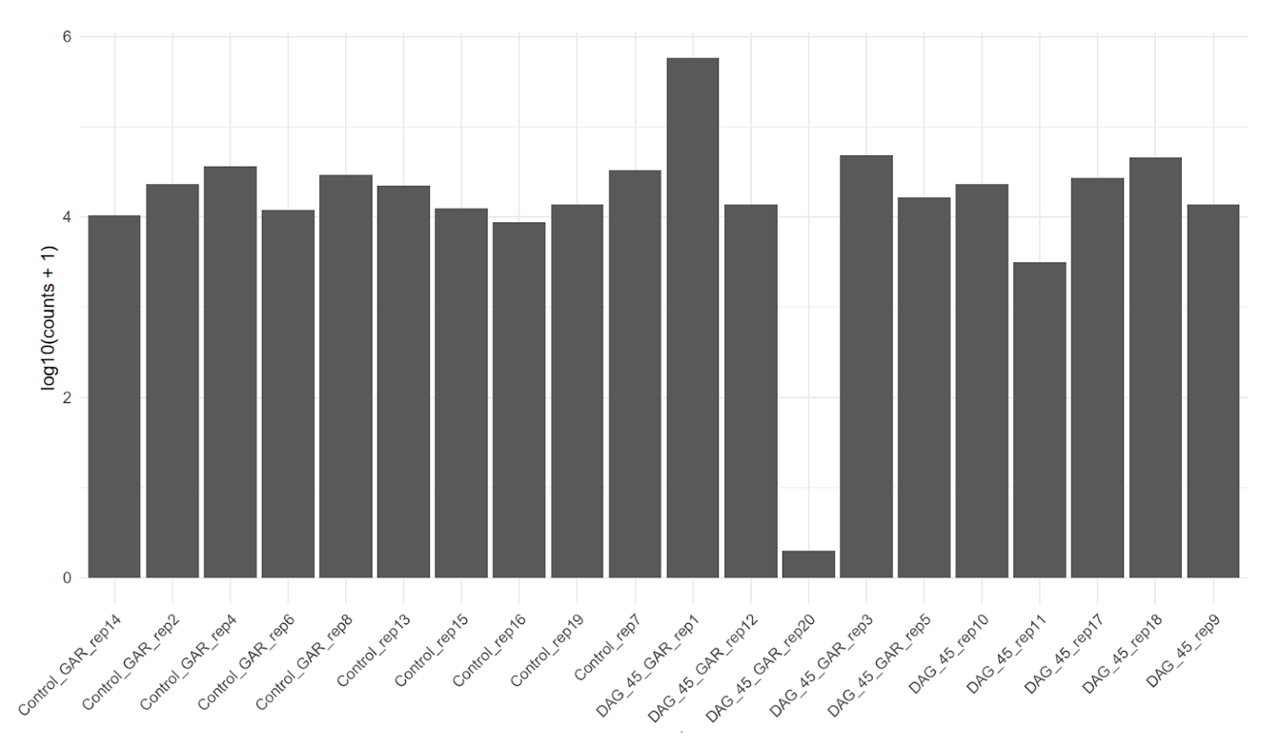
Supplementary Fig. 1. Reads obtained in each sample. An average of ~10,000 fragments were observed. Data are shown on a log10 (counts + 1) scale.

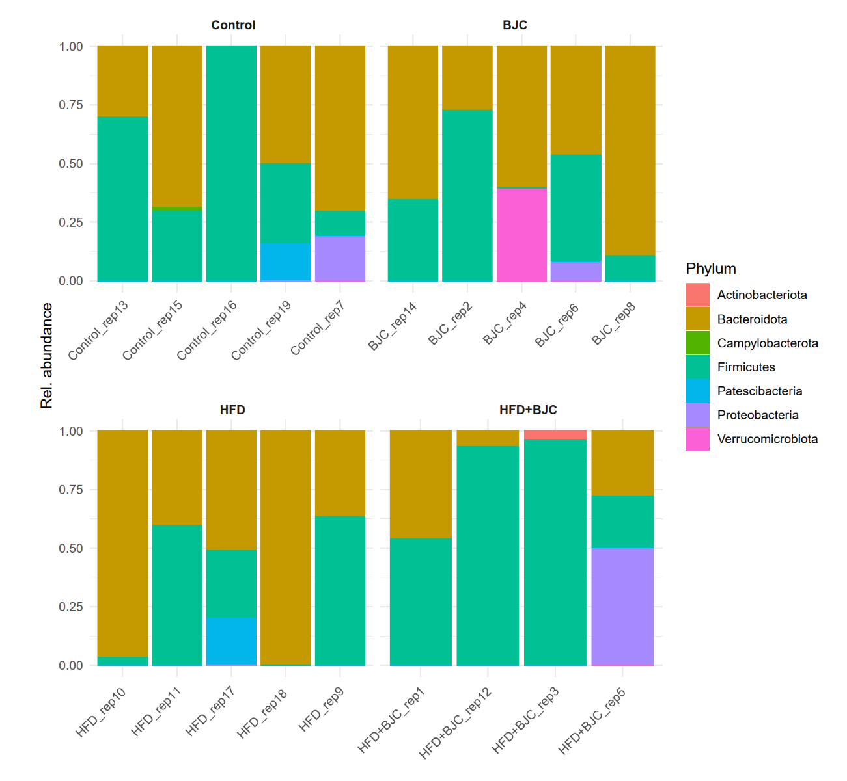
Supplementary Fig. 2. Phylum relative abundance. In each replicate and experimental group.

Supplementary Fig. 3. Network of association between taxa and pathways in HFD administered with BJC treatment group compared with the control and the AIN-93 diet plus BJC treatment groups. all the experimental groups. (a) control and HFD + BJC comparison. (b) Comparison of BJC and HFD + BJC. Relevant genera and pathway nodes are highlighted in color, HFD + BJC in red, and other experimental groups in blue. The red and blue edges indicate positive and negative correlations, respectively. Yellow circles indicate genera, and green squares indicate KEGG pathways. Control, AIN-93 diet. BJC, AIN-93 diet plus BJC treatment group. HFD-BJC, high-fat diet with berry cactus treatment.

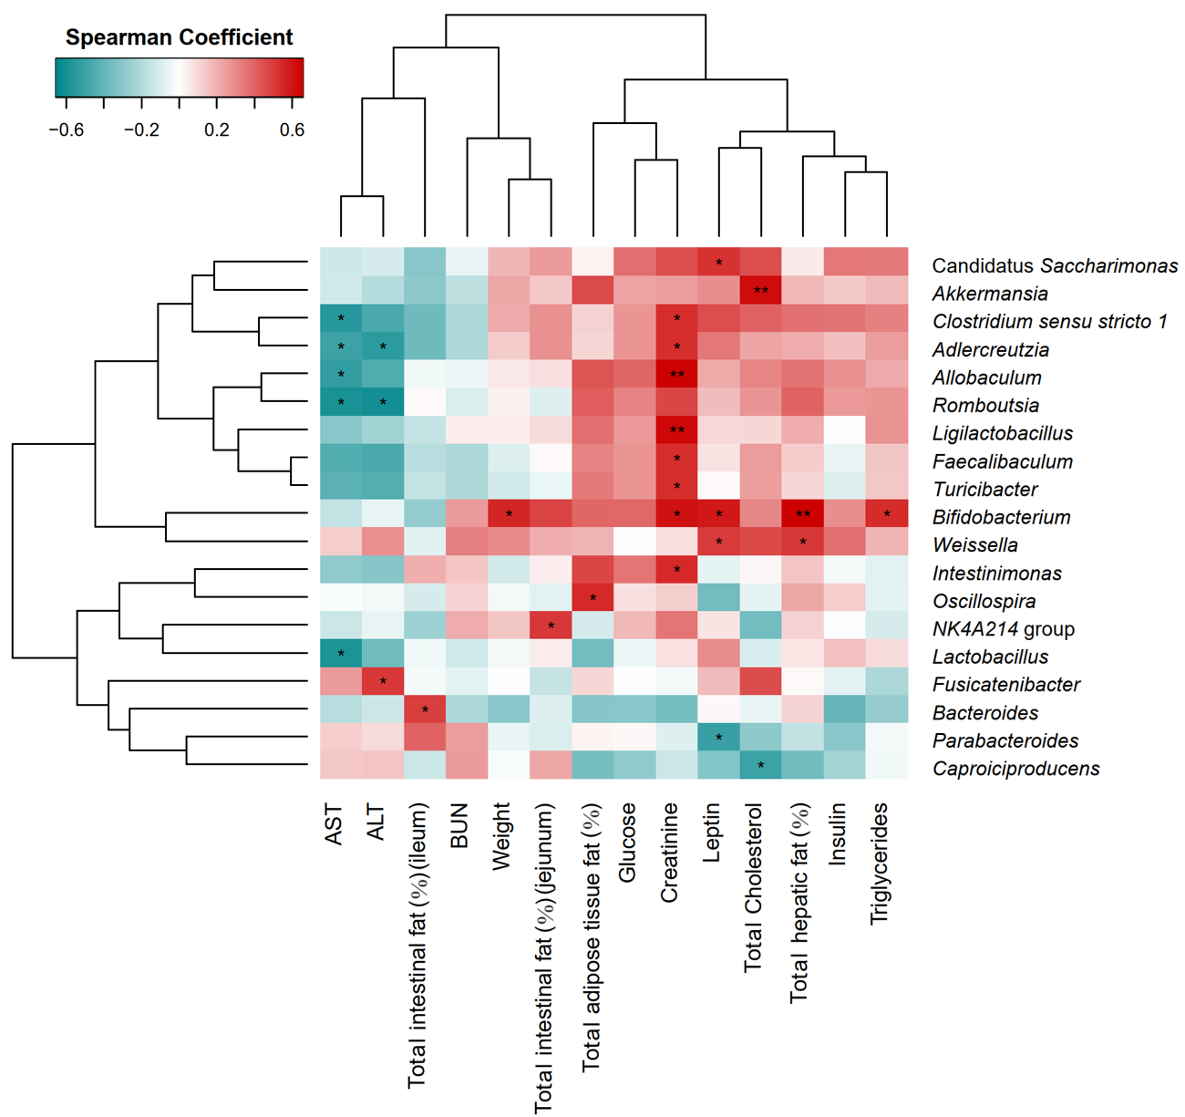
Supplementary Fig. 4. Significant correlations between genus abundance and biochemical parameters were observed. The Spearman correlation coefficient is shown in red for positive correlation and blue for negative association. (*) p-value <0.05; (**) p-value < 0.01, (***) p-value < 0.001.

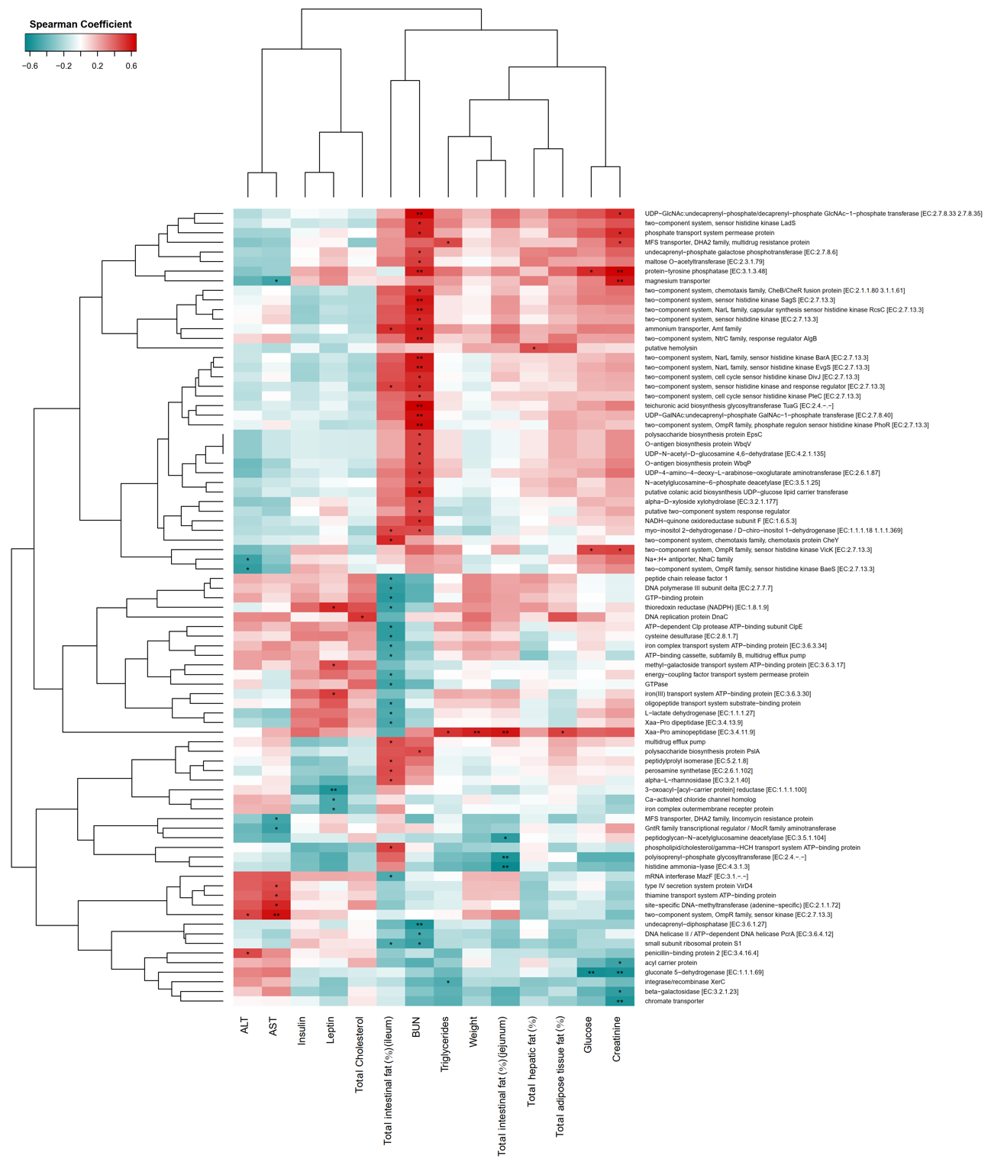
Supplementary Fig. 5. Significant correlations between enriched functions and clinical parameters The Spearman correlation coefficient is shown in red for positive correlation and blue for negative association. (*) p-value <0.05; (**) p-value < 0.01, (***) p-value < 0.001.

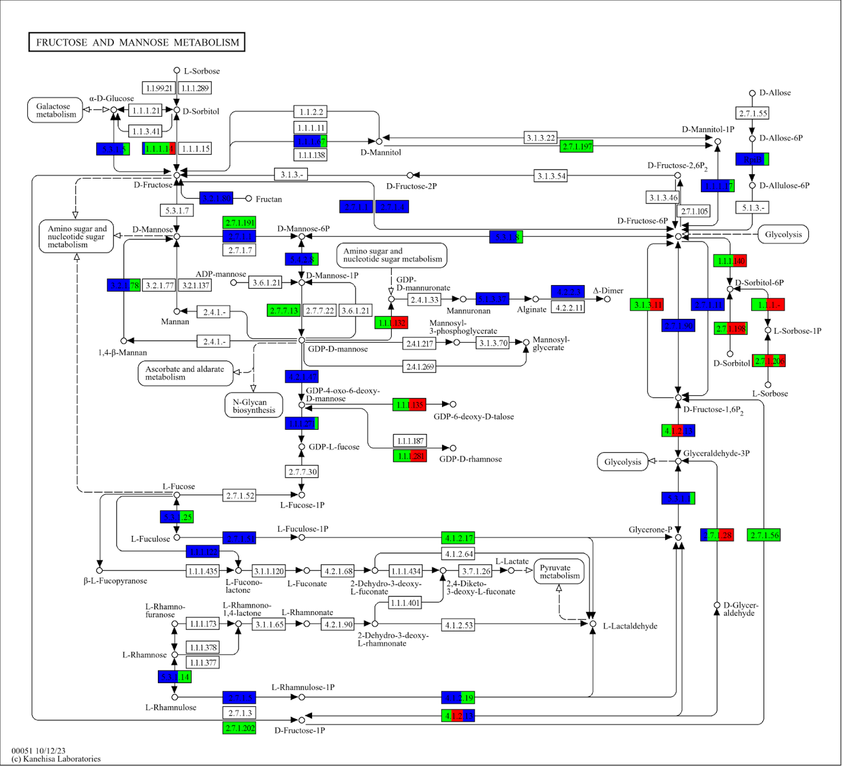
Supplementary Fig. 6. Fructose and mannose metabolism in the KEGG pathway The color of the boxes represents the presence of the gene in a group of genera. Blue represents group 1 Parabacteroides and Bacteroides. Green, group 2, Akkermansia, Candidatus saccharimonas, Adlercreutzia, and Clostridium sensu stricto. Red, group 3, Allobaculum, Clostridium sensu stricto 1, Adlercreutzia, Faecalibacterium, Intestinimonas, Ligilactobacillus, and Turicibacter.

Supplementary Table 1. (a) Proximate BJC composition used in the feeding trial. (b) Experimental diet formulation.
a. Proximate BCJ composition (g/100g)
Carbohydrates | 23.33 ± 0.02
Protein | 1.24 ± .005
Fat | 0.13 ± 0.00
Ash | 1.12 ± 0.01
Fiber | 2.05 ± 0.01
Moisture | 74.19 ± 0.04
Kj | 99.41 ± 0.11

^{b} Protein, fat, ash, fiber, and moisture content were gravimetrically evaluated, and the difference in proximal analysis determined total carbohydrates. All samples were analyzed in duplicate in independent experiments and expressed as a g/100g, BJC, grams (g), kilojoule (Kj).
b. Ingredient (g/100g diet) | Control  (AIN-93) | HFD  (45 %)
Cornstarch | 33.00 | 0
Casein (85 % protein) | 19.87 | 24.15
Maltodextrin 10 | 22.20 | 30.00
Sucrose | 10.00 | 10.00
Soybean oil | 5.16 | 5.70
Lard | 0 | 17.70
Fiber (Cellulose) | 2.84 | 1.72
Mineral mix | 4.70 | 5.70
Vitamin mix | 1.90 | 2.90
L-Cystine | 0.14 | 0.18
Choline bitartrate  (41.1% choline) | 0.19 | 0.23
Tert-butylhydroquinone (TBHQ) | 0.0014 | 0.0014
Energy (Kj/g) | 16.2 | 19.9

^{c} AIN-93, diet control, high-fat diet (HFD), and BJC Vitamin mix (g/Kg diet): nicotinic acid, 3.00; d-calcium pantothenate, 1.60; pyridoxine HCl, 0.70; thiamine HCl, 0.60; riboflavin, 0.60; folic acid, 0.20; d-biotin, 0.02; vitamin B12 (0.1% triturated in mannitol), 2.50; α-tocopherol powder (250 U/gm), 30.00; vitamin A palmitate (250,000 U/gm), 1.60; vitamin D3 (400,000 U/gm), 0.25; phylloquinone, 0.075; powdered sucrose, 959.6. Mineral mix (g/Kg diet): Calcium carbonate, 35.7%; monopotassium phosphate, 19.6%; potassium citrate monohydrate, 7.078%; sodium chloride, 7.4%; potassium sulfate, 4.66%; magnesium oxide, 2.4%; ferric citrate, 0.606%; zinc carbonate, 0.165%; manganese carbonate, 0.063%; copper carbonate, 0.03%; potassium iodate, 0.001%; sodium selenate anhydrous, 0.00103%; ammonium molybdate•4H₂O, 0.000795%; sodium metasilicate•9H₂O, 0.145%; chromium potassium sulfate•12H₂O, 0.0275%; lithium chloride, 0.00174%; boric acid, 0.008145%; sodium fluoride, 0.00635%; nickel carbonate, 0.00318%; ammonium vanadate, 0.00066%; powdered sugar, 22.1%.

Supplementary Table 2. Alpha diversity values of all groups and samples.
Group | Sample | Observed | Chao1 | Shannon | Simpson
Control | Control_rep13 | 164.00 | 170.88 | 4.28 | 0.98
Control | Control_rep15 | 135.00 | 151.67 | 3.83 | 0.97
Control | Control_rep16 | 109.00 | 128.00 | 3.50 | 0.96
Control | Control_rep19 | 160.00 | 172.00 | 4.25 | 0.98
Control | Control_rep7 | 234.00 | 251.08 | 4.38 | 0.98
BJC | BJC_rep14 | 116.00 | 131.55 | 3.63 | 0.96
BJC | BJC_rep2 | 235.00 | 256.00 | 4.53 | 0.99
BJC | BJC_rep4 | 236.00 | 237.50 | 4.93 | 0.99
BJC | BJC_rep6 | 146.00 | 164.06 | 3.79 | 0.97
BJC | BJC_rep8 | 170.00 | 201.00 | 4.10 | 0.98
HFD | HFD_rep10 | 161.00 | 165.23 | 4.13 | 0.98
HFD | HFD_rep11 | 80.00 | 82.77 | 3.30 | 0.94
HFD | HFD_rep17 | 250.00 | 272.94 | 4.51 | 0.98
HFD | HFD_rep18 | 285.00 | 333.24 | 4.64 | 0.99
HFD | HFD_rep9 | 217.09 | 4.17 | 0.98 | 0.98
HFD  +BJC | HFD+BJC_rep1 | 1473.00 | 1473.36 | 6.46 | 1.00
HFD  +BJC | HFD+BJC_rep12 | 172.00 | 197.00 | 4.35 | 0.98
HFD  +BJC | HFD+BJC_rep3 | 167.00 | 167.00 | 4.72 | 0.99
HFD  +BJC | HFD+BJC_rep5 | 177.00 | 182.00 | 3.88 | 0.97

^{d} The observed Chao1, Shannon, and Simpson alpha diversity are presented. The control group was fed an AIN 93 diet. The berry cactus juice concentrated (BJC) group was administered 200 mg/kg of BJC and fed the AIN 93 diet. The HFD group was fed 45% lipids. The HFD + BJC group was fed 45% HFD and BJC.

Supplementary Table 3. Biochemical parameters, genus abundance, pathways, and function data
This table is provided in the supplementary CSV file.

Supplementary Table 4. Spearman’s correlation coefficients and p-values of biochemical parameters with genera abundances, pathways, and functions.
Table 4 is provided in the supplementary CSV file.

