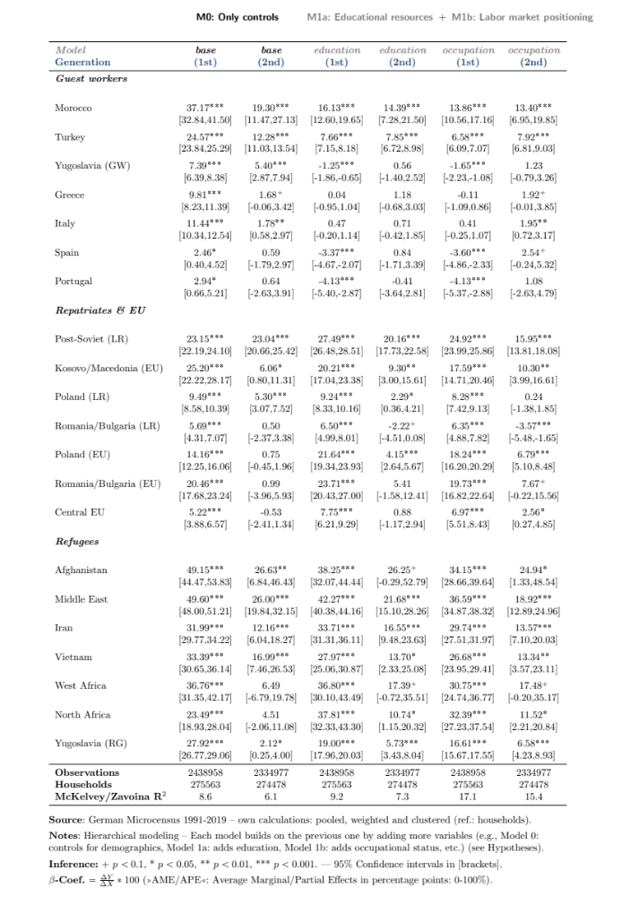
Table 1: Poverty gaps (in %) explained by »Educational resources and labor market positioning«. Population: Prime-age individuals (25-54 years) living in private households (Table 1–4).
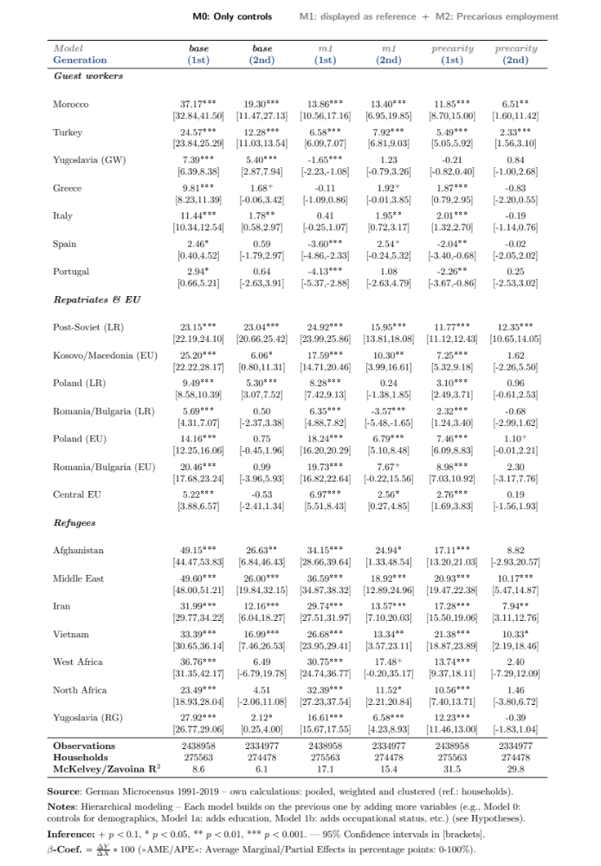
Table 2: Poverty gaps (in %) explained by »Precarious employment«.
Table 3: Poverty gaps (in %) explained by »Household resources and needs«.
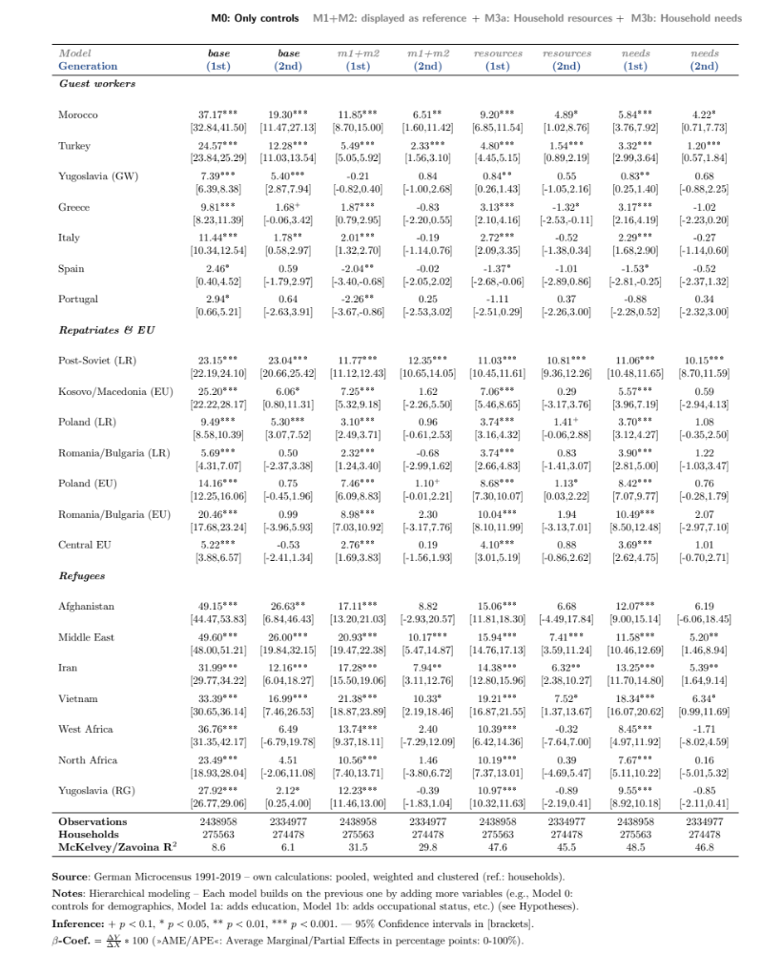
Table 4: Poverty gaps (in %) explained by »Legal arrangements«.
