Modulating Coordinate Site Occupancy in High-entropy Spinel Electrocatalysts

Jihyun Baek^{1,†}, Yuzhe Li^{2,†}, Kiran Srinivasan Hamkins^{1,5†}, Angel T. Garcia-Esparza³, Cheng-Tai Kuo³, Jun-Sik Lee³, Adam Wallace Potter¹, Sungsoon Kim¹, Yifan Wang^{1,2}, Tianying Liu⁴, Honghe Ding⁴, Jialu Li⁴, Zengqing Zhuo⁴, Jinghua Guo^{4,*}, Michal Bajdich^{5,*}, and Xiaolin Zheng^{1,6,*}

¹Department of Mechanical Engineering, Stanford University, Stanford, CA, USA
²Department of Materials Science and Engineering, Stanford University, Stanford, CA, USA
³Stanford Synchrotron Radiation Lightsource, SLAC National Accelerator Laboratory, Menlo Park, CA, USA
⁴Advanced Light Source, Lawrence Berkeley National Laboratory, Berkeley, CA, USA
⁵SUNCAT Center for Interface Science and Catalysis, SLAC National Accelerator Laboratory, Menlo Park, CA, USA
⁶Department of Energy Science & Engineering, Stanford University, Stanford, CA, USA

†These authors contributed equally to this work.

Corresponding authors
Jinghua Guo jguo@lbl.gov
Michal Bajdich bajdich@slac.stanford.edu
Xiaolin Zheng xlzheng@stanford.edu

Supplementary Note 1. hXAS analysis for electronic state and coordination environment of Co and Fe.
Upon elemental substitution, all five constituent cations exhibit a discernible positive shift in their X-ray absorption near-edge structure (XANES) edge energies, reflecting an overall increase in their effective oxidation states. This observation is consistent with charge compensation mechanisms in HEOs, where the introduction of aliovalent species, such as Zn²⁺, necessitates oxidation of neighboring transition metals to maintain electroneutrality. Notably, Zn-HESO demonstrates the most significant edge shifts for both cobalt and iron, indicating that these two elements are particularly sensitive to the chemical environment perturbations induced by Zn incorporation. This suggests a preferential oxidation of Co and Fe cations, potentially due to their higher redox flexibility compared to other constituent metals. In parallel, the pre-edge peak intensity, associated with 1s → 3d electronic transitions, exhibits a marked decrease following Zn substitution. Since pre-edge features are sensitive to both oxidation state and local coordination symmetry, the observed suppression points toward a transition from lower symmetry environments to higher symmetry configurations, most plausibly reflecting the stabilization of Co³⁺ and Fe³⁺ in centrosymmetric O_{h} sites. This assignment is supported by ligand field considerations, where octahedral coordination reduces p-d orbital mixing, thereby diminishing the pre-edge intensity.
To quantitatively elucidate changes in the local coordination environment, extended X-ray absorption fine structure (EXAFS) analysis was performed. Reference compounds—CoCr₂O₄ and CoFe₂O₄ for Co, and NiFe₂O₄ for Fe—were employed to calibrate the amplitude reduction factor (S_{o}²), ensuring accurate fitting of experimental data. These S_{o}² values, once determined, were held constant across fitting procedures to reliably extract first-shell coordination numbers. (Supplementary Figs. 14–15) The Fourier-transformed EXAFS spectra reveal that the first major peak corresponds to metal–oxygen (M–O) scattering paths, reflecting the immediate oxygen coordination shell around metal cations. Given the inherent mixed occupancy of tetrahedral (CN = 4) and octahedral (CN = 6) sites in the spinel lattice, the average metal–oxygen coordination number is expected to fall between these two canonical values. Post Zn-substitution, the Co–O coordination number increases from 4.1 to 4.8, while Fe–O increases from 5.5 to 5.8. These subtle yet significant increments suggest a redistribution of Co and Fe species from tetrahedral to octahedral sites, aligning with the pre-edge analysis indicating enhanced local symmetry. Collectively, the XANES edge shifts, pre-edge suppression, and EXAFS coordination analysis converge to a consistent interpretation: Zn substitution in HESO preferentially oxidizes Co and Fe cations while simultaneously promoting their stabilization in octahedral coordination environments.

Supplementary Note 2. sXAS analysis for Mn, Ni, Cr L-edge, and O K-edge and sXAS analysis for different elements depending on different Zn concentrations
To elucidate the role of manganese in M-HESOs, Mn L-edge XAS and XMCD measurements were performed (Supplementary Fig. 18). The spectral profiles across the series consistently exhibit features characteristic of a mixed-valent state, with contributions from Mn²⁺, Mn³⁺, and Mn⁴⁺ species. The energy positions and overall line shapes align well with established references, confirming the coexistence of Mn in both O_{h} and T_{d} coordination environments. Quantitative deconvolution by linear fitting of the site occupancies reveals that the relative ratios of Mn²⁺ in T_{d} sites, and Mn³⁺ and Mn⁴⁺ in O_{h} sites, remain largely invariant across different compositions. This indicates that, in contrast to the more responsive Co and Fe cations, the local electronic and coordination environment of Mn is relatively insensitive to entropy-driven compositional variations within this system. Further insights were obtained from Ni and Cr L-edge XAS and XMCD analyses (Supplementary Fig. 19). Unlike the mixed-valence behavior observed for Co, Fe, and Mn, both Cr and Ni display sharp and well-defined spectral features that are consistent across all M-HESO samples. The absence of edge shifts or significant changes in spectral intensity indicates that Cr and Ni are stabilized in single oxidation states, specifically Cr³⁺ and Ni²⁺, residing predominantly in octahedral sites. These observations suggest a robust chemical environment for Cr and Ni, largely unaffected by the introduction of other cations. To evaluate the incorporation and oxidation states of dopant elements, XAS measurements of Zn, Ga, Al, and Mg L-edges were conducted (Supplementary Fig. 20). The absorption spectra of these dopants in M-HESOs closely match those of corresponding spinel oxide references, confirming their expected oxidation states: Zn²⁺, Ga³⁺, Al³⁺, and Mg²⁺.

Supplementary Note 3. Depth-Resolved sXAS with Zn Substitution concentration
To gain a more comprehensive understanding of how Zn substitution perturbs the local electronic environment, a systematic series of XAS L-edge measurements was performed across samples with 0, 10, 20, and 40 atomic percent Zn (Supplementary Fig. 21). Measurements were conducted in both total electron yield (TEY) mode, which probes surface-near regions (~5–10 nm), and total fluorescence yield (TFY) mode, which provides bulk-sensitive information (~100 nm). This dual-mode approach enables depth-resolved analysis of coordination geometry and electronic structure. For Cr and Ni, the XAS line shapes and edge positions remain essentially unchanged across the Zn substitution series in both TEY and TFY modes, reaffirming their inert electronic behavior in response to compositional tuning. In stark contrast, Co and Fe L-edge spectra exhibit progressive broadening and intensity redistribution with increasing Zn content, particularly pronounced in the surface-sensitive TEY mode. These changes reflect enhanced local disorder or the emergence of mixed coordination environments for Co and Fe, corroborating prior XMCD findings. Given that Zn preferentially occupies tetrahedral sites, its substitution perturbs the local symmetry and electronic structure of neighboring transition metals, thereby selectively influencing Co and Fe environments while leaving Cr and Ni largely unaffected.

Supplementary Note 4. O K-edge XAS Analysis: Probing Metal–Oxygen Hybridization
Finally, to assess the impact of entropy-driven substitution on oxygen electronic structure and metal–oxygen covalency, O K-edge XAS measurements were conducted for M-HESOs alongside conventional spinel references (CoFe₂O₄ and NiFe₂O₄) (Supplementary Fig. 22). All samples exhibit a distinct pre-edge feature in the 528–531 eV range, corresponding to transitions from O 1s to O 2p states hybridized with transition metal 3d orbitals. This pre-edge signature is indicative of strong covalent interactions between oxygen and the transition metal network. Among the M-HESOs, Zn-HESO displays a noticeably broader and slightly attenuated pre-edge feature compared to Ga-, Mg-, and Al-substituted analogs. The diminished intensity and increased width of this feature suggest a reduction in the degree of TM–O hybridization near the surface, potentially arising from increased local disorder or altered electronic structure due to Zn incorporation. This weakening of metal–oxygen covalency could lower the binding strength of OER intermediates, providing a plausible mechanistic explanation for the enhanced catalytic activity observed in Zn-HESO.

Supplementary Note 5. Fully High-Entropy Zn-HESO Model Development with Crystal Field Theory
The simple local impurity HESO and Zn-HESO model used includes several assumptions to simplify the problem and reduce the number of calculations needed. One of these is the bulk structure composed of Co₃O₄ instead of the mixed spinel oxide, which introduces different strains around the active sites due to the difference in relaxed volume between Co₃O₄ spinel and the mixed HESO. Our method of introducing local impurities around a fixed active site also necessitated creating permutations of the (100) surface slabs directly instead of generating surfaces from a fully relaxed bulk structure, which could have additionally introduced artificial strain effects. Additionally, the simple HESO model uses a normal spinel configuration, i.e., coordination states of metal atoms were restricted to +2 oxidation states in T_{d} sites and +3 oxidation states in O_{h} sites. Our experimental analysis demonstrates mixed spinel structures rather than purely normal or inverse (Fig. 2a-g), motivating a need for a more complex Zn-HESO model that allows for mixed spinel states.
We subsequently develop a bulk Zn-HESO model without restricting the coordination states by employing Crystal Field Theory (CFT) calculations⁴² to predict stable configurations of the six Zn-HESO metal elements (Co, Fe, Ni, Mn, Cr, and Zn) within a primitive spinel cell (Supplementary Fig. 34). In the primitive cell structure containing two Td sites and four Oh sites, we calculate the CFT energy of all possible permutations of the six metal elements holding either +2 or +3 oxidation states while keeping the total charge conserved to two +2 and four +3 states. From these, we used DFT to find the relaxed energy of the lowest 21 out of 225 total possibilities. We use Bader charge and magnetic moment analysis to determine the converged coordination states of each cation within these structures, and compare to the Bader charges and magnetic moments of the pure spinels for Co, Mn, Fe, Ni, and Cr, and to ZnO for Zn which does not form a spinel structure on its own (Supplementary Tables 2-3). These converged coordination states did not always match the initialized coordination values, demonstrating atomic preferences for certain coordination states within the mixed Zn-HESO structure. When recalculating the CFT energies to match the converged coordination states of the DFT simulations, we see a positive linear correlation (R²=0.48) between the CFT and DFT energies (Supplementary Fig. 35). This indicates that while CFT energy predictions do not provide a fully accurate picture of which coordination state combinations are the most stable within a HESO structure, they are a good first estimate of the relative energy of stable structures.
We also observe some notable patterns in the coordination states of the Zn-HESO structures. We see the occurrence of both Co²⁺ and Co³⁺ in O_{h} sites as expected. Only Cr³⁺ exists in Oh sites and no Cr²⁺. Primarily Fe³⁺ exists in O_{h} sites instead of Fe²⁺, which does not match the Fe preference to form inverse spinels and have 2+ charges in O_{h} sites, so Fe³⁺ must have been stabilized by the mixed spinel structure. Interestingly, Mn mostly appears as Mn⁴⁺ in O_{h} sites, and Ni solely exists as Ni²⁺, suggesting that the extra electrons from the Mn are donated to the Ni, forming this Mn⁴⁺/Ni²⁺ coupling within this structure.

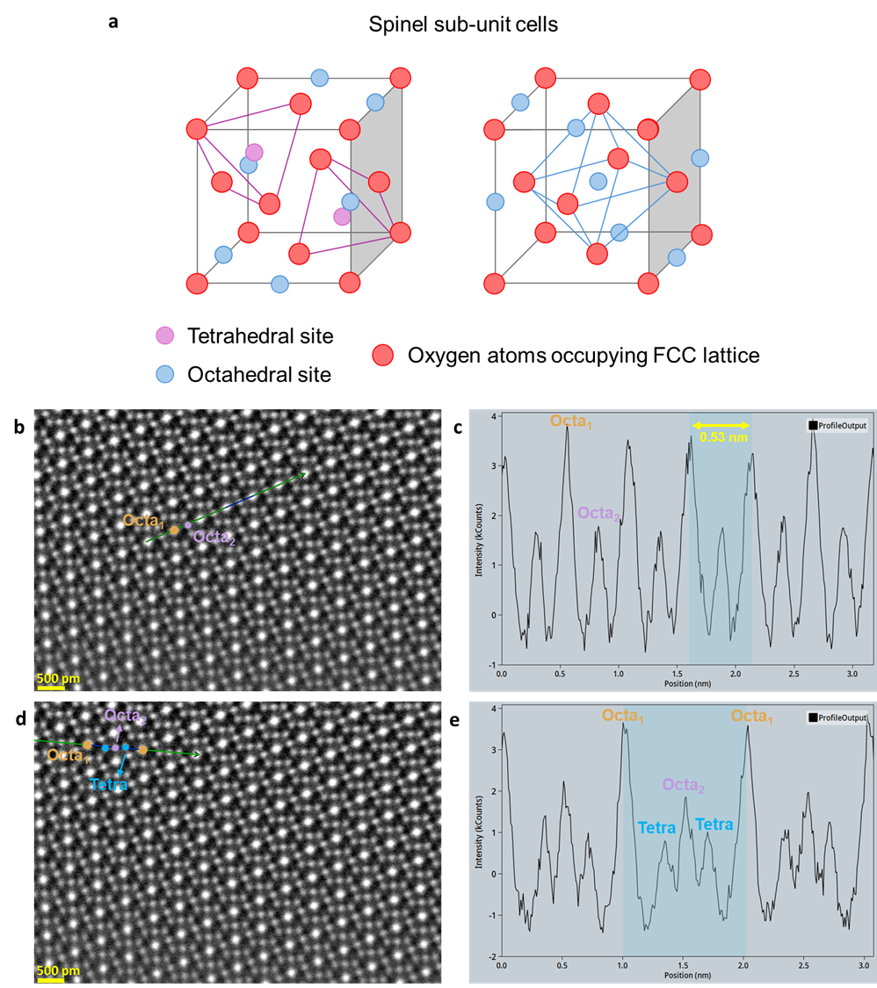
Supplementary Fig. 1 a Schematic of spinel oxide. b Schematic of tetrahedral and octahedral site in spinel oxide. c-f High angle annual dark-field STEM (HAADF-STEM) images of Zn-HESO along the [110] direction and the relative line intensity profiles among different atomic columns along the lines.

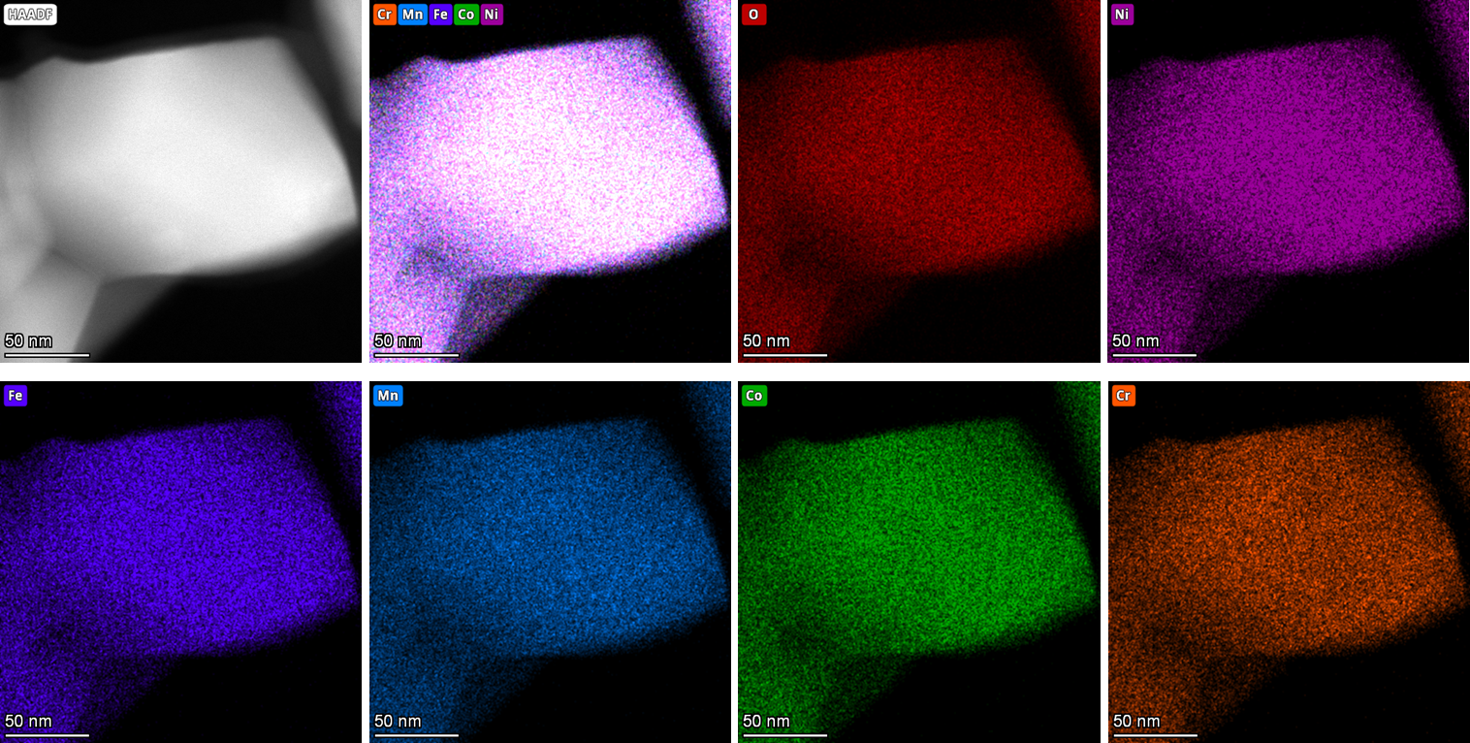
Supplementary Fig. 2 Energy dispersive X-ray spectroscopy mapping images of pure HESOs.

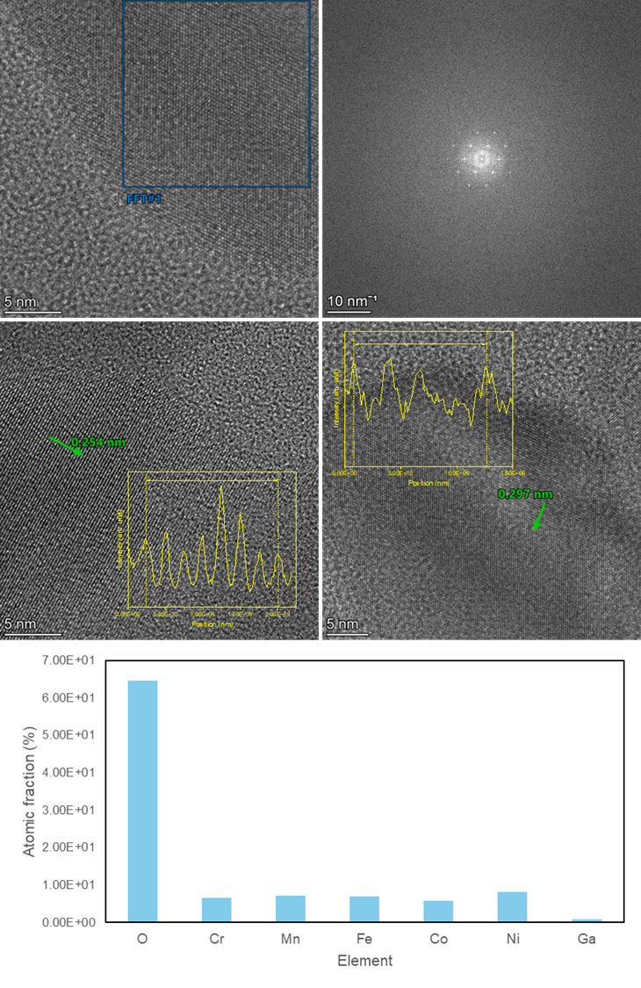
Supplementary Fig. 3 High-resolution transmission electron microscopy images for Ga-HESO.
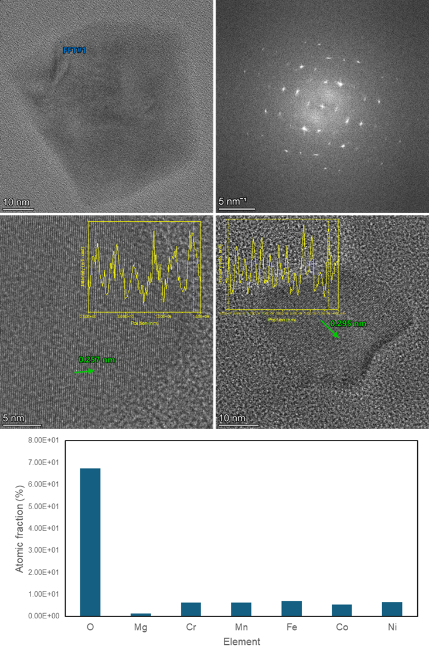
Supplementary Fig. 4 High-resolution transmission electron microscopy images for Mg-HESO.
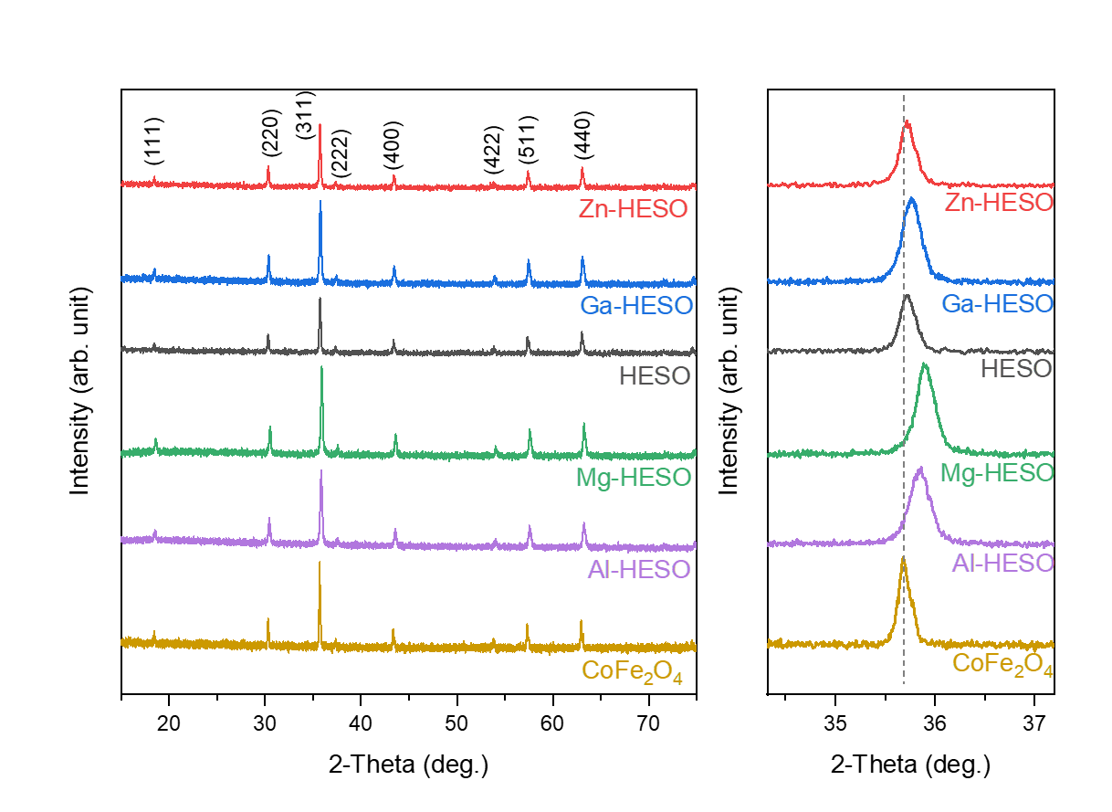
Supplementary Fig. 5 X-ray diffraction of different HESOs as well as CoFe₂O₄ and enlarged view of the (311) diffraction peaks.

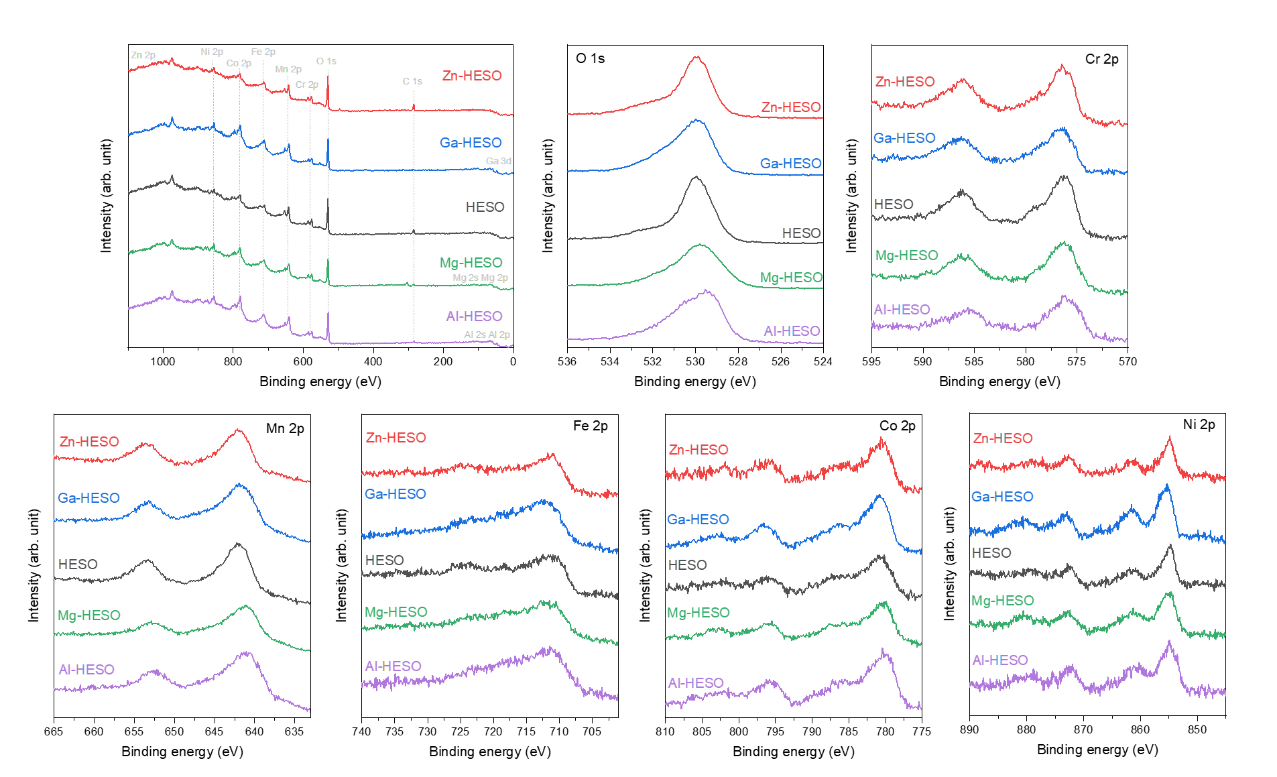
Supplementary Fig. 6 X-ray photoelectron spectroscopy survey and high-resolution elemental spectra for different HESOs.

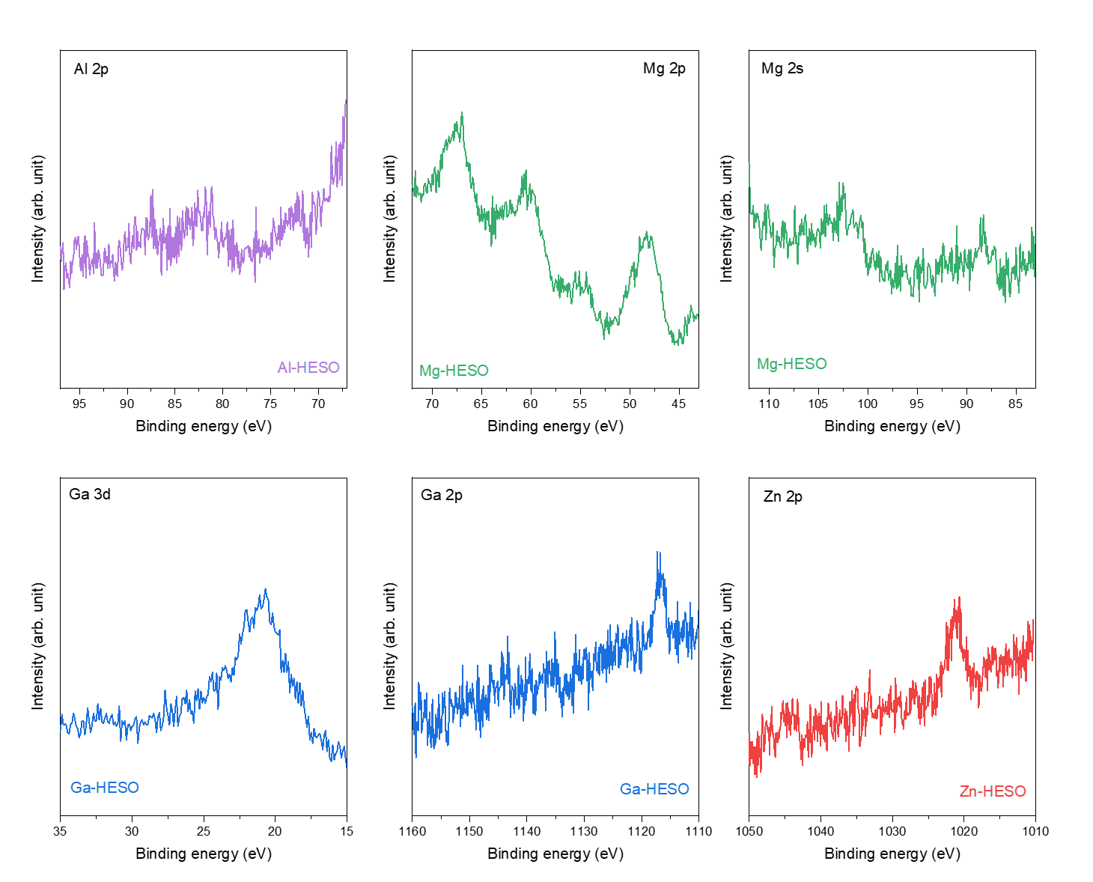
Supplementary Fig. 7 X-ray photoelectron spectroscopy high-resolution elemental spectra (Al for Al-HESO, Mg for Mg-HESO, Ga for Ga-HESO, and Zn for Zn-HESO).

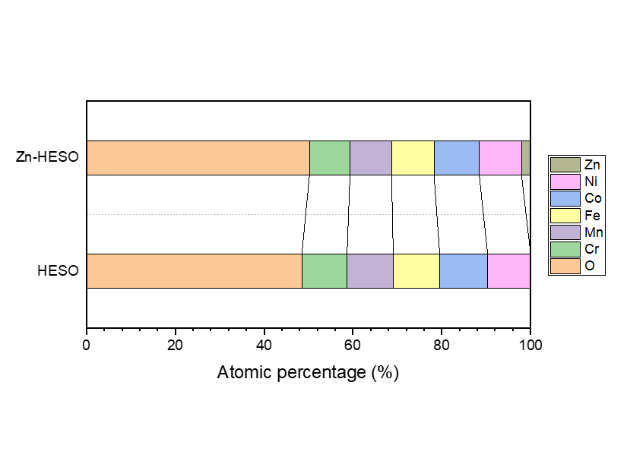
Supplementary Fig. 8 Quantification of atomic percentage through X-ray photoelectron spectroscopy high-resolution elemental spectra for pristine and Zn-HESO.

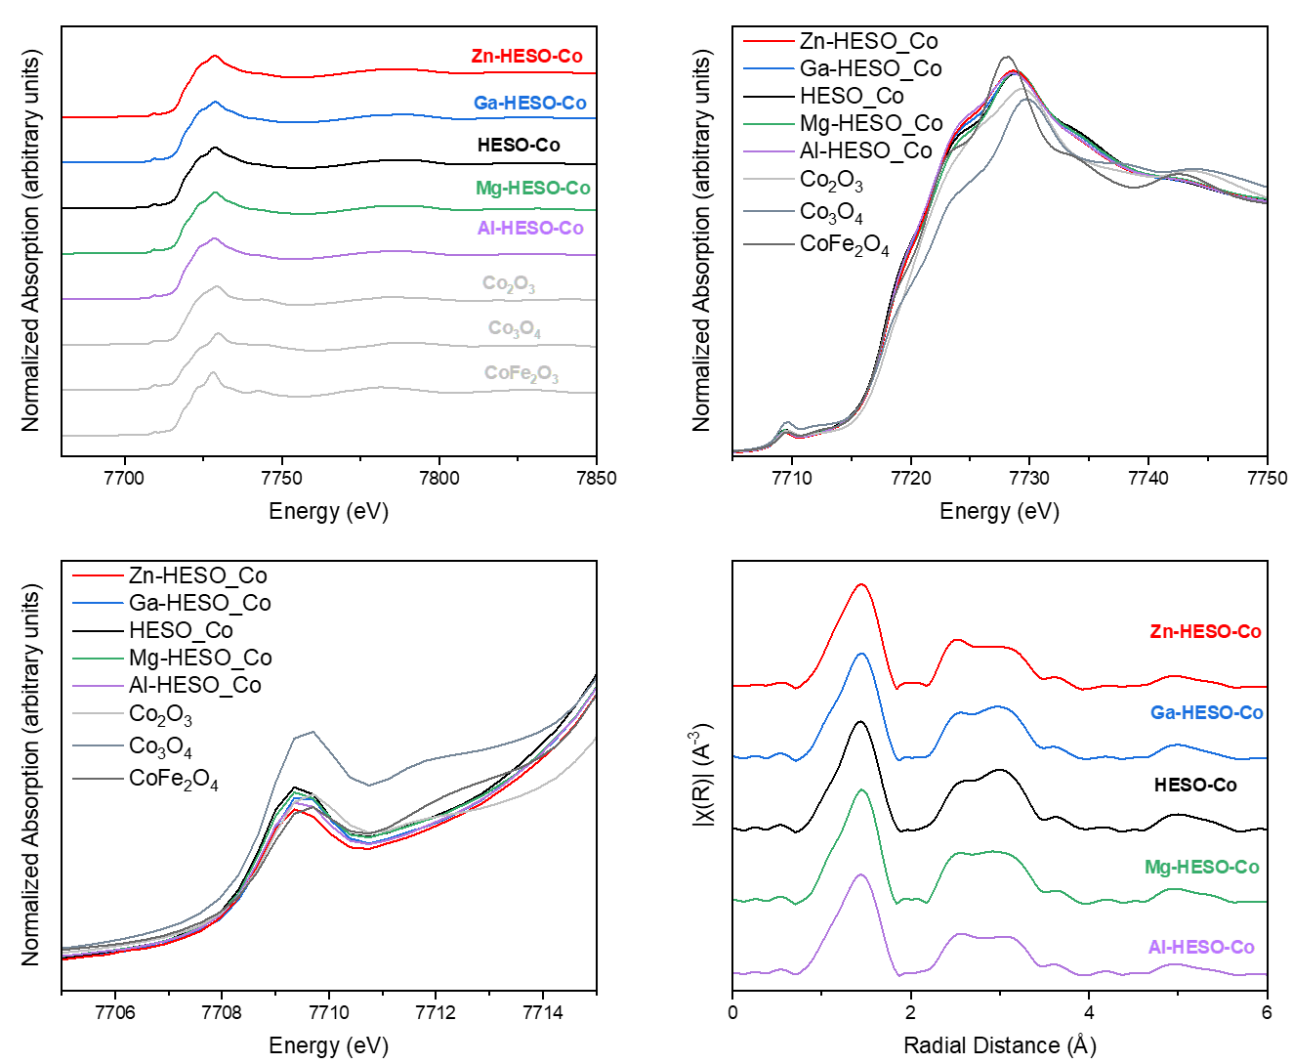
Supplementary Fig. 9 Co K-edge XANES and EXAFS spectra for different HESOs.

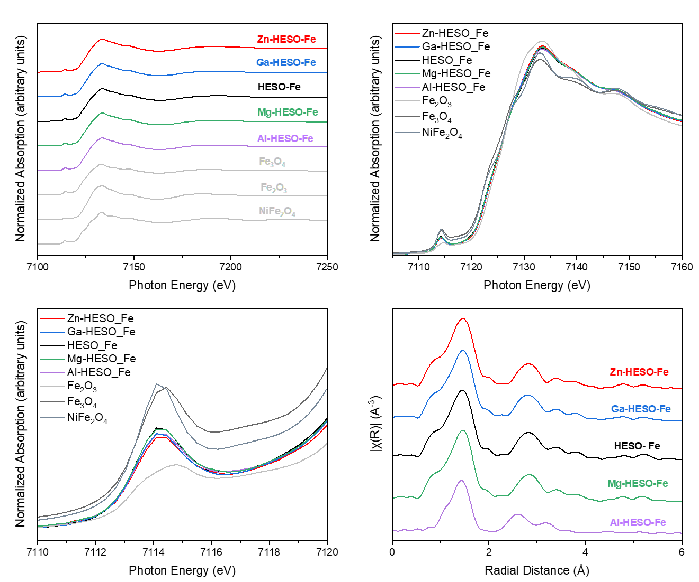
Supplementary Fig. 10 Fe K-edge XANES and EXAFS spectra for different HESOs.
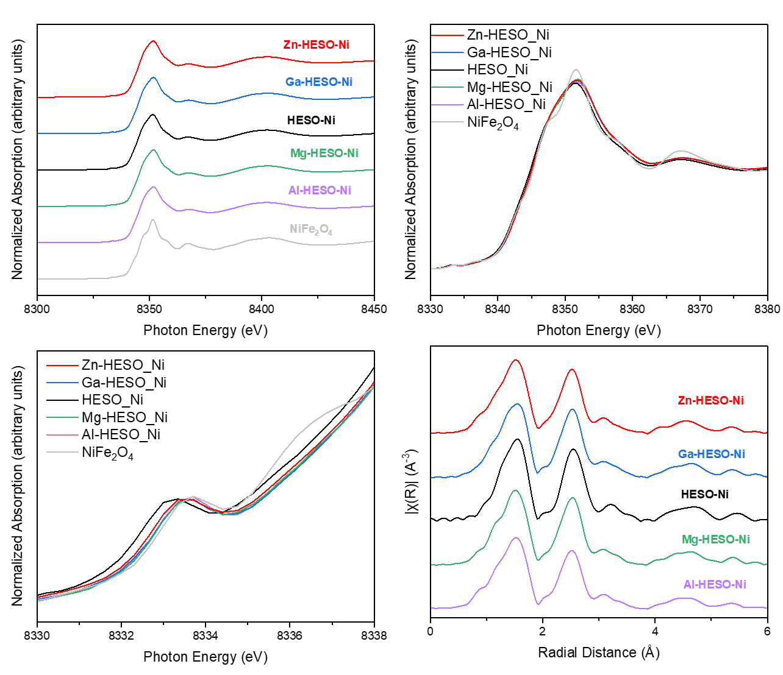
Supplementary Fig. 11 Ni K-edge XANES and EXAFS spectra for different HESOs.

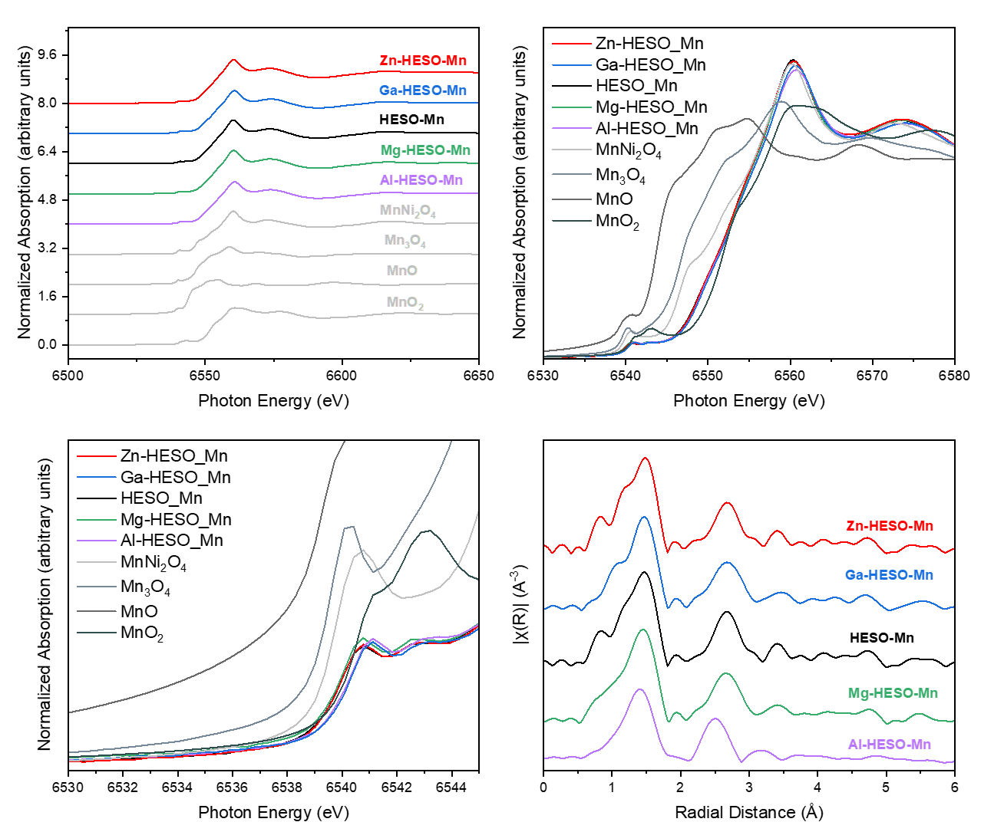
Supplementary Fig. 12 Mn K-edge XANES and EXAFS spectra for different HESOs.

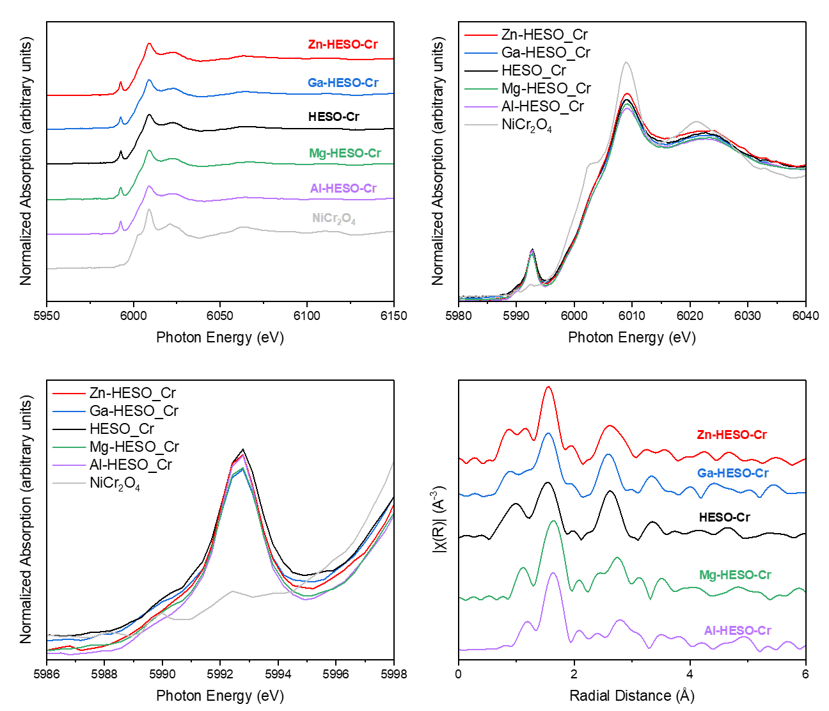
Supplementary Fig. 13 Cr K-edge XANES and EXAFS spectra for different HESOs.

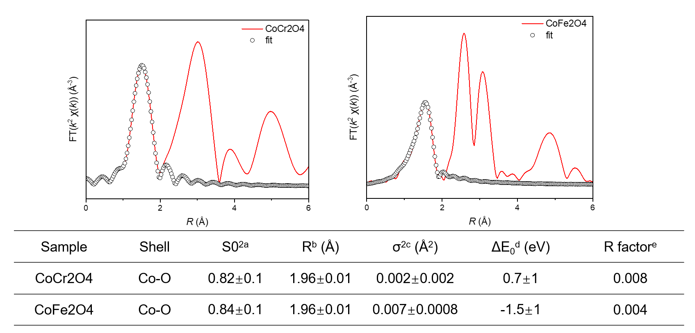
a Amplitude reduction factor. b Bond distance. c Debye-Waller factors. d Inner potential correction. e Goodness of fit. Coordination number was set to 4, according to the known crystallographic value.
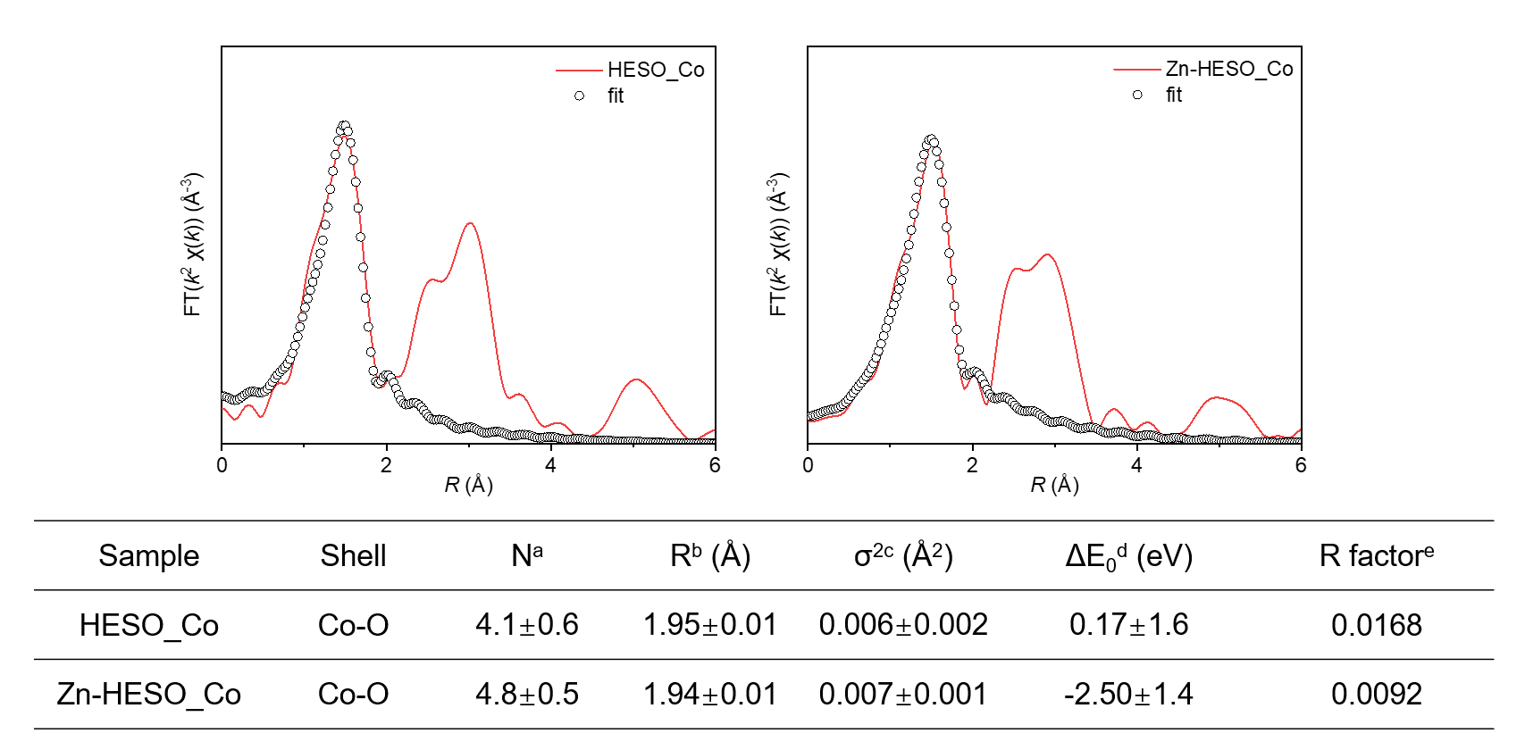
a Coordination numbers. b Bond distance. c Debye-Waller factors. d Inner potential correction. e Goodness of fit. S_{o}² was set to 0.79, according to the experimental EXAFS fit of CoFe₂O4 by fixing N as the known crystallographic value.
Supplementary Fig. 14 Extended X-ray absorption fine structure (EXAFS) Co spectra and corresponding fits for reference spinel oxides, HESO, and Zn-HESO.
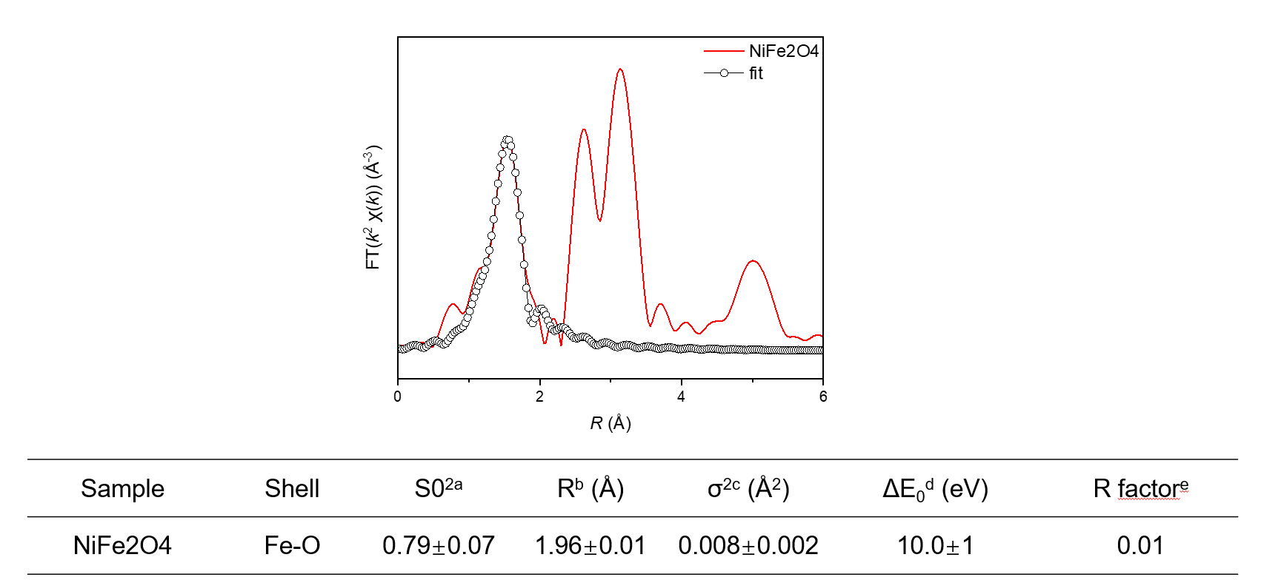
a Amplitude reduction factor. b Bond distance. c Debye-Waller factors. d Inner potential correction. e Goodness of fit. Coordination number was set to 4, according to the known crystallographic value.
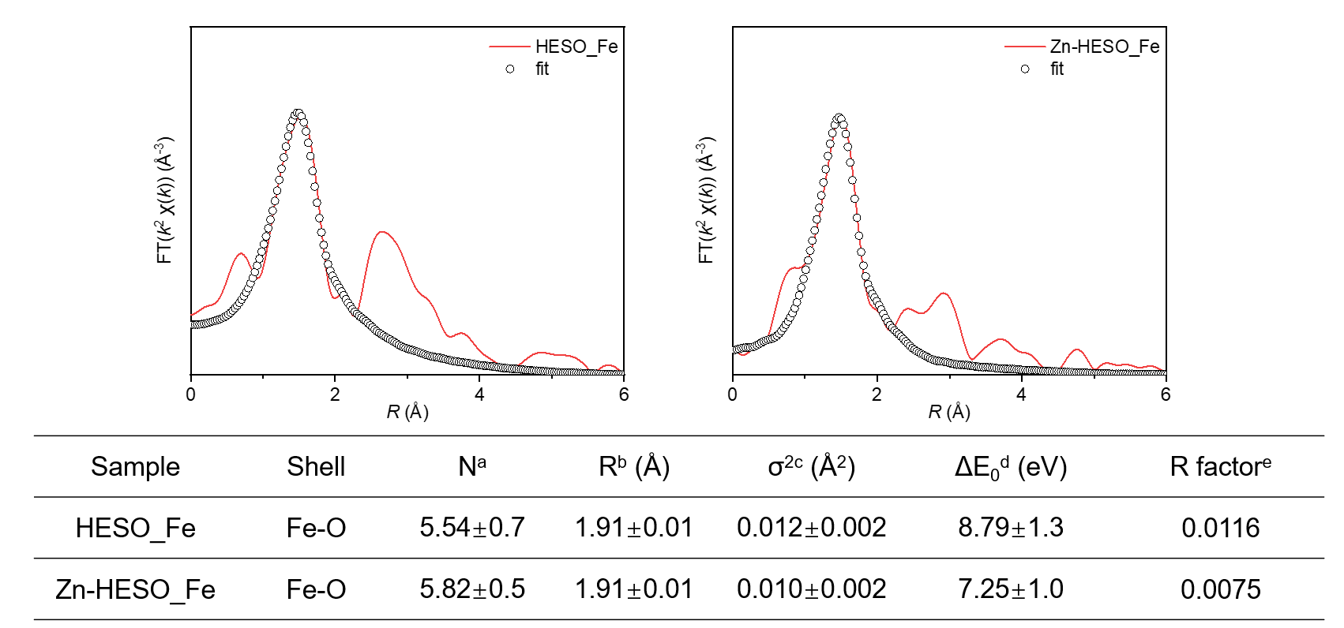
a Coordination numbers. b Bond distance. c Debye-Waller factors. d Inner potential correction. e Goodness of fit. S_{o}² was set to 0.79, according to the experimental EXAFS fit of CoFe₂O4 by fixing N as the known crystallographic value.
Supplementary Fig. 15 Extended X-ray absorption fine structure (EXAFS) Fe spectra and corresponding fits for reference spinel oxides, HESO, and Zn-HESO.

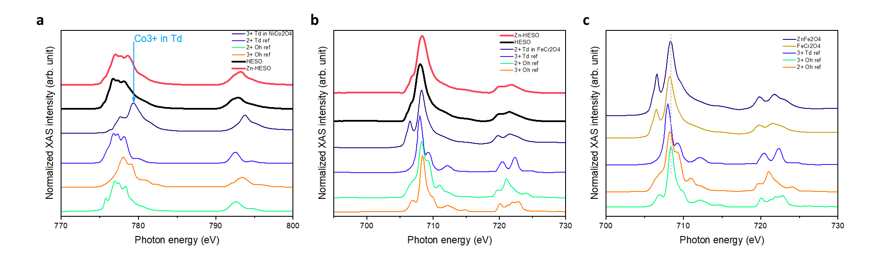
Supplementary Fig. 16 Soft XAS spectra (Co and Fe L edge) to investigate the different valence states for Co and Fe in HESOs and references.
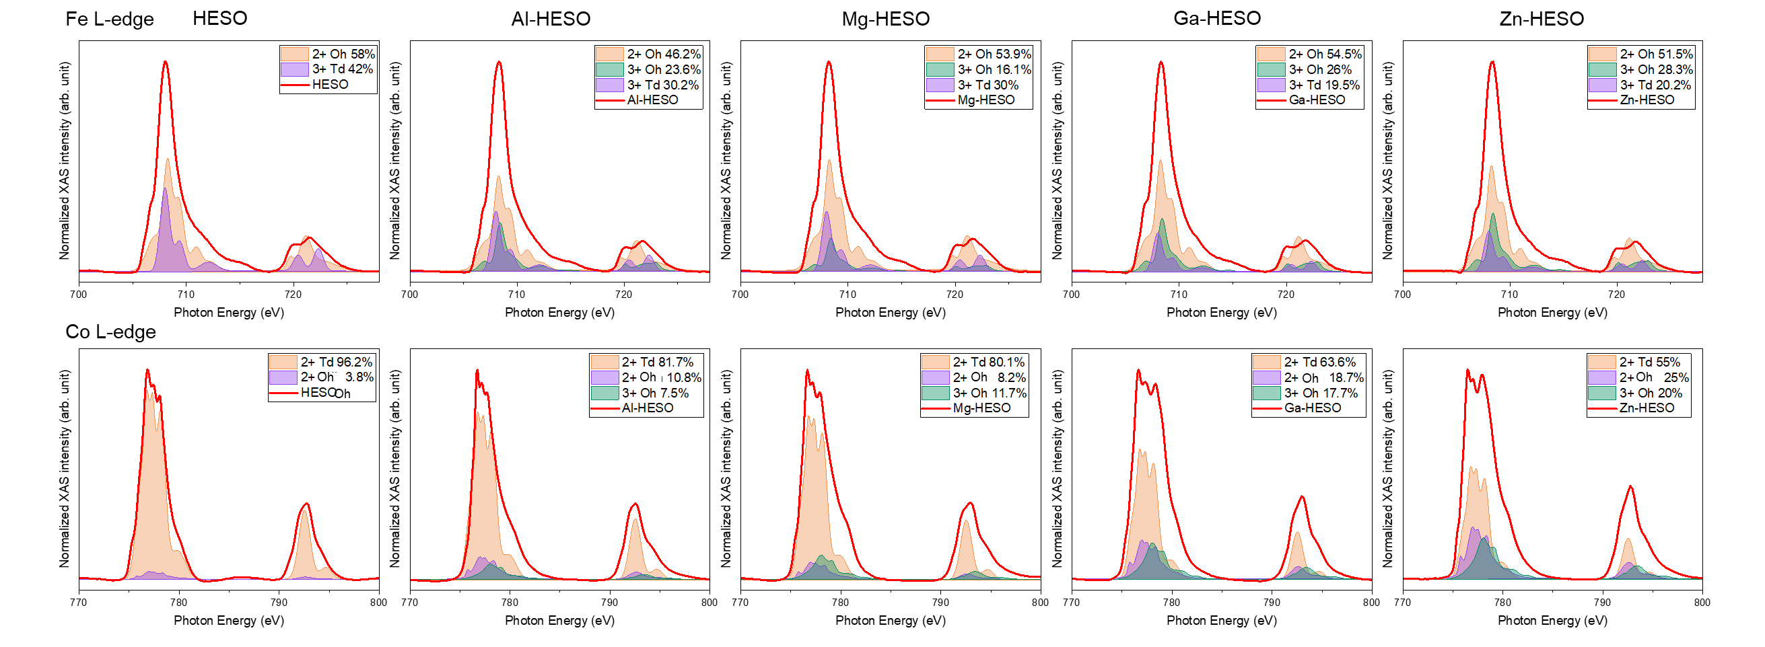
Supplementary Fig. 17 Quantification of elemental L-edge for different HESOs using different reference valence states. Here, we used linear fitting for the different metals (Co, Fe) L-edge using reference with various oxidation states.

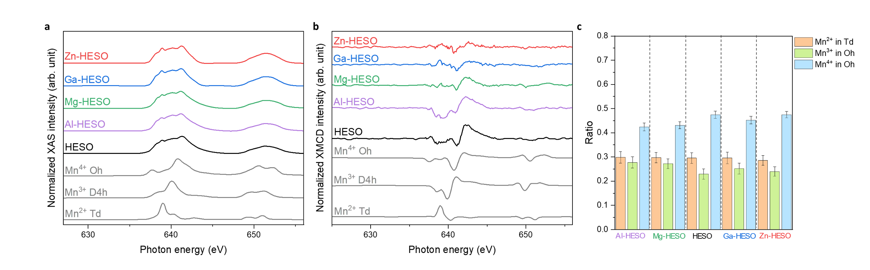
Supplementary Fig. 18 Soft XAS spectra (Mn L edge) for different HESOs and the ratio of different Mn valence states.

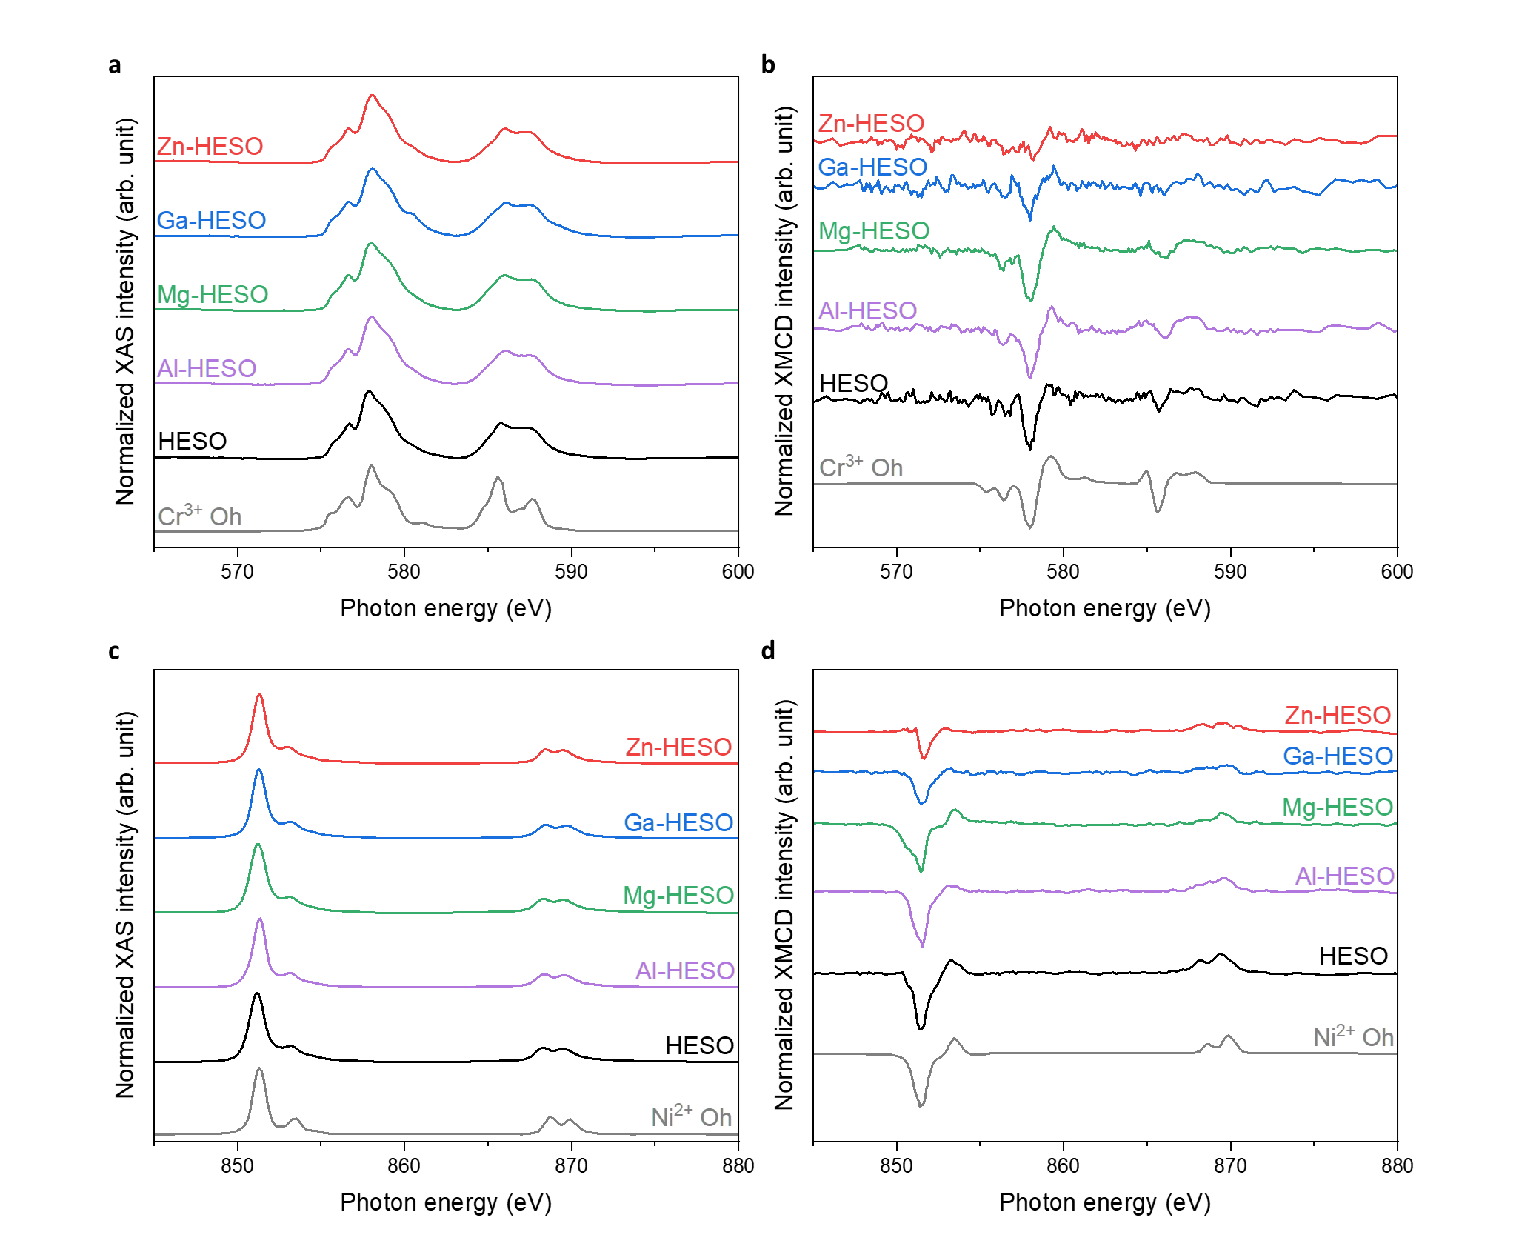
Supplementary Fig. 19 Soft XAS spectra (Ni and Cr L edge) for different HESOs.
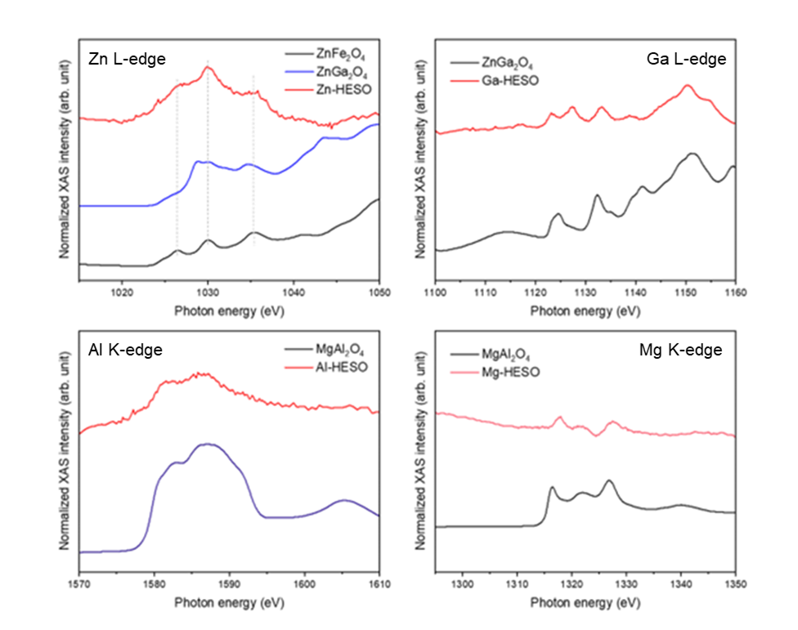
Supplementary Fig. 20 Soft XAS spectra for Zn-L, Ga-L, Al-K, and Mg-K edge in M-HESOs with reference spinel oxides.

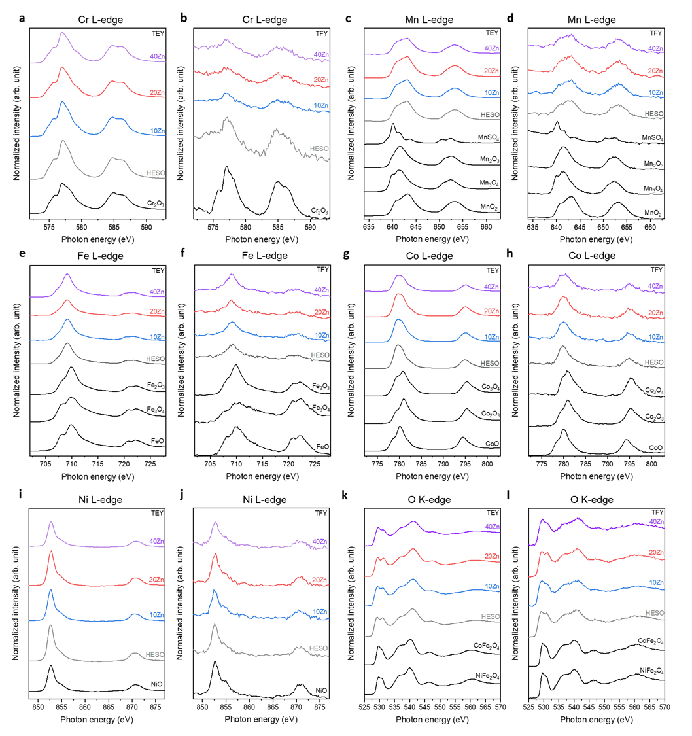
Supplementary Fig. 21 Soft XAS spectra for 3d transition metal L-edge and O K-edge for different concentrations of Zn in Zn-HESO compared with different reference oxides.

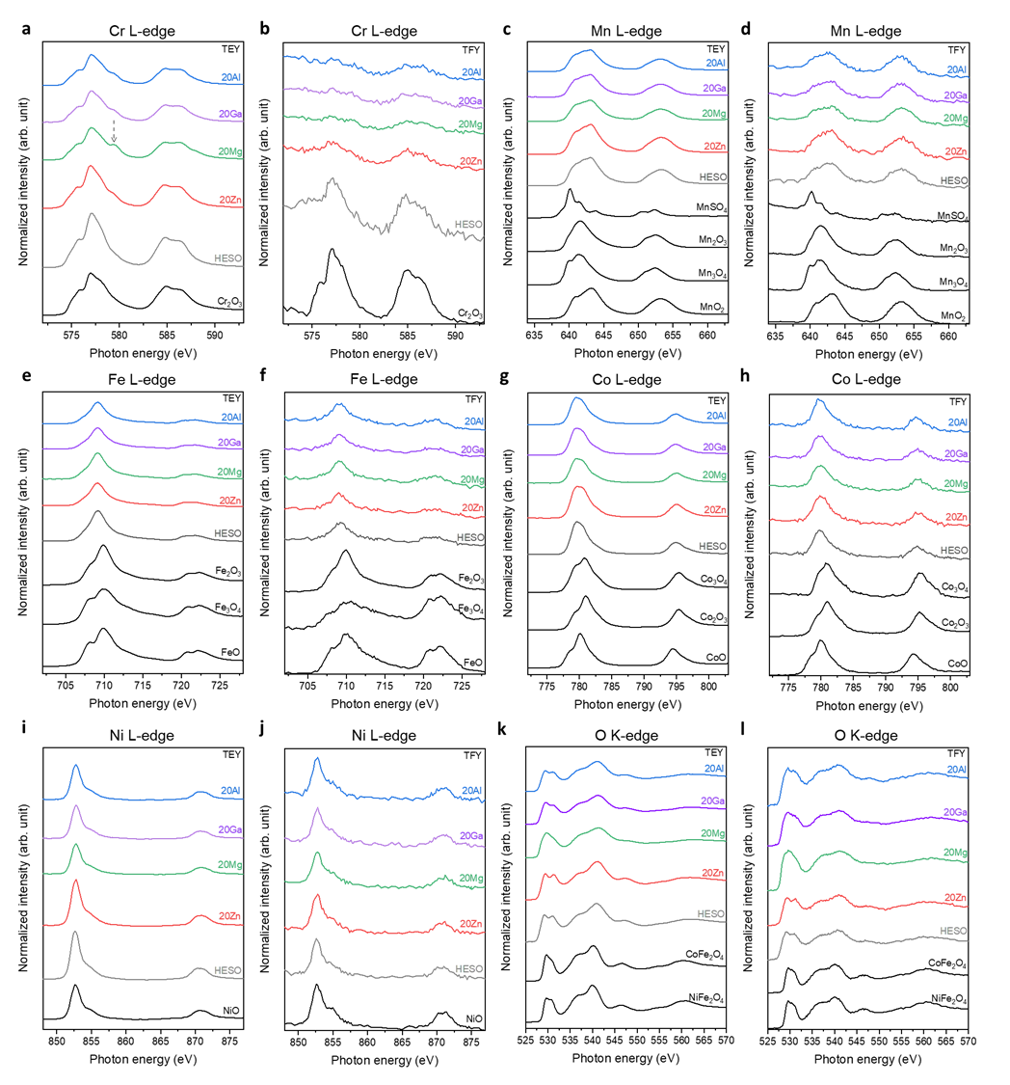
Supplementary Fig. 22 Soft XAS spectra for 3d transition metal L-edge and O K-edge for different HESOs compared with different reference oxides.
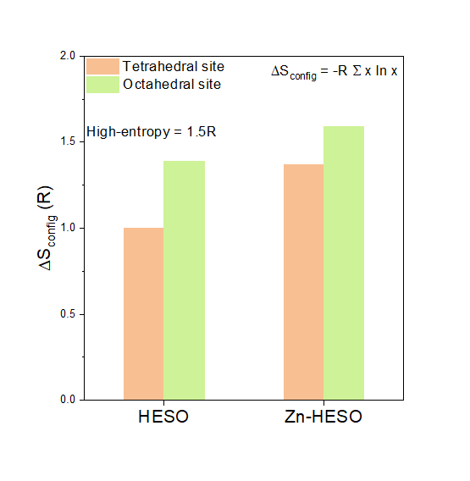
Supplementary Fig. 23 Configurational entropy calculation of pristine HESO and Zn-HESO.

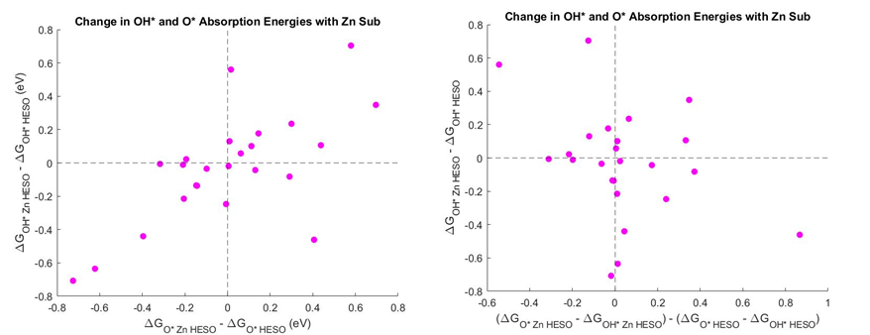
Supplementary Fig. 24 Correlation between OH* and O* absorption energies for simple Zn-HESO compared to simple original HESO. The leftmost plot shows a relatively linear correlation between change in OH* and O* binding energies, which leads to no systematic shift in the descriptor energy of ΔG_{O*} - ΔG_{OH*} (right plot).

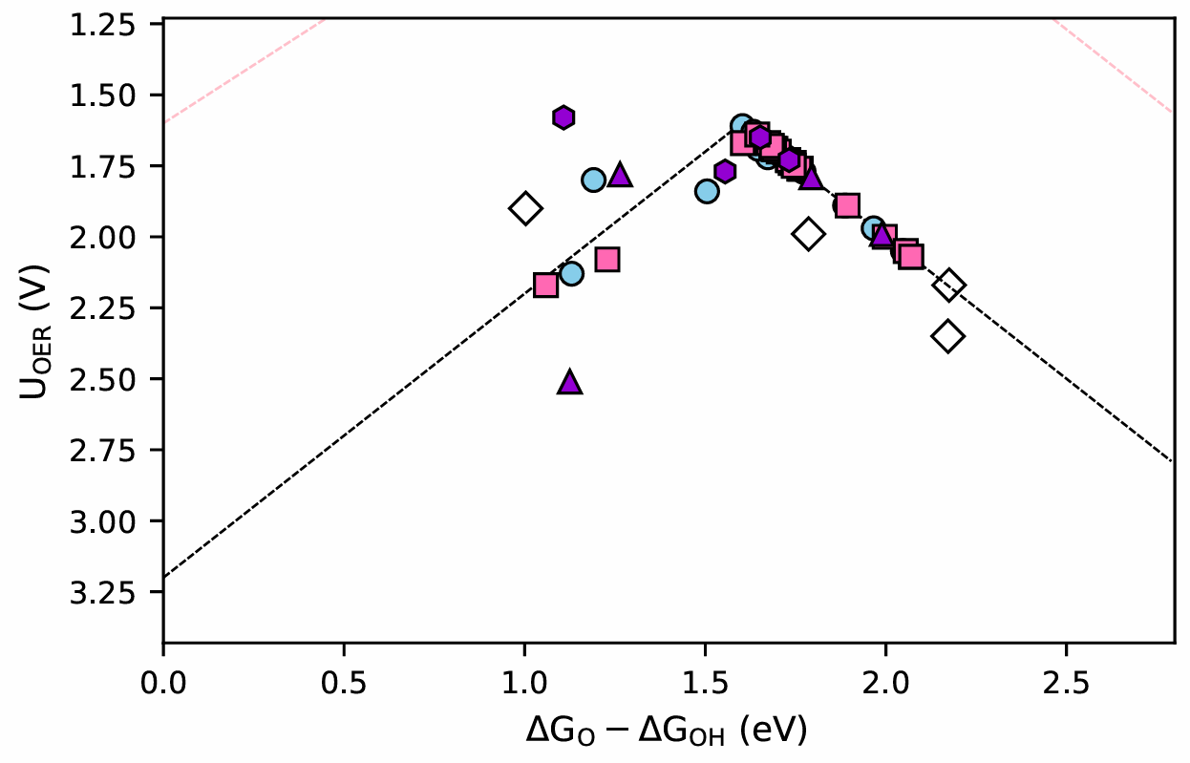
Supplementary Fig. 25 One-dimensional volcano plot of the pristine local impurity HESO model (blue), local impurity Zn-HESO (pink), fully high-entropy Zn-HESO Co active sites (purple), and fully high-entropy Zn-HESO other element active sites (hollow). These data are shown in Fig. 4c.

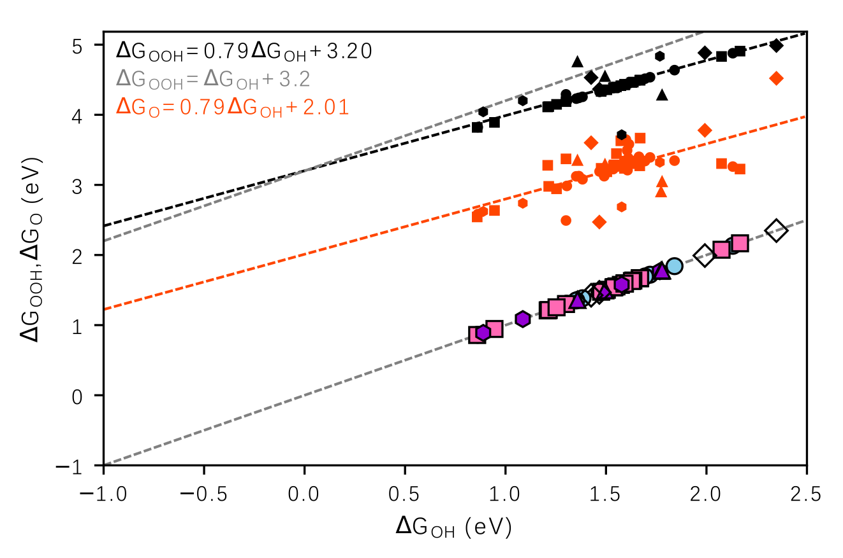
Supplementary Fig. 26 Scaling plot showing the relationship between absorption energies for O and OH (red) and OOH and OH (black). All data from Fig. 4c is plotted here.
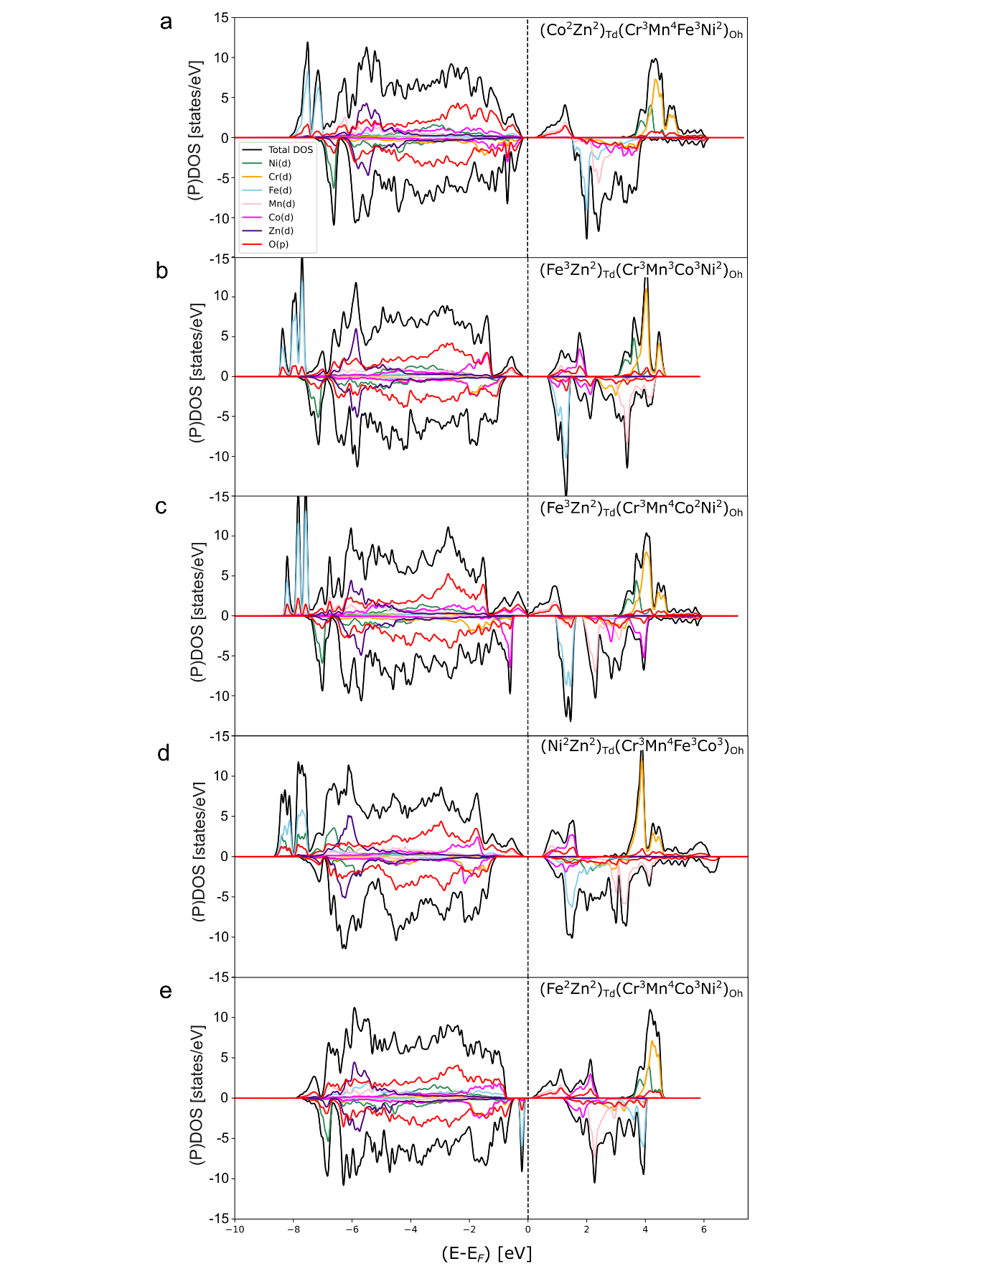
Supplementary Fig. 27 Projected density of states for the lowest energy complex bulk HESO structures ((Co²Zn²)_{Td}(Cr³Mn⁴Fe³Ni²)_{Oh}, (Fe³Zn²)_{Td}(Cr³Mn³Co³Ni²)_{Oh}, (Fe³Zn²)_{Td}(Cr³Mn⁴Co²Ni²)_{Oh}, (Ni²Zn²)_{Td}(Cr³Mn⁴Fe³Co³)_{Oh}, and (Fe²Zn²)_{Td}(Cr³Mn⁴Co³Ni²)_{Oh}), listed here in order of increasing energy.

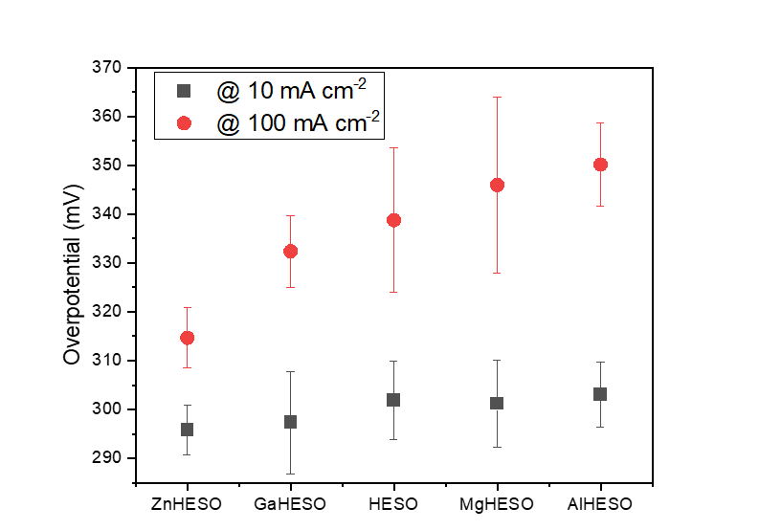
Supplementary Fig. 28 Comparison of overpotentials at different current densities for different HESOs.

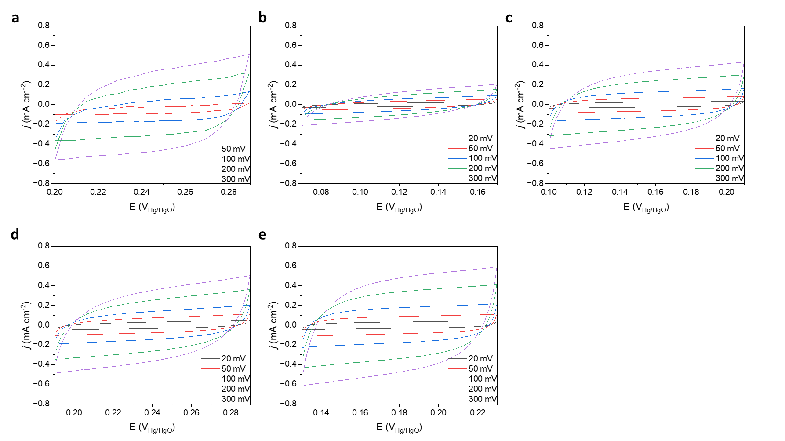
Supplementary Fig. 29 CV scans for different HESOs. a HESO, b Al-HESO, c Mg-HESO, d Ga-HESO, and e Zn-HESO
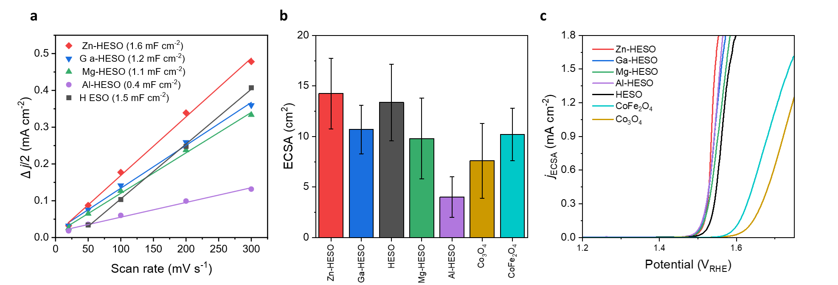
Supplementary Fig. 30 ECSA and normalized current densities by ECSA for different spinel oxides including pristine and M-HESOs.

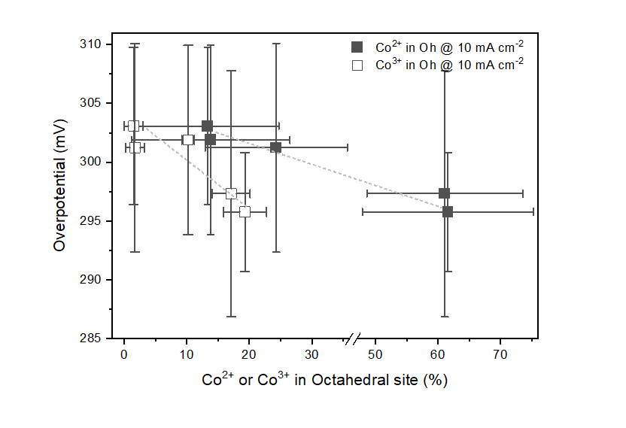
Supplementary Fig. 31 Correlation between Co valence states in the octahedral site and overpotentials at 10 mA cm⁻².

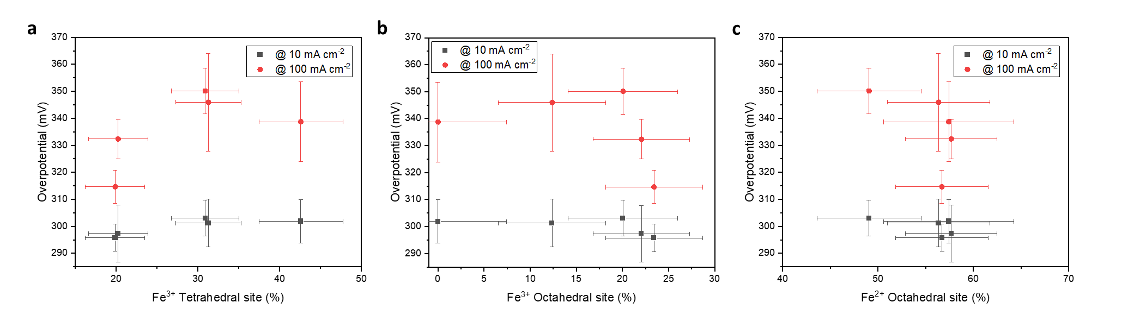
Supplementary Fig. 32 Correlation between Fe valence states in each tetrahedral and octahedral site and overpotential values.

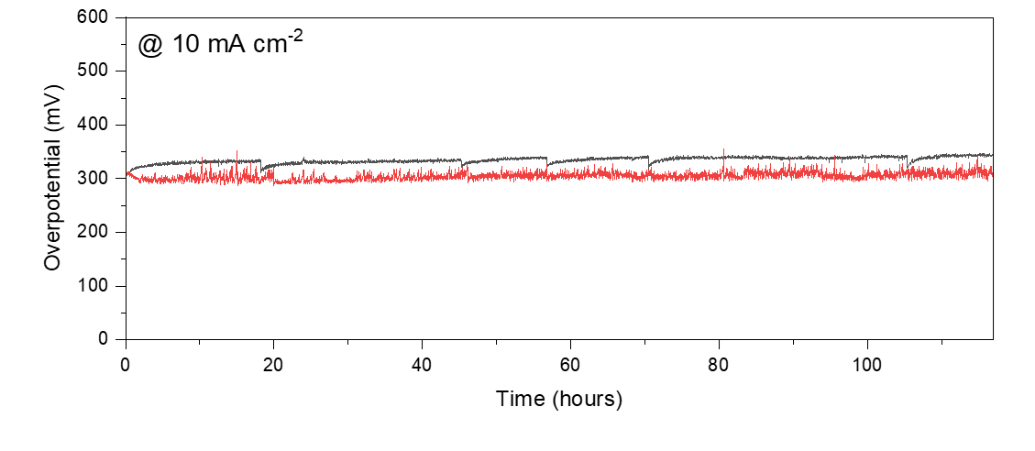
Supplementary Fig. 33 Chronopotentiometry plots for pristine HESO (black) and Zn-HESO (red) at 10 mA cm⁻².

Supplementary Table 1. Simple Zn-HESO energy distribution parameters by site replacement.
Site Zn replaces | µ (eV) | σ (eV) | µ_{oct} – µ_{tet}
Co Td | -221 | 0.496 | 1.291
Co Oh | -219.709 | 0.526 | 1.291
Ni Td | -220.644 | 0.564 | 1.155
Ni Oh | -219.489 | 0.471 | 1.155
Mn Td | -220.86 | 0.309 | 1.161
Mn Oh | -219.699 | 0.559 | 1.161
Fe Td | -220.729 | 0.510 | 1.36
Fe Oh | -219.369 | 0.4725 | 1.36
Cr Td | -220.76 | 0.443 | 1.224
Cr Oh | -219.536 | 0.494 | 1.224

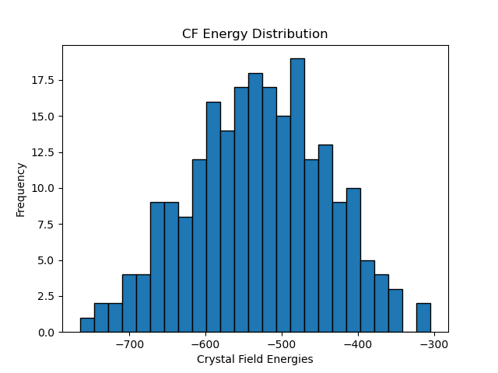
Supplementary Fig. 34. Crystal field theory energy distributions of primitive cell of Zn-HESO, containing two T_{d} sites and four O_{h} sites. The six elements Co, Cr, Mn, Fe, Ni, and Zn were permutated through each type of site and each coordination state (+2 or +3), keeping the total charge for each case conserved to two +2 and four +3 elements.

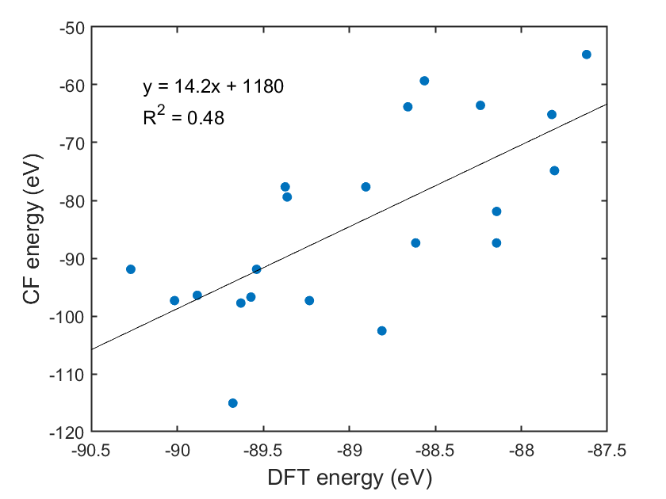
Supplementary Figure 35. Crystal field theory energy vs. DFT energy for the complex Zn-HESO bulk structures.

Supplementary Table 2. Bader Charges for Zn-HESOs used for OER activity calculations, compared with pure HESOs (Co₃O₄, Fe₃O₄, Mn₃O₄, Cr₃O₄, Ni₃O₄) and ZnO.
 | Co | Fe | Mn | Cr | Ni | Zn
Pure spinel Td | 1.33 | 1.63 | 1.43 | 1.40 | 1.23 | 1.184
Pure spinel Oh | 1.50 | 1.37, 1.70 | 1.65 | 1.65 | 1.31 | 1.184
(Co²Zn²)_{Td}(Cr³Mn⁴Fe³Ni²)_{Oh} | 1.4239 | 1.7231 | 1.7637 | 1.6779 | 1.2179 | 1.218
(Fe³Zn²)_{Td}(Cr³Mn⁴Co²Ni²)_{Oh} | 1.4023 | 1.6372 | 1.7701 | 1.676 | 1.2199 | 1.260
(Fe²Zn²)_{Td}(Cr³Mn⁴Co³Ni²)_{Oh} | 1.5096 | 1.3579 | 1.7481 | 1.6349 | 1.1944 | 1.2315
(Ni²Zn²)_{Td}(Cr³Mn⁴Fe³Co³)_{Oh} | 1.5004 | 1.6841 | 1.6265 | 1.633 | 1.2406 | 1.2501
(Mn²Zn²)_{Td}(Cr³Fe³Co³Ni²)_{Oh} | 1.5233 | 1.7039 | 1.4722 | 1.6283 | 1.1921 | 1.2569
(Mn²Fe³)_{Td}(Cr³Co²Ni²Zn²)_{Oh} | 1.6879 | 1.6405 | 1.5612 | 1.7151 | 1.2401 | 1.3091
(Ni²Zn²)_{Td}(Cr³Mn⁴Fe³Co²)_{Oh} | 1.3892 | 1.6609 | 1.7239 | 1.6113 | 1.2403 | 1.2236
(Fe³Zn²)_{Td}(Cr³Mn³Co³Ni²)_{Oh} | 1.5085 | 1.6384 | 1.6335 | 1.6347 | 1.1894 | 1.2492
(Fe³Ni²)_{Td}(Cr³Mn⁴Co²Zn²)_{Oh} | 1.3883 | 1.6231 | 1.7508 | 1.6820 | 1.2281 | 1.2939

Supplementary Table 3. Magnetic Moments for Zn-HESOs used for OER activity calculations, compared with pure HESOs (Co₃O₄, Fe₃O₄, Mn₃O₄, Cr₃O₄, Ni₃O₄) and ZnO.
 | Co | Fe | Mn | Cr | Ni | Zn
Pure spinel Td | 2.646 | 4.182 | 4.564 | 3.762 | 1.845 | 0.0
Pure spinel Oh | 0.0 | 3.739, 4.252 | 3.863 | 3.004 | 1.243 | 0.0
(Co²Zn²)_{Td}(Cr³Mn⁴Fe³Ni²)_{Oh} | 2.888 | 4.297 | 3.191 | 2.957 | 1.776 | 0.009
(Fe³Zn²)_{Td}(Cr³Mn⁴Co²Ni²)_{Oh} | 2.728 | 4.199 | 3.192 | 2.934 | 1.758 | 0.001
(Fe²Zn²)_{Td}(Cr³Mn⁴Co³Ni²)_{Oh} | 0.002 | 3.69 | 3.195 | 2.862 | 1.78 | 0.007
(Ni²Zn²)_{Td}(Cr³Mn⁴Fe³Co³)_{Oh} | 0.009 | 4.295 | 3.857 | 2.862 | 1.863 | 0.017
(Mn²Zn²)_{Td}(Cr³Fe³Co³Ni²)_{Oh} | 0.013 | 4.118 | 4.329 | 2.943 | 1.77 | 0.004
(Mn²Fe³)_{Td}(Cr³Co²Ni²Zn²)_{Oh} | 3.028 | 4.172 | 4.095 | 2.986 | 1.763 | 0.021
(Ni²Zn²)_{Td}(Cr³Mn⁴Fe³Co²)_{Oh} | 2.695 | 4.285 | 3.181 | 2.969 | 1.840 | 0.008
(Fe³Zn²)_{Td}(Cr³Mn³Co³Ni²)_{Oh} | 0.050 | 4.201 | 3.887 | 2.932 | 1.761 | 0.002
(Fe³Ni²)_{Td}(Cr³Mn⁴Co²Zn²)_{Oh} | 2.718 | 4.208 | 3.190 | 2.944 | 1.817 | 0.021

Supplementary Table 4. Bulk Zn-HESO converged structures with their spinel types (normal, mixed normal/inverse, or inverse), and their CFT and DFT energies.
Converged structure | Spinel Type | CFT Energy (eV) | DFT Energy (eV)
(Co²Zn²)_{Td}(Cr³Mn⁴Fe³Ni²)_{Oh} | N | -91.92102 | -90.2699
(Fe³Zn²)_{Td}(Cr³Mn³Co³Ni²)_{Oh} | N+I | -97.33333 | -90.01562751
(Fe³Zn²)_{Td}(Cr³Mn⁴Co²Ni²)_{Oh} | N+I | -96.41913 | -89.88347
(Ni²Zn²)_{Td}(Cr³Mn⁴Fe³Co³)_{Oh} | N | -97.75406 | -89.70446117
(Fe²Zn²)_{Td}(Cr³Mn⁴Co³Ni²)_{Oh} | N | -115.0645 | -89.67629
(Fe²Co²)_{Td}(Cr³Mn⁴Ni²Zn²)_{Oh} | N | -96.72384 | -89.57138
(Fe³Co²)_{Td}(Cr³Mn⁴Ni²Zn²)_{Oh} | N+I | -91.92102 | -89.53889
(Mn²Zn²)_{Td}(Cr³Fe³Co³Ni²)_{Oh} | N | -77.65767 | -89.37232
(Co²Ni²)_{Td}(Cr³Mn⁴Fe³Zn²)_{Oh} | N | -79.41338 | -89.3607506
(Fe³Zn²)_{Td}(Cr³Mn³Co³Ni²)_{Oh} | N+I | -97.33326 | -89.23163
(Mn²Fe³)_{Td}(Cr³Co³Ni²Zn²)_{Oh} | N+I | -77.65767 | -88.9035
(Fe²Ni²)_{Td}(Cr³Mn⁴Co³Zn²)_{Oh} | N | -102.5569 | -88.81025
(Mn²Fe³)_{Td}(Cr³Co²Ni²Zn²)_{Oh} | N+I | -63.8151 | -88.65948
(Cr³Zn²)_{Td}(Mn⁴Fe³Co³Ni²)_{Oh} | N+I | -87.36488 | -88.61379561
(Mn²Co²)_{Td}(Cr³Fe³Ni²Zn²)_{Oh} | N | -59.31699 | -88.56317739
(Cr²Co²)_{Td}(Mn⁴Fe³Ni²Zn²)_{Oh} | N | -63.56843 | -88.23739067
(Cr³Fe³)_{Td}(Mn⁴Co³Ni²Zn²)_{Oh} | I | -87.36488 | -88.14383254
(Cr²Fe³)_{Td}(Mn⁴Co³Ni²Zn²)_{Oh} | N+I | -81.90911 | -88.14319
(Mn²Ni²)_{Td}(Cr³Fe³Co³Zn²)_{Oh} | N | -65.15002 | -87.82260271
(Cr³Ni²)_{Td}(Mn⁴Fe³Co³Zn²)_{Oh} | N+I | -74.85723 | -87.80701939
(Cr³Mn²)_{Td}(Fe³Co³Ni²Zn²)_{Oh} | N+I | -54.76084 | -87.62053829

