Supplementary file
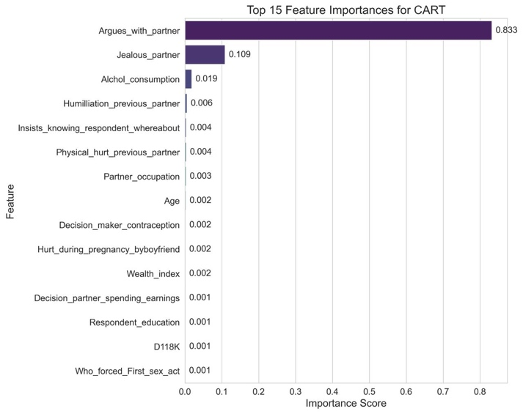
Figure S1: Feature importance for the top 15 features of CART model

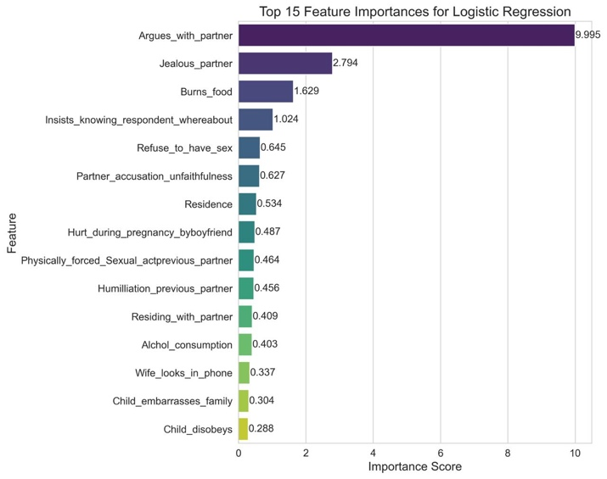
Figure S2: Feature importance for the top 15 features of Logistic Regression model

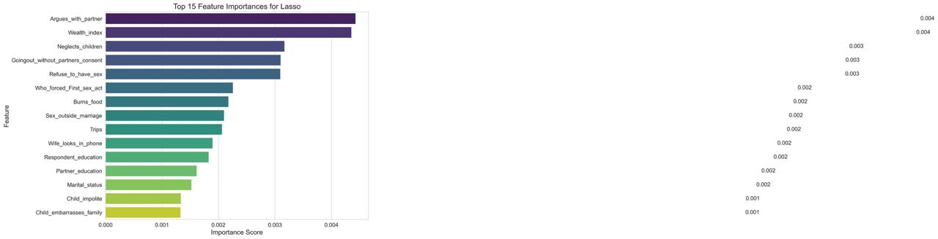
Figure S3: Feature importance for the top 15 features of Lasso model
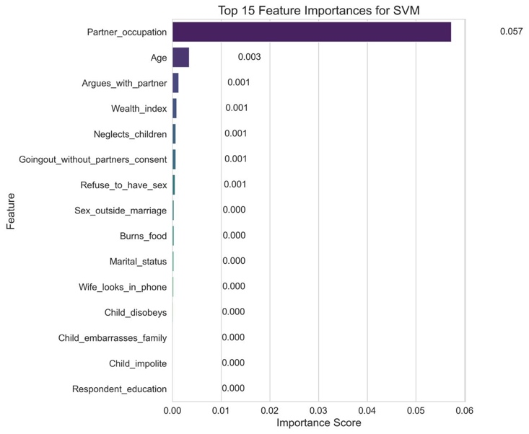
Figure S4: Feature importance for the top 15 features of the SVM model

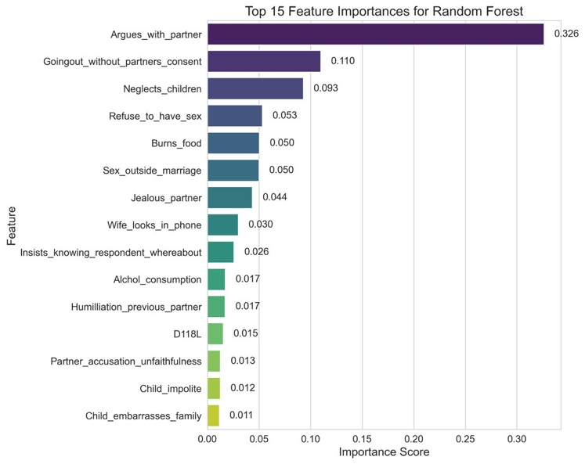
Figure S5: Feature importance for the top 15 features of the Random Forest model

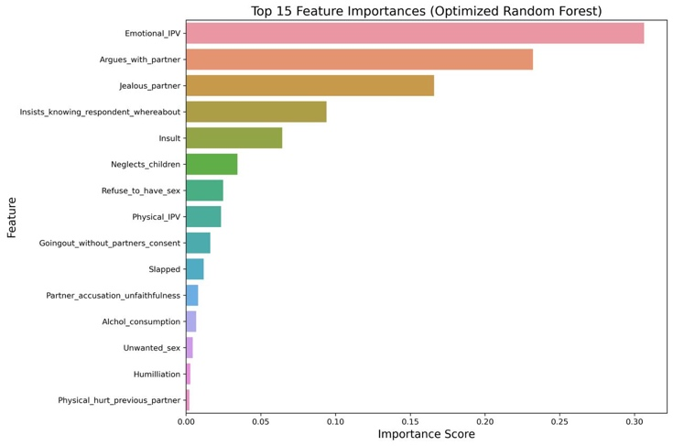
Figure S6: Feature importance for the top 15 features of the optimized Random Forest model

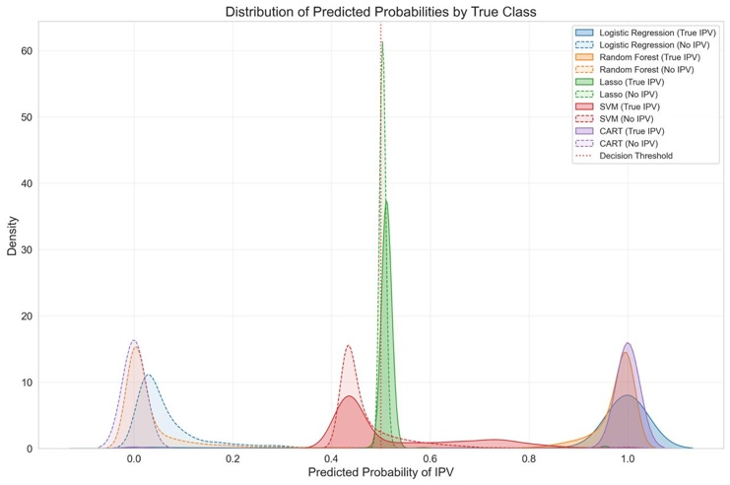
Figure S7: Distribution of the predicted probability by true class among each ML model

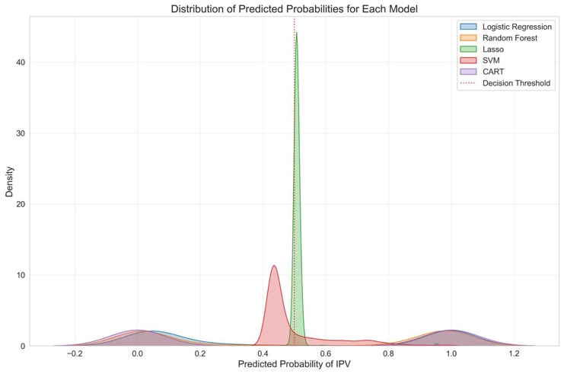
Figure S8: Distribution of the predicted probability of each ML model

