Supplemental file 2
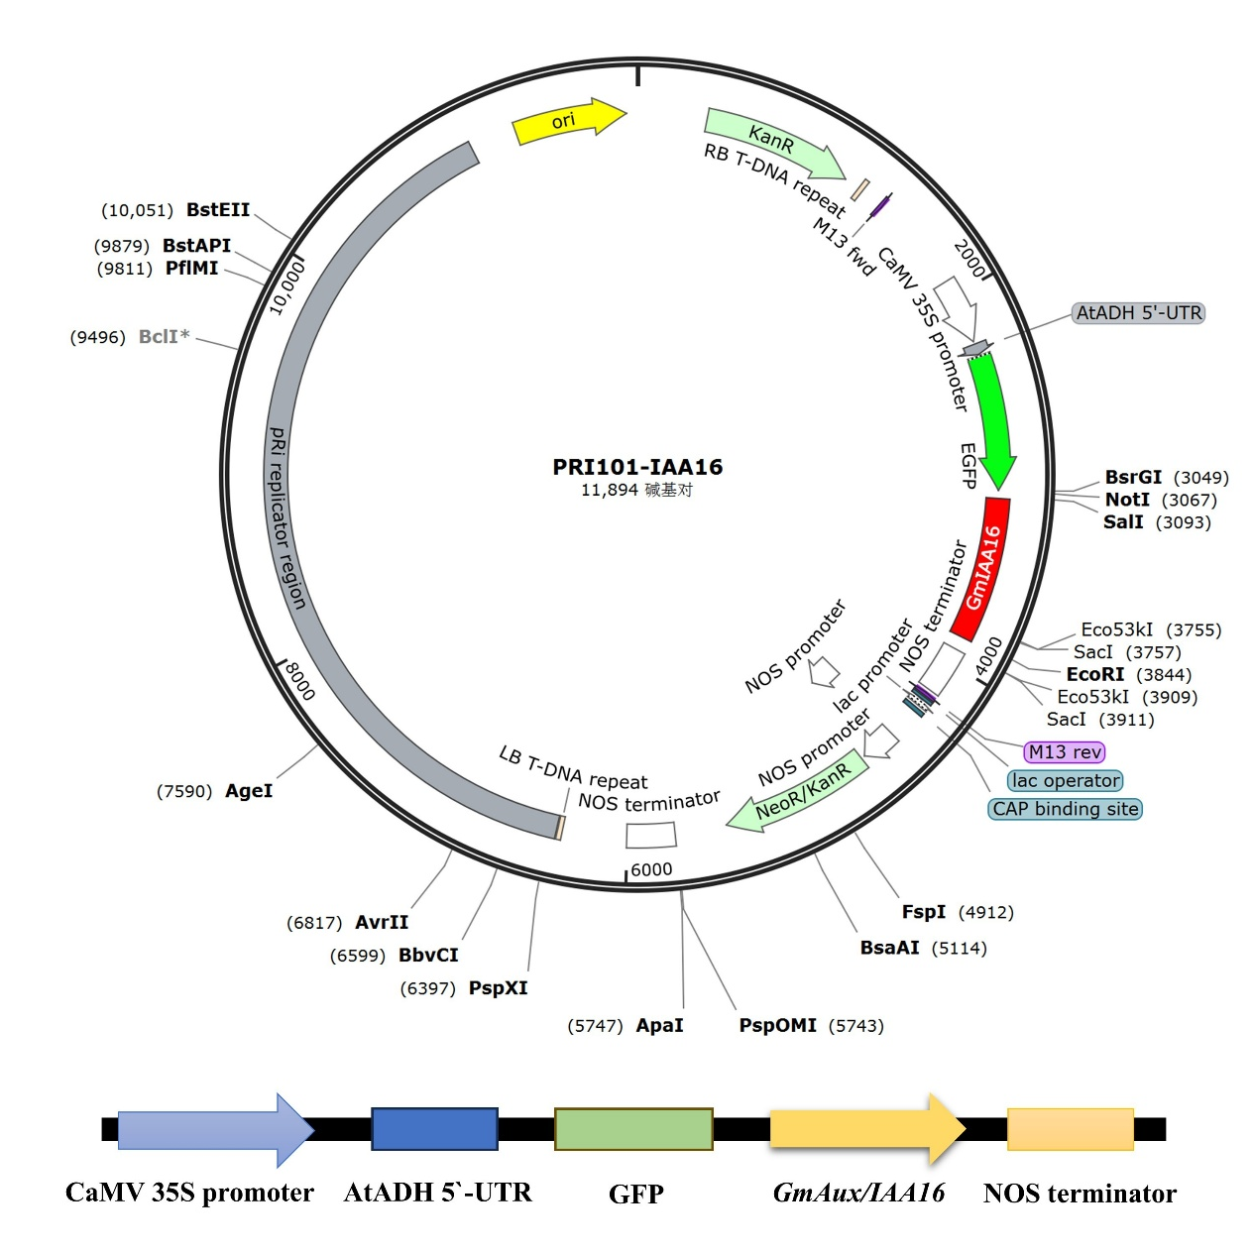
Fig. S1 Schematic diagram of the carrier used in this study.
The pRI101-GFP vector is used for subcellular localization and tobacco gene transformation

