Supplemental file 3
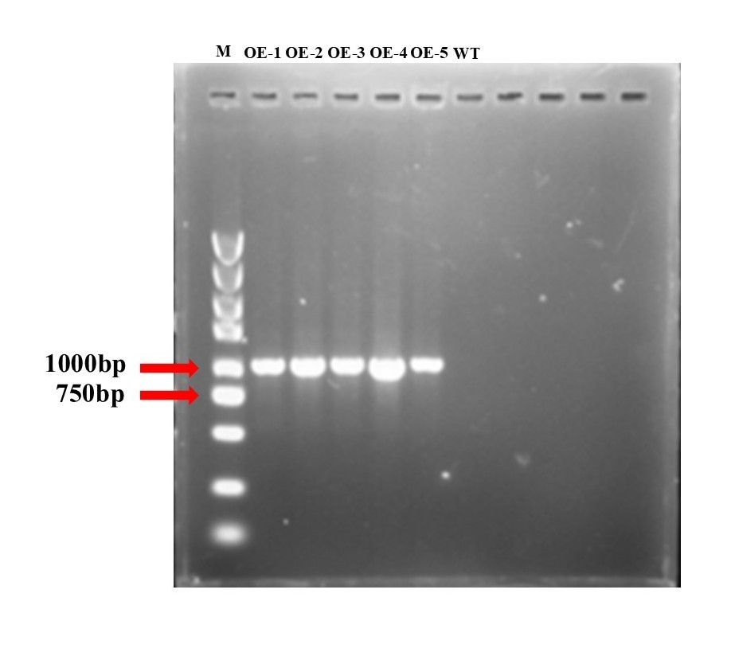
Fig. S2 PCR analysis of GmAux/IAA16-overexpression transgenic tobacco lines.
The GmAux/IAA16-overexpressing transgenic tobacco were identified by PCR, and GmAux/IAA16 gene had a size of 954bp fragment. M, DNA Marker DL5000; WT, wild type tobacco line; OE-1 to 5, independent transgenic tobacco lines

