Probing the active site heterogeneity of Fe-N-C catalysts using integrated multimodal spectroscopy measurements and simulations

(Supporting Information)

Jiayi Xu¹, Prajay Patel², Matthew E. Sweers¹, A. Jeremy Kropf¹, Esen E. Alp³, Hoon Taek Chung^{4,¶}, Piotr Zelenay⁴, Deborah Myers^{1, *}, Cong Liu^{1, *}

¹ Chemical Sciences and Engineering Division, Argonne National Laboratory, Lemont, IL 60439 USA
² Chemistry Department, University of Dallas, Irving, TX, 75062 USA
³ X-ray Science Division, Advanced Photon Source, Argonne National Laboratory, Lemont, IL 60439
⁴MPA-11, Materials Physics and Applications Division, Los Alamos National Laboratory, Los Alamos, NM 87545, USA

*Corresponding Author: dmyers@anl.gov, congliu@anl.gov; ¶Current Affiliation: Department of Chemistry, Sejong University, Seoul, Korea

Keywords: Oxygen Reduction Reaction, Fe Single Atom Catalyst, Density Functional Theory, X-ray Absorption Spectroscopy, Mössbauer spectroscopy
EXAFS Analysis
Fe(II)-phthalcyanine (Fe(II)-pc) and Fe(III)-pc tetrasulfonic acid (Fe(III)-pc-so) EXAFS were fit as close analogs to the FeN-C samples. All fits are partially model-dependent. Selected coordination numbers were fixed to the expected or proposed values as shown in Table S1. To obtain the expected Fe-N coordination numbers and good fits (i.e. a low R factor), the next-nearest neighbor Fe-C scattering paths had to be included due to interference with the nearest-neighbor Fe-N (and Fe-O) path. Multiple scattering and other longer scattering paths (i.e. 3rd shell Fe-N/C) were not included. Although R_{max} values were chosen to minimize the effects of longer scattering paths, the absence of the overlapping paths in the model can be assumed to influence the measured Fe-C path parameters. Multiple Fe coordination environments in the catalysts, each with two 2nd shell Fe-C bond lengths accounts for the lower amplitude in the Fourier transform above 2 Å (Figure S1). The 2nd shell has been modeled with one pair of 2nd-shell Fe-C paths with a fixed bond length difference.
The fit for Fe(II)-pc confirms that with appropriate consideration of the 2nd-shell Fe-C, the expected Fe-N coordination number will be obtained. This is a highly ordered structure with low mean-square relative displacement (msrd or σ²). For Fe(III)-pc-so, both the nearest-neighbor Fe-O and next-nearest-neighbor Fe-C paths were required to get a good fit (R factor < 1.0%). However, σ²_{Fe-O} is unusually large (0.031 Å²), which means this path contributes significantly only at very low k. The consequence is high correlation between k_{min} and the structural parameters N_{Fe-O}, N_{Fe-N}, R_{Fe-O}, σ²_{Fe-O}, and ΔE₀. Therefore, all coordination numbers have been fixed and k_{min} has been set to 3.0 Å⁻¹ for consistency with the other fits with the effect of understating the statistical uncertainty in R_{Fe-O}, σ²_{Fe-O}, and ΔE₀.
As indicated by Figure S2, the comparison between catalyst post air exposure and ex situ Mössbauer test indicates almost identical XANES feature, which suggests that the air exposed sample and Mössbauer sample should be the same. As shown by the XANES and Mössbauer analysis, multiple Fe coordination environments are present in pyrolyzed catalyst, both before and after exposure to air. This significantly complicates the analysis, especially given the Fe-pc precedent of the higher shell structure impacting nearest-neighbor coordination number and the expected significant interference between Fe-N and Fe-O scattering paths. Fe-N-C (pre-air) was fit using the calculated Pyrrolic_Vac_N as the model. Compared to Fe(II)-pc the msrd has increased, reflecting multiple sites, while R_{Fe-N} has only increased by 0.015 ± 0.013 Å. This essentially confirms square planar Fe-N₄ structure before air exposure. Although we assume that the Fe-N-C structure remains intact after exposure to air, fitting Fe-N-C (post-air) is less straight-forward due to the Fe-O scattering path that interferes with the Fe-N path. Two fits are shown to highlight the parameters that are most stable. In the first fit, the Fe-O coordination number is allowed to vary, while in the second it has been fixed to two (-1σ from the first fit CN). Although the msrd decreases substantially, the bond lengths remain nearly the same. This is considerable evidence that the Fe-N bond length is much larger than before air exposure (R_{Fe-N} = 2.067 Å vs. 1.947 Å) and that the Fe-O bond (R_{Fe-O} ~ 1.92 Å) in the calculated model should be about 0.15 ± 0.03 Å shorter than the Fe-N bond.

Table S1. EXAFS fit results with simultaneous k^{N}-weight (N=1,2,3), Hanning windows with Δk = 0.5 Å⁻¹, and S₀² = 0.764±0.05.
 | Path | CN | R (Å) | σ²  (x10⁻³ Å²) | ΔE₀ (eV) | R-factor  (%)
Fe(II)-pc | Fe-N | 4.3(3) | 1.932(6) | 2.4(6) | 0.4(13) | 0.5
k range: 3.0 - 13.5 Å⁻¹  R range: 1.0 - 2.5 Å | Fe-C | 8 | 2.961(12) | 4.8(12)
Fe(III)-pc tetrasulfonic acid | Fe-N | 4 | 1.957(6) | 4.6(6) | 1.2(12) | 0.6
k range: 3.0 - 13.5 Å⁻¹ | Fe-O | 2 | 1.928(40) | 31(8)
R range: 1.0 - 2.7 Å | Fe-C | 8 | 2.957(12) | 4.5(8)
FeN-C (pre-air) | Fe-N | 4.3(6) | 1.947(12) | 8.1(17) | -0.8(25) | 0.5
k range: 3.0 – 11.5 Å⁻¹ | Fe-C | 4 | 2.866(22) | 6.5(33)
R range: 1.0 – 2.5 Å | Fe-C | 4 | 3.079(22) | “”
FeN-C (post-air)^{A} | Fe-N | 4 | 2.067(19) | 7.3(36) | -0.9(19) | 0.6
k range: 3.0 – 13.5 Å⁻¹ | Fe-O | 3.2(1.2) | 1.921(24) | 7.4(45)
R range: 1.0 – 2.7 Å | Fe-C | 4 | 2.853(32) | 11.3(48)
 | Fe-C | 4 | 3.052(32) | “”
FeN-C (post-air, fixed N_{Fe-O})^{A} | Fe-N | 4 | 2.064(14) | 5.4(14) | 0.5(14) | 1.0
k range: 3.0 – 13.5 Å⁻¹ | Fe-O | 2 | 1.911(15) | 3.5(13)
R range: 1.0 – 2.7 Å | Fe-C | 4 | 2.857(34) | 13.1(48)
 | Fe-C | 4 | 3.056(34) | “”
FeN-C (post-air)^{B} | Fe-N | 4 | 2.052(11) | 6.7(18) | -0.3(12) | 0.3
k range: 3.0 – 13.5 Å⁻¹ | Fe-O | 1.8(5) | 1.910(18) | 4.6(27)
R range: 1.0 – 2.7 Å | Fe-C | 4 | 2.882(22) | 18.7(44)
 | Fe-C | 4 | 3.081(22) | “”
FeN-C (post-air)^{B} | Fe-N | 4 | 2.053(10) | 7.2(13) | -0.5(10) | 0.3
k range: 3.0 – 13.5 Å⁻¹ | Fe-O | 2 | 1.913(14) | 5.5(12)
R range: 1.0 – 2.7 Å | Fe-C | 4 | 2.882(20) | 18.1(35)
 | Fe-C | 4 | 3.080(20) | “”
^{A}Insitu XAFS and pyrolysis, after air exposure
^{B}Sample used for Mössbauer spectroscopy, after air exposure, ex situ.

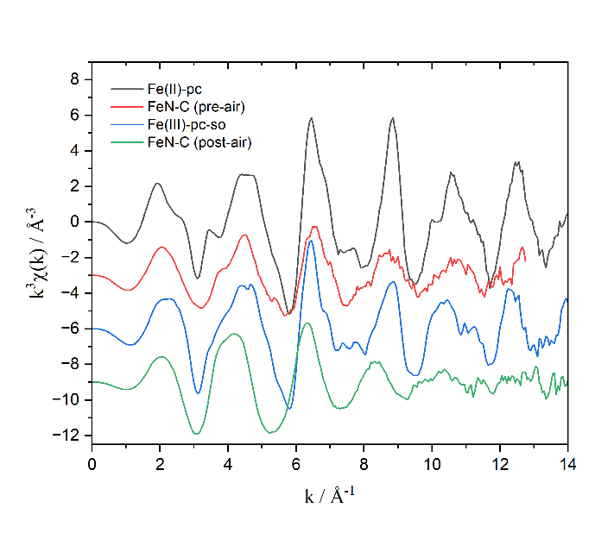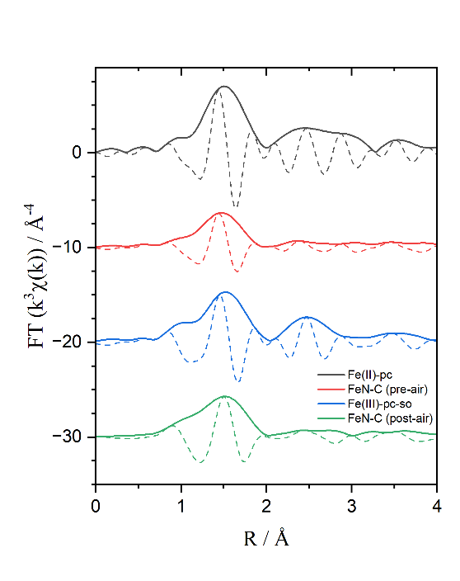
Figure S1. EXAFS k³χ(k) (left) and FT (right) for the Fe-pc standards and FeN-C catalysts.

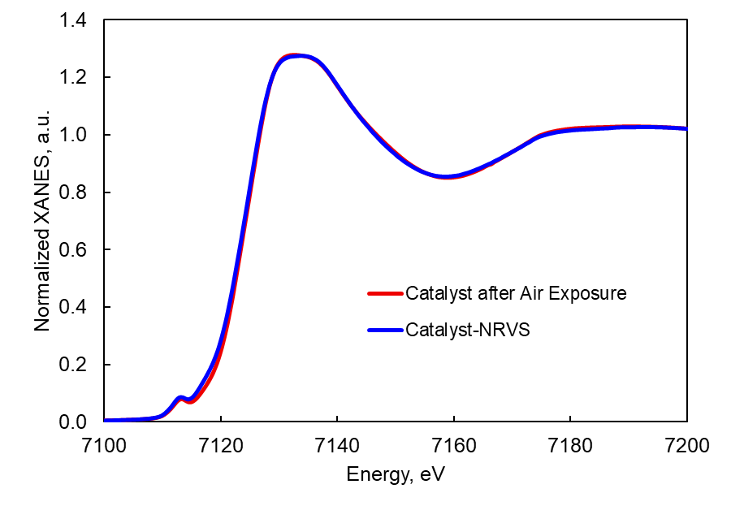
Figure S2. Comparison of XANES spectra between Fe-N-C catalysts after air exposure and NRVS test.
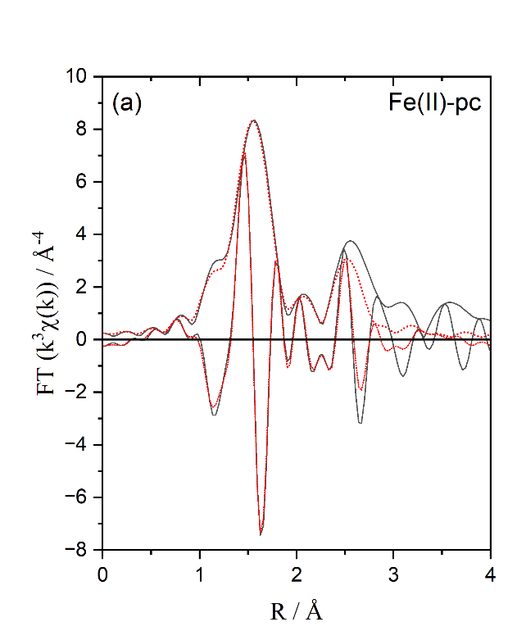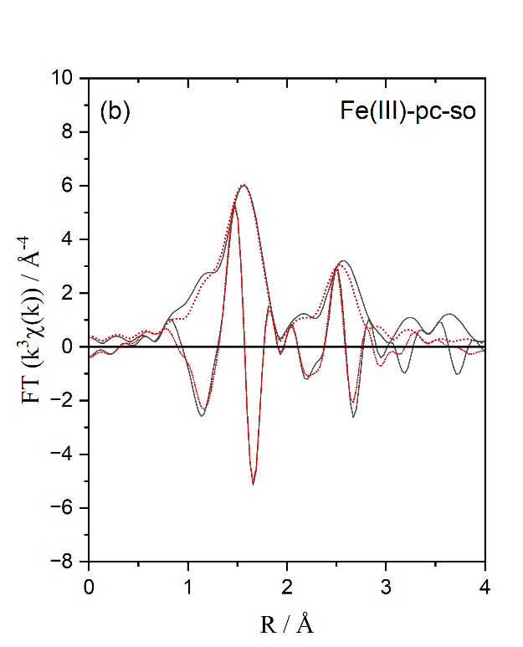
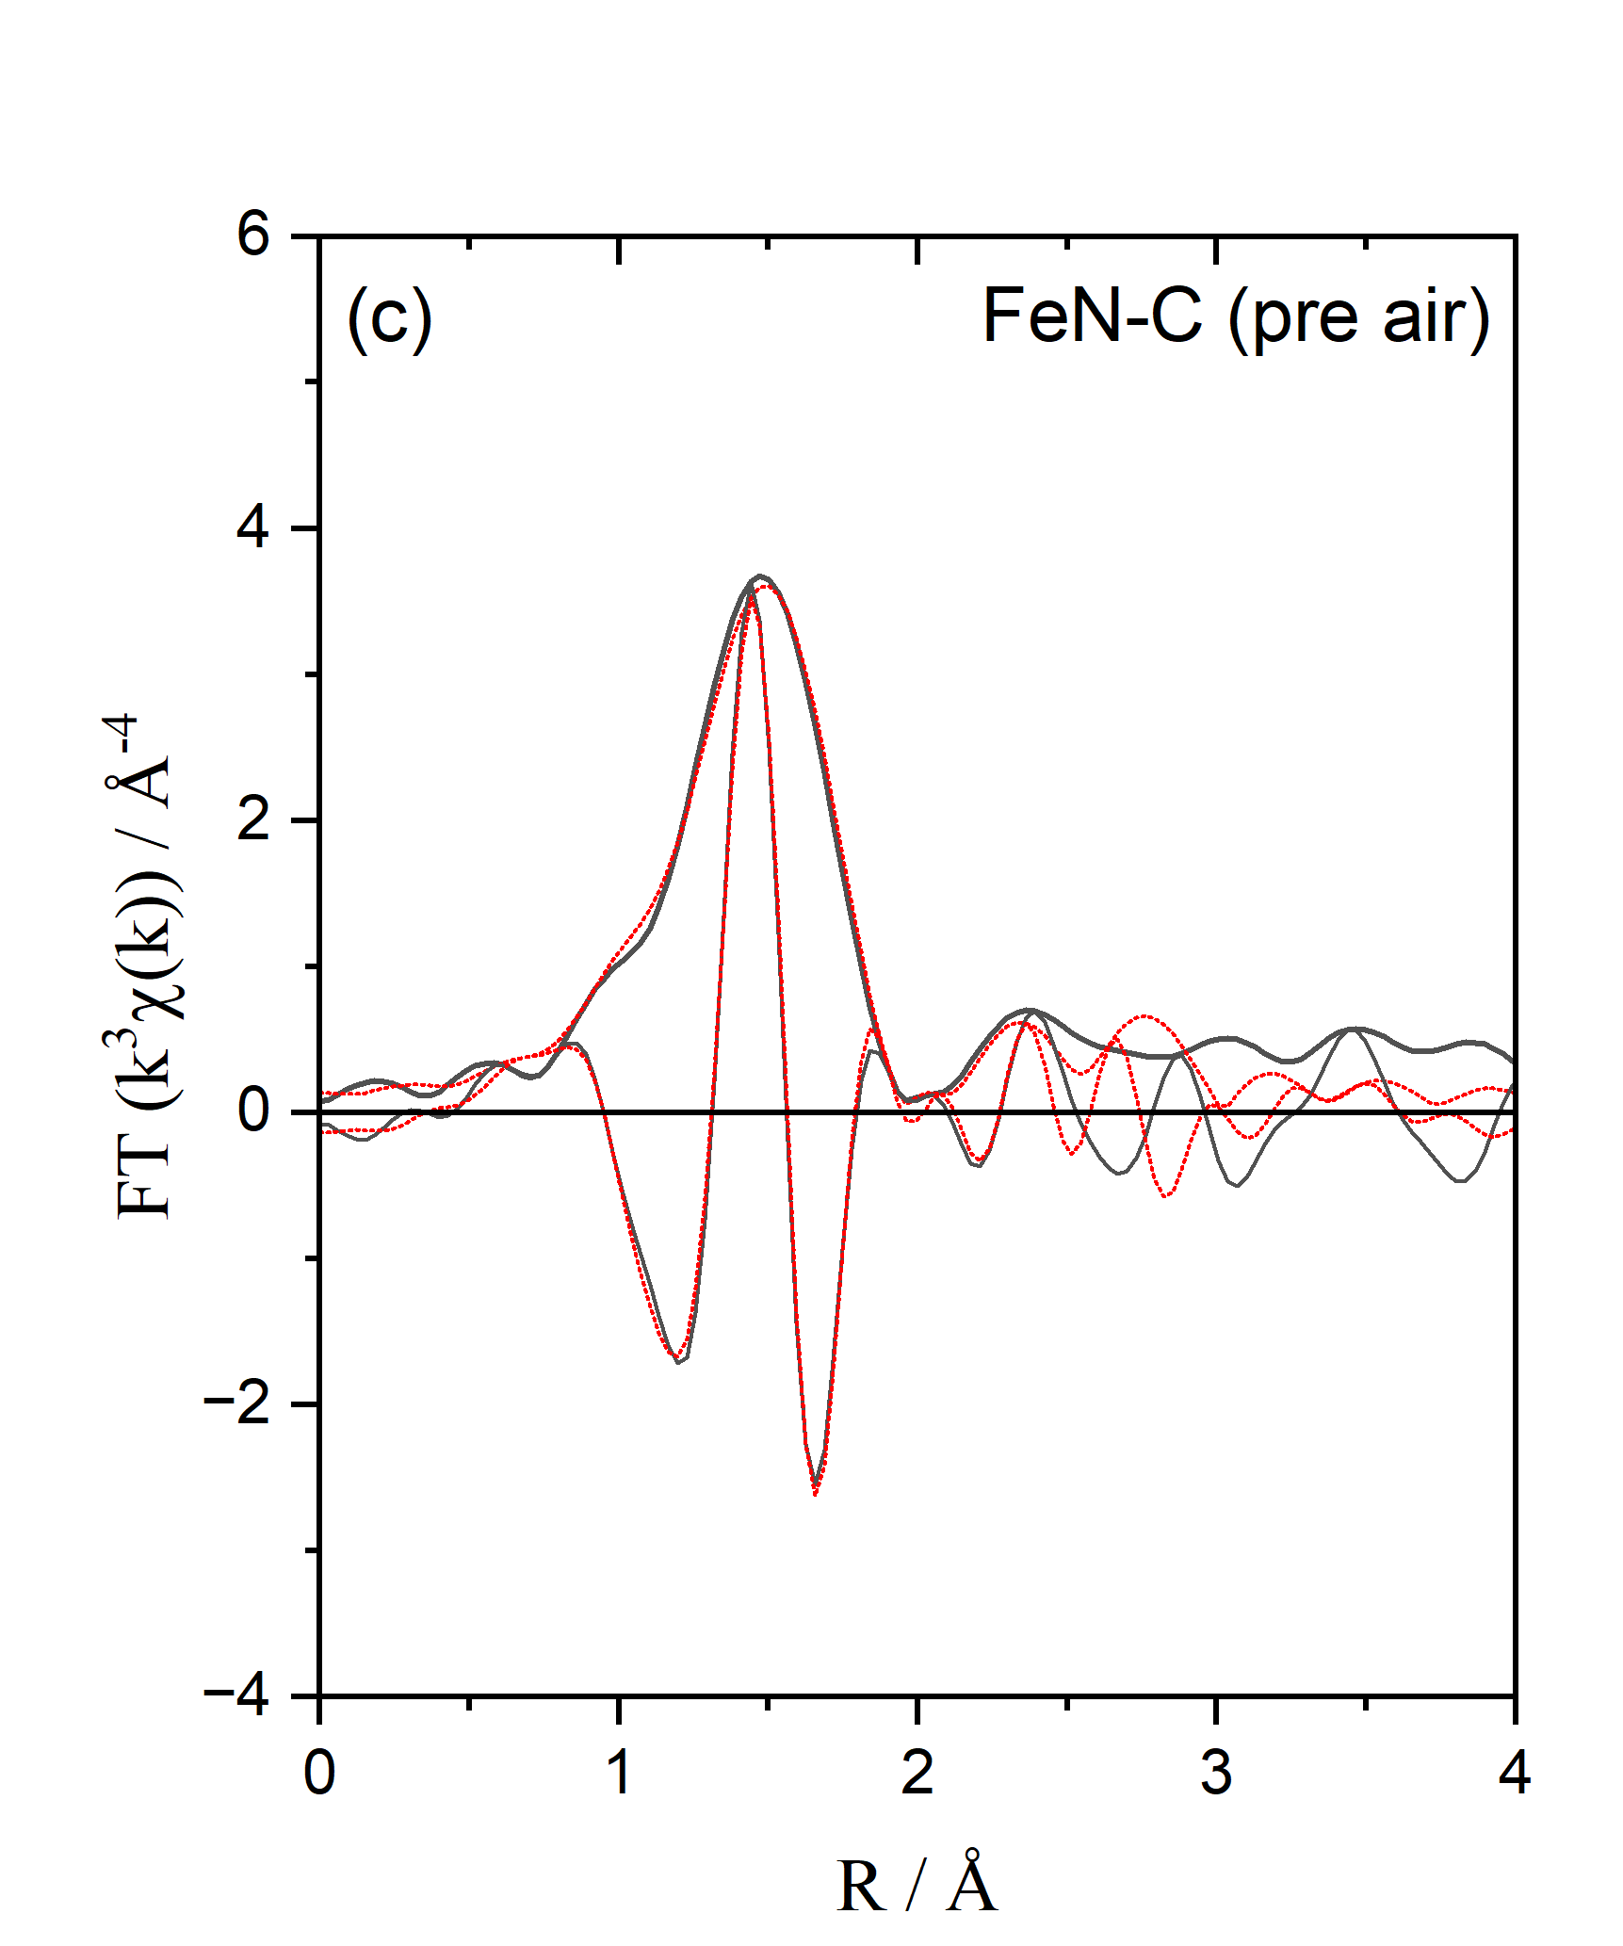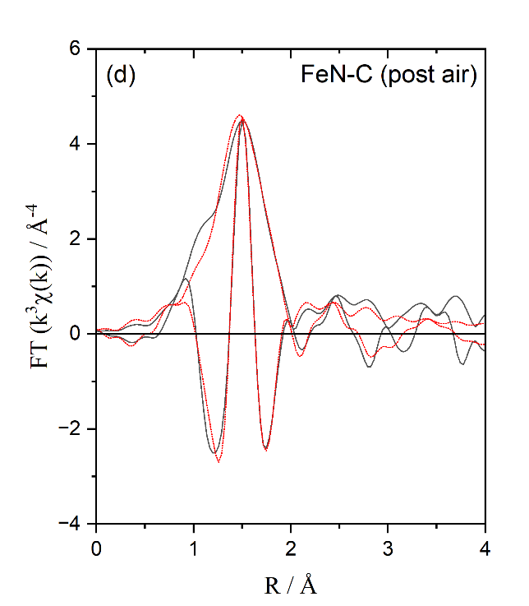
Figure S3. EXAFS experimental data (solid black) and fits (dotted red) for (a) Fe(II)-pc, (b) Fe(III)-pc-so, (c) FeN-C (pre air), and (d) FeN-C (post air). Fourier transforms are over the same k range as in Table S1.

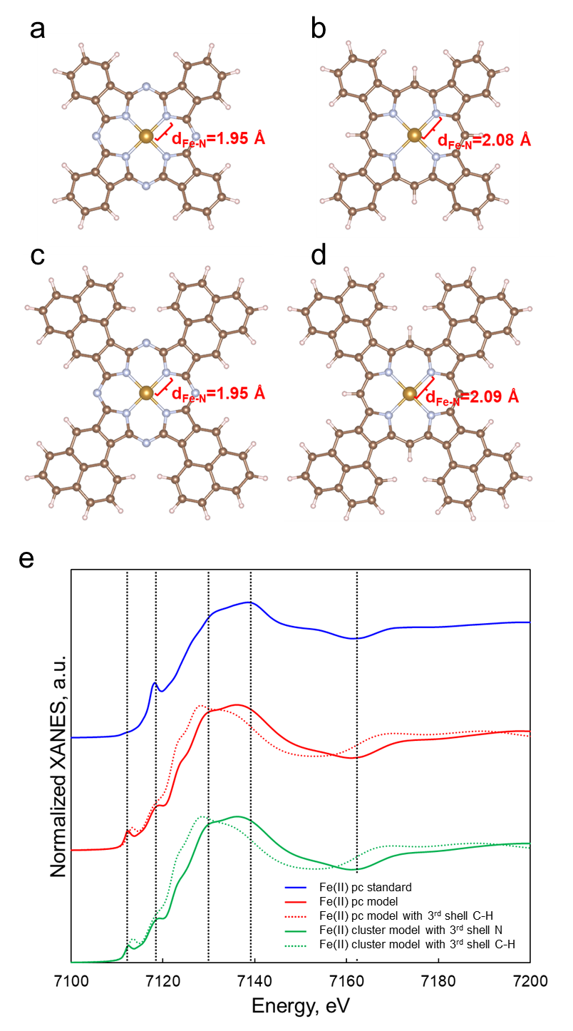
Figure S4. Optimized structure of (a) Fe²⁺ Phthalocyanine (pc), (b) Fe²⁺ pc with third-shell N replaced by C-H, and Fe²⁺ structure with third-shell (c) N and (d) C-H cleaved from periodic model, and their corresponding XANES spectra in comparison with the (e) experimental measured Fe²⁺ pc standard.
Theoretical simulations were conducted to provide comprehensive understanding of the active site structures. As shown in Figure 1, the spectrum of the pre-air exposed sample (blue) exhibits similar features as that of the Fe²⁺ standard, Fe(II) pc (green), whose molecular structure is shown in Figures 1b and S4a, with experimentally measured Fe-N bond distance of 1.93 Å. Therefore, we used this Fe²⁺ standard to benchmark our simulation methodologies. Notably, the Fe(II) pc species is not only surrounded by the four first-shell N atoms, but also by four third-shell N atoms, which have been considered not important to the Fe center in most computational studies that investigated the FeN₄ motif for the Fe-N-C catalysts.¹⁻³ As shown in Figure S4a and b, optimizing Fe(II) pc with and without third-shell N resulted in different Fe-N bond distances, hence differences in XANES features (Figure S4e). Specifically, the presence of N atoms in the third coordination shell results in a computed average Fe-N bond distances of 1.95 Å, similar to the measured EXAFS fitted bond length of 1.932 Å for Fe (II) pc (Table S1). The calculated white line and post-edge features of the Fe(II) pc K-edge (red solid line in Figure S4e) are also consistent with its experimental XANES. With C-H in the third coordination shell instead of N, the Fe-N bond distances become longer (2.08 Å), thus shifting the white line and post-edge features towards a lower energy region (red dashed line in Figure S4e). We further examined whether adding additional phenyl rings affects the XANES features. As shown in Figure S4c, d, and e, the optimized geometries and their corresponding XANES features also show consistent trends as described above (green solid and dashed line in Figure S4e), regardless of the added phenyl rings on the original phenyl rings. This concludes that the local FeN₄ structural parameters are significantly influenced by the third-shell coordination (whether it is N or C-H) and therefore should be considered when analyzing the Fe-N-C site.
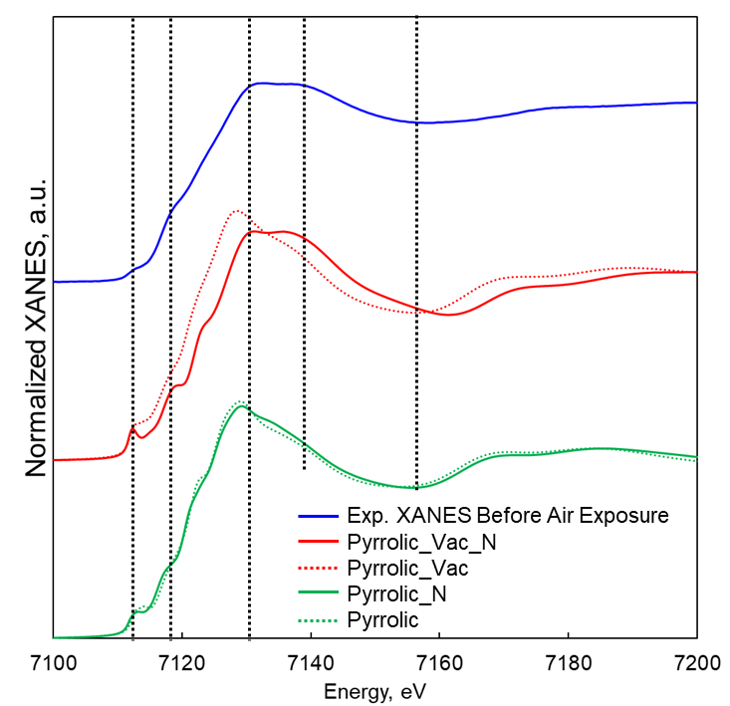
Figure S5. Normalized XANES comparison among the experimental measured XANES before air exposure (blue) and simulated XANES of Pyrrolic_Vac_N (red solid), Pyrrolic_Vac (red dotted), Pyrrolic_N (green solid), and Pyrrolic (green dotted).
To analyze the catalyst structure before air exposure, XANES calculations were performed on these optimized structures. As shown in Figure S5, spectral features of Pyrrolic_Vac_N (red solid line) match well with the experimentally measured XANES with consistent pre-edge, rising-edge, white line region, and post-edge features; in contrast, the Pyrrolic_Vac site with C-H in the third shell (red dashed line in Figure S5) has a lower white line energy compared to the same site with N in the third shell. This trend is consistent with what has been observed in the comparison of standard complexes with the third-shell N or C-H shown in Figure S4. The pyrrolic sites in the perfect graphene framework, the XANES features with and without the third-shell N are very similar, indicated by the green solid and dashed lines in Figure S5; however, in the computed XANES the peak after the white line at 7139.3 eV is missing, inconsistent with the experimental XANES.
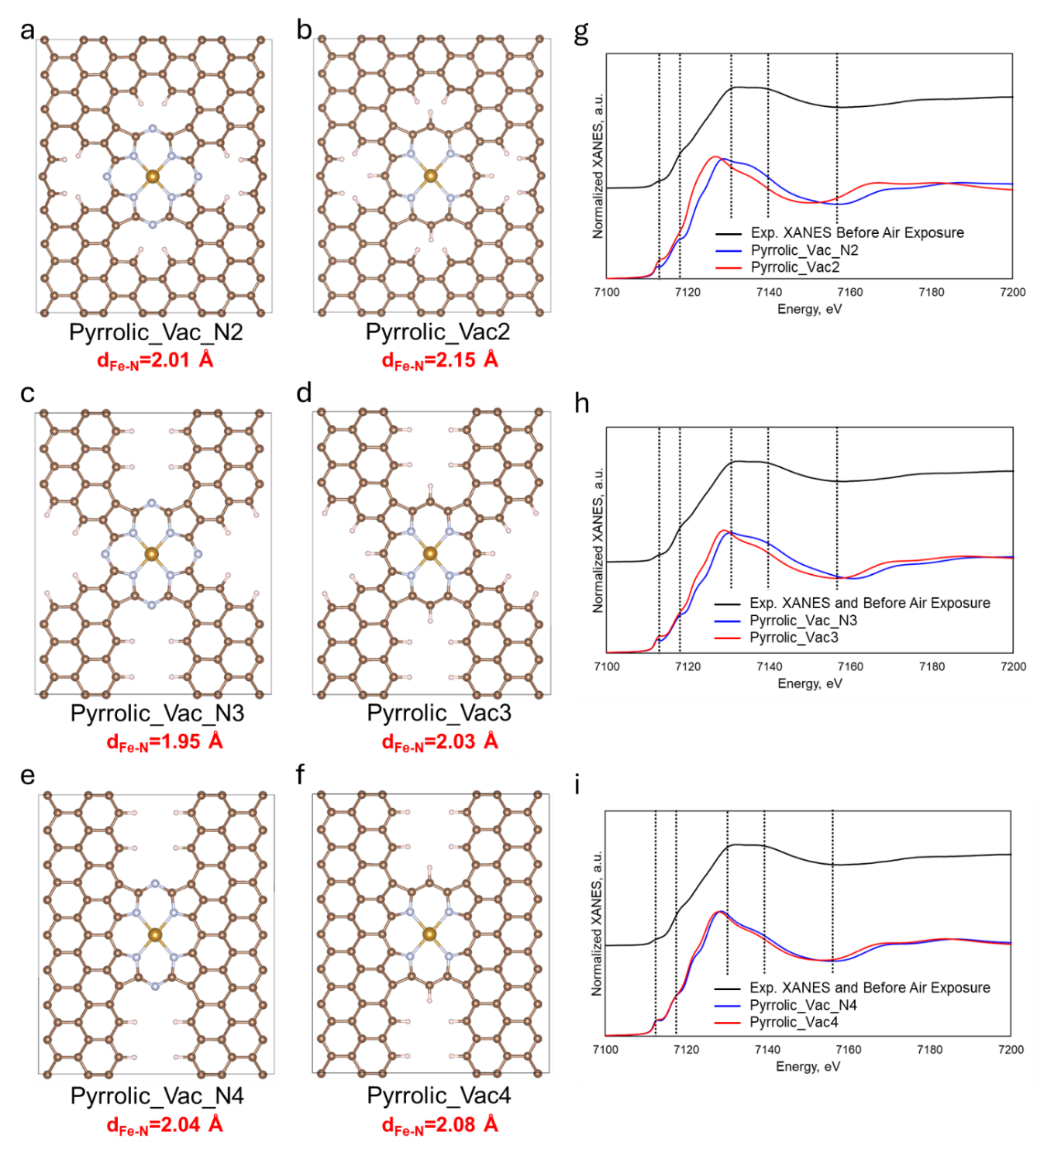
Figure S6. Optimized structures of (a) Pyrrolic_Vac_N2, (b) Pyrrolic_Vac2, (c) Pyrrolic_Vac_N3, (d) Pyrrolic_Vac3, (e) Pyrrolic_Vac_N4, and (f) Pyrrolic_Vac4, as well as their corresponding simulated XANES (g-i).
Other pyrrolic sites embedded in other graphene defects were considered and summarized in Figure S6. It is consistent that with third-shell N atoms, the Fe sites exhibit shorter Fe-N bond distances than C-H on the third coordination shells. Pyrrolic_Vac_N3 sites is more defective compared to the other two sites, which results in a more consistent Fe-N bond distances with EXAFS fitting. Although the trends in XANES features and Fe-N bond lengths associated with third-shell N and C-H coordination persist upon inclusion of large defects, the calculated XANES spectra for these defect models do not match the experimental data. These observations suggest stronger electronic communication between the first-shell and third-shell N atoms compared to that between the first-shell N and third-shell C. The interaction likely influences the Fe-N bond distance, as reflected in the XAS features of the pyrrolic sites.

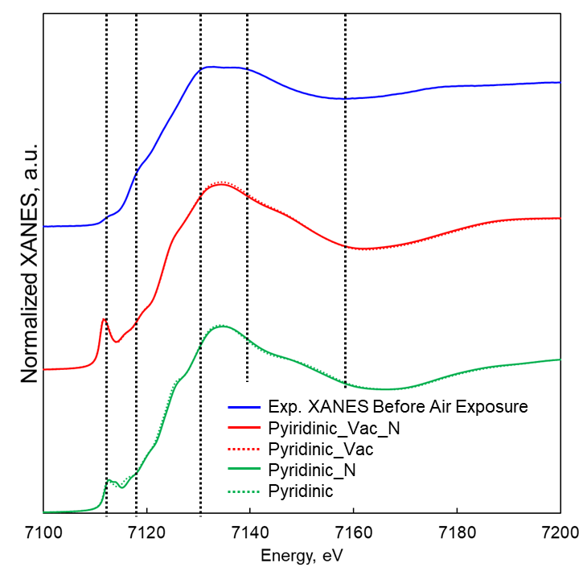
Figure S7. Normalized XANES comparison among the experimental measured XANES before air exposure (blue) and simulated XANES of Pyridinic_Vac_N (red solid), Pyridinic_Vac (red dotted), Pyridinic_N (green solid), and Pyridinic (green dotted).
The XANES spectra of pyridinic sites show negligible changes upon introduction of defect structures or substitution of third-shell N with C-H (Figure S7). This demonstrates that local coordination environment has a smaller impact on the XANES of pyridinic sites as much as the pyrrolic sites. Differences are observed in the rising edge and white line regions when comparing the XANES of pyrrolic sites to experiment. This could also indicate that the pyridinic species should have very stable electronic structures (Figure S8), which is hardly impacted by the third shell coordination and surrounding defects.
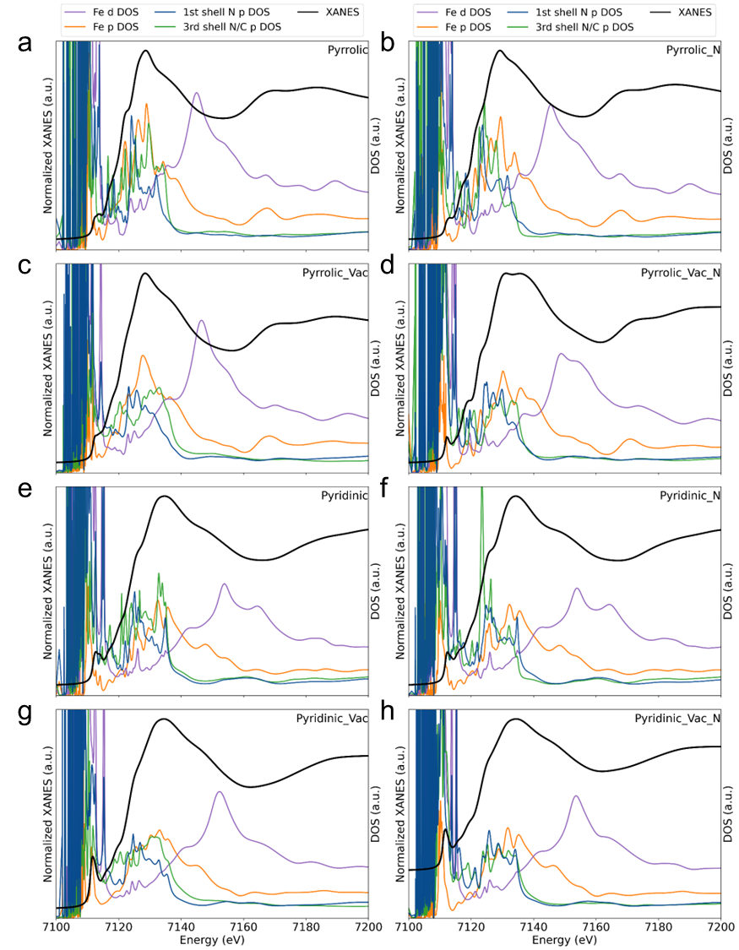
Figure S8. Simulated XANES and the density of states of (a) Pyrrolic, (b) Pyrrolic_N, (c) Pyrrolic_Vac, (d) Pyrrolic_Vac_N, (e) Pyridinic, (f) Pyridinic_N, (g) Pyridinic_Vac, and (h) Pyridinic_Vac_N.
For the pyrrolic sites, according to density of state (DOS) analysis (Figure S8a-d), the Fe K-edge XANES white line region features mainly reflect the Fe p DOS. The extent of overlap between Fe-p and the first-shell N p orbitals is reflected in the rising edge region of the XANES. Additionally, the rising-edge peak at 7118.4 eV likely results from Fe-p and d interaction.⁴ Furthermore, the overlap of the DOS between p orbitals of the first-shell N and third-shell N are observed in the white line region of Pyrrolic_Vac_N XANES (Figure S8 d); on the other hand, the overlap of the DOS between the first-shell N and third-shell C p orbitals are less intense for the Pyrrolic_Vac model (Figure S8 c).
The DOS analysis for the pyridinic sites (Figure S8e-h) reveals orbital overlap between the first- and third-shell atoms across all structures considered; however, the Fe p orbital DOS remains largely unaffected by the local coordination environment, indicating that pyridinic sites possess relatively stable electronic structures that are consistent with the similar XANES features observed across all the pyridinic sites.
Pyrrolic sites show changes in DOS based on the structures considered. However, pyridinic sites show consistent or similar Fe p features regardless of the local environment, which indicate stable Fe electronic structures.
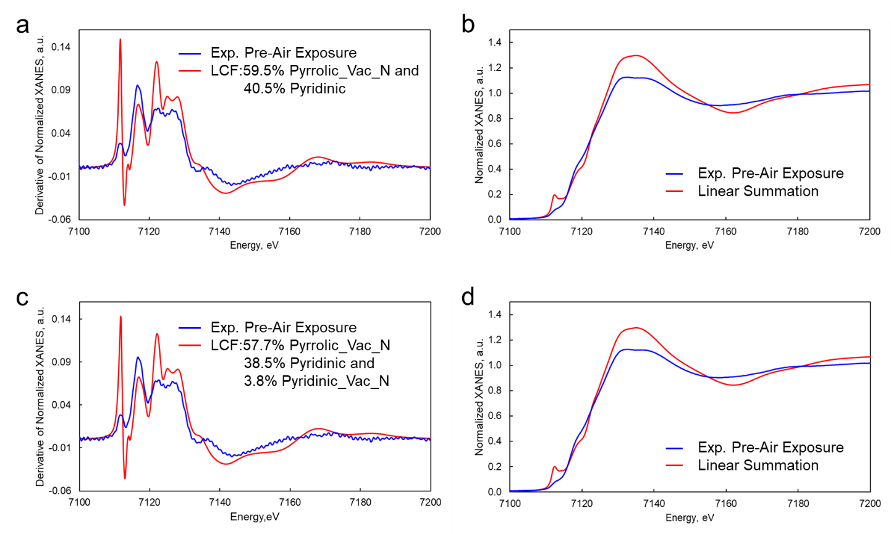
Figure S9. (a) Linear combination fitting (LCF) of the derivative of normalized experimental XANES using Pyrrolic_Vac_N and Pyridinic sites on pre-air exposure XANES, the resultant percentage are used for linear summation for XANES feature and compared with (b) experimental XANES. (c) Linear combination fitting using Pyrrolic_Vac_N, Pyridinic, and Pyirinic_Vac_N sites, the resultant percentage are used for linear summation for XANES feature and compared with (d) experimental XANES.
The linear combination fitting of the derivative of the normalized experimental XANES indicates approximately 60:40 ratio of Pyrrolic_Vac_N and Pyridinic sites. And the linear summation using fitted percentage can roughly capture the major XANES feature of the experimental XANES, Figure S9 b. When considering Pyridinic_Vac_N as a third component, Figure S9c, the fit suggests these sites only contribute 3.8%. This further supports the conclusion that Pyrrolic_Vac_N sites are the major species, which coexist with a lower percentage of pyridinic sites.
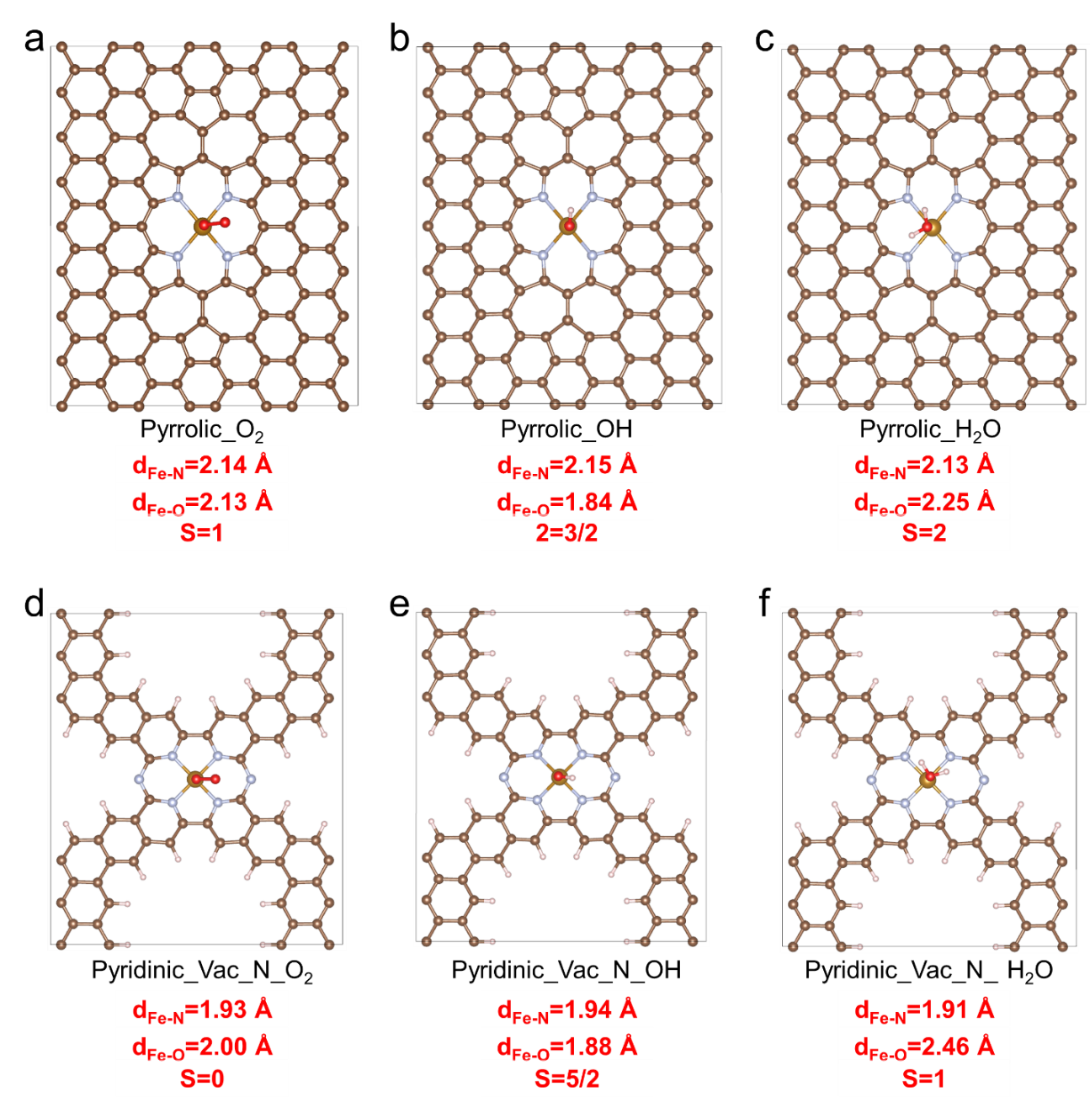
Figure S10. Optimized Structures of (a) Pyrrolic_O₂, (b) Pyrrolic_OH, (c) Pyrrolic_H₂O, (d) Pyidinic_Vac_N_O₂, (e) Pyridinic_Vac_N_OH, and (f) Pyridinic_Vac_N_H₂O.
Different spin states were considered during geometry optimization, and the results indicate that bond lengths and symmetry can be highly sensitive to the spin state, Table S2. The structures of the adsorbates on the Pyrrolic and Pyridinic_Vac_N sites are summarized in Figure S10. Both Pyrrolic and Pyridinic_Vac_N sites with adsorbates show variations in terms of Fe-O and Fe-N bond distances, which suggests these sites could be unlikely.
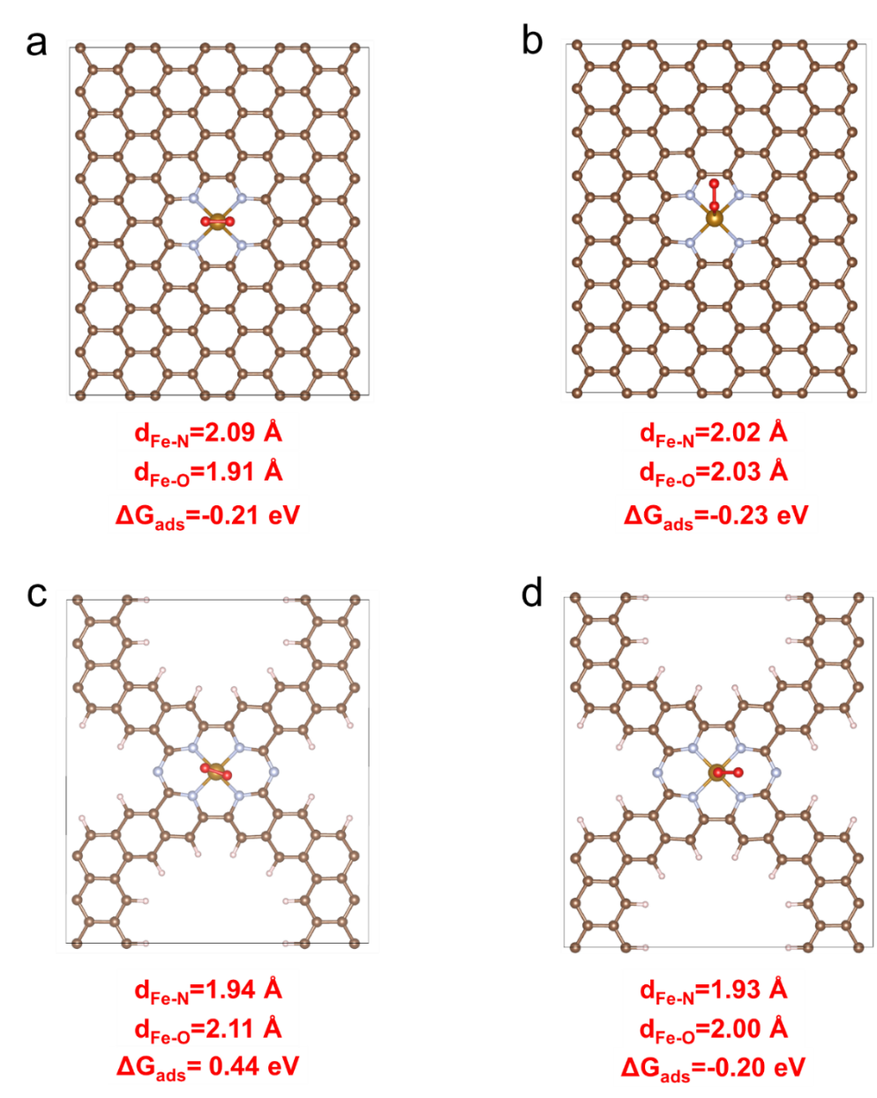
Figure S11. Optimized Structures of (a) Pyridinic_O₂ side-on binding mode, (b) Pyridinic_O₂ end-on binding mode, (c) Pyridinic_Vac_N_O₂ side-on binding mode, (d) Pyridinic_Vac_N_O₂ end-on binding mode.
When considering O₂ adsorption, two binding configurations, i.e., side-on binding mode and end-on binding mode, were considered. Both binding modes can be found over pyridinic sites, Figure S11a and S11b, while only end-on binding mode was found thermodynamically favorable over pyrrolic sites, Figure S11d. When comparing the O₂ binding energies, Figure S11, on the pyridinic site, both binding modes are thermodynamically favorable with the end-on binding mode being more stable by -0.02 eV, while only the end-on binding mode is favorable on the Pyridinic_Vac_N site (ΔG_{ads} = -0.20 eV). As summarized in Table S1, many of the optimized structures show bond distances that are in good agreement with those derived from fitting the EXAFS data making it challenging to identify the most probable active site structure post-air exposure solely based on the structural parameters.
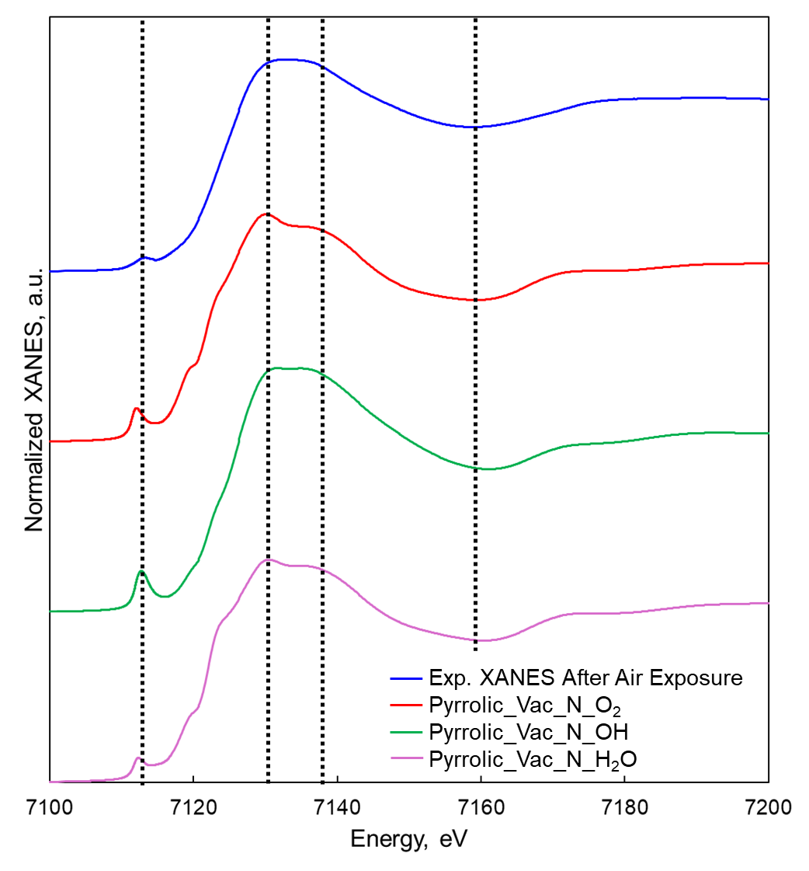
Figure S12. Normalized XANES comparison among the experimental measured XANES after air exposure (blue) and simulated XANES of Pyrrolic_Vac_N_O₂ (red), Pyrrolic_Vac_N_OH (green), and Pyrrolic_Vac_N_H₂O (purple).
The simulated XANES based on the optimized structures of Pyrrolic sites with adsorbate, only Pyrrolic_Vac_N_OH exhibit consistent XANES features compared with experiment, which indicates that this structure could be abundant and dictate the overall XANES feature.
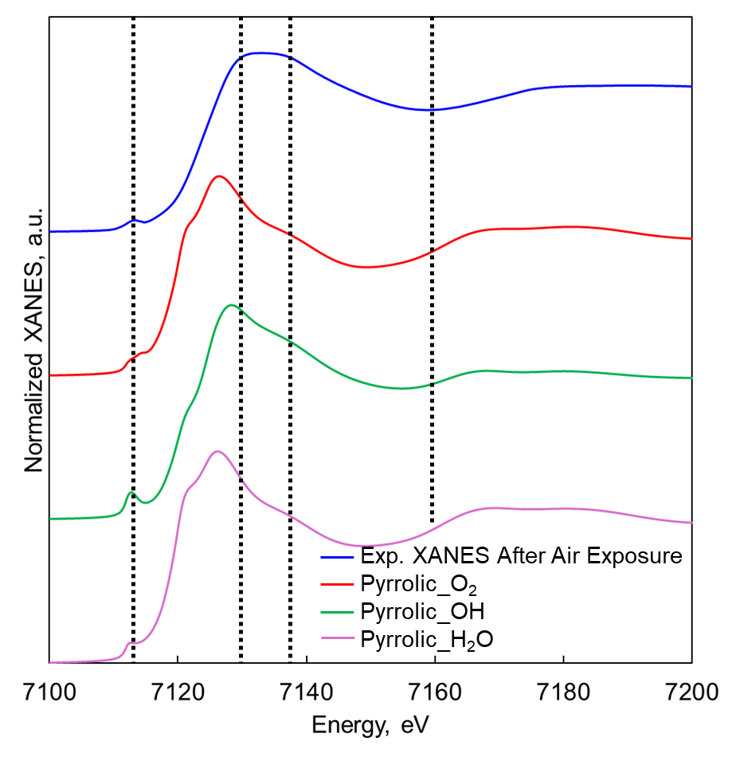
Figure S13. Normalized XANES comparison among the experimental measured XANES after air exposure (blue) and simulated XANES of Pyrrolic_O₂ (red), Pyrrolic_OH (green), and Pyrrolic_H₂O (purple).
The simulated XANES of Pyrrolic sites with adsorbates show inconsistent XANES features compared with experimental XANES, especially at the white line region, indicating that these sites are not likely after air exposure.
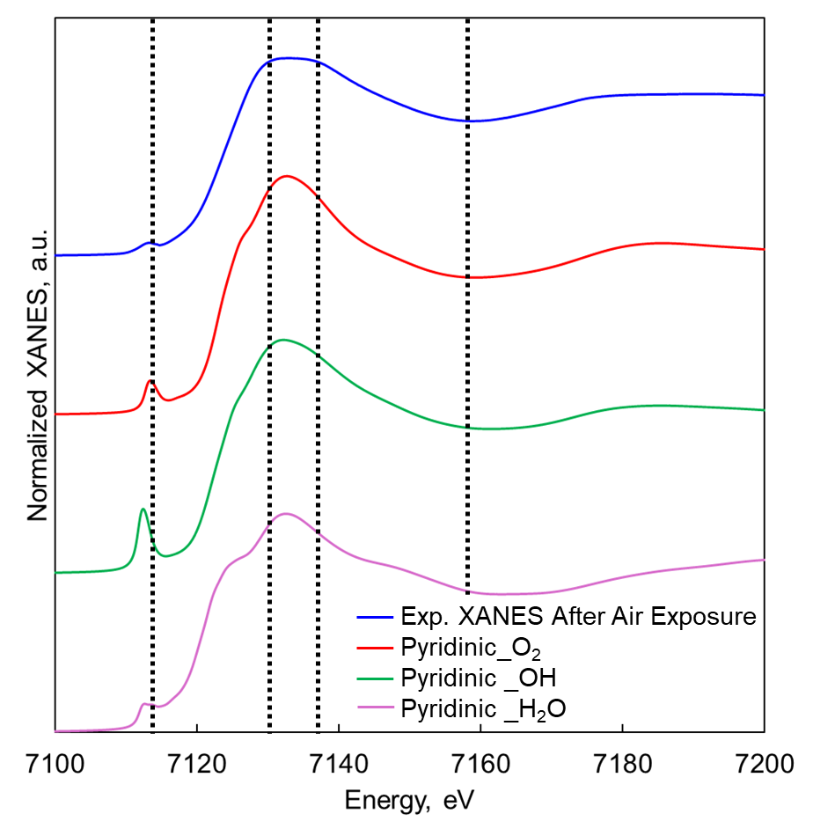
Figure S14. Normalized XANES comparison among the experimental measured XANES after air exposure (blue) and simulated XANES of Pyridnic_O₂ (red), Pyridnic_OH (green), and Pyridnic_H₂O (purple).
The simulated XANES features of Pyridinic_O₂ show consistent pre-edge and post edge feature, and white line region could also contribute to the formation of the white line region of the experimentally measured XANES. For Pyridinic_OH and Pyridinic_H₂O, inconsistent pre-edge feature was observed, which suggests that these two sites are unlikely.
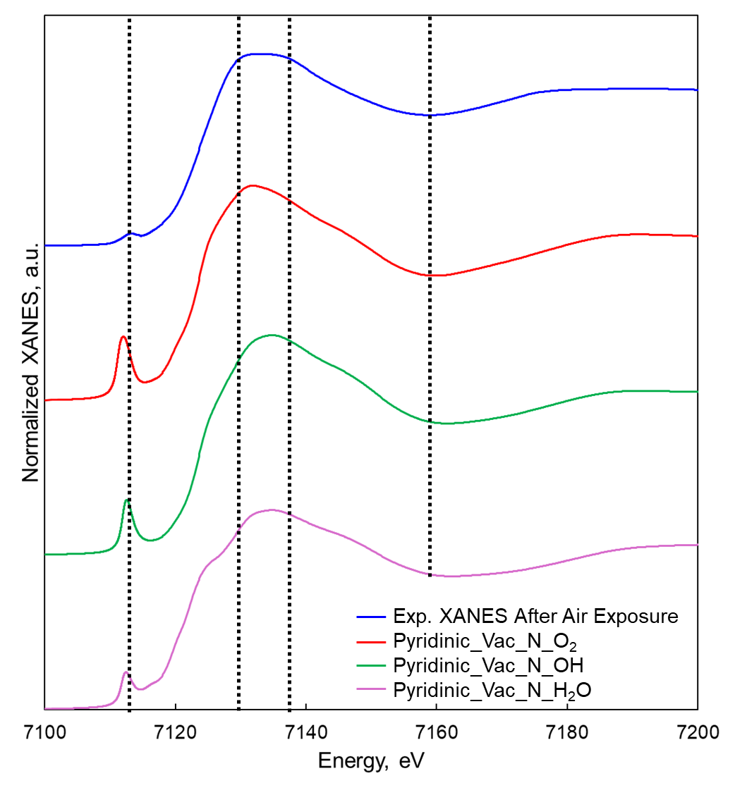
Figure S15. Normalized XANES comparison among the experimental measured XANES after air exposure (blue) and simulated XANES of Pyridinic_Vac_N_O₂ (red), Pyridinic_Vac_N_OH (green), and Pyridinic_Vac_N_H₂O (purple).
Pyridinic_Vac_N sites with adsorbates shown consistent pre-edge and post-edge features; however, Pyridinc_Vac_N site is already minor or low impact on the XANES features based on the analysis of the pre-air exposed XANES.
The XANES features of Pyrrolic_Vac_N_OH, green line in Figure S12, closely resembles the experimental XANES. In contrast, the pyrrolic sites with adsorbed O₂, OH, and H₂O display markedly different features, and the significantly lower white line energy than observed experimentally, indicating these sites are unlikely. The white line region of the pyridinic sites with adsorbates, Figure S14, may partially account for the experimental white line feature, and the calculated and experimental post edge regions show better agreement. However, the pre-edge region of Pyridinic_OH and Pyridinic_H₂O exhibit slightly lower pre-edge energies. Despite some consistent post-edge features observed for Pyridinic_Vac_N sites with adsorbates, Figure S15, this site has already demonstrated minor or low impact on the XANES features of the as-pyrolyzed, pre-air exposure sample. By comparing the pre- and post-air exposure sample XANES, the peak at 7118.4 eV in the rising edge region of the XANES for the as-pyrolyzed sample is not present in the post-air exposure sample’s XANES. The disappearance of the peak at 7118.4 eV was also observed for the simulated XANES for structures with OH coordination.
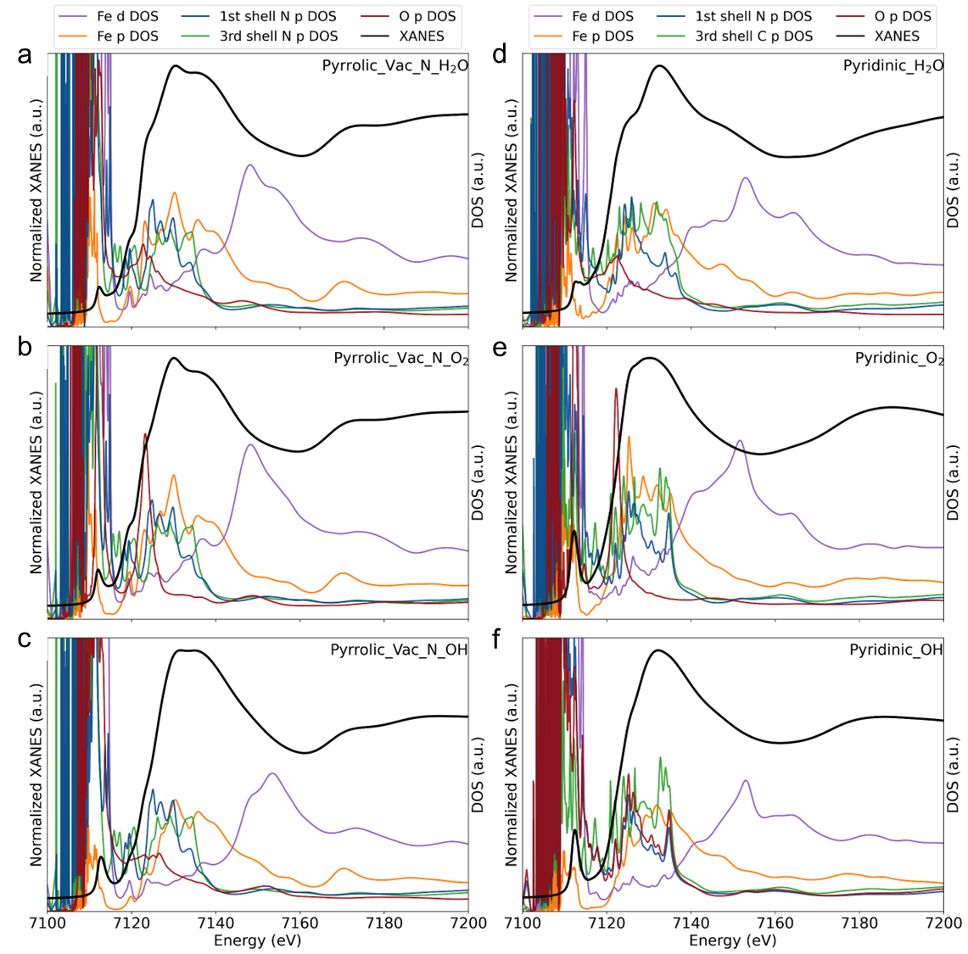
Figure S16. Simulated XANES and the density of states of (a) Pyrrolic_Vac_N_H₂O, (b) Pyrrolic_VAC_N_O₂, (c) Pyrrolic_Vac_N_OH, (d) Pyridinic_H₂O, (e) Pyridinic_O₂, and (f) Pyridinic_OH.
Due to the binding interaction between the adsorbates and Fe center, it is clear that the O-p orbitals overlap with Fe-p orbitals for all cases between the pre-edge region to white line region. Upon the interaction, Fe²⁺ are oxidized to Fe³⁺ via the changes in structural symmetry from square planer to square pyramidal, hence disappearing of the peak at 7118.4 eV. This is consistent with the observed increase in the edge energy of the XANES spectra upon air exposure.
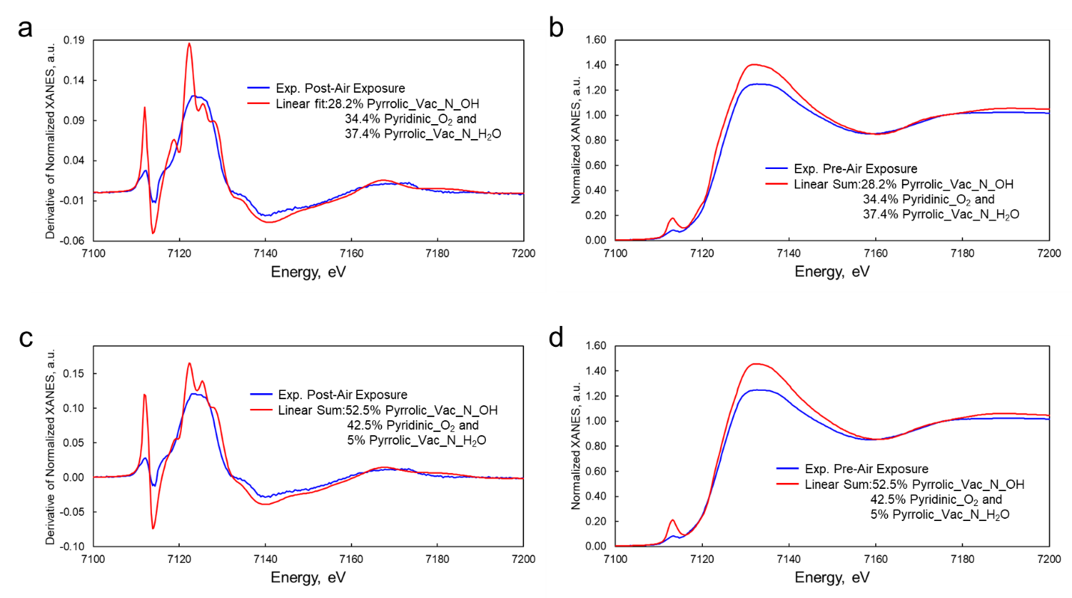
Figure S17. (a) Linear combination fitting using Pyrrolic_Vac_N_OH, Pyridinic_O₂, and Pyrrolic_Vac_N_H₂O on the post-air exposure XANES, (b) the resultant percentage are used for linear summation for XANES feature and compared with experimental XANES. The linear summation using the Mössbauer fraction to reproduce the (c) 1st derivative of the XANES feature and (d) reproduced XANES compared with the experimental spectrum.
Figure S17a and b: Linear combination fitting using Pyrrolic_Vac_N_OH, Pyridinic_O₂, and Pyrrolic_Vac_N_H₂O shows good consistency in terms of the derivative of the XANES feature. The resultant percentage shows total of 65.6% of Pyrrolic_Vac_N sites and 34.4 % of Pyridinic sites. Linear summation with the resultant percentage and simulated spectra can reproduce XANES feature that can almost capture the XANES feature observed from experiment.
Figure S17c and d: Using the Mössbauer fraction to form linear summation with the simulated XANES spectra, the first derivative fitting also show good comparison with the experimental results. Similarly, the linear summed XANES feature can also well reproduce the experimental XANES spectra.

Table S2. Calculated spin states, Fe-N and Fe-O bond lengths, the isomers shift (IS), and quadrupole splitting (QS) from the models selected for Mössbauer simulations.
Species | spin state | Fe-N | Fe-O | IS | QS
Pyrrolic | singlet | 2.08 |  | 0.92 | 2.96
 | triplet | 2.12 |  | 0.86 | 0.46
 | quintet | 2.1 |  | 0.86 | 0.5
Pyrrolic_O₂ | singlet | 2.1 | 1.96 | 0.76 | 1.73
 | triplet | 2.14 | 2.13 | 0.91 | 1.77
 | quintet | 2.08 | 2.28 | 0.96 | 2.91
Pyrrolic_H₂O | singlet | 2.09 | 2.20 | 0.95 | 2.32
 | triplet | 2.13 | 2.37 | 1.03 | 2.32
 | quintet | 2.13 | 2.25 | 0.97 | 1.04
Pyrrolic_OH | doublet | 2.09 | 1.82 | 0.49 | 1.94
 | quartet | 2.15 | 1.84 | 0.56 | 0.31
 | sextet | 2.15 | 1.82 | 0.56 | 0.32
Pyrrolic_Vac_N | singlet | 1.95 |  | 0.77 | 4.22
 | triplet | 1.95 |  | 0.58 | 1.32
 | quintet | 1.95 |  | 0.60 | 1.28
Pyrrolic_Vac_N_O₂ | singlet | 1.96 | 2.22 | 0.66 | 3.58
 | triplet | 1.96 | 2.05 | 0.56 | 1.73
 | quintet | 1.96 | 2.08 | 0.41 | 1.48
Pyrrolic_Vac_N_H₂O | singlet | 1.96 | 2.31 | 0.74 | 3.60
 | triplet | 1.96 | 2.38 | 0.63 | 1.47
 | quintet | 2.04 | 2.2 | 0.89 | 2.26
Pyrrolic_Vac_N_OH | doublet | 1.96 | 1.88 | 0.31 | 1.22
 | quartet | 1.98 | 1.88 | 0.36 | 1.15
 | sextet | 2.05 | 1.84 | 0.41 | 0.35
Pyridinic | singlet | 1.91 |  | 0.69 | 4.31
 | triplet | 1.91 |  | 0.40 | 2.02
 | quintet | 1.92 |  | 0.43 | 1.97
Pyridinic_O₂_end-on | singlet | 1.92 | 2.12 | 0.53 | 3.11
 | triplet | 2.01 | 2.03 | 0.62 | 1.83
 | quintet | 1.93 | 2.92 | 0.45 | 1.85
Pyridinic_O₂_side-on | triplet | 2.09 | 1.91 | 0.69 | 2.24
Pyridinic_H₂O | singlet | 1.92 | 2.46 | 0.69 | 3.69
 | triplet | 1.92 | 2.44 | 0.47 | 2.17
 | quintet | 1.92 | 2.41 | 0.50 | 2.10
Pyridinic_OH | doublet | 1.92 | 1.85 | 0.30 | 2.23
 | quartet | 1.95 | 1.88 | 0.32 | 0.85
 | sextet | 2.05 | 1.84 | 0.44 | 1.16
Pyridinic_Vac_N | singlet | 1.90 |  | 0.30 | 4.69
 | triplet | 1.91 |  | 0.40 | 2.18
 | quintet | 1.90 |  | 0.51 | 3.71
Pyridinic_Vac_N_O₂ | singlet | 1.93 | 2.00 | 0.38 | 3.61
 | triplet | 1.92 | 2.09 | 0.33 | 3.79
 | quintet | 1.91 | 2.89 | 0.40 | 2.10
Pyridinic_Vac_N_H₂O | singlet | 1.91 | 2.21 | 0.63 | 3.79
 | triplet | 1.91 | 2.46 | 0.45 | 2.30
 | quintet | 1.91 | 2.47 | 0.56 | 3.34
Pyridinic_Vac_N_OH | doublet | 1.92 | 1.89 | 0.22 | 3.28
 | quartet | 1.92 | 1.83 | 0.18 | 1.39
 | sextet | 1.94 | 1.88 | 0.25 | 0.81

As shown in Table 2, the Fe-O and Fe-N bond distances, as well as corresponding Mössbauer parameters (IS and QS) are very sensitive to the spin states, due to changes in magnetic moments, electronic structures, and structural parameters. In this report, the structures reported are at the lowest total energies, which also shown great consistency with EXAFS and Mössbauer fittings.
By comparing the Mössbauer parameters, Site 1 is very likely to be Pyrrolic_Vac_N_OH (Figure 4b) with very comparable IS and QS values. Site 2 is likely to be a pyridinic site with O₂* in a side-on binding mode, which exhibits good agreement between the calculated and EXAFS fit-derived bond distances and coordination numbers (Figure 4d). Moreover, the calculated IS and QS for this structure also agree with the Site 2 IS and QS derived from fitting the Mössbauer spectrum, Table 1. Therefore, there is strong evidence that Site 2 is Pyridinic_O₂ with side-on binding. Site 3 from experimental fitting gives an extremely high QS value, which was only observed in our calculations for Pyrrolic_Vac_H₂O and Pyridinic_H₂O, Table S2. The Pyrrolic_Vac_N_H₂O structure (Figure 4c) provide IS and QS values that are more comparable with the fitted parameters. Site 3, therefore is likely, Pyrrolic_Vac_N_H₂O. The calculated adsorption energy of H₂O, ΔG = -0.28 eV, on this site also supports this assignment.

References
1. Liu, K. X.; Wu, G.; Wang, G. F., Role of Local Carbon Structure Surrounding FeN4 Sites in Boosting the Catalytic Activity for Oxygen Reduction. J Phys Chem C 2017, 121 (21), 11319-11324.
2. Levell, Z.; Yu, S.; Wang, R.; Liu, Y., What Is the “Other” Site in M–N–C? Journal of the American Chemical Society 2025, 147 (1), 603-609.
3. Xu, J.; Patel, P.; Yan, C.; Liu, C., Understanding the active site structures and achieving catalytic activity tuning of atomically dispersed FeN4 sites for oxygen reduction reaction. ChemPhysChem 2025, e202401158.
4. Rossi, G.; d'Acapito, F.; Amidani, L.; Boscherini, F.; Pedio, M., Local environment of metal ions in phthalocyanines: K-edge X-ray absorption spectra. Phys Chem Chem Phys 2016, 18 (34), 23686-23694.

