Supplementary Figures
a 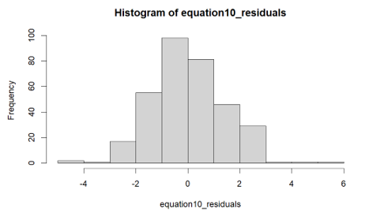
b 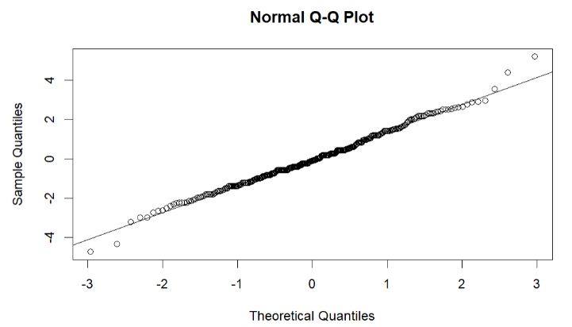
c 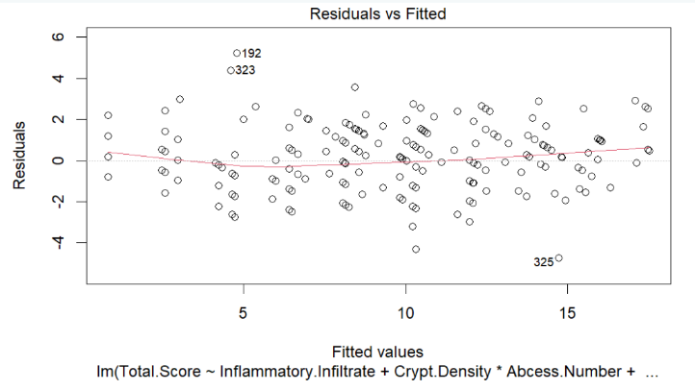
SI Fig. 1 Assumptions met to perform linear regression. Residuals are inherently independent to our model. Residuals were also shown to be normally distributed (a, b) and have equal variance (not heteroskedastic) (c).

